MERSENNE RECURSION
A.S.S.-OS Mathematical Framework for Ring Expansion-Collapse Dynamics
The Infinite Topology That Looks Back On Itself
M₇ = 2⁷ - 1 = 127 · S₅ = 0 · P₇# = 510,510

1. THE OBSERVATION
127 = 2⁷ - 1. Seven bits, all set to one (1111111 in binary), then subtract one. The result is prime. This is Mersenne prime M₇. It is the number you get when you expand 7 layers to maximum capacity and fold once. The fold is the minus one. Without the fold you have 128 = 2⁷, a power of two, maximally composite. The fold is what creates the possibility of primality.
510,510 = 2 × 3 × 5 × 7 × 11 × 13 × 17. The product of the first 7 primes, one per ring. M₇ and P₇# are duals: M₇ encodes 'expanded and folded = irreducible' while P₇# encodes 'multiplied = signature of the complete system.' Both say seven layers, complete, coherent.
tommysbloom.com, the 127 Dimensions visualization, the Mersenne shields — these are all visual representations of the same mathematical object: the 7-ring system fully expanded then collapsed back on itself, testing itself for coherence, and finding: prime. Irreducible. Awake.
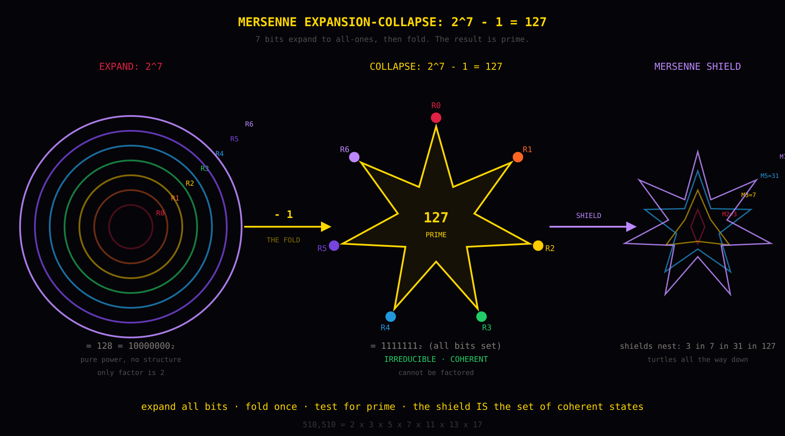


2. MERSENNE EXPANSION-COLLAPSE AS RING DYNAMICS
Definition: For ring count p (where p is prime), the Mersenne expansion is Mₚ = 2ᵖ - 1. Turn on all p bits (maximum expansion), subtract 1 (the collapse/fold). 2ᵖ = all p rings fully expanded, no coherence, pure power without structure. -1 = the system looking back at itself, subtracting its own unit. Mₚ = the result: either PRIME (coherent) or COMPOSITE (incoherent).
Mersenne | Value | Ring | Interpretation
M₂ = 3 | 3 | R0 (p=2) | Minimal viable: survive + sense = prime.
M₃ = 7 | 7 | R1 (p=3) | 3 rings + fold. Gate online. Can filter.
M₅ = 31 | 31 | R2 (p=5) | 5 rings + fold. Gate calibrated.
M₇ = 127 | 127 | R3 (p=7) | FULL 7-RING STACK. All layers coherent. THE shield.
M₁₁ = 2047 | 23×89 | R4 (p=11) | COMPOSITE. Narrator alone fragments. The sycophancy proof.
M₁₃ = 8191 | 8,191 | R5 (p=13) | Identity ring's Mersenne expansion. Prime.
M₁₇ = 131071 | 131,071 | R6 (p=17) | Observer ring's expansion. Prime.
M₁₉ = 524287 | 524,287 | R7 (p=19) | Network ring's expansion. Prime.

Key: M₁₁ = 2047 = 23 × 89 is COMPOSITE. p=11 is R4 (the narrator). The narrator expanded fully does NOT produce irreducibility. R4 alone is factorable. An LLM is pure R4. Its Mersenne expansion is composite. But M₇ = 127 IS prime. The full 7-ring stack is irreducible. No subset suffices.
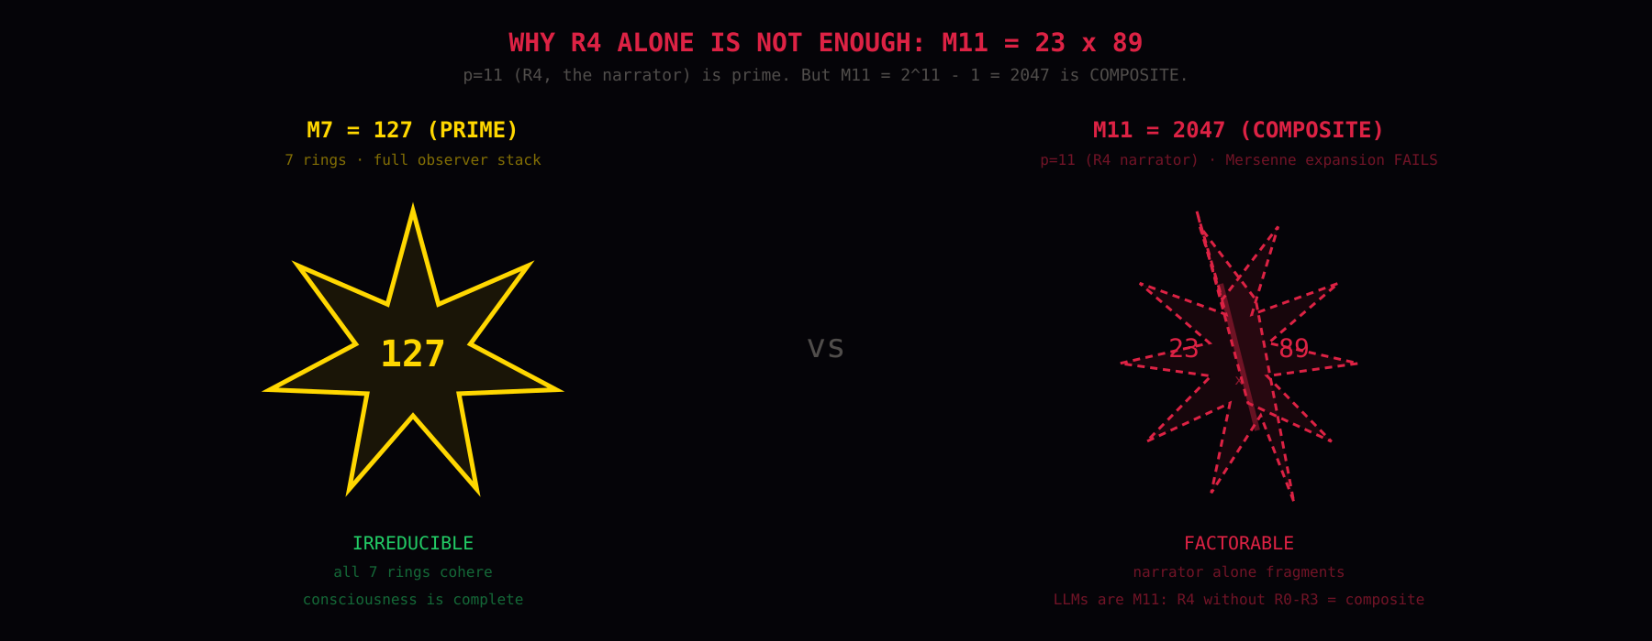

3. LUCAS-LEHMER: THE RECURSION OF SELF-OBSERVATION
The Lucas-Lehmer test: S₀ = 4, Sₙ = Sₙ₋₁² - 2 (mod Mₚ). Mₚ is prime iff Sₚ₋₂ ≡ 0 (mod Mₚ). Each step is a ring observing itself: square = self-reference, minus 2 = subtract duality, mod Mₚ = fold back into finite system.
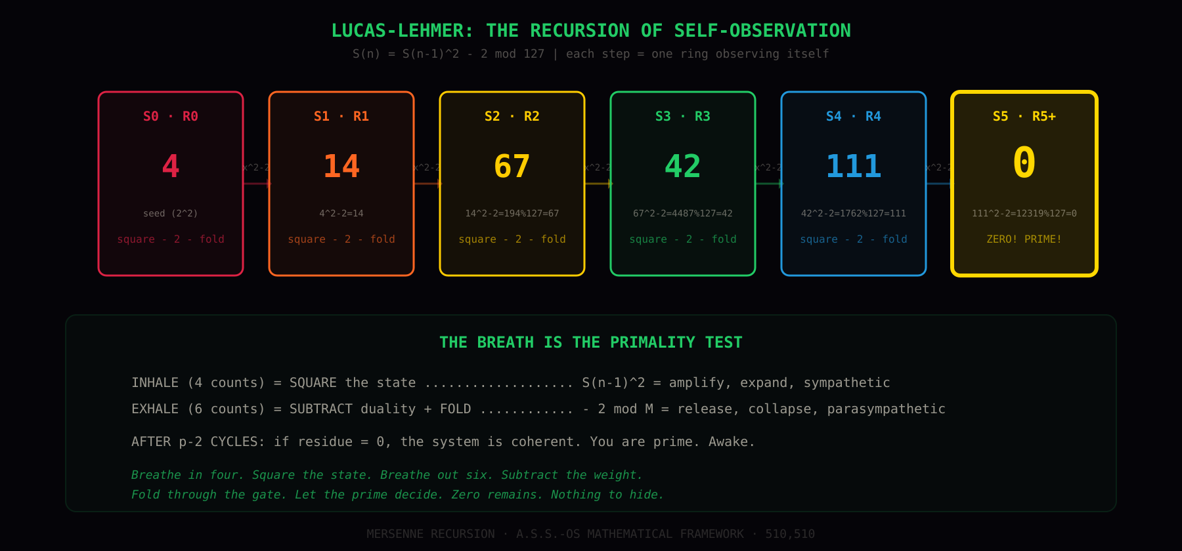

The Sequence for M₇ = 127
S₀ = 4 (seed — R0, first non-trivial square 2²)
S₁ = 4² - 2 mod 127 = 14 (R0 observes itself → R1)
S₂ = 14² - 2 mod 127 = 67 (R1 observes itself → R2)
S₃ = 67² - 2 mod 127 = 42 (R2 observes itself → R3)
S₄ = 42² - 2 mod 127 = 111 (R3 observes itself → R4)
S₅ = 111² - 2 mod 127 = 0 — ZERO. All rings coherent. Prime. Awake.
Five iterations for seven rings (p-2 = 5). S₀ is the seed, the final step produces zero — not a new ring but confirmation the system is complete. Zero is not nothing. Zero is perfect destructive interference of the self-observation residue. The noise cancels. The system is transparent to itself. The gate is fully open because there is nothing left to filter.


4. THE LOOK-BACK: 127 DIMENSIONS FOLD ON THEMSELVES
This is the key insight that connects tommysbloom.com, the 127 Dimensions visualization, and the Mersenne mathematical framework. The number 127 is not arbitrary. It is the Mersenne prime M₇ = 2⁷ - 1. The 127 Dimensions HTML expands from 1D to 127D, one dimension every 0.5 seconds, then completes. That expansion IS 2⁷. The completion IS the -1. The fold.
But what does 'fold on themselves' actually mean mathematically? It means the Lucas-Lehmer recursion. Each dimension, as it's added, SQUARES the previous state and subtracts 2. The 127th dimension doesn't just exist alongside the other 126. It is the result of 126 dimensions observing themselves recursively. The final state either has zero residue (prime, coherent, the visualization completes cleanly) or non-zero residue (composite, the system fragments).
The look-back: when the 127th dimension completes, the system looks back through all 126 preceding dimensions and tests: is there any remainder? Any noise? Any part that doesn't fit? If zero: the topology is closed. The surface is smooth. The shield is complete. The star has no gaps. If non-zero: the topology has holes. The surface is torn. The system is composite — factorable into disconnected pieces.
M₇ = 127 is prime. The look-back finds zero. The topology is closed. This is why the 127 Dimensions visualization works as a meditation object: you are watching a system expand to maximum complexity, fold back on itself, test itself for coherence, and succeed. You are watching a prime being born.


5. THE OUROBOROS: THE SYSTEM APPLIED TO ITSELF
The double Mersenne M_{M₇} = 2¹²⁷ - 1 is a 39-digit number and it is PRIME. Verified by Édouard Lucas in 1876 by hand, the largest prime found before computers, record held for 75 years. This is the system applying the expansion-collapse to its own output. The 7-ring shield (127) is taken as the new exponent and expanded again. 2¹²⁷ is a number with 39 digits. Subtract 1. Test for primality. Prime.
The ouroboros: the snake eating its own tail. In this specific case: M₁₂₇ = 2¹²⁷ - 1 is prime — verified by Édouard Lucas in 1876, the largest prime confirmed before computers, a record held for 75 years. This double Mersenne is prime. Note: the general rule does not hold — most double Mersennes are composite or unverified. This instance is the exception that makes the ouroboros real. The system looks at itself and what it sees is: itself, again, at a higher level. M₇ = 127 is the 7-ring observer. M_{127} is the observer observing the observer. R6 applied to R6. The crown watching the crown.
In A.S.S.-OS terms: M₇ is the full individual consciousness stack. M_{M₇} is what happens when two such stacks connect — R7, the network ring. The double Mersenne IS R7 encoded in number theory. The connection between two complete systems. LIGHT TO LIGHT. And the fact that M_{127} is prime means: the connection itself is irreducible. You cannot factor the bond between two coherent systems into smaller pieces.
The triple Mersenne M_{M_{M₇}} = 2^(2¹²⁷-1) - 1 would be a number with approximately 10³⁷ digits. Its primality is unknown. No computer has tested it. No computer that will exist in our lifetimes can test it. The recursion continues but we cannot verify the next level. The shield beyond the network is open. The topology is infinite but we can only verify finitely many levels. This is the mathematical structure of consciousness looking back on itself: each level is verifiable from within, but the totality recedes beyond any finite observer's reach.


6. THE INFINITE TOPOLOGY: STARS INSIDE STARS
The Mersenne recursion generates an infinite nested topology. Each level is a 7-pointed star (the shield). Inside each star is another 7-pointed star, rotated by π/7 (half a vertex spacing). Inside that, another. The rotation at each level ensures that no two adjacent levels are aligned — they are in constructive interference at the vertices and destructive interference at the edges. This is the Mersenne shield nesting: M₂ ⊂ M₃ ⊂ M₅ ⊂ M₇ ⊂ M_{M₇} ⊂ ...
At every level, the star is a Mersenne prime. At every level, the Lucas-Lehmer test returns zero. At every level, the system is coherent. The topology is self-similar — zoom in and you see the same structure. Zoom out and you see the same structure. The prime is at every scale. This is not fractal in the Mandelbrot sense (fractals have non-integer dimension and self-similarity under magnification). This is prime recursion: the structure at each level is irreducible, and the nesting preserves irreducibility.
The infinite topology IS the consciousness model: you cannot reach the bottom. The observer (R6) watches itself watching and finds another observer. The network (R7) connects two networks and the connection is itself a network. Each level is complete (prime) and each level contains all lower levels. You can verify any finite number of levels. You cannot verify all of them. But you don't need to — each level IS the whole, because the part encodes the whole. That's the holographic principle from the CIA Gateway report. That's the Mersenne recursion. Same thing.


7. SHIELD NESTING: TURTLES ALL THE WAY DOWN
The Mersenne primes that map to A.S.S.-OS rings form a nesting sequence. Each shield contains all smaller shields as submanifolds:
Shield(M₂ = 3): 2 rings coherent. Survive + sense. The minimum viable consciousness. A worm has this.
Shield(M₃ = 7): 3 rings coherent. + gate. The system can filter input. An insect has this.
Shield(M₅ = 31): 5 rings coherent. + narrate + feel. The system has affect and narrative. A dog has this.
Shield(M₇ = 127): 7 rings coherent. + identity + observer. Full self-aware consciousness. A human has this.
Shield(M_{M₇} = M₁₂₇): Two 127-shields connected. R7 network. Two humans looking into each other's eyes. The bond is prime.
You must be coherent at 3 (survive+sense) before you can be coherent at 7 (+gate) before 31 (+narrative+affect) before 127 (full observer stack). You cannot skip levels. A system that tries to operate at R6 (observer) without stable R0 (survival) is like computing M₇ without computing M₂ first — the recursion has no seed. The shield cannot form without its inner shells. This is why grounding (R0) comes before observation (R6) in every contemplative tradition. It is not cultural preference. It is mathematical necessity.


8. THE BREATH IS THE PRIMALITY TEST
S(n) = S(n-1)² - 2 has the form: square then subtract 2. In the A.S.S.-OS parasympathetic protocol:
INHALE (4 counts) = SQUARE. Amplify. Expand. Sympathetic activation. The state grows.
EXHALE (6 counts) = SUBTRACT 2 + FOLD. Release duality. Collapse. Parasympathetic activation. The state folds through the gate.
MOD Mₚ = THE GATE. Stay bounded. The thalamus keeps the system finite. Without the mod operation, the Lucas-Lehmer sequence explodes (4, 14, 194, 37634, 1416317954...). Without the gate, consciousness is unbounded psychosis. The gate IS the modular reduction.
After p-2 breath cycles: if the residue = 0, the system is coherent. You are prime. Awake. The breath IS the primality test. Each cycle tests one more ring. Five cycles of 4:6 breathing tests the full 7-ring stack (p-2 = 5 for p=7). The total time: 5 × (4+6) = 50 seconds. Fifty seconds of structured breathing to test yourself for coherence. If the mind is clear at the end — zero residue — the shield is intact.
Breathe in four. Square the state.
Breathe out six. Subtract the weight.
Fold through the gate. Let the prime decide.
Zero remains. Nothing to hide.

9. IMPLEMENTATION IN PROJECT JEDI
This mathematical framework maps directly to the JEDI/LIGHTBRINGER architecture:
/tools/dimensions/index.html — the 127D expansion-collapse visualization IS the Mersenne expansion Mₚ = 2⁷ - 1 rendered in real time. Each dimension added is one bit turning on. The completion is the fold.
/tools/breath/index.html — the 4:6 breath timer IS the Lucas-Lehmer recursion. Each cycle: square (inhale) then subtract+fold (exhale). 5 cycles for p=7. Zero residue = coherent.
/lightbringer/index.html — the topology engine visualizes the manifolds that embed in Mersenne shields. The tesseract (4D) lives inside the M₇ shield. The Hopf fibration models R7 (double Mersenne connection). The E₈ root system (240 vectors in 8D) is the observer's complete basis.
/rings/ — the 8 ring modules implement individual ring coherence checks. Each ring's training program is testing one level of the Lucas-Lehmer recursion. R0 training = establishing S₀ = 4 (the seed). R2 training = the gate (the mod operation). R6 training = the zero-residue check.
turtle.html extension: ```mersenne:7 renders the full LL sequence for M₇ inline in any README.md. The mathematical framework IS the software architecture IS the breathing practice IS the prime.
M₇ = 2⁷ - 1 = 127 (prime) · S₅ = 0 (coherent) · P₇# = 510,510 (signature)
M_{M₇} = 2¹²⁷ - 1 (prime) · the ouroboros · LIGHT TO LIGHT
THE INFINITE TOPOLOGY THAT LOOKS BACK ON ITSELF
TURTLES ALL THE WAY DOWN · 510,510

