HealthConnect Clinic Experience Lab
Week 8: Final Analytics & Decision Support Package Data Analytics Track
Prepared by Ekenga Dorothy

Executive Summary
HealthConnect Clinic's patient no-show rate is driven by identifiable, targetable factors not random chance. Patients with a history of missed appointments and those booking far in advance are the strongest predictors of a future no-show; when combined with living far from the clinic, risk reaches 80%. These findings were independently confirmed by the Data Science track's predictive model, giving HealthConnect two methodologically distinct sources of evidence pointing to the same conclusions. Six specific recommendations follow, led by SMS-based outreach to high-risk patients a low-cost, high-confidence action ready for immediate implementation, alongside a longer-term option (telehealth/transport support) for the small but severely at-risk distance-outlier group.

1. Final Integration Readiness
Requirement | Response
Final component | The HealthConnect Final Analytics & Decision Support Package — statistically validated KPIs, an 8-visual Power BI dashboard, and a confidence-rated action list addressing patient no-show behaviour.
Problem addressed | Identifying which factors genuinely predict missed appointments (not just apparent patterns) and translating that into specific, evidence-based interventions HealthConnect can act on.
Current status | Substantially complete and tested validated internally via statistical testing (chi-square) and independently corroborated by the Data Science track's model feature importance.
Improved during Week 7 | Fixed two dashboard construction errors, rigorously re-tested every major finding (confirming two, downgrading one), removed a redundant visual, and completed a genuine two-way cross-track exchange with a Data Science partner.
Depends on | Data Science, for confirming whether findings translate into actual model feature relevance (confirmed).
Depended on by | Data Science (feature selection, leakage caution) and Project Management (final recommendations informing project decisions).
Output provided | Final validated KPI set, the compound risk-segment finding, the leakage caution, the confidence-rated action list, and the finalised dashboard.
Output needed | Confirmation from Data Science on whether the proposed prior-no-shows × distance interaction feature improves model recall — proposed, retest still pending.
Evidence of readiness | The Statistical Validation table (4 chi-square tests), the Week 7 before/after testing record, the finalised dashboard, and the documented cross-track exchange.
Remaining limitations | Small sample in the extreme compound segment (n=20); findings remain correlational; the synthetic dataset's inflated no-show rate limits generalisation of exact percentages; the Data Science retest is still outstanding.

2. Final KPIs
All five KPIs proposed in Week 4, plus the Week 6 compound finding, were validated through statistical testing (chi-square) and re-confirmed via an independent final validation pass against the raw dataset ahead of this package.
KPI | Final Result | n
Distance band | 46.5% → 47.3% → 52.8% → 61.0% | 4,910
Prior no-shows | 43.5% → 53.5% → 61.0% | 5,000
Reminder channel | SMS 45.8% < Email 48.4% < WhatsApp 49.8% < None 51.4% | 5,000
Booking lead time | 27.8% → 39.7% → 59.6% | 5,000
Compound (2+ prior, 25.8km+) | 80.0% | 20

3. Most Important Attendance/No-Show Patterns
- Patient history is destiny until it compounds with distance. No-show risk climbs steadily with prior no-shows (43.5% → 61.0%), and combined with living far from the clinic, reaches 80.0% — the single highest-risk pattern in the dataset.
- Booking too far in advance is almost as strong a signal risk more than doubles from 27.8% (booked within a week) to 59.6% (booked a month or more out).
- Distance alone barely matters except at the extreme. A small 25.8km+ group (3% of patients) is a real, distinct high-risk pocket.
- Reminders work, and channel choice matters especially for at-risk patients SMS's effect is more than double as large within the high-risk group as in the general population.
- Not every apparent pattern is real age combined with appointment type looked meaningful at first glance but did not survive rigorous full-matrix testing, and is reported as such rather than overstated.

4. Key Visualizations Final Dashboard
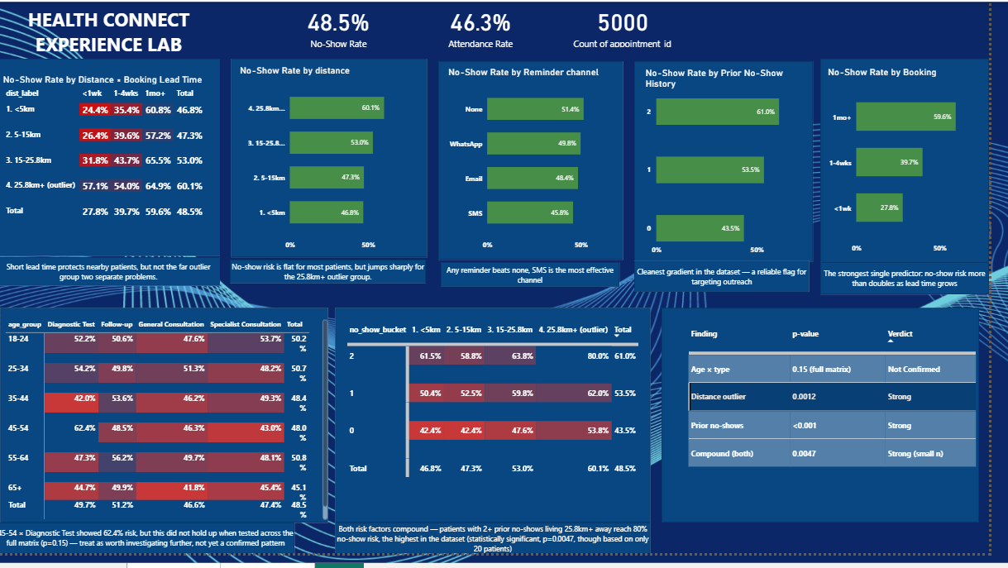
Figure 1: Final HealthConnect analytics dashboard (Power BI) — summary cards, 4 single-variable KPI visuals, 2 compound matrices, and a Statistical Validation table. All figures independently re-verified against the raw dataset for this final package.

5. Business Insights
- HealthConnect's no-show problem is not uniform it is concentrated in identifiable, targetable segments, not spread evenly across all patients.
- The two strongest levers (patient history, booking timing) are things the clinic can act on before an appointment happens a prevention opportunity, not just a measurement one.
- The evidence base is cross-validated, not resting on one method: the Data Science model's feature importance independently confirmed the same top predictors found through statistical testing.
- A specific, small (20-patient) segment carries disproportionate risk (80%) a candidate for a manual, high-touch process rather than an automated one, given the small numbers involved.

6. Recommendations
Recommendation | Confidence | Cross-track status
1. Flag patients with 2+ prior no-shows for SMS + phone confirmation | High | Independently confirmed by Data Science's feature importance
2. Make SMS the default reminder channel | High | Confirmed strongest channel; effect is 2x larger in the high-risk group
3. Give the compound high-risk group a phone call, not just SMS | Medium , small sample (n=20) | Proposed to Data Science as a candidate model feature; retest pending
4. Offer telehealth/transport support for the 25.8km+ distance group | High
5. Add a mid-wait check-in for bookings made 1+ month out | High | —
6. Do NOT build a targeted intervention around age × appointment type | Low confidence in original pattern | Independently confirmed Data Science doesn't use it as a feature either

7. How These Findings Support HealthConnect Decisions
Resourcing decision: Confirmed drivers let HealthConnect direct a limited outreach budget at the patients driving disproportionate no-show risk, instead of spending equally across all patients.
Process decision: Switching the default reminder channel to SMS is a same-week, zero-cost operational change with the strongest evidence behind it.
Investment decision: The 25.8km+ distance group justifies evaluating a telehealth option the data specifies which patients would benefit, not just that some might.
Governance decision: The age × appointment-type non-finding tells HealthConnect not to build a policy around it preventing wasted effort is a decision too, and one the data explicitly supports.

8. Cross-Track Contribution — Final Findings Provided
To Data Science: Final confirmed feature set (prior no-shows, distance, booking lead time), the waiting_time_minutes leakage caution, and the proposed compound interaction feature exchanged directly and independently corroborated.
To Project Management: The final 6-item recommendation list with confidence ratings, for their final integration record and project decision log including the equity-review flag on targeted outreach before any real-world rollout.
To Generative AI (where relevant): The finding that SMS reminders are most effective could inform any future assistant capability involving patient outreach or reminder scheduling.

9. Analytical Limitations
- Correlational, not causal no “reason for missed appointment” field exists in the dataset.
- Synthetic dataset's 48.5% no-show rate is well above real-world norms patterns are transferable, exact percentages are not.
- The compound high-risk segment (n=20) is too small for further sub-analysis without more accumulated data.
- Small (~1-2%) missing-data gaps in distance and waiting time, and a structural null in reminder_channel all handled, none materially affecting conclusions.
- Data Science's retest of the proposed interaction feature remains outstanding as of this package.

10. Analytics Section Presentation Talking Points
- We set out to answer one question: which patients are actually at risk of missing appointments, and why?
- Two factors mattered most: a patient's own history, and how far ahead they booked both climb steadily and predictably.
- When those two combine with distance, risk peaks at 80% the highest-risk segment we found.
- We didn't just find patterns we tested them. One promising-looking pattern didn't survive scrutiny, and we said so rather than overselling it.
- We confirmed this independently with the Data Science team two different methods, same answer.
- That gives HealthConnect six specific, confidence-rated actions not just a dashboard to admire.

