HealthConnect Clinic Experience Lab
Week 6: Advanced Analytics & Decision Support Report — Data Analytics Track
Prepared by Ekenga Dorothy

1. Week 5 → Week 6 Transition
Main Week 5 output: HealthConnect Week 5 Initial Analytics Report, a Power BI dashboard (6 visuals), and a supporting Excel workbook
Most important Week 5 result: Prior no-show history was identified as the strongest predictor of appointment outcome (43.5% → 61.0% no-show rate as prior no-shows rise from 0 to 2+)
Main issue/limitation discovered: Findings were pattern-based (pivot table percentages) but not statistically tested; the age × appointment-type finding (62.4%) rested on a small cell (85 records) whose reliability had been flagged but not verified
Relevant track(s) for Week 6: Data Science (feature relevance for the no-show prediction model), ML Engineering (data-quality/leakage findings for pipeline design), and Project Management (coordination given cross-track non-response)
What this report improves, integrates, or validates: Statistically validates the most important Week 5 KPIs, deepens the analysis with a new compound finding, revises a Week 5 conclusion that did not hold up under scrutiny, improves the dashboard, and documents a completed cross-track coordination activity

2. Integration Readiness

A. Integration Point
Track(s) worked with: Project Management (completed); Data Science and ML Engineering (attempted, response pending)
Output needed from Project Management: A structured mechanism to coordinate cross-track pairing, given two direct outreach attempts to Data Science and ML Engineering received no response
Output provided to Project Management: A fully completed Cross-Track Integration & Progress Questionnaire covering Week 5 position, Week 6 progress, statistical validation results, the new compound finding, revised conclusions, risks, decisions, and an explicit escalation of the blocked Data Science/ML Engineering dependency
Why the connection is relevant: Project Management coordinates dependencies and integration across all tracks (per the Week 6 Integration Matrix); with peer-to-peer outreach unsuccessful, PM coordination is the legitimate path to closing the Data Science/ML Engineering dependency before the deadline

B. Integration Objective
After this integration activity, Project Management has full visibility into the Data Analytics track's validated findings and the specific blocker preventing Data Science/ML Engineering engagement, enabling PM to facilitate a direct pairing rather than the dependency remaining invisible or unresolved.

C. Evidence
HealthConnect_Week6_CrossTrack_Questionnaire_FILLED.docx — submitted to the Project Management coordinator (coordination record, per the accepted evidence types in the Week 6 brief).

3. Advanced Analysis: Selecting and Validating Week 5 Findings
Rather than repeating the full Week 5 EDA, three of the highest-impact Week 5 findings were selected for deeper, statistically rigorous investigation: prior no-show history, the distance outlier group, and the age × appointment-type pattern (chosen because it carried the most uncertainty — a small sample size flagged but not tested in Week 5). Each was tested using a chi-square test of independence to determine whether the pattern is statistically real or could be explained by random chance.
Finding | Sample size | p-value | Verdict
Prior no-shows (0/1/2+) | n=5,000 | <0.001 | Strong — statistically real
Distance outlier (25.8km+) | n=146 | 0.0012 | Strong — statistically real
Compound: prior no-shows × distance (2+, 25.8km+) | n=20 | 0.0047 | Real, but small sample — monitor as more data accumulates
Age × appointment type (45-54, Diagnostic Test) | n=85 | 0.0097 alone; 0.15 across full matrix | Not confirmed — does not survive multiple-comparisons testing

The age × appointment-type finding illustrates an important statistical caution: tested in isolation, the 45-54/Diagnostic Test cell appears significant (p=0.0097). However, testing the full 24-cell matrix at once (accounting for the fact that some cells are expected to look extreme purely by chance when many combinations are checked) returns p=0.15 — not significant. This is the multiple-comparisons problem, and it directly informed the decision to revise this conclusion (see Section 5).

4. New Compound Finding: Prior No-Shows × Distance
Investigating whether the two strongest validated predictors act independently or compound, a two-way breakdown reveals a consistent, monotonic escalation in both directions — both risk factors are real and stack rather than substitute for one another:
Prior no-shows \ Distance | <5km | 5-15km | 15-25.8km | 25.8km+
0 | 42.1% | 42.3% | 47.4% | 55.3%
1 | 50.6% | 52.4% | 59.4% | 62.0%
2+ | 59.1% | 59.7% | 64.5% | 80.0%

Patients with 2+ prior no-shows who also live 25.8km+ away reach an 80.0% no-show rate — the highest-risk segment in the entire dataset, and statistically significant (p=0.0047) despite the small underlying sample (n=20).

Does the reminder effect still hold for this high-risk group?
At the exact 20-patient extreme segment, splitting further by reminder channel leaves only 2-7 patients per channel — too few for a reliable read, and this is reported honestly as a limitation rather than a forced conclusion. However, at the broader “2+ prior no-shows” level (531 patients, a reliable sample), the reminder effect not only holds but is substantially stronger than in the general population:
Reminder channel | No-show rate (general population) | No-show rate (within 2+ prior no-shows group)
SMS | 45.8% | 56.2%
Email | 48.4% | 57.6%
WhatsApp | 49.8% | 61.4%
No reminder | 51.4% | 68.2%

The reminder effect (SMS vs. no reminder) is roughly twice as large within the high-risk group (12 points) as in the general population (5.6 points), and this within-group difference is itself statistically significant (p=0.024). This strengthens rather than complicates the Week 5 Priority Recommendation: SMS reminders targeted at high-risk patients is the intervention with the strongest evidence behind it.

5. Revised Conclusion from Week 5
Per the Week 6 requirement to review whether Week 5 conclusions need revising: the age × appointment-type finding (45-54 patients booking Diagnostic Tests, 62.4% no-show rate) is downgraded from a confirmed high-risk group to a pattern worth further investigation. While statistically significant in isolation (p=0.0097), it does not survive testing across the full matrix of 24 combinations (p=0.15), which is the more appropriate test given that many segment combinations were examined. The dashboard caption and underlying report text have both been updated to reflect this explicitly, rather than silently carrying the Week 5 claim forward.

6. Updated Dashboard
The Week 5 dashboard was extended with two new visuals — a Prior No-Shows × Distance compound matrix and a Statistical Validation summary table — plus corrected distance-band ordering and one-line interpretive captions under every visual, including the revised age × type caption.
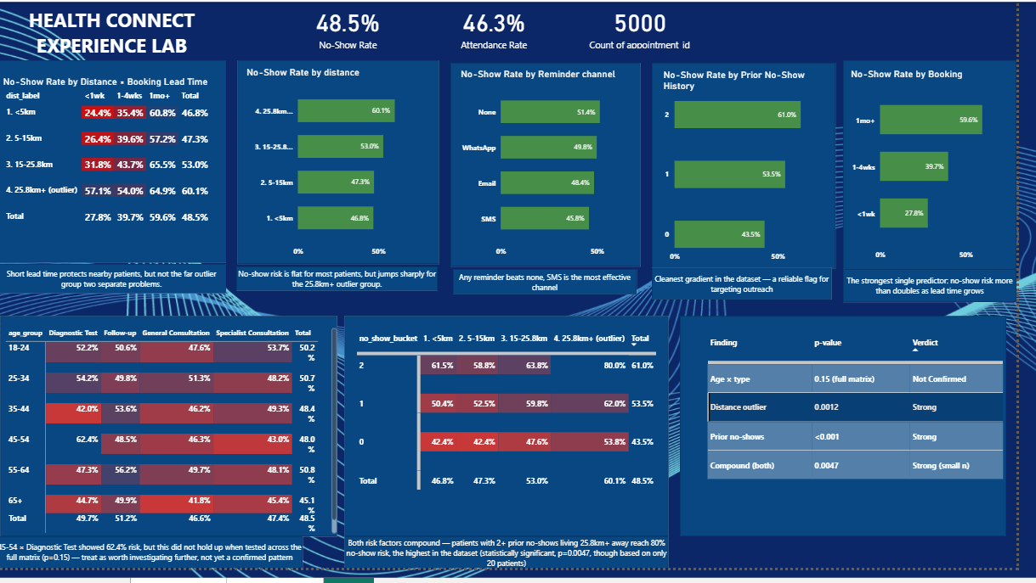
Figure 1: Updated HealthConnect analytics dashboard (Power BI) — 8 visuals covering all validated KPIs, the new compound finding, and statistical validation evidence.

Ranked Action List
Each action below is explicitly tied to its evidence and honestly labelled by confidence — distinguishing recommendations backed by strong statistical evidence from patterns that deserve further investigation before HealthConnect commits resources.
1. Flag patients with 2+ prior no-shows for SMS + phone confirmation on their next booking.
Evidence: p<0.001, n=531 Confidence: High
2. Switch the clinic's default reminder channel to SMS across the board.
Evidence: p=0.024 within the high-risk group specifically; consistently best channel overall Confidence: High
3. Within the flagged high-risk group, prioritise patients who also live 25.8km+ away for a phone call rather than SMS alone.
Evidence: 80.0% no-show rate, p=0.0047, but only 20 patients so far — top-priority tier while more data accumulates Confidence: Medium — real pattern, small sample
4. Offer telehealth or transport-assistance options specifically for the 25.8km+ distance group.
Evidence: p=0.0012; Week 5 showed short lead time does not fix this group's risk — a distance-specific fix is needed Confidence: High
5. For bookings made 1+ month ahead, add a mid-wait check-in touchpoint beyond the standard reminder.
Evidence: Strong Week 5 gradient (27.8% → 59.6%) Confidence: High
6. Hold off on a dedicated intervention for the 45-54 / Diagnostic Test group; flag for further data collection before committing resources.
Evidence: p=0.0097 alone, but full-matrix test not significant (p=0.15) — real risk of a multiple-comparisons fluke Confidence: Low — investigate, don't act yet

7. Cross-Track Analytical Contribution
Track collaborated with: Project Management (completed); Data Science and ML Engineering (attempted, response pending)
Dependency: Confirmation from Data Science/ML Engineering on whether validated findings (prior no-shows, booking lead time, the waiting_time_minutes leakage caution) inform their feature selection and pipeline design
Information received: A structured Cross-Track Integration & Progress Questionnaire template from the Project Management coordinator, introduced specifically to address unresponsive peer-to-peer outreach across the cohort
Information provided: A fully completed questionnaire documenting Week 6 progress, statistically validated findings, the new compound risk segment, the revised age × type conclusion, risks, decisions, and an explicit request for PM-facilitated pairing with Data Science or ML Engineering
Integration activity completed: Submission of the completed questionnaire to the Project Management coordinator — a documented coordination record
What changed as a result: Project Management now has full visibility into the Data Analytics track's validated findings and the specific blocker preventing Data Science/ML Engineering engagement, positioning PM to facilitate a direct pairing before the deadline. Direct engagement with Data Science/ML Engineering itself remains pending as of this submission.
Evidence: HealthConnect_Week6_CrossTrack_Questionnaire_FILLED.docx

8. Data & Analytical Limitations (Week 4 → 6 Review)
- reminder_channel structurally null when no reminder was sent — resolved by treating “No reminder” as its own category (Week 5).
- Small missing gaps in distance/waiting time (~1-2%) — still present, excluded consistently; too small to materially affect results.
- Inflated overall no-show rate (48.5% vs. 15-30% real-world norm) — still relevant; all specific percentages should be read as this dataset's pattern, not literal real-world figures.
- No “reason for missed appointment” field — still relevant; every finding in this report remains correlational, not causal.
- waiting_time_minutes data leakage risk — resolved; fully excluded from any predictive framing.
- NEW (Week 6): the extreme compound segment (2+ prior no-shows AND 25.8km+ distance) is based on only 20 patients — statistically significant but too small to break down further (e.g. by reminder channel) without more accumulated data.
- NEW (Week 6): the age × appointment-type finding does not survive multiple-comparisons testing and has been downgraded accordingly — a caution that should generalise to any future segment-matrix analysis on this dataset.
- Equity risk in targeting recommendations — more concrete this week given specific, actionable targeting proposals (SMS to flagged patients, transport support for the distance group); any real-world rollout should include an equity/access review first.

9. Week 7 Analytical Testing Requirements
- Confirm whether Data Science's model incorporates the validated predictive features and the waiting_time_minutes leakage caution, once cross-track engagement is achieved.
- Monitor whether the compound risk segment (2+ prior no-shows × 25.8km+ distance) holds up as more appointment data accumulates, given its current small sample (n=20).
- Re-test the age × appointment-type pattern once more data is available, to determine whether it becomes statistically confirmed or continues to fail the full-matrix test.
- Validate that the dashboard's calculated values remain consistent if the underlying dataset is refreshed or extended.

