HealthConnect Clinic Experience Lab
Week 5: Initial Analytics Report — Data Analytics Track
Prepared byEkenga Dorothy

1. Week 4 Foundation Review
In Week 4, I identified the core problem for the Data Analytics track: understanding the patterns behind HealthConnect's appointment no-shows and translating them into business questions and KPIs to guide clinic decisions. My proposed approach was staged — Excel pivot validation first, then a Power BI dashboard. Key resources used were HealthConnect_Appointment_Data.csv and HealthConnect_Data_Dictionary.xlsx. Key limitations identified included a structurally-null reminder_channel field, small gaps in distance/waiting-time data, an inflated no-show rate limiting real-world generalisation, and the absence of a “reason for missed appointment” field limiting findings to correlation rather than causation. For Week 5, I proposed finalising distance and lead-time bands, building the Power BI dashboard, and calculating the 5 proposed KPIs — all of which this report now delivers.

2. Data Preparation Summary
Building on Week 4's data quality assessment (0 duplicate rows, structurally-null reminder_channel, small missing gaps in distance/waiting time), additional checks this week confirmed the dataset is otherwise clean and ready for analysis:
- age ranges 18-80 with no under-18 records, consistent with the dictionary's adults-only note.
- gender, appointment_type, appointment_day, appointment_time and age_group contain only clean, expected categories with no typos or stray values.
- distance_to_clinic_km (0.5-45km) and booking_lead_days (0-60 days) contain no negative or impossible values.
- booking_date and appointment_date are stored as text rather than proper dates — not an issue for the derived booking_lead_days field already provided, but noted for any future day-of-week or seasonal analysis.
The original dataset was not modified; all derived fields (distance bands, prior-no-show buckets, booking lead-time bands) were added as helper columns in a separate working copy.

3. Exploratory Data Analysis
Week 5 EDA moved beyond Week 4's single-variable checks into interactions and combinations. Six findings were investigated:

3.1 Reminders × Distance (interaction)
The reminder effect is not uniform across distance: for 5-15km patients, reminders cut the no-show rate by ~6 points (51.8% → 45.6%), but for 15km+ patients the effect nearly disappears (54.8% → 53.8%). This suggests distant patients may be missing appointments for reasons reminders cannot fix, such as transport cost or travel time.

3.2 Personal no-show rate (history, normalised)
Using previous_no_shows as a proportion of previous_appointments (rather than a raw count) produced a cleaner gradient: 43.6% (0% personal rate) → 54.1% (1-34%) → 57.2% (35%+), confirming the KPI 2 pattern on a fairer, visit-adjusted basis.

3.3 Appointment day
No-show rate is essentially flat across all seven days of the week (46.6%-50.5%). Reported honestly as a null result rather than a forced pattern.

3.4 Waiting time by appointment type (Attended only)
Average wait time ranges narrowly from 23.9 to 24.8 minutes across all four appointment types — under a one-minute spread. Also a null result; wait time does not meaningfully differ by appointment type, and (per Week 4) cannot be used predictively regardless, since it is recorded even for No-Show/Cancelled appointments.

3.5 Distance outliers
Using the IQR method (Q1 = 5.3km, Q3 = 13.5km, upper fence = 25.8km), 148 patients (about 3% of the dataset) fall beyond the fence. This outlier group no-shows at 61.0%, compared to 48.0% for everyone else — a materially stronger signal than the modest gap suggested by simple averages in Week 4.

3.6 Cancellations vs. No-Shows
Cancelled patients consistently sit between Attended and No-Show on both distance (10.11km) and booking lead time (29.6 days). Since cancelling still requires the patient to notify the clinic — unlike a no-show, which requires no action — this suggests cancellations share some of the same underlying risk factors as no-shows, but represent a more engaged, milder version of that risk. Worth treating as an early-warning signal rather than routine housekeeping.

4. KPI Development
Per the Week 5 brief, all 5 KPIs proposed in Week 4 were selected, calculated, and interpreted, plus one bonus compound KPI produced directly from this week's EDA.
KPI 1 — No-show rate by distance band
Definition: The percentage of appointments resulting in a no-show, grouped into four distance bands.
Why it matters: A simple average hid this pattern in Week 4 (9.67 vs 10.53km); banding reveals risk is concentrated in a specific group rather than spread evenly.
Calculation: 46.5% → 47.3% → 52.8% → 61.0% as distance increases.
Linked to: Q1
Interpretation: Distance barely matters for the majority of patients (<15km), but the 148 patients living 25.8km+ away no-show at 61%, 14+ points above the clinic average — a targeted-intervention opportunity rather than a clinic-wide policy.
KPI 2 — Outcome rate by prior no-show count
Definition: The percentage of appointments resulting in a no-show, grouped by the patient's prior no-show count (0 / 1 / 2+).
Why it matters: Identifies which patients are statistically most likely to miss their next appointment, enabling targeted rather than blanket intervention.
Calculation: 43.5% (0 prior) → 53.5% (1 prior) → 61.0% (2+ prior) — the cleanest, steadiest gradient in the dataset.
Linked to: Q2
Interpretation: Best treated as a flag for identifying at-risk patients, not a proven lever for reducing future risk — the data cannot confirm what is actually driving the pattern (see Limitations).
KPI 3 — Outcome rate by age group × appointment type
Definition: The percentage of appointments resulting in a no-show, cross-tabulated by patient age group and appointment type.
Why it matters: Age alone appeared flat in Week 4; combining it with appointment type reveals compound risk that a single variable hides.
Calculation: Ranges from 41.8% (65+, General Consultation) to 62.4% (45-54, Diagnostic Test) — a 20-point spread.
Linked to: Q3
Interpretation: 45-54 patients booking Diagnostic Tests are a specific, evidence-based outreach target, rather than assuming middle-aged patients are broadly risky. Note: the 62.4% figure is based on only 85 appointments (see Limitations).
KPI 4 — Outcome rate by reminder channel
Definition: The percentage of appointments resulting in a no-show, grouped by reminder channel used (including “No reminder” as its own category).
Why it matters: Tells the clinic not just whether reminders help, but which specific channel is most effective — a directly actionable choice.
Calculation: SMS 45.8% < Email 48.4% < WhatsApp 49.8% < No reminder 51.4%.
Linked to: Q4
Interpretation: Any reminder outperforms none; SMS is the strongest channel. Correlational — patients who opt into SMS may differ from WhatsApp users in other ways — but still a low-cost, actionable lever.
KPI 5 — No-show rate by booking lead-time band
Definition: The percentage of appointments resulting in a no-show, grouped into booking lead-time bands.
Why it matters: Distance and history describe who is at risk; lead time describes a schedulable, changeable factor the clinic has more direct control over.
Calculation: 27.8% (<1wk) → 39.7% (1-4wks) → 59.6% (1mo+).
Linked to: Q5
Interpretation: The strongest single-variable gradient in the dataset. Booking patients sooner where possible is a broadly applicable, low-cost lever.
Bonus KPI — Distance × Booking lead-time interaction
Definition: No-show rate cross-tabulated by distance band and booking lead-time band together.
Why it matters: Tests whether the two strongest individual KPIs act independently or interact — directly relevant to which intervention to prioritise.
Calculation: Short lead time (<1wk) drops no-show risk sharply for nearby patients, but the 25.8km+ group still no-shows at 57.1% even when booked under a week out.
Linked to: Q1 + Q5
Interpretation: Short-lead-time/reminder interventions will help most patients but will not meaningfully help the distance-risk group — that group needs an intervention addressing distance itself (transport, telehealth), not scheduling.

5. Dashboard / Analytical Visualisation
An initial Power BI dashboard was built covering all 5 KPIs plus the bonus interaction finding: a summary row (total appointments, overall no-show rate, overall attendance rate), one bar chart per single-variable KPI, and two matrix visuals with conditional-formatting colour scales for the two compound findings (age × appointment type; distance × booking lead time). All figures were verified against the Excel pivot calculations above.
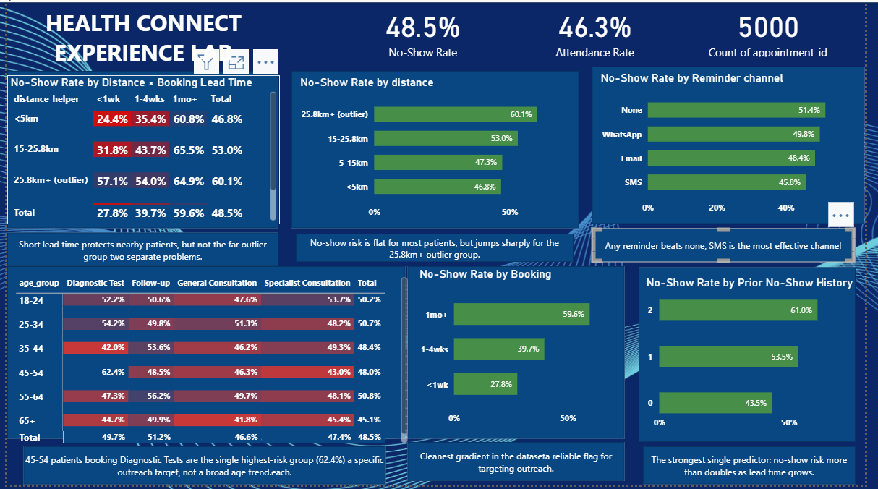
Figure 1: Initial HealthConnect analytics dashboard (Power BI) — summary cards, four single-variable KPI charts, and two compound matrix visuals.

6. Business Insights & Recommendations
At least 5 business insights were developed from the KPIs and EDA above, each with a stated implication for HealthConnect. A combined priority recommendation synthesises the two most actionable findings.
Priority Recommendation: Target SMS reminders at high-risk patients.
Patients with 2+ prior no-shows — a small, identifiable group making up roughly 10.6% of patients (531 of 5,000) — have a 61.0% no-show rate on their current appointment, compared to 43.5% for patients with no prior no-shows. Separately, SMS is the most effective reminder channel (45.8% no-show rate vs. 51.4% for no reminder). Combining these findings: HealthConnect could prioritise SMS-based reminders and confirmation contact specifically for patients flagged with 2+ prior no-shows — using the highest-performing channel on the group most likely to need it. This targets future appointments for the at-risk group; prior no-show history itself cannot be changed, only used to flag who needs the intervention.
Insight 1: Distance risk is concentrated in a small tail, not spread evenly.
Most patients (under 15km) sit around 46-47% no-show regardless of exact distance, but the 148 patients (about 3%) living beyond 25.8km no-show at 61.0%.
Implication: A clinic-wide distance policy would waste resources on the majority of patients distance barely affects. A small, targeted intervention (transport support or telehealth) for this ~3% outlier group offers a far higher return on effort.
Insight 2: Reminder channel is a low-cost, immediately actionable lever.
Any reminder reduces no-shows compared to none (45.8-49.8% vs. 51.4%), and SMS consistently outperforms WhatsApp and Email.
Implication: Switching the default reminder channel to SMS-first is one of the fastest, cheapest changes HealthConnect could make — no new infrastructure required — and should be an early-win recommendation.
Insight 3: Short booking lead time only protects patients who live nearby.
Booking within a week drops no-show risk sharply overall (27.8% vs 59.6% for 1-month-plus), but this protection nearly disappears for the 25.8km+ distance group (still 57.1% even when booked under a week out).
Implication: Tightening booking windows will help most patients but will not meaningfully help the distance-risk group — these should be treated as two separate problems requiring separate fixes.
Insight 4: One age × appointment-type combination carries disproportionate risk.
Age alone looked nearly flat in Week 4, but combined with appointment type, patients aged 45-54 booking Diagnostic Tests no-show at 62.4%, the single highest-risk cell in the dataset, while patients 65+ booking General Consultations are the most reliable at 41.8%.
Implication: HealthConnect can target confirmation outreach specifically at 45-54 patients scheduling diagnostic tests — a precise, evidence-based target rather than a broad demographic assumption. (Note: based on 85 appointments — see Limitations.)
Insight 5: Averages can hide real effects — a methodological insight, not just a data one.
Several variables that appeared to have little effect in Week 4 (distance, age) turned out to have strong effects once properly banded or combined with a second variable (appointment type, booking lead time).
Implication: An average alone can conceal a real pattern that only appears in a subgroup or a combination of variables — a caution worth applying to any future HealthConnect analysis, including the Data Science track's feature engineering.

7. Cross-Track Collaboration
Reached out to a Data Science-track cohort-mate to share the KPI findings most relevant to no-show prediction (prior no-show count and booking lead time as strong signals; the waiting_time_minutes data-leakage caution) and to ask what would help their feature selection and target-variable definition, including their planned treatment of cancellations. [Awaiting reply — to be completed with: which track, what was exchanged, why it was relevant, and what changed or improved as a result, once the response is received.]

8. Assumptions, Limitations, Risks & Dependencies (Week 4 → Week 5 Review)
Item | Status | Notes
reminder_channel structurally null | Resolved | Treated “No reminder” as its own category in the KPI rather than excluding those patients.
Small missing gaps: distance/waiting time (~1-2%) | Still relevant, unchanged | Excluded consistently across all Week 5 calculations; too small to materially affect results.
Inflated no-show rate (48.5% vs. 15-30% real-world norm) | Still relevant, unchanged | All Week 5 percentages should be read as this dataset's pattern, not literal real-world figures.
No “reason for missed appointment” field | Still relevant, unchanged | Every Week 5 insight remains correlational, not causal.
waiting_time_minutes data leakage risk | Resolved/mitigated | Fully excluded from predictive KPIs; used only descriptively (wait time by appointment type).
Equity risk in targeting recommendations | Still relevant, more important now | Sharper this week since specific targeting recommendations (SMS to high-risk patients, transport support) are now proposed, not hypothetical.
NEW: small sample sizes inside the age × appointment-type matrix | New this week | The 62.4% finding (45-54, Diagnostic Test) is based on only 85 appointments — a lead worth further testing, not a fully proven pattern. Good candidate for Data Science to validate statistically.

Appendix: KPI Summary Table
KPI | Linked to | Week 5 calculated result
No-show rate by distance band | Q1 | 46.5% (<5km) → 47.3% (5-15km) → 52.8% (15-25.8km) → 61.0% (25.8km+)
Outcome rate by prior no-show count | Q2 | 43.5% (0) → 53.5% (1) → 61.0% (2+)
Outcome rate by age group × appointment type | Q3 | 41.8% (65+, General Consultation) to 62.4% (45-54, Diagnostic Test)
Outcome rate by reminder channel | Q4 | SMS 45.8% < Email 48.4% < WhatsApp 49.8% < No reminder 51.4%
No-show rate by booking lead-time band | Q5 | 27.8% (<1wk) → 39.7% (1-4wks) → 59.6% (1mo+)
Bonus: distance × lead-time interaction | Q1+Q5 | Short lead time protects nearby patients but not the 25.8km+ group (still 57.1% even when booked <1wk out)

