Mobile_Analytics.R

DoryChen

2019-05-11

setwd("/Users/DoryChen/Desktop")  
  
library(dplyr)

##   
## Attaching package: 'dplyr'

## The following objects are masked from 'package:stats':  
##   
## filter, lag

## The following objects are masked from 'package:base':  
##   
## intersect, setdiff, setequal, union

Geo_fence <- read.csv("Geo-Fence Analytics.csv", header=T)  
  
#Create variable: "imp_large", "cat_entertainment", "cat_social", "cat_tech", "os_ios", "distance"  
  
attach(Geo_fence)  
  
Geo_fence$imp_large <- ifelse(imp_size == "728x90", 1, 0)  
Geo_fence$cat_entertainment <-ifelse(app_topcat == "IAB1" | app_topcat == "IAB1-6", 1, 0)  
Geo_fence$cat_social <- ifelse(app_topcat == "IAB14", 1, 0)  
Geo_fence$cat_tech <- ifelse(app_topcat == "IAB19-6", 1, 0)  
Geo_fence$os_ios <- ifelse(device_os == "iOS", 1, 0)  
  
## Create variable distance using Harvesine formula to calculate the distance   
## for a pair of latitude/longitude coordinates.  
  
library(aspace)

## Loading required package: splancs

## Loading required package: sp

##   
## Spatial Point Pattern Analysis Code in S-Plus  
##   
## Version 2 - Spatial and Space-Time analysis

##   
## Attaching package: 'splancs'

## The following object is masked from 'package:dplyr':  
##   
## tribble

## Loading required package: Hmisc

## Loading required package: lattice

## Loading required package: survival

## Loading required package: Formula

## Loading required package: ggplot2

##   
## Attaching package: 'Hmisc'

## The following object is masked from 'package:splancs':  
##   
## zoom

## The following objects are masked from 'package:dplyr':  
##   
## src, summarize

## The following objects are masked from 'package:base':  
##   
## format.pval, units

## Loading required package: shapefiles

## Loading required package: foreign

##   
## Attaching package: 'shapefiles'

## The following objects are masked from 'package:foreign':  
##   
## read.dbf, write.dbf

Geo_fence$distance <- 6371 * acos(cos(as_radians(device_lat)) * cos(as_radians(geofence_lat))   
 * cos(as_radians(device_lon) - as_radians(geofence_lon))   
 + sin(as_radians(device_lat)) * sin(as_radians(geofence_lat)))  
  
#Create distance group and calculate click-through-rate  
attach(Geo_fence)

## The following objects are masked from Geo_fence (pos = 13):  
##   
## app_id, app_name, app_pub, app_review_val, app_review_vol,  
## app_topcat, device_lat, device_lon, device_os, device_zip,  
## didclick, geofence_lat, geofence_lon, gepfence_radius,  
## imp_size

Geo_fence$distance_group <-ifelse(between(distance, 0, 0.5), 1,   
 ifelse(between(distance, 0.5, 1), 2,   
 ifelse(between(distance, 1, 2), 3,   
 ifelse(between(distance, 2, 4), 4,   
 ifelse(between(distance, 4, 7), 5,  
 ifelse(between(distance, 7, 10), 6,   
 ifelse(distance >10, 7, 0)))))))  
  
  
library("sqldf")

## Loading required package: gsubfn

## Loading required package: proto

## Warning in doTryCatch(return(expr), name, parentenv, handler): unable to load shared object '/Library/Frameworks/R.framework/Resources/modules//R_X11.so':  
## dlopen(/Library/Frameworks/R.framework/Resources/modules//R_X11.so, 6): Library not loaded: /opt/X11/lib/libSM.6.dylib  
## Referenced from: /Library/Frameworks/R.framework/Resources/modules//R_X11.so  
## Reason: image not found

## Warning in system2("/usr/bin/otool", c("-L", shQuote(DSO)), stdout = TRUE):  
## running command ''/usr/bin/otool' -L '/Library/Frameworks/R.framework/  
## Resources/library/tcltk/libs//tcltk.so'' had status 1

## Could not load tcltk. Will use slower R code instead.

## Loading required package: RSQLite

mean_ctr <- sqldf("select distance, distance_group, avg(didclick) as mean_didclick   
 from Geo_fence group by distance_group")  
  
barplot(mean_ctr$mean_didclick, mean_ctr$distance_group,   
 xlab="Distance_group", ylab="CTR",  
 names.arg=c("<0.5", "0.5-<1.0", "1.0-<2.0", "2.0-<4.0", "4.0-<7.0", "7.0-<10.0","10.0>"),width =500  
)

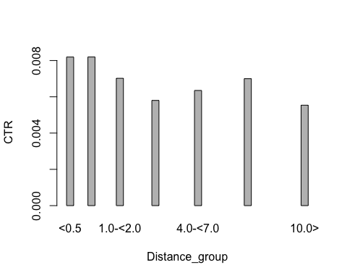

#Create variables "distance_squared", "ln_app_review_vol"  
Geo_fence$ln_app_review_vol <- log(app_review_vol)  
Geo_fence$distance_squared <- distance^2  
  
# Descriptive Statisitcs  
  
attach(Geo_fence)

## The following objects are masked from Geo_fence (pos = 7):  
##   
## app_id, app_name, app_pub, app_review_val, app_review_vol,  
## app_topcat, cat_entertainment, cat_social, cat_tech,  
## device_lat, device_lon, device_os, device_zip, didclick,  
## distance, geofence_lat, geofence_lon, gepfence_radius,  
## imp_large, imp_size, os_ios

## The following objects are masked from Geo_fence (pos = 18):  
##   
## app_id, app_name, app_pub, app_review_val, app_review_vol,  
## app_topcat, device_lat, device_lon, device_os, device_zip,  
## didclick, geofence_lat, geofence_lon, gepfence_radius,  
## imp_size

statfun<- function(x){  
 data.frame(Mean=mean(x),Median=median(x),STDEV=sd(x),Min=min(x),Max=max(x))  
}  
  
  
sum_table<-rbind(statfun(didclick),  
 statfun(distance),  
 statfun(imp_large),  
 statfun(cat_entertainment),  
 statfun(cat_social),  
 statfun(cat_tech),  
 statfun(os_ios),  
 statfun(ln_app_review_vol),  
 statfun(app_review_val)  
)  
row.names(sum_table)<-c("didclick", "distance", "imp_large", "cat_entertainment",   
 "cat_social", "cat_tech","os_ios","ln_app_vol","app_val")  
print(sum_table)

## Mean Median STDEV Min Max  
## didclick 0.006811059 0.000000 0.08224794 0.00000000 1.00000  
## distance 2.983737139 2.020864 2.64852620 0.02075894 11.78666  
## imp_large 0.230876800 0.000000 0.42139550 0.00000000 1.00000  
## cat_entertainment 0.283925736 0.000000 0.45090308 0.00000000 1.00000  
## cat_social 0.125124417 0.000000 0.33086130 0.00000000 1.00000  
## cat_tech 0.517846126 1.000000 0.49968347 0.00000000 1.00000  
## os_ios 0.250363997 0.000000 0.43322443 0.00000000 1.00000  
## ln_app_vol 10.056798904 10.087225 0.63696194 7.08086790 12.93770  
## app_val 3.654872622 3.400000 0.36081251 1.40000000 4.70000

#Correlations between the variables  
library(corrgram)

##   
## Attaching package: 'corrgram'

## The following object is masked from 'package:lattice':  
##   
## panel.fill

cor_geofence <- subset(Geo_fence, select = c(didclick, distance, imp_large, cat_entertainment, cat_social, cat_tech, os_ios, ln_app_review_vol, app_review_val))  
cor(cor_geofence)

## didclick distance imp_large cat_entertainment  
## didclick 1.000000000 -0.006628356 -0.004786218 -0.007117972  
## distance -0.006628356 1.000000000 0.020024918 -0.028992663  
## imp_large -0.004786218 0.020024918 1.000000000 -0.254731873  
## cat_entertainment -0.007117972 -0.028992663 -0.254731873 1.000000000  
## cat_social -0.005623417 0.060484490 -0.185311155 -0.238133905  
## cat_tech 0.012454366 0.023499545 0.414049273 -0.652575678  
## os_ios -0.002147325 -0.060281389 -0.190194050 0.312647684  
## ln_app_review_vol 0.003982875 -0.157864184 0.049929790 -0.105545185  
## app_review_val -0.006523592 0.022481133 -0.321439020 0.642212363  
## cat_social cat_tech os_ios ln_app_review_vol  
## didclick -0.005623417 0.01245437 -0.002147325 0.003982875  
## distance 0.060484490 0.02349954 -0.060281389 -0.157864184  
## imp_large -0.185311155 0.41404927 -0.190194050 0.049929790  
## cat_entertainment -0.238133905 -0.65257568 0.312647684 -0.105545185  
## cat_social 1.000000000 -0.39192721 0.513672844 -0.115376574  
## cat_tech -0.391927215 1.00000000 -0.598919227 0.049503835  
## os_ios 0.513672844 -0.59891923 1.000000000 -0.013523794  
## ln_app_review_vol -0.115376574 0.04950383 -0.013523794 1.000000000  
## app_review_val 0.194394425 -0.73206714 0.366139311 0.014457854  
## app_review_val  
## didclick -0.006523592  
## distance 0.022481133  
## imp_large -0.321439020  
## cat_entertainment 0.642212363  
## cat_social 0.194394425  
## cat_tech -0.732067145  
## os_ios 0.366139311  
## ln_app_review_vol 0.014457854  
## app_review_val 1.000000000

corrgram(cor_geofence, order = TRUE, lower.panel = panel.shade,  
 upper.panel = panel.pie, text.panel = panel.txt,  
 main = "Correlations of Geo-fense")

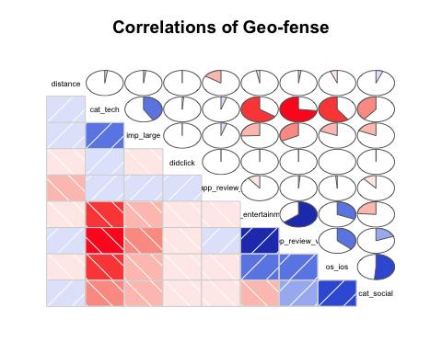

#Scatterplot of distance and click-through-rate  
library(car)

## Loading required package: carData

##   
## Attaching package: 'car'

## The following object is masked from 'package:dplyr':  
##   
## recode

attach(mean_ctr)

## The following objects are masked from Geo_fence (pos = 6):  
##   
## distance, distance_group

## The following object is masked from Geo_fence (pos = 11):  
##   
## distance

scatterplot(mean_didclick ~ distance, xlab = "distance",   
 ylab = "click_through_rate", main = "distance and click-through-rate")

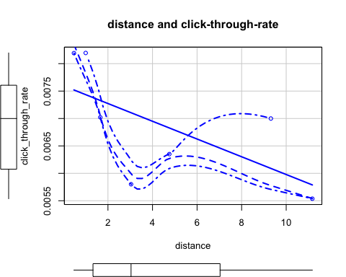

#We found that the closer mobile device to geofence, the higher the click-through-rate.  
  
#Logistic regression of "didclick"  
fit.didclick <- glm(didclick ~ distance + imp_large + cat_entertainment  
 + cat_social + cat_tech + os_ios + ln_app_review_vol + app_review_val,  
 data = Geo_fence, family = binomial())  
summary(fit.didclick)

##   
## Call:  
## glm(formula = didclick ~ distance + imp_large + cat_entertainment +   
## cat_social + cat_tech + os_ios + ln_app_review_vol + app_review_val,   
## family = binomial(), data = Geo_fence)  
##   
## Deviance Residuals:   
## Min 1Q Median 3Q Max   
## -0.1439 -0.1307 -0.1144 -0.1041 3.4177   
##   
## Coefficients:  
## Estimate Std. Error z value Pr(>|z|)   
## (Intercept) -6.76438 0.89749 -7.537 4.81e-14 ***  
## distance -0.02880 0.01425 -2.020 0.043333 *   
## imp_large -0.34794 0.09173 -3.793 0.000149 ***  
## cat_entertainment -0.09613 0.17893 -0.537 0.591087   
## cat_social -0.22237 0.21137 -1.052 0.292777   
## cat_tech 0.69306 0.17660 3.924 8.70e-05 ***  
## os_ios 0.38421 0.12634 3.041 0.002357 **   
## ln_app_review_vol 0.03263 0.06301 0.518 0.604590   
## app_review_val 0.32515 0.18716 1.737 0.082337 .   
## ---  
## Signif. codes: 0 '***' 0.001 '**' 0.01 '*' 0.05 '.' 0.1 ' ' 1  
##   
## (Dispersion parameter for binomial family taken to be 1)  
##   
## Null deviance: 9912.5 on 121566 degrees of freedom  
## Residual deviance: 9861.4 on 121558 degrees of freedom  
## AIC: 9879.4  
##   
## Number of Fisher Scoring iterations: 8

fit.didclick_distance_sqrt <- glm(didclick ~ distance + distance_squared + imp_large + cat_entertainment  
 + cat_social + cat_tech + os_ios + ln_app_review_vol + app_review_val,  
 data = Geo_fence, family = binomial())  
summary(fit.didclick_distance_sqrt)

##   
## Call:  
## glm(formula = didclick ~ distance + distance_squared + imp_large +   
## cat_entertainment + cat_social + cat_tech + os_ios + ln_app_review_vol +   
## app_review_val, family = binomial(), data = Geo_fence)  
##   
## Deviance Residuals:   
## Min 1Q Median 3Q Max   
## -0.1510 -0.1272 -0.1148 -0.1042 3.4025   
##   
## Coefficients:  
## Estimate Std. Error z value Pr(>|z|)   
## (Intercept) -6.616818 0.896958 -7.377 1.62e-13 ***  
## distance -0.117927 0.045073 -2.616 0.008888 **   
## distance_squared 0.009166 0.004362 2.102 0.035583 *   
## imp_large -0.352164 0.091782 -3.837 0.000125 ***  
## cat_entertainment -0.096143 0.178941 -0.537 0.591069   
## cat_social -0.226695 0.211394 -1.072 0.283550   
## cat_tech 0.687657 0.176312 3.900 9.61e-05 ***  
## os_ios 0.385895 0.126361 3.054 0.002259 **   
## ln_app_review_vol 0.030512 0.063037 0.484 0.628368   
## app_review_val 0.323831 0.186656 1.735 0.082757 .   
## ---  
## Signif. codes: 0 '***' 0.001 '**' 0.01 '*' 0.05 '.' 0.1 ' ' 1  
##   
## (Dispersion parameter for binomial family taken to be 1)  
##   
## Null deviance: 9912.5 on 121566 degrees of freedom  
## Residual deviance: 9857.1 on 121557 degrees of freedom  
## AIC: 9877.1  
##   
## Number of Fisher Scoring iterations: 8

fit.didclick_reduced <- glm(didclick ~ distance + distance_squared + imp_large   
 + cat_tech + os_ios,  
 data = Geo_fence, family = binomial())  
summary(fit.didclick_reduced)

##   
## Call:  
## glm(formula = didclick ~ distance + distance_squared + imp_large +   
## cat_tech + os_ios, family = binomial(), data = Geo_fence)  
##   
## Deviance Residuals:   
## Min 1Q Median 3Q Max   
## -0.1471 -0.1254 -0.1152 -0.1045 3.3277   
##   
## Coefficients:  
## Estimate Std. Error z value Pr(>|z|)   
## (Intercept) -5.091004 0.110148 -46.220 < 2e-16 ***  
## distance -0.119992 0.045032 -2.665 0.007708 **   
## distance_squared 0.009158 0.004364 2.099 0.035858 *   
## imp_large -0.346716 0.091717 -3.780 0.000157 ***  
## cat_tech 0.574871 0.100695 5.709 1.14e-08 ***  
## os_ios 0.292210 0.111257 2.626 0.008628 **   
## ---  
## Signif. codes: 0 '***' 0.001 '**' 0.01 '*' 0.05 '.' 0.1 ' ' 1  
##   
## (Dispersion parameter for binomial family taken to be 1)  
##   
## Null deviance: 9912.5 on 121566 degrees of freedom  
## Residual deviance: 9862.8 on 121561 degrees of freedom  
## AIC: 9874.8  
##   
## Number of Fisher Scoring iterations: 8