Data list
The variants shared here are exclusively those associated with temperature (BIO1-11) and precipitation(BIO12-19), which were used to predict genomic vulnerability.

- freq: This directory stores allele frequencies of LD-pruned adaptive introgressed variants and environmentally associated variants across 82 pops.

##### intro means adaptive introgressed; neutral means environmentally associated (no introgression). I performed LD pruning using PLINK with the following parameters: --double-id --maf 0.05 --geno 0.1 --indep-pairwise 50 10 0.2. After LD pruning, just 26 intro variants were retained. I have also shared the unfiltered files to facilitate flexible usage.

- vcf: This directory stores the vcf-files of intro and neutral variants.

- Data S3.xlsx: This file contains detailed information for all variants.

Demographic model parameters, including effective population size, migration rate and divergence time, as well as their corresponding confidence intervals, are presented on the next page. All values were inferred using fastsimcoal2.

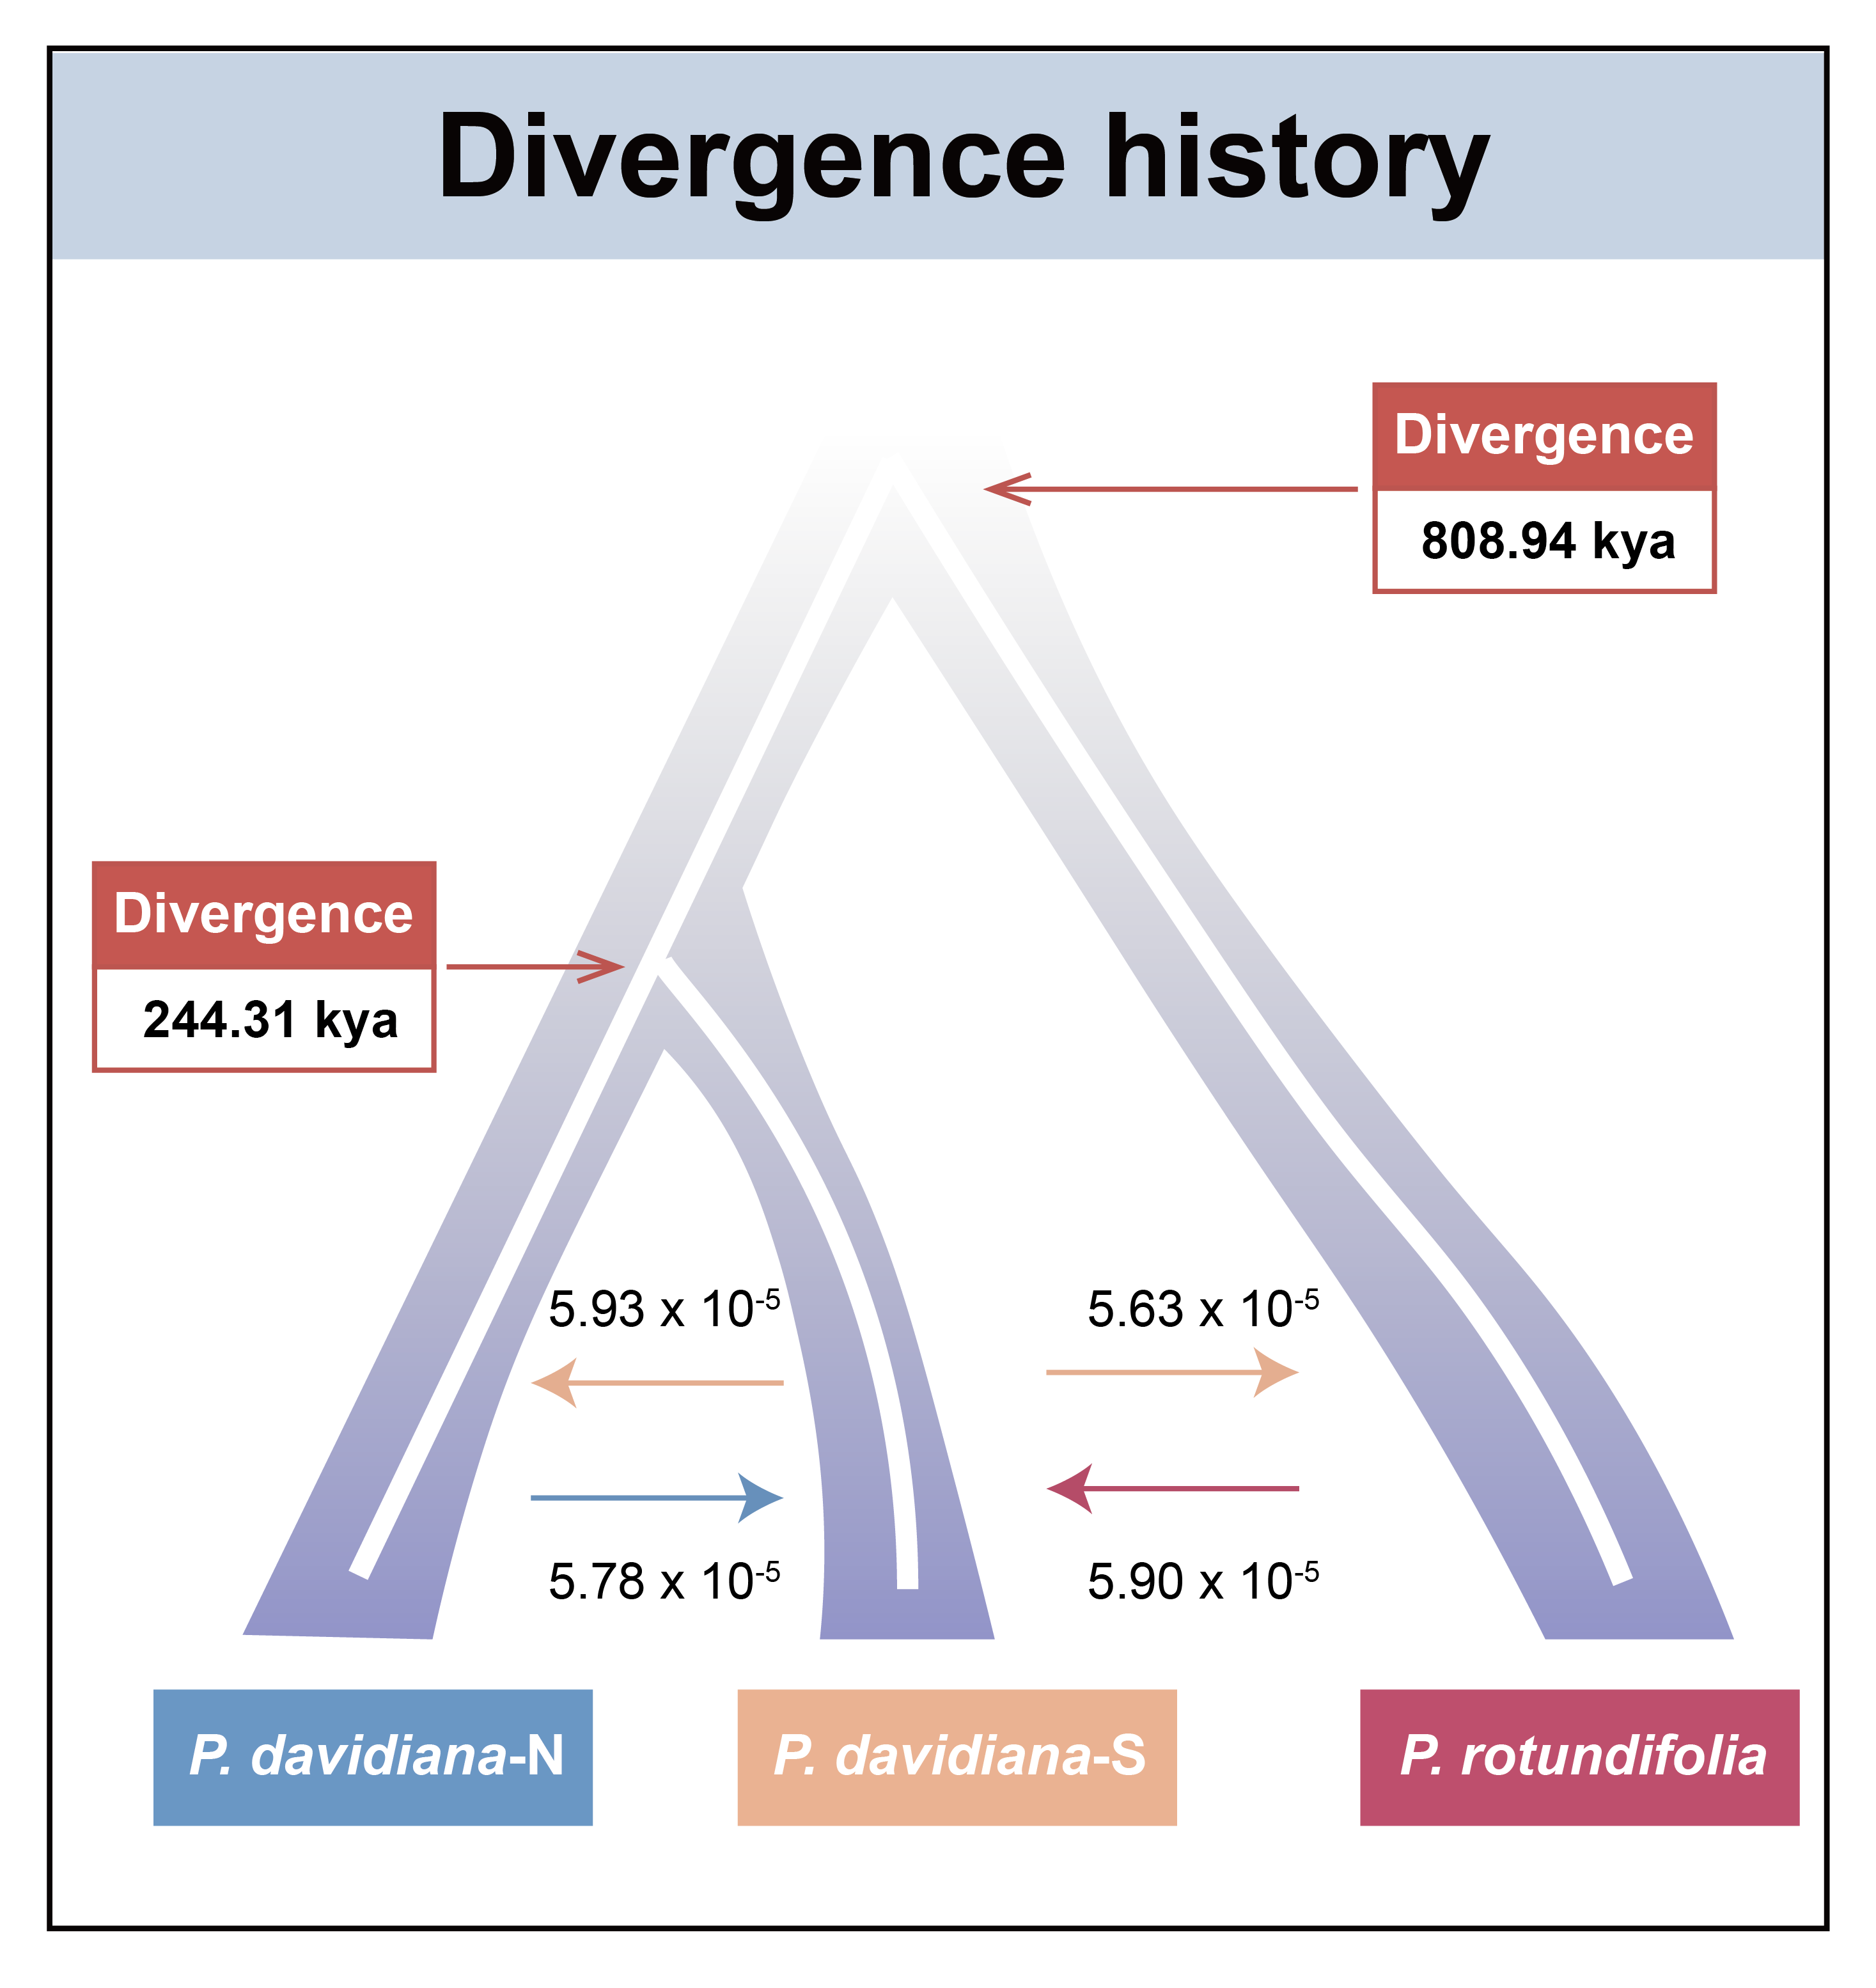
Table S2. Inferred demographic parameters derived from the best-fitting demographic model (Model 3 in Fig. S6), as presented in Fig. 1G.

Parameters | Point estimation | 95% CIª
 |  | Lower bound | Upper bound
ANC1 | 39781 | 38193 | 41369
ANC2 | 605639 | 577304 | 633973
NPOP1 | 56592 | 56024 | 57159
NPOP2 | 26166 | 25630 | 26703
NPOP3 | 20455 | 20302 | 20607
T1 | 16287 | 16045 | 16529
TINT | 37643 | 36677 | 38608
T2 | 53930 | 52824 | 55036
MIG21 | 5.93e-05 | 5.87e-05 | 5.99e-05
MIG12 | 5.78e-05 | 5.73e-05 | 5.83e-05
MIG32 | 5.90e-05 | 5.87e-05 | 5.94e-05
MIG23 | 5.63e-05 | 5.61e-05 | 5.66e-05

Note: Parameters correspond to the model3 from Fig. S6. ANC1 indicates the effective population size of the common ancestor of three lineages. ANC2 indicate the effective population size of the ancestor population before the split of P. davidiana-N and P. davidiana-S. NPOP1, NPOP2, NPOP3 indicate the effective population size of P. davidiana-N, P. davidiana-S and P. rotundifolia, respectively. T1 indicates the estimated divergence time between P. davidiana-N and P. davidiana-S. T2 indicates the estimated divergence time between P. rotundifolia and ancestor populations of P. davidiana-N and P. davidiana-S. TINT estimated the time interval between T1 and T2. MIG21, MIG12, MIG32, MIG23 indicate the per-generation migration rate from P. davidiana-S to P. davidiana-N, from P. davidiana-N to P. davidiana-S, from P. rotundifolia to P. davidiana-S, from P. davidiana-S to P. rotundifolia, respectively.
ª Parametric bootstrap estimates obtained by parameter estimation from 50 datasets simulated according to the overall maximum composite likelihood estimates shown in point estimation columns. Estimations were obtained from 100,000 simulations per likelihood.

####### Note: T1, T2 and TINT represent the number of generations. We adopted a putative mutation rate of 3.75×10⁻⁸ mutations per site per generation, with a generation time of 15 years.

