Supporting Information TABLES S1-S4, FIG S1-S5
STRONG EXTRINSIC REPRODUCTIVE ISOLATION BETWEEN PARAPATRIC POPULATIONS OF AN AUSTRALIAN GROUNDSEL

Maria Clara Melo, Alicia Grealy, Beth Brittain, Greg M. Walter, and Daniel Ortiz-Barrientos¹

The University of Queensland
School of Biological Sciences
St Lucia, Queensland
Australia

Table S1 Geographic location of Senecio lautus populations used in this study
Locality | Environment | Location
Cabarita Beach | Dune | S 28° 19' 54.66" E 153° 34' 17.04"
Cabarita Beach | Headland | S 28° 21' 45.07" E 153° 34' 46.82"
Hat Head | Dune | S 30° 52' 57.06" E 153° 4' 7.32"
Hat Head | Headland | S 30° 53' 15.06" E 153° 4' 3.96"
Lennox Head | Dune | S 28° 47' 10.7" E 153° 35'
Lennox Head | Headland | S 28° 48' 10" E 153° 36' 9.94"
Bayron Bay | Headland | S 28° 38' 4.62" E 153° 38' 14.22"
Lamington Park | Tableland | S 28° 13' 49.83" E 153° 08' 6.28"
Port Macquarie | Dune | S 31° 28' 31.14" E 152° 56' 14.46"
Stradbroke Island | Dune | S 27° 23' 20.20" E 153° 27' 13.71”
Stradbroke Island | Headland | S 27° 26' 9.94" E 153° 32' 42.81”

Table S2 Proportion of Senecio lautus individuals that germinated in Dune or Headland soil under glasshouse (GH) or field (FIELD) conditions. The analysis was performed pooling together both F1-D and F1-H into a single category F1. F1-D are hybrids with a Dune cytoplasm and F1-H are hybrids with a Headland cytoplasm (CB, Cabarita Beach; LN, Lennox Head; SI, Stradbroke Island). N is the number of seeds sown in each soil.
Experiment | Soil/Habitat | Genotype | N | G | SE
GH | Dune | D | 160 | 0.42 | 0.039
GH | Dune | H | 160 | 0.32 | 0.037
GH |  | Mean |  | 0.37 | 0.027
GH | Headland | D | 160 | 0.25 | 0.035
GH | Headland | H | 160 | 0.20 | 0.032
GH |  | Mean |  | 0.23 | 0.024
GH | Dune(CB) | D | 35 | 0.31 | 0.080
GH | Dune(CB) | H | 35 | 0.23 | 0.072
GH | Dune(CB) | Mean |  | 0.27 | 0.053
GH | Headland(CB) | D | 35 | 0.49 | 0.086
GH | Headland(CB) | H | 35 | 0.43 | 0.085
GH | Headland(CB) | Mean |  | 0.46 | 0.060
GH | Dune(LH) | D | 35 | 0.48 | 0.086
GH | Dune(LH) | H | 35 | 0.06 | 0.040
GH | Dune(LH) | Mean |  | 0.27 | 0.053
GH | Headland(LH) | D | 35 | 0.14 | 0.060
GH | Headland(LH) | H | 35 | 0.48 | 0.086
GH | Headland(LH) | Mean |  | 0.31 | 0.055
GH | Dune(SI) | D | 35 | 0.46 | 0.085
GH | Dune(SI) | H | 35 | 0.23 | 0.072
GH | Dune(SI) | Mean |  | 0.34 | 0.057
GH | Headland(SI) | D | 35 | 0.31 | 0.080
GH | Headland(SI) | H | 35 | 0.26 | 0.07
GH | Headland(SI) | Mean |  | 0.28 | 0.054

Continuation Table S2 Proportion of Senecio lautus individuals that germinated in Dune or Headland soil under glasshouse (GH) or field (FIELD) conditions. N is the number of individuals sown in each habitat.

Experiment | Soil/Habitat | Genotype | N | Proportion Germinated | SE
FIELD | Dune | D | 275 | 0.34 | 0.029
FIELD | Dune | F1-D | 159 | 0.54 | 0.040
FIELD | Dune | F1-H | 159 | 0.40 | 0.039
FIELD | Dune | H | 269 | 0.30 | 0.028
FIELD | Dune | F1 * | 318 | 0.47 | 0.028
FIELD |  | Mean |  | 0.38 | 0.016
FIELD | Headland | D | 271 | 0.12 | 0.020
FIELD | Headland | F1-D | 151 | 0.22 | 0.034
FIELD | Headland | F1-H | 153 | 0.23 | 0.034
FIELD | Headland | H | 265 | 0.18 | 0.024
FIELD | Headland | F1 * | 304 | 0.23 | 0.024
FIELD |  | Mean |  | 0.18 | 0.013

Table S3 Senecio lautus mortality in the field as measured by the average number of days alive at the time of flowering, and the proportion of individuals (seedlings) killed by herbivores before flowering occurred in the Dune and Headland habitats. N number of individuals that germinated in each habitat.
Measurement | Habitat | Genotype | N | Average days alive and proportion killed | SE
SURVIVAL | Dune | D | 94 | 115.78 | 11.15
SURVIVAL | Dune | F1-D | 86 | 65.10 | 9.82
SURVIVAL | Dune | F1-H | 64 | 75.13 | 12.26
SURVIVAL | Dune | H | 83 | 57.61 | 9.36
SURVIVAL | Dune | F1 * | 150 | 69.38 | 7.67
SURVIVAL |  | Mean |  | 79.72 | 5.46
SURVIVAL | Headland | D | 34 | 30.77 | 8.02
SURVIVAL | Headland | F1-D | 34 | 41.18 | 8.16
SURVIVAL | Headland | F1-H | 36 | 47.11 | 8.29
SURVIVAL | Headland | H | 52 | 46.52 | 7.06
SURVIVAL | Headland | F1 * | 70 | 44.23 | 5.79
 |  | Mean |  | 42.06 | 3.92
PREDATION | Dune | D | 94 | 0.27 | 0.04
PREDATION | Dune | F1-D | 86 | 0.53 | 0.05
PREDATION | Dune | F1-H | 64 | 0.48 | 0.06
PREDATION | Dune | H | 82 | 0.52 | 0.05
PREDATION | Dune | Mean |  | 0.44 | 0.03
PREDATION | Headland | D | 32 | 0.53 | 0.09
PREDATION | Headland | F1-D | 34 | 0.53 | 0.09
PREDATION | Headland | F1-H | 35 | 0.37 | 0.09
PREDATION | Headland | H | 44 | 0.29 | 0.07
 | Headland | Mean |  | 0.42 | 0.04

* The analysis was performed pooling together both F1-D and F1-H into a single category F

Table S4 Detailed information on statistical tests used in each experiment
Test | Locality | Comparison | Statistical test | N | Parameter | P value
F1 seed set | Glasshouse | Parental (intrapopulation) crosses vs interpopulation crosses | ANOVA | 64 | F = 0.0825 | 0.9693
Seed germination | Glasshouse - D Soil | Dune population seeds vs Headland population seeds | GLM | 320 | z = -1.732 | 0.0834
Seed germination | Glasshouse - H Soil | Dune population seeds vs Headland population seeds | GLM | 320 | z = -1.059 | 0.2900
Seed germination | Field | All crosstype germination in the Sandy Dunes vs Rocky Headland | GLM | 1702 | z = -9.279 | 0.0000
Seed germination | Field - Sandy Dunes | Dune population seeds vs Headland population seeds | GLM | 862 | z = -0.913 | 0.3610
Seed germination | Field - Rocky Headland | Dune population seeds vs Headland population seeds | GLM | 840 | z = -1.673 | 0.0943
Seed germination | Field - Sandy Dunes | F1 cross seeds vs Dune population seeds | GLM | 862 | z = 3.137 | 0.0017
Seed germination | Field - Sandy Dunes | F1-D (D cytoplasm) cross seeds vs Dune population seeds | GLM | 862 | z = 3.973 | 0.0001
Test | Locality | Comparison | Statistical test | N | Parameter | P value
Seed germination | Field - Sandy Dunes | F1-H (H cytoplasm) cross seeds vs Dune population seeds | GLM | 863 | z = 1.248 | 0.2120
Seed germination | Field - Rocky Headland | F1 cross seeds vs Headland population seeds | GLM | 840 | z = 1.366 | 0.1719
Seed germination | Field - Rocky Headland | F1-D (D cytoplasm) cross seeds vs Headland population seeds | GLM | 840 | z = 1.036 | 0.3001
Seed germination | Field - Rocky Headland | F1-H (H cytoplasm) cross seeds vs Headland population seeds | GLM | 840 | z = 1.251 | 0.2108
Survival analyses | Field - Sandy Dunes | Dune population vs Headland population | GLM | 327 | z = -5.847 | 0.0000
Survival analyses | Field - Sandy Dunes | F1-D (D cytoplasm) cross vs Dune population | GLM | 327 | z = -3.035 | 0.0024
Survival analyses | Field - Sandy Dunes | F1-H (H cytoplasm) cross vs Dune population | GLM | 327 | z = -3.158 | 0.0015
Survival analyses | Field - Rocky Headland | Dune population vs Headland population | GLM | 156 | z = -1.396 | 0.1630

Test | Locality | Comparison | Statistical test | N | Parameter | P value
Survival analyses | Field - Rocky Headland | F1-D (D cytoplasm) cross vs Headland population | GLM | 156 | z = 0.459 | 0.6460
Survival analyses | Field - Rocky Headland | F1-H (H cytoplasm) cross vs Headland population | GLM | 156 | z = 0.276 | 0.7820
Predation analyses | Field - Sandy Dunes | Dune population vs Headland population | GLM | 326 | z = 3.753 | 0.0001
Predation analyses | Field - Sandy Dunes | F1-D (D cytoplasm) cross vs Dune population | GLM | 326 | z = 3.763 | 0.0002
Predation analyses | Field - Sandy Dunes | F1-H (H cytoplasm) cross vs Dune population | GLM | 326 | z = 2.904 | 0.0037
Predation analyses | Field - Rocky Headland | Dune population vs Headland population | GLM | 145 | z = 2.159 | 0.0309
Predation analyses | Field - Rocky Headland | F1-D (D cytoplasm) cross vs Headland population | GLM | 145 | z = 2.124 | 0.0337
Predation analyses | Field - Rocky Headland | F1-H (H cytoplasm) cross vs Headland population | GLM | 145 | z = 0.766 | 0.4434
Other mortality causes | Field - Sandy Dunes | Dune population vs Headland population | GLM | 326 | z = 0.235 | 0.8139
Other mortality causes | Field - Sandy Dunes | F1-D (D cytoplasm) cross vs Dune population | GLM | 326 | z = -0.404 | 0.6863
Test | Locality | Comparison | Statistical test | N | Parameter | P value
Other mortality causes | Field - Sandy Dunes | F1-H (H cytoplasm) cross vs Dune population | GLM | 326 | z = -0.017 | 0.9863
Other mortality causes | Field - Rocky Headland | Dune population e vs Headland population | GLM | 145 | z = 0.103 | 0.9181
Other mortality causes | Field - Rocky Headland | F1-D (D cytoplasm) cross vs Headland population | GLM | 145 | z = -0.038 | 0.9699
Other mortality causes | Field - Rocky Headland | F1-H (H cytoplasm) cross vs Headland population | GLM | 145 | z = -0.186 | 0.8526
Fecundity | Field - Sandy Dunes | All cross types | GML | 84 | F =0.7789 | 0.5092
Fecundity | Field - Rocky Headland | All cross types | GML | 47 | F =0.3474 | 0.7912
Germination of CB seeds in other localities soil | Cabarita Beach Soil – D Soil | CB Dune population vs CB Headland population | GLM | 70 | z = -0.804 | 0.4210
Germination of CB seeds in other localities soil | Cabarita Beach Soil – H Soil | CB Dune population vs CB Headland population | GLM | 70 | z = -0.305 | 0.7600
Germination of CB seeds in other localities soil | Lennox Head Soil - D Soil | CB Dune population vs CB Headland population | GLM | 70 | z = -2.794 | 0.0050

Test | Locality | Comparison | Statistical test | N | Parameter | P value
Germination of CB seeds in other localities soil | Lennox Head Soil – H Soil | CB Dune population vs CB Headland population | GLM | 70 | z = 2.942 | 0.0030
Germination of CB seeds in other localities soil | Stradbroke island Soil – D Soil | CB Dune population vs. CB Headland population | GLM | 70 | z = -1.938 | 0.0526
Germination of CB seeds in other localities soil | Stradbroke Soil – H Soil | CB Dune population vs CB Headland population | GLM | 70 | z = -0.549 | 0.5830
Germination of CB seeds in other localities soil | Glasshouse | Full interaction model vs simpler one | ANOVA | 1df | X² = 36.807 | 0.0000
Morphology (Height) | Glasshouse | Dune population vs Headland population | ANOVA | 1,37 | F= 33.501 | 0.0000
Morphology (No. Branches) | Glasshouse | Dune population vs Headland population | ANOVA | 1,37 | F= 28.655 | 0.0000

Fig. S1 Typical morphologies of Senecio lautus populations at Cabarita beach and example of transplant experiment plot. The top pictures show the rocky headland at Cabarita Beach, and a typical Headland plant growing at this site. The pictures below show both the sand dunes at Cabarita Beach and an example of the set up for the transplant experiments, and a Dune individual.
Fig. S2 Fruits of Senecio lautus (top panel) and an example of seed counting (lower panel) in the Dune population.
Fig. S3 Senecio lautus mortality in reciprocal transplant experiments in the glasshouse. Left pictures show plants growing in trays filled with soil collected from either the sand dunes or the rocky headlands at Cabarita Beach. Right panels show the proportion of Dune and Headland seeds that germinated in each environmental condition. Bars show means and standard errors for binomial probabilities, with different letters denoting significant differences in the proportion of germinations between genotypes by using a nominal logistic model.
Fig. S4 Examples of Senecio lautus seedling individual in the field (left panel), a predated seedling (middle panel), and one of the predator individuals (Spilosoma sp.) found eating a seedling in the field, and eating a leaf under the stereoscope (right panel).
Fig. S5 Examples of Senecio lautus pollinators observed in both sand dune and rocky headlands field.

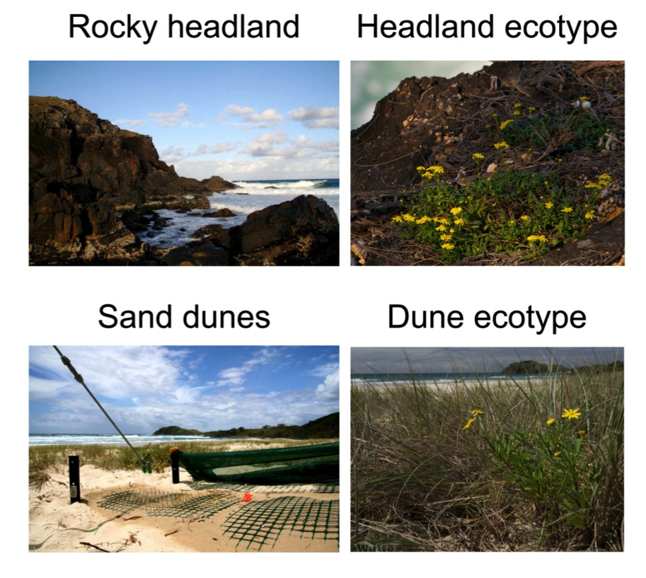
Fig. S1

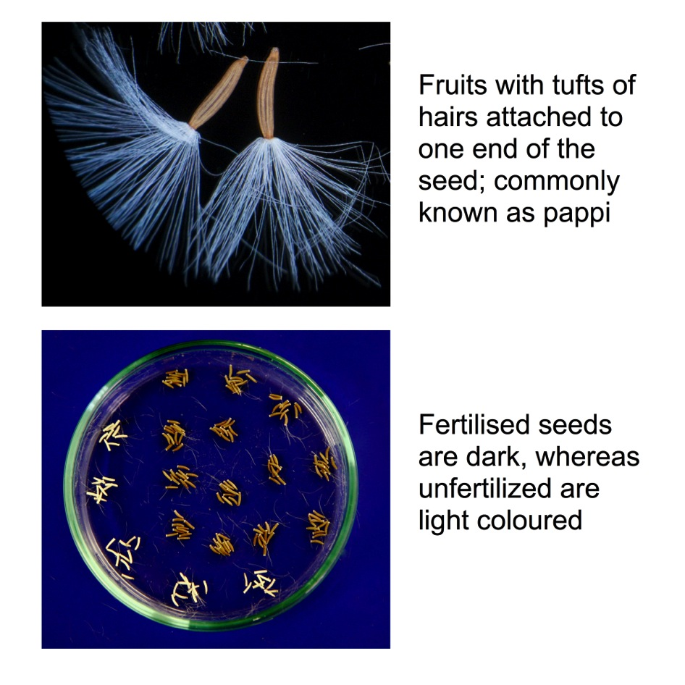
Fig. S2

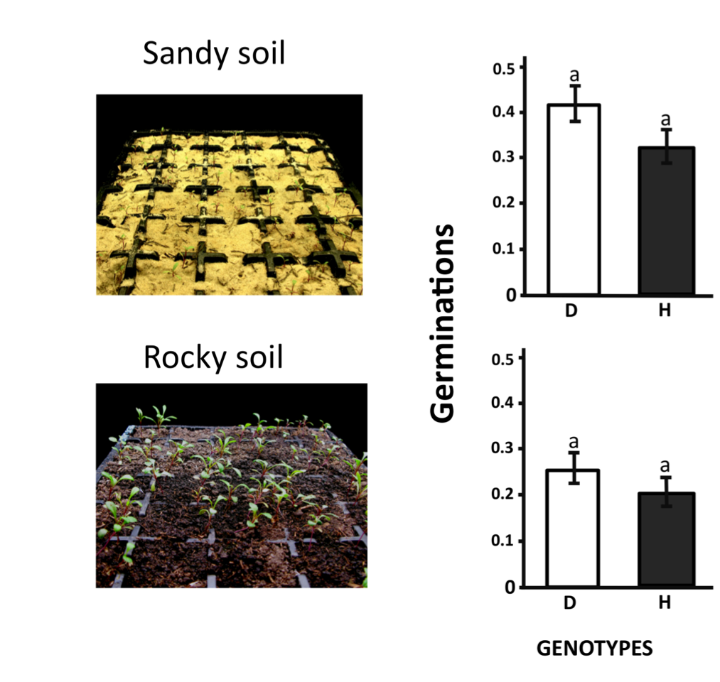
Fig. S3

Fig. S4
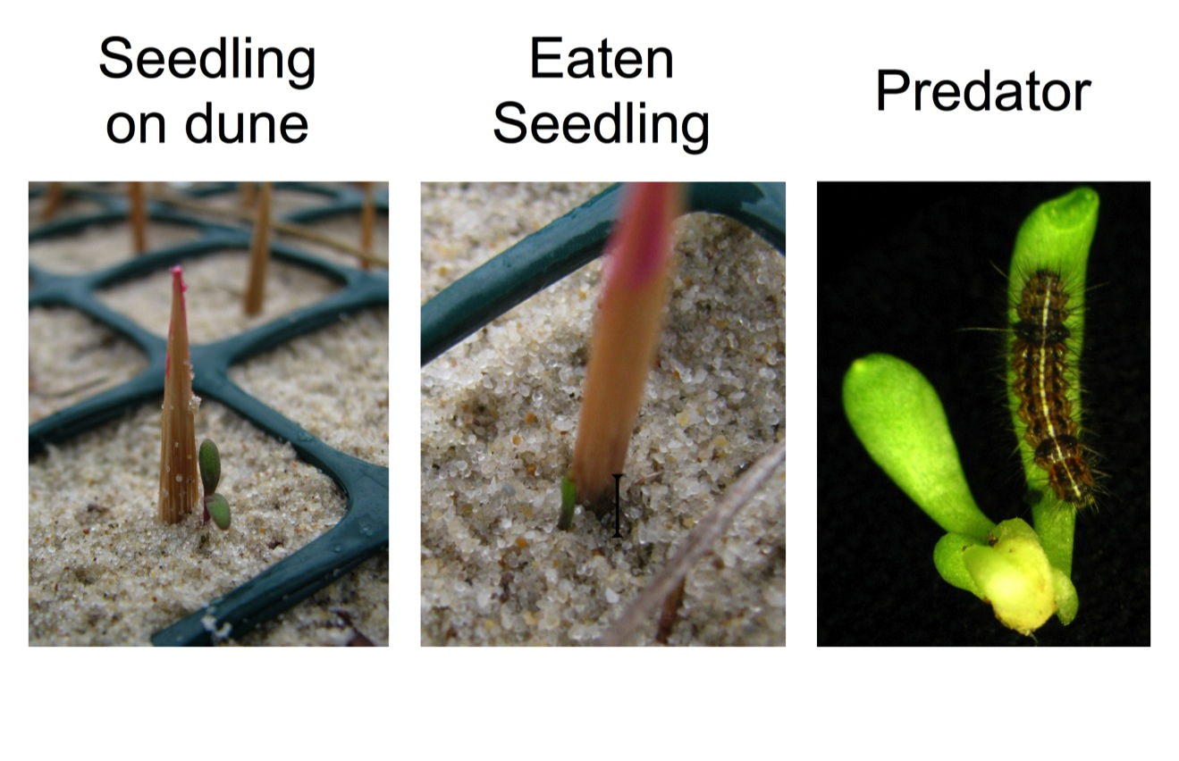

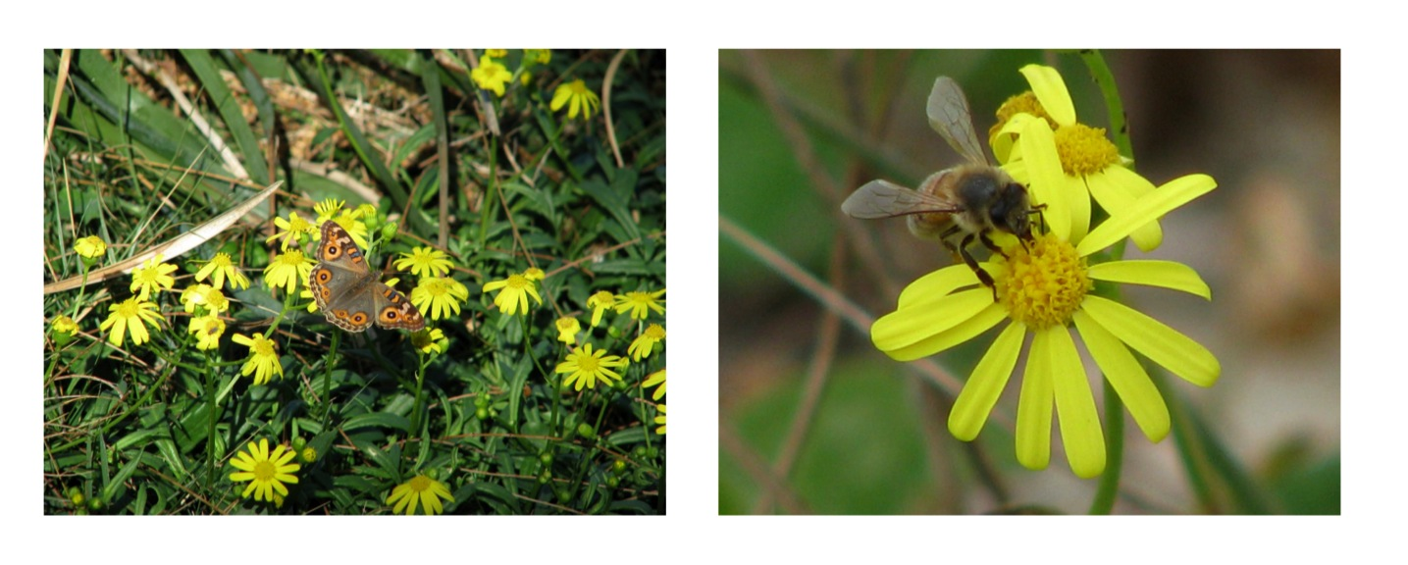
Fig. S5

