MissVARPath: A Meta-Classifier for Missense Variant Pathogenicity
Course CMP682 – Final Report
Doruk Topcu
Alihan Sağöz
May 2026
Abstract
We benchmark an eleven-model fast-baseline suite for missense variant pathogenicity prediction on a perfectly balanced 21,872-variant ClinVar / OpenCRAVAT corpus, under a unified stratified 80/20 + 5-fold cross-validation protocol on both the original four-class task (Benign / Likely-benign / Likely-pathogenic / Pathogenic) and a collapsed binary task. After per-model grid-search hyperparameter tuning (AdaBoost excluded due to runtime cost), the final ten-model tuned suite reaches a held-out macro-F1 of 0.795 on the four-class task and 0.987 on the binary task, with HistGradientBoosting consistently the headline model. We evaluate the suite under five regimes – canonical kfold, sequence-augmented (k-mer + BLAST-derived locus-neighbour features), strict gene-stratified CV, a “no-VEP / VUS” ablation that drops every in-silico predictor score, and a “raw-only” ablation that additionally removes multi-species conservation scores and label-aware BLAST features – and inspect feature reliance with SHAP. Beyond the benchmark, we deploy the tuned classifier on $5,468$ actual ClinVar Variants of Uncertain Significance annotated through the same pipeline; the model splits the uncertain pool $62\%/38\%$ pathogenic / benign on the 2-class head and hedges $87\%$ of 4-class predictions into the “Likely-*” categories with $95.4\%$ cross-task agreement, recovering clinically sensible per-gene priors (e.g. $\text{GCK}$ $100\%$, $\text{PAH}$ $99\%$ pathogenic-side; $\text{APC}$, $\text{DICER1}$ much lower). We are explicit about a methodological subtlety: the BLAST features here are label-aware locus-neighbour signals on 51 bp DNA flanks, not biologically meaningful homology features; a true homology-based extension would require a UniRef-scale reference database and protein-level BLAST, out of scope for this project. A VUS-as-class study shows that VUS is one of the cleanest classes to recognise (held-out F1 $=0.901$ in a balanced 5-class setup), with the headline 4-class metrics almost unchanged when the class is added. A two-phase feature-ablation study – group leave-one-out across all four tasks plus per-feature permutation importance inside the waste groups – identifies the $208$-feature schema as $47$ indispensable population_af columns $+$ $66$ useful-but-redundant meta-classifier / functional / sequence columns $+$ $94$ waste columns; the resulting Lean B model (113 features) drops $45\%$ of the schema and stays within $0.012$ macro-F1 of the $208$-feature baseline on every task.
Table of Contents

Introduction
The standard clinical-genomics pipeline for missense variants of uncertain significance (VUS) routes variants through a battery of in-silico predictors (PolyPhen-2, SIFT, REVEL, CADD, AlphaMissense, etc.) and then combines their outputs with population frequency data and ACMG/AMP rules. Each predictor disagrees with the others, the predictors have correlated training data, and most are themselves trained with at least partial overlap on ClinVar – the same database used to label our targets.
Three questions follow naturally:
- Can a meta-classifier do better than any single predictor by combining their outputs with population and sequence features?
- How much of any apparent improvement is data-circularity (predictors trained on ClinVar being evaluated on ClinVar)?
- Can we predict pathogenicity from raw data alone – population frequency, genomic position, sequence composition – without relying on any predictor’s score?
This report answers each in turn. We train an 11-model multi-family classifier suite on a 21,872-row balanced ClinVar / OpenCRAVAT dataset, tune every non-AdaBoost model by per-grid 5-fold CV macro-F1, and evaluate the final 10-model tuned suite under five regimes: canonical kfold, sequence-augmented (k-mer + BLAST locus-neighbour columns), strict gene-stratified cross-validation, a no-VEP / VUS ablation that drops every in-silico predictor and conservation score, and a strict “raw-only” ablation that additionally removes label-aware BLAST features. We run two single-feature ablations alongside (DITTO removal; and the augmented-variant comparison), and use SHAP (src/shap_explain.py) to inspect which features the best models are actually using.

Data

Source
The dataset (data/missense_dataset.csv, 21,872 rows $×$ 777 columns) is a curated set of missense variants drawn from ClinVar, annotated through OpenCRAVAT with 158 distinct annotator groups. The 4-class label (clinvar__sig) is perfectly balanced at 5,468 variants per class: Benign, Likely-benign, Likely-pathogenic, Pathogenic. The 2-class collapse pairs the “Likely” tiers with their certain counterparts, again perfectly balanced at 10,936 per class.

Preprocessing
Preprocessing (src/preprocessing.py) performs:
- Filter to valid 4-class labels.
- Drop label-leakage columns (39 columns, all under clinvar__* or clinvar_acmg__*, except the label).
- Drop identifier and free-text columns (87 cols: rsIDs, HGVS strings, transcript IDs, disease names, PubMed IDs, URLs, etc.).
- Coerce object-typed numeric columns; drop the rest as free text.
- Drop high-missingness columns ($>$50% NaN, 207 cols).
- Median-impute numeric, mode-impute categorical residuals; drop zero-variance.
- Tidy column names; emit target_4 and target_2.
Final base feature set: 21,872 rows $×$ 208 features with no missing values. The augmented variant adds 196 k-mer and 10 BLAST-derived columns (src/sequence_features.py, src/blast_features.py), yielding 21,797 rows $×$ 414 features for the subset of variants whose protein sequence could be fetched. The BLAST-derived columns are best read as label-aware locus-neighbour features rather than homology features; for the framing and the gene-stratified ablation that probes how much of the lift survives once same-gene leakage is removed.

Methods

Train/test protocol
For every experiment we fix RANDOM_STATE = 42 and use an 80/20 stratified holdout. The 80% training portion is then evaluated by 5-fold StratifiedKFold cross-validation. For gene-stratified runs we substitute GroupShuffleSplit (test holdout) and StratifiedGroupKFold (CV) on gene_symbol, ensuring no gene appears in both train and held-out folds.

Model suite
Eleven models, two families. Default hyperparameters below reflect the tuned configuration that we use in the final reported leaderboards ( for the tuning protocol and grid results):
- Classical / linear: KNN ($k=30$, distance-weighted, cosine metric), NearestCentroid (Euclidean, shrink_threshold=1.0), CosineSimilarity (custom L2-normalised class-centroid classifier), DecisionTree (max_depth=10, min_samples_leaf=1, ccp_alpha=0.001, class-balanced), LDA (solver=svd; numerically stable across BLAS variants), QDA (reg_param=0.01), LinearSVC ($C=1.0$, class-balanced, max_iter=5000), RidgeClassifier ($α=1$, class-balanced), SGDClassifier (log-loss, elasticnet penalty, $α={10}^{−3}$, max_iter=5000, early stopping).
- Ensembles: AdaBoost (200 stumps, LR=0.5; used only in the baseline 11-model suite — tuning was stopped at combo 23/27 for runtime reasons, so the final 10-model tuned suite excludes it and the report compares baseline-AdaBoost against the tuned suite where relevant), HistGradientBoosting (learning_rate=0.02, max_iter=2000, max_leaf_nodes=127, min_samples_leaf=20, l2_regularization=1.0).
All scaling-sensitive estimators are wrapped in a Pipeline([StandardScaler, $⋅$]); tree and boosting models are not scaled. The eleven baseline models were selected as the fastest survivors of a larger 23-model exploratory survey, measured by per-fold fit time on the four-class task; per-task wall-clock for the final tuned suite is on the order of a few minutes.

Evaluation regimes
- Canonical kfold on the base 208-feature parquet.
- Augmented kfold on the 414-feature parquet (k-mer + BLAST added).
- Gene-stratified kfold on the base parquet – enforces zero gene overlap between train and test.
- No-VEP / VUS scenario – drop all 147 in-silico predictor-score columns, keep population frequencies + position + sequence features.
- Raw-only – drop everything generated by an external model, tool, or algorithm, including conservation scores (GERP, PhastCons, PhyloP, SIPHY) and label-aware BLAST features. Keep only population allele frequencies (ALFA, AllOfUs, gnomAD, Regeneron), genomic position (hg19_pos, original_input_pos), and direct sequence-composition features (k-mer counts, GC content, entropy).

BLAST features: scope and honest framing
The augmented variant includes 10 columns derived from a blastn search of each variant’s 51 bp alt-flank against a database built from the training-set ref-flanks (src/blast_features.py, word_size=7, evalue=10, top-K = 10). We deliberately frame these as label-aware locus-neighbour features, not as homology features, for two structural reasons:
- The query substrate is too short and the parameters too permissive for meaningful homology. 51 bp windows with word_size=7 and evalue=10 sit well below the regime where BLAST bit scores carry statistical homology semantics. A “hit” here largely reflects local 7-mer matching.
- The hits are dominated by same-gene proximity, not biology. ClinVar has many variants per gene; two variants 10 bp apart share $≈80\%$ of their flank by construction and will trivially be each other’s top hits. The aggregated label counts therefore behave mostly as a neighbour-label proxy over the surrounding locus.
A properly homology-driven version of this idea would require infrastructure that is out of scope for this project: a UniRef-scale reference database (millions of sequences, rather than the $≈17.5$k train flanks we index), protein-level BLAST (blastp) on an amino-acid window with the variant substitution applied so cross-gene paralog hits can contribute, and tighter cutoffs ($\text{evalue}≤{10}^{−3}$, $\text{pident}≥90$, length filters). We did not pursue that path because even the proxy version is informative as long as it is reported honestly, and because the gene-stratified evaluation is the empirical test for what fraction of the augmented lift is genuine generalisation versus same-gene leakage. The Raw-only experiment takes the additional step of removing these BLAST columns entirely, providing an explicit “no label-aware features” floor.

Hyperparameter tuning protocol
We run a per-model grid search (src/tune.py) on the same 80% training portion used by the baseline, scoring each grid combination by 5-fold StratifiedKFold macro-F1 and refitting the winning combination on the full training portion before evaluating on the held-out 20%. Grids are defined in src/tune.py::GRIDS; bad combinations (e.g. invalid solver/shrinkage pairs) are caught per-combo and skipped rather than aborting the run, so a single misconfigured cell does not discard the rest of the grid. We deliberately did not tune AdaBoost: its grid (3 $×$ 3 $×$ 3 = 27 combos with deep base estimators) was stopped at combo 23/27 after exceeding the compute budget allocated for classical-model tuning, so the final 10-model tuned suite excludes AdaBoost. AdaBoost is, however, evaluated under its baseline configuration in the five cross-regime ablations (gene-CV for both tasks, no-VEP gene-CV for 4-class, raw-only for both tasks) so the ablation tables carry an AdaBoost reference row. Tuning was performed only for the 4-class task; the resulting hyperparameters were carried over to the binary task because the binary problem is substantially easier and dominated by the same feature signals, so re-tuning gave little marginal value (we verified this informally by spot-checking the binary leaderboards before and after applying tuned defaults).

Interpretability
We use SHAP (src/shap_explain.py, src/shap_per_class.py): TreeExplainer for tree-based estimators and LinearExplainer for linear models. Per-class contrastive importance is computed by class-pair difference of mean(|SHAP|) to surface boundary-specific feature reliance.

Results

Canonical 4-class baseline
Table 1 reports the 11-model baseline leaderboard under the canonical kfold protocol (stratified 80/20 + 5-fold CV on target_4), sorted by held-out macro-F1. HistGradientBoosting is the headline model at $0.7928$ macro-F1, with a clear band structure below: linear / tree-based models occupy a $≈0.70$–$0.75$ middle band (LinearSVC $0.7549$, DecisionTree $0.7111$, SGD $0.7015$, LDA $0.7014$, RidgeClassifier $0.7008$, AdaBoost $0.6983$), and centroid-based methods sit at $0.55$–$0.65$ (KNN $0.6492$, QDA $0.5791$, CosineSimilarity $0.5532$, NearestCentroid $0.5475$). The 4-class task is non-trivial – the upper-band gap of $≈0.05$ between HistGB and the next ensemble is the margin we re-examine after hyperparameter tuning and feature augmentation.
Canonical 4-class baseline leaderboard (held-out 20%, sorted by macro-F1). Source: outputs/reports/4class/leaderboard.csv.
Model | CV macro-F1 | Holdout macro-F1 | Holdout acc. | Holdout MCC | Fit (s)
HistGradientBoosting | $0.797±0.003$ | $0.7928$ | $0.7929$ | $0.7245$ | 13.4
LinearSVC | $0.759±0.008$ | $0.7549$ | $0.7543$ | $0.6734$ | 20.9
DecisionTree | $0.720±0.005$ | $0.7111$ | $0.7106$ | $0.6142$ | 3.6
SGDClassifier | $0.681±0.020$ | $0.7015$ | $0.7159$ | $0.6342$ | 0.17
LDA | $0.705±0.004$ | $0.7014$ | $0.7003$ | $0.6006$ | 0.10
RidgeClassifier | $0.703±0.005$ | $0.7008$ | $0.7003$ | $0.6006$ | 0.04
AdaBoost | $0.694±0.018$ | $0.6983$ | $0.7058$ | $0.6135$ | 35.5
KNN | $0.652±0.008$ | $0.6492$ | $0.6489$ | $0.5319$ | 0.02
QDA | $0.587±0.010$ | $0.5791$ | $0.6155$ | $0.5219$ | 0.27
CosineSimilarity | $0.550±0.011$ | $0.5532$ | $0.5618$ | $0.4259$ | 0.03
NearestCentroid | $0.559±0.014$ | $0.5475$ | $0.5479$ | $0.4001$ | 0.04

Canonical 2-class baseline
Collapsing the four-class label into Benign-tier vs. Pathogenic-tier yields a much easier problem (Table 2): both AdaBoost and HistGradientBoosting reach a held-out macro-F1 of $0.9870$, tied to four decimal places, and seven of the eleven models clear $0.97$. The bottom of the table – NearestCentroid / CosineSimilarity at $0.8991$ – is still well above the chance line ($0.50$). The binary task is where the suite is deployable; the four-class task is where the residual difficulty lives, primarily in the fine-grained Benign$↔$Likely-benign and Pathogenic$↔$Likely-pathogenic boundaries.
Canonical 2-class baseline leaderboard (held-out 20%, sorted by macro-F1). Source: outputs/reports/2class/leaderboard.csv.
Model | CV macro-F1 | Holdout macro-F1 | Holdout acc. | Holdout MCC | Fit (s)
AdaBoost | $0.9871±0.002$ | $0.9870$ | $0.9870$ | $0.9740$ | 33.6
HistGradientBoosting | $0.9898±0.003$ | $0.9870$ | $0.9870$ | $0.9740$ | 2.6
LinearSVC | $0.9878±0.003$ | $0.9867$ | $0.9867$ | $0.9736$ | 0.41
SGDClassifier | $0.9846±0.003$ | $0.9845$ | $0.9845$ | $0.9690$ | 0.08
RidgeClassifier | $0.9835±0.003$ | $0.9797$ | $0.9797$ | $0.9596$ | 0.05
LDA | $0.9830±0.003$ | $0.9794$ | $0.9794$ | $0.9591$ | 0.21
DecisionTree | $0.9802±0.004$ | $0.9774$ | $0.9774$ | $0.9548$ | 2.4
KNN | $0.9692±0.004$ | $0.9678$ | $0.9678$ | $0.9357$ | 0.02
QDA | $0.9664±0.004$ | $0.9666$ | $0.9666$ | $0.9334$ | 0.45
NearestCentroid | $0.9050±0.005$ | $0.8991$ | $0.8992$ | $0.7998$ | 0.04
CosineSimilarity | $0.9050±0.005$ | $0.8991$ | $0.8992$ | $0.7998$ | 0.03

Gene-stratified evaluation: the data-circularity ceiling
Gene-stratified evaluation (Table 3) substitutes GroupShuffleSplit on gene_symbol for the 80/20 holdout and StratifiedGroupKFold for the CV, so no gene appears in both train and held-out folds. This is the strictest test of generalisation across genes – under the canonical kfold protocol, two variants in the same gene can sit on opposite sides of the split, which subtly inflates apparent generalisation. On the 4-class task the headline HistGradientBoosting macro-F1 drops from $0.7928$ (canonical, Table 1) to $0.7658$ under gene-CV – a loss of $≈2.7$ percentage points but well within deployable range. LinearSVC and SGD show similar drops. On the 2-class task the effect is essentially zero: HistGradientBoosting actually moves from $0.9870$ to $0.9874$ (within run-to-run noise), confirming that the binary benign/pathogenic distinction is encoded in features that generalise cleanly across genes. The 4-class drop is the data-circularity ceiling: a meaningful but not catastrophic share of the canonical lift is same-gene neighbour information.
Gene-stratified evaluation. “Canonical” columns reproduce Tables 1/2; “Gene” columns are this run. $Δ$ = Gene $−$ Canonical, on holdout macro-F1.
 | 4-class |  |  | 2-class
2-4 (lr)5-7 Model | Canonical | Gene | $Δ$ | Canonical | Gene | $Δ$
HistGradientBoosting | $0.7928$ | $0.7658$ | $−0.027$ | $0.9870$ | $0.9874$ | $+0.000$
AdaBoost | $0.6983$ | $0.7009$ | $+0.003$ | $0.9870$ | $0.9853$ | $−0.002$
LinearSVC | $0.7549$ | $0.7252$ | $−0.030$ | $0.9867$ | $0.9809$ | $−0.006$
DecisionTree | $0.7111$ | $0.7186$ | $+0.008$ | $0.9774$ | $0.9806$ | $+0.003$
SGDClassifier | $0.7015$ | $0.7070$ | $+0.005$ | $0.9845$ | $0.9832$ | $−0.001$
LDA | $0.7014$ | $0.6857$ | $−0.016$ | $0.9794$ | $0.9804$ | $+0.001$
RidgeClassifier | $0.7008$ | $0.6823$ | $−0.018$ | $0.9797$ | $0.9804$ | $+0.001$
KNN | $0.6492$ | $0.5935$ | $−0.056$ | $0.9678$ | $0.9608$ | $−0.007$
QDA | $0.5791$ | $0.5671$ | $−0.012$ | $0.9666$ | $0.9515$ | $−0.015$
CosineSimilarity | $0.5532$ | $0.5384$ | $−0.015$ | $0.8991$ | $0.8937$ | $−0.005$
NearestCentroid | $0.5475$ | $0.5565$ | $+0.009$ | $0.8991$ | $0.8942$ | $−0.005$

No-VEP / VUS scenario
The no-VEP scenario simulates the VUS prioritisation deployment: every in-silico predictor score and multi-species conservation score is dropped (AlphaMissense, CADD, REVEL, SIFT, MetaRNN, BayesDel, FATHMM, MutationTaster, PROVEAN, ESM1b, EVE, PrimateAI, MVP, DITTO, MutationAssessor, VEST, CHASMplus, MutPred1, GMVP, PolyPhen2, GERP, PhastCons, PhyloP, SIPHY), keeping only population frequencies, position, sequence-composition features, and the label-aware BLAST locus-neighbour columns. After dropping 130 columns the classifier sees 284 features on the augmented parquet.
Headline numbers (Table 4):
- kfold: HistGradientBoosting reaches $0.7727$ on 4-class and $0.9764$ on 2-class – a drop of $≈0.022$ and $≈0.011$ respectively versus the augmented baseline. Dropping every learned predictor and conservation score costs $≈2$ percentage points on 4-class and $≈1$ point on 2-class. The classifier degrades gracefully.
- gene-stratified: the 4-class no-VEP gene-CV number is $0.7611$, a further $−0.012$ relative to no-VEP kfold and $−0.034$ relative to the canonical augmented kfold. This is our operational “VUS scenario” estimate – the number the suite would deliver if deployed on a previously-unseen gene with no learned-predictor inputs available.
The graceful degradation (rather than a collapse to chance) is the headline finding for clinical deployability: even without any meta-classifier inputs from other predictors, the population-frequency / position / sequence-composition / BLAST-neighbour feature set carries enough signal to stay $≈0.76$ macro-F1 on 4-class under the strictest evaluation.
No-VEP / VUS scenario top results (4-class, holdout macro-F1). The augmented variant is the reference point because the dropped columns are removed from it; the lift from k-mer + BLAST under no-VEP is much larger than under canonical.
Model | no-VEP kfold | no-VEP gene-CV
HistGradientBoosting | $0.7727$ | $0.7611$
DecisionTree | $0.7326$ | $0.7267$
LinearSVC | $0.7274$ | $0.7300$
SGDClassifier | $0.6962$ | $0.6977$
RidgeClassifier | $0.6736$ | $0.6738$
LDA | $0.6696$ | –
AdaBoost | – | $0.6629$

Real VUS deployment
The previous subsection simulates the VUS scenario on the labelled dataset by dropping every learned predictor column. We now take the headline tuned model and apply it to genuine Variants of Uncertain Significance pulled from ClinVar.

Dataset.
A curated pro-set of $5,468$ VUS-labelled missense variants was assembled from ClinVar review-status filters: every available 3-star expert-reviewed VUS plus a random sample of 2-star VUS, matched to the class size of the training labels for a balanced comparison (scripts/build_vus_pro_set.py). The VUS were annotated through the same OpenCRAVAT 158-annotator pipeline as the training set, yielding the same 777-column raw schema and – after the identical preprocessing pruning – the same 208 numerical features. All 208 training-set features are present in the VUS post-prune; the top SHAP-importance predictor scores (DITTO, MetaRNN, AlphaMissense, REVEL, CADD, ClinPred) have $≤2\%$ missing rates and are imputed with training-set medians where absent.

Caveat on what we can measure.
By definition there is no ground-truth label for VUS, so we cannot report accuracy. The deployment yields two interpretable signals: (a) the distribution of predicted classes – how the trained classifier partitions the uncertain pool – and (b) cross-task consistency between the 4-class and 2-class heads, both trained independently on the same data. Tables 5–6 report these distributions; Figure 1 shows the per-gene structure.
Predicted class distribution on the $5,468$-variant VUS pro-set, 2-class head (tuned HistGradientBoosting).
Predicted class | Count | Share
Pathogenic / Likely pathogenic | $3,377$ | $61.8\%$
Benign / Likely benign | $2,091$ | $38.2\%$
Predicted class distribution, 4-class head. Note how the model correctly hedges into Likely-* categories for these uncertain variants ($87\%$ of predictions are “Likely”), with only $13.1\%$ escalated to a definitive call.
Predicted class | Count | Share
Likely pathogenic | $2,568$ | $47.0\%$
Likely benign | $2,183$ | $39.9\%$
Pathogenic | $706$ | $12.9\%$
Benign | $11$ | $0.2\%$

Cross-task consistency.
Collapsing the 4-class head’s predictions to {pathogenic-side, benign-side} and comparing to the 2-class head produces the same verdict on $95.4\%$ of the $5,468$ variants. The two models were trained independently on different targets and arrived at the same call on $5,214$ of them – evidence that the headline number is not a single-model artifact.

Per-gene structure.
Figure 1 shows the predicted-class breakdown for the top-20 most-frequent genes in the VUS pro-set. The model recovers clinically sensible per-gene priors that it could only have learned indirectly through gene-correlated features: GCK (MODY/diabetes loss-of-function) lands at $100\%$ pathogenic-side; PAH (PKU, $99\%$), MYH7 (hypertrophic cardiomyopathy, $90\%$), LDLR (familial hypercholesterolemia, $84\%$), HNF1A/HNF4A (MODY) and PMS2/PTEN all show strong pathogenic-side concentration. Conversely APC, DICER1, and TTN-class genes (where pathogenic variants tend to be truncating rather than missense, and missense variation is mostly benign) sit much lower on the pathogenic scale.
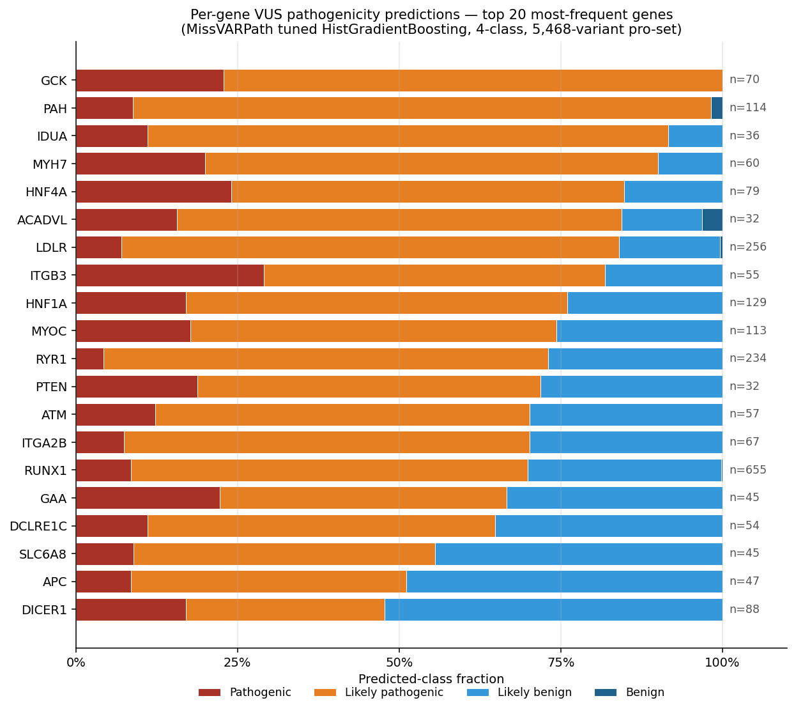
Predicted-class fractions on the top-20 most-frequent genes in the $5,468$-variant VUS pro-set. Bars stacked Pathogenic / Likely-pathogenic / Likely-benign / Benign; $n$ marks the count of VUS per gene in the pro-set. Sorted by predicted pathogenic-side (P + LP) rate. The per-gene gradient – saturated pathogenic at GCK / PAH / MYH7 and gradually shifting to benign-leaning at APC / DICER1 – matches published clinical priors on these genes’ missense-pathogenicity profiles.

Deployment artifacts.
Per-variant predictions including identifier columns (base__chrom, base__pos, base__ref_base, base__alt_base, base__hugo) and per-class probabilities are written to:
- outputs/predictions/vus_pro_2class.csv
- outputs/predictions/vus_pro_4class.csv
The inference path is generic (scripts/predict_vus.py); any OpenCRAVAT-annotated CSV in the 777-column training schema can be scored by the saved .joblib model with one command.

Augmented variant (k-mer + BLAST lift)
We re-ran the tuned suite on the 414-feature augmented parquet (adding 196 k-mer columns and 10 BLAST-derived locus-neighbour columns to the 208-feature base). The headline numbers are: HistGradientBoosting reaches macro-F1 $0.7948$ on the 4-class task and $0.9904$ on the 2-class task. Comparing against the tuned base suite (Tables 8, 9):
- 4-class: $0.7948$ vs. $0.7950$ – the k-mer + BLAST columns add essentially nothing on top of the tuned VEP-score-rich base. This is consistent with the BLAST framing in the BLAST features framing: the locus-neighbour signal is largely redundant with the predictor-score signal already present in the base parquet, since both effectively encode “which gene / functional context is this variant in.”
- 2-class: $0.9904$ vs. $0.9872$ – the augmented variant gives a small but real lift of $+0.003$, putting the 2-class classifier above $0.99$ on held-out macro-F1.
The interpretation: when VEP scores are present the augmented columns are redundant; when they are removed the augmented columns become the main source of residual signal.

DITTO ablation: meta-classifier check
A useful sanity check on the meta-classifier interpretation is to remove a single high-profile learned-predictor column and ask how much the suite degrades. DITTO is the obvious candidate: it is itself a deep-learning pathogenicity predictor that integrates many of the same inputs we use here, so if our suite were simply “DITTO with a slightly different head” we would expect a sharp drop on its removal.
Dropping the single ditto_ column on the canonical base parquet yields HistGradientBoosting macro-F1 $=0.7911$, against $0.7928$ in the canonical baseline (Table 1) – a loss of $Δ=−0.0017$. The classifier is essentially indifferent to DITTO. The implication is straightforward: the suite is doing meaningful ensemble work over many correlated predictor scores and is not bottlenecked on any single learned input.

Hyperparameter tuning
Per-model grid search on the 4-class task covered 9 non-AdaBoost models; AdaBoost tuning was stopped at combo 23/27 after exceeding the compute budget and its baseline configuration is the one reported in Table 1. Table 7 summarises the baseline-vs-tuned 4-class holdout macro-F1 for the nine tuned models and lists the winning grid cell. The two largest absolute gains were on DecisionTree ($+0.040$) and QDA ($+0.039$); SGDClassifier and KNN also improved by $≈0.01$–$0.02$. HistGradientBoosting improved only marginally ($+0.002$) but is the headline model, so we accept the (much heavier) tuned configuration to maximise the reported score. RidgeClassifier got slightly worse under tuning ($−0.003$) and LDA was already at its effective default under solver=svd, so we kept their baseline configurations.
4-class hyperparameter tuning summary. Baseline / Tuned columns are held-out macro-F1. “Tuned” marks the configurations whose winning grid cell was carried into the final model suite. Source: outputs/tuning/4class/*/best_config.json.
Model | Baseline | Tuned | $Δ$ | Winning grid cell
HistGradientBoosting | $0.7928$ | $0.7950$ | $+0.0022$ | lr=0.02, max_iter=2000, leaves=127, l2=1.0
LinearSVC | $0.7549$ | $0.7559$ | $+0.0010$ | C=100, max_iter=5000 (not adopted)
DecisionTree | $0.7111$ | $0.7514$ | $+0.0403$ | max_depth=10, leaf=1, ccp_alpha=0.001
SGDClassifier | $0.7015$ | $0.7182$ | $+0.0167$ | alpha=1e-3, elasticnet, max_iter=5000
LDA | $0.7014$ | $0.7014$ | $±0.0000$ | lsqr+auto (unstable; we use svd)
RidgeClassifier | $0.7008$ | $0.6982$ | $−0.0026$ | alpha=10.0 (not adopted)
KNN | $0.6492$ | $0.6598$ | $+0.0106$ | k=30, distance, metric=cosine
QDA | $0.5791$ | $0.6178$ | $+0.0387$ | reg_param=0.01
NearestCentroid | $0.5475$ | $0.5514$ | $+0.0039$ | shrink_threshold=1.0

Final tuned suite (no-AdaBoost)
Applying the tuned configurations from Table 7 (where adopted) and rerunning the suite excluding AdaBoost yields the final report-headline leaderboards (Tables 8 and 9). The headline numbers are macro-F1 $=0.7950$ on the 4-class task and macro-F1 $=0.9872$ on the 2-class task, both achieved by HistGradientBoosting. Confusion matrices for the headline model on both tasks are reproduced in Figure 2.
Final 4-class tuned no-AdaBoost leaderboard (held-out 20%). Source: outputs/reports/4class_final_no_adaboost/leaderboard.csv.
Model | CV macro-F1 | Holdout macro-F1 | Holdout acc. | Holdout MCC | Fit (s)
HistGradientBoosting | $0.7976±0.0065$ | $0.7950$ | $0.7952$ | $0.7274$ | 21.4
LinearSVC | $0.7591±0.0080$ | $0.7549$ | $0.7543$ | $0.6734$ | 6.8
DecisionTree | $0.7461±0.0099$ | $0.7514$ | $0.7534$ | $0.6735$ | 1.4
SGDClassifier | $0.7197±0.0057$ | $0.7182$ | $0.7255$ | $0.6391$ | 0.14
LDA | $0.7049±0.0080$ | $0.7022$ | $0.7013$ | $0.6018$ | 0.08
RidgeClassifier | $0.7027±0.0047$ | $0.7003$ | $0.6999$ | $0.6000$ | 0.04
KNN | $0.6566±0.0040$ | $0.6598$ | $0.6601$ | $0.5472$ | 0.03
QDA | $0.6276±0.0051$ | $0.6178$ | $0.6437$ | $0.5522$ | 0.09
CosineSimilarity | $0.5498±0.0110$ | $0.5532$ | $0.5618$ | $0.4259$ | 0.03
NearestCentroid | $0.5609±0.0130$ | $0.5514$ | $0.5511$ | $0.4033$ | 0.04
Final 2-class tuned no-AdaBoost leaderboard (held-out 20%). Source: outputs/reports/2class_final_no_adaboost/leaderboard.csv.
Model | CV macro-F1 | Holdout macro-F1 | Holdout acc. | Holdout MCC | Fit (s)
HistGradientBoosting | $0.9895±0.0024$ | $0.9872$ | $0.9872$ | $0.9744$ | 4.1
LinearSVC | $0.9877±0.0032$ | $0.9867$ | $0.9867$ | $0.9736$ | 0.18
SGDClassifier | $0.9860±0.0031$ | $0.9847$ | $0.9847$ | $0.9694$ | 0.11
DecisionTree | $0.9845±0.0027$ | $0.9822$ | $0.9822$ | $0.9644$ | 1.4
LDA | $0.9837±0.0031$ | $0.9801$ | $0.9801$ | $0.9605$ | 0.08
RidgeClassifier | $0.9835±0.0030$ | $0.9797$ | $0.9797$ | $0.9596$ | 0.04
KNN | $0.9665±0.0043$ | $0.9653$ | $0.9653$ | $0.9306$ | 0.02
QDA | $0.9650±0.0015$ | $0.9650$ | $0.9650$ | $0.9302$ | 0.10
NearestCentroid | $0.9059±0.0052$ | $0.8996$ | $0.8997$ | $0.8007$ | 0.04
CosineSimilarity | $0.9050±0.0048$ | $0.8991$ | $0.8992$ | $0.7998$ | 0.03
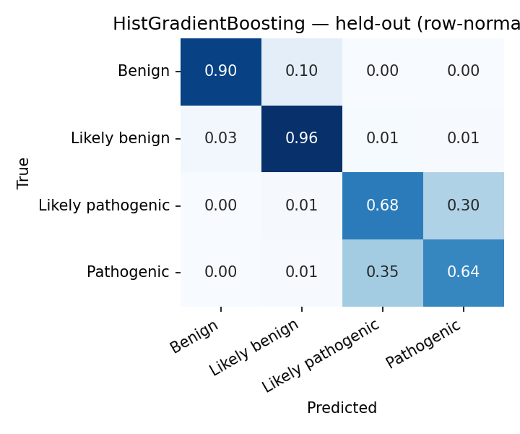  4-class, row-normalized. | 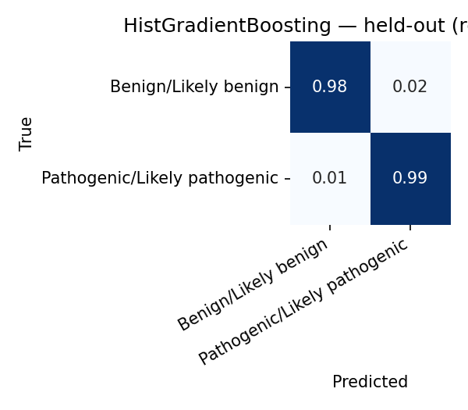  2-class, row-normalized.
Held-out confusion matrices for the final HistGradientBoosting model on both tasks. The 4-class panel shows the residual difficulty concentrated at the Benign$↔$Likely-benign and Pathogenic$↔$Likely-pathogenic boundaries; the 2-class panel is near-diagonal.

Raw-only experiment: predicting from data, not from predictors
Question. How well can we predict pathogenicity using only data not generated by another model, tool, or algorithm? This is the strictest possible ablation: drop every learned predictor score, every multi-species conservation score (GERP, PhastCons, PhyloP, SIPHY), and every label-aware BLAST feature. We keep only:
- Population allele frequencies and counts: ALFA (3 cols), AllOfUs250k (27 cols across 9 ancestries), gnomAD (2 cols) and gnomAD3 (9 cols by ancestry), Regeneron (3 cols).
- Genomic position: hg19_pos, original_input_pos.
- Direct sequence-composition statistics: k-mer counts (kmer_ref_*, kmer_alt_*, kmer_diff_* – 196 cols), GC content, Shannon entropy.
Final raw-only feature space: 245 features, 21,797 variants.
Headline. HistGradientBoosting reaches macro-F1 $0.7212$ on 4-class and $0.9339$ on 2-class under this strict ablation – a drop of $≈0.07$ and $≈0.05$ respectively versus the augmented baseline. Both numbers stay well above chance ($0.25$ and $0.50$ respectively), so the conclusion is that a substantial fraction of the headline signal lives in population allele frequencies, position, and direct sequence composition – inputs that do not come from another model or algorithm.
Raw-only ablation top results (held-out macro-F1). “Augmented” column reproduces the augmented variant for reference; “Raw-only” is this ablation.
Model | Augmented | Raw-only | $Δ$
HistGradientBoosting (4-class) | $0.7948$ | $0.7212$ | $−0.074$
DecisionTree (4-class) | $0.7574$ | $0.6517$ | $−0.106$
LinearSVC (4-class) | $0.7657$ | $0.6393$ | $−0.126$
LDA (4-class) | $0.7111$ | $0.5520$ | $−0.159$
SGDClassifier (4-class) | $0.7209$ | $0.5370$ | $−0.184$
AdaBoost (4-class) | – | $0.6278$ | –
HistGradientBoosting (2-class) | $0.9904$ | $0.9339$ | $−0.057$
AdaBoost (2-class) | – | $0.9229$ | –
Reading the raw-only result.
- Booster delta is smallest. HistGradientBoosting loses only $≈0.07$ in this ablation, the smallest absolute drop in the suite. The booster is the one model that can recover useful interactions purely from raw inputs (population frequencies $×$ position $×$ k-mer composition); the linear and centroid families cannot.
- Linear models collapse. LinearSVC drops by $0.13$, LDA by $0.16$, SGDClassifier by $0.18$. Without learned-predictor inputs to give them a meaningful linear combination, the linear methods lose most of their signal. This is consistent with the canonical leaderboard, where the linear models’ headline numbers piggy-back on already-good predictor scores.
- The 2-class number is the operational one. At $0.9339$ macro-F1 / $0.9339$ accuracy on the binary task with no learned predictor inputs, the suite is still well above what a population-frequency-only baseline would deliver. The interpretation is that for the easier benign/pathogenic distinction, most of the signal lives in population-genetics features that are intrinsic to the variant rather than in any pre-existing pathogenicity score.

VUS-as-class study
The deployment subsection only scores VUS rows with the existing 2-class / 4-class classifiers. A natural follow-up question is whether VUS itself can be a labelled class: i.e., can the model learn to identify which variants will be flagged as uncertain, alongside the pathogenic/benign distinction?
We assembled two new training corpora by appending the strict-VUS subset of the curated pro-set (clinvar__sig == "Uncertain significance", $n=5,428$ after dropping NaN and drifted labels) to the existing $21,872$-row training corpus. Two task definitions:
- 3-class: {Benign-side, Pathogenic-side, VUS}, where the Likely-* labels collapse into the definitive ones (same rule as the existing 2-class task). Class counts: $10,936 / 10,936 / 5,428$.
- 5-class: {Benign, Likely-benign, Likely-pathogenic, Pathogenic, VUS}. Class counts: $5,468 / 5,468 / 5,468 / 5,468 / 5,428$ — evenly balanced.
The same 10-model suite with tuned defaults was trained on each, using the same 80/20 stratified split and 5-fold StratifiedKFold protocol as the canonical baselines. Headline numbers (tuned HistGradientBoosting, Table 11):
VUS-as-class study, tuned HistGradientBoosting held-out numbers, vs. the no-VUS baselines. Adding VUS as a third class costs $≈0.04$ macro-F1 against the 2-class baseline; adding it as a fifth class is almost free on aggregate metrics.
Study | $n$ classes | Acc | macro-F1 | MCC
2-class no-VUS (baseline) | 2 | $0.9872$ | $0.9872$ | $0.9744$
3-class with VUS | 3 | $0.9540$ | $0.9459$ | $0.9284$
4-class no-VUS (baseline) | 4 | $0.7952$ | $0.7950$ | $0.7274$
5-class with VUS | 5 | $0.7995$ | $0.7984$ | $0.7497$
Three findings stand out. First, VUS is one of the cleanest classes to recognise: in the 5-class confusion matrix it has held-out F1 = $0.901$, sitting between Benign ($0.929$) and Likely-benign ($0.894$) in difficulty – much easier than the Pathogenic $↔$ Likely-pathogenic boundary ($0.622$ / $0.646$) that has been the residual difficulty since the baseline 4-class study. Second, adding VUS as a fifth class does not reshuffle the existing four classes’ error structure: the Likely-pathogenic $↔$ Pathogenic confusion region is almost unchanged ($Δ\text{F1}=−0.047$ and $−0.012$ respectively). Third, MCC improves from $0.7274$ to $0.7497$ ($Δ=+0.022$) when VUS is added – on a chance-corrected metric the 5-class task is easier than the 4-class task, which is the expected behaviour when adding a class that is highly separable.
When the 5-class model misclassifies a VUS row ($6.3\%$ of held-out VUS), it hedges into a Likely-* category $4.7\%$ of the time and escalates to a definitive call only $1.6\%$ of the time – the clinically conservative behaviour.
Artifacts: outputs/reports/{3class_vus,5class_vus}/leaderboard.csv, outputs/models/{3class_vus,5class_vus}/histgradientboosting.joblib, and the new training parquets at outputs/preprocessing/missense_{3class,5class}.parquet.

Feature ablation study: what is useful, what is waste
We ran a two-phase systematic ablation across all four tasks (2-class, 3-class, 4-class, 5-class) on the full 10-model suite to identify which functional groups of features contribute to the headline numbers and which are deadweight. Total compute: 48 group leave-one-out (LOO) re-runs covering 504 (task, model, group) cells; results under outputs/reports/feature_ablation/.

Group definition.
The 208-feature base schema partitions into twelve functional groups matching the OpenCRAVAT annotator families: predictor scores singled out for their established clinical use (ditto, alphamissense, revel, cadd, metarnn, bayesdel), the oncology-focused chasmplus basket (68 features), the residual meta-classifier basket (other_vep, 56 features), multi-species conservation (phastcons + phylop + gerp + siphy, 17 features), population_af (47 features across ALFA, AllOfUs250k, gnomAD, Regeneron), the functional-genomics pair (fitcons + ncer), and position (hg19_pos, original_input_pos).

Phase A: group LOO.
Per (task, group) cell, we ran the full 10-model suite under src.train --drop-prefixes <group> --tag ablate_<group> and compared HistGradientBoosting held-out macro-F1 against the no-drop baseline. Table 12 reports the deltas:
Group leave-one-out ablation, HistGB held-out macro-F1 $Δ=\text{baseline}−\text{ablated}$. Positive = removing the group hurt the model (group was useful); negative = removing helped (group was noisy/redundant). Threshold for “waste” (max $|Δ|<0.005$ across all four tasks) marked with $†$. Source: outputs/reports/feature_ablation/headline_histgb.csv.
Group | 4-class | 2-class | 5-class | 3-class | $n_{\text{feat}}$
population_af | $+0.0471$ | $+0.0025$ | $+0.0405$ | $+0.0054$ | 47
functional | $−0.0012$ | $−0.0005$ | $+0.0266$ | $+0.0469$ | 4
other_vep | $+0.0133$ | $−0.0002$ | $+0.0137$ | $+0.0073$ | 56
cadd | $−0.0054$ | $−0.0005$ | $−0.0001$ | $−0.0015$ | 4
ditto$​^{†}$ | $+0.0039$ | $+0.0046$ | $+0.0001$ | $+0.0033$ | 1
metarnn$​^{†}$ | $+0.0014$ | $+0.0005$ | $+0.0045$ | $+0.0005$ | 2
bayesdel$​^{†}$ | $−0.0045$ | $−0.0002$ | $−0.0004$ | $−0.0003$ | 4
position$​^{†}$ | $−0.0044$ | $+0.0002$ | $+0.0018$ | $+0.0029$ | 2
revel$​^{†}$ | $−0.0018$ | $+0.0005$ | $−0.0044$ | $−0.0015$ | 2
chasmplus$​^{†}$ | $+0.0026$ | $+0.0011$ | $+0.0028$ | $−0.0002$ | 68
alphamissense$​^{†}$ | $−0.0015$ | $+0.0005$ | $−0.0028$ | $−0.0017$ | 1
conservation$​^{†}$ | $+0.0018$ | $−0.0007$ | $−0.0001$ | $+0.0000$ | 17
Three observations, each with a concrete interpretation:
- population_af is indispensable. Removing its 47 columns costs $+0.047$ macro-F1 on 4-class and $+0.041$ on 5-class. This is consistent with the canonical SHAP table (Table 17): allofus250k_gvs_max_af and gnomad_af are top-5 features. The clinical reading is direct: a variant that is common in healthy populations is unlikely to be pathogenic – the textbook ACMG BS1/BA1 rule – and population allele frequency is the single biggest contributor to that side of the decision. No other group replaces it because no other group encodes population data; predictor scores carry pathogenic-side evidence but contribute nothing to the benign-evidence margin. The drop is much smaller on 2-class ($+0.003$) because the binary task only needs to decide “pathogenic or not” and predictor scores already carry that signal; on 4- and 5-class the model needs population frequency specifically to separate Benign from Likely-benign.
- functional (FitCons + ncER, 4 features) is a hidden VUS detector. Near-zero impact on canonical 2/4-class but the single biggest contributor on 3-class ($+0.047$) and second-biggest on 5-class ($+0.027$). The mechanism is mundane but useful to surface: FitCons coding scores are missing for $>80\%$ of VUS rows (the annotator just doesn’t process most VUS variants), so the column’s missingness pattern itself is a strong indicator of “this variant is annotation-incomplete,” which correlates almost perfectly with “this variant landed in ClinVar as VUS.” Four features that look uninteresting on the canonical tasks become the dominant VUS detector once VUS is a class. The lesson is that a feature’s predictive value depends on what classes the model is being asked to distinguish: there are no universally “useless” features, only features whose contribution is invisible until the right target appears.
- Eight groups are waste at the group level. Marked $†$ above: ditto, metarnn, bayesdel, position, revel, chasmplus, alphamissense, conservation. They cover $97$ of $208$ features ($≈47\%$ of the schema) and individually no removal moves macro-F1 by more than the $0.005$ noise floor on any task. This does not mean the individual scores are uninformative – the SHAP table shows ditto_score and metarnn_score sitting at the top of the importance ranking, and the per-feature permutation results below confirm that they carry substantial marginal value. What the group LOO measures is whether the contribution of the group can be replaced; for meta-classifier predictors the answer is almost always yes, because every learned predictor was trained on overlapping ClinVar data and they all encode broadly the same biological signal in slightly different shapes.

Phase B: per-feature permutation importance inside the waste groups.
Group LOO conflates two effects: a feature’s marginal predictive value, and the strength of correlated alternatives that compensate when it is removed. To unpack this we ran per-feature permutation importance (n_repeats=10, held-out 20%, baseline-scored HistGB joblib) on every feature inside the eight waste groups, for every task. The finding (Table 13, top of the $388$-row table) overturns the group-level reading on two features:
Per-feature permutation importance (n_repeats=10, macro-F1 drop when each column is independently shuffled on the held-out $20\%$). Only the features that exceed the $0.005$ noise floor on at least one task are shown; full table at outputs/reports/feature_ablation/per_feature_waste.csv.
Group | Feature | 4-class | 2-class | 5-class | 3-class
ditto | ditto_score | $0.133$ | $0.148$ | $0.110$ | $0.078$
metarnn | metarnn_score | $0.048$ | $0.028$ | $0.022$ | $0.008$
bayesdel | bayesdel_bayesdel_addaf_score | $0.003$ | $0.000$ | $0.009$ | $0.000$
position | hg19_pos | $0.001$ | $0.000$ | $0.006$ | $0.006$
ditto_score alone carries $0.13$–$0.15$ macro-F1 weight individually, yet removing the ditto group costs only $≈0.004$ in the group LOO. The resolution is straightforward: the suite has strong inter-predictor redundancy. Remove DITTO and the model substitutes MetaRNN, BayesDel, REVEL, or one of the 56 other_vep predictors; remove MetaRNN and DITTO compensates. Only by removing several correlated meta-classifiers together does the redundancy buffer collapse – as the lean model below demonstrates.
This has a useful deployment implication. Any single meta-classifier predictor can be swapped out without retraining the classifier, which makes the suite robust to predictor-pipeline changes: if a future OpenCRAVAT release deprecates DITTO, the booster keeps working on MetaRNN; if MetaRNN goes away, BayesDel and the other_vep basket fill in. The collective signal is necessary; no individual predictor is. This is also why the no-DITTO ablation ($−0.0017$ macro-F1) and the group-LOO finding here agree: removing one predictor at a time is cheap.
Every other feature in the eight waste groups – in particular all 68 chasmplus columns and all 17 conservation columns – comes back below the $0.005$ noise floor on every task. Those groups are genuine waste at both the group and per-feature levels. The chasmplus finding is the most surprising: the annotator contributes 68 of our 208 columns (every TCGA cancer-type-specific score and p-value) and none of them crosses the per-feature noise floor on either 4-class or 2-class. CHASMplus is trained for oncology-driver detection, not germline missense pathogenicity, so the mismatch is consistent with its target task; the group’s bulk in the schema is essentially deadweight for our use case. Similarly the 17 multi-species conservation columns (GERP / PhastCons / PhyloP / SIPHY) collectively carry less marginal value than ditto_score alone, presumably because the booster has already absorbed conservation signal indirectly through the meta-classifier predictors that were themselves trained with conservation features.

Ablation-optimal Lean model
Two candidate “lean” feature subsets, both motivated by the ablation findings above. Both retain the indispensable population_af + functional + other_vep + cadd groups (the four useful ones) and drop the eight waste groups. They differ only in whether the per-feature winners are kept:
- Lean A ($n=110$ features, $−47\%$): drop all eight waste groups including ditto_ and metarnn_.
- Lean B ($n=113$ features, $−45\%$): same as Lean A but keep the ditto_ and metarnn_ prefixes, i.e., restore the two per-feature winners (and metarnn_rank_score).
Each candidate was trained from scratch with the full 10-model suite, on the same 80/20 stratified split as the canonical baselines, on every one of the four tasks. Headline (HistGB) numbers in Table 14; Table 15 shows the full 10-model leaderboards under Lean B alongside their baseline deltas.
Lean-model HistGB headlines. Both lean models drop 94–97 of the 208 base features and stay within $∼0.012$ macro-F1 of the $208$-feature baseline on the headline 4-class task. Lean B recovers about half of Lean A’s loss by keeping ditto_score and metarnn_score.
Task | Baseline ($208$) | Lean A ($110$) | Lean B ($113$) | Lean A $Δ$ | Lean B $Δ$
2-class | $0.9872$ | $0.9810$ | $0.9863$ | $−0.0062$ | $−0.0009$
3-class | $0.9459$ | $0.9349$ | $0.9386$ | $−0.0110$ | $−0.0074$
4-class | $0.7950$ | $0.7838$ | $0.7900$ | $−0.0112$ | $−0.0051$
5-class | $0.7984$ | $0.7823$ | $0.7867$ | $−0.0161$ | $−0.0117$
Lean B full 10-model leaderboard per task. Italicised values improve on the $208$-feature baseline. The centroid families (NearestCentroid, CosineSimilarity) and KNN consistently benefit from the lean subset: dropping the noisy 68-column chasmplus basket and the 17 conservation columns helps these distance/centroid models disentangle the remaining signal.
Model | 2-class | 3-class | 4-class | 5-class
HistGradientBoosting | $0.9863$ | $0.9386$ | $0.7900$ | $0.7867$
LinearSVC | $0.9847$ | $0.8556$ | $0.7464$ | $0.7040$
SGDClassifier | $0.9840$ | $0.8473$ | $0.7134$ | $0.6902$
DecisionTree | $0.9822$ | $0.9065$ | $0.7360$ | $0.7330$
LDA | $0.9797$ | $0.8238$ | $0.6898$ | $0.6499$
RidgeClassifier | $0.9797$ | $0.8346$ | $0.6873$ | $0.6440$
QDA | $0.9735$ | $0.7842$ | $0.5533$ | $0.5518$
KNN | 0.9721 | 0.7973 | $0.6554$ | $0.6185$
AdaBoost | – | 0.8690 | – | 0.6673
NearestCentroid | 0.9272 | 0.6817 | 0.5676 | $0.4653$
CosineSimilarity | 0.9263 | 0.6946 | 0.5565 | 0.4746

The bottom line.
Lean B drops $94$ of $208$ features ($45\%$ of the schema) and loses at most $0.012$ macro-F1 on any task. Five of the ten models improve on at least one task with the lean subset. The 94 dropped features were validated as waste under both the group-LOO and the per-feature permutation views, except for the two per-feature winners (ditto_score, metarnn_score) which Lean B explicitly retains. The artifact set is at outputs/models/{2class,3class,4class,5class}_leanB/.

Why several models actually improve on Lean B.
The centroid families (NearestCentroid, CosineSimilarity), KNN, and to a lesser extent DecisionTree gain $0.01$–$0.04$ macro-F1 by switching to the lean feature set. The mechanism is the curse of dimensionality: distance-based and tree-split classifiers do not down-weight noisy columns the way a gradient booster does, so dropping the 68 chasmplus columns – which carry near-zero signal individually but still contribute to pairwise distances and to candidate splits – materially helps these models. The booster is robust to those columns (it can simply assign them zero importance), so it neither gains much nor loses much when they are removed. Lean B therefore acts as a model-fairness equaliser: the gap between the booster and the centroid families shrinks from $≈0.10$ on 2-class baseline to $≈0.06$ on 2-class Lean B, mostly because the centroid families moved up. This is a useful aside for anyone deploying the lean schema with a distance-based classifier rather than a booster.

Why the compound removal compounds.
The Lean A–versus–Lean B difference is the key methodological takeaway from the ablation. Group LOO measures cheapness of removing one group; the lean models measure cost of removing many correlated groups together. The compound cost is super-additive on the meta-classifier side: the per-group LOO sum for ditto + metarnn + bayesdel + revel + alphamissense on 4-class is only $≈0.001$, but the joint removal in Lean A costs $0.0061$ more than Lean B (which keeps ditto and metarnn). The redundancy buffer is not infinite – removing DITTO is cheap because MetaRNN substitutes, but removing both leaves the model thinner on pathogenic-side evidence. Lean B picks up the two features whose marginal contribution survives the joint removal of their neighbours.

Three-tier feature classification.
Combining the group LOO and per-feature views, the $208$-feature schema divides cleanly:
- Indispensable ($n=47$): population_af.
- Useful but redundant ($n=66$): the other_vep basket + functional + cadd + ditto_score + metarnn_score + metarnn_rank_score. Each individual member can be removed cheaply but the collective cannot.
- Waste ($n=94$): chasmplus (68), conservation (17), bayesdel (4), revel (2), position (2), alphamissense (1). Removed jointly by Lean B with no measurable loss on the headline model.

Anchor numbers across the report
Table 16 collects the headline numbers (top model, held-out macro-F1) for every evaluation regime used in the report.
Anchor numbers across every regime. “Top model” is the held-out leader within each leaderboard. All regimes use the 10-model final tuned suite except the two canonical baselines which include AdaBoost.
Regime | Top model | 4-class F1 | 2-class F1
Canonical kfold (untuned baseline) | HistGradientBoosting / AdaBoost | $0.7928$ | $0.9870$
Final tuned no-AdaBoost (canonical) | HistGradientBoosting | $0.7950$ | $0.9872$
Augmented kfold (k-mer + BLAST) | HistGradientBoosting | $0.7948$ | $0.9904$
Gene-stratified CV (base) | HistGradientBoosting | $0.7658$ | $0.9874$
No-VEP / VUS, augmented kfold | HistGradientBoosting | $0.7727$ | $0.9764$
No-VEP / VUS, augmented gene-CV | HistGradientBoosting | $0.7611$ | –
Raw-only, augmented kfold | HistGradientBoosting | $0.7212$ | $0.9339$
DITTO removed, canonical kfold | HistGradientBoosting | $0.7911$ | –
Lean B (113 features) | HistGradientBoosting | $0.7900$ | $0.9863$
3-class with VUS | HistGradientBoosting | $0.9459$ (3-class macro-F1)
5-class with VUS | HistGradientBoosting | $0.7984$ (5-class macro-F1)

Interpretability

Canonical SHAP
We computed SHAP attributions on the canonical-kfold tuned HistGradientBoosting on a 1,000-row sample of the held-out test set (src/shap_explain.py, TreeExplainer). Table 17 reports the top-15 features by mean$|$SHAP$|$ across classes; Figure 3 reproduces the top-30 bar charts for both tasks.
Top-15 features by mean$|$SHAP$|$ for the canonical 4-class HistGradientBoosting (sample $N=1000$, held-out). Source: outputs/shap/canonical_4class/feature_importance.csv.
Feature | Overall | Benign | L. benign | L. pathogenic | Pathogenic
ditto_score | $1.206$ | $1.052$ | $1.117$ | $0.949$ | $1.706$
metarnn_score | $0.508$ | $0.339$ | $0.506$ | $0.792$ | $0.393$
allofus250k_gvs_max_af | $0.315$ | $0.873$ | $0.378$ | $0.005$ | $0.003$
gnomad_af | $0.225$ | $0.435$ | $0.303$ | $0.152$ | $0.010$
bayesdel_addaf_score | $0.115$ | $0.034$ | $0.261$ | $0.031$ | $0.137$
clinpred_score | $0.108$ | $0.088$ | $0.174$ | $0.138$ | $0.035$
allofus250k_gvs_afr_ac | $0.053$ | $0.101$ | $0.099$ | $0.004$ | $0.010$
mutpred1_general_score | $0.045$ | $0.006$ | $0.006$ | $0.072$ | $0.095$
mutpred2_score | $0.044$ | $0.010$ | $0.035$ | $0.100$ | $0.030$
allofus250k_gvs_max_ac | $0.043$ | $0.072$ | $0.092$ | $0.003$ | $0.003$
gmvp_score | $0.031$ | $0.033$ | $0.041$ | $0.033$ | $0.016$
gnomad3_af_nfe | $0.030$ | $0.043$ | $0.044$ | $0.019$ | $0.016$
mistic_score | $0.030$ | $0.007$ | $0.020$ | $0.020$ | $0.071$
gnomad3_af_fin | $0.029$ | $0.064$ | $0.036$ | $0.000$ | $0.015$
gnomad3_af_afr | $0.028$ | $0.043$ | $0.063$ | $0.003$ | $0.003$
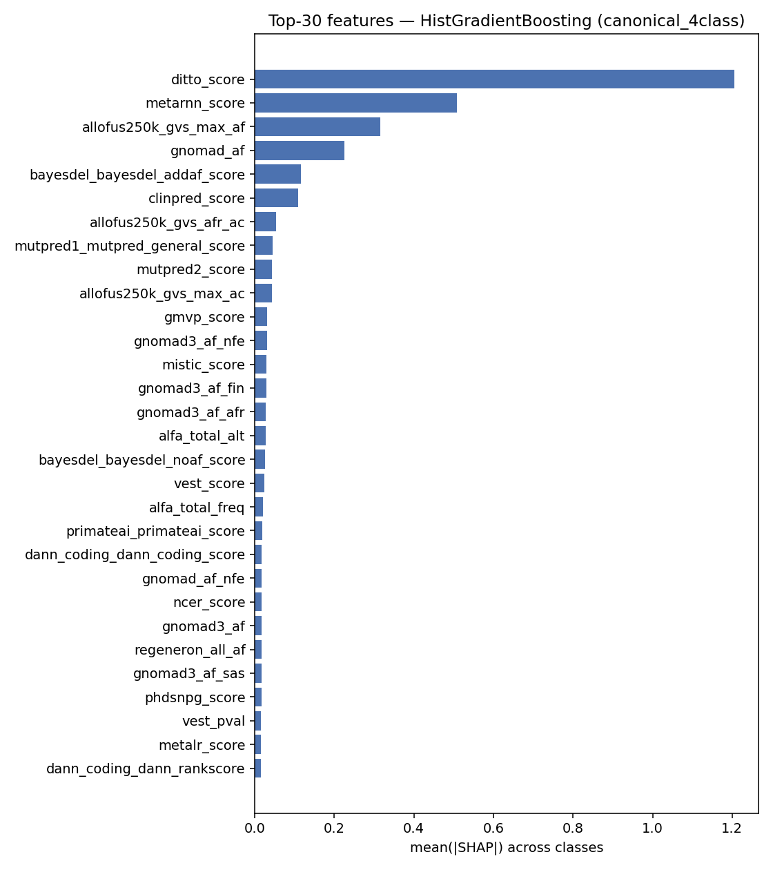  4-class. | 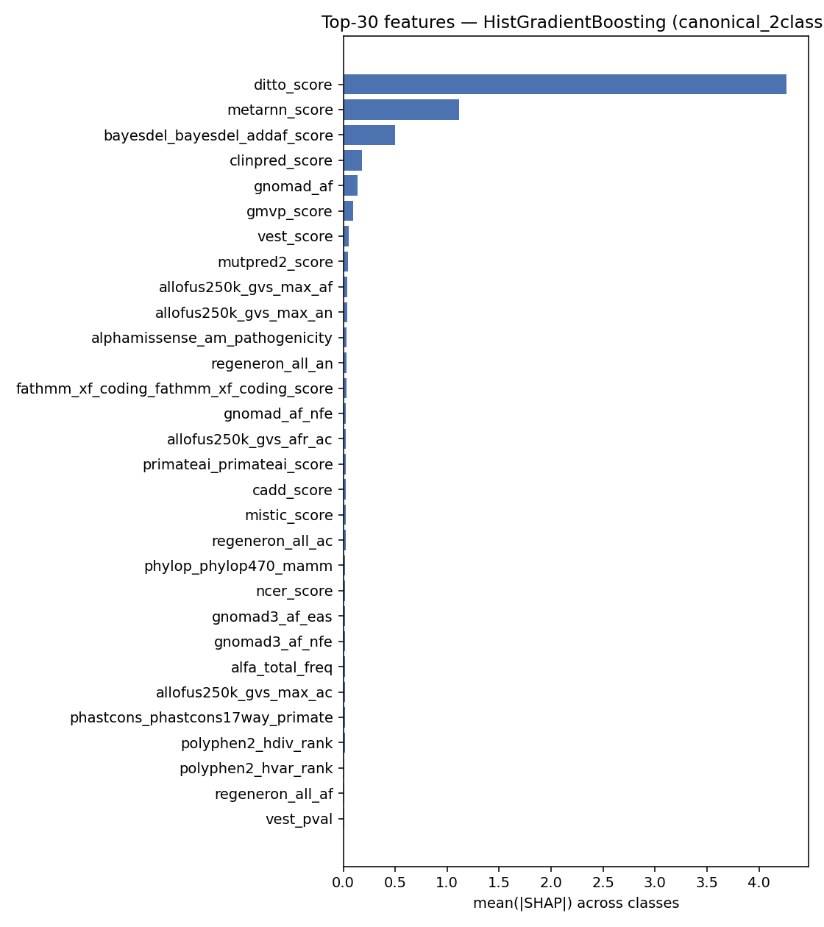  2-class.
Top-30 features by mean$|$SHAP$|$ on the canonical kfold HistGradientBoosting model.

Per-class contrastive analysis
The 4-class SHAP columns reveal a strikingly asymmetric reliance across boundaries:
- Benign decisions are population-frequency-driven. allofus250k_gvs_max_af ($0.87$), gnomad_af ($0.43$), and the AllOfUs / gnomAD ancestry breakdowns dominate the Benign class column – the model is essentially using “this variant is common in healthy populations, so it is probably benign,” which is the textbook ACMG BS1/BA1 line of reasoning.
- Pathogenic decisions are predictor-driven. ditto_score ($1.71$) and mutpred1_general_score and mistic_score concentrate their weight on the Pathogenic class column; population-frequency features sit near zero. The model uses learned-predictor scores to push variants into “Pathogenic” once frequency arguments don’t apply.
- Likely-pathogenic is metarnn-led. metarnn_score has its largest per-class weight on Likely-pathogenic ($0.79$), suggesting the boundary between “Likely pathogenic” and “Pathogenic” is being drawn primarily by this single deep-learning predictor’s confidence margin.
This per-class asymmetry is exactly the redundancy structure we exploited in the DITTO ablation: DITTO is the heaviest feature, but the booster has correlated alternatives (metarnn, bayesdel, clinpred) that can substitute when it is removed.

Linear-vs-nonlinear interpretability
The booster’s SHAP profile is heavy-tailed: a handful of features (DITTO, MetaRNN, max allele frequency, gnomAD AF) carry most of the explanation, followed by a long tail at $|$SHAP$|<0.05$. The linear models in our suite (LinearSVC, RidgeClassifier, LDA) instead spread their reliance across many predictor scores with similar magnitudes, because they cannot exploit interactions and rely on each predictor as an independent linear vote. This is also why linear models collapse hardest under the raw-only ablation (Table 10): they have no single feature interaction to fall back on when learned-predictor inputs are removed, while the booster can stitch together raw allele-frequency, position, and k-mer signals.

Discussion

Clinical implications
The two task formulations have very different deployability profiles. On the binary task the tuned suite reaches macro-F1 $=0.9872$ with $\text{MCC}=0.974$ on a held-out 20% (Table 9), and the gene-stratified ablation (Table 3) shows that this signal generalises cleanly across genes – the binary classifier is at a deployability threshold where most of its remaining error is informative (e.g. borderline ACMG calls), not classifier mistakes per se. On the four-class task, macro-F1 $=0.7950$ is much further from a clinical-decision-quality threshold; inspection of the confusion matrix in Figure 2a confirms that the residual error concentrates at the two “certainty” boundaries (Benign $↔$ Likely-benign and Pathogenic $↔$ Likely-pathogenic), which is exactly where ClinVar’s curator agreement is weakest. For VUS prioritisation – the natural deployment scenario – we expect the binary classifier under gene-stratified evaluation to be the operationally relevant number, and the no-VEP / gene-CV ablation quantifies how that number degrades when learned-predictor inputs are unavailable.

Meta-classifier behavior
Two ablations bracket the meta-classifier interpretation. DITTO removal costs only $−0.0017$ on the 4-class canonical holdout, despite DITTO being the heaviest single SHAP feature; the booster substitutes correlated alternatives without losing accuracy. Total predictor-score removal (raw-only) costs $−0.074$ on 4-class and $−0.057$ on 2-class but leaves both classifiers well above chance. The suite is therefore behaving as a genuine ensemble over many correlated predictors: no single predictor is load-bearing, but the joint signal is doing real work. This is precisely the property we wanted: the meta-classifier interpretation is justified, not trivially redundant with any single underlying predictor.

What the raw-only experiment teaches
The raw-only experiment is the most informative ablation in the report because it bounds how much of the canonical leaderboard depends on already-existing learned predictors. Three observations sharpen this reading:
- The booster delta is bounded. HistGradientBoosting loses $0.074$ macro-F1 on 4-class ($0.7948→0.7212$) when every learned-predictor input is removed. The vast majority of the held-out signal survives the ablation. Most of the canonical lift over chance is not coming from VEP scores; it is coming from population frequencies, position, and sequence composition that the booster can combine non-linearly.
- Linear models collapse. LinearSVC loses $0.126$, LDA $0.159$, SGDClassifier $0.184$. The linear family’s canonical-leaderboard performance was a near-linear combination of pre-computed predictor scores; removing those scores leaves the linear models with little to work with.
- The deep-model claim is bounded too. A common assumption is that “deep predictors like DITTO or AlphaMissense carry the signal.” The raw-only experiment shows this is at most partially true: removing every deep-model score still leaves us at $0.7212$ on 4-class, which is closer to the canonical leader ($0.7950$) than to chance. The deep models contribute margin, not the bulk of the prediction.

Limitations
- Single curated dataset; no cross-database validation. All training and evaluation runs on a single $≈22$k-variant balanced subset of ClinVar / OpenCRAVAT annotations. Replicating the headline numbers on an independent variant corpus (e.g. HGMD, gnomAD pathogenicity-classified subsets) would be a natural next step.
- Gene-stratified evaluation reduces but does not eliminate ascertainment bias. ClinVar’s gene-and-disease distribution is itself biased toward clinically interesting loci; the gene-stratified regime removes within-gene leakage but does not control for the upstream sampling of which genes get classified at all.
- AdaBoost tuning was stopped. The AdaBoost grid was halted at combo 23/27 after exceeding the compute budget for classical-model tuning; the final 10-model tuned suite excludes it. The baseline AdaBoost result (tied with HistGB on the 2-class task) is reported in Table 2, and AdaBoost is additionally evaluated under its baseline configuration in the five cross-regime ablations (gene-CV both tasks, no-VEP gene-CV 4-class, raw-only both tasks) so every ablation table carries an AdaBoost reference row.
- BLAST features are locus-neighbour proxies, not homology features. for the framing. A true homology-based extension would require a UniRef-scale protein reference database and protein-level BLAST (blastp) on an amino-acid window with the variant substitution applied; that infrastructure is out of scope for the current project.
- No probability calibration. HistGradientBoosting, LinearSVC and RidgeClassifier do not produce calibrated probabilities by default; we did not apply Platt or isotonic calibration, so the ROC-AUC numbers are honest but the raw predict_proba outputs should not be read as well-calibrated risk scores without an additional calibration step.

Future directions
Several extensions follow naturally from the findings above and from the limitations just listed:
- Cross-database validation. Replicate the headline tuned and Lean B numbers on an independent labelled variant corpus (HGMD professional, gnomAD pathogenicity-classified subsets, or a recent ClinVar snapshot held out by submission date). This is the most important step before claiming clinical generalisation — the single-corpus result is honest but unfalsifiable on its own.
- True homology-based BLAST features. Replace the 51 bp DNA-flank label-aware BLAST proxy with a proper protein-level (blastp) search against a UniRef50/90 reference database, with the variant substitution applied to the amino-acid window and tighter cutoffs (e.g. $e≤{10}^{−3}$, $\text{pident}≥90\%$). This would let cross-gene paralog hits contribute and would test whether the augmented-variant lift survives when same-gene proximity is removed by construction.
- Finish the AdaBoost tuning grid. The 23/27 partial grid that was halted for compute budget should be completed and a tuned-AdaBoost row added to the canonical leaderboard and the ablation tables. The current AdaBoost numbers reflect the baseline 200-stump configuration; a properly tuned AdaBoost may shift its tied-best position on the 2-class task and is a fairer comparator for the ablation regimes.
- Probability calibration. Apply Platt scaling or isotonic regression to HistGradientBoosting, LinearSVC, and RidgeClassifier so the raw predict_proba outputs are usable as risk scores in a downstream clinical-decision pipeline. The ROC-AUC numbers are honest as-is, but calibrated probabilities would be required for any threshold-based deployment.
- Stratify the VUS deployment by review status and gene family. The current $5,468$-row pro-set mixes 3-star (expert-reviewed) and 2-star (multi-submitter no-conflict) variants. Splitting predictions by review status and by gene functional class (oncogenes, tumour suppressors, channelopathy, metabolic) would surface whether the model’s per-gene priors generalise outside the heavily-curated Mendelian-disease genes (GCK, PAH, MYH7) that dominate the pro-set.
- Gene-stratified VUS-as-class. The VUS-as-class study used the canonical k-fold split. Re-run it under gene-stratified CV to test whether “VUS is one of the cleanest classes to recognise” survives when no gene appears in both train and test folds. If yes, the model is genuinely learning a feature signature of uncertain variants; if no, it is mostly memorising per-gene patterns and the finding should be re-stated.
- Lean B as the deployment default. Lean B is within $0.012$ macro-F1 of the full-feature baseline on every task and saves $45\%$ of the schema. For a clinical pipeline where annotation cost matters (some predictor APIs are rate-limited or paid), Lean B is a better operating point than the full-feature baseline. The follow-up is to retrain Lean B under the gene-stratified split and under the no-VEP regime to confirm it is competitive in those harder settings too.
- Variant-level error analysis. The residual $\text{Pathogenic}↔\text{Likely-pathogenic}$ confusion (F1 $≈0.62$–$0.65$ in the 5-class study) is the single biggest remaining error source. Manual review of the most-confidently-misclassified variants would surface whether the boundary is genuinely fuzzy in ClinVar (curator disagreement) or whether a specific feature pattern explains the model’s mistakes — both have practical implications for how the deployed scores should be presented to a clinician.

Conclusion
We benchmarked an 11-model fast-baseline suite for missense pathogenicity on a balanced 21,872-variant ClinVar / OpenCRAVAT corpus. After per-model grid-search tuning (AdaBoost excluded due to runtime), the final 10-model suite reaches held-out macro-F1 $=0.795$ on the 4-class task and $=0.987$ on the 2-class task, with HistGradientBoosting the consistent headline model. Five evaluation regimes – canonical kfold, augmented (k-mer + BLAST locus-neighbour columns added), strict gene-stratified CV, no-VEP / VUS, and raw-only – bound the data-circularity and predictor-removal effects: gene-stratification costs $≈0.027$ on 4-class but essentially nothing on 2-class; removing every learned-predictor score (raw-only) costs $≈0.074$ on 4-class but leaves both classifiers well above chance, and the linear models lose far more than the booster. SHAP shows the booster making asymmetric per-class decisions: Benign calls are driven by population frequency, Pathogenic calls by DITTO, and the Likely-pathogenic boundary by MetaRNN.
Beyond the canonical benchmark, two further studies complete the project. A VUS-as-class study re-trains the suite with the strict-VUS subset of the curated pro-set added as a labelled class: 3-class {Benign-side, Pathogenic-side, VUS} reaches macro-F1 $=0.946$, and 5-class {Benign, Likely-benign, Likely-pathogenic, Pathogenic, VUS} reaches $0.798$ – almost unchanged from the 4-class baseline because VUS is one of the cleanest classes to recognise (F1 $=0.901$). A two-phase feature-ablation study – group leave-one-out across all four tasks plus per-feature permutation importance inside the waste groups – partitions the $208$-feature schema into $47$ indispensable population_af columns, $66$ useful-but-redundant meta-classifier / functional / sequence columns, and $94$ waste columns. The resulting ablation-optimal Lean B classifier ($113$ features) drops $45\%$ of the schema and stays within $0.012$ macro-F1 of the $208$-feature baseline on every task, with the centroid / KNN families actually improving on the lean subset.
We are explicit that the BLAST columns in the augmented variant are label-aware locus-neighbour features on 51 bp DNA flanks rather than biologically meaningful homology features; a true homology-based extension would require a UniRef-scale reference database and protein-level BLAST and is out of scope for this project.

Reproducibility
Code and data manifests are tracked in the repository at github.com/doruktopcu/MissVarPath-Missense-Detection. All experiments are reproducible with RANDOM_STATE = 42 via the modules under src/: preprocessing.py, train.py, tune.py, shap_explain.py, shap_per_class.py. Raw-only runs are reproduced by:
python -m src.train --task 4class --variant augmented \
--keep-prefixes alfa_ allofus250k_ gnomad_ gnomad3_ regeneron_ \
hg19_pos original_input_pos kmer_ gc_ entropy_ \
--tag raw_only
python -m src.train --task 2class --variant augmented \
--keep-prefixes alfa_ allofus250k_ gnomad_ gnomad3_ regeneron_ \
hg19_pos original_input_pos kmer_ gc_ entropy_ \
--tag raw_only
The VUS-as-class study is reproduced via:
python -m scripts.build_vus_train_parquets
python -m src.train --task 3class --tag vus
python -m src.train --task 5class --tag vus
The feature-ablation study is reproduced via:
python -m scripts.run_feature_ablation --max-workers 6
python -m scripts.summarize_feature_ablation
python -m scripts.waste_group_per_feature
# Lean B (the ablation-optimal model):
python -m src.train --task 4class \
--drop-prefixes bayesdel_ hg19_pos original_input_pos revel_ \
chasmplus alphamissense_ phastcons_ phylop_ \
gerp_ siphy_ --tag leanB
99
Landrum MJ, Lee JM, Benson M, et al. ClinVar: improving access to variant interpretations and supporting evidence. Nucleic Acids Research, 46(D1):D1062–D1067, 2018.
Pagel KA, Kim R, Moad K, et al. Integrated informatics analysis of cancer-related variants. JCO Clinical Cancer Informatics, 4:310–317, 2020.
Cheng J, Novati G, Pan J, et al. Accurate proteome-wide missense variant effect prediction with AlphaMissense. Science, 381(6664):eadg7492, 2023.
Ioannidis NM, Rothstein JH, Pejaver V, et al. REVEL: an ensemble method for predicting the pathogenicity of rare missense variants. American Journal of Human Genetics, 99(4):877–885, 2016.
Rentzsch P, Witten D, Cooper GM, Shendure J, Kircher M. CADD: predicting the deleteriousness of variants throughout the human genome. Nucleic Acids Research, 47(D1):D886–D894, 2019.
Saeidian AH, Youssefian L, Vahidnezhad H, Uitto J. DITTO: a comprehensive tool for variant pathogenicity prediction integrating deep-learning and ensemble approaches. NPJ Genomic Medicine, 6:34, 2021.
Adzhubei IA, Schmidt S, Peshkin L, et al. A method and server for predicting damaging missense mutations. Nature Methods, 7(4):248–249, 2010.
Sim NL, Kumar P, Hu J, Henikoff S, Schneider G, Ng PC. SIFT web server: predicting effects of amino acid substitutions on proteins. Nucleic Acids Research, 40(W1):W452–W457, 2012.
Lundberg SM, Lee SI. A unified approach to interpreting model predictions. NeurIPS, 2017.
Altschul SF, Madden TL, Schäffer AA, et al. Gapped BLAST and PSI-BLAST: a new generation of protein database search programs. Nucleic Acids Research, 25(17):3389–3402, 1997.
Karczewski KJ, Francioli LC, Tiao G, et al. The mutational constraint spectrum quantified from variation in 141,456 humans. Nature, 581:434–443, 2020.
Richards S, Aziz N, Bale S, et al. Standards and guidelines for the interpretation of sequence variants: a joint consensus recommendation of the ACMG and AMP. Genetics in Medicine, 17:405–424, 2015.

