

<Your Name>
<Your Student ID>
BABY CRY ANALYSER USING deepSVM
BSc (Hons) Computer Science and Software Engineering Final Report

Department of Computer Science and Technology The University of Bedfordshire

Supervisor: <Your Supervisor Name>
AY 24/25
ASSIGNMENT TOP SHEET
Faculty of Creative Arts, Technologies & Science
Department of Computer Science & Technology

Student Ref. No 2133095 | Unit Code: CIS017-3

Unit Name:  Undergraduate Project |  | Deadline for Submission(s)  Friday 26th April 2024

Student's Surname: Kafle |  | Student's Forename: Kushal

Unit Leader's Name:  Enjie Liu | Supervisor:  Krishna Aryal
Assignment Details: Assessment 2: Final Report

Instructions to Student:
Please note: Work presented in an assessment must be the student's own. Plagiarism is where a student copies work from another source, published or unpublished (including the work of a fellow student) and fails to acknowledge the influence of another's work or to attribute quotes to the author. Plagiarism is an academic offence.
Work presented in an assessment must be your own. Plagiarism is where a student copies work from another source, published or unpublished (including the work of another student) and fails to acknowledge the influence of another’s work or to attribute quotes to the author. Plagiarism is an academic offence and the penalty can be serious. The University’s policies relating to Plagiarism can be found in the regulations at http://www.beds.ac.uk/aboutus/quality/regulations. To detect possible plagiarism we may submit your work to the national plagiarism detection facility. This searches the Internet and an extensive database of reference material including other students’ work to identify. Once your work has been submitted to the detection service it will be stored electronically in a database and compared against work submitted from this and other universities. It will therefore be necessary to take electronic copies of your materials for transmission, storage and comparison purposes and for the operational back-up process. This material will be stored in this manner indefinitely.
I have read the above information and I confirm that this work is my own and that it may be processed and stored in the manner described.
Signature (Print Name): <Your Name> Date: 25th April 2024
Extension deadline
CAAS agrees that the assignment may be submitted days after the deadline and should be marked without penalty.
CAAS confirmation...................................................................................................................

Please leave sufficient time to meet this deadline and do not leave the handing-in of assignments to the last minute. You need to allow time for any system problems or other issues.

Abstract
Write Your Abstract part here!!!
Keywords: Baby Cry Analyser, Conventional Neural Network (CNN), Recurring Neural Network (RNN), Mel Frequency Cepstral Coefficient (MFCC), Support Vector Machine (SVM),

Acknowledgement

Write Your Acknowledgement part here!!!
With sincere thanks, Sutdent Name: <> Student ID: <>

Table of Contents
Abstract i
Acknowledgement ii
Table for Figures viii
Table of Tables x
- Introduction 1
  - Background 1
  - Problem Statement 1
  - Proposed Solution 1
  - Aim 1
  - Objectives 2
  - Target User 2
    - Primary Users 2
    - Secondary Users 2
    - Tertiary Users 2
  - Intellectual Challenges 2
- Project Plan 4
  - GANTT Chart 4
  - Work Breakdown Structure 5
- Literature Review 6
  - Baby Cry 6
  - Not all cries are same 6
  - Baby Cry Analyser 6
  - Significance of Baby Cry Analyser 6
  - Techniques to Classify Baby cry 7
  - Related Work 11
  - Proposed Method 17
- Market Research 21
  - Secondary Market Research 21
  - Primary Market Research 23
    - Survey Questions 23
    - Data Analysis 24
- Artefact Planning 35
  - System Requirement 35
  - System Architecture Design 37
  - UML Design 37
  - Activity Diagram 38
  - Database Schema 39
- Testing Plan 41
  - Unit Testing 41
  - Integration Testing 42
- Evaluation Plan 43
- Development 45
  - Methodology 45
- Testing 53
- Evaluation 56
  - User Evaluation 56
  - Performance Analysis 57
- Critical Analysis 59
- Limitations and Future Scope 61
- Conclusion 61
- References 62
- Appendix 65
  - Appendix 1 65
  - Appendix 2 77
  - Appendix 3 84
  - Appendix 4 84
  - Appendix 5 84

Table for Figures
Figure 1 GANTT Chart of Research Methodology and Emerging Technologies 4
Figure 2 GANTT Chart of Undergraduate Project 4
Figure 3 Work breakdown 5
Figure 4 Steps of Feature Extraction (Ji & Mudiyanselage, 2021) 7
Figure 5 Different Audio Features (Ji & Mudiyanselage, 2021) 8

Similarly, add your Table of Figures here.

Table of Tables
Table 1 Functional Requirements 35
Table 2 Non-Functional Requirements 36
Table 3 Unit Testing 42
Table 4 Integration Testing 42

Similarly, add your Table of Tables here.

From Topic 1-7 (Introduction Section to Evaluation Plan Section), that was done in contextual report part in RMET so you can copy paste that part here. Only thing that you need to add in this report is from the Development section where you actually started to develop your project.

Also actual page numbers or numerical page numbers beginning from 1 should be started from this page i.e. “Introduction page”.
Pages before “Introduction” can be marked as page no. a, b, c, … or i, ii, iii, iv, ….

[Note: This Thesis Format needs to be followed strictly. Failing to match this thesis format will result in Cancellation of your University Viva as we won’t allow you to take part in it, and ultimately you need to repeat your semester.]

Contents That Needed to be added in “UG – thesis” are as follows:

8. Development
The development of Smart Irrigation System included the IoT and AI to automate an irrigation solution based on data driven approach. This part outlines the methodology that was used, tools and technologies that were employed, and the process of implementation in details.
This system was designed with the ability of soil moisture monitoring, temperature and humidity monitoring, and data on crop type and crop age to ensure better irrigation plans. The overall development process, included hardware integration, software development, AI model training, and real-time monitoring features. The following sections contain a detailed discussion on the technology stack and the methodology chosen.

8.1 Methodology
The project employed the Agile methodology in software development, thus securing the possibility to use a flexible method and a series of changes for the entire process. An Agile strategy was utilized that made it possible to incorporate changes from feedback as the project was underway, as well as to build step by step and respond to challenges encountered during implementation.
Effectiveness of Agile Methodology
- Flexibility: Enabled iterative improvements based on testing and supervisor feedback.
- Continuous Integration: Allowed seamless hardware and software integration.
- Incremental Development: Ensured timely feature additions and improvements.
- Collaboration: Helped in regular supervisor meeting for problem solving then implementing the required changes.
8.2 Tools and Technologies Used
A combination of hardware and software technologies was used to ensure efficiency and reliability. The most important elements are:
Hardware:
ESP32 Microcontroller: Acts as the central processing unit for sensor data receiving and sending.
Sensors:
Soil Moisture Sensor: Measures soil water content to determine irrigation needs.
Temperature and Humidity Sensor (DHT11): Provides the environmental conditions i.e. temperature and humidity readings.
Water Pump and Motor driver (L293D): Controls irrigation based on AI-based decisions.
Software and Development Tools:
VSCode PlatformIO: To program the ESP32 microcontroller.
Python & Random Forest: For creating AI models and processing data.
NodeJS and Express: Back-end framework for real-time monitoring and API development.
Python Http Server: Another backend for deploying AI model.
Random Forest: Machine learning libraries for training the irrigation prediction model.

8.3 Implementation Process
The system was developed in several key phases which are listed below:
Hardware Setup and Sensor Calibration:
→ Individual Sensor readings were tested and calibrated for effective data collection.
→ Microcontroller programming was done using VSCode PlatformIO.
First of all, individual components and sensors like temperature and humidity, soil moisture sensor and water pump with L293D motor drivers were connected to the microcontroller and tested if they work. Then the actual system programming was started.

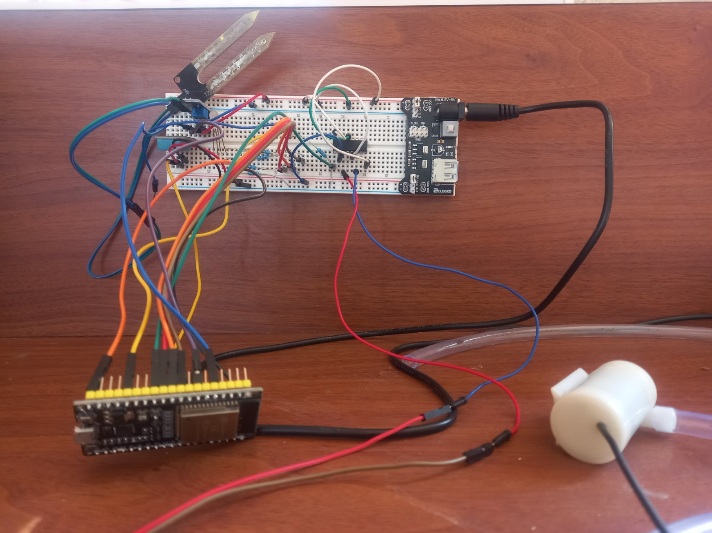Figure 1: Final device after hardware components integration

The above figure shows how the final IoT device or the irrigation system looks like once every sensors and microcontroller are assembled together.
Data Collection and Preprocessing:
There were numerous datasets available and in huge quantity but none of them contained the actual dataset required for my AI model. Mostly the datasets only contained, the columns like (temperature, humidity, soil moisture, irrigation status). However my system required two more columns i.e. (plant type and plant age).
This made the search for dataset really tough. Finally one dataset was found in kaggle but it only contained limited crop types and also the quantity wasn’t huge. However the dataset was sufficiently enough for my purpose, as the system mainly focused on small scale farm and resource constrained environment, only supporting limited crops wasn’t really a problem.
Since the dataset was available in kaggle, it did not require significant preprocessing, however minor label encoding was applied.

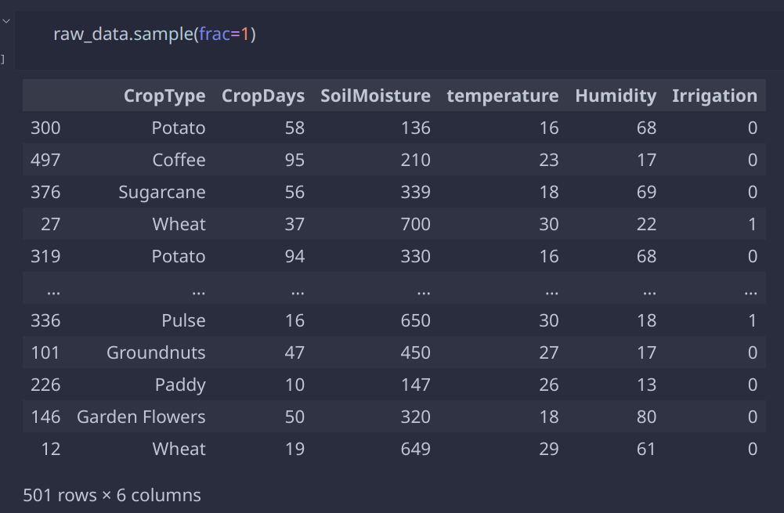Figure 2: Raw dataset

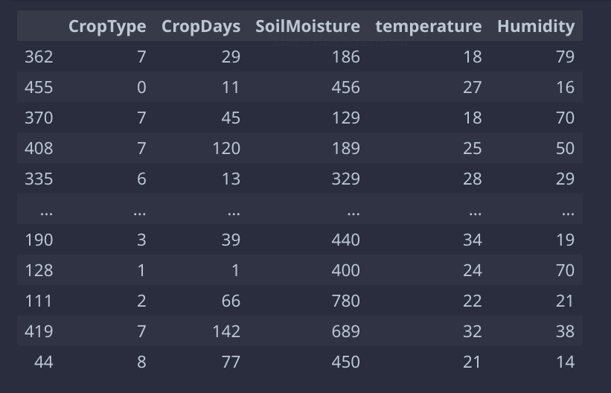Figure 3: Dataset after label encoding

AI Model Training and Optimization:
Once the data was collected from kaggle, various machine learning algorithms were experimented and trained on the same data. Finally the best model was selected. Various criteria like model accuracy, efficiency, prediction time and model size (or total numbers of parameters) were considered while selecting the final model to use in production.
S.N | Model | Hyperparameters | Accuracy %
1 | MLP Classifier | Hidden layer size: (10, )  learning rate: adaptive  max iter: 100  random state: 42  n_iter_no_change: 10 | 88.11
2 | Sequential Keras, tensorflow | Layers: Dense(5, activation: relu), Dense(5, activation: tanh), Dense(5, activation: sigmoid)  loss: binary_crossentropy  optimizer: Adam | 91.09
3 | Logistic Regression | Max iter: 100  solver: lbfgs  class weight: balanced | 91
4 | Random Forest | n_estimators: 15  max depth: 8  random state: 0 | 98.02

<< Refer to appendix for other models confusion matrix: add reference, appendix ko link >>
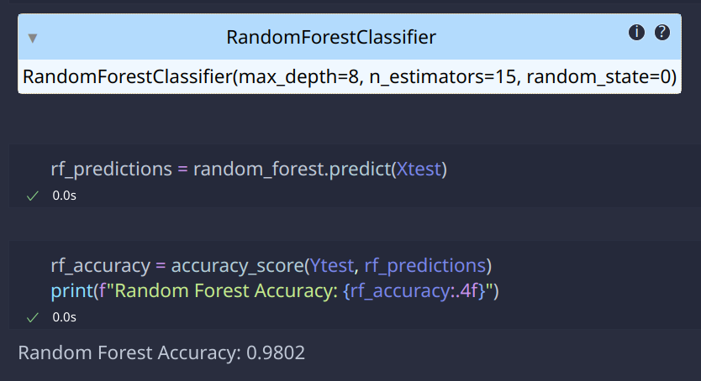Figure 4: Random Forest: model parameters and accuracy

Since the random forest model only uses 15 n_estimators and maximum decision tree depth of just 8 levels, this makes the random forest model really lightweight and also decrease the prediction time because of less numbers of decision trees. This decreases the computational cost while still maintaining the decent accuracy score of 98%. So, it is decided that the random forest classifier model shall be used for the purpose of irrigation prediction in this project.
Backend and API Development:
The main backend server to handle the direct connection with the IoT device is written using nodejs. The server uses MySql database for storing and retrieving data and Express library for building REST api. The IoT devices is controlled and monitored via this server.
For deploying the AI model, another python http server is built, all it does is handles one single REST api which receives the environmental data like temperature, humidity, moisture, plant type and plant age, then makes the prediction whether to irrigate or not. This server is deployed on the same machine where the nodejs server is deployed.
The nodejs server sends request to the python server for making irrigation related decisions.
Frontend Development and Real-time Monitoring:
A web based dashboard is created using Reactjs and material UI for modern look and feel. The interface is kept simple and intuitive for easy navigation and ease of access. However users may need some guidance at first.
The user can monitor and control the system from this dashboard. User can view the live status of the farmland i.e. temperature, humidity and soil moisture as well as the current irrigation status. User can also manually control whether to irrigate or not by using the manual override feature given in the dashboard. Besides, user can view the irrigation schedules and also the overall water consumption graph by the particular plant throughout it’s lifetime.
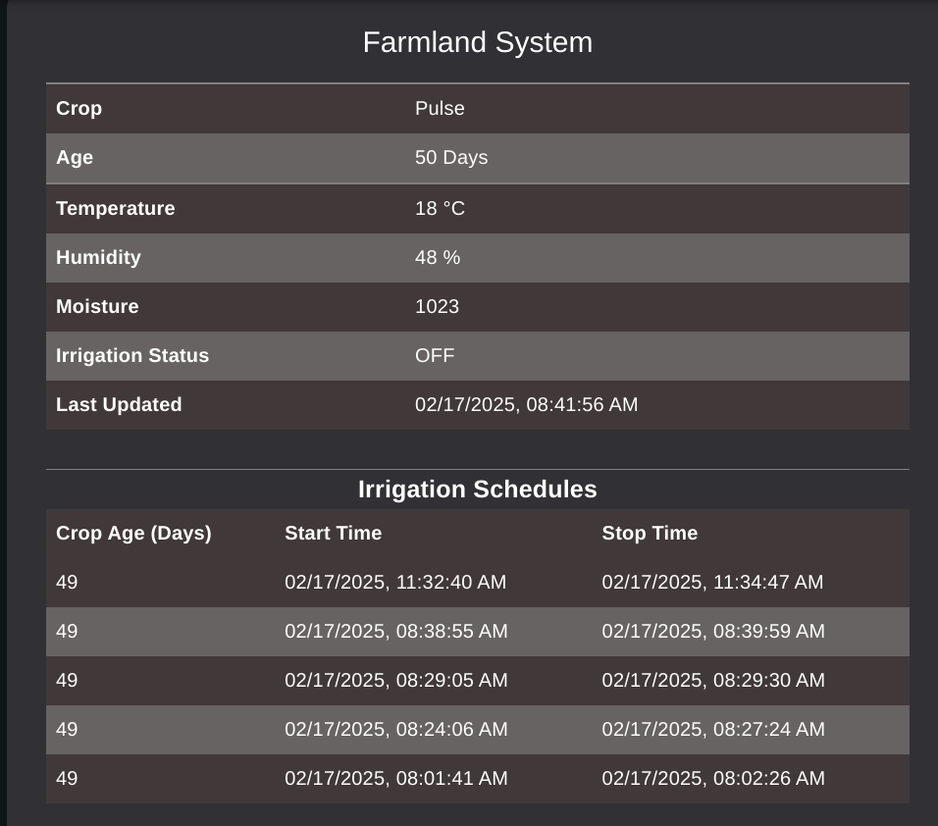Figure 5: System Live Status and recent irrigation schedules

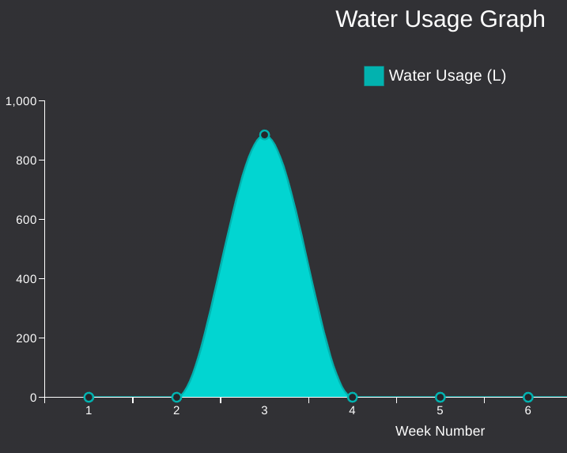Figure 6: Water usage graph from week 2 to week 4

Interoperability ( Data flow between each element of the system )
The entire Smart Irrigation System consists of three sub systems i.e. the IoT device or irrigation device deployed in the field, the nodejs backend server to control and monitor the irrigation device and also store and retrieve user data, this also provides the necessary data for the frontend web dashboard. Finally the python server which hosts the AI model for prediction. Now, all these systems need to communicate with each other in order to function properly.
To establish the seamless communication and data transfer between the systems, the REST api are used over http protocol. The IoT device monitors the local environment and sends the data to the nodejs server for processing, storage and predictions related tasks, it also handles the web dashboard. The nodejs server then sends the environmental data to the python server to use the AI model for making irrigation related prediction. Finally the nodejs server receives the decision from the AI model and then send the response back to the IoT device. Also the IoT device send the request to update the live status to the nodejs server, the server than keeps track of environmental statuses, irrigation schedules etc. And when the user navigates to the web based dashboard, the frontend system sends request to the same nodejs server to retrieve the stored data and statistics.
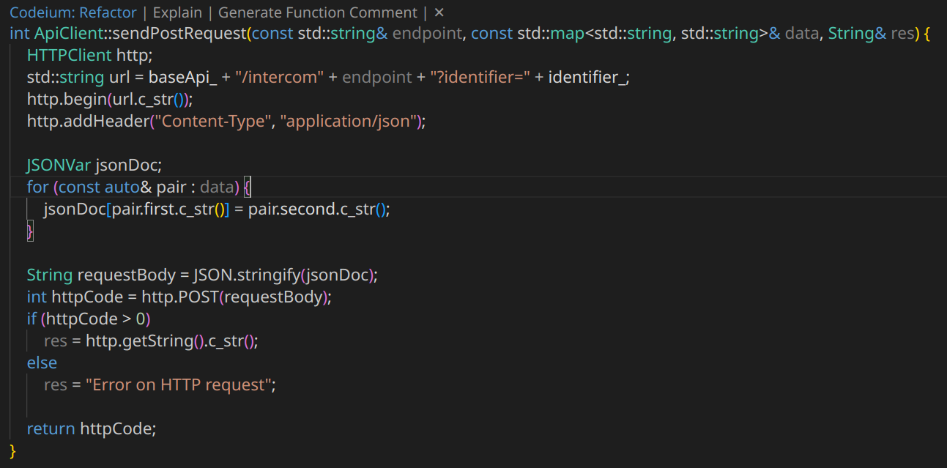Figure 7: IoT device: send http post request to the nodejs server
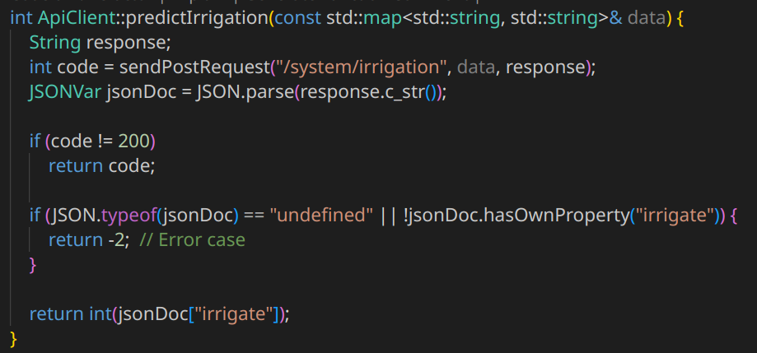Figure 8: IoT device: send environmental data to nodejs for prediction

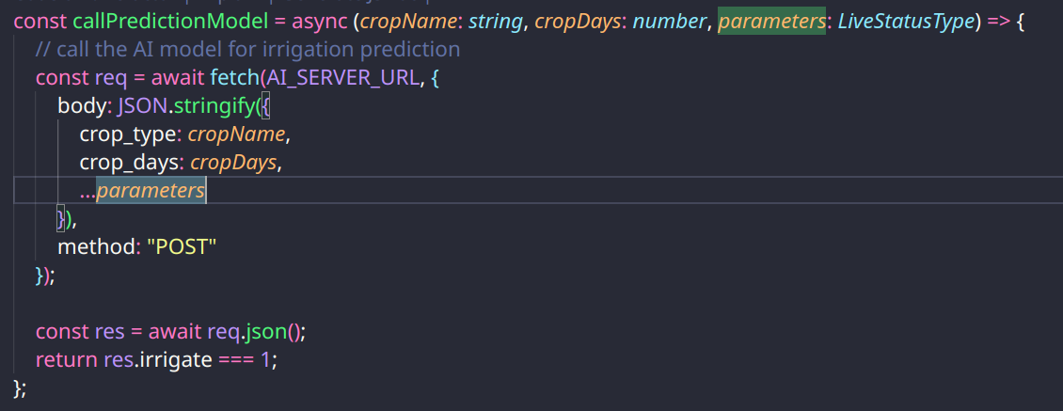Figure 9: Nodejs server: calling python server for AI prediction
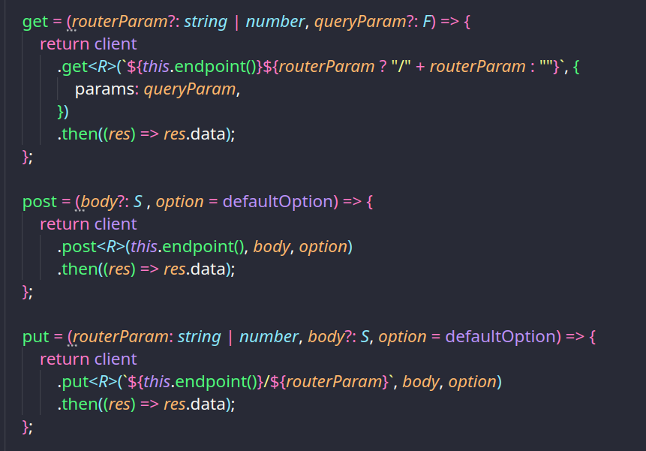Figure 10: Reactjs: apiClient class to handle http calls to nodejs REST api
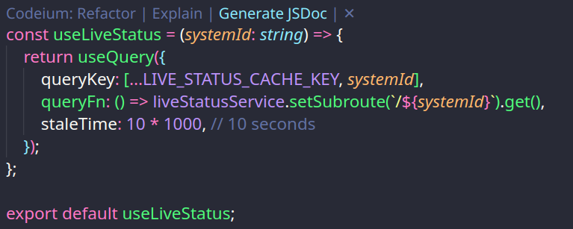Figure 11: ReactJS: fetching live status from nodejs server using react query and react hooks

This is how all the modules interoperate with each other and act as a single system i.e. Smart Irrigation System.
8.4 Challenges and Solutions
During development of the smart irrigation system, the following problems were encountered:
→ Library Compatibility Issues: Majority of libraries for controlling hardware like RTC module were available for Arduino and was hard to use that in ESP32, as a solution server side time tracking was implemented.
→ Connectivity Issues: Rural areas faced stable network connection issues, this was solved by implementing a fallback offline mode for the irrigation system using predefined threshold sensor values.
→ Power Management: Improved power usage by limiting the total number of times the esp32 communicates with server.
Smart Irrigation System development managed to connect the IoT with AI and thus smartly and efficiently manage irrigation, as well as water resource. The iterative approach enabled the system to improve step by step over time and thus created a strong and reliable system.
9. Testing
Initially each sensors and components including temperature and humidity sensor, soil moisture sensor were connected to the microcontroller and then were tested to check if they work by writing a simple test programs i.e. just reading the sensor value and printing on the display.
To test the backend nodejs server which is the main controller component of the entire irrigation system, unit and integration testings were done using the vitest nodejs testing library.
Following are the major test cases that covers the most significant functionality of the system.
a. Authorization Middleware Test
Trying to access the currently installed IoT devices by calling the /api/systems route.
S.N | Test Case | Expected Result | Actual Result
1 | Try to fetch the system info without logging in. | It should return 401 i.e. unauthorized | As expected
2 | Try to fetch the system info, after logging in, but by sending invalid session token. | It should return 401 status code | As expected
3 | Try to fetch the system info, after logging in, but this time with expired session token | It should return 401, unauthorized status | As expected
4 | Try to fetch the system info, after logging in, and with valid session token | It should return all the available systems info | As expected

b. Login tests
Trying to test the login feature of the system if it properly works under any kind of input credentials. Try to login with different username and passwords and check if the system properly handles that.

S.N | Test Case | Expected Result | Actual Result
1 | Try to log in with correct credentials. | It should return 200 status and include the username in the response. | As expected
2 | Try to log in with incorrect credentials. | It should return 401 status with an error message mentioning incorrect credentials. | As expected
3 | Check if sessionId is set on successful login. | The response should include a Set-Cookie header containing sessionId. | As expected

c. Crop Session Controller testings
This is the part where the user logs in to the system and then adds a new crop session. Crop session refers to the period of time where a specific crop is grown. User have to enter the details like which crop is s/he growing and the crop age if there is already a crop growing while installing the system, if the crop is to be cultivated later, the age count becomes 0. The system then monitors and irrigates the currently active session.
Following test cases cover if the system correctly handles creating a new crop session with various inputs.

S.N | Test Case | Expected Result | Actual Result
1 | Attempt to create a crop session without cropName. | Should return 400 with a validation error mentioning cropName is required. | As expected
2 | Attempt to create a crop session without ageCount. | Should return 400 with a validation error mentioning ageCount is expected. | As expected
3 | Attempt to create a crop session with an invalid cropName. | Should return 400 with a validation error mentioning Invalid crop name. | As expected
4 | Attempt to create a crop session with a negative ageCount. | Should return 400 with a validation error mentioning ageCount cannot be negative. | As expected
5 | Create a crop session with valid data. | Should return 200 and return the created session details (cropName, ageCount, cropSessionId, and systemId). | As expected
6 | Verify the crop session is added to the database. | The database should contain the created crop session with correct details (cropName, ageCount, initialCropAge, and lastAgeUpdated). | As expected

d. Intercom Controller testings
This is the part of the server that actually communicates with the IoT device in the farmland. The IoT devices send multiple requests to this endpoints by sending the environmental conditions of the farmland. Since this is one of the most important part of the system i.e. receiving and updating the live status of the farmland so the user can view the real time status of the land.
Following tests cases ensure that the system correctly handles the communication with the remote IoT device and successfully updates the database and store the live status. The tests also ensures whether the system correctly authenticates the IoT device or not, and also if the system can handle incorrect inputs.

S.N | Test Case | Expected Result | Actual Result
1 | Attempt to send live status without systemIdentifier. | Should return 401 with an error mentioning system identification is required. | As expected
2 | Attempt to send live status with an invalid systemIdentifier. | Should return 401 with an error mentioning system identification is invalid. | As expected
3 | Attempt to send live status without irrigationStatus. | Should return 400 with a validation error mentioning irrigationStatus is required. | As expected
4 | Attempt to send live status without temperature. | Should return 400 with a validation error mentioning temperature is required. | As expected
5 | Attempt to send live status without humidity. | Should return 400 with a validation error mentioning humidity is required. | As expected
6 | Attempt to send live status without moisture. | Should return 400 with a validation error mentioning moisture is required. | As expected
7 | Attempt to send live status with an invalid irrigationStatus. | Should return 400 with a validation error mentioning invalid irrigation status. | As expected
8 | Send valid live status data. | Should return 200 with a success message. | As expected
9 | Verify live status update in the database. | The database should contain the updated live status with correct values for irrigationStatus, temperature, humidity, and moisture. | As expected

e. System Controller testings
This is the part where the user registers the IoT device in the server which s/he just installed in the farmland. Since there can be multiple IoT devices even in the same field, they need to be registered into the server and also properly authenticated for their identification.
This testing ensures that the IoT device is properly registered into the server and also the server is able to handle inputs in different edge cases.

S.N | Test Case | Expected Result | Actual Result
1 | Attempt to register a system without pumpFlowRate. | Should return 400 with a validation error mentioning pumpFlowRate is required. | As expected
2 | Attempt to register a system with systemName too short. | Should return 400 with a validation error mentioning name must be longer. | As expected
3 | Attempt to register a system with pumpFlowRate too low. | Should return 400 with a validation error mentioning it must be at least 0.1L/min. | As expected
4 | Register a system with valid data. | Should return 200 with system details including systemName, pumpFlowRate, and identifier. | As expected
5 | Verify system registration in the database. | Database should contain the new system with correct systemName and pumpFlowRate. | As expected
6 | Verify related records are created upon registration. | systems, liveStatus, systemSessions should contain relevant records. | As expected
7 | Verify system session includes systemIdentifier. | systemSessions table should have an entry with systemIdentifier. | As expected

Above test cases summarizes almost all of the major functionalities of the irrigation system and make sure that the system is properly functioning without any errors. Below is the image of the final result of all those test cases code execution. For detailed screenshots of each of the test case code snippets, please refer to the appendix section.

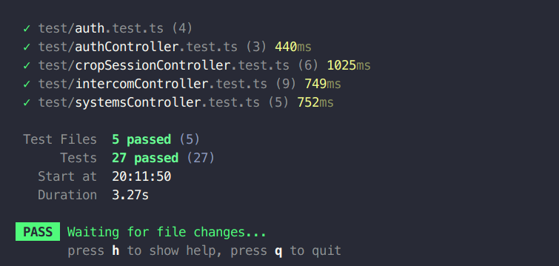Figure 12: Result of test cases execution

10. Evaluation
The evaluation phase of the Smart irrigation system includes its assessment based on system’s usability, performance and reliability. The system was deployed for testing under real world conditions to ensure that all the elements like IoT devices, backend server and AI model met the operational expectations.
However due to geographical and time constraints the testing couldn’t be done in real farm land. After consulting with my supervisor, a small indoor garden was set up inside the college premises itself and the irrigation system was deployed to monitor and irrigate the test garden.
And for the user feedback and evaluation part, the system was exhibited in the science exhibition hosted by the Patan college on 31st March 2025 where many students including me presented our artifact to numerous users and stakeholders.
This section of the report presents the user evaluations and the assessment of the system based on it’s performance in the test environment.

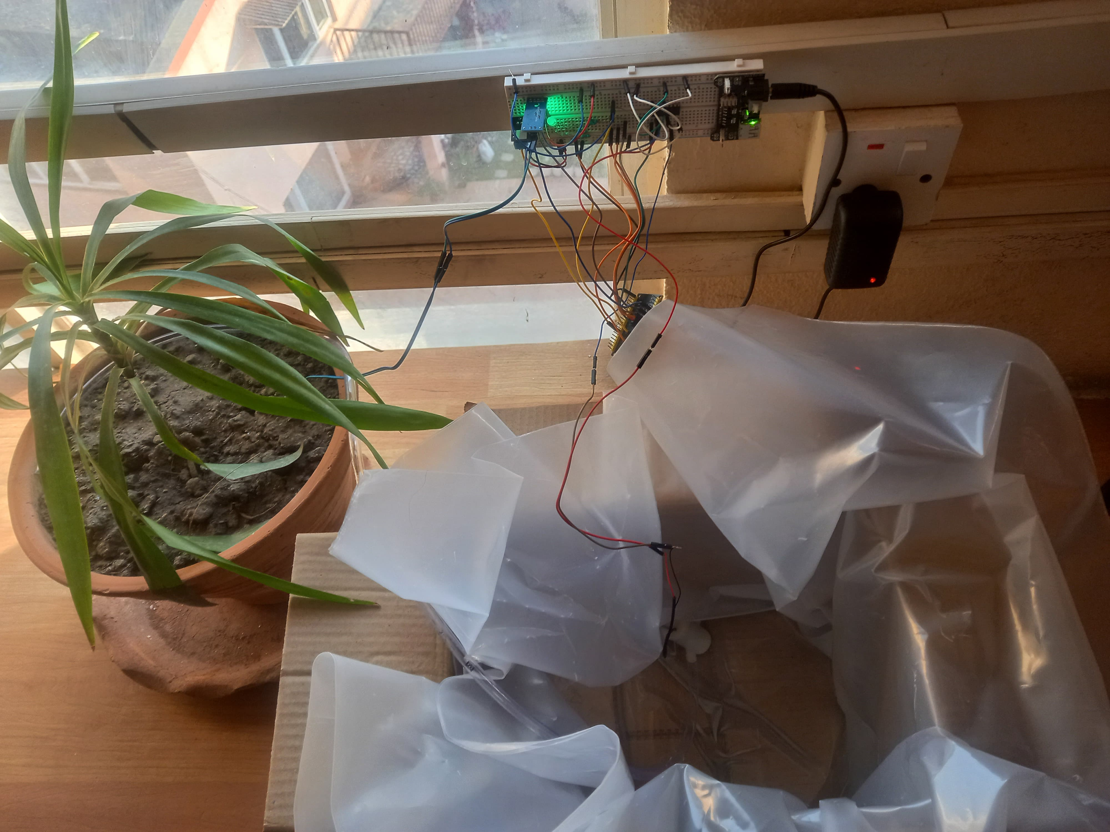
Drawing 1: System Deployment for testing and evaluation

10.1 User Evaluation
During the exhibition of the project, many users used and interacted with the system. Each one of them had their own opinion and feedback regarding the system. Some of those feedback are listed below.

S.N | Full Name | Feedback / Opinion
1 | Ram Kumar Acharya  (IT Student) | Appreciations: The system is responsive and for me it’s easy to navigate. I liked the dashboard, it shows live status and water usage graph clearly. Logging in and registering a system was smooth.  Criticisms: Some form validations error message weren’t user-friendly. They just showed raw error messages, this can be improved by displaying user friendly error messages.
2 | Harish Neupane  (Business Student) | Appreciations: I found the system simple and effective. The water tracking features are great to have, also its good to see AI and IoT integrating so well.
3 | Kritika Thapa  (Agriculture Student) | Ctiricisms: Though the UI is feature wise good but lacks the modern looks and feels, and also it doesn’t have a user friendly and intuitive design, it’s confusing and overwhelming for farmers with limited knowledge. They need proper training before being able to use it.
4 | Krishna Baral  (Farmer, no IT knowledge) | Appreciations: It’s really nice to see that agriculture being modernized, the hassle of manually irrigating field finally seems to be addressed. Irrigating the field as per specific plants needs is really a great idea.  Criticisms: Only monitoring the environmental condition and deciding to irrigate is not enough. Irrigating just before rainfall maybe a waste of water. Also only controlling the irrigation aspect won’t boost the crop productivity as it is heavily affected by flood and soil erosion.
5 | Parbati Paudel  (Farmer, Illiterate) | Appreciations: I am amazed to see machine automatically irrigating the field when necessary. This cuts off a lot of manual works.  Criticisms: I cannot use this system on my own. Setup and configuration process is tough. Besides I cannot really use the dashboard too as there are just buttons with no visual feedback. It would be easy if there were images with manual, or voice support to help people like me.
6 | Niru Adhikari  (IT student with farming background) | Appreciations: I loved the concept of irrigating field based on specific crop type and its age. Also it’s feature to remotely monitor live status and also manually control the irrigation. It’s a solid application for farmers with basic tech skills.  Criticisms: The device and app itself is not yet usable for my parents in the village. It needs to integrate some visual user manuals, and more local language integration and voice support.
7 | Komal Niraula  (Farmer, Limited IT knowledge) | Appreciations: The feature to track the total water usage per crop harvest is really helpful along with the device automatically irrigating the field. As it tracks the water usage, it helps in pre-estimating the total water required for a crop cycle allowing us to more efficiently manage the water resources.  Criticisms: Rather than having the complicated initial configuration or setup, it would be easy and helpful if the system had just one physical button to start it.
8 | Hari Ghimire  (Agriculture Student) | Appreciations: I’m glad to see AI finally making it’s way into agriculture and efficiently irrigating the field based on environmental conditions and crop types. This reduces a lot of manual tasks. Also the ability to remotely track the live status of the system and farmland is really appreciable.  Criticisms: Right now the system only seems to control the water flow. System does not consider other factors like soil pH level, fertilizer requirements and weather data, which greatly hamper the crop production. Considering these factors would make the system truly smart farming.

The above table only documents the feedback and opinion of some specific users, however the overall views and opinions of all the users are summarized below.
Appreciations:
- Users found the automated irrigation system easy and intuitive after initial training.
- User interface is considerable and is intuitive after initial manual or guidance.
- Some users with agricultural and science background claimed this would certainly reduce the water wastage, proving its effectiveness.
- The ability to remotely monitor the real time soil moisture, plant age and irrigation status was really appreciated.
- Majority of users liked the feature of remotely enabling/disabling the irrigation when needed bypassing the system decisions.
- Users found that the system would significantly reduce the manual work required to irrigate the field. And this was the most appreciated feature.

Criticisms:
- Almost all the users needed initial guidance or explanation to navigate the user interface, showing the need to further improve the UI to make it more intuitive and self explanatory.
- Users with IT background criticized the manual override feature being remotely controlled, as this would generally fail in areas with limited internet connectivity.
- Users criticized the real time updated being actually delayed due to poor internet connection.
- Farmers with limited technical knowledge denied to adopt it, as it required some technical knowledge for initial setup and configuration.
- Users without WiFi or internet connections found that the system has limited offline functionality and is barely usable.

10.2 Performance Analysis
Examines system efficiency and responsiveness.

11. Critical Analysis
Smart Irrigation System was developed using an iterative approach in different phases. The process included a thorough research and development, and field implementation. It started with the identification of inefficiencies in traditional irrigation, moving towards a solution integrating AI and IoT thereby automating the irrigation as per the specific needs of the crop.

Initial stages involved clearly defining the aims and objectives and project scopes, performing literature reviews, and selecting methodologies that aligns with precision irrigation and sustainable irrigation practices. And then gradually evolving the system into an intelligent, data-driven system that could interpret real-time environmental conditions and plant type & age then control the irrigation autonomously.

Hardware integration and establishing the seamless communication between ESP32, cloud server and AI model was the biggest challenge in development. Soil moisture, temperature, and humidity sensors required a proper calibration and map their reading to suitable threshold in order to feed into the AI model. Also maintaining a reliable connection between cloud server, AI model and IoT device was a challenging task. The ESP32 microcontroller and REST API were integrated to facilitate real-time data transmission and system responsiveness. Another significant aspect was the development of the AI model for predictive irrigation, requiring extensive data collection and refinement to achieve reliable decision-making.

As the system gradually took its form from basic prototype to operational artifact then employed in the real world for testing, some issues and areas for improvements were noticed. Issues with sensor inconsistencies, excessive network reliability, and scalability were addressed by iterative refinement. Likewise, fallback mechanisms for offline mode and power management are the some features that enhanced the system robustness.

Following are the analysis of the system based on it’s strength, weaknesses and possible improvements:

Strengths:
AI-Powered Decision Making: The system automatically adjusts irrigation schedules based on real-time sensor data, reducing water wastage.
IoT Integration: Real-time data acquisition through sensors enables precise monitoring of soil and environmental conditions.

Scalability: The system can be scaled up to accommodate different kinds of crops, larger agricultural lands, and additional environmental parameters.

Automation: Reduces manual labor through automating irrigation, benefiting farmers with limited access to labor.

Cost Efficiency: Since it optimizes water utilization, the system reduces the operational cost for farmers in the long run.

Weaknesses:
Hardware Dependency: System performance relies heavily on the precision and longevity of sensors that may require maintenance now and then.

Internet Connectivity Issues: Since the system communicates with a cloud-based server, unstable internet connectivity can hinder its real-time decision-making capability.

Initial Setup Cost: Although the system reduces long-term costs, the upfront cost of IoT devices and infrastructure can be expensive for small-scale farmers.

Possible Improvements:

Integration of Renewable Energy: Incorporating solar energy for IoT devices can help increase sustainability and decrease the reliance on external power sources.

Machine Learning Enhancements: Tuning AI models to fit different crop cycles, soil types, and weather patterns can continue to optimize irrigation.
Offline Functionality: Building an offline mode wherein the system can operate based on cached data when the connectivity is lost.

12. Limitations and Future Scope
The project mainly focused on developing an affordable system targeting the resource constrained environment. On top of that the system was developed in the limited resources provided by the college in the given limited time frame. Due to which the system has many flaws and limitations that can be improved in the future enhancements. This section lists the project constraints and describes possible ways for it to be improved in the future.
Limitations:
AI model with poor training data quality: The model was trained in limited dataset and the accuracy of the AI model largely depends on the quality and quantity of data used in training, which might need continuous updating to avoid data skews.

Environmental Factors: Unexpected climatic conditions such as heavy rainfall or severe drought might necessitate the installation of additional sensors in order to make the system more adaptive.

No user friendly setup: Though the system once installed is autonomous, the initial setup and configuration can be overwhelming for non technical users.

Limited Crop Types: The AI model currently only supports eight types of crop types, highly limiting it’s applicability in diverse farming settings.

Limited field size: Currently the system only performs well when used in small garden or farmland due to its limited sensors and peripherals.

Future Scope:
Consider whether data: Currently the system only considers local environmental data to decide irrigation needs which can be influenced heavily due to whether conditions like rainfall. In future the system can consider the rainfall prediction to avoid unnecessary irrigation.

App Integration that is Mobile-friendly: Not everyone is comfortable with the web app. An easy to use mobile app can be developed for farmers allowing them to conveniently monitor the system status and also manually intervene the irrigation decisions if necessary.

Support diverse crop types: Increase the model dataset to support large number of crop types to increase the system’s applicability in diverse agricultural settings.

Support the large agricultural lands: Multiple sensors and water motor pumps can be installed across large fields to make irrigation decisions in each specific sections of the field, this ways the system can support large agricultural lands. The system should be scaled to add support for multiple sensors and pumps in future iterations.

13. Conclusion
The Smart Irrigation System was developed to increase the efficient use of water and the health of crops by the help of AI and IoT technologies. This system operates the irrigation automatically according to the sensors data in the field, which constantly monitor soil moisture, temperature, humidity, and tracks the plant age. Thus, it optimizes the water use, thereby saving water and increasing crop yields, unlike conventional irrigation methods.
The entire process included AI models being trained for decision-making purposes and IoT devices being remotely monitored and controlled. The system provided high accuracy and a high level of responsiveness during its demonstration in a small environment in a short span of time. However it’s accuracy and robustness is yet to be tested in large environments over a long period of time.

Key Findings:
- AI-driven automation significantly reduces water wastage.
- IoT integration allows remote monitoring and control, improving convenience.
- Scalability enables adaptation for different crops and climates.

Contributions:
- Provides a sustainable irrigation model for smart agriculture.
- Introduces real-time analytics for decision-making.
- Reduces manual labor and increases efficiency.
Outcomes:
→ Demonstrated optimal water delivery to the crops thus saving water and increasing crop yields.
→ Cost efficient
→ Decreased manual human interventions in the field for irrigating.

Thus, this project can be viewed as a practical and Eco-friendly approach to agriculture which composes of various human technology interactions. It saves the humans a lot of manual work while only requiring sufficient resources. In the future, this can be further improved and enhanced leading towards a fully autonomous irrigation practices which rarely requires human interventions.

14. References
Lists all sources cited in the thesis in a consistent citation format.

15. Appendix
Includes supplementary materials such as raw data, additional diagrams, and extended explanations.
15.1 Appendix 1 – Weekly Progress Status Forms from UG
15.2 Appendix 2 – Proposal from RMET
15.3 Appendix 3 – Questions, Responses & Result of Survey conducted in RMET
15.4 Appendix 4 – Ethics Form
15.5 Appendix 5 Models Accuracies and confusion matrix

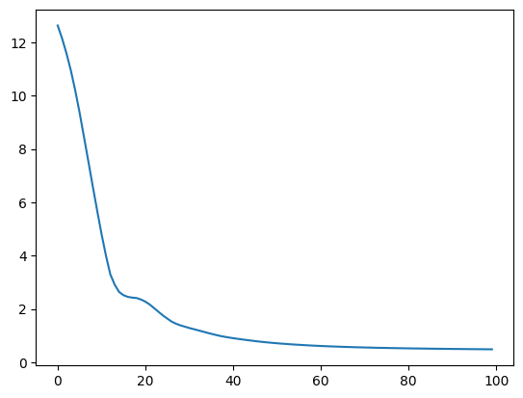Figure 13: MLP Classifier: loss curve

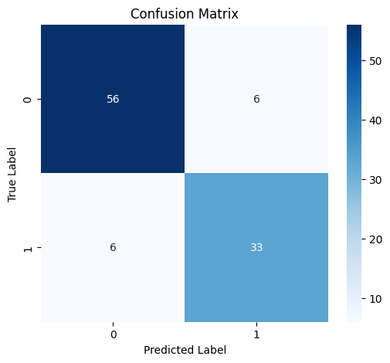Figure 14: MLP Classifier: Confusion Matrix

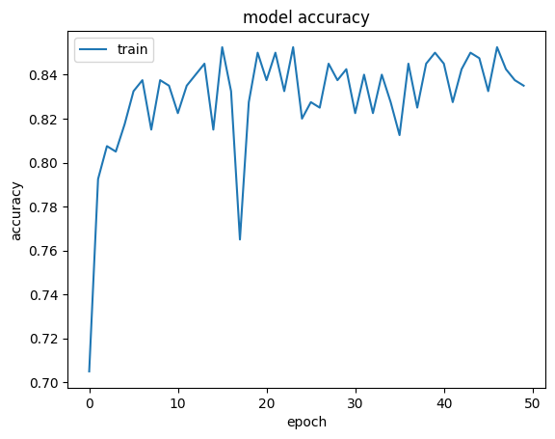Figure 15: Keras: model accuracy

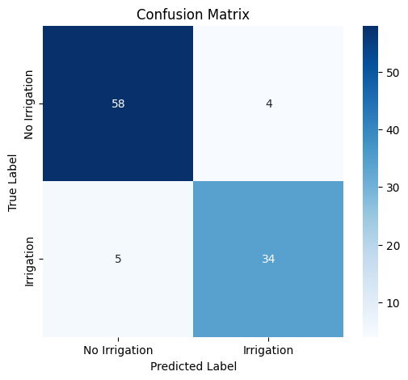Figure 16: Logistic Regression: confusion matrix

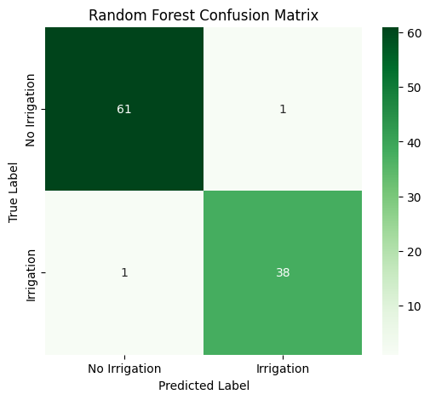Figure 17: Random Forest: confusion matrix

15.6 Test Cases code snippets
15.6.1 Authorization Middleware Test

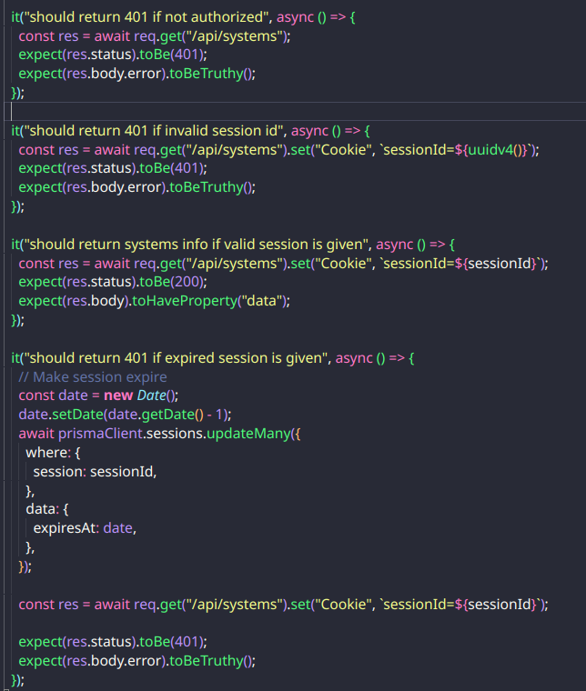Figure 18: Code Snippets: Authorization middleware tests

15.6.2 Login Test

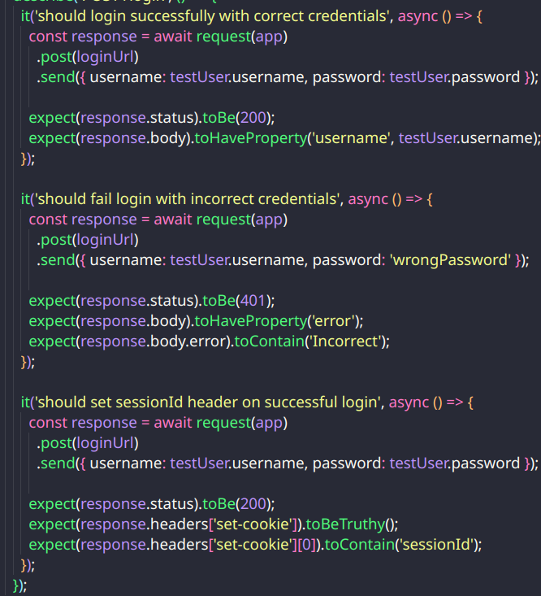Figure 19: Code Snippets: Login tests

15.6.3 Crop Session Controller Test

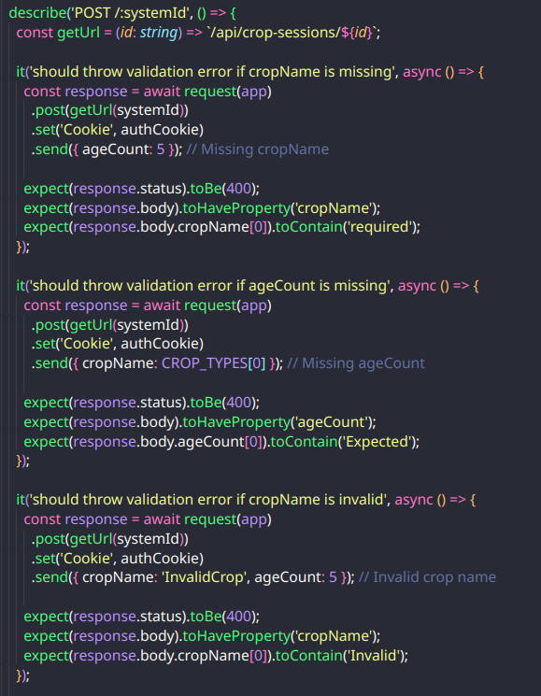Figure 20: Code Snippets: Crop session controller test 1

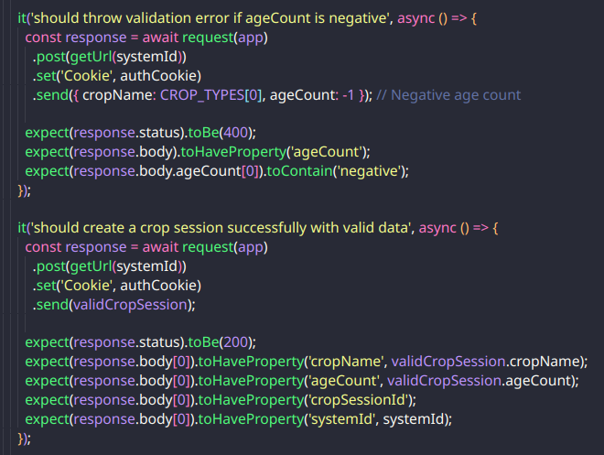Figure 21: Code Snippets: Crop Sessions Controller test 2

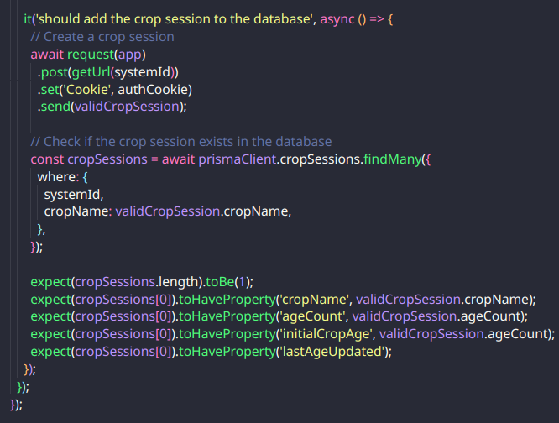Figure 22: Code Snippets: Cropp Sessions Controller test 3

15.6.4 Intercom Controller Test

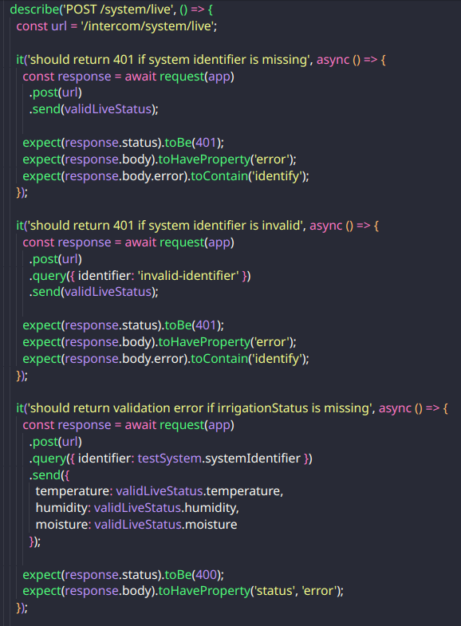Figure 23: Code Snippets: Intercom Controller test 1

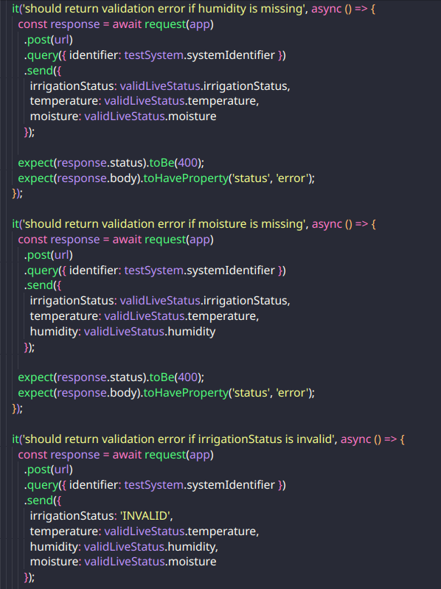Figure 24: Code Snippets: Intercom Controller test 2

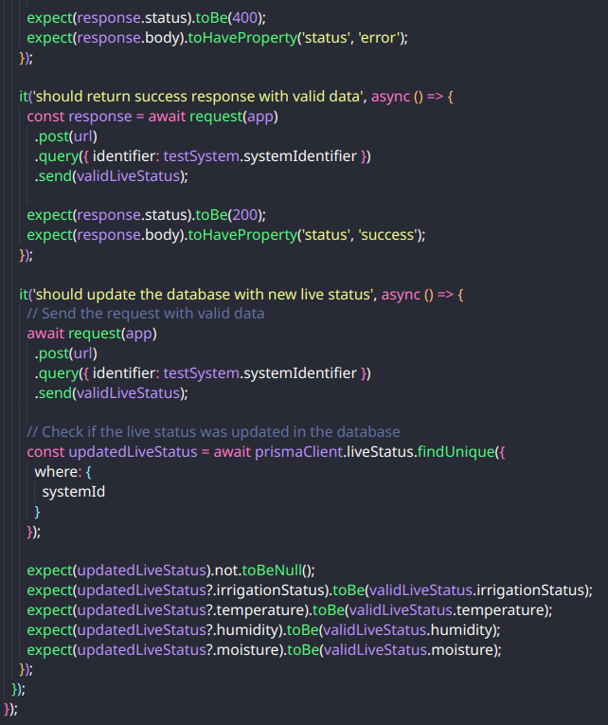Figure 25: Code Snippets: Intercom Controller test 3

15.6.5 System Controller Test
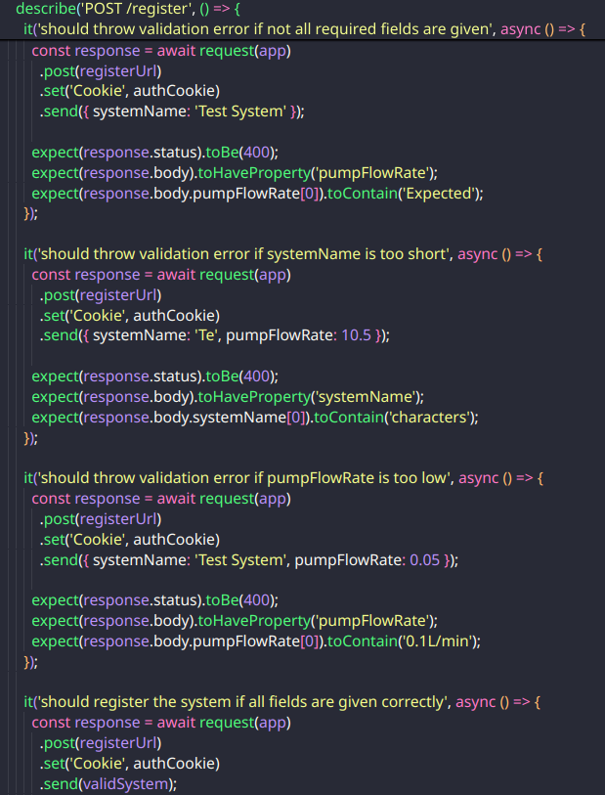Figure 26: Code Snippets: Systems Controller test 1

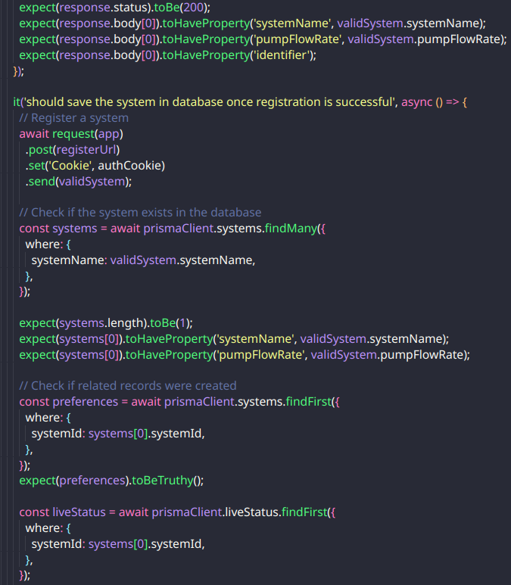Figure 27: Code Snippets: Systems Controller test 2

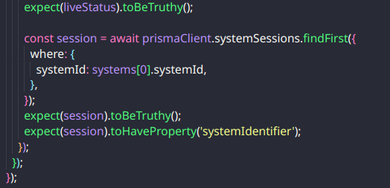Figure 28: Code Snippets: Systems Controller test 3

[Note: This Thesis Format needs to be followed strictly. Failing to match this thesis format will result in Cancellation of your University Viva as we won’t allow you to take part in it, and ultimately you need to repeat your semester.]

