**Final Term Project**

**Analyzing using Power BI and Tableau**

Selected Dataset: Super Store US 2015

Yi-Sin Yang #300368638

Mino Wong #300375436

Commerce and Business Administration, Douglas College

CSIS 3860: Data Visualization

Instructor: Rupa Manabala

December 6, 2023

Table of Contents

Abstract 3

Dataset 3

Power BI - Analysis and Visualized Charts 4

Analysis 1: What are the highest and lowest sales among the regions? 4

Analysis 2: What are the sales and profit monthly? Which month has suffered in profit? 5

Analysis 3: What is number of returned and no returned packages? How does customer satisfy on their purchase? 6

Analysis 4: Which delivery method customer is willing to choose? 7

Tableau - Analysis and Visualized Charts 8

Analysis 1: What is the trend in Profit and Shipping Cost? 8

Analysis 2: What is the correlation between Orders and Returns? 9

Analysis 3: What is sales weighting in regions? Which state has highest among the country? 10

Analysis 4: Who makes negative impact on profit? Which category will have uptrend sales? 11

Conclusion 12

References 13

Abstract

This document served as Final Term Project for the course of CSIS 3860 Data Visualization, with manipulation on using the two most famous BI tools: Microsoft Power BI and Tableau. Comparing to previous assignments, this project we have further enhanced and improved the presentation to have better visualization on colors, structures, and comparison of data, also adapted the new techniques we have learnt from class and textbooks. Moreover, we have defined several analysis questions which need to be answered through the tools. In following contents, we are demonstrating the skills and techniques visualization charts, trend lines, filled maps, tables and more to presents the in-depth analysis in the form of analytical essay and insightful explanations from the data.

Dataset

The chosen dataset is the Super Store US 2015 (Power BI Docs, n.d.). which is available online for learners to practice on Business Intelligent using data visualization tools, such as Power BI or Tableau. After our group discussion, we believe this dataset is ideal for assignments and beginners in data visualization due to its moderate size, volume, and coverage. It offers a good depth of data without being overwhelming, and its content aligns well with our specific needs.

The dataset contains information of orders, returns, and regional managers in three tables named:

1. Orders table  
   Includes details such as order priority, discounts, pricing, shipping costs, order dates, profitability, and order identifiers. Also, additional information on each order, such as product name, category, order data and ship date. This table represents the super store’s sales and order management data with a focus on various factors that contribute to the overall profitability and efficiency of the sales process.
2. Return table  
   Includes the status of an order with order ID, it links to Orders with order ID
3. Users table  
   Includes sales region and the name of manager in each region, and linked to Orders

Here below list out the details of the dataset:

|  |  |  |  |
| --- | --- | --- | --- |
| Table Name | Orders | Return | Users |
| Number of fields | 25 | 2 | 2 |
| Rows | 1,952 | 1634 | 4 |
| Data size | 366 KB | | |

Power BI - Analysis and Visualized Charts

**Analysis 1: What are the highest and lowest sales among the regions?**

Analyzing total sales by region and assigning weightage provides important insights for management about revenue distribution. By focusing resources on high-weightage regions, stores can optimize marketing strategies, enhance customer engagement, then further improve profitability. This data-driven approach enables effective decision-making, leading to increased sales performance.

As we can see in Figure 1 below, the pie chart indicates the highest sales in the region is the East with 592 thousand dollars in sales, then followed by the West with slight low 526 thousand dollars in sales. Meanwhile, the lowest is the South region with only 357 thousand dollars in sales, which around 40% less comparing to the East. This sales gap can be observed easily while looking at the bar chart in Figure 1.

In the map, there are more dots stamped on the East side of America, where the sales activities are highly concentrated. The detailed table shows the exact information when investigate the sales figures in numbers, the East contributing almost 31% of sales amount in the country, however the East region only weighted 19%.

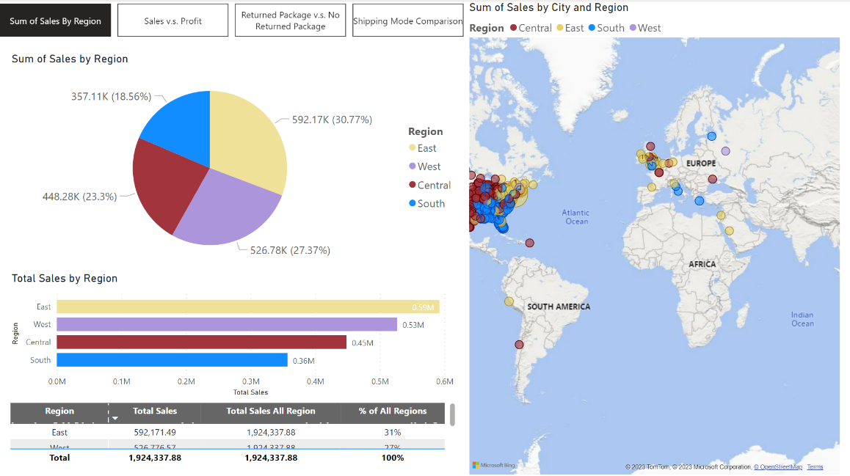  
Figure 1: Chart of Sales in each region

## **Analysis 2: What are the sales and profit monthly? Which month has suffered in profit?**

Examining monthly total sales and profit data is essential to understand the store’s financial performance over time. By tracking these metrics monthly, management can identify the change of revenue patterns, market behavior, and seasonal trends. This analysis could help management to make timely adjustments to strategies, optimize inventory, and manage expenses effectively. That ensures the store can respond promptly to market fluctuations.

As seen in Figure 2, we observed both January and February are the most stable months in terms of monthly profit and sales. However, it’s not hard noticed the significate drop of profit in March 10, but unfortunately, we are not able to locate the reason or root cause that trigger this profit drop after researching through the Internet regards the events and holidays occurred in March 2015. After then, the sales and profit level seem return to normal and receiving three peak moments on mid of April, the beginning of June and mid of June.

Figure 2: Chart of Monthly Total Sales and Profit

## **Analysis 3: What is number of returned and no returned packages? How does customer satisfy on their purchase?**

Upon merging the Returns and Orders tables, it's evident that most customers decide not to return their purchases within the return policy period, indicating customer has high satisfaction levels on buying from stores. This analysis guides management to maintain the store businesses in terms of quality and reliability at retailing while addressing the issues of those customers who opt for returns and try to find solutions to further lower the return rate.

As seen in Figure 3, we can see the huge difference between the number counts on returned purchase and no returned purchase. It means customers are most likely happy with their purchase and shopping experience that not going to return. The average No Returning count is around 300 per month and it remains flat throughout months the data covered where is the first half of 2015, the pie chart on the bottom right of Figure 3 below clearly visualizes each piece is evenly spread, thus store manager can easily understand the insight just by a simple look.

Figure 3: Chart of Return Count and No Return Count

## **Analysis 4: Which delivery method customer is willing to choose?**

This analysis aims to shed light on the preferred delivery methods favored by super store customers, providing valuable information for the management to optimize the delivery processes. Understanding these preferences enables the business to cater to customer needs effectively, ensuring a seamless satisfactory delivery experience.

When we first calculated the numbers on the three shipping methods, as seen in the bar chart in Figure 4 below, most of the customers tend to use regular air to receive their purchases. The reason why they choose regular air over others method might because the reasonable price and acceptable delivery days. The main drawback of Delivery Truck option is longer delivery days, even though it is the most affordable option for customers. The number of Express Air is also lower than Regular Air, that higher in price retain the key hesitation to customers while they select the delivery method.

As seen in Figure 4, the highest number of Regular Air delivery happened in January, which is up to 268 packages in a month, is the leading month on shipping as well. The peak of delivery might cause by seasonal buying that January is traditional period that consumer is more willing to purchase for their new year celebration. Regular Air secures its lead on delivery option, that could be easily observe with extensive long in the bar chart and massive colored in the area chart.

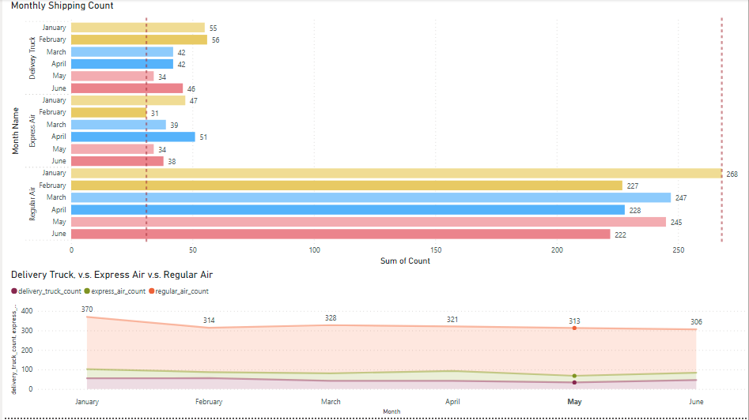Figure 4: Chart Comparing three types of shipping method

Tableau - Analysis and Visualized Charts

## **Analysis 1: What is the trend in Profit and Shipping Cost?**

Analyzing the profit trend alongside with shipping costs is critical for understanding the financial dynamics of a business. It shows the trend of profits over time, and its goal is to identify patterns and potential relationships between profit fluctuations and shipping expenses. This guides store manager on strategic decision-making, optimizing shipping strategies to enhance profitability. This analysis, complemented by a concise analytic essay, provides valuable insights for refining operational strategies and maximizing overall financial performance.

On Figure 5 below, shipping cost weights extremely heavy in Furniture category because transportation on furniture requires intensive labors that creating many expenses; however, this also makes negative impact on profitability in the category. Technology definitely gains its advantage on low cost of shipping because its characteristic of online access and light weight packaging. The overall trend of shipping cost in the three product categories are stable however its profit level is fluctuated. Surprisingly the peak profit of each category is not happened in the same month but dispatch evenly from April to June, this somehow makes Q2 has the most profitable quarter in the year.

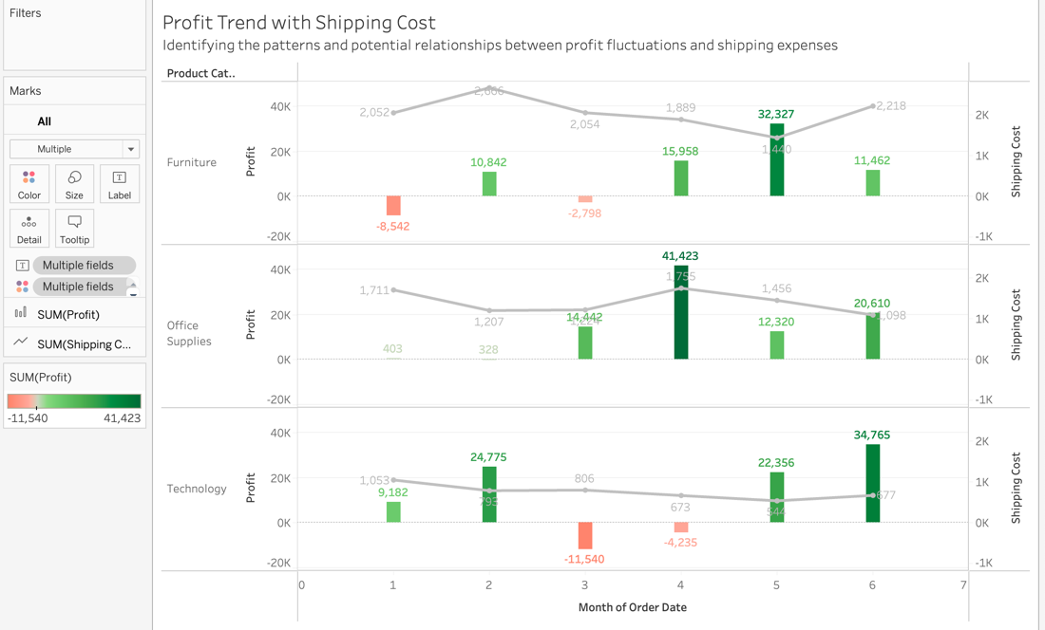Figure 5: Chart compares the profit and shipping cost

## **Analysis 2: What is the correlation between Orders and Returns?**

Analyzing monthly trends in Orders vs Returns is crucial for evaluating customer satisfaction on their purchases and efficiency on store operation. Store manager can identify patterns and potential correlations, guiding decision-making for improved customer experiences which could lead to reduce in number of returning purchases. This analysis helps store manager refining strategies and maintaining operational efficiency. Also inventory manager can further improve their inventory management and prepare additional storage for returning purchases if needed.

On Figure 6 below, Sales numbers have serval up and down trend within a period of 6-months, however it remains around 70 orders per month regularly but currently in a downtrend. It shows no correlation to its return rate which stable in around 4% every month. Even though there were couple peak on orders on January and April, the holiday season, which does not lead to higher number of returns. Customers improved their purchase ability due to the needs of gifting or seasoning, and those additional purchase are mostly not going to return. Store manager can enhance and improve their strategy on each seasonal period that further generates more revenues that will not be withdrawn later-on.

Figure 6: Chart of Order vs Return by Month

## **Analysis 3: What is sales weighting in regions? Where has highest among the country?**

Analyzing the geographical distribution of sales provides valuable insights into regional revenue patterns and aids in refining sales and marketing strategies. Visualized map helps store manager easily identify states that make significant contributions to the sales of the region. This analysis facilitates the identification of high-performing states in the region of Central, East, South and West among the United States, giving overall picture when regional sales manager makes their strategic decisions for effective regional sales campaign to distribute company resources across the states.

Figure 7 shows the sales weighting of each state for its region. And each region is separated in four colors to better visualization. As a result, California contributes almost 55% to the West, Illinois has 22% to the Central, Florida has 24% to the South and New York has close to 38% to the East. California is dominating the sales weighting in the West. Therefore, we should not be surprised most of the companies would like to set their feet in California, so same for regional sales manager of super store will also allocate more resources to fulfill the sales and demands in California.

Figure 7: Chart of Sales Distribution

## **Analysis 4: Who makes negative impact on profit? Which category will have uptrend sales?**

Analyzing the relationship between sales and profits across product categories is important to understand the store performance. While high sales don't always transfer to profits, this analysis allows store managers to identify the key revenue generators assess category. Management can prioritize high-performing categories and develop suitable strategies for profitability. Simultaneously, forecasting sales in each category by using visualizations can understand trends, enabling proactive inventory planning and preventing stock shortages that could impact sales performance.

On Figure 8 below shows a dashboard of relationship on sales and profits, the advantage of dashboard is user can filter the information as wish while the visuals maintain the same formation. It is very clear that the South is the only one make negative impact to the total profits among the regions. By using the top right Product Category filter, we can further investigate the data deeper that Technology has dragged the profit level in the South, especially due to the orders on its sub-category of Office Machines in April. With given six months of sales data, Tableau is able to project the trend that Office Supplies will maintain its uptrend momentum in the coming three months.

Figure 8: Dashboard of relationship on Sales and Profit

Conclusion

This Final Term Project for the CSIS 3860 Data Visualization course showcases the application of Microsoft Power BI and Tableau on the Super Store US 2015 dataset. This document highlights the utilization of visualization techniques on both BI tools, and throughout the self-defined analysis questions that lead to observation on charts, we can further investigate the trend and insightful facts behind the data.

The project aims to not only demonstrate proficiency in BI tools but also to present a nuanced understanding of the factors contributing to overall profitability and efficiency in common business sales process, a retail super store here for example. Last but not least, we aim to contribute meaningful insights for effective decision-making in a business context and manner, illustrating the power of data visualization in extracting valuable information from big data that is the one most crucial element in the modern business world nowadays.

# **References**

Power BI Docs. (n.d.). *Power BI – Excel Sample Data Set for practice*. Retrieved Nov 2023, from Power BI Docs: https://powerbidocs.com/2019/11/28/power-bi-sample-data-set-for-practice/