# How to use MATLAB Version of GADIHOM

(This code is provided freely, but if you use it, please cite publication linked with this code : "F. Dos Reis and N. Karathanasopoulos, Inverse metamaterial design combining genetic algorithms with asymptotic homogenization schemes. International Journal of Solids and Structures (2022), doi: https://doi.org/10.1016/j.ijsolstr.2022.111702.")

DOS REIS F.

04.04.2022

## Introduction

This is the MATLAB version of GADIHOM, a Genetic Algorithm for Inverse HOMogenization[1].

The code is composed with modules :

1. GADIHOM.m : main function module of the genetic algorithm
2. Homogenization.m : asymptotic homogenization module
3. Mesh.m : mesh module
4. Compliance.m : Compute the compliance tensor from mechanics moduli
5. Save_matrix.m : save a matrix in csv format
6. Fcost.m : cost function for the genetic algorithm
7. mechanic_moduli.m : extract mechanic moduli from homogenized compliance tensor

## How to use

* modify the data values in a ExampleUsei.m code to call the main function GADIHOM(…)

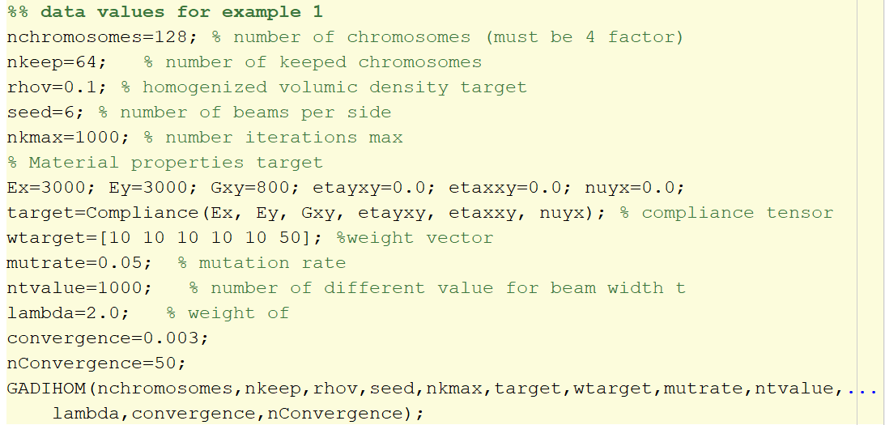

* Run
* Results are stored in various csv file :
  + Tb.csv : width’s beam values of best lattice found. See the appendix in paper to know the store order used
  + Mechanic_homogenized.csv : homogenized mechanic moduli values for best lattice. Contain :
  + Other files containing the topology of the lattice

1. Not all the features are included. A translated fastest and enhanced C code was available.