How to use MATLAB Version of GADIHOM
DOS REIS F.
04.04.2022

Introduction
This is the MATLAB version of GADIHOM, a Genetic Algorithm for Inverse HOMogenization.
The code is composed with modules :
- GADIHOM.m : main function module of the genetic algorithm
- Homogenization.m : asymptotic homogenization module
- Mesh.m : mesh module
- Compliance.m : Compute the compliance tensor from mechanics moduli
- Save_matrix.m : save a matrix in csv format
- Fcost.m : cost function for the genetic algorithm
- mechanic_moduli.m : extract mechanic moduli from homogenized compliance tensor

How to use
- modify the data values in a ExampleUsei.m code to call the main function GADIHOM(…)
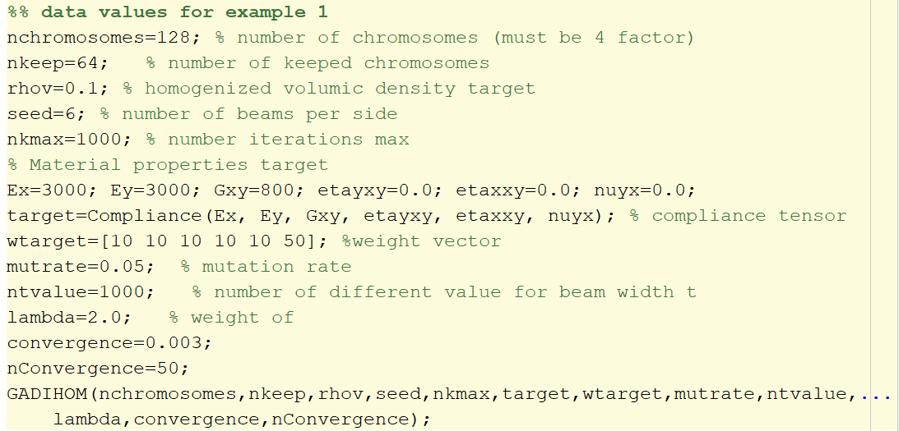
- Run
- Results are stored in various csv file :
  - Tb.csv : width’s beam values of best lattice found. See the appendix in paper to know the store order used
  - Mechanic_homogenized.csv : homogenized mechanic moduli values for best lattice. Contain :
- Other files containing the topology of the lattice

Not all the features are included. A translated fastest and enhanced C code was available.

