Software Requirements Specification
for
Personal Portfolio Website
Version 1.0 approved
Prepared by Michael Vincent Dosado
CMSC 128 Lab University of the Philippines - Visayas
January 14, 2022
Table of Contents
Table of Contents ii
Revision History ii
1. Introduction 1
1.1 Purpose 1
1.2 Document Conventions 1
1.3 Project Scope 1
1.4 Intended Audience 1
1.5 References 1
2. Overall Description 2
2.6 User Needs 2
2.7 Assumptions and Dependencies 2
3. System Features 2
3.1 Login Feature 2
3.2 Registration Feature 2-3
4. External Interface Requirements 3-5
4.1 User Interfaces 3-5
4.2 Hardware Interfaces 5
4.3 Software Interfaces 5
4.4 Communications Interfaces 5
Appendix A: Issues List 6

Revision History
Name | Date | Reason For Changes | Version
None

Introduction

Purpose
The purpose of this Document is to provide a detailed description of this Project which is Personal Portfolio Website. It will be explaining the main features of the product, its interface, and its functionality. This document will be intended for both the stakeholders and the developers, in which in this case, is intended for both the instructor and the student which will be presented for approval and grading.

Document Conventions

The font used is “Helvetica” with font size 11 and with a 1-inch margin on every side.

Project Scope
The software/project specified is Personal Portfolio Website that serves as a promotional website for the developer mentioned. This aims to be a semi-Resume that showcases the developer’s skills and interests intended for potential employers or business partners.

Intended Audience
The primary intended audience for this document is the instructor for this subject, the project or the software itself. In addition, other intended audiences for the document are employers, business partner, potential clients, developers, managers, and other personnel with technical knowledge related to the project or this document.

References
Portfolio Website:
http://localhost:5000/
Flask Python:
https://flask.palletsprojects.com/en/2.0.x/
Database:
https://mariadb.org/
Programming Language:
https://www.python.org/
HTML Tips:
https://www.w3schools.com/html/
CSS Tips:
https://www.w3schools.com/css/

Overall Description

User Needs
The users of this product will be employers, business partners, and potential clients who are interested on the featured developer or the website owner. The users will only be required to login on their created account prior to viewing the portfolio website.

Assumptions and Dependencies
The project is assumed to be running on an updated Windows framework. Technology used is not assumed to be latest, but limited to such technology that supports Python 3, Flask, mariaDB, HTML, and CSS.

System Features

Log-in Feature

3.1.1 Description and Priority
This lets the users “log-in” to their respective created accounts before entering the main page. This feature is a High priority feature as instructed by the evaluator/instructor.
3.1.3 Functional Requirements
Since the login feature checks the existence of the user’s created account on the database (mariaDB), this will require that the database servers are running (Apache and MySQL Modules) through the XAMPP Control Panel. The website server must be already running prior to any actions carried out by the user. In case of a typo error where the user has given an incorrect username or password, the system shall notify the user of such error and the website shall refresh and redirect the user on the same page.

Registration Feature

3.1.1 Description and Priority
This lets the users “Register” to create their respective accounts before logging-in towards the Main page. This feature is also a High priority features as instructed by the evaluator/instructor.

3.1.3 Functional Requirements
Since the registration feature first checks the existence of the user’s created username on the database (mariaDB) before proceeding on creating the account and writes on the database the information filled out by the user in the given forms on the register page, this will require that the database servers are running (Apache and MySQL Modules) through the XAMPP Control Panel. The website server must be already running prior to any actions carried out by the user. In case of a typo error where the user has given an empty entry on any of the forms required or if the user’s input on the “password” section does not match the input on the “confirm password” section, the system shall notify the user of such error and the website shall refresh and redirect the user on the same page.

External Interface Requirements

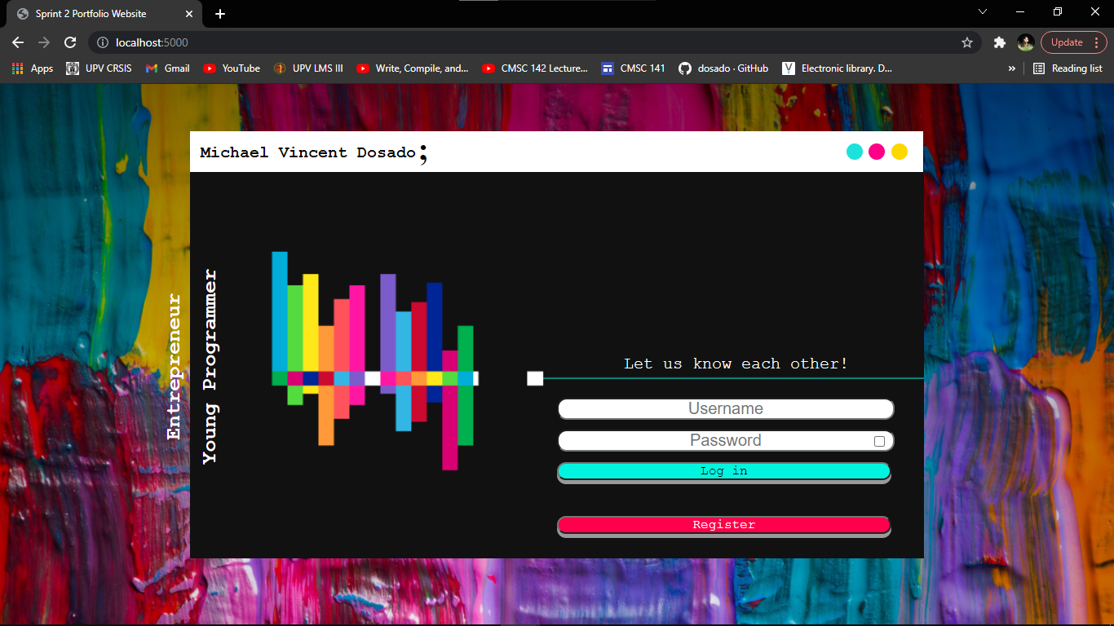
User Interfaces

Home Page/ Login Page

Log in Button


Register Button

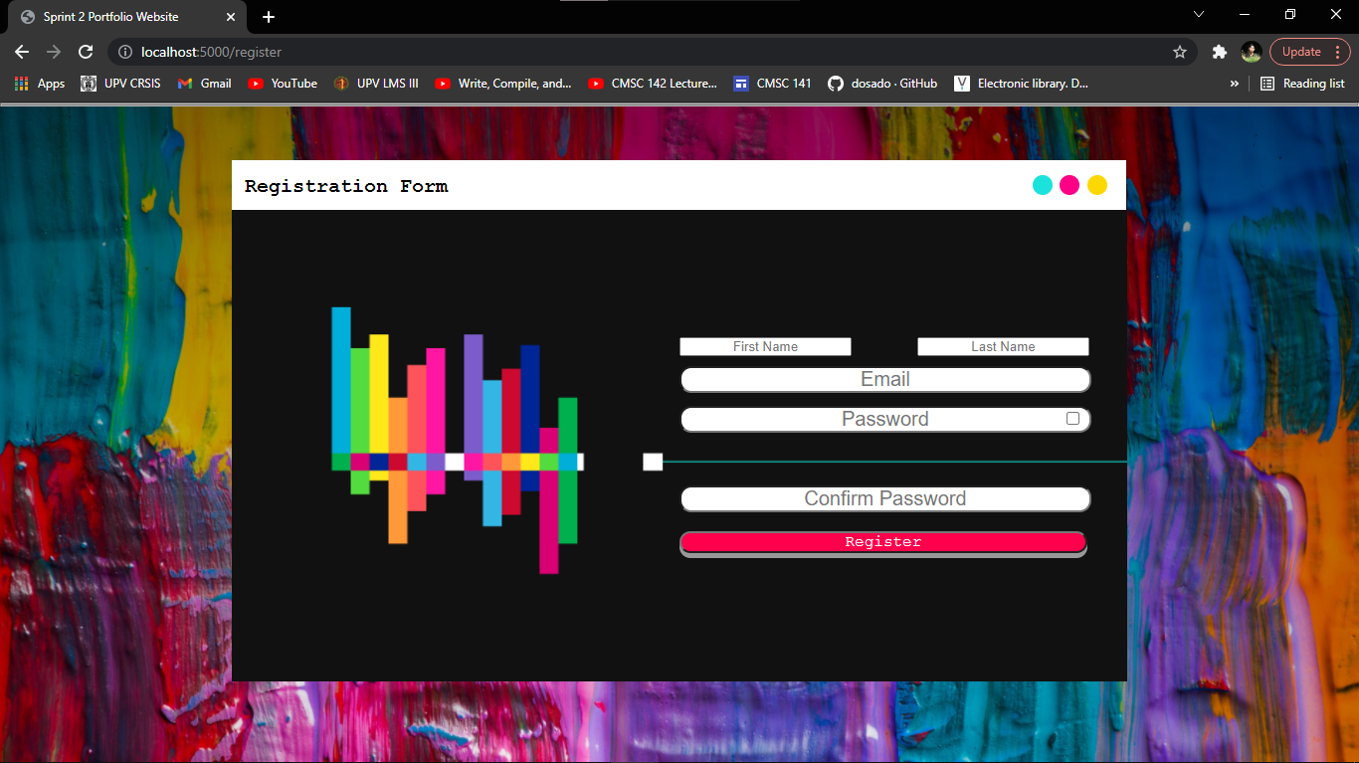

Register Page
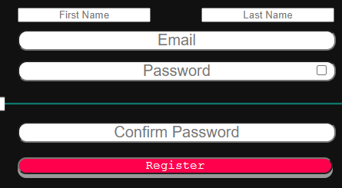

Forms consisting of First Name, Last Name, Email, Password,
Confirm password and the Register Button

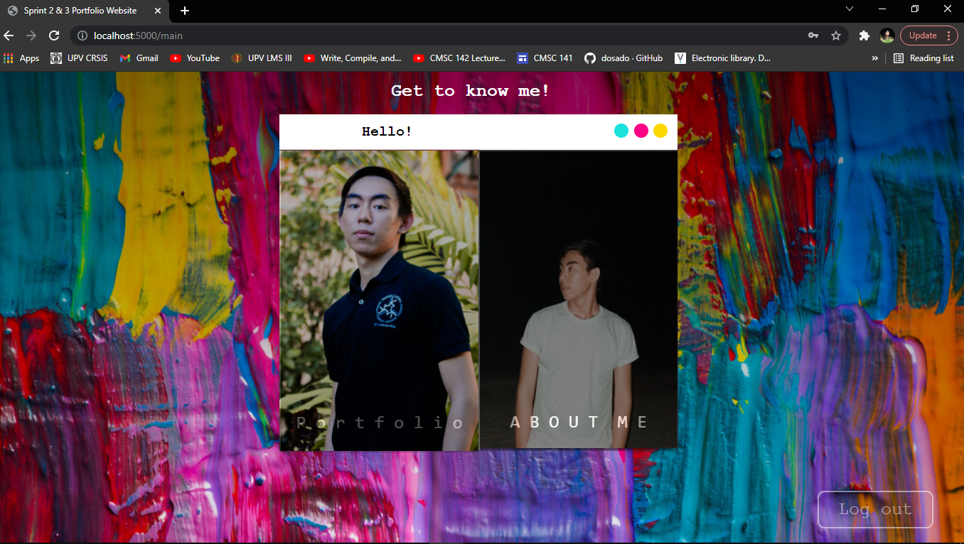
Main page


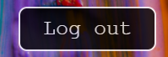

Log out Button Log out Button (Cursor Hover)

Hardware Interfaces
The project supports all versions of device types, but is only limited to devices that support the required front-end and back-end tools of the project.

Software Interfaces
This portfolio website is connected to a MariaDB version 10.4.19 database through the XAMPP Control Panel version 3.3.0 Back-end framework is supported by Flask version 2.0.1 Werkzeug 2.0.1 Programming Language used is Python 3.8.5

Communications Interfaces
TBD

Appendix A: Issues List
Communication Interfaces Requirements not yet known/to be resolved

