Heart Disease Prediction
An End-to-End MLOps Pipeline
MLOps Experimental Learning Assignment 01
AIMLCZG523 — Machine Learning Operations
Repository: https://github.com/dosdbosb/heart-disease-mlops

1. Project Overview
This project builds and deploys a machine learning system that predicts the presence of heart disease from patient health data. It covers the full lifecycle expected of a production ML system: data preparation, model training and comparison, experiment tracking, automated testing, containerization, deployment to a local Kubernetes cluster, and basic monitoring.
The dataset used is the Heart Disease UCI dataset, obtained programmatically from the UCI Machine Learning Repository. The target task is binary classification: predicting whether a patient has heart disease (1) or not (0).

Tool Stack
- Language & data handling: Python, pandas, NumPy
- Visualization: Matplotlib, Seaborn
- Modeling: scikit-learn (Logistic Regression, Random Forest)
- Experiment tracking: MLflow
- Testing: Pytest
- API framework: FastAPI + Uvicorn
- Containerization: Docker
- Orchestration: Kubernetes (Minikube, local)
- CI/CD: GitHub Actions
- Monitoring: structured logging + Prometheus-format metrics endpoint
- Version control: Git & GitHub

2. Setup & Installation Instructions
The steps below reproduce the full project from a clean environment on Linux.

2.1 Clone the repository
git clone https://github.com/dosdbosb/heart-disease-mlops.git
cd heart-disease-mlops

2.2 Create a virtual environment and install dependencies
python3 -m venv venv && source venv/bin/activate
pip install -r requirements.txt

2.3 Download and prepare the data
python scripts/download_data.py
python scripts/clean_data.py
python scripts/eda.py

2.4 Train models and log to MLflow
python scripts/train_model.py
mlflow ui # view results at http://localhost:5000

2.5 Save the final packaged model
python scripts/save_model.py

2.6 Run tests
pytest tests/ -v

2.7 Build and run the Docker container
docker build -t heart-disease-api .
docker run -d -p 8000:8000 --name heart-disease-container heart-disease-api

2.8 Deploy to local Kubernetes (Minikube)
minikube start
eval $(minikube docker-env) && docker build -t heart-disease-api .
kubectl apply -f k8s/deployment.yaml
kubectl apply -f k8s/service.yaml
curl -X POST $(minikube service heart-disease-api-service --url)/predict -H "Content-Type: application/json" -d '{...}'

3. Data Acquisition & Exploratory Data Analysis
The raw dataset (303 patient records, 14 attributes) was fetched directly via the ucimlrepo package (dataset ID 45), avoiding any manual download step. Two columns, ca and thal, contained a small number of missing values (4 and 2 records respectively). Since this represented under 2% of the data, affected rows were dropped rather than imputed, preserving 297 clean records.
The multi-class target (0–4, indicating disease severity) was converted to a binary label: 0 (no disease) vs 1 (disease present), matching the assignment's risk-classification objective. Categorical attributes (cp, restecg, slope, thal, ca) were one-hot encoded, expanding the dataset to 21 columns, since these values represent categories rather than an ordered scale.

Class Balance
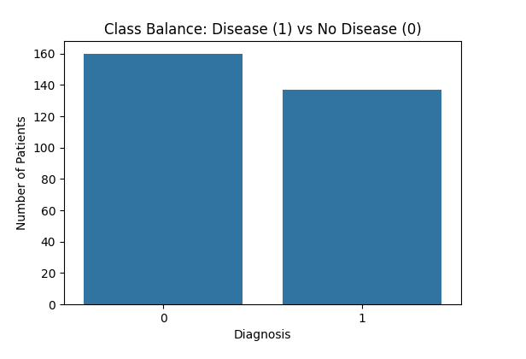
Figure 3.1 — Class balance: 160 patients with no disease vs 137 with disease. The near-even split (54%/46%) means accuracy is a meaningful metric here, with no special class-imbalance correction required.

Feature Distributions
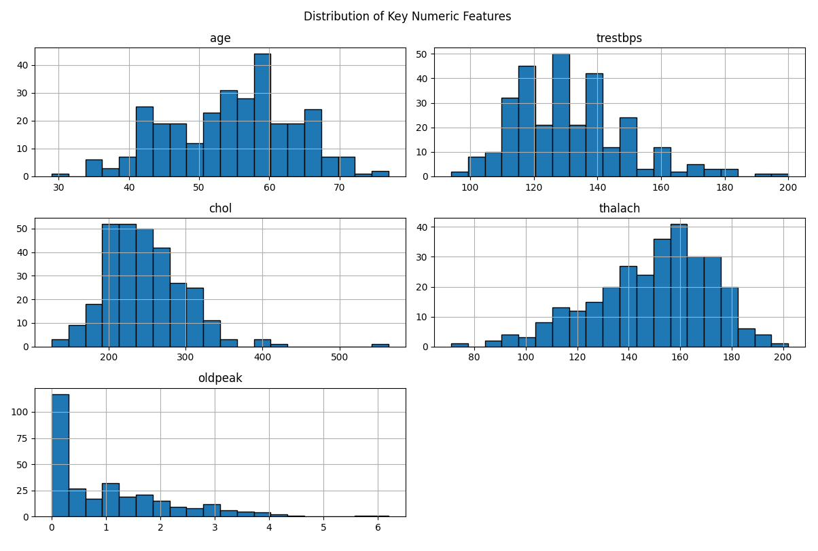
Figure 3.2 — Distributions of the key numeric features (age, resting blood pressure, cholesterol, max heart rate, ST depression).

Correlation Heatmap
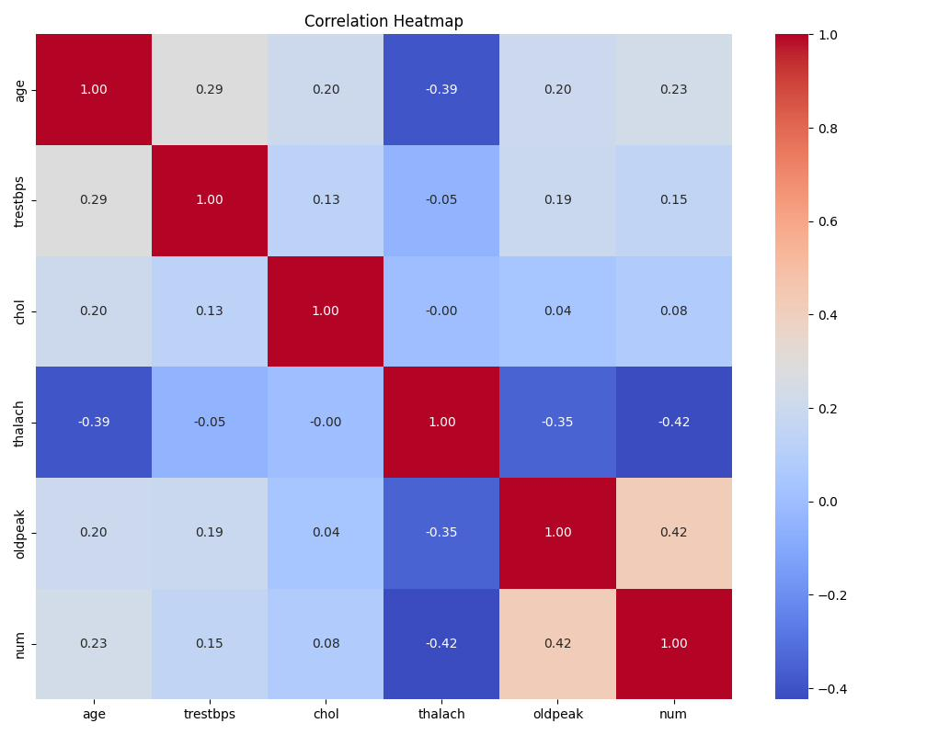
Figure 3.3 — Correlation heatmap of numeric features against the target. Max heart rate (thalach) shows the strongest negative correlation with disease presence; ST depression (oldpeak) shows a positive correlation.

Feature Relationships with Diagnosis
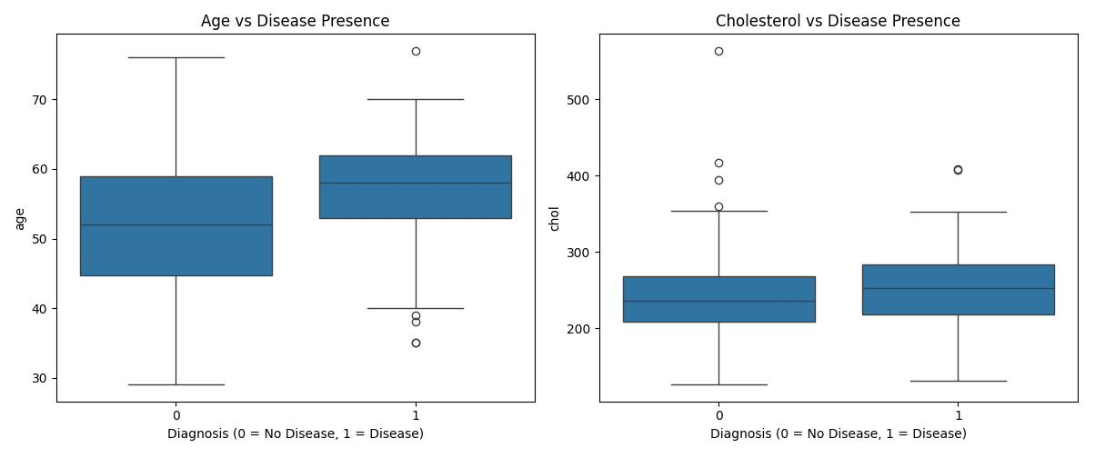
Figure 3.4 — Age and cholesterol compared across diagnosis groups. Patients with disease skew slightly older on average.

4. Feature Engineering & Model Development
Numeric features were standardized (zero mean, unit variance) using scikit-learn's StandardScaler prior to training. This step is necessary for Logistic Regression, which is sensitive to feature scale, and harmless for Random Forest, which is scale-invariant by design.
Data was split 80/20 into train and test sets using stratified sampling, preserving the original class ratio in both splits. Two classifiers were trained and tuned via 5-fold cross-validated GridSearchCV, optimizing for ROC-AUC:
- Logistic Regression — tuned over regularization strength C ∈ {0.01, 0.1, 1, 10}
- Random Forest — tuned over n_estimators ∈ {100, 200} and max_depth ∈ {None, 5, 10}

Model Comparison (default 0.5 threshold except where noted)
Metric | Logistic Regression | Random Forest
Best hyperparameters | C = 0.01 | n_estimators = 100, max_depth = 5
Accuracy | 0.850 (at threshold 0.35) | 0.800
Precision | 0.788 (at threshold 0.35) | 0.864
Recall | 0.929 (at threshold 0.35) | 0.679
ROC-AUC | 0.936 | 0.925

Decision Threshold Tuning
Logistic Regression outperformed Random Forest on every metric and was selected as the final model. At the default 0.5 probability threshold, recall was only 0.714 — meaning 29% of true disease cases would be missed. In a medical screening context, a false negative (missed disease) is more costly than a false positive (an unnecessary follow-up test).
A threshold sweep was performed on the held-out test set:
Threshold | Precision | Recall
0.50 | 0.870 | 0.714
0.40 | 0.800 | 0.857
0.35 (selected) | 0.788 | 0.929
0.30 | 0.750 | 0.964
0.25 | 0.651 | 1.000

A threshold of 0.35 was selected: recall improves substantially (71% → 93%) with only a modest precision drop (87% → 79%), and overall accuracy also improves (0.817 → 0.850). Lower thresholds (0.25) push recall to 100% but degrade precision to 65%, which was judged an unacceptable trade-off. This threshold is stored in the model's configuration file and applied consistently by the serving API.

ROC Curves & Confusion Matrices
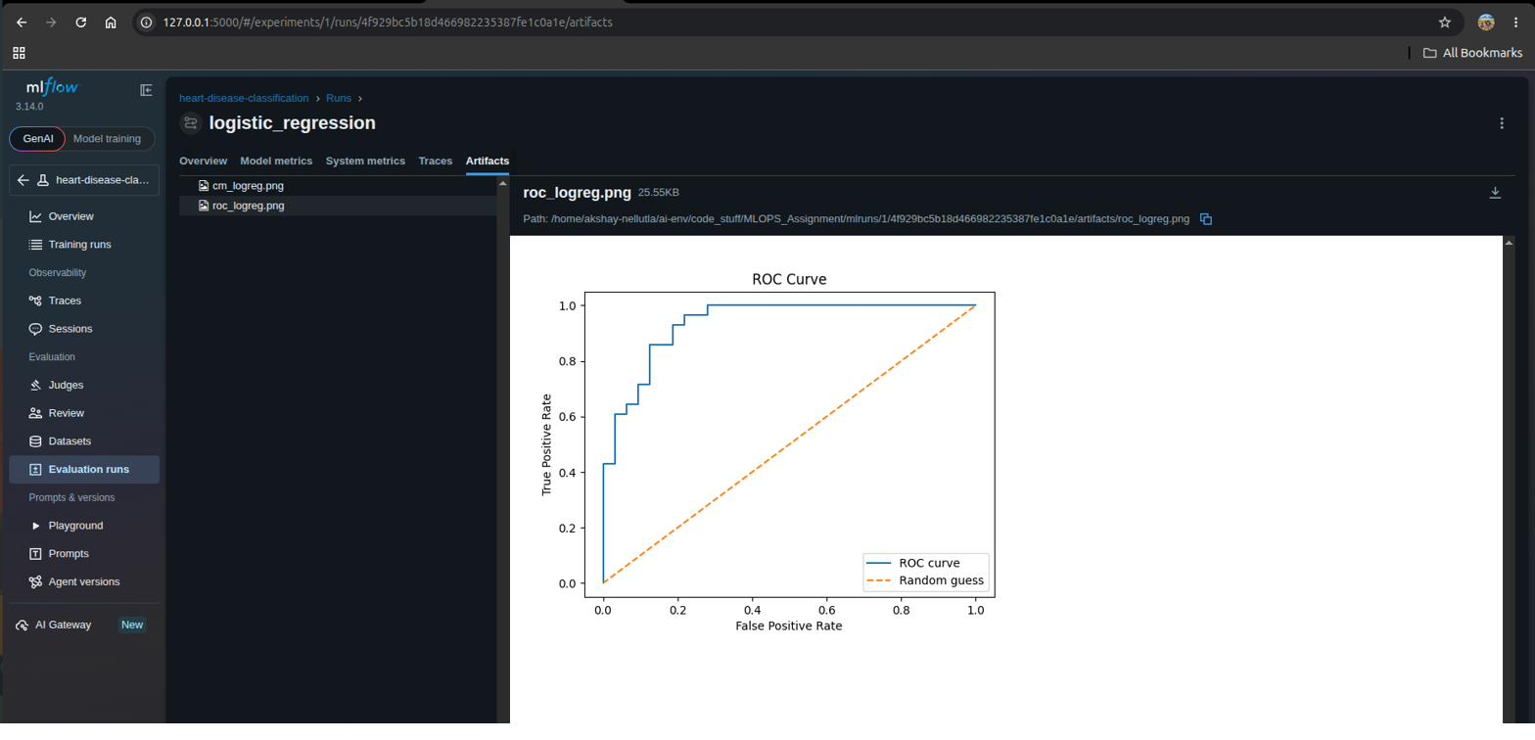
Figure 4.1 — ROC curve, Logistic Regression (AUC = 0.936).
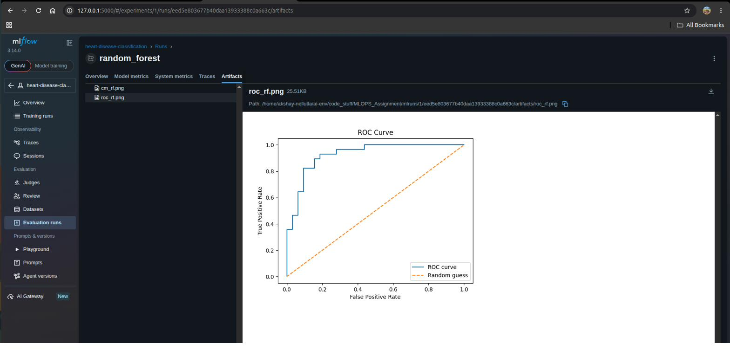
Figure 4.2 — ROC curve, Random Forest (AUC = 0.925).

5. Experiment Tracking with MLflow
Every training run logs its hyperparameters, evaluation metrics, and output artifacts (confusion matrix, ROC curve, and the serialized model itself) to MLflow, under a single experiment named heart-disease-classification. This replaces ad-hoc terminal output with a searchable, comparable record of every experiment.
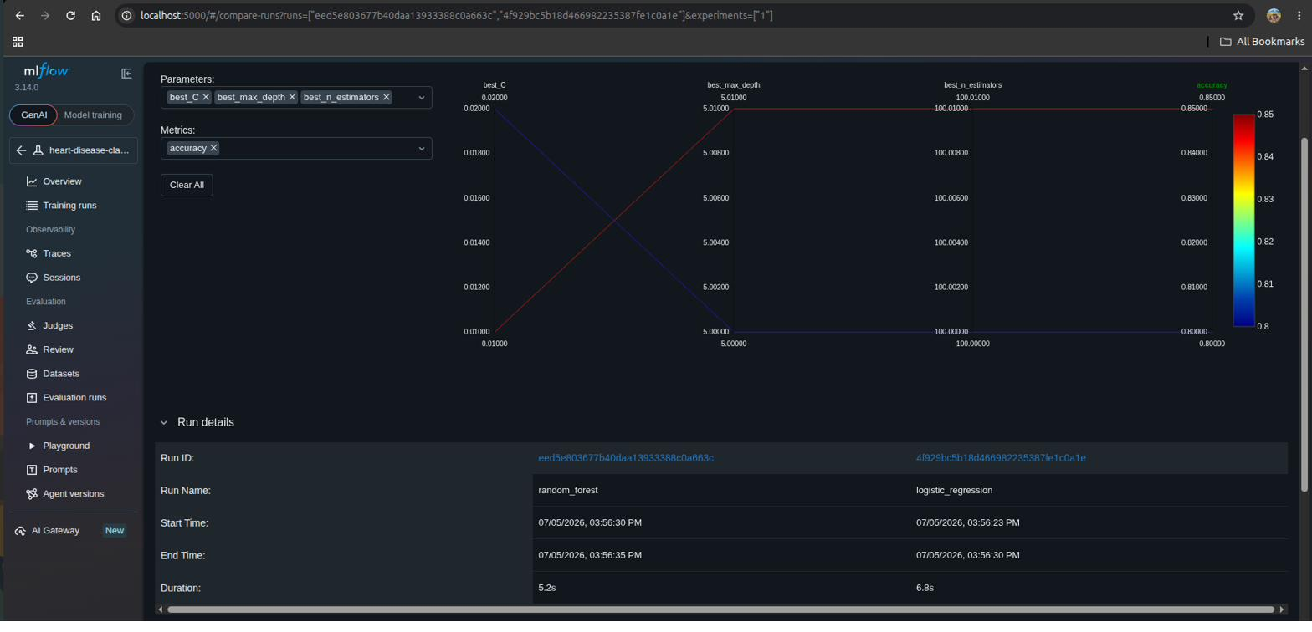
Figure 5.1 — MLflow run comparison: hyperparameters plotted against accuracy for both runs.
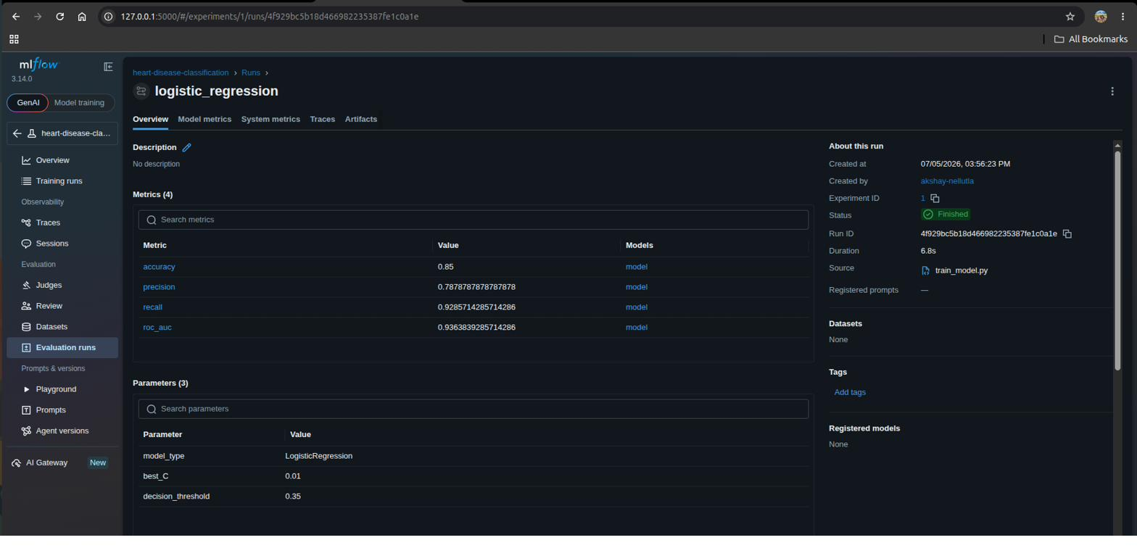
Figure 5.2 — MLflow run detail for the selected Logistic Regression model, showing logged parameters and metrics.
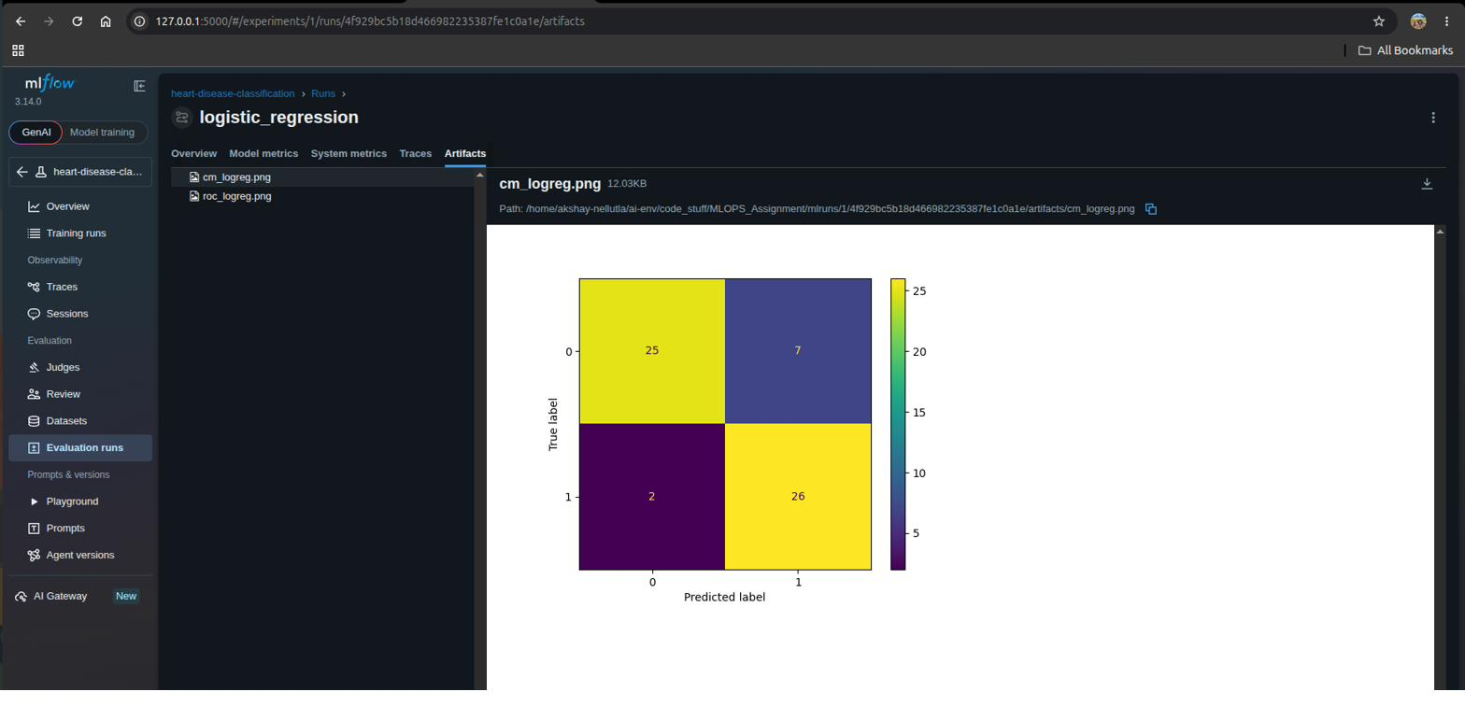
Figure 5.3 — Confusion matrix artifact logged for the Logistic Regression run (25 true negatives, 26 true positives, 7 false positives, 2 false negatives).

6. Model Packaging & Reproducibility
The final Logistic Regression model was retrained on the full cleaned dataset (all 297 records) using the best hyperparameter found during tuning (C = 0.01), to make the deployed model as well-informed as possible after evaluation was complete.
Three artifacts are saved to the models/ directory to guarantee reproducible inference:
- model.pkl — the trained Logistic Regression model (joblib format)
- scaler.pkl — the fitted StandardScaler, ensuring new data is scaled identically to training data
- model_config.json — the exact feature column order and the chosen decision threshold (0.35)
A requirements.txt file, generated with pipreqs (which scans actual imports rather than the full environment) and manually corrected for one dependency conflict, pins exact package versions for full environment reproducibility.

Resolved reproducibility issue
An initial version of the Docker image installed a newer scikit-learn version than the one used to train and save the model, producing an InconsistentVersionWarning at runtime. This was fixed by pinning scikit-learn in requirements.txt to the exact training-time version, eliminating the warning and guaranteeing identical behavior between training and serving environments.

7. CI/CD Pipeline & Automated Testing
Seven unit tests validate the data cleaning logic and the saved model artifacts:
- Data cleaning: target is correctly binarized, missing values are dropped, categorical columns are one-hot encoded, row counts match expectations
- Model artifacts: model and scaler load without error, the config file contains required keys, and a real input row produces a valid probability between 0 and 1
A GitHub Actions workflow (.github/workflows/ci.yml) runs automatically on every push to main. It checks out the code, installs dependencies, lints with flake8, and runs the full pytest suite — failing the build if any step errors.
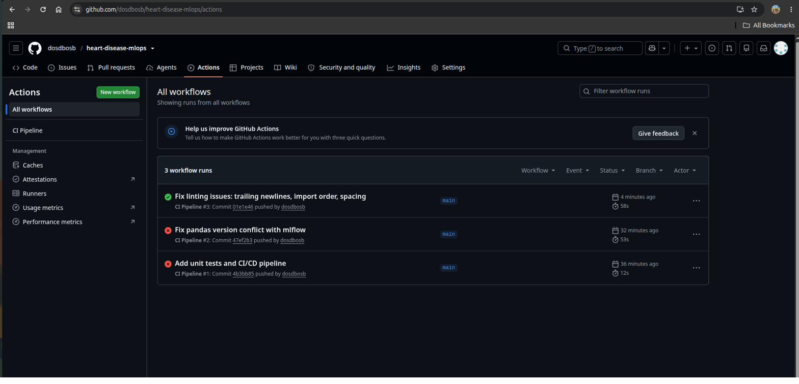
Figure 7.1 — Workflow run history. The first two runs failed intentionally-surfaced issues (a pandas/MLflow dependency conflict, then linting style violations); both were diagnosed and fixed, and the third run passed — demonstrating the pipeline correctly blocks broken code.
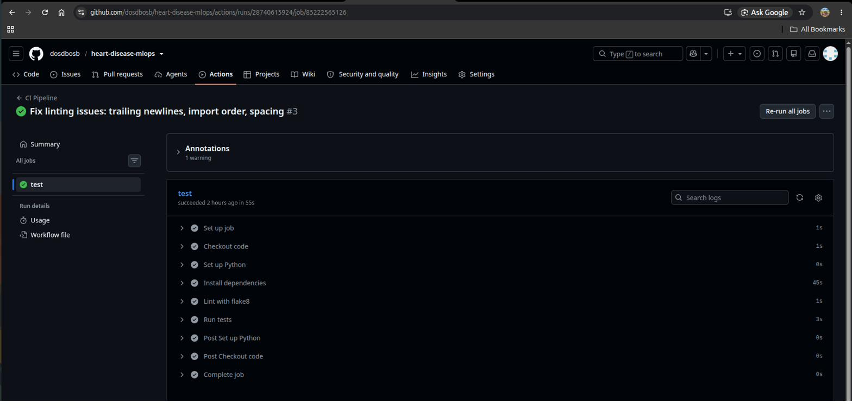
Figure 7.2 — Successful pipeline run showing all steps (checkout, dependency install, lint, test) passing.

8. Model Containerization
The serving API is built with FastAPI, exposing a POST /predict endpoint that accepts a JSON payload of patient attributes and returns a prediction, a confidence score, a human-readable diagnosis label, and the decision threshold used. Incoming data is one-hot encoded and column-aligned identically to training data before being scaled and passed to the model.
The Dockerfile uses a slim Python 3.12 base image, installs dependencies before copying application code (so unchanged dependency layers are cached across rebuilds), and runs Uvicorn bound to 0.0.0.0 so the API is reachable from outside the container.
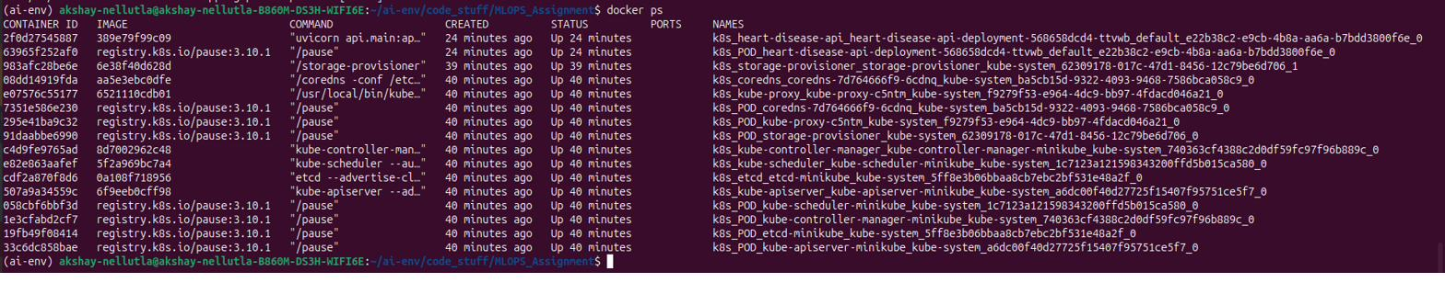
Figure 8.1 — docker ps confirming the container is running with port 8000 mapped.
Figure 8.2 — A successful prediction request against the containerized API via curl.
The container's identity as the source of the API response was independently verified: stopping the container immediately caused requests to fail (“connection refused”), and restarting it restored service — confirming API availability is entirely tied to the container's lifecycle, and that no separate local process was serving the requests.

9. Production Deployment (Kubernetes / Minikube)
The container was deployed to a local single-node Kubernetes cluster using Minikube. A Deployment manifest (k8s/deployment.yaml) runs one replica pod of the image, with imagePullPolicy: Never since the image was built directly inside Minikube's Docker environment rather than pulled from a registry. A Service manifest (k8s/service.yaml) of type NodePort exposes the pod on port 30080, making it reachable from the host machine.
In a real cloud deployment (AWS/GCP/Azure), a LoadBalancer-type Service or an Ingress resource would typically replace NodePort; NodePort was used here as the standard approach for local Minikube development.
Figure 9.1 — kubectl get pods: one pod running, zero restarts.
Figure 9.2 — kubectl get services: NodePort service mapping port 8000 to 30080.
Figure 9.3 — A successful prediction request sent through the Kubernetes-exposed service URL (via `minikube service --url`), confirming the full deployment path works end-to-end.

10. Monitoring & Logging
Two lightweight monitoring mechanisms were added to the API, proportional to this project's scale:
- Structured request logging — every prediction request is logged with a timestamp, the input age, the predicted class, the confidence score, and processing latency, written both to console and to a file (api_requests.log).
- A Prometheus-format /metrics endpoint — using the prometheus-client library, exposing a running total of requests, predictions broken down by outcome class, and a latency histogram. This endpoint is directly scrapeable by a real Prometheus server, without requiring one to be deployed for this assignment.
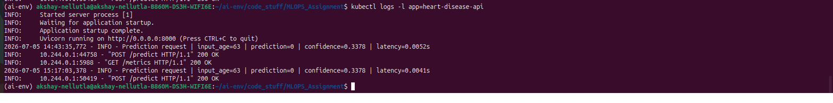
Figure 10.1 — Kubernetes pod logs showing a structured prediction log line alongside Uvicorn's own request logs.
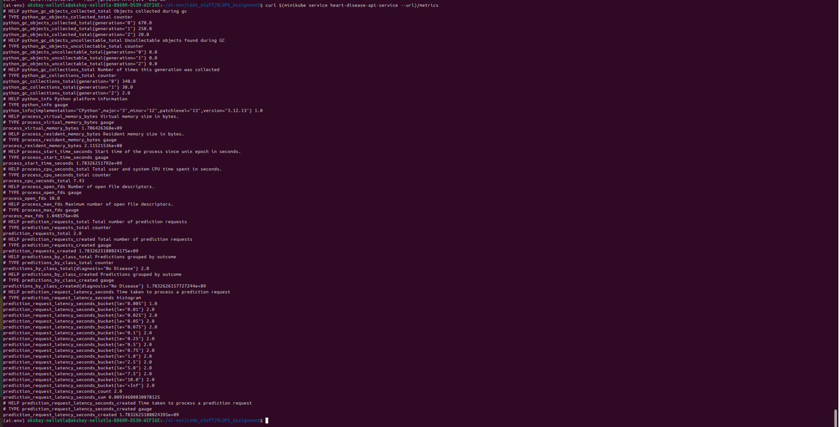
Figure 10.2 — /metrics endpoint output, showing prediction_requests_total, predictions_by_class_total, and request latency histogram buckets in standard Prometheus text format.
This kind of monitoring matters in production because model behavior can silently degrade over time (data drift, unexpected input patterns, latency regressions) without any visible error — metrics and logs are what make that degradation observable.

11. Architecture Diagram
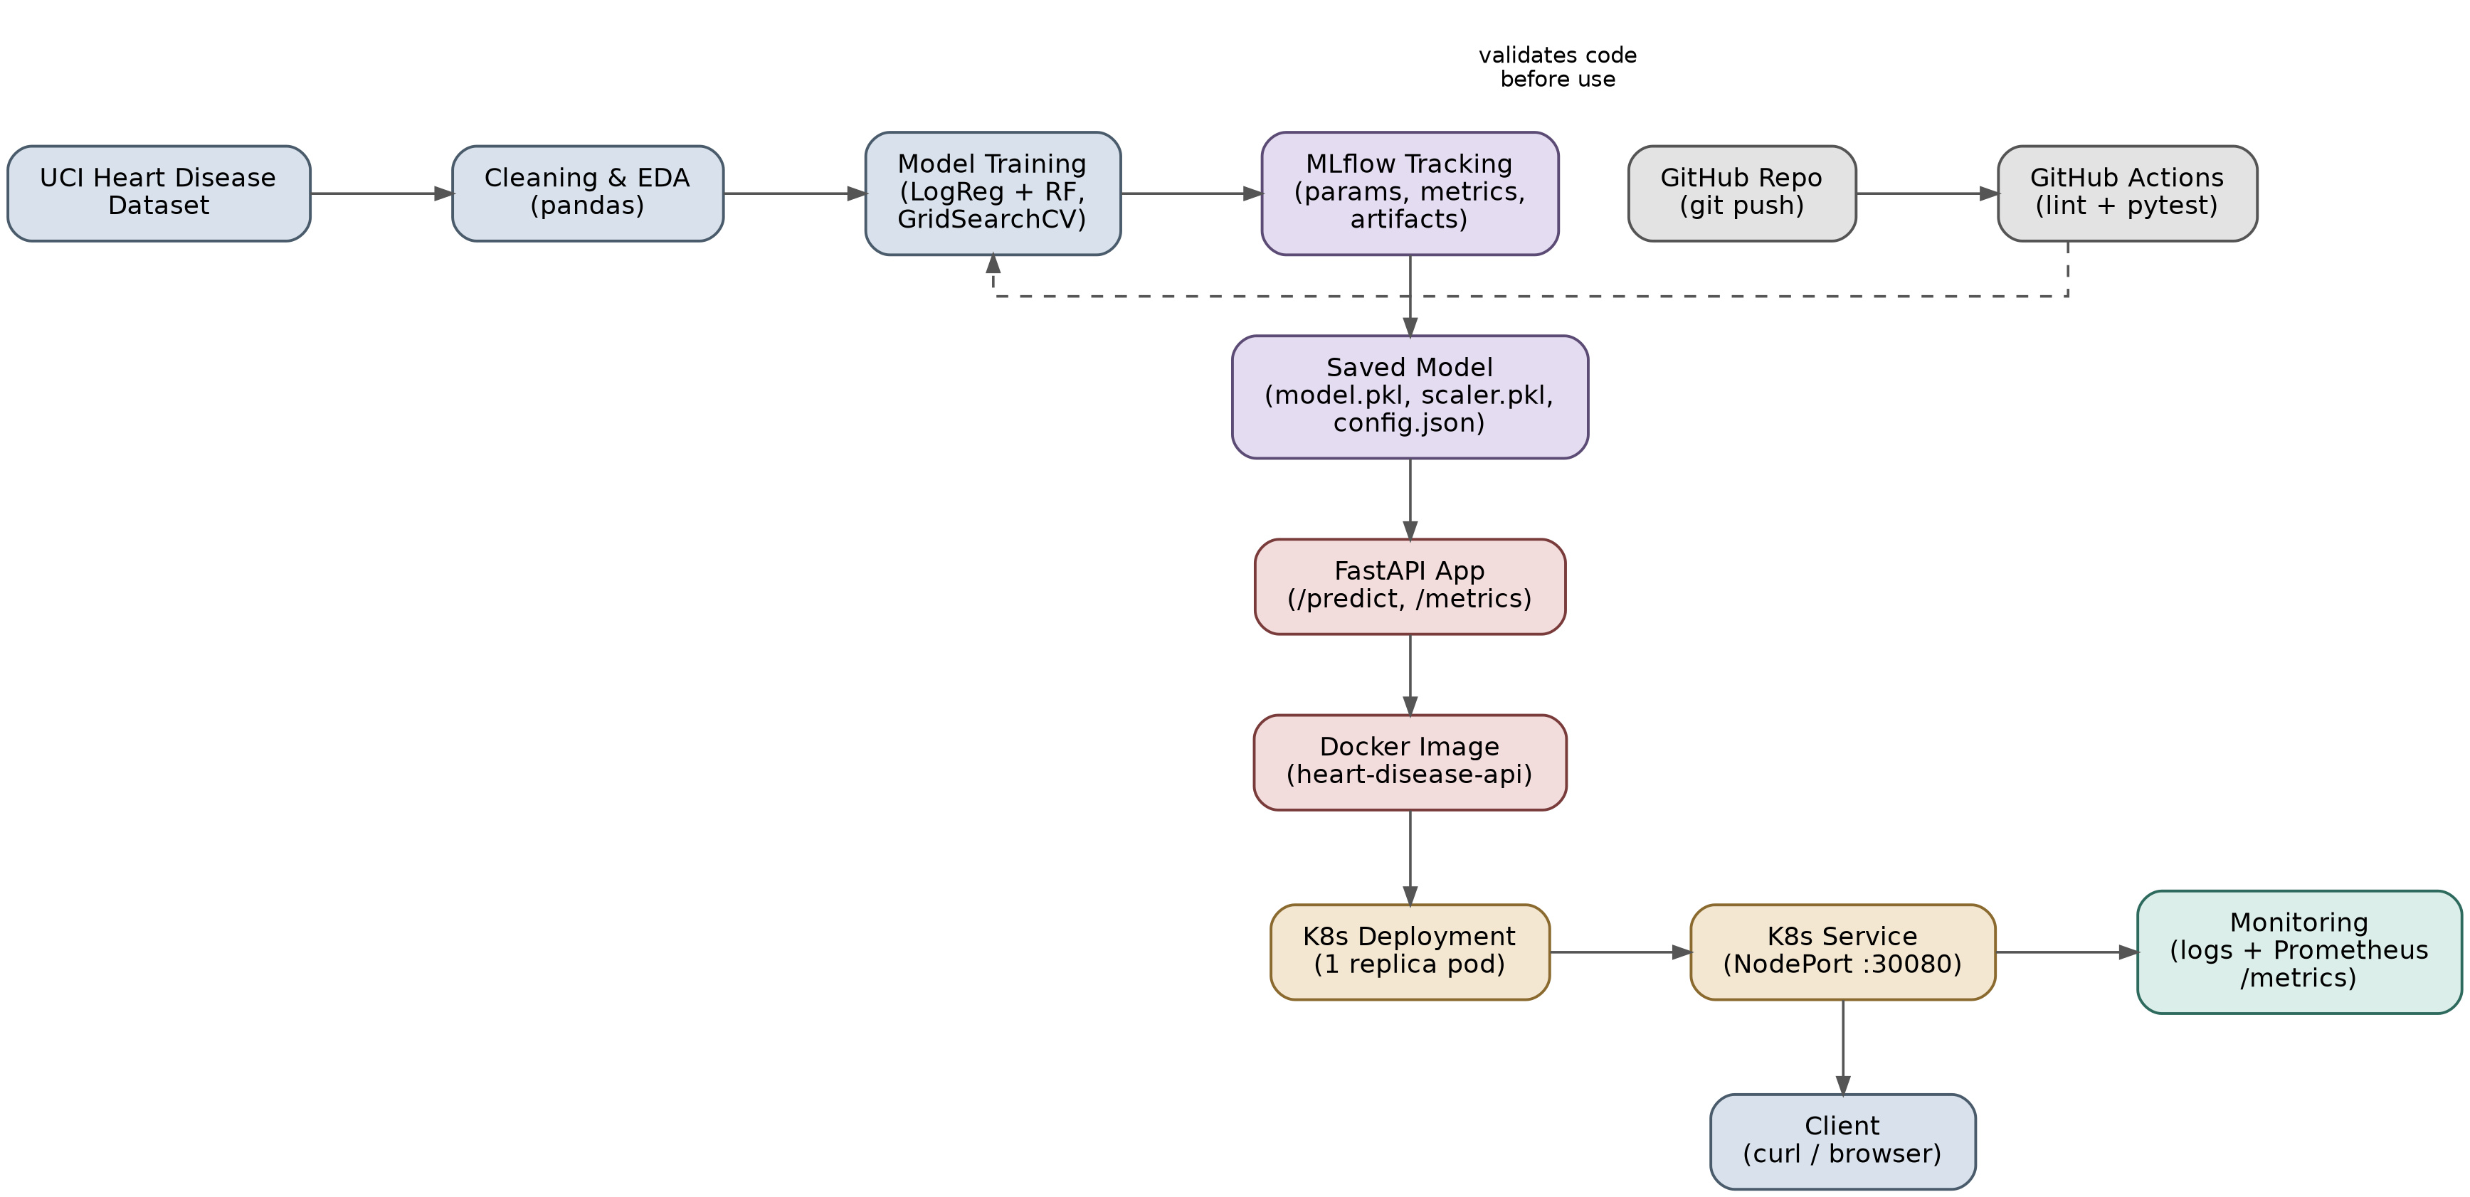
Figure 11.1 — End-to-end architecture: data pipeline and training (blue), experiment tracking and packaging (lavender), the serving API (rose), Kubernetes deployment (amber), monitoring (teal), and the CI/CD path (gray) that validates code before it reaches the tracked/deployed pipeline.

12. Conclusion & Repository
This project implements a complete MLOps lifecycle for a heart disease risk classifier: reproducible data preparation, comparative model development with a deliberately justified decision threshold, full experiment tracking, automated testing enforced by a CI/CD pipeline, a containerized serving API, deployment to a local Kubernetes cluster, and basic production monitoring.
The selected Logistic Regression model achieves 0.936 ROC-AUC and, at the chosen 0.35 decision threshold, a 92.9% recall — prioritizing the detection of true disease cases, which is the more clinically important error to minimize in a screening context.

Repository: https://github.com/dosdbosb/heart-disease-mlops

