Sneak preview of what 90% (or 99%) of our work is going to look like.

Foreword: this document became possible only to the fact that we finalized our understanding of WHAT the PCIe Endpoint's (core's) interface looks like, which is TLP packet wrapped in AXI wrapper. I hoped that we could use TLP packets directly but it appears we have to use some wrapper for TLP packets.Credits for finalizing of our decision on PCIe interface goes solely and exclusively to "PCIe Team or Sub-Team" which does not include myself because I am on OCP team. (Anyone can remove "personal" comments from here and use this document for pure technical stuff). [Man, why do I feel the urge to write all this Small Legal Print stuff? Legal engineering?]

Block RAM's FSM (as interfaced with PCIe).

Initially, our PCIe is interfaced with Block RAM test module, instead of Bridge's PCIe side. Block RAM test module should be written by us from scratch because it is easy to do and it will copy all PCIe side details of the Bridge. But we always can use examples for Block RAM creation from CoreGen or from anywhere else.

The states of our Block RAM FSM ("controller", or arbiter) are:

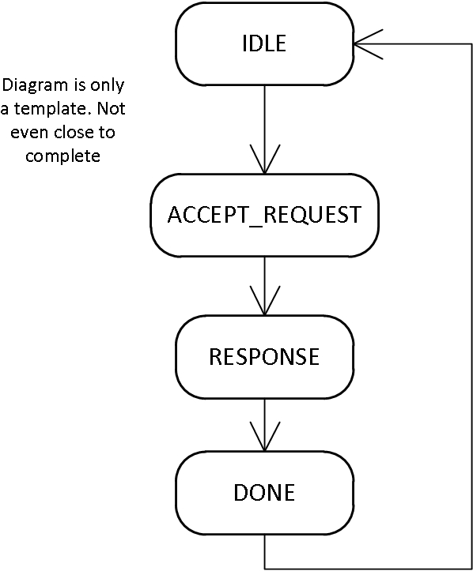

RESPONSE state is further expanded, per page 90 timing diagram of "Virtex-6 FPGA Integrated Block for PCIe", Figure 5-3: "TLP 3-DW Header Without Payload". In this diagram, our "user app" (Block RAM, or Bridge) is responding to some previous request, so it is in a RESPONSE state (states are actually called "SEND_FIRST_TLP", etc):

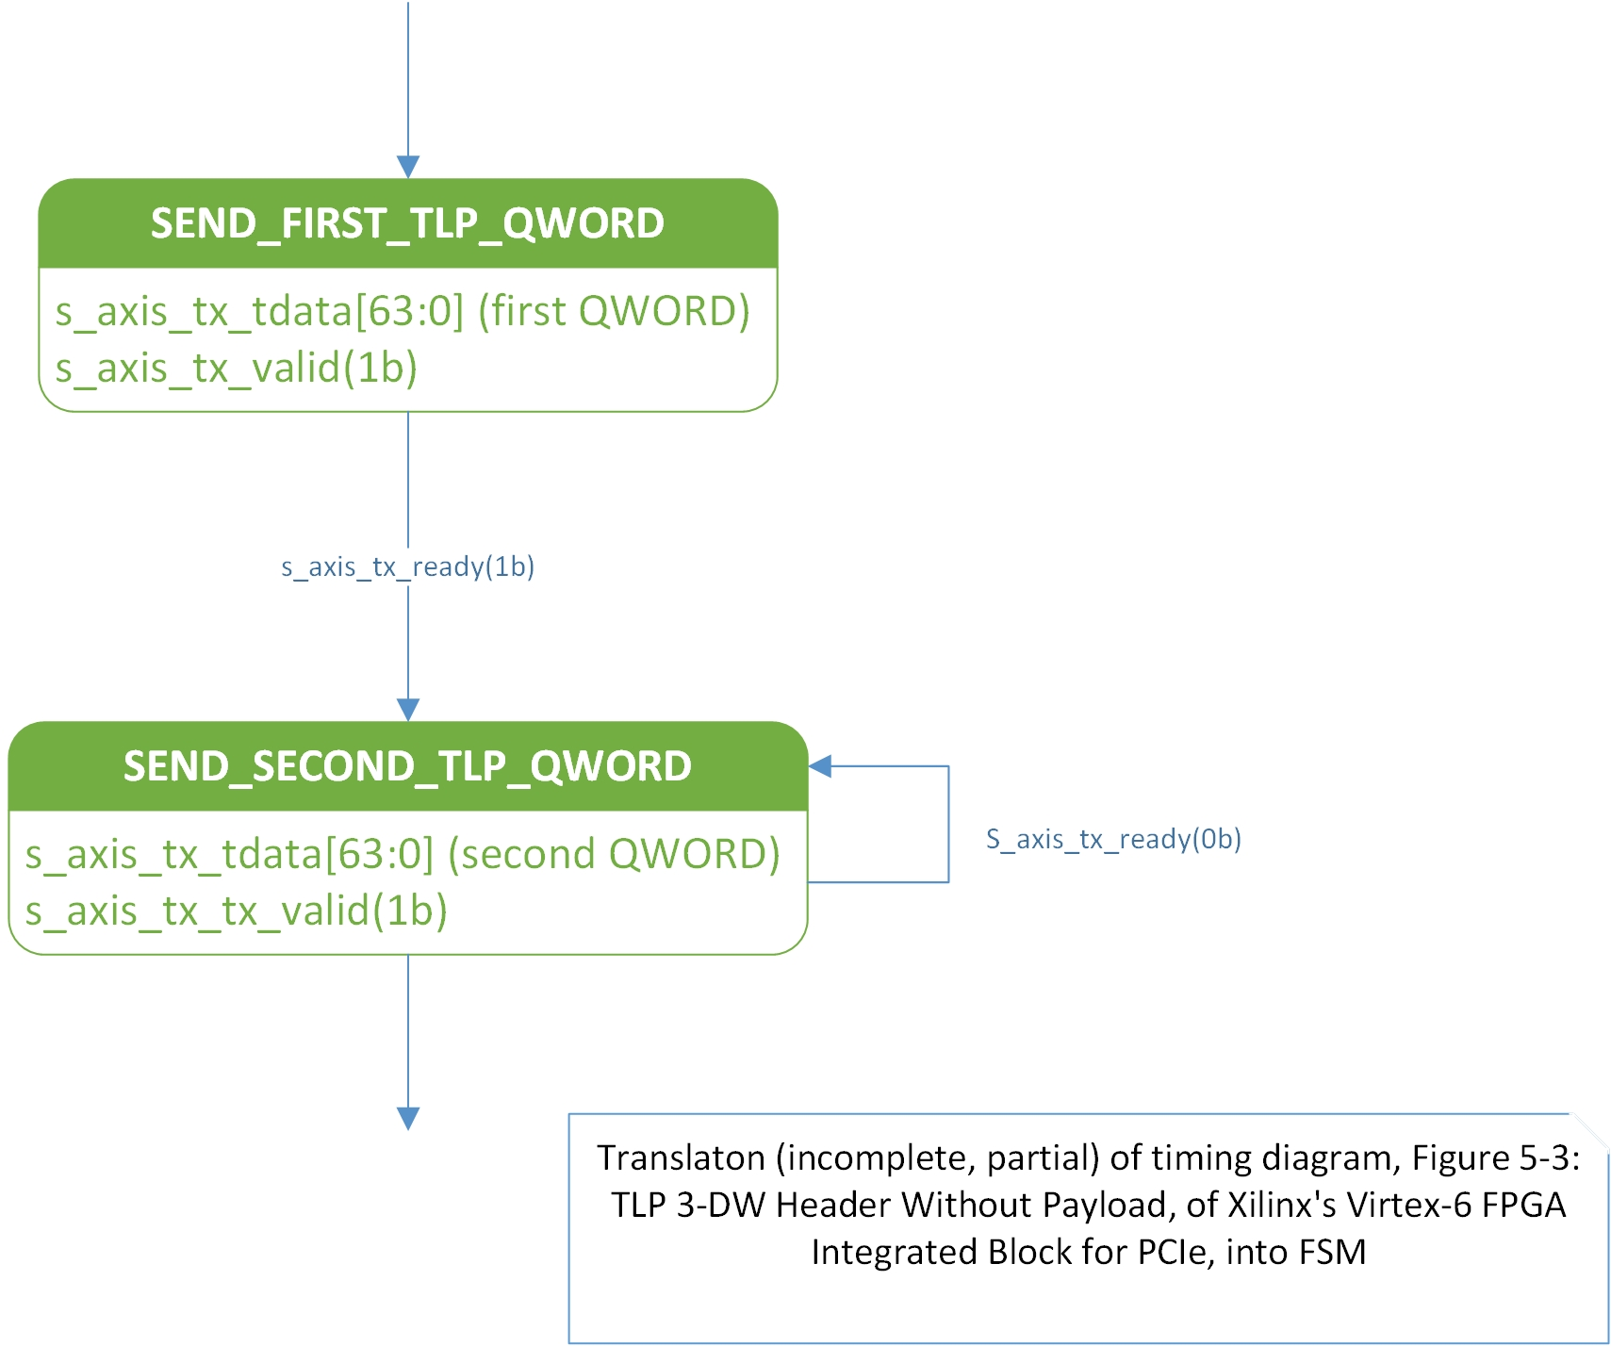

(1b) represents signal with wire state of "1", and (0b) is wire state with value "0"
Transition condition from one state to another is arrow with label where that label is a signal with certain value (1b or 0b).
State name is in green. Outputs are under the State Name, in white area of a "bubble" state block.

This FSM design stage is most labor intensive, most error-prone. After this stage, the coding is just straight from FSM diagrams, a no-brainer. But during the coding it is often the bugs in FSM logic are exposed, too, and FSM diagram is modified (iterative development).

FSM diagram tool used: Visio.

Visio 2010: I have not figured out yet how to use Visio's representation of state according to standard academic and scientific practice, "State with internal behavior": the State name goes above the line, and the outputs go under the line, but I saw pictures on Google of what seems to be Visio state representation (bubbles) with correct State Name / Outputs nodes (not manually drawn dashed line). It appears that Visio 2010 does not conform to accepted UML standard for representation of Finite Automata (e.g. State Machines): http://en.wikipedia.org/wiki/State_diagram_(UML)

Vision 2013 is compliant with UML Finite Automata representation standard.

Also, we cannot just copy diagram from Visio and paste diagram into Libre Office or OpenOffice. I had to first save the Visio diagram as JPEG and then insert JPEG into LibreOffice. But MS Office allows direct copy from Vision and pasting into Office.

Drawing these FSM diagrams in Visio is tedious and time consuming. I have heard (on google) that there might be some other ways of representing state machines such as tabular (tables) way. This might be topic of our investigations after we get fed up with drawing FSMs as diagrams.

