January 26, 2014

OCP Summary

Open Core Protocol (OCP) is a protocol for communications on busses. OCP is flexible, scalable and configurable protocol (as compared for example with very rigid PCI express protocol.)

Each device that wants to communicate on OCP bus should have either Master or Slave OCP interface, or both. Such interface is also called a socket or a port. A port (interface) is just an input and or output singal or signals for communication on the OCP bus. For each Slave (or Master) OCP socket on a bus there must be a corresponding (complimentary) Master or Slave OCP socket, respectively.
Master OCP port initiates OCP requests. Slave OCP port only responds to OCP requests.

eMMC (Flash memory)
module
OCP
(Slave
port,
socket,
inter-
face)
Bridge
OCP
(Master
port,
socket,
inter-
face)

It should be noted that Master or Slave are not controllers (not arbiters). They are just sockets (aka ports or interfaces) that were named so based on their function.

OCP Flash interface design will be simulated via loopback (dummy) Flash module with Slave OCP interface. Loopback OCP-interfaced module will have an array, Address_Data, to store the data being written and read. Flash needs only Slave OCP interface because Flash memory only responds to requests from the Bridge or a bus anddoes not initiate any requests. Verilog module Flash initially will have minimum OCP Slave interface which allows Write or Read request of a single word.

OCP Slave interface signals required to accomplish a non-posted Write are:
OCP Clock: Input. 1 bit. Sampled on rising edge
Reset: Intput. 1 bit.
MCmd: Input. 3 bits. Command from master. Read, Write, etc.
MAddr: Input. Configurable width. Address.
MData: Input. Configurable width. Data from master (Bridge), to write to slave.
SCmdAccept: Output. 1 bit. Asserted by Slave "command accepted" signal
SResp: Output. 2 bits. Slave's Response to Master's request.
E.g., data succesfully written to slave device.
SData: Data returned by Slave (Flash) to Master (Bridge). Configurable width.

Simple Non-Posted Write operation:
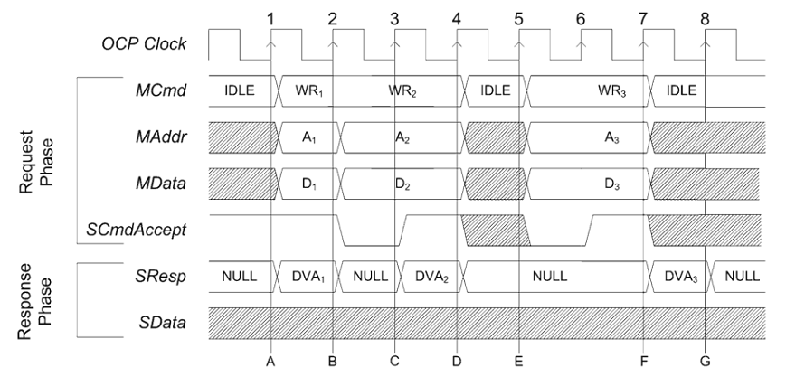
MCmd values (partial listing):
Idle (IDLE) 000
Write (WR) 001
Read (RD) 010
Non Posted Write (WRNP) 101

SResp values (partial listing):
NULL 00 No response
Data valid/accept 01 DVA
Request failed 10 FAIL
Response error 11 ERR

Simple Read operation of a device on a bus is as follows:
Master places command, MCmd, and Address on the bus. Slave asserts SAccept upon accepting command and address.
Simple Write operation: master places command, address and data on the bus. Slave asserts SAccept indicating it accepted the request. Upon succesful write operation slave asserts DVA for one OCP clock cycle.

Verilog module named Flash should have following OCP interface (e.g, to Bridge module):

module Flash (
input ocp_clk,
input sys_reset,
input [2:0] MCmd,
input ['ADDR_WIDTH-1:0] MAddr,
input ['DATA_WIDTH-1:0] MData,
output SCmdAccept,
output [1:0] SResponse,
output ['DATA_WIDTH-1:0] SData
);

Note: this seems like much simpler interface compared to PCIe. Unless I am missing something.
Inside of Flash module we will have memory array data structure:
reg ['DATA_WIDTH-1:0] flash_memory [0:'ADDRESS_WIDTH-1];
Flash FSM (controller) code will handle writing, reading data from this array and handling of the OCP interface signals (state).

