A
PROJECT SYNOPSIS
ON
“Strings – An Artsy Social Networking Site”

Submitted to
Rashtrasant Tukadoji Maharaj Nagpur
University, Nagpur

In the Partial Fulfillment of
B. Com. Computer Application Final Year

Submitted By
Mr. Doshant Giradkar

Under The Guidance of
Prof. Shripad Dixit



G.S. College of Commerce, Wardha
2023-24

Introduction:
- In an era where every artist’s dream is to stand out, Strings emerges as the bridge between creators and their global audience. Whether you wield a stylus or a mouse, this digital gallery invites you to showcase your masterpieces, share your process, and find kindred spirits who resonate with your vision.
- Curate your digital gallery. Showcase your best work, from that mesmerizing digital landscape to the quirky pixel portrait. Each piece is a thread in your artistic journey on Strings.
Objectives of the project: -
- To allow artists to create profiles and share their artwork.
- To enable artists to connect with each other.
- To provide features for discovering and appreciating artwork.
- To build an engaging community for artists around the world.
Project Category: -
- Full Stack Web Application:
A Full Stack Web Application is an application which implements both Backend, Frontend & Database, And serves webpages to its users, as per the user’s request.
Tools Platform/Languages to be used: -
- Front End: HTML, CSS, JavaScript
- Back End: NodeJS, PostgreSQL
Software Requirements: -
- Vscode: Vscode is a lightweight but powerful code editor that runs on multiple operating systems including windows, linux and
- Browser: A browser is an application which is used to request web-urls and render the output to users.
- NPM: Node Package Manager is the command line tool, used to manage external libraries & dependencies in a NodeJS project.
Hardware Requirements: -
- Processor: Dual Core Processor
- Ram: 2 GB RAM Or More
- Hard Disk: 8 GB Of Free Space Or More

Complete structure of the system:-
- Number of module and its description:
- Login & Registration Module: This module contains login & registration form, to allow users to login & register to the application.
- Upload Module: This module contains a HTML POST from for upload. And the functionality to upload images with the title
- Like & Dislike Module: This module handles the functionality of Like & Dislike.
- Delete Module: Allows user to delete their own post, and administrator to delete other user’s posts.
- Content Module: The content moudle adds the content to HTML document, before sending it over to users.

- E-R Diagram: -
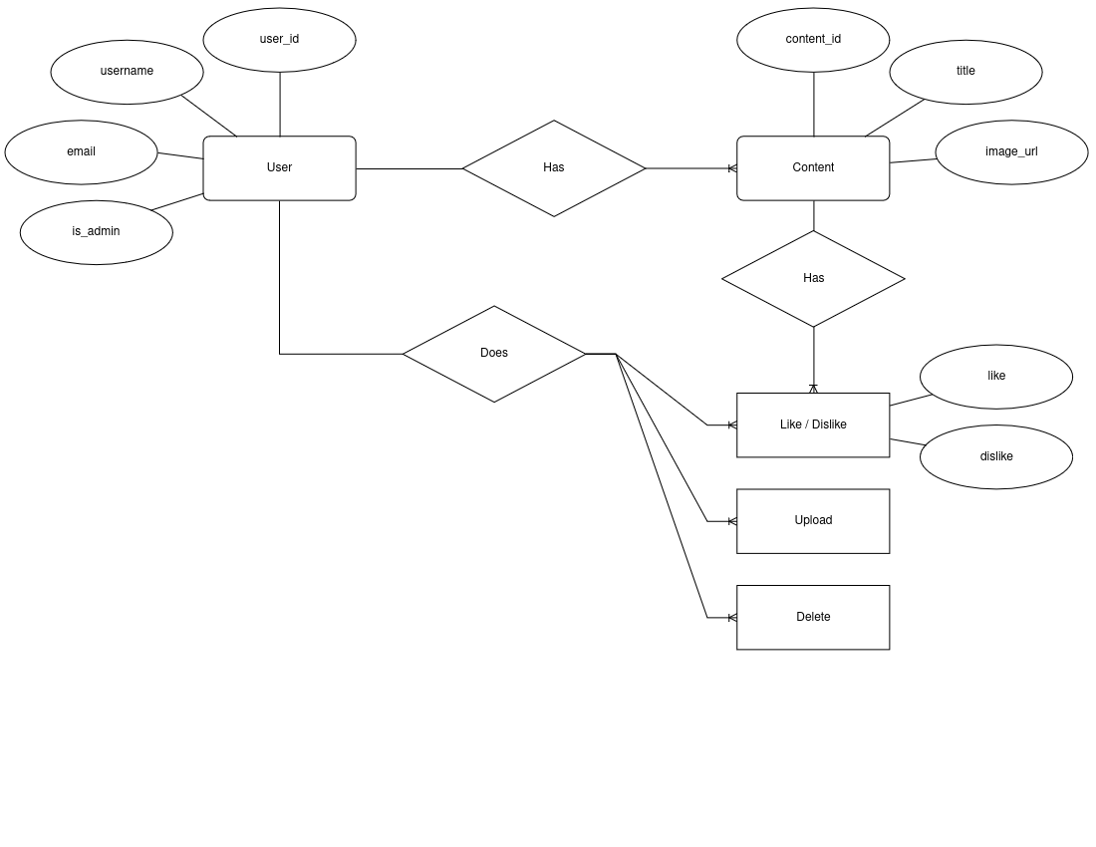

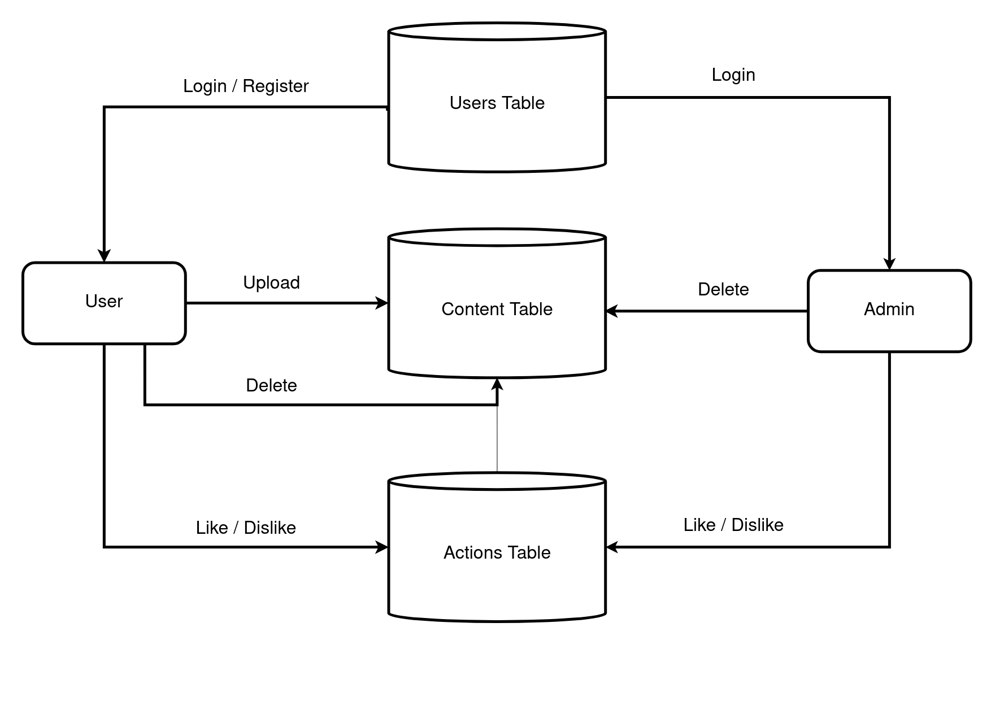
- Modular Chart: -

- Data Structure or Tables

- Users Table
Feild | Type | Description
user_id | INTEGER | NOT NULL AUTO INCREMENT PRIMARY KEY
username | VARCHAR(50) | NOT NULL UNIQUE (50 characters)
email | VARCHAR(255) | NOT NULL UNIQUE (255 characters)
is_adm | BOOLEAN | NOT NULL
pass_hash | VARCHAR(255) | NOT NULL (255 characters)
- Content Table
Feild | Type | Description
content_id | BIGINT | NOT NULL AUTO INCREMENT PRIMARY KEY UNIQUE
user_id | INTEGER | NOT NULL FOREIGN KEY
title | VARCHAR(255) | NOT NULL (Size 255 characters)
img | VARCHAR(255) | NOT NULL UNIQUE (Size 255 characters)
- Actions Table
Feild | Type | Description
content_id | BIGINT | NOT NULL FOREIGN KEY
user_id | INTEGER | NOT NULL FOREIGN KEY
_like | BOOLEAN
_dislike | BOOLEAN
Submitted by
Mr. Doshant M. Giradkar

