CLSR- Core LSRs | ELSR- Edge LSRs | H-Hosts

Tunnel- T1 | Tunnel- T2

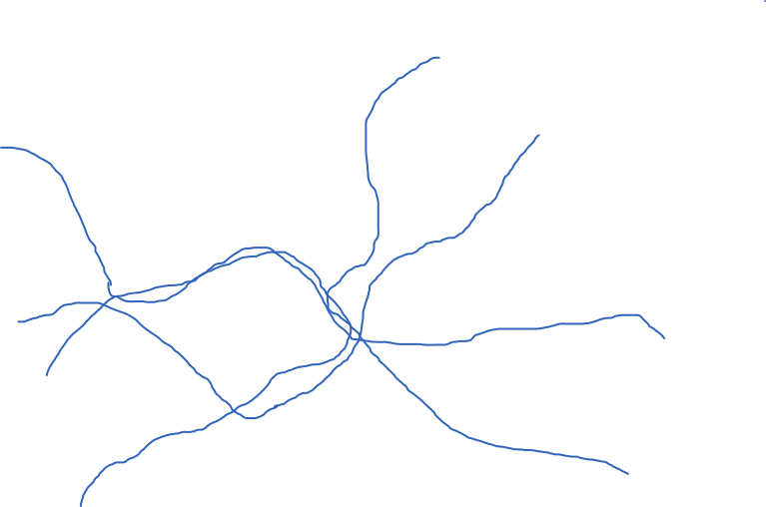

H5

ELSR2

H9

H8

H7

H6

H4

H3

H2

H1

ELSR6

ELSR7

ELSR5

ELSR4

ELSR3

ELSR1