Báo Cáo CSDL

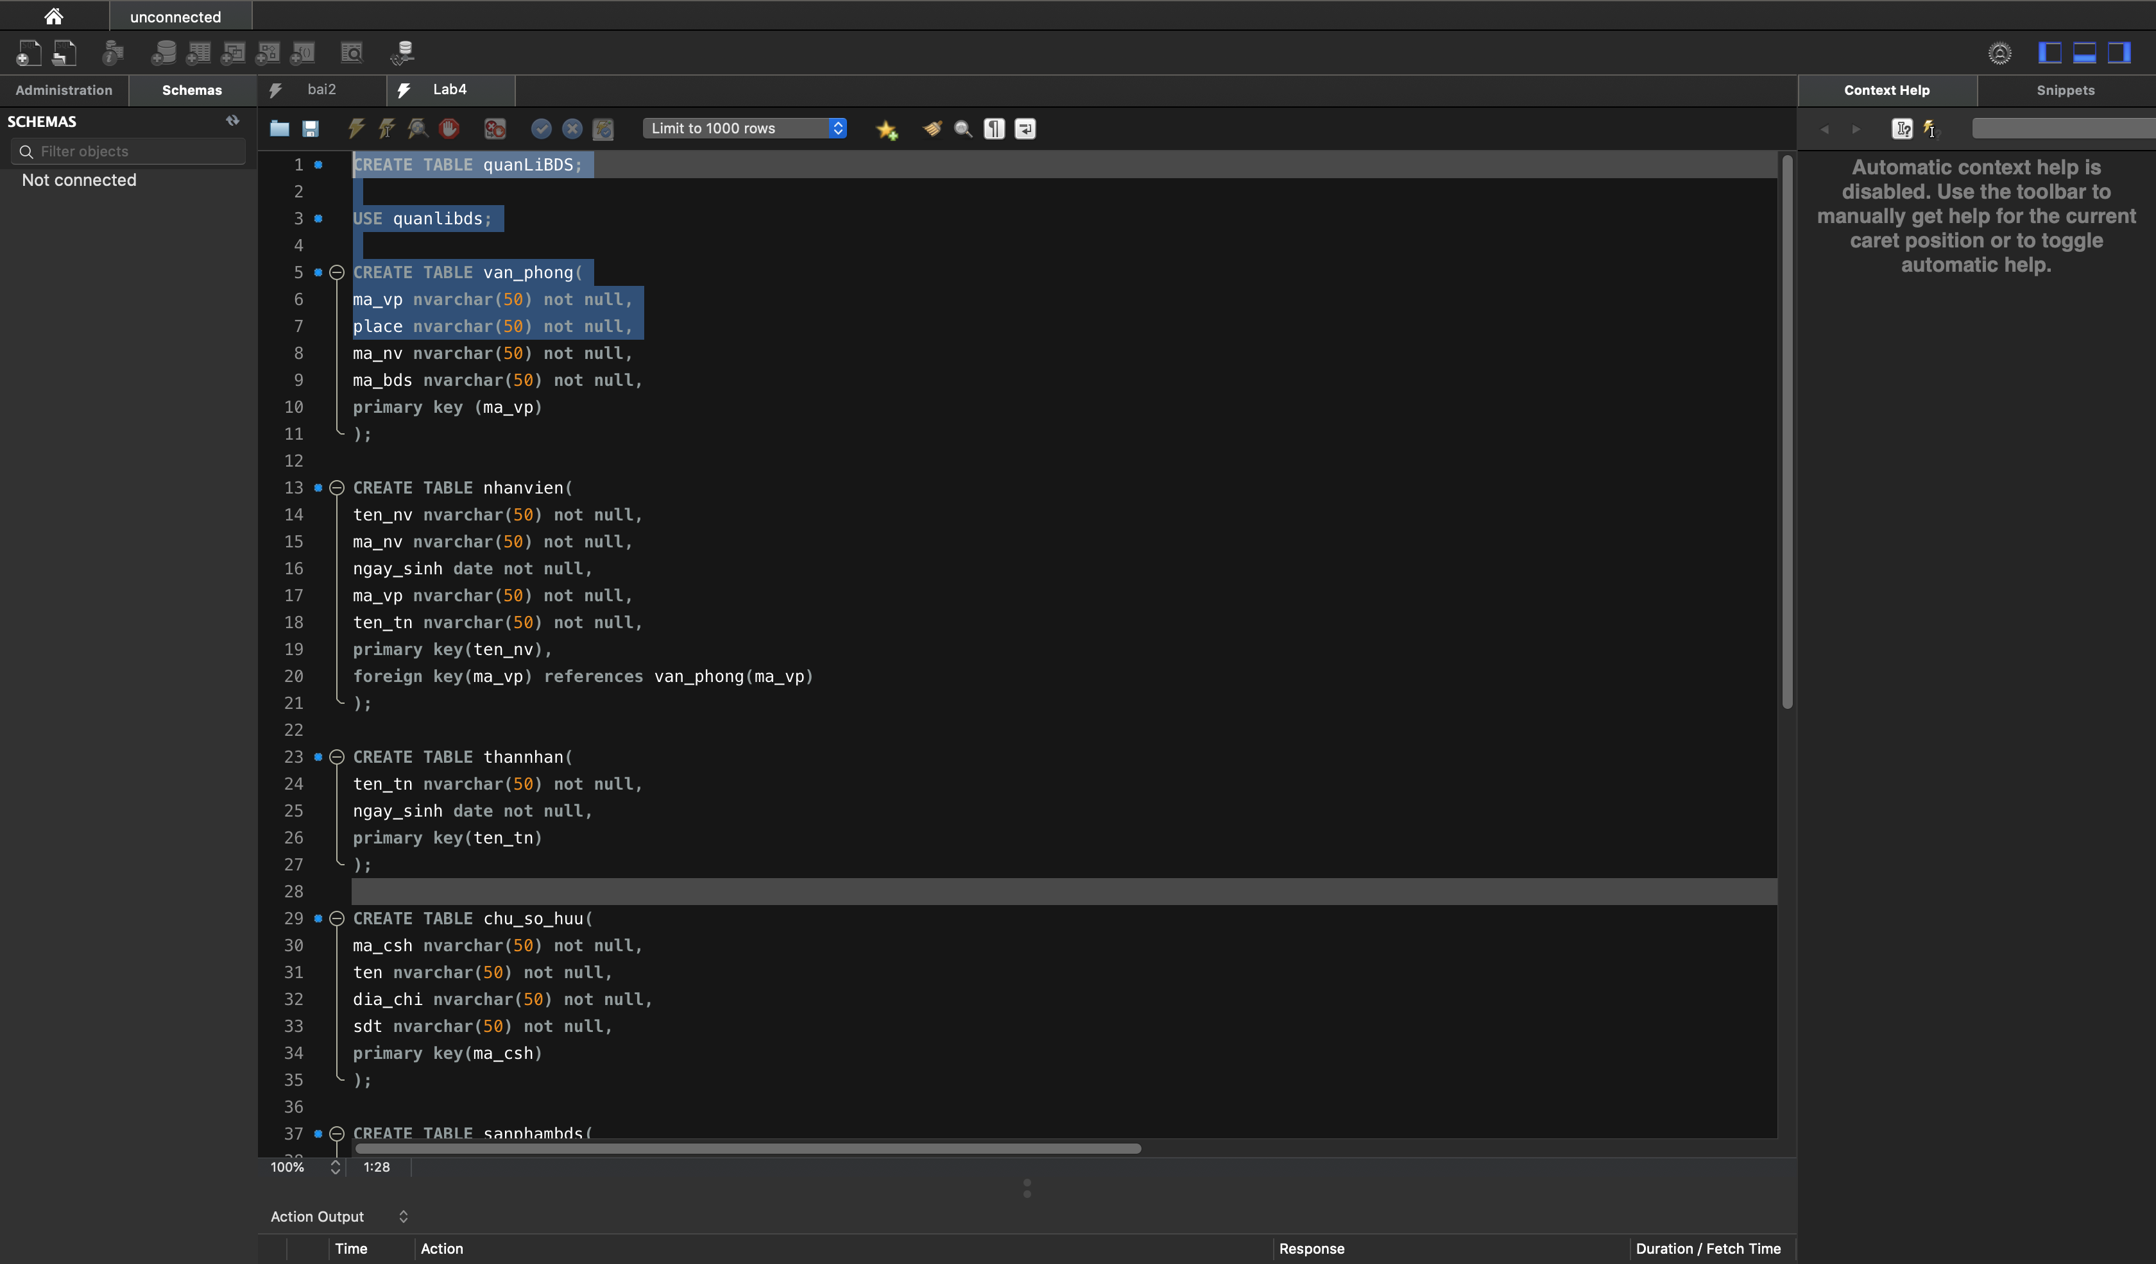

CREATE TABLE quanLiBDS;

USE quanlibds;

CREATE TABLE van_phong(

ma_vp nvarchar(50) not null,

place nvarchar(50) not null,

ma_nv nvarchar(50) not null,

ma_bds nvarchar(50) not null,

primary key (ma_vp)

);

CREATE TABLE nhanvien(

ten_nv nvarchar(50) not null,

ma_nv nvarchar(50) not null,

ngay_sinh date not null,

ma_vp nvarchar(50) not null,

ten_tn nvarchar(50) not null,

primary key(ten_nv),

foreign key(ma_vp) references van_phong(ma_vp)

);

CREATE TABLE thannhan(

ten_tn nvarchar(50) not null,

ngay_sinh date not null,

primary key(ten_tn)

);

CREATE TABLE chu_so_huu(

ma_csh nvarchar(50) not null,

ten nvarchar(50) not null,

dia_chi nvarchar(50) not null,

sdt nvarchar(50) not null,

primary key(ma_csh)

);

CREATE TABLE sanphambds(

ma_bds nvarchar(50) not null,

ten_bds nvarchar(50) not null,

ma_csh nvarchar(50) not null,

ma_vp nvarchar(50) not null,

primary key(ma_bds),

foreign key(ma_vp) references van_phong(ma_vp),

foreign key(ma_csh) references chu_so_huu(ma_csh)

);

CREATE TABLE chitiet_tn(

ten_tn nvarchar(50) not null,

ten_nv nvarchar(50) not null,

moi_quan_he nvarchar(50) not null,

primary key(ten_nv,ten_tn),

foreign key(ten_tn) references thannhan(ten_tn),

foreign key(ten_nv) references nhanvien(ten_nv)

);

CREATE TABLE truong_phong(

ten_tp nvarchar(50) not null,

ma_tp nvarchar(50) not null,

ma_vp nvarchar(50) not null,

foreign key(ma_vp) references van_phong(ma_vp)

);