1. 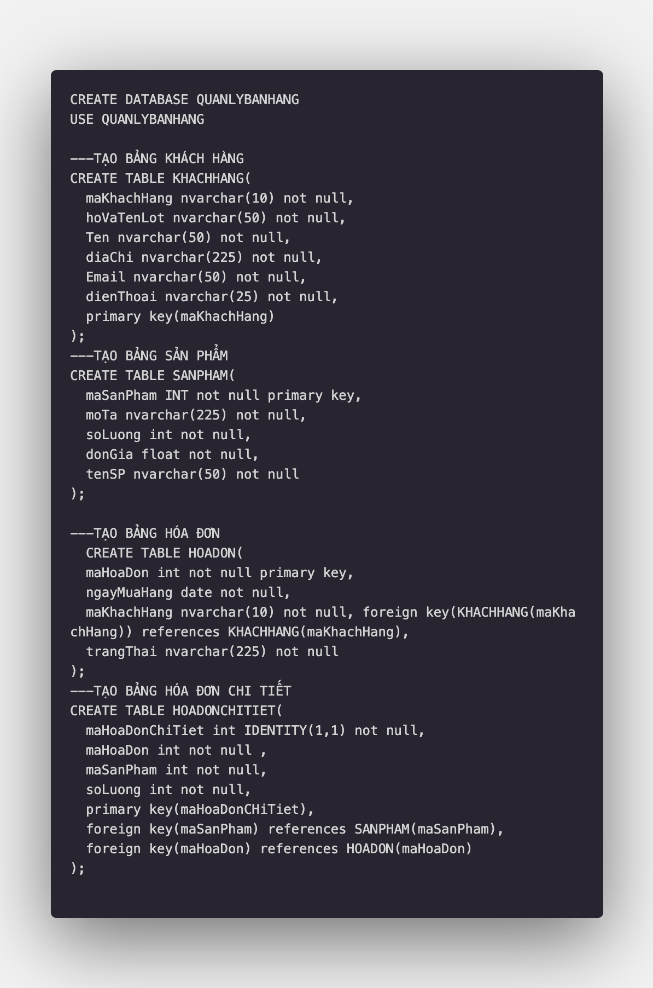Tạo bảng liên kết
2. Nhập Dữ liệu

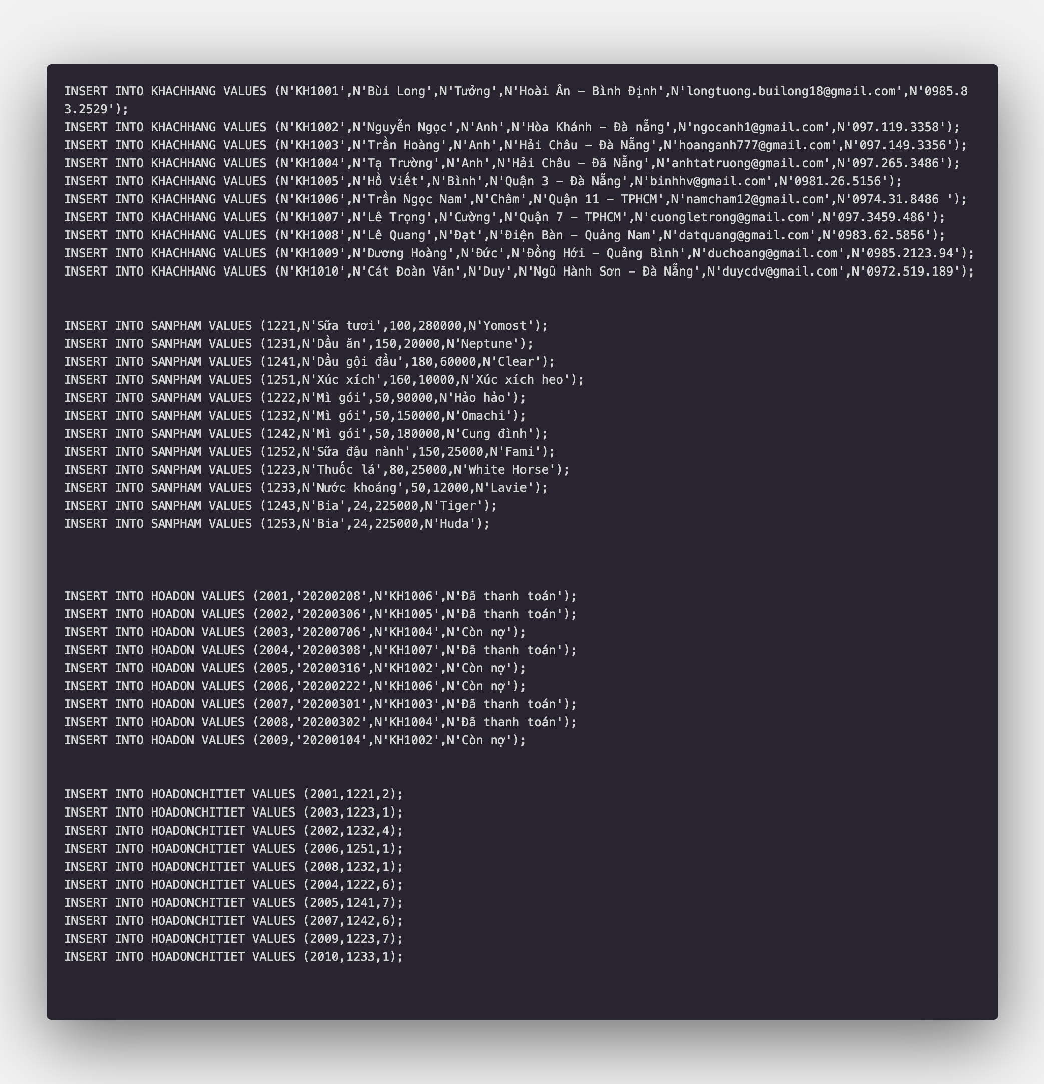

1. Truy vấn dữ liệu

Phần 1

Bài 1

1a: SELECT\*FROM KHACHHANG

Select \* from table

1b: SELECT TOP(10)

maKhachHang,hoVaTenLot,Ten,Email,dienThoai FROM KHACHHANG

* Get top 10 from table khach hang

1c: SELECT maSanPham,tenSP, donGia\*soLuong AS TongTienTonKho FROM SANPHAM

* Alias

1d: SELECT maKhachHang,CONCAT(hoVaTenLot,Ten) AS HoVaTen , diaChi FROM KHACHHANG

* Concat and alias

1e: SELECT\*FROM KHACHHANG WHERE diaChi LIKE N'%Đà Nẵng%'

* Select table end find character “ da nang”

1f: SELECT\*FROM SANPHAM WHERE soLuong > 100 and soLuong < 500

* Filter value 100 to 500

1g: SELECT\*FROM HOADON WHERE trangThai = N'Còn nợ' and ngayMuaHang LIKE '%2020%'

* Filter more condition

1h: SELECT\*FROM HOADON WHERE maKhachHang in (N'KH1001',N'KH1003',N'KH1006')

Phần 2:

Bài 2:

2a. SELECT COUNT(\*) FROM KHACHHANG

2b. SELECT MAX(donGia) FROM SANPHAM

2c. SELECT MIN(soLuong) FROM SANPHAM

2d. SELECT SUM(soLuong) FROM SANPHAM

2e. SELECT COUNT(\*) FROM HOADON WHERE trangThai = N'Còn nợ' and ngayMuaHang LIKE '%2020%'

2f. SELECT maHoaDonChiTiet,soLuong FROM HOADONCHITIET INNER JOIN HOADON ON HOADON.maHoaDon = HOADONCHITIET.maHoaDon

2g. SELECT maHoaDonChiTiet,soLuong FROM HOADONCHITIET INNER JOIN HOADON ON HOADON.maHoaDon = HOADONCHITIET.maHoaDon WHERE soLuong > 5

2h. SELECT\*FROM HOADON ORDER BY ngayMuaHang DESC ( filter)