Section Assignment 3

1. True OR False
   1. True
   2. True
2. The run method calls bludger(2001);
   1. The bludger method sets int x to y(2001) / 1000, z to x +y(2+2001)
   2. X is the set to quaffle(z,y)
      1. The quaffle method calls the snitch method
      2. The snitch method sets y to x / the remainder of x /10
      3. The snitch method prints a statement and the different variables then returns y
   3. The final output is: [ bludger: x = 1001+ 2001 = " + 2001 + 2003 = + 2003]
3. Solution for question 3

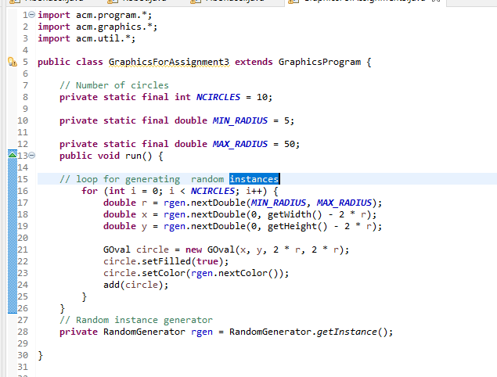

1. The solution for question 4, though I wasn’t able to print lines with this code

