Capítulo 1

[
exp2flux: Convert Gene EXPression Data to FBA FLUXes.]Constraining a tissue-specific metabolic reconstruction: Incorporating expression data as FBA limits through ‘exp2flux’ R package.
Original title: | exp2flux: Convert Gene EXPression Data to FBA FLUXes.
Written by: | Daniel Osorio, Kelly Botero, Janneth Gonzalez and Andrés Pinzón-Velasco

Abstract
Computational simulations of metabolism can help to predict the metabolic phenotype of an organism in response to different stimuli, through constraint-based modeling approaches. To recreate specific metabolic phenotypes and enhance the model predictive accuracy, several methods for the integration of transcriptomics data into constraint-based models have been proposed. The majority of available implemented methods are based on the discretization of data to incorporate constraints into the metabolic models via boolean logic representation, which reduces the accurate of physiological representations. The implemented methods for gene-expression data integration as continuous values are very few. The exp2flux package was designed as a tool to incorporate in a continuous way the gene-expression data as FBA flux limit in a metabolic reconstruction. Also, a function to calculate the differences between fluxes in different metabolic scenarios was included.

1 Introduction
Metabolism is a cellular system suited for developing studies at the systemic level of the genotype-phenotype relationship and genetic interactions 1 (). Genome sequencing projects have been contributed to our understanding of the metabolic capabilities in cellular systems since functional annotation of the gene products (enzymes) allow the reconstruction of genome-scale metabolic networks (GMNs), that summarize these metabolic capabilities consistently and compactly in a stoichiometric matrix 2 (); 3 (). The GMNs can be converted into computational models to predict the metabolic phenotype of an organism in response to different stimuli, through constraint-based modeling approaches 4 (); 5 (). A widely used approach to perform in silico metabolic simulations is the flux balance analysis (FBA), a linear optimization method which uses the imposed mass balance and constraints (that represent genetic or environmental conditions) to define the space of feasible steady-state flux distributions of the network and then identify optimal network states that maximize a defined objective function 1 (); 6 ().
Given that steady-state simulations assume enzymatic constant rate and does not consider the real expression of each gene or the subcellular localization of gene products, flux constraints based on different “omics” data (such as transcriptomics, proteomics, and metabolomics) must be integrated into the GMNs, in order to recreate specific metabolic phenotypes and enhance the model predictive accuracy 7 ()-10 (). Integrative methods have a powerful potential to describe molecular and biochemical mechanisms of organisms metabolism under specific environmental or genetic conditions, as well as, to allow contextualize high-throughput data 11 ().
Several algorithms and methods have been developed to integrate experimental data at GMNs 12 (). Given the increase of gene expression data, these algorithms have focused on incorporate transcriptomics data into constraint-based models 13 ()-15 (), and in this way constrain the flux distribution (solution space) in GMNs 4 (); 16 (). Each of the algorithms is based on the assumption that mRNA transcript levels are a strong indicator of the level of protein activity 17 (). The algorithms differ mainly in the way to integrate expression data, some of the implemented algorithms incorporate data in a discrete or continuous way, using absolute values for a single condition, or the relative expression levels between different conditions 18 (). The most of the methods are based on the discretization of data to incorporate constraints into the metabolic models via boolean logic representation (activation/inactivation flux) 17 (). Even when continuous integration could be more accurate for physiological representation of the continuous of the reactions activity gradient 10 (), the methods of continuous integration are very few 18 ().
With the aim of offer an open source tool that facilitates the integration of gene-expression data as a continuous constraint (FBA limits) in metabolic models, we introduce the ‘exp2flux’ R package. The exp2flux package incorporates a previously described but not implemented continuous gene-expression data integration method 19 (); 20 (). The implemented method is based on the association of ‘omics’ data to the genes included in the Gene-Protein-Reaction (GPR) related to each reaction in a genome-scale metabolic model each reaction 21 () and considers different possible biological scenarios that occur during the catalysis of biochemical reactions 19 (). Also, a function to calculate the difference in reaction fluxes between simulated scenarios was included.

2 Installation and functions
exp2flux includes two functions and is available for download and installation from CRAN, the Comprehensive R Archive Network. To install and load it, just type:
[Sorry. Ignored \begin{Schunk} ... \end{Schunk}]
The exp2flux package requires R version 2.10 or higher. Development releases of the package are available on the GitHub repository http://github.com/gibbslab/exp2flux.

Inputs
Functions included in exp2flux package takes as input two kind of objects, metabolic models as an object of class modelorg for the ‘sybil’ R package, and gene-expression data as an object of class ExpressionSet, a container for high-throughput assays and experimental metadata described in the ‘Biobase’ Bioconductor package.

Converting gene expression data to FBA limits
Gene-protein-reaction (GPR) associations indicate which gene has what function into a genome-scale metabolic network and are represented as boolean relationships between genes. This function calculates and assigns the flux boundaries for each reaction based in their associated GPR. Value is obtained as follows: (1) When two genes are associated with an AND operator according to the GPR rule, a minimum function is applied to their associated expression values. In the AND case, down-regulated genes alter the reaction acting as the enzyme formation limiting, due both are required to the enzymatic complex formation. In turn, (2) when the genes are associated with an OR rule, each one of them can code an entire enzyme to act as a reaction catalyst. In this case, a sum function is applied for their associated expression values. To missing gene expression values, the function do a data imputation and assigns one of: ‘min’, ‘1q’,‘mean’, ‘median’, ‘3q’, or ‘max’ expression value calculated from the genes associated to the same metabolic pathway. Metabolic pathway assignation for each reaction performed through an organism-specific search in the KEGG database. In the case of not possible pathway assignment to a gene, the value to be assigned is calculated from all gene expression values. The fluxes boundaries of exchange reactions are not modified. To show the potential use of data integration through the exp2flux function, in this example, we simulate values to represent gene-expression data and integrate it into the Escherichia coli core metabolic model included in the ‘sybil’ R package.
Integration of gene-expression data begins loading the ‘exp2flux’, ‘sybil’ and ‘biobase’ required packages.
[Sorry. Ignored \begin{Schunk} ... \end{Schunk}]
After that, the E. coli core metabolic model can be loaded from the ‘sybil’ package. The model includes 95 biochemical reactions associated with 137 genes in 69 GPR rules.
[Sorry. Ignored \begin{Schunk} ... \end{Schunk}]
Five different measures to represent the gene-expression data for each gene included in the metabolic model was simulated, generated matrix was converted to an ExpressionSet.
[Sorry. Ignored \begin{Schunk} ... \end{Schunk}]
Incorporation of gene-expression data into the metabolic model through exp2flux function requires two objects, a metabolic model and an ExpressionSet as arguments. The exp2flux function returns a constrained metabolic model.
[Sorry. Ignored \begin{Schunk} ... \end{Schunk}]
To visualize the metabolic changes induced by the incorporation of gene-expression data as FBA limits of the reactions included in the metabolic model, a Flux Variability Analysis was performed using the original E. coli core metabolic model and the constrained one.
[Sorry. Ignored \begin{Schunk} ... \end{Schunk}]

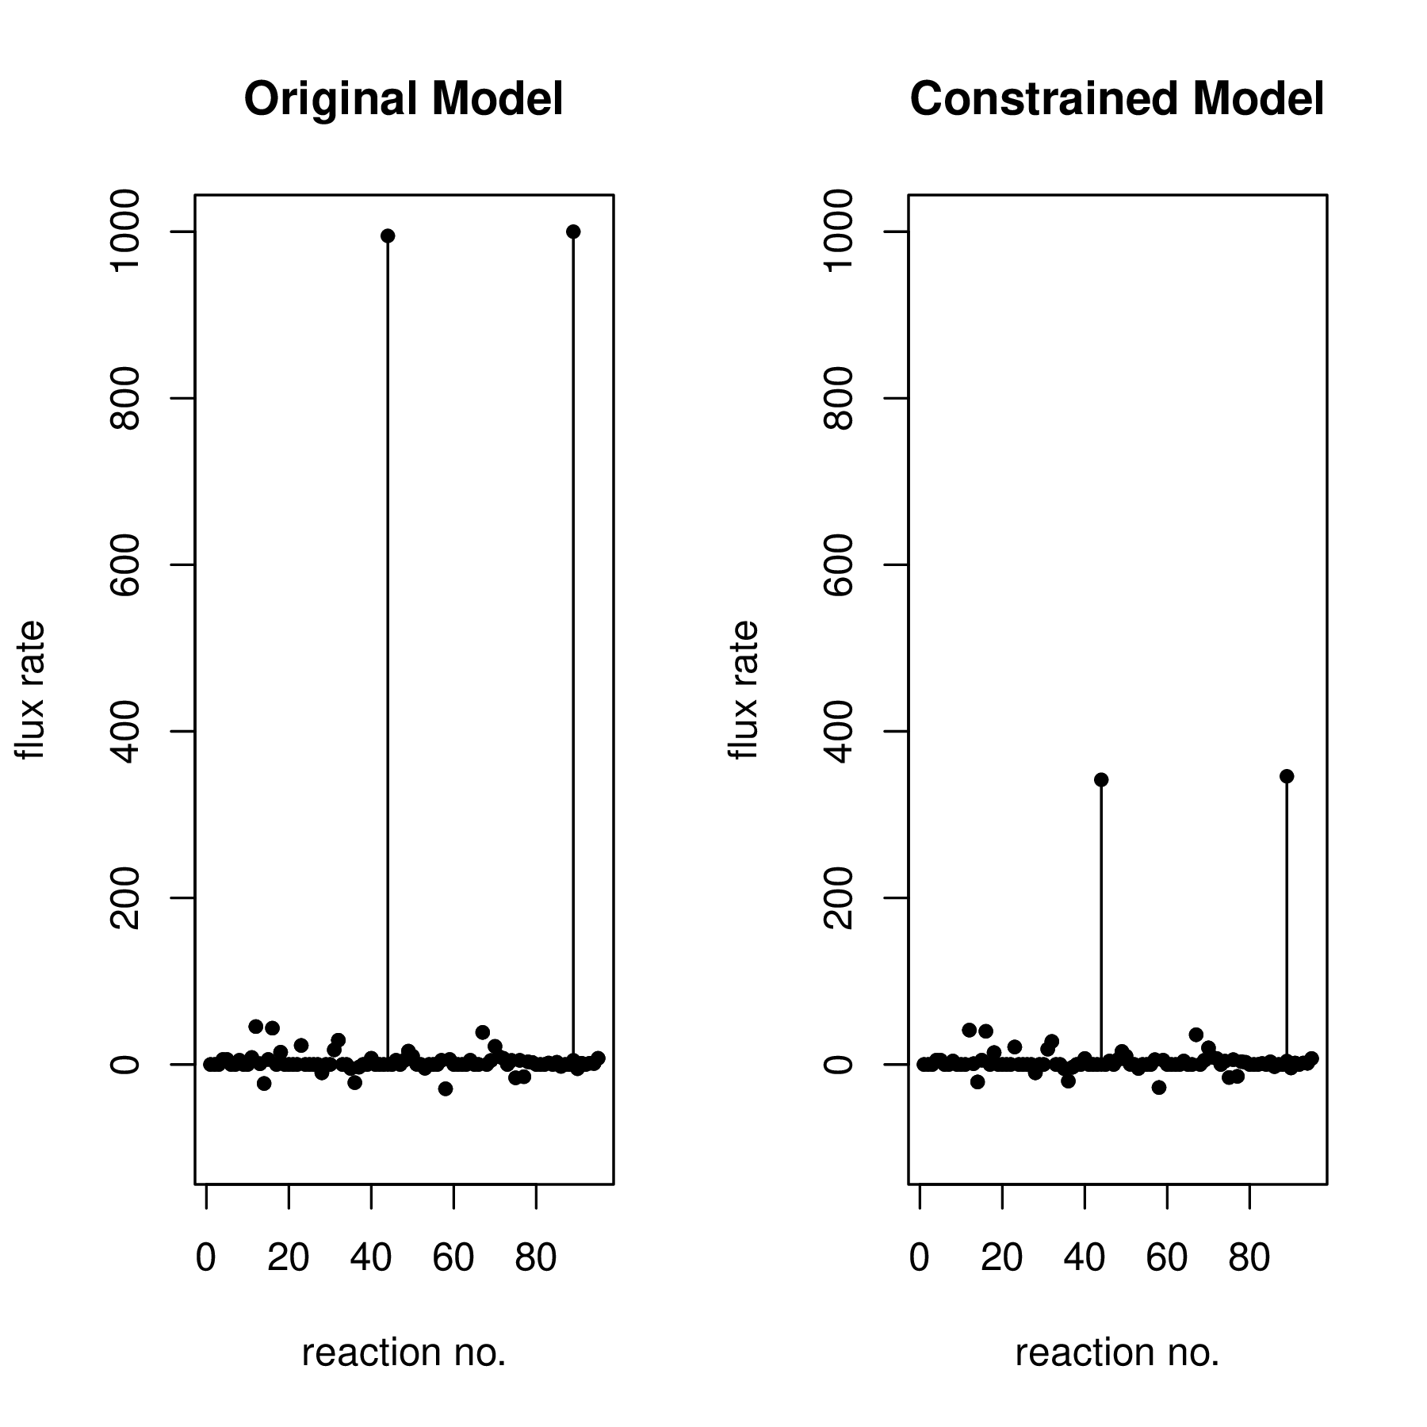

Figura 1: Flux differences between an unconstrained and a constrained model. Constraints were calculated through the exp2flux R package using simulated gene expression data.

Identifying flux changes between scenarios
The measurement of flux change for each reaction between metabolic scenarios is a task generally carried out manually and oriented directly to the research objective. However, at system level analysis this process can become laborious. The fluxDifferences function calculates the fold change for each common reaction between metabolic scenarios. Fold change is a measure that describes how much a quantity changes going from an initial to a final value. Implemented algorithm in the fluxDifferences functions are described in equation 1, function takes as argument two valid models for the ‘sybil’ R package and a customizable threshold value to filter functions to be reported.

[Sorry. Ignored \begin{split} ... \end{split}]
(1)As an example, we report the fold change of all reactions with an absolute change greatest or equal to 2-fold between the unconstrained and constrained metabolic scenarios simulated previously.
[Sorry. Ignored \begin{Schunk} ... \end{Schunk}]

3 Summary
We introduced the exp2flux package, an implementation of a previously described method to integrate gene-expression data in a continuous way into genome-scale metabolic network reconstructions. We show as an example, how the integration of a set of simulated data modifies the behavior of the E.coli core metabolic model using Flux Balance Analysis simulations. Also, a example of the measurement of flux change between metabolic scenarios was showed.
Referencias
Balázs Szappanos, Károly Kovács, Béla Szamecz, Frantisek Honti, Michael Costanzo, Anastasia Baryshnikova, Gabriel Gelius-Dietrich, Martin J Lercher, Márk Jelasity, Chad L Myers, and Others. An integrated approach to characterize genetic interaction networks in yeast metabolism. Nature genetics, 43(7):656–662, 2011.
Nathan D Price, Jennifer L Reed, and Bernhard Ø Palsson. Genome-scale models of microbial cells: evaluating the consequences of constraints. Nature Reviews Microbiology, 2(11):886–897, 2004.
Liming Liu, Rasmus Agren, Sergio Bordel, and Jens Nielsen. Use of genome-scale metabolic models for understanding microbial physiology. FEBS letters, 584(12):2556–2564, 2010.
Jan Schellenberger, Richard Que, Ronan M T Fleming, Ines Thiele, Jeffrey D Orth, Adam M Feist, Daniel C Zielinski, Aarash Bordbar, Nathan E Lewis, Sorena Rahmanian, and Others. Quantitative prediction of cellular metabolism with constraint-based models: the COBRA Toolbox v2. 0. Nature protocols, 6(9):1290–1307, 2011.
Samuel M D Seaver, Christopher S Henry, and Andrew D Hanson. Frontiers in metabolic reconstruction and modeling of plant genomes. Journal of experimental botany, 63(6):2247–2258, 2012.
Amlt Varma and Bemhard O Palsson. Metabolic Flux Balancing: Basic Concepts, Scientific and Practical Use. Bio/technology, 12, 1994.
Bernhard Palsson. In silico biology through “omics”. Nature biotechnology, 20(7):649–650, 2002.
Ning Chen, Ioscani Jimenez del Val, Sarantos Kyriakopoulos, Karen M Polizzi, and Cleo Kontoravdi. Metabolic network reconstruction: advances in in silico interpretation of analytical information. Current opinion in biotechnology, 23(1):77–82, 2012.
Nathan E Lewis, Harish Nagarajan, and Bernhard O Palsson. Constraining the metabolic genotype–phenotype relationship using a phylogeny of in silico methods. Nature Reviews Microbiology, 10(4):291–305, 2012.
Nadine Töpfer, Camila Caldana, Sergio Grimbs, Lothar Willmitzer, Alisdair R Fernie, and Zoran Nikoloski. Integration of genome-scale modeling and transcript profiling reveals metabolic pathways underlying light and temperature acclimation in Arabidopsis. The Plant Cell, 25(4):1197–1211, 2013.
Matthew A Oberhardt, Bernhard Ø Palsson, and Jason A Papin. Applications of genome-scale metabolic reconstructions. Molecular systems biology, 5:320, jan 2009.
Daniel Machado and Markus Herrgård. Systematic Evaluation of Methods for Integration of Transcriptomic Data into Constraint-Based Models of Metabolism. PLoS Computational Biology, 10(4):e1003580, apr 2014.
Markus W Covert and Bernhard Ø Palsson. Transcriptional regulation in constraints-based metabolic models of Escherichia coli. Journal of Biological Chemistry, 277(31):28058–28064, 2002.
Mats Åkesson, Jochen Förster, and Jens Nielsen. Integration of gene expression data into genome-scale metabolic models. Metabolic engineering, 6(4):285–293, 2004.
Markus W Covert, Eric M Knight, Jennifer L Reed, Markus J Herrgard, and Bernhard O Palsson. Integrating high-throughput and computational data elucidates bacterial networks. Nature, 429(6987):92–96, 2004.
Jennifer L Reed. Shrinking the metabolic solution space using experimental datasets. PLoS Comput Biol, 8(8):e1002662, 2012.
Anna S Blazier and Jason A Papin. Integration of expression data in genome-scale metabolic network reconstructions. Frontiers in physiology, 3:299, 2012.
Daniel Machado and Markus Herrgård. Systematic evaluation of methods for integration of transcriptomic data into constraint-based models of metabolism. PLoS Comput Biol, 10(4):e1003580, 2014.
Caroline Colijn, Aaron Brandes, Jeremy Zucker, Desmond S Lun, Brian Weiner, Maha R Farhat, Tan-Yun Cheng, D Branch Moody, Megan Murray, and James E Galagan. Interpreting expression data with metabolic flux models: predicting Mycobacterium tuberculosis mycolic acid production. PLoS Comput Biol, 5(8):e1000489, 2009.
Pablo Carbonell. Hepatotoxicity prediction by systems biology modeling of disturbed metabolic pathways using gene expression data. ALTEX, pages 1–23, 2016.
Ines Thiele and Bernhard Ø Palsson. A protocol for generating a high-quality genome-scale metabolic reconstruction. Nature Protocols, 5(1):93–121, jan 2010.

