Data exploration using the palmerpenguins dataset

[Gbadamassi G.O. Dossa](dossa@xtbg.org.cn)

last updated: 2022-06-29

# Acknowledgements

The content of this module are based on materials from: [olivier gimenez’s materials](https://oliviergimenez.github.io/)

# Data exploration

## Motivation

In this section, we **explore** the data from package palmerpenguins. A recent publication from the researcher, Dr Kristen Gorman, who shared the data is Connors et al. (2020).

## Data

The data are displayed below (first 10 rows) :

penguins %>%   
 slice(1:10) %>%  
 knitr::kable()

| species | island | bill_length_mm | bill_depth_mm | flipper_length_mm | body_mass_g | sex | year |
| --- | --- | --- | --- | --- | --- | --- | --- |
| Adelie | Torgersen | 39.1 | 18.7 | 181 | 3750 | male | 2007 |
| Adelie | Torgersen | 39.5 | 17.4 | 186 | 3800 | female | 2007 |
| Adelie | Torgersen | 40.3 | 18.0 | 195 | 3250 | female | 2007 |
| Adelie | Torgersen | NA | NA | NA | NA | NA | 2007 |
| Adelie | Torgersen | 36.7 | 19.3 | 193 | 3450 | female | 2007 |
| Adelie | Torgersen | 39.3 | 20.6 | 190 | 3650 | male | 2007 |
| Adelie | Torgersen | 38.9 | 17.8 | 181 | 3625 | female | 2007 |
| Adelie | Torgersen | 39.2 | 19.6 | 195 | 4675 | male | 2007 |
| Adelie | Torgersen | 34.1 | 18.1 | 193 | 3475 | NA | 2007 |
| Adelie | Torgersen | 42.0 | 20.2 | 190 | 4250 | NA | 2007 |

## Numerical exploration

There are 344 penguins in the dataset, and 3 different species. The data were collected in 3 islands of the Palmer archipelago in Antarctica.

The mean of all traits that were measured on the penguins are:

## # A tibble: 3 × 6  
## species bill_length_mm bill_depth_mm flipper_length_mm body_mass_g year  
## <fct> <dbl> <dbl> <dbl> <dbl> <dbl>  
## 1 Adelie 38.8 18.3 190. 3701. 2008.  
## 2 Chinstrap 48.8 18.4 196. 3733. 2008.  
## 3 Gentoo 47.5 15.0 217. 5076. 2008.

## Graphical exploration

A histogram of body mass per species:

penguins %>%  
 ggplot() +  
 aes(x = body_mass_g) +   
 geom_histogram(aes(fill = species),   
 alpha = 0.5,   
 position = "identity") +  
 scale_fill_manual(values = c("darkorange","purple","cyan4")) +  
 theme_minimal() +  
 labs(x = "Body mass (g)",  
 y = "Frequency",  
 title = "Penguin body mass")

## Warning: Removed 2 rows containing non-finite values (stat_bin).

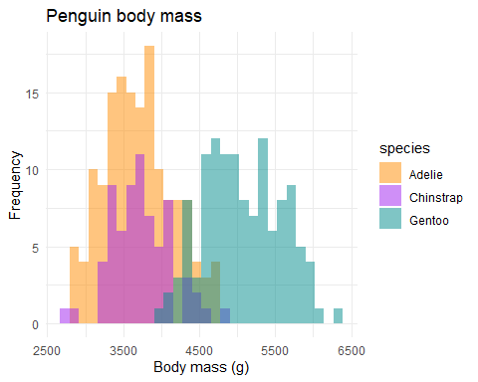

## The end

The 3 species of penguins:

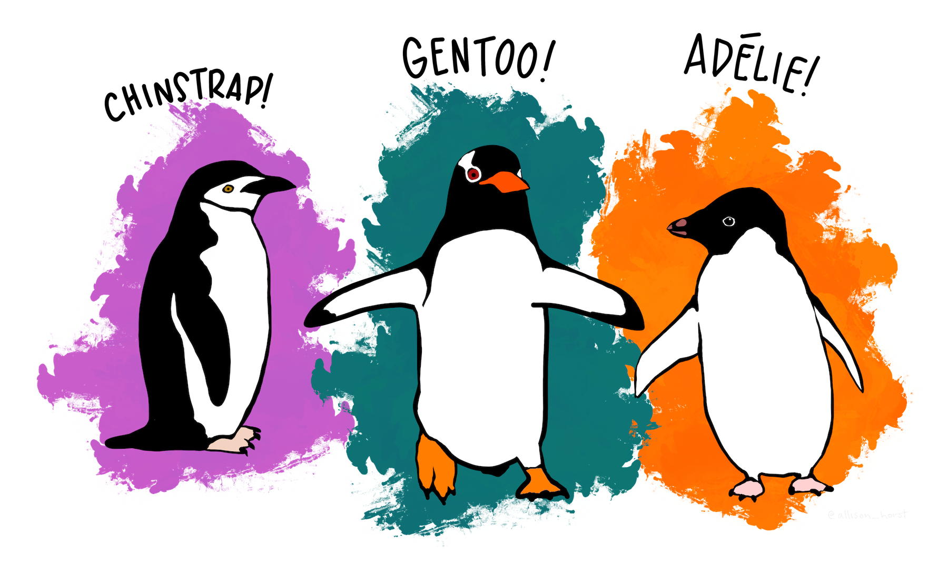

## References

Connors, B., M. J. Malick, G. T. Ruggerone, P. Rand, M. Adkison, J. R. Irvine, R. Campbell, et al. 2020. [Climate and competition influence sockeye salmon population dynamics across the Northeast Pacific Ocean](https://doi.org/10.1139/cjfas-2019-0422). Canadian Journal of Fisheries and Aquatic Sciences 77:943–949.