Proceedings

Enhanced Pedestrian Dead Reckoning Sensor Fusion for  
Firefighting

Tobias Augustin 1 *, Daniel Ossmann 1

|  |
| --- |
| **Citation:** To be added by editorial staff during production.  Academic Editor: Firstname Lastname  Published: date **Copyright:** © 2023 by the authors. Submitted for possible open access publication under the terms and conditions of the Creative Commons Attribution (CC BY) license (https://creativecommons.org/licenses/by/4.0/). |

­1 Munich University of Applied Sciences HM

**\*** Correspondence: tobias.augustin@hm.edu

**Abstract:** Knowing the exact position of firefighters in a building during an indoor firefighting operation is critical to improving the efficiency and safety of firefighters. For the estimation of an individual’s position in indoor or Global Positioning System (GPS) denied environments commonly Pedestrian Dead Reckoning (PDR) is used. PDR tries to estimate the required position via sensors without external references, for example using accelerometers and gyroscopes. One of the most common techniques of PDR is step-detection. Applications like firefighting, however, involve more dynamic movements like crouching. Thus, the accuracy of a step-detection algorithm is reduced dramatically. Therefore, this paper presents a novel PDR algorithm that augments the conventional PDR technique with a tracking camera. The position estimates of a zero-crossing step-detection algorithm and the tracking camera estimates are fused via a Kalman filter. A system prototype, designed for algorithm validation, is presented in detail. The experimental results confirm that enhancing the system with a secondary sensor leads to a substantial increase in the position estimation accuracy also for dynamic crouching maneuvers compared to conventional step-detection algorithms.

**Keywords:** Pedestrian Dead Reckoning; Kalman Filter; Firefighting

1. Introduction

While safety standards in firefighting are continuously improving, indoor operations in burning buildings still present a dangerous task for firefighters. At least 240 injuries and 10 deaths involving firefighters conducting firefighting operations in buildings were reported in the United States in 2022 [2]. To improve safety while performing such a dangerous task, knowing the exact position of firefighters in indoor environments can shorten rescue time of injured personnel or help firefighters avoiding dangerous situations. To determine the position of a person in indoor or GPS-denied environments, a technique called Pedestrian Dead Reckoning (PDR) is used. It relies on sensors such as accelerometers, gyroscopes, and magnetometers integrated into wearable devices, smartphones or smartwatches. By continuously tracking a pedestrian's step counts, stride length, and heading changes, PDR algorithms can calculate their relative displacement from a known starting point. Other means of PDR include simultaneous locating and mapping (SLAM)[9], magnetic field mapping [14] or magnetic triangulation [1].  
For an application in firefighting operations, many of the aforementioned PDR methods are not feasible. While radio tracking [5] or magnetic mapping [14] produce accurate results in indoor environments, they are technologies that have to be installed before use. It may be possible to achieve this for some large buildings, however it would not be feasible to do for every building in an area where a fire might occur. For tracking firefighters in any indoor environment, a stand-alone, body-worn device is required. Stand-alone PDR systems often rely on a form of step-detection [7]. Algorithms based on step-detection can estimate an accurate position mainly during walking. Movements occurring in a firefighting application, however, also include more dynamic activities like crouching. Those movements are hard to detect by standard step-detection algorithms. Thus, a secondary sensor measuring position or velocity is necessary to improve accuracy in those scenarios. A common sensor chosen for this is a Light Detection and Ranging (LIDAR) sensor [14]. While this approach can yield good results in smoke-free environments, tests show that distance readings of LIDAR systems are heavily influenced by smoke particles and therefore are not usable in a firefighting environment.  
Due to these shortcomings in PDR for firefighting application, in this paper a novel approach for enhanced PDR is presented. The step-detection algorithm is extended with a stereo tracking camera as a secondary sensor. This tracking camera can visually determine velocity and position relative to a starting point, even is smoky scenarios. The camera providing position and velocity is combined with a step-detection algorithm providing position information. The gathered data is fused using a Kalman filter to robustly estimate the firefighter’s position. While in section 2 the fundamentals of the step-detection and the model for the Kalman filter is presented, in section 3 the overall PDR system setup including software and hardware components is described. Finally, section 4 discusses the results of a verification campaign in which position data from the proposed algorithm is compared to data generated by step-detection only.

2. Sensor-Data Processing Algorithms

The PDR relies on an advanced sensor data fusion algorithm combining position data estimated by a step-detection algorithm and the velocity and position data estimates of a secondary sensor.

2.1. Step-Length Estimation

Step-detection describes the process of detecting and counting a persons steps by measuring and analysing the accelerations of a body-worn inertial measurement unit (IMU). The most common ways of step-detection utilize the vertical acceleration signal and analyse the signal using peak-, zero-crossing or flat zone detection. A zero-crossing detection approach is chosen since flat zone detection only works for foot mounted sensors and peak-detection accuracy is dependent on a persons walking speed [13]. Zero-crossing detection analyses the characteristic shape of the vertical acceleration of a torso mounted sensor [20]. To improve detection accuracy, the high-frequency content of the signal is filtered out using a low-pass filter. A straightforward implementation of a first order low pass filter is the so-called exponentially weighted moving average

|  |  |
| --- | --- |
|  | (1) |

where is the raw signal at time step , and and is the filtered signal of the current and the last time step, respectively [12]. The smoothing factor lies between 0 and 1 and can be calculated as

|  |  |
| --- | --- |
|  | (2) |

with being the sampling time and being the required cut-off frequency. For a step to be counted as complete, the filtered, vertical acceleration signal has to cross the zero line twice, once rising, i.e.,

|  |  |
| --- | --- |
|  | (3) |

and afterwards once falling, i.e.,

|  |  |
| --- | --- |
|  | (4) |

Only if these two conditions have been registered in the algorithm, a step can be finally counted.  
Once a step is registered as complete, the step length has to be added to the current estimated position in the direction of movement. To estimate the step-length *d* a method using the relation between hip acceleration and the length of a step following [15] is applied, i.e.,

|  |  |
| --- | --- |
| . | (5) |

In equation (5) the maximum measured acceleration and the minimal acceleration both measured during the last step and is a constant for unit conversion. This method produces accurate estimates with low computational effort compared to other algorithms [10,13,21].

2.2. Sensor-Data Fusion

Sensor-data fusion describes the process of using multiple sensor outputs to estimate the state of a system. A common approach for sensor fusion complementary filtering, which combines high frequency data of one sensor, that fast but prone to drift, with low frequency data from another sensor, which stabilized the output signal.  
In this paper we use the more advanced method of a Kalman filtering. The idea of the Kalman filter is to use an optimal recursive algorithm for sensor-data fusion. The filter operates in two steps: the prediction step, where the system's state is predicted using a prediction model, i.e., a mathematical model of the underlying dynamics; and the update step, where on the one hand the measurements are used to correct the predicted state via the Kalman gain, and on the other hand the Kalman gain itself is updated based on the measurements. This gain balances the model's predictions and the actual measurements [4]. The process continually refines the state estimate as new data becomes available, making it robust against noise and capable of handling real-time applications. The required prediction model is described by the non-linear function As underlying model in this paper we define for each of the three-coordinate axis the function

|  |  |
| --- | --- |
|  | (6) |

with the input *u* to the model being the measured acceleration *a* by the inertial measurement unit and the state vector . Based on this model the Kalman filter provides estimates of the position and the velocity in the corresponding axis. Note that the dependency of the signals on time, i.e., on , is omitted in equation (6) for readability reasons. By changing the covariance matrices of the Kalman filter, the accuracy of the predictions and measurement updates is tuned [16].

3. Enhanced Pedestrian Dead Reckoning System

The enhanced PDR makes use of a robust step detection-scheme with which the position of the firefighter is estimated. Additionally, a tracking camera serves as secondary sensor providing position and speed measurement to back up the step detection based position. Finally, all available signals are fused together via a Kalman filter providing the position and velocity of the firefighter.

3.1 Robust Step-Length Estimation and secondary Sensor Setup

As basis, step-detection herein uses the zero-crossing technique as described in Section 2.1. The vertical acceleration signal used for the step-detection is filtered with a low-pass filter to remove the undesired, high frequency parts of the signal that occur during movement. Since the frequency range of normal human walking is in the range of 1 Hz to 5 Hz, the bandwidth of the low-pass filter is specified at fc = 10 Hz in equation (1) ensuring an adequate roll-off at higher frequencies. Figure 1 shows a comparison of the raw data with the filtered acceleration data. Clearly, sharp peaks and noise are filtered out. To also consider dynamic movements of firefighters as crouching, the step-detection algorithm's robustness is improved via an additional threshold-crossing detection: To initiate the counting process, the acceleration signal has to pass the negative threshold at m/s2. Afterwards, a step is counted as valid, only if between the detection of two subsequent zero-crossings, a rise above the positive threshold m/s2 is registered. If after the initialization via the negative threshold the described sequence is not completed in a specified time the step-detection logic is reset and no step is counted. After a step is detected, the length of the step is added to the last known position in the direction of movement which is determined by the heading angle measured by the IMU. The step-length is estimated via equation (5). It is assumed, that due to the limited field of view and restriction of movement by gear during an indoor operation, firefighters move in the direction their body is aligned. Since the IMU is mounted on the air tank of the firefighter, the orientation of the IMU equals the direction of movement. To describe the position in a global reference frame, the coordinate origin of the global reference frame is defined when the device is initialized, where the initial heading defines the x-axis. As the secondary sensor a stereo tracking camera is used to provide additional position and velocity information. Such a device has two calibrated cameras that are placed with a distance to each other and are horizontally aligned. By measuring the displacement of a tracked object between the two cameras, the distance to the object can be calculated. Doing this for multiple objects and repeating this process every frame, the position and average velocity is provided

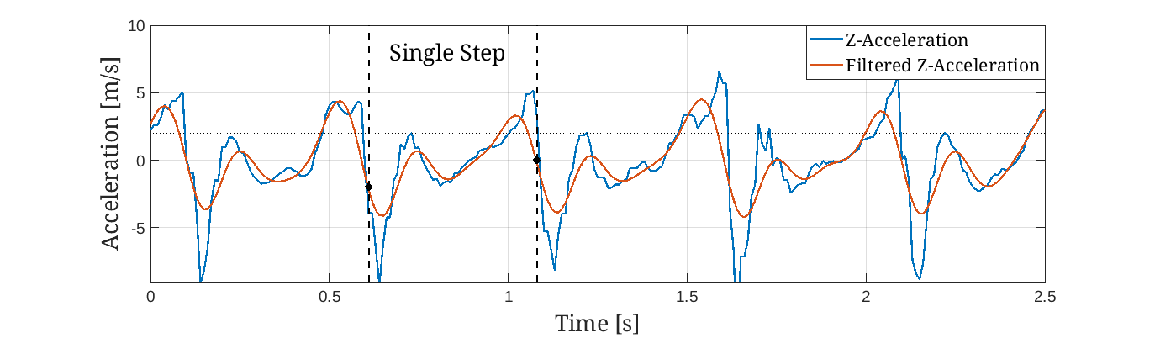**Figure 1**. Raw and filtered vertical acceleration during walking, with the illustration of a single step.

3.2 Sensor Fusion Algorithm

Based on the model in equation (6), the available acceleration signal by the IMU, and position and velocity information the Kalman filter estimates the firefighter’s velocity and position. The position data from the step-detection and the tracking-camera, however, needs to be fused before entering the filter, as discrete confidence levels of the camera are available, which cannot be handled by the Kalman filter. Thus, the fusion of the two signals is performed via a simple weighting scheme using discrete weights. The tracking camera provides a confidence value of the tracking results. This tracking confidence four discrete cases, from the highest confidence to the lowest. For the step-detection it is assumed that the estimated position accuracy by the step-detection algorithm deteriorates the longer no step is fully registered. To limit the weighting possibilities to a discrete set also for the step-detection, three discrete conditions are used to reflect the accuracy after the last detection based on the time passed since the last detection event: if best accuracy, if medium accuracy, and if worst accuracy is assumed. The resulting weighting scheme, motivated by the work in [3], includes twelve cases. If the quality of both markers is bad, the step detection gets highly favored, since it provides stable results during walking, even in zero visibility environments. If the tracking confidence is high, the camera measurements get slightly favored. This is because in theory the tracking cameras results will more accurate since it produces continuous position updates and can track the position regardless of the type of movement. The combination of the measurements is performed before they are used in the Kalman Filter. With a weighting gain the weighted measurement input for the x- and y-position is calculated via

|  |  |
| --- | --- |
|  | (7) |

with and are the position estimates produced by the step-detection and and being the position estimate from the tracking camera. Since the step-detection cannot estimate the z-position, only the measurement from the tracking camera is used, therefore no weighting is performed.

3.3 Sensor Hardware Assembly

The IMU used is the Bosch Sensortech BNO055 MEMS absolute orientation sensor. The device measures acceleration in three axes and provides absolute heading data by measuring the earth’s magnetic field and fusing gyroscope and Magnetometer data. The secondary sensor is a RealSense T265 stereo tracking camera. Its main advantage is the on-chip, online data processing. Thus, no other means of interpreting the data is necessary and the velocity and position data are directly available for the sensor fusion algorithm presented herein. Note that by using parts of the infrared spectrum the camera also can produce accurate tracking results in environments with bad lighting.

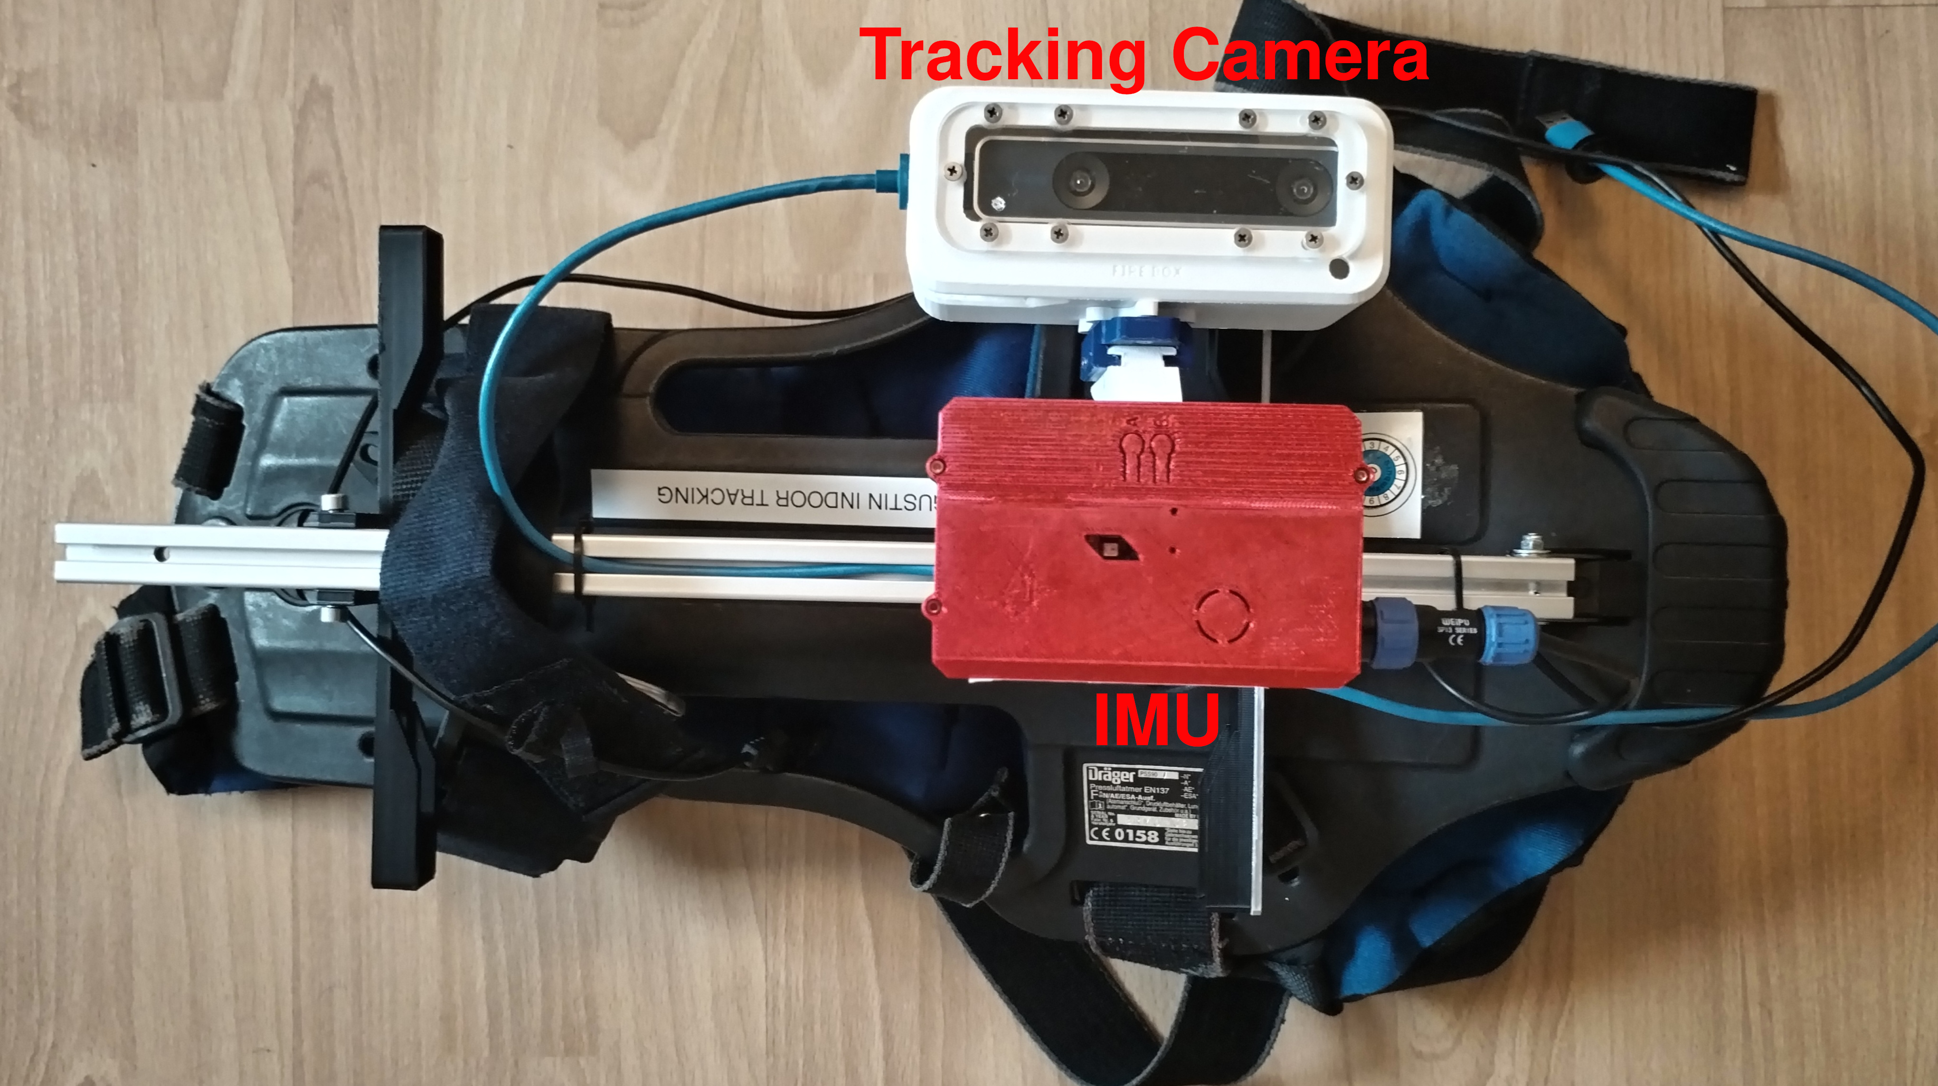

**Figure 2.** Sensor assembly mounted on the equipment to be worn by a firefighter.

For validation of the system, a wearable sensor assembly is designed. Both sensors are mounted on a backplate of a self-contained breathing apparatus. This design is chosen to imitate an application in firefighting settings, where the sensors are placed on the pressurized air tank. For this a 3D-printed spacer is designed to mount the sensors at the right distance. Weight is added to represent the air tank. Camera and IMU are protected from damage by an enclosure. Figure *2* shows the developed experimental setup.

4. Results

For a realistic validation of the sensor setup and the algorithms, tests on predefined paths are performed. First, to validate the performance during regular walking scenarios, a 33m long path is tested. The right diagram in Figure 3 shows the estimated position of the different algorithms compared to the true path. While at the beginning of the test all three algorithms deliver accurate results, the step-detection deviates strongly after the first heading change. The proposed sensor fusion is able to stay close to the real path and deliver the best results most of the time. The tracking camera alone, however, delivers the best result in the middle of the experiments. This is due to the fact, that here the step-detection shows a big error dragging also the sensor fusion algorithm away from the real path.

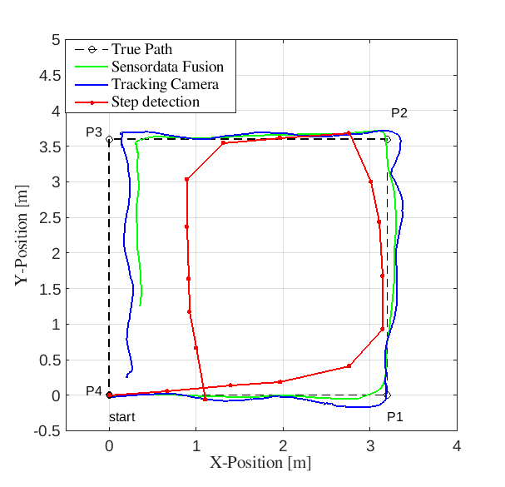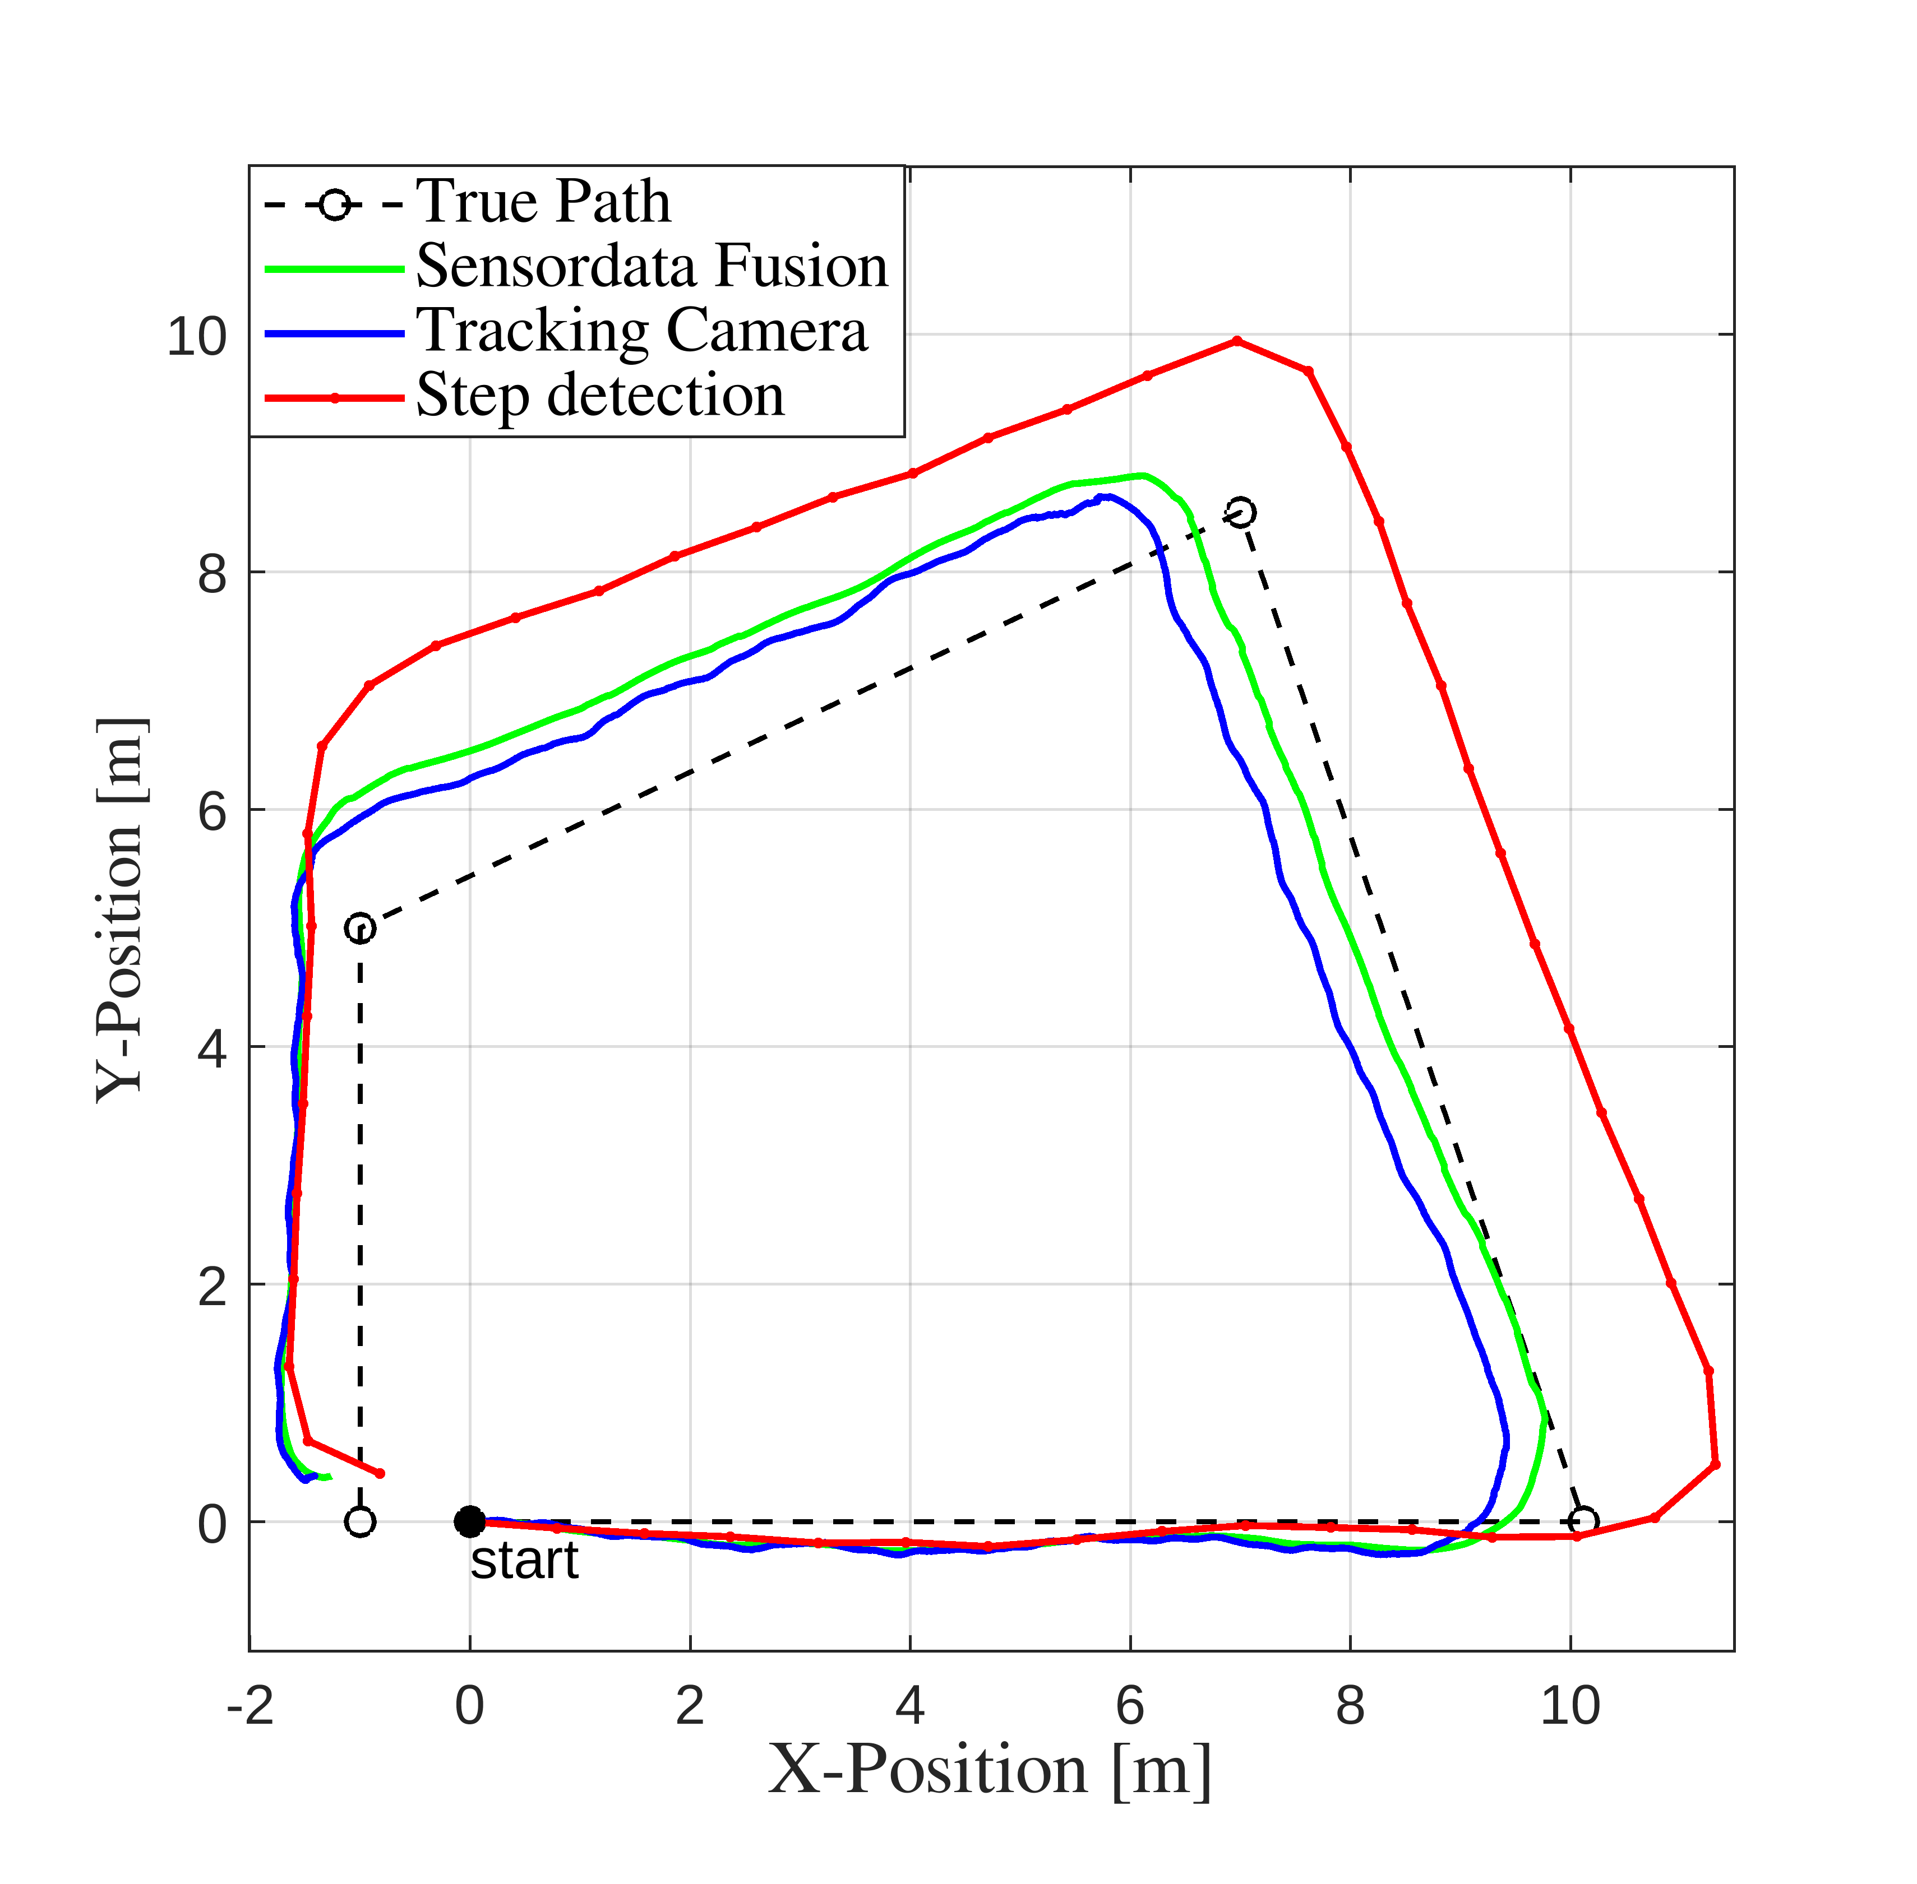

Figure 3. Experimental results comparing step detection only, tracking camera only, and the proposed sensor data fusion to the true path for crouching (left) and walking (right):

In the second validation experiment, dynamic crouching, frequently employed in firefighting, was tested. The test path, illustrated in the left diagram of Figure 3, covers a total length of 12 m and includes four 90° turns. The starting- and endpoint are identical and 10 test runs are performed. Clearly, the step detection alone performs the worst in this scenario, because simply no steps are performed during the movement. The mean values over 10 runs, as listed in Table 1, demonstrate significant improvements in tracking accuracy, with at least a five-fold enhancement at the four corner points (P1 to P4) when utilizing the proposed algorithm compared to relying solely on step detection. To simulate potential obstructions of the tracking camera caused by dirt or heavy smoke, the tracking confidence is artificially reduced so that the step detection is highly favored. In these scenarios, the mean deviation at each control point is degraded but lies still within the acceptable range of 1 m. The data in Table 1 also indicates that the tracking camera alone performs similar well to the sensor fusion algorithm. In these results, however, the tracking camera confidence was set to its highest possible level. To ensure reliable results, even in scenarios where the camera confidence is degraded, it is essential to incorporate data from step detection for crouching scenarios. This is crucial because the camera may produce highly inaccurate data in those scenarios.

**Table 1.** Mean deviation from the true path at four corners of the path.

|  |  |  |  |  |
| --- | --- | --- | --- | --- |
| **Estimation Method** | **P1** | **P2** | **P3** | **P4** |
| Step-Detection | 1.60 m | 2.45 m | 2.44 m | 1.80 m |
| Sensordata Fusion | 0.28 m | 0.42 m | 0.27 m | 0.32 m |
| Low tracking confidence S.F | 0.66 m | 0.68 m | 0.76 m | 0.54 m |
| Tracking Camera only | 0.27 m | 0.43 m | 0.24 m | 0.29 m |

**5. Conclusion**

An enhanced Pedestrian Dead Reckoning method for firefighting applications has been presented. The step-detection has been successfully upgraded with a secondary sensor to improve position estimates in different moving scenarios. The required sensor fusion algorithm has been successfully validated in an experimental validation campaign showing promising results for the usage of the developed prototype system.

Author Contributions: T.A.: methodology, visualization, analysis, synthesis, testing, validation and original draft preparation. D.O.: Supervision, scientific review and proofreading. All authors have read and agreed to the published version of the manuscript.

References

1. D. D. Arumugam, P. Littlewood, N. Peng, and D. Mishra. Long-Range Through-the-Wall Magnetoqua sistatic Coupling and Application to Indoor Position Sensing. IEEE Antennas and Wireless Propagation Letters, 19(3):507–511, March 2020.
2. Atemschutzunfälle.eu. Unfälle in Amerika. https://www.atemschutzunfaelle.de/unfaelle/amerika/, 2023
3. F. Caron, E. Duflos, D. Pomorski, and P. Vanheeghe. GPS/IMU data fusion using multisensor Kalmanfiltering: Introduction of contextual aspects. Information Fusion, 7(2):221–230, June 2006.
4. C. K. Chui and G. Chen. Kalman Filtering: With Real-Time Applications. Springer, Berlin, 4th ed edition, 2009.
5. L. Cong, J. Tian, and H. Qin. Practical Step Length Estimation Combining FM Radio Signal and Accelerometer. IEEE Transactions on Instrumentation and Measurement, 72:1–13, 2023.
6. N. Hajati and A. Rezaeizadeh. A Wearable Pedestrian Localization and Gait Identification System Using Kalman Filtered Inertial Data. IEEE Transactions on Instrumentation and Measurement, 70, 2021.
7. X. Hou and J. Bergmann. Pedestrian Dead Reckoning with Wearable Sensors: A Systematic Review. IEEE Sensors Journal, (1):143–152, 2021.
8. Y. H. Jen, C. H. Huang, S. Tsai, and K. W. Chiang. A MULTI-IMU BASED SELF-CONTAINED PEDESTRIAN NAVIGATION ALGORITHM. The International Archives of the Photogrammetry, Remote Sensing and Spatial Information Sciences, XLVIII-1/W1- 2023:603–608, May 2023
9. C. Lu, H. Uchiyama, D. Thomas, A. Shimada, and R.-I. Taniguchi. Indoor positioning system based on chest-mounted IMU Sensors (Switzerland), 19(2), 2019.
10. N. I. Petukhov, Vladimir N. Zamolodchikov, Alexander P. Malyshev, Tatyana A. Brovko, Sergey A. Serov, and Ilya V Korogodin. Synthesis of PDR Algorithm and Experimental Estimation of Accuracy of Step Length Estimation Methods. Moscow Russian Federation, March 2022. IEEE.
11. H. Sadruddin, A. Mahmoud, and M. M. Atia. Enhancing Body-Mounted LiDAR SLAM using an IMU-based Pedestrian Dead Reckoning (PDR) Model. In 2020 IEEE 63rd International Midwest Symposium on Circuits and Systems (MWSCAS), pp. 901–904, August 2020.
12. NIST SEMATECH. NIST/SEMATECH e-Handbook of Statistical Methods. https://www.itl.nist.gov/div898/handbook/, 2012.
13. S. H. Shin, C. G. Park, J. W. Kim, H. S. Hong, and J. M. Lee. Adaptive Step Length Estimation Algorithm Using Low-Cost MEMS Inertial Sensors. In 2007 IEEE Sensors Applications Symposium, February 2007
14. Q. Wang, H. Luo, F. Zhao, and W. Shao. An indoor self-localization algorithm using the calibration of the online magnetic fingerprints and indoor landmarks. In 2016 International Conference on Indoor Positioning and Indoor Navigation (IPIN), October 2016
15. H. Weinberg. Using the ADXL202 in Pedometer and Personal Navigation Applications. 2002.
16. G. Welch and G. Bishop. An Introduction to the Kalman Filter. 2006
17. Y. Wu, J. Kuang, and X. Niu. Wheel-INS2: Multiple MEMS IMU-based Dead Reckoning System for Wheeled Robots with Evaluation of Different IMU Configurations, November 2022
18. A. Zaarane, I. Slimani, W. Al Okaishi, I. Atouf, and A. Hamdoun. Distance measurement system for autonomous vehicles using stereo camera. Array, 5:100016, March 2020.
19. T. Zhao and M. J. Ahamed. Pseudo-Zero Velocity Re-Detection Double Threshold Zero-Velocity Update (ZUPT) for Inertial Sensor-Based Pedestrian Navigation. IEEE Sensors Journal, 21(12):13772–13785, June 2021.
20. Y. Zhao, J. Wang, and C. Duan. Design and application research of mine underground disaster relief personnel positioning system based on MEMS sensor. In International Conference on Neural Networks, Information, and Communication Engineering (NNICE 2022), Vol. 12258, pp. 695–704. SPIE, July 2022.
21. G. Zizzo and L. Ren. Position Tracking During Human Walking Using an IntegratedWearable Sensing System. Sensors, 27(12):2866, December 2017.

**Disclaimer/Publisher’s Note:** The statements, opinions and data contained in all publications are solely those of the individual author(s) and contributor(s) and not of MDPI and/or the editor(s). MDPI and/or the editor(s) disclaim responsibility for any injury to people or property resulting from any ideas, methods, instructions or products referred to in the content.