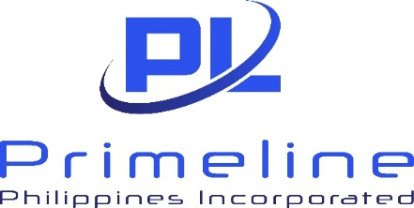

LEGAL REQUEST FORM(LRF)

REQUESTOR: |  |  | DATE:
DEPARTMENT: LRF No.:
PROJECT/COMPANY: (One LRF per project/company)
PURPOSE/OTHER DETAILS:

Please check/indicate the specific request needed:
- Contract Review / Drafting ◻ Special Projects
- Request for Legal Opinion / Research ◻ Other Requests (Please specify):
- Secretary’s Certificate / Board Resolution / Certification/ Letters / Affidavits
- Compliance Document/s (SEC, BIR, LGUs, etc.)

NOTE: All LRFs must be sent to compliance.bpic@primeline.ph

*LRFs not sent to the email stated above will not be entertained.
*Legal and Compliance Dept. will not accept LRFs with incomplete details/requirements.
*Any requests beyond 6PM will be considered requested the next working day.
*Counting will start from the day any staff from Legal confirms the receipt of LRF
*Standard turnaround time may be extended if the signatory/ies is/are not available on the date of request
*Standard turnaround time:
a. Research, Review, Revision, and Drafting of Contracts, Legal Opinion, Letters, Affidavits, and other legal documents – 5-10 working days
b. Secretary’s Certificate/Certification – 3 working days
c. Board Resolution – 5 working days
d. Copy of Compliance/Legal documents (if available) – 2 days
e. Other requests – to be determined depending on the request

REQUESTOR’S HEAD  SIGNATURE: | RECEIVED  BY:
Date Needed: | Date & Time:

*** FOR LEGAL DEPARTMENT USE ***
*COMMENTS:

*DATE RELEASED:

