LABORATORY WORK No. 3
OBJECT-ORIENTED ANALYSIS.
USE CASE DIAGRAM

Description of the Automated Business Processes
The company's business processes to be automated are presented in the following table:

Table 1.
No. | Business Process Code | Business Process Name
1. | Закуп-1 | Procurement
2. | Склад-2 | Warehousing
3. | Прод-3 | Sales
4. | Врасч-4 | Settlements with Suppliers and Customers

Each business process has its own unique number. Business processes are numbered according to the following principle: “prefix-number,” where the prefix denotes the group of business processes being described, and the number is the sequence number of the business process in the list.
Use Case Diagram of the “MED” Company
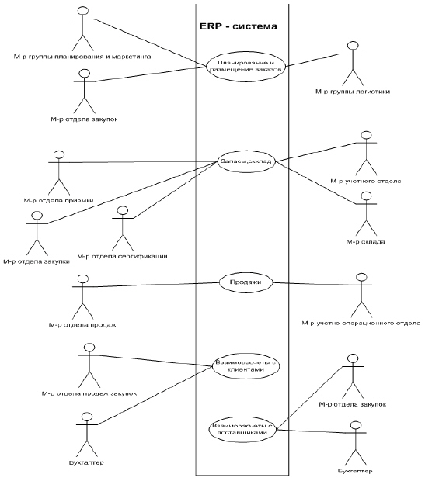
Fig. 1. Use Case Diagram of the Company
The Use Case Diagram shows the company's business processes to be automated and their actors.
Development of Business Process Models for a Pharmaceutical Wholesale Company
Table 2. Terms
External Sales Statistics | Sales statistics obtained from the pharmacy network;
Internal Sales Statistics | Sales statistics obtained from sales reports for the company's customers;
Product Item | name of the medicine and manufacturer;
ABC | classification of products by revenue from sales to customers;
XYZ | classification of products by popularity rating;
Accounting Price | the supplier's price for the product, including discounts;
Active Contracts | contracts under which the parties have obligations for a specified period of time;
Delivery Schedule | the order in which suppliers are contacted, necessary to maintain business relations;
Safety Stock | the minimum quantity of goods required to cover demand until a new batch is delivered;
Information system development includes several stages. However, the initial stage of creating a system is always the study, analysis, and modeling of the customer's activities.
To describe the company's high-level interaction with external counterparties, a physical diagram is created. When preparing the physical diagram, the first interview should identify the external counterparties and their main functions.

TASK 1. CREATING A PHYSICAL DIAGRAM
Create a physical diagram according to the description of the activities of the MED distributor company.
The distributor company “MED” purchases medicines from domestic and foreign manufacturers and sells them through its own distribution network and a pharmacy network. The company plans purchases based on sales statistics provided by the pharmacy network and distributors. The company delivers medicines using both its own transport and third-party services. The company has its own warehouse for storing medicines.
Task 1 Solution
The company purchases medicines from domestic and foreign manufacturers; therefore, its counterparties include domestic and foreign medicine suppliers. The company uses transport companies to deliver medicines; therefore, transport companies are external counterparties. In addition, the company sells medicines through its distribution network and pharmacy network. Therefore, its counterparties include customers (distributors and pharmacies). Thus, the external counterparties of the “MED” company are suppliers (domestic and foreign), customers (distributors and pharmacies), and transport companies.
On the physical diagram, the company is represented by a rectangle, while counterparties are represented using the Actor graphical symbol (stick figure). Lines (Communications) are used to show relationships between the company and its counterparties. The relationships between the company and external counterparties should be named so that the counterparties' functions in relation to the company are clear when viewing the physical diagram.
Creating a Physical Diagram in Enterprise Architect.
1. Create a root element – a rectangle – in the workspace.
2. To represent counterparties on the diagram, use the graphic symbol depicting a
human figure .
3. Connect the image of each counterparty to the rectangle using lines.
4. Enter the following counterparty names: "Buyers (pharmacies)," "Buyers (distributors)," "Suppliers (Russia)," "Suppliers (imports)," and "Transport companies."
5. Enter the company name "MED" into the drawn rectangle by clicking on it.
6. Similarly, add labels to the lines connecting the firm and the counterparties.

The physical diagram of “MED” CJSC is shown in Figure 2.

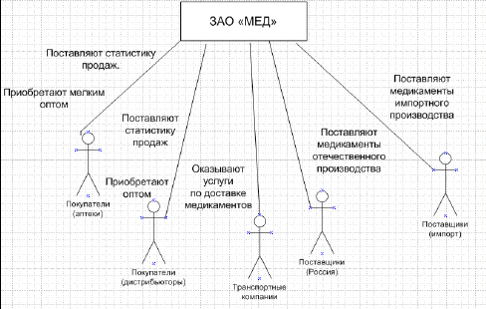

Fig. 2. Physical Diagram of “MED” CJSC

TASK 2. CREATING A LIST OF BUSINESS PROCESSES
Based on the description of the company's activities given in Task 1, identify the main business processes and enter their abbreviated names in a table with the following structure:
Table 3.
Business Process Number | Business Process Name

Create the business process number using letters and digits so that its meaning is intuitively clear from the number.
Task 2 Solution
To identify the business processes, it is necessary to identify the activities performed by the company. In this case, the company plans purchases, purchases medicines, delivers medicines to the warehouse, receives medicines into the warehouse, and sells medicines. An example of a completed business process table is given below:

Table 4.
Business Process Number | Business Process Name
1Пл_Зак | Purchase Planning
2-Закпк | Procurement
3-Доствк | Delivery
4-Склад | Warehousing
5-Прод | Sales

Note. To simplify the task, we will subsequently combine the “Procurement” and “Purchase Planning” business processes into a single business process called “Purchase Planning and Order Placement” and assign it the number 1Пл_Зак.
Business Process “Purchase Planning and Placing Orders with Suppliers”
General Description of the Business Process
The company plans purchases of medicines. Purchase planning is carried out in the Marketing Department, within the Marketing and Planning Group. Purchase planning is performed as follows:
1. The Planning and Marketing Group Manager receives daily sales reports from counterparties containing external and internal data on pharmaceutical sales.
2. To plan pharmaceutical procurement, the Planning and Marketing Group Manager calculates product requirements weekly based on sales statistics. This calculation results in the creation of a Product Requirements Table.
3. After determining the quantity and product mix to be ordered, the Purchasing Department Manager analyzes supplier offers. This process is carried out monthly or as needed. The most favorable supply terms are selected by comparing supplier prices; this information is sourced from the procurement price list. When selecting a supplier, it is important to consider the deferred payment terms provided; this information is obtained from contracts marked as priority (active). Consequently, a list of suppliers is generated, and each entry is designated as either a primary or backup supplier based on descending order of priority.
4. Each month, based on the Product Requirements Table and the list of selected suppliers, the Purchasing Department Manager creates delivery schedules specifying dates and frequency, though not delivery quantities.
5. Each month, following the determination of product requirements, the Logistics Group Manager calculates the necessary procurement volume. This calculation is based on actual warehouse stock levels and the required minimum and maximum inventory levels. Minimum and maximum inventory norms are established in days. The calculation also accounts for goods-in-transit time. Thus, the calculation aims to ensure uninterrupted product availability in the warehouse. The results are used to generate a monthly order plan.
6. Subsequently, the Logistics Group generates supplier orders daily based on the order plan, delivery schedule, and supplier price lists.
7. If an order is to be placed with an international supplier, the Logistics Group Manager calculates certification costs and generates a certification cost report. Certification costs are checked for compliance with internal company standards. This procedure is carried out as necessary.
8. If certification costs exceed internal company standards, the logistics group manager repeats the supplier order generation process. New orders are created.
9. The prepared supplier order is approved daily; it must be signed by the logistics manager and the Director of the Marketing and Inventory Management Department.
10. The logistics group manager forwards the order to the purchasing department daily. The purchasing department manager sends the order to the supplier.

