FINAL PROJECT ASSIGNMENT IN JAVA PROGRAMMING
Project Topics
Develop a GUI application based on a specific example (the topics are listed below). The GUI application development must include the creation of classes and interaction between classes in accordance with object-oriented programming requirements. The GUI application must also provide data input and output (using a database) and the necessary forms for data input/output. Implement CRUD operations, data sorting, and 4–5 queries. The application must contain real data (at least 10–15 records). A written report of 23–25 pages must also be prepared for the mini-project.
Application Quality Requirements
The mini-project must be implemented as a complete, well-designed, and functional Java GUI application. The application should look professional and be suitable for demonstration during practical classes.
• The application must have a main window and logically organized forms.
• Use appropriate GUI controls such as buttons, text fields, labels, tables, menus, and dialog windows.
• The interface must be clear, neat, user-friendly, and easy to navigate.
• Use a consistent layout, fonts, spacing, and visual style throughout the application.
• Input forms must include data validation and clear messages for incorrect input.
• Project data should be displayed in a convenient form; use tables where appropriate.
• All main project functions must be accessible through the GUI.
• The implemented OOP classes, fields, constructors, and methods must be used in the application logic.
• The final mini-project should look and work like a complete software application, not only a collection of Java classes or console output.
Week 7 / Rating 1: at least 50% of the mini-project must be completed. All required classes, main fields (variables), constructors, and methods should be implemented, and a working GUI window should be demonstrated.
Final Project Topics
1. Personal Organizer
Create a parent class Event (date, time) and child classes:
• Birthday (person whose birthday it is, celebration venue, and age);
• Meeting (person with whom the meeting is scheduled and meeting place);
• Other (description).
Implement a class for storing a list of events, with a method for adding an event and a method for printing the list of events.
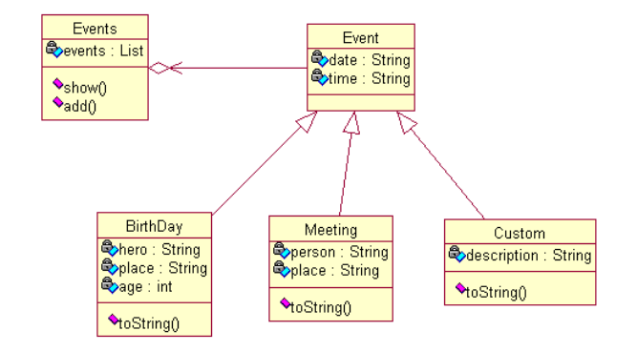
Figure 1. Example class structure for the Personal Organizer project
2. Product Delivery Management System
Create a parent class Order (date, time, identifier) and child classes:
• Regular Order;
• Express Order (courier, delivery date);
• Insured Order (insurance company, amount).
Implement a class for storing a list of orders, with a method for adding an order and a method for printing the list of orders.
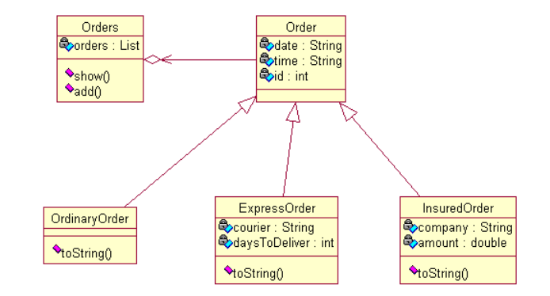
Figure 2. Example class structure for the Product Delivery Management System
3. TV Program
Create a parent class TVProgram (program name, time) and child classes:
• Educational Program (field of science);
• Children’s Program (minimum age, maximum age);
• Show (topic);
• Movie (description, year).
Implement a class for storing a list of TV programs, with a method for adding a TV program and a method for printing the list of TV programs.
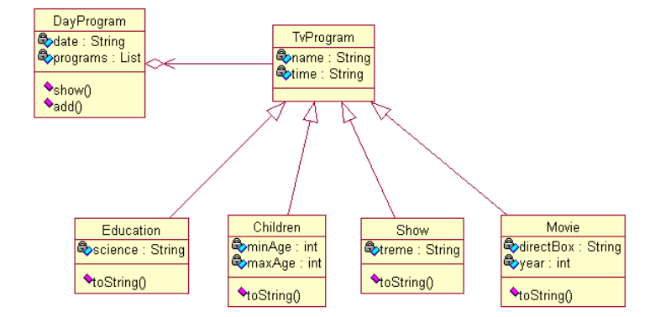
Figure 3. Example class structure for the TV Program project
4. Hotel
Create a parent class Room (identifier, room number, number of guests, price) and child classes:
• Standard Room;
• Junior Suite;
• Suite (minimum rental period, maximum rental period).
Implement a class for storing a list of rooms, with a method for adding a room and a method for printing the list of rooms.
5. Finished Goods Sales
Create a parent class Product (identifier, code, name, price, description) and child classes:
• Fragile Product (fragility coefficient);
• Perishable Product (maximum storage time);
• Oversized Product (height, width, length).
Implement a class for storing a list of products, with a method for adding a new product and a method for printing the list of products.
6. University Student Academic Performance Records
Create a parent class Student (student record-book number, surname, first name, group, department, discipline, grade, teacher’s surname) and child classes:
• Full-Time Study (Unified State Exam score, average school certificate grade);
• Part-Time Study (place of work, position, tuition amount);
• Targeted Education (name of sponsoring enterprise, tuition amount).
Implement a class for storing a list of students, with a method for adding a new student and a method for printing the list of students.
7. Faculty Management Automation
Create a parent class Faculty (room, building, contact phone number, dean’s surname) and child classes:
• Faculty Staff (full name, position);
• Departments (name, field of study);
• Department Teachers (teacher’s full name, department, position, work experience, disciplines taught).
Implement a class for storing a list of faculties, with a method for adding a new faculty, its departments and teachers, and a method for printing complete information about the faculty structure.
8. Supermarket Product Sales
Create a parent class Supermarket (department name, product name, country of origin, retail price, supplier) and child classes:
• Toys (age group, type);
• Fruit (maximum storage time, storage temperature);
• Oversized Product (height, width, length).
Implement a class for storing a list of products, with a method for adding a new product and a method for printing the list of products.
9. Military Personnel Records
Create a parent class MilitaryPersonnel (surname, company, rank, date of birth, service start date, military unit) and child classes:
• Military Administration Bodies (district name, position, years of service, allowance amount);
• Contract Military Service (contract period, contract date, protocol number, salary amount);
• Awarded Personnel (award name, bonus, allowance amount).
Implement a class for storing a list of military personnel, with a method for adding a new person and a method for printing the list.
10. Literature Records
Create a parent class Literature (source code, literature type, title, year of publication, publisher, number of pages, author) and child classes:
• Scientific and Technical Literature (field of science, number of copies);
• Periodicals (type of periodical, publication frequency);
• Reference Books (field, volume, part).
Implement a class for storing a list of literature sources, with a method for adding a new source and a method for printing the list.
11. Travel Voucher Sales Records
Create a parent class TravelVoucher (voucher code, client surname, resort/boarding-house name, room number, accommodation type, check-in date, check-out date, number of people, price) and child classes:
• International Vouchers (international passport, insurance);
• Sanatoriums (medical insurance policy, diagnosis, referral);
• Children’s Health Vouchers (child’s age, birth certificate, gender).
Implement a class for storing a list of vouchers, with a method for adding a voucher and a method for printing the list.
12. Service Station Work Records
Create a parent class MaintenanceService (station name, station address, vehicle under repair, repair type, admission date, release date, repair result, staff surname, repair cost) and child classes:
• Preventive Maintenance for Passenger Vehicles (type: scheduled/major, year, mileage, period);
• Faults (fault name, description of completed work);
• Preventive Maintenance for Trucks (type: TO-1, TO-2, TO-3, year, mileage, period, engine capacity).
Implement a class for storing a list of completed repair works, with a method for adding a repair and a method for printing the list of repairs.
13. Patient Medical Services
Create a parent class MedicalService (clinic name, clinic address, patient surname, insurance policy number, examination date, doctor’s surname, doctor’s position, diagnosis) and child classes:
• Preventive Examination (type: outpatient/inpatient, year, validity period, result);
• Vaccination (vaccine name, vaccination date, validity period);
• Medical Care for Children and Adolescents (birth certificate, gender, child’s age).
Implement a class for storing a list of patient medical services, with a method for adding a record and a method for printing the list.
14. Library
Create a parent class Library (library name, address, city, director’s full name) and child classes:
• Reading Room (room name, number of literature sources, floor, room number);
• Readers (surname, first name, patronymic, place of work, age, gender);
• Literature Issue (reading room name, reader surname, literature title, issue date, loan period, deposit amount).
Implement a class for storing a list of literature, with a method for adding a record and a method for printing the list.
15. Car Sales
Create a parent class Car (car make, year of manufacture, price, configuration, country of manufacture, sale date, buyer’s full name) and child classes:
• Used Cars (condition level, owner’s full name, mileage);
• Sports Cars (seconds to reach target speed, engine capacity, power);
• Special-Purpose Vehicles (type: construction, freight, road, etc.; weight, overall dimensions).
Implement a class for storing a list of sold cars, with a method for adding a new car and a method for printing the list of cars.
16. Online Store Sales Records
Create a parent class OnlineStore (store name, product name, country of manufacture, payment type, purchase amount, sale date, buyer’s full name) and child classes:
• Living Room Furniture (name, price, furniture type, manufacturer);
• Kitchen Furniture (name, price, length, height, width, material);
• Bathroom Furniture (name, price).
Implement a class for storing a list of products, with a method for adding a new product and a method for printing the list of products.
17. Hospital
Create a parent class Hospital (hospital name, head, city, address) and child classes:
• Departments (department name, building, floor, head’s full name);
• Patients (department name, patient’s full name, insurance policy number, admission date, discharge date, diagnosis, operation date, operation name, treatment cost);
• Doctors (department name, doctor’s full name, position, academic title, work experience).
Implement a class for storing a list of hospitals, including departments, patients, and doctors, with a method for adding records and a method for printing the list.
18. Naval Exercises
Create a parent class NavalExercise (military unit name, exercise date, number of personnel, exercise location, exercise result) and child classes:
• Ships (ship name, ship type, operating hours, military unit name);
• Personnel (service member’s full name, rank, experience, position, military unit name);
• Exercise Location (name, region, district).
Implement a class for storing a list of naval exercises, with a method for adding a record and a method for printing the list.
19. Tourist Tour Records
Create a parent class TouristTour (tour name, meal plan, tour price, departure date) and child classes:
• International Tours (countries, cities, transport type, accommodation type, duration);
• Hiking Tours (excursion name, duration, accommodation type);
• Sports and Wellness Tours (sports event, city, participation type, accommodation type).
Implement a class for storing a list of tourist tours, with a method for adding a tour and a method for printing the list.
20. Circus Performance Records
Create a parent class Circus (performance name, city, premiere date, performance period, ticket price, author, genre, number of performers) and child classes:
• Acrobatic Performances (type of acrobatics, number of performers, equipment);
• Animal Training (training type: large animals, small animals, birds, predators; number of animals, number of performers);
• Magic Acts (type: illusion, manipulation; number of performers, equipment).
Implement a class for storing a list of performances, with a method for adding a new performance and a method for printing the list.
21. Pharmacy Medicine Sales Records
Create a parent class Pharmacy (pharmacy name, address, city, director’s full name) and child classes:
• Pharmacy Clients (pharmacy name, client surname, first name, patronymic, discount percentage);
• Pharmacy Medicine Stock (pharmacy name, medicine name, medicine type, medicine price, country of manufacture);
• Sales (pharmacy name, medicine name, medicine price, client’s full name, quantity, amount payable).
Implement a class for storing a list of medicines, with a method for adding a new medicine and a method for printing the list.
22. Subscription Fee Records
Create a parent class SubscriptionFee (subscriber surname, first name, patronymic, address, city, passport details) and child classes:
• International Calls (country, city, duration in minutes, price, payment amount, month, year);
• Local Calls (tariff, duration in minutes, payment amount, month, year);
• Internet Connection (connection name, allocated data volume, payment amount, month, year).
Implement a class for storing a list of subscription payments, with a method for adding a new payment and a method for printing the complete list.
23. Dentistry
Create a parent class Dentistry (dental clinic name, clinic address, city, number of doctors) and child classes:
• Departments (department name, floor, head’s full name);
• Doctors (department name, doctor’s full name, position, academic title, work experience);
• Patient Medical History (patient’s full name, insurance policy number, treatment date, services provided, payment amount, doctor’s full name).
Implement a class for storing the relevant clinic information, including departments, patients, and doctors, with a method for adding records and a method for printing the list.
24. Rolling Stock Maintenance Records
Create a parent class TechnicalDepot (depot name, depot address, city, number of employees) and child classes:
• Scheduled Preventive Inspection of Rolling Stock (repair type: TO-1, TO-2, TO-3; year, month, railcar number, repair result);
• Current Repair (repair type: TR-1, TR-2, TR-3; locomotive number, faults, description of completed work, repair cost);
• Major Repair (year, month, railcar number, repair cost).
Implement a class for storing a list of completed works, with a method for adding a repair and a method for printing the list of repairs.
25. Department Management Automation
Create a parent class Department (room, building, contact phone number, dean’s surname, number of teachers) and child classes:
• Student Groups (group name, admission year, department);
• Department Students (department, group, student’s full name, gender, address);
• Department Teachers (department, teacher’s full name, position, work experience, disciplines taught).
Implement a class for storing a list of departments, with a method for adding a new department, its groups, students, and teachers, and a method for printing complete information about its structure.
References
1. Schildt, H. Java: The Complete Reference. Moscow: Williams, 2012.
2. Setter, R. V. Learning Java through Examples and Problems. St. Petersburg: Nauka i Tekhnika, 2016.
3. Lafore, R. Data Structures and Algorithms in Java. St. Petersburg: Piter, 2013.
4. Eckel, B. Thinking in Java. St. Petersburg: Piter, 2015.
5. Blinov, I. N., Romanchik, V. S. Java. Programming Methods. Minsk: Chetyre Chetverti, 2013.
6. Vasiliev, A. N. Java. Object-Oriented Programming. St. Petersburg: Piter, 2012.
7. Vyazovik, N. A. Java Programming. Moscow: Intuit, 2016.
8. Khabibullin, I. Java 7. St. Petersburg: BHV-Petersburg, 2012.
9. Monakhov, V. V. The Java Programming Language and the NetBeans Environment. St. Petersburg: BHV-Petersburg, 2011.
10. Bloch, J. Effective Java. Moscow: Lori, 2014.
11. Sedgewick, R., Wayne, K. Algorithms in Java. Moscow: Williams, 2013.
12. Goodrich, M. T., Tamassia, R. Data Structures and Algorithms in Java. Moscow: Novoe Znanie, 2013.
13. Blinov, I. N., Romanchik, V. S. A Practical Guide to Learning Java. Moscow: UniversalPress, 2005.
14. Ball, D., Patel, P., Thomas, M., Hudson, A. Secrets of Internet Programming in Java. St. Petersburg: Piter, 2002.

