Task 1. Connect to the server
I launch SQL Server Management Studio, select SQL Server Authentication, user sa, empty password, and connect to the server MyServ (the alias configured in Lab 1).
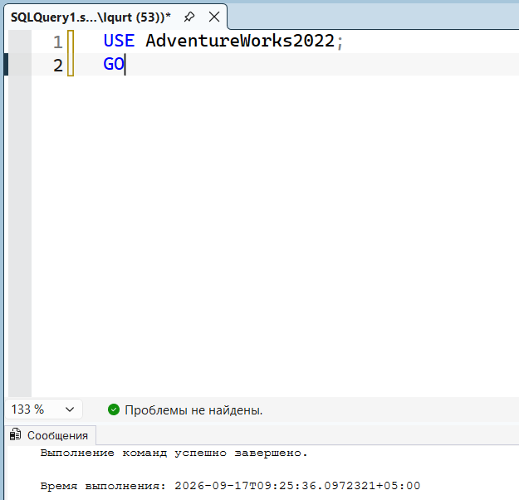

Task 2. List of countries with code and last modified date
I set the current database to AdventureWorks2008. I use AS to rename the columns in the output.

USE AdventureWorks2008
GO

SELECT CountryRegionCode AS 'Code', [Name] AS 'Country',
ModifiedDate AS 'Modified Date'
FROM Person.CountryRegion
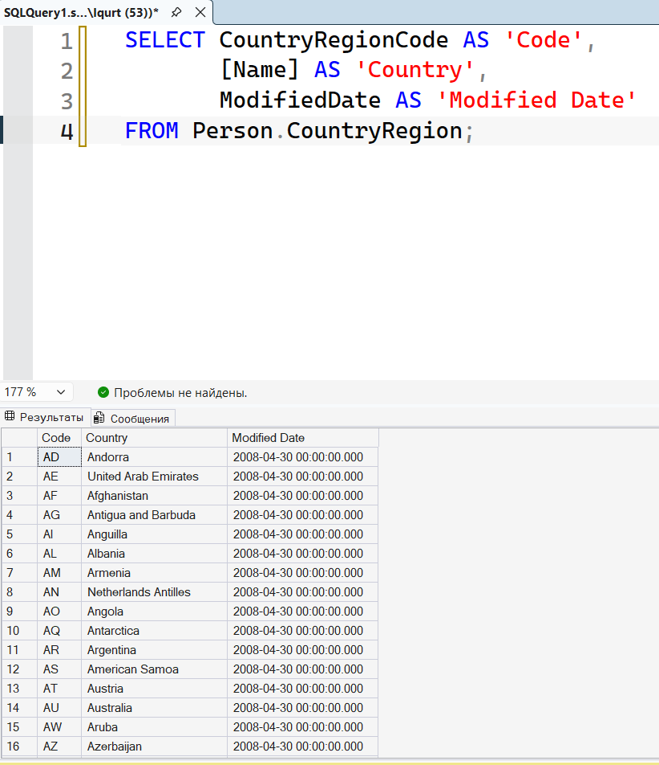

Result: the query returns all countries with the renamed columns Code / Country / Modified Date. [Name] is in square brackets because Name is a reserved word in T-SQL.

Task 3. Last name + first initial + ID, sorted
I concatenate LastName, the first character of FirstName (via Substring), and a dot. Strings in T-SQL are joined with +. The alias [Employee Name] is then used directly in ORDER BY.

SELECT LastName + ' ' + Substring(FirstName, 1, 1) + '.' AS [Employee Name],
BusinessEntityID
FROM Person.Person
ORDER BY [Employee Name]
GO

Result: the list is sorted by last name and initial in ascending order (ASC is the default; DESC would be needed for descending).

Task 4. Products with price from $12 to $20, sorted by price
Two equivalent variants. The first uses two comparisons with AND; the second uses BETWEEN. Both include the boundary values 12 and 20.
Variant 1:

SELECT [Name], ListPrice
FROM Production.Product
WHERE (ListPrice >= 12) AND (ListPrice <= 20)
ORDER BY 2
GO

Variant 2:

SELECT [Name], ListPrice
FROM Production.Product
WHERE ListPrice BETWEEN 12 AND 20
ORDER BY ListPrice
GO

Result: both variants return the same rows, sorted by price ascending. ORDER BY 2 sorts by the second column in the SELECT list (ListPrice); ORDER BY ListPrice is more readable.

Task 5. Employees and positions outside the USA
LIKE searches by pattern; % means any number of characters. NOT LIKE '%United States%' excludes everyone whose country contains that substring.

SELECT LastName, JobTitle
FROM HumanResources.vEmployee
WHERE CountryRegionName NOT LIKE '%United States%'
GO

Result: only employees outside the United States are returned.

Task 6. Employees from the USA and Canada
IN (list) checks membership in a list. It is equivalent to a chain of OR conditions but shorter.

SELECT LastName, JobTitle
FROM HumanResources.vEmployee
WHERE CountryRegionName IN ('United States', 'Canada')
GO

Result: all employees from the USA and Canada are returned.

Task 7. Products with no color specified
NULL is not an empty string and not 0 — it is the absence of a value. It cannot be compared with = NULL; the correct operator is IS NULL.

SELECT [Name]
FROM Production.Product
WHERE Color IS NULL
GO

Result: only products with no color specified are returned.

Independent Work
1. ShipMethod — if the user has read permission
I check the zero bit of the PERMISSIONS mask before showing the data. & 1 isolates the SELECT ALL bit.

IF PERMISSIONS(OBJECT_ID('Purchasing.ShipMethod')) & 1 = 1
SELECT * FROM Purchasing.ShipMethod
ELSE
PRINT 'No selection rights'
GO

Result: depends on the rights of the current user. Under sa the data is returned.
2. Employee list: ID, birth date (dd.mm.yyyy), age today
CONVERT(VARCHAR, BirthDate, 104) gives the dd.mm.yyyy format (style 104). Age is not just the year difference: DATEDIFF(YEAR, ...) counts year-number changes, not full years. If the birthday has not yet come this year, I subtract 1.

SELECT EmployeeID,
CONVERT(VARCHAR, BirthDate, 104) AS BirthDateFormatted,
DATEDIFF(YEAR, BirthDate, GETDATE())
- CASE WHEN (MONTH(BirthDate) > MONTH(GETDATE()))
OR (MONTH(BirthDate) = MONTH(GETDATE())
AND DAY(BirthDate) > DAY(GETDATE()))
THEN 1 ELSE 0 END AS Age
FROM HumanResources.Employee
GO

Result: each row shows EmployeeID, the birth date in dd.mm.yyyy, and the correct age as of today (the CASE correction handles birthdays still ahead this year).
3. Discontinued products with their color
SellEndDate IS NOT NULL means the product has been discontinued (the sell end date is set).

SELECT [Name], Color
FROM Production.Product
WHERE SellEndDate IS NOT NULL
GO

Result: only discontinued products are returned, together with their color.
4. Warehouse locations containing 'Paint'
LIKE '%Paint%' matches any string containing the substring Paint.

SELECT [Name]
FROM Production.Location
WHERE [Name] LIKE '%Paint%'
GO

Result: locations whose name contains Paint (for example, "Paint" and "Paint Shop").
5. Countries where customers are registered (from vIndividualCustomer)
I use the view Sales.vIndividualCustomer, not the table, because the table does not store the customer's country directly — that requires joining several tables, which the view already does. DISTINCT removes duplicates so the result is a list of countries, not one row per customer.

SELECT DISTINCT CountryRegionName
FROM Sales.vIndividualCustomer
GO

Result: a list of unique countries where customers are registered; the United States appears once even though several customers are from there.

