LABORATORY WORK NO. 4–5
OBJECT ANALYSIS.
ACTIVITY DIAGRAM

TASK 1. CREATING AN ACTIVITY DIAGRAM
Based on the general description of the "Procurement Planning and Supplier Order Placement" business process, create an activity diagram showing the process participants, the operations performed by each participant, and the relationships between them. The operations on the diagram must follow the chronological order defined in the provided business process description.

Completing Task 1
- Study the general description of the business process and identify the participants involved. In steps 1 and 2 of the description, the participant is the "Planning and Marketing Group Manager"; in steps 3 and 4, it is the "Purchasing Department Manager"; and in steps 5 through 9, the participant is the "Logistics Group Manager." Thus, the "Purchasing" business process involves three participants: the Planning and Marketing Group Manager, the Purchasing Department Manager, and the Logistics Group Manager.
- Begin creating the activity diagram. To do this, divide the workspace into three sections, with each section dedicated to displaying the actions of a specific process participant.
- Select the "Line Tool" icon from the "Standard" toolbar. While holding down the left mouse button, divide the sheet into three sections.
- Select the icon displaying the letter "A" from the "Standard" toolbar. Enter the full name of the business process, its abbreviated name (1Pl_Zak), and the business process participants as a heading, following the layout shown in Figure 1.
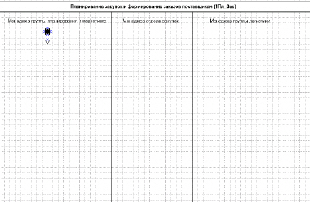

Fig. 1. Preparatory stage for depicting an activity diagram.

- Analyze the general description of the business process and identify the participant with whom the process begins. Clearly, this is the Planning and Marketing Group Manager. Indeed, the procurement process should only commence once the company's need for the product (medicines) has been determined.
- Mark the start of the process on the diagram with the "Initial state" symbol and draw an arrow pointing downwards.
- Using the text description, identify the actions performed by the marketing planning group manager. The actions (operations) performed by the marketing planning group manager are: "Obtaining internal sales statistics", "Obtaining external sales statistics", and "Calculating product requirements".
- Represent the actions performed by the marketing planning group manager on a diagram. Note that the processes of obtaining internal and external statistics occur independently of each other. The sequence in which the statistical data is obtained does not matter; therefore, depict the actions (operations) for obtaining internal and external statistics in parallel on the diagram.
- Use the shape to represent an action on the diagram. Inside the shape, enter the name and sequence number of the action (or operation). Use numbers such as 1a) and 1b) for parallel operations.
- Connect the actions on the diagram with arrows.
- To represent the parallel processes of obtaining internal and external statistics, use a (Transition|Fork).
- The manager calculates product requirements only after receiving both internal and external statistics; therefore, the parallel processes of obtaining statistics must be merged into one. To merge independent, parallel processes, use a (Transition|Join).
- As a result of the product requirement calculation operation (Operation No. 2) (Item 2 of the general description), the manager generates a document—a table of product requirements. To represent the document on the diagram, use a rectangle. Draw the rectangle by selecting the Rectangle Tool icon.
- On the diagram, connect the operation and the document resulting from its execution with a dashed line. To draw the dashed line, select the "Line Tool" icon and choose the dashed line style from the icon's menu (Line Pattern).
- As a result, the diagram (Fig. 2) will display the actions (operations) performed by the planning and marketing group manager.
- Once the planning and marketing group manager has generated the product requirements table, the purchasing department manager becomes involved in the process; therefore, draw an arrow from the "Calculate product requirements" operation to the purchasing manager's activity area, as shown in
Fig. 2.

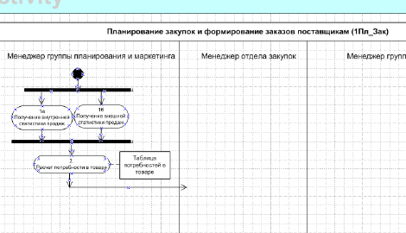

Рис. 2. Activity diagram for the Planning and Marketing Group Manager

- Read the general description of the business process and identify the actions (operations) performed by the purchasing manager. Also, identify the actions the purchasing manager performs after the logistics group manager's actions.
- Sequentially depict the following actions of the purchasing manager on the diagram:
o Entering supplier price lists into the system (Operation No. 3)
o Analyzing supplier offers (Operation No. 4)
o Selecting suppliers (Operation No. 5)
o Creating a delivery schedule without specifying quantities (Operation No. 6)
Construct a diagram following the procedure described in item 11.
- Connect the purchasing manager's actions with arrows, following the description provided in step 12.
- Map the purchasing manager's actions to the documents generated in the system. The documents generated in this instance are price lists and contracts, a prioritized supplier list, and a delivery schedule. Draw the diagram in accordance with the descriptions in steps 15–16.
- Once the purchasing manager has generated the delivery schedule, the logistics group manager begins their work.
- The following actions of the logistics group manager must be depicted on the diagram:
o Calculation of required purchase quantities (Operation No. 7)
o Preparation of orders to suppliers (Operation No. 8)
o Calculation of certification costs for imported goods (if the medicines are imported)* (Operation No. 9)
o Verification that certification costs do not exceed the internal company limit*
o Preparation of orders to suppliers in the event that certification costs exceed the limit (Operation No. 10)
o Signing the order (Operation No. 11)
o Forwarding the order to the purchasing department manager (Operation No. 12)
When reviewing the general description of the business process, note that the logistics group manager performs a condition check twice and carries out a specific action depending on the result. In the list of operations above, condition-checking operations are marked with the symbol *). This is a distinctive feature of how the logistics group manager's actions are diagrammed.
- Represent the "Calculate required purchase quantity" action and draw an arrow pointing downwards.
- Since supplier orders may need to be generated multiple times if certification costs are exceeded, account for this scenario and use a join element (Transition|Join) to merge parallel flows.
- Place the "Generate supplier orders" action after the join element.
- Represent a decision diamond symbol . Draw two arrows extending from it and label them "Import" and "Russia".
- Direct the "Russia" arrow to operation No. 11, "Sign order".
- Following the "Import" arrow, diagram two sequential actions: "Calculation of certification costs for imported goods" and "Verification that certification costs do not exceed the internal company limit."
- After the "Verification that certification costs do not exceed the internal company limit" operation, place a decision diamond symbol . Draw two arrows from it and label them "greater than x%" and "less than x%," where x% represents the certification cost limit.
- Connect the arrow labeled "greater than x%" to operation No. 8, "Generation of supplier orders," via a flow merge symbol.
- Direct the arrow labeled "less than x%" toward operation No. 11, "Order signing."
- Since two action flows (items 29 and 33) are directed toward operation No. 11, "Order signing," it is necessary to use the symbol for merging independent (parallel) flows (Transition/Join). As with any operation, only a single arrow should enter operation No. 11; the flow merge symbol is used to satisfy this rule.
- Associate the "Order Signature" operation with the "Accepted Supplier Order" document, following the instructions in steps 15–16.
- Represent operation No. 12, "Forwarding the order to the purchasing manager," as the next step. This concludes the actions performed by the logistics manager. Since the workflow shifts back to the purchasing manager, draw an arrow from operation 12 to the purchasing manager's action area.
- Show the transfer of the "Supplier Order" document from the logistics manager to the purchasing manager on the diagram. To do this, first associate operation No. 12 ("Forwarding the order to the purchasing manager") with the "Supplier Order" document, as described in steps 15–16. Next, copy the "Supplier Order" document icon and place it in the purchasing manager's action area. Then, draw a dashed arrow (Object Flow) between the two "Supplier Order" document icons, pointing toward the purchasing manager's action area.
- Connect operation 12 ("Forwarding the order to the purchasing manager") to operation No. 13 ("Sending the order to the supplier"), which is performed by the purchasing manager. This is the final operation in the assignment.
- Indicate the end of the process on the diagram. Use the "Final State" symbol for this purpose. Connect operation No. 13 ("Sending the order to the supplier") to the Final State symbol with an arrow.
A general view of the action diagram of the business process “Planning purchases, generating orders for suppliers” is shown in Fig. 3.

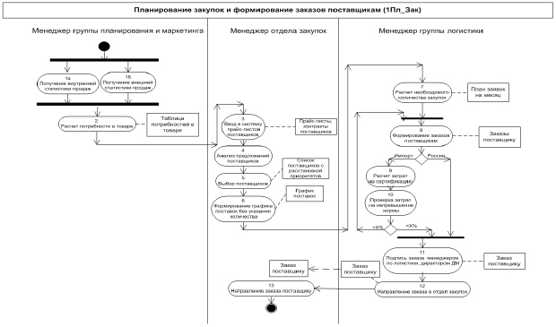
Fig. 3. Action diagram of the business process "Purchasing planning, generating orders for suppliers"

The general view of the activity diagram for the "Inventory – Warehouse (Goods Receipt)" business process is shown in Fig. 4.
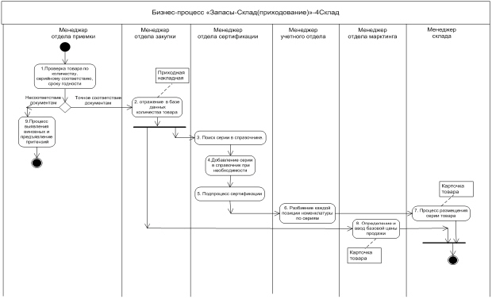
Fig. 4. Activity diagram for the "Inventory-Warehouse (Goods Receipt)" business process.

TASK 2. CREATING THE OPERATIONS TABLE

Record all operations involved in the "Procurement planning and supplier order generation" process in the operation description table, using the following format:

Table 1.
Diagram and diagram number | Operation | Performer | Frequency | Incoming documents (source documents) | Outgoing document (document to be prepared) | Accounting entry (debit, credit, amount, analytics) | Comment
1 | 2 | 3 | 4 | 5 | 6 | 7 | 8

Note: Subsequently, the completed operation description table will be used to map the operations listed therein to the information system.

TASK 3. CREATING THE DOCUMENT DESCRIPTION TABLE
List all documents involved in the business process in the document description table, using the following format:

Table 2
Diagram and operation number on the diagram | Document to be prepared (outgoing document) | Operation | Preparer (executor) | Frequency | Source documents (incoming documents) | Registry where the document is recorded | Comment
1 | 2 | 3 | 4 | 5 | 6 | 7 | 8

Note: Once the documents have been described, the process of developing them within the information system begins. Document forms are not included in this study guide; however, in actual practice, a set of forms is created as an appendix to the document description table.

"Goods Receipt" Business Process
General Description of the Business Process
CJSC "MED" operates 10 warehouses: one Central warehouse in Moscow and others at branch locations. The inventory comprises between 1,000 and 2,000 medication items.
In practice, warehouse operations are based on batches rather than individual item types; a single item type may correspond to multiple medication batches.
The warehouse is divided into several storage zones, with zones designated according to the specific storage requirements of different medications.
Nested units of measurement are used: package (minimum unit), block (multiple packages), and factory carton (multiple blocks).
The warehouse holds reserved stock—goods that are unavailable for sale.
Inventory accounting is maintained in two currencies, including rubles (the currency of receipt).
The process for receiving medications into the warehouse is as follows:
- The receiving department manager accepts goods based on the supplier's delivery note, verifying the product range (SKUs), quantities, serial number correspondence, and expiration dates.
- If the goods actually received fully match those listed in the waybill and the purchase order, the receiving department manager forwards the documents to the purchasing department manager. Otherwise, a process is initiated to identify the responsible parties and file claims.
- The purchasing department manager verifies that the delivery matches the order regarding product range, quantities, and prices; based on the supplier's delivery note, they generate a goods receipt note, recording the quantity and accounting price of the received goods in the database. Generating the goods receipt note creates an accounting entry: Debit Account 41 (Goods) – Credit Account 60 (Suppliers). Subsequently, managers from the certification and marketing departments begin their work.
- Using the waybill, the certification department manager checks whether the serial numbers exist in the reference database. If necessary, the serial number database is updated.
- The certification department manager carries out the certification process. In this context, the certification process encompasses both the formal entry of medication certificates (documents) into the system and the actual certification procedures required to obtain such certificates.
- When recording the receipt of inventory based on the waybill, the accounting department manager breaks down each product item by serial number and specifies the expiration date.
- Concurrently with the certification manager's work—and after the purchasing department manager has recorded the quantity of goods in the database—the marketing department manager uses the waybill to determine the base selling price and enters it into the product record.
- The warehouse manager places the goods in storage locations in accordance with the product storage layout plan. The storage location is entered into the product record.

TASK 4. CREATING AN ACTIVITY DIAGRAM
Based on the general description of the business processes, create activity diagrams for your chosen topic that show the process participants, the operations performed by each participant, and the relationships between them. The operations in the diagram must follow the chronological order specified in the provided business process description.

