> ################################ Librerias #####################################

> library(ggplot2)

> install.packages("statsr")

WARNING: Rtools is required to build R packages but is not currently installed. Please download and install the appropriate version of Rtools before proceeding:

https://cran.rstudio.com/bin/windows/Rtools/

Installing package into ‘C:/Users/bjxtr/AppData/Local/R/win-library/4.2’

(as ‘lib’ is unspecified)

trying URL 'https://cran.rstudio.com/bin/windows/contrib/4.2/statsr_0.3.0.zip'

Content type 'application/zip' length 1293965 bytes (1.2 MB)

downloaded 1.2 MB

package ‘statsr’ successfully unpacked and MD5 sums checked

The downloaded binary packages are in

C:\Users\bjxtr\AppData\Local\Temp\RtmpWYdVnb\downloaded_packages

> library(statsr)

Loading required package: BayesFactor

Loading required package: coda

Loading required package: Matrix

************

Welcome to BayesFactor 0.9.12-4.4. If you have questions, please contact Richard Morey (richarddmorey@gmail.com).

Type BFManual() to open the manual.

************

> Data <- read.csv(file.choose(), header = T, sep=";")

> ########################## Factoriza los datos ################################@

> Data$t <- as.factor(Data$t)

> Data$Csour <- as.factor(Data$Csour)

> Data$Rt <- as.factor(Data$Rt)

> ######################### Profe ################################################

> m1 <- aov(A450 ~ Rt, data=Data) # se consideran todos los Csour

> summary(m1)

Df Sum Sq Mean Sq F value Pr(>F)

Rt 7 0.215 0.03070 3.031 0.0039 **

Residuals 552 5.592 0.01013

---

Signif. codes: 0 ‘***’ 0.001 ‘**’ 0.01 ‘*’ 0.05 ‘.’ 0.1 ‘ ’ 1

> TukeyHSD(m1)

Tukey multiple comparisons of means

95% family-wise confidence level

Fit: aov(formula = A450 ~ Rt, data = Data)

$Rt

diff lwr upr p adj

20-10 -0.0223714286 -0.07413413 0.02939127 0.8930821

30-10 -0.0230000000 -0.07476270 0.02876270 0.8782436

40-10 0.0122714286 -0.03949127 0.06403413 0.9963576

50-10 0.0067714286 -0.04499127 0.05853413 0.9999263

60-10 0.0141571429 -0.03760556 0.06591984 0.9912293

70-10 0.0412857143 -0.01047699 0.09304842 0.2304447

80-10 -0.0041428571 -0.05590556 0.04761984 0.9999975

30-20 -0.0006285714 -0.05239127 0.05113413 1.0000000

40-20 0.0346428571 -0.01711984 0.08640556 0.4582549

50-20 0.0291428571 -0.02261984 0.08090556 0.6788053

60-20 0.0365285714 -0.01523413 0.08829127 0.3859670

70-20 0.0636571429 0.01189444 0.11541984 0.0049497

80-20 0.0182285714 -0.03353413 0.06999127 0.9624512

40-30 0.0352714286 -0.01649127 0.08703413 0.4336753

50-30 0.0297714286 -0.02199127 0.08153413 0.6542525

60-30 0.0371571429 -0.01460556 0.08891984 0.3629811

70-30 0.0642857143 0.01252301 0.11604842 0.0043134

80-30 0.0188571429 -0.03290556 0.07061984 0.9549260

50-40 -0.0055000000 -0.05726270 0.04626270 0.9999821

60-40 0.0018857143 -0.04987699 0.05364842 1.0000000

70-40 0.0290142857 -0.02274842 0.08077699 0.6837679

80-40 -0.0164142857 -0.06817699 0.03534842 0.9790798

60-50 0.0073857143 -0.04437699 0.05914842 0.9998677

70-50 0.0345142857 -0.01724842 0.08627699 0.4633317

80-50 -0.0109142857 -0.06267699 0.04084842 0.9982669

70-60 0.0271285714 -0.02463413 0.07889127 0.7535475

80-60 -0.0183000000 -0.07006270 0.03346270 0.9616450

80-70 -0.0454285714 -0.09719127 0.00633413 0.1339961

> boxplot(A450 ~ Rt, data=Data)

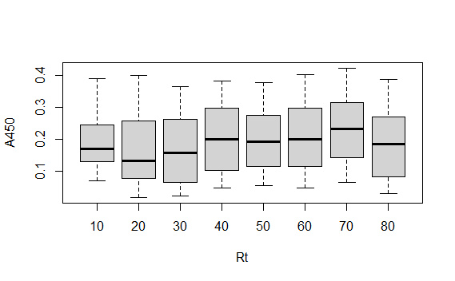

> #################################improved boxplot#######################################

> A_450_all <- Data$A450

> All_Ratio <- Data$Rt

> All_time <- Data$t

> # Define the data frame

> Data_Fs <- data.frame(

+ A_450_all,

+ All_time,

+ All_Ratio

+ )

> # Create the boxplot with separated colors

> ggplot(Data_Fs, aes(x = (All_time), y = A_450_all, fill = (All_Ratio))) +

+ ggtitle("todos los Csour todos los ratios") +

+ geom_boxplot() +

+ scale_fill_manual(values = c("magenta", "blue","yellow","cyan","green","gray50","pink","purple")) +

+ # Add vertical lines at Rt boundary

+ geom_vline(xintercept = c(1.5, 2.5, 3.5, 4.5, 5.5, 6.5, 7.5, 8.5, 9.5, 10.5, 11.5, 12.5, 13.5, 14.5, 15.5, 16.5), linetype = "dotted", color = "black") +

+ theme_classic()

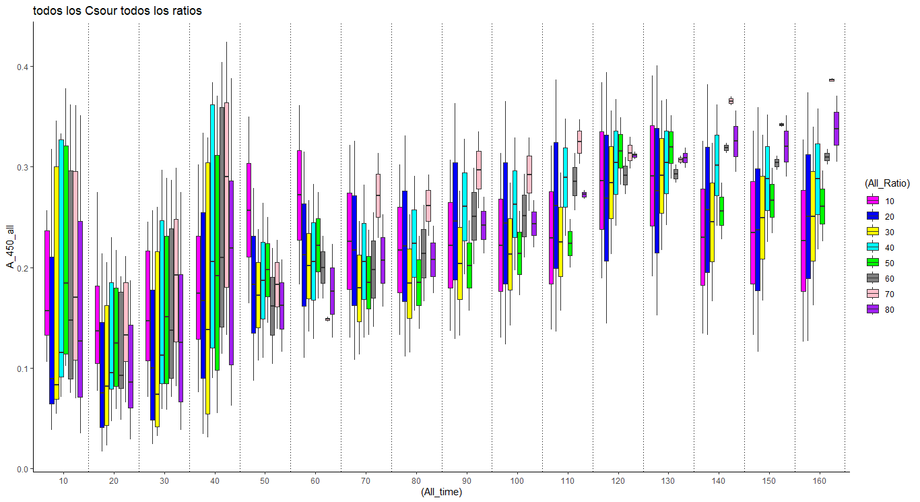

> ################################################################################

> ################################################################################

> Absorbance_450nm <- Data$A450

> Colagen_source <- Data$Csour

> Time_all <- Data$t

> # Define the data frame

> Data_Fs <- data.frame(

+ Absorbance_450nm,

+ Time_all,

+ Colagen_source

+ )

> # Create the boxplot with separated colors

> ggplot(Data_Fs, aes(x = (Time_all), y = Absorbance_450nm, fill = (Colagen_source))) +

+ ggtitle("All colagen sources vs time") +

+ geom_boxplot() +

+ scale_fill_manual(values = c("magenta", "blue","yellow","red","orange","green","pink","purple")) +

+ # Add vertical lines at Rt boundary

+ geom_vline(xintercept = c(1.5, 2.5, 3.5, 4.5, 5.5, 6.5, 7.5, 8.5, 9.5, 10.5, 11.5, 12.5, 13.5, 14.5, 15.5, 16.5), linetype = "dotted", color = "black") +

+ theme_classic()

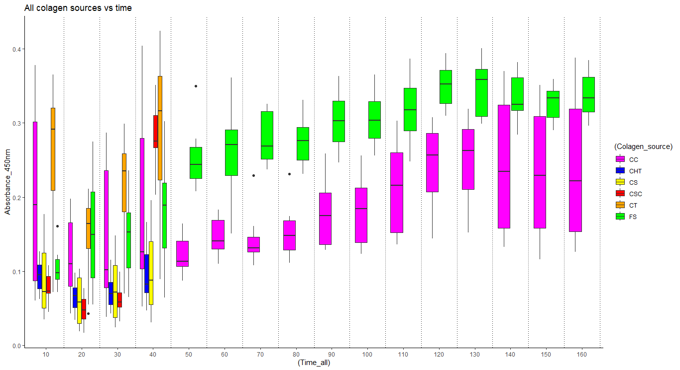

#fish scales (FS) es mas estable vs CC ya que hay mas datos hasta el min 160

> #Rt70

> #Se elije porque tiene el unico valor por debajo de 0.05. Ademas se elige

> # 70 por el hecho que es mas diferente a los comparados con 20 vs otros ratios

> Data_Rt70 = subset(Data, Rt=="70")

> m1_Rt70 <- aov(A450 ~ t, data=Data_Rt70)

> anova(m1_Rt70)

Analysis of Variance Table

Response: A450

Df Sum Sq Mean Sq F value Pr(>F)

t 15 0.35188 0.0234589 3.6158 0.0002498 ***

Residuals 54 0.35035 0.0064879

---

Signif. codes: 0 ‘***’ 0.001 ‘**’ 0.01 ‘*’ 0.05 ‘.’ 0.1 ‘ ’ 1

> boxplot(A450 ~ t, data=Data_Rt70)# se plotean los datos solo para el ratio 70

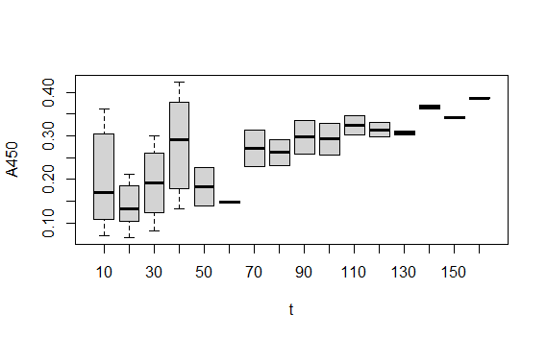

> Absorbance_450nm_Ratio_70 <- Data_Rt70$A450

> Rt_70 <- Data_Rt70$Rt

> Time <- Data_Rt70$t

> # Define the data frame

> Data_Fs <- data.frame(

+ Absorbance_450nm_Ratio_70,

+ Time,

+ Rt_70

+ )

> # Create the boxplot with separated colors

> ggplot(Data_Fs, aes(x = (Time), y = Absorbance_450nm_Ratio_70, fill = (Rt_70))) +

+ ggtitle("All colagen sources for ratio 70") +

+ geom_boxplot() +

+ scale_fill_manual(values = c("magenta", "blue","yellow","orange","white","red","pink","purple")) +

+ # Add vertical lines at Rt boundary

+ geom_vline(xintercept = c(1.5, 2.5, 3.5, 4.5, 5.5, 6.5, 7.5, 8.5, 9.5, 10.5, 11.5, 12.5, 13.5, 14.5, 15.5, 16.5), linetype = "dotted", color = "black") +

+ theme_classic()

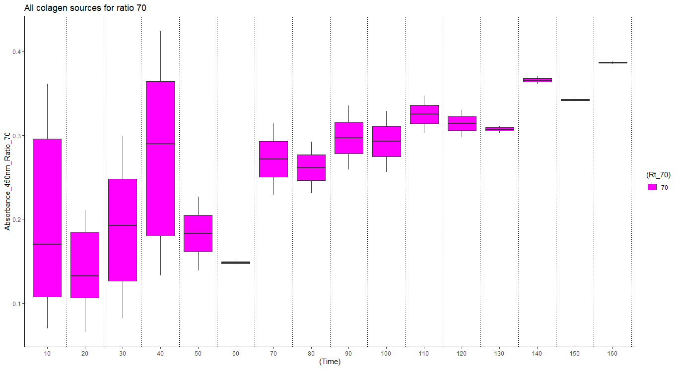

> #$$$$$$$$$$$$$$$$$$$$$ Solo de FS N3 ###############################

>#mejores resultados en tukey y anova

> # Warning: Borrar las variables de workspace y cargar el archivo "Sin_Mai_ni_ Isaac.csv

> # este archivo solo tiene el FS N3. mas adelante se hará con FS N3 y N5

> Data <- read.csv(file.choose(), header = T, sep=";")

> ########################## Factoriza los datos ################################@

> Data$t <- as.factor(Data$t)

> Data$Csour <- as.factor(Data$Csour)

> Data$Rt <- as.factor(Data$Rt)

> Data_FS = subset(Data, Csour=="FS")

> m2 <- aov(A450 ~ Rt, data=Data_FS) # se consideran solos los datos para FS

> summary(m2)

Df Sum Sq Mean Sq F value Pr(>F)

Rt 7 0.02207 0.0031526 7.495 8.19e-05 ***

Residuals 24 0.01009 0.0004206

---

Signif. codes: 0 ‘***’ 0.001 ‘**’ 0.01 ‘*’ 0.05 ‘.’ 0.1 ‘ ’ 1

># P value muy bajo a 0.05. Por lo que hay diferencias entre las medias de los grupos A450 y ratio

> TukeyHSD(m2)

Tukey multiple comparisons of means

95% family-wise confidence level

Fit: aov(formula = A450 ~ Rt, data = Data_FS)

$Rt

diff lwr upr p adj

20-10 -0.04775 -0.095781062 0.0002810624 0.0521312

30-10 -0.08275 -0.130781062 -0.0347189376 0.0001660

40-10 -0.03975 -0.087781062 0.0082810624 0.1583094

50-10 -0.04725 -0.095281062 0.0007810624 0.0561278

60-10 -0.03725 -0.085281062 0.0107810624 0.2156974

70-10 -0.00175 -0.049781062 0.0462810624 1.0000000

80-10 -0.06250 -0.110531062 -0.0144689376 0.0050095

30-20 -0.03500 -0.083031062 0.0130310624 0.2795188

40-20 0.00800 -0.040031062 0.0560310624 0.9991529

50-20 0.00050 -0.047531062 0.0485310624 1.0000000

60-20 0.01050 -0.037531062 0.0585310624 0.9953228

70-20 0.04600 -0.002031062 0.0940310624 0.0673585

80-20 -0.01475 -0.062781062 0.0332810624 0.9671413

40-30 0.04300 -0.005031062 0.0910310624 0.1028401

50-30 0.03550 -0.012531062 0.0835310624 0.2643184

60-30 0.04550 -0.002531062 0.0935310624 0.0723877

70-30 0.08100 0.032968938 0.1290310624 0.0002227

80-30 0.02025 -0.027781062 0.0682810624 0.8501612

50-40 -0.00750 -0.055531062 0.0405310624 0.9994426

60-40 0.00250 -0.045531062 0.0505310624 0.9999997

70-40 0.03800 -0.010031062 0.0860310624 0.1970229

80-40 -0.02275 -0.070781062 0.0252810624 0.7633259

60-50 0.01000 -0.038031062 0.0580310624 0.9965312

70-50 0.04550 -0.002531062 0.0935310624 0.0723877

80-50 -0.01525 -0.063281062 0.0327810624 0.9608311

70-60 0.03550 -0.012531062 0.0835310624 0.2643184

80-60 -0.02525 -0.073281062 0.0227810624 0.6623043

80-70 -0.06075 -0.108781062 -0.0127189376 0.0066915

> boxplot(A450 ~ Rt, data=Data_FS)

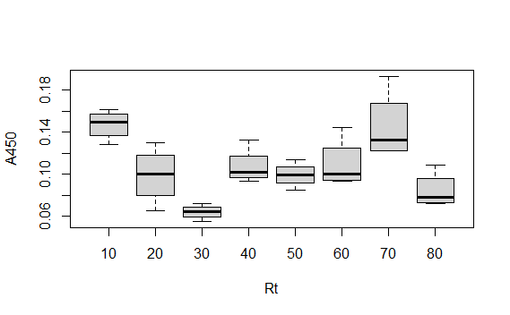

> ################################ A450 ~ Rt plot ################################

> Absorbance_450nm_Fs<- Data_FS$A450

> All_ratios_Fs<- Data_FS$Rt

> # Define the data frame

> Data_Fs <- data.frame(

+ Absorbance_450nm_Fs,

+ All_ratios_Fs

+ )

> # Create the boxplot with separated colors

> ggplot(Data_Fs, aes(x = (All_ratios_Fs), y = Absorbance_450nm_Fs, fill = "magenta")) +

+ ggtitle("Fs for all ratios") +

+ geom_boxplot() +

+ scale_fill_manual(values = c("yellow","orange","white","red","pink","purple")) +

+ # Add vertical lines at Rt boundary

+ geom_vline(xintercept = c(1.5, 2.5, 3.5, 4.5, 5.5, 6.5, 7.5, 8.5, 9.5, 10.5, 11.5, 12.5, 13.5, 14.5, 15.5, 16.5), linetype = "dotted", color = "black") +

+ theme_classic()

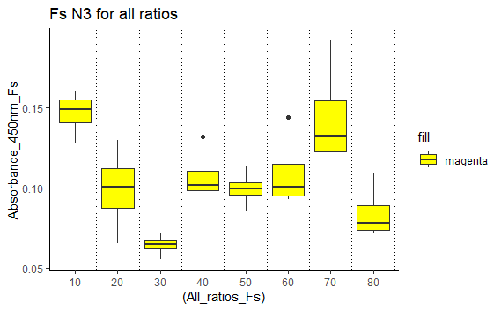

#Rt30

#Se elije porque tiene un valor por debajo de 0.05. Ademas se elige 30 por el hecho que es mas diferente a los comparados vs otros ratios. Se observa en tukey y en el grafico anterior

> # Revisar. Se supone que solo se eligen los datos para Rt=30 y Csour=FS N3

> Data_selected_ratio = subset(Data_FS, Rt=="30")

> m1_selected_ratio <- aov(A450 ~ t, data=Data_selected_ratio)

> summary(m1_selected_ratio)

Df Sum Sq Mean Sq

t 3 0.000146 4.867e-05

> anova(m1_selected_ratio)

Analysis of Variance Table

Response: A450

Df Sum Sq Mean Sq F value Pr(>F)

t 3 0.000146 4.8667e-05 NaN NaN

Residuals 0 0.000000 NaN

Warning message:

In anova.lm(m1_selected_ratio) :

ANOVA F-tests on an essentially perfect fit are unreliable

> boxplot(A450 ~ t, data=Data_selected_ratio)# se plotean los datos solo para el selected_ratio

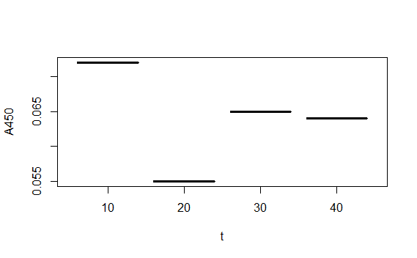

#estos resultados arrojan estos valores nulos de Pr ya que no hay suficientes datos de Fs para comparar medias.

# la solución es usar los datos de Fs considerando N3 y N5

################################ FS N3 y N5 ##################################

> # Warning: Borrar las variables de workspace y cargar el archivo "Knockout4"

> Data <- read.csv(file.choose(), header = T, sep=";")

> ########################## Factoriza los datos ################################@

> Data$t <- as.factor(Data$t)

> Data$Csour <- as.factor(Data$Csour)

> Data$Rt <- as.factor(Data$Rt)

#######################

> Data_FS_N3_N5 = subset(Data, Csour=="FS")

> m2 <- aov(A450 ~ Rt, data=Data_FS_N3_N5) # N3 y N5 Fish scales

> summary(m2)

Df Sum Sq Mean Sq F value Pr(>F)

Rt 7 0.0914 0.013061 1.544 0.157

Residuals 144 1.2181 0.008459

> selected_ratio = subset(Data_FS_N3_N5, Rt=="30")

> m1_selected_ratio <- aov(A450 ~ t, data=selected_ratio)

> summary(m1_selected_ratio)

Df Sum Sq Mean Sq F value Pr(>F)

t 15 0.1734 0.011559 1.534 0.406

Residuals 3 0.0226 0.007533

> anova(m1_selected_ratio)# hace lo mismo que la linea anterior

Analysis of Variance Table

Response: A450

Df Sum Sq Mean Sq F value Pr(>F)

t 15 0.173385 0.011559 1.5344 0.4059

Residuals 3 0.022599 0.007533

> boxplot(A450 ~ t, data=selected_ratio)# se plotean los datos solo para el selected_ratio

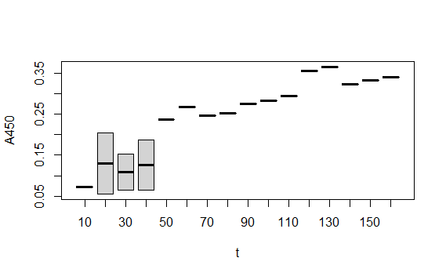

# P value mayor que 0.05. Por lo que se dice que no existen diferencias significativas entre las medias de los grupos A450 ~ Rt y t

# no se hace tukey porque no es necesario buscar diferencias entre pares por el resultado de la aov

# al tomar Fs de N3 y N5 , ya sale p values. Sin embargo, no hay diferencias en los experimentos para Fs con ratio 30

# por lo que se pueden usar ambas soluciones extractoras N3 y N5 para extraer colageno de Fs sin que hayan diferencias significativas en los resultados

# no se pudo obtener el mejor ratio para este caso porque no se hicieron pruebas de tukey

###################### Plot final ##############################

> Absorbance_450nm_Fs_N3_N5 <- selected_ratio$A450

> Rt_30 <- selected_ratio$Rt

> Time <- selected_ratio$t

> # Define the data frame

> Data_Fs <- data.frame(

+ Absorbance_450nm_Fs_N3_N5,

+ Time,

+ Rt_30

+ )

> # Create the boxplot with separated colors

> ggplot(Data_Fs, aes(x = (Time), y = Absorbance_450nm_Fs_N3_N5, fill = (Rt_30))) +

+ ggtitle("FS N3 y N5 ratio 30 ") +

+ geom_boxplot() +

+ scale_fill_manual(values = c("magenta", "blue","yellow","orange","white","red","pink","purple")) +

+ # Add vertical lines at Rt boundary

+ geom_vline(xintercept = c(1.5, 2.5, 3.5, 4.5, 5.5, 6.5, 7.5, 8.5, 9.5, 10.5, 11.5, 12.5, 13.5, 14.5, 15.5, 16.5), linetype = "dotted", color = "black") +

+ theme_classic()

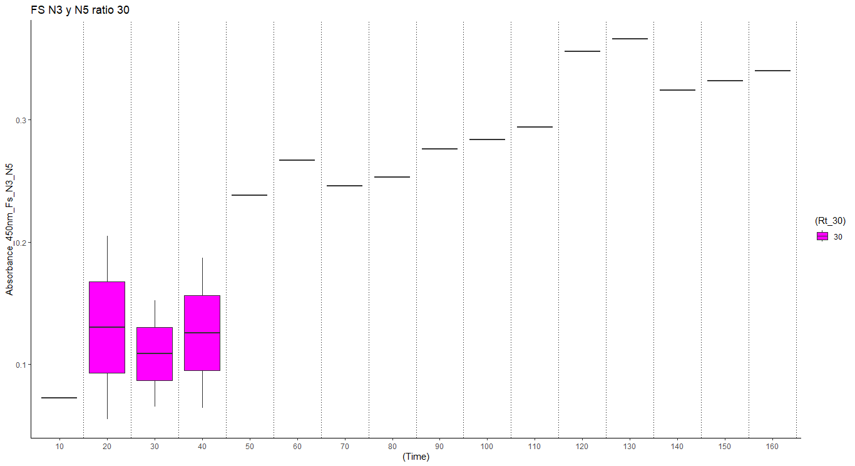

# Los resultados del análisis de p values de varianza podrían ser menores si solo se toman los tiempos de 20min a 40min. Ya que en los demás casos solo hay datos de N3 o de N5

###################### FS N3 y N5 time 20-40 min #####################

> summary(m2)

Df Sum Sq Mean Sq F value Pr(>F)

Rt 7 0.03319 0.004742 1.281 0.285

Residuals 40 0.14812 0.003703

> selected_ratio = subset(Data_FS_N3_N5, Rt=="30")

> m1_selected_ratio <- aov(A450 ~ t, data=selected_ratio)

> summary(m1_selected_ratio)

Df Sum Sq Mean Sq F value Pr(>F)

t 2 0.000514 0.000257 0.034 0.967

Residuals 3 0.022599 0.007533

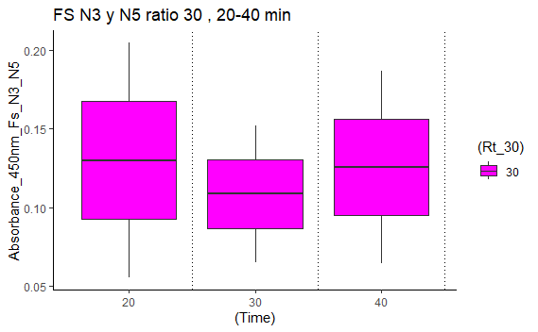

# No se observan cambios para decir que las medias son distintas. No se hace Tukey. Y se conserva el ratio de 30 por no poder realizar de nuevo Tukey.

# A mi criterio no tendría sentido comparar Fs con otra fuente de colageno ya que seguramente habrían varianzas en los experiementos al usarse distintos tejidos que pueden tener menor o mayor cantidad de colageno. En nuestro caso de Fs se usó las mismas escamas de pescado de la misma raza de pescado. Las únicas variaciones fueron los tratamientos N3 y N5