Logbook working journal

Zhuoming Lei

Sprint 1

* Spend some time doing research about using machine learning for a stock market. (3 hours) <https://towardsdatascience.com/how-to-use-machine-learning-to-possibly-become-a-millionaire-predicting-the-stock-market-33861916e9c5>
* Wrote some quality assurance testing cases with some help from a teammate such as performance and functional testing. At first, I brainstormed some ideas with a rough draft. (3 hours)
* A bit of independent research about reinforcement learning in general (3 hours) <https://www.youtube.com/watch?v=05NqKJ0v7EE> <https://skymind.ai/wiki/deep-reinforcement-learning>
* Helped with the PowerPoint (1 hour)
* Meeting with my team once a week for about 2 hours

Sprint 2

* Watched many tutorial videos on how to implement our system. (6 hours)
* Code some htmls like login.html and register.html. (6 hours)
* Worked on the main.css (2 hours)
* Tested our system for quality assurance by making sure it works on different browsers like Google Chrome and IE (for example, for my laptop the layout and format looks off in chrome but it is fine in IE). (2 hours)
* Met with the group for 2 hours to discuss our plans.

Sprint 3

* Worked on setting up database to pull historical data and import it
* We want to do it without manually entering the data and find a way to secure the data safely
* Also, we want to connect to the database and use its data to plot the graphs
* Met with team few times during this sprint period

Sprint 4

* Implemented on pulling and importing data to a database
* Make it so we can plot data from csv files (using historical data from multiple companies)
* Trying to figure out how to run python script through html
* Met with the group to discuss a solution

Sprint 5

* Implemented and help with a buy and sell tab in our webpage
* Updated server and some quality assurance test
* Made a sequence diagram to tell what else we can implement to our webpage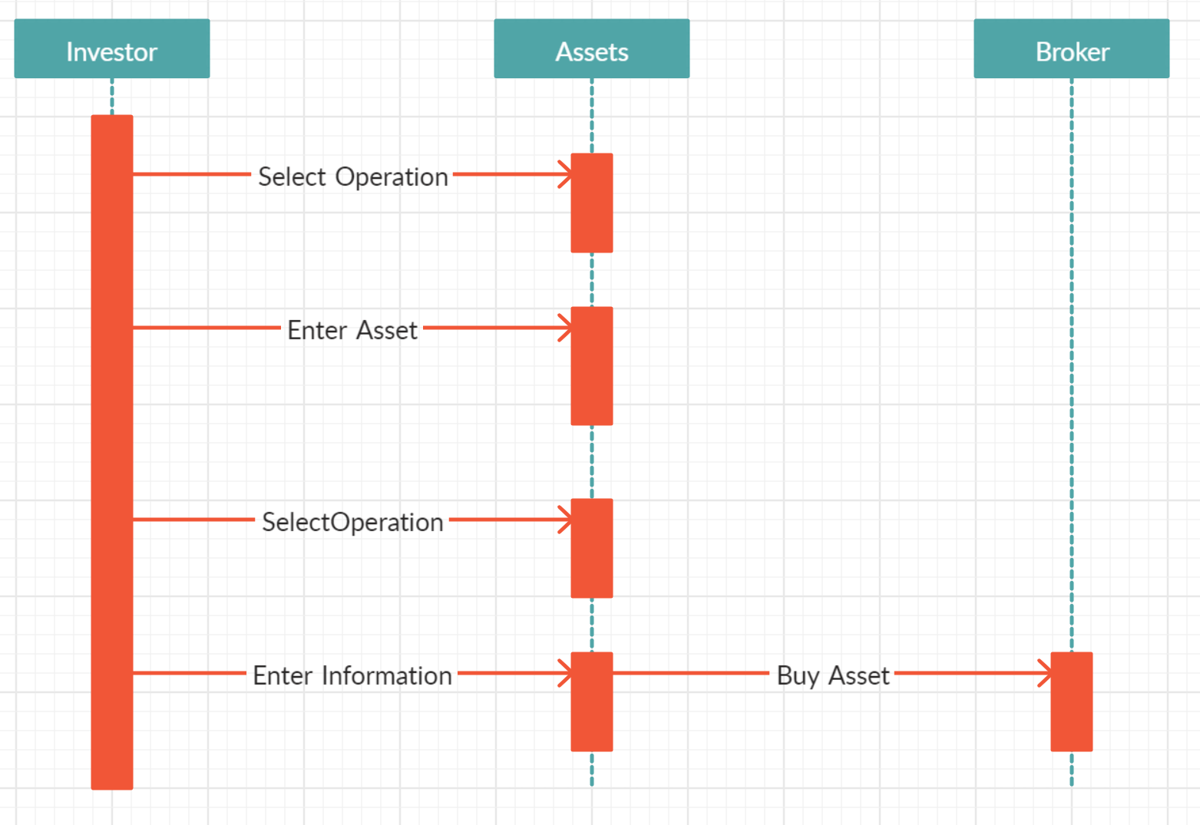
* Almost close to merge our front end and back end work

Our website is: <http://chenson.pythonanywhere.com/>