
RIGA TECHNICAL UNIVERSITY
FACULTY OF COMPUTER SCIENCE AND INFORMATION TECHNOLOGY
INSTITUTE OF APPLIED COMPUTER SYSTEMS

Practical assignment #2
“Database Management Systems”
SQL constructs

Developed by: Paulinus Tochukwu
Course, group: 3, 1
Student card no.: XXXADBXXX

Checked: Andrejs Gaidukovs
2016 / 2017 study year

Table of Contents
1 Goal 3
2 Task 3
3 Database description 4
4 SQL queries 5
4.1 query with one table and multiple conditions in WHERE clause; 5
4.2 query with two related tables and multiple conditions in WHERE clause; 5
4.3 query with grouping GROUP BY; 6
4.4 query with grouping and HAVING clause (contitions for groups); 6
4.5 query with subquery in SELECT clause; 7
4.6 query with subquery in FROM clause; 7
4.7 query with subquery in WHERE clause; 8
4.8 query with UNION construction; 8
4.9 query with EXISTS construction; 9
4.10 at least 3 queries with INNER JOIN; 9
4.11 at least 3 queries with LEFT JOIN; 11
4.12 at least 3 queries with RIGHT JOIN; 12
5 Conclusions 15
6 References 18

Goal
Learn about and use various SQL constructs

Task
- Create the following types of SQL queries:
- query with one table and multiple conditions in WHERE clause;
- query with two related tables and multiple conditions in WHERE clause;
- query with grouping GROUP BY;
- query with grouping and HAVING clause (contitions for groups);
- query with subquery in SELECT clause;
- query with subquery in FROM clause;
- query with subquery in WHERE clause;
- query with UNION construction;
- query with EXISTS construction;
- at least 3 queries with INNER JOIN;
- at least 3 queries with LEFT JOIN;
- at least 3 queries with RIGHT JOIN;
In queries include predicates LIKE together with "?", "*", &; and predicates ANY; ALL; IN; BETWEEN; DISTINCT.
In queries include aggregation functions COUNT(), SUM(), MAX(), AVG().
In queries include text and datetime functions;
In queries include expressions (e.g. addition and subtraction).

Database description
In this assignment, I have designed a database for University system. Where information about students, teachers, faculty, subjects and marks are kept.
- Teacher: Stores information about teacher.
- First Name
- Last Name
- Teacher Id (PK)
- Address
- Phone number
- Subject id (FK)
- Subject: Stores details of subjects.
- Subject id(PK)
- Name
- Full mark
- Pass mark
- Student: Store information about Students
- student Id (PK)
- First Name
- Last name
- DOB
- Faculty id(FK)
- Faculty: Stores information about faculty
- Faculty id(PK)
- Name
- Marks: Store information about marks.
- Mark id(PK)
- Student id(FK)
- Subject id(FK)
- Mark
- FacultySubjects: Relationship table between faculty and subject.
- Subject id
- Faculty id

SQL queries

query with one table and multiple conditions in WHERE clause;

Goal:
To find detail of teacher whose address is stabu and lastname is Kikova.

SELECT *
FROM TEACHER
WHERE ADDRESS ='stabu iela' and LASTNAME='Kikova';
Result:
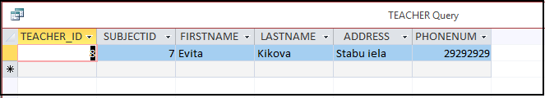

Analysis: Query returned the detail of teacher who lives in stabu iela and last name is Kikova. And got as specified in query.

query with two related tables and multiple conditions in WHERE clause;

GOAL:
goal: List out firstname and phone number and subject what those teachers will teach who lives in brivibas iela.

SQL code:
SELECT t.firstname, t.phonenum,s.name
FROM SUBJECT AS s inner join TEACHER AS t
on s.subjectid = t.subjectid where t.address='bribibas iela';
Result:
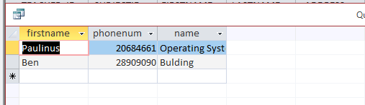

Analysis: Query returned specified columns detail about those teacher who lives in brivibas.

query with grouping GROUP BY:
GOAL:
display total number of students who study each faculty.

SQL code:
SELECT COUNT(S.STUDENTID) AS STUDENT_COUNT, F.NAME AS FACULTY_NAME
FROM STUDENT AS S INNER JOIN FACULTY AS F ON S.FACULTYID = F.FACULTYID
GROUP BY F.NAME;

Result:
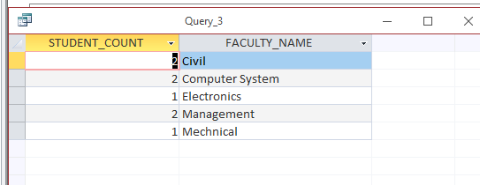

Analysis: Here student_count and faculty_name tables are expected and we got as we expected.

query with grouping and HAVING clause (contitions for groups):

GOAL:
display product_id which is used in more than or equal to two orders. Display student and average_marks if the average marks is more then 4.
SQL code:
SELECT AVG(m.Mark) AS average_mark, s.firstname AS firstname
FROM Marks AS m INNER JOIN Student AS s ON s.studentid = m.studentid
GROUP BY s.firstname
HAVING AVG(m.mark) > 4;
Result:
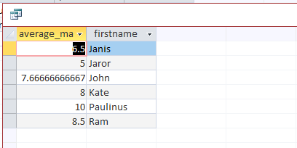
Analysis: From his query it was expected that it will return average marks of all students who have average marks is more than 4. And we got it as we expected.

query with subquery in SELECT clause:

GOAL:
to find students first and last name of top 3 students according to average marks.
SQL code:
SELECT s.firstname AS firstname, s.lastname AS lastname
FROM student AS s
WHERE s.studentid IN
(select top 3 st.studentid as studentid from
student st inner join marks m on st.studentid = m.studentid
group by st.studentid order by AVG(m.mark) DESC );

Result:
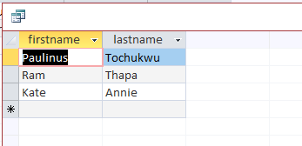
Analysis of results:- Here, we can see the name of 3 students who have best average marks in decending order.

query with subquery in FROM clause:
GOAL:
Find out average marks of students according to studentid
SQL code:
SELECT id, AVG(student_marks)
FROM (SELECT studentid AS id, mark AS student_marks FROM marks) AS obtained_marks
GROUP BY id;
Result:
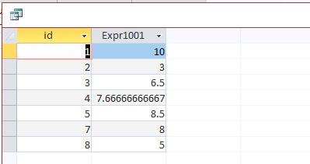

Analysis: When this query run, subquery will run first. It means it will take studentid and student_marks from table marks and after that it will display average marks as obtained marks. Group by id.

query with subquery in WHERE clause:
GOAL:
Get top three students first and last name from table student with connection with table marks.
SQL code:
SELECT s.firstname AS firstname, s.lastname AS lastname
FROM student AS s
WHERE s.studentid IN
(select top 3 st.studentid as studentid from
student st inner join marks m on st.studentid = m.studentid
group by st.studentid order by AVG(m.mark) DESC );WHERE o.order_id = (select order_id from orders
where number_of_items = (SELECT MAX(number_of_items) from orders));

Result:
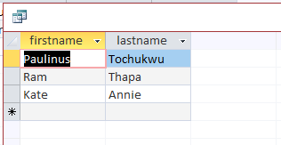

Analysis: In this query, first of all, it runs subqueries, it selects marks of three students from marks table. After evaluating sub-queries, it start to execute main query and display order according to conditions applied in main query.

query with UNION construction:
GOAL:
Get teachers and students first name.
SQL code:
SELECT s.firstname AS firstname, s.lastname AS lastname
FROM student AS s
WHERE s.studentid IN
(select top 3 st.studentid as studentid from
student st inner join marks m on st.studentid = m.studentid
group by st.studentid order by AVG(m.mark) DESC );WHERE o.order_id = (select order_id from orders
where number_of_items = (SELECT MAX(number_of_items) from orders));

Result:
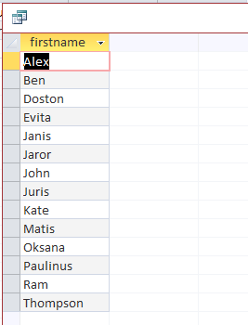

Analysis: The UNION operator is used to combine the result-set of two or more SELECT statements.Each SELECT statement within UNION must have the same number of columns.The columns must also have similar data types.The columns in each SELECT statement must also be in the same order
In this query, it selects name of students and teacher and display in one column.

query with EXISTS construction:
GOAL:
find all teachers first name and last name where their subjects have pass marks greater or equal to 4.
SQL code:
SELECT firstname, lastname
FROM teacher
WHERE exists
(select s.subjectid from subject s inner join teacher t on t.subjectid = s.subjectid
where s.passmark <=4);
Result:
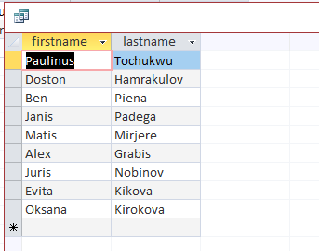
Analysis: The EXISTS operator is used to test for the existence of any record in a subquery. Here EXISTS query returns first and last name of teachers according to subjects they teach if the subject have pass marks 4 or more than it.

at least 3 queries with INNER JOIN:
4.10.1:
GOAL:
Select all students id,first name, marks and subject id if marks is more or equal to 8.
SQL code:
SELECT s.studentid, s.firstname, m.mark, m.subjectid
FROM student AS s INNER JOIN marks AS m ON s.studentid = m.studentid
WHERE m.mark >= 8;

Result:
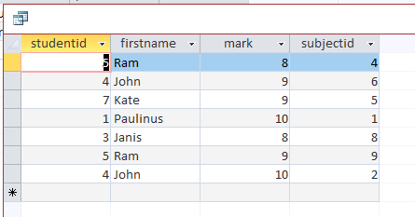

Analysis: This query should return students id, first name, marks and subject id if marks is more or equal to 8. And we get what we expect from this inner join.

4.10.2:
GOAL:
To display students fist name, subject id, and marks of student.
SQL code:
SELECT st.firstname, m.subjectid, m.mark
FROM (student AS st INNER JOIN facultysubjects AS f ON st.facultyid = f.facultyid) INNER JOIN marks AS m ON f.subjectid = m.subjectid
WHERE m.studentid= 5;
Result:
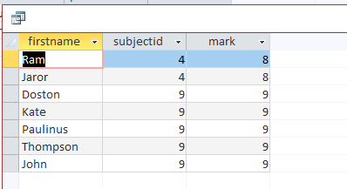

Analysis: We got result as we want from this query.
4.10.3:
GOAL:
Select first name and last name of teacher where their subject have full mark is 10 or less than that.
SQL code:
SELECT firstname, lastname
FROM teacher
WHERE exists
(select s.subjectid from subject s inner join teacher t on t.subjectid = s.subjectid
where s.fullmark <= 10);
Result:
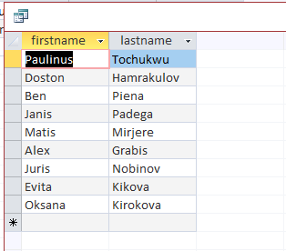

Analysis: We got what we expect from this query.

at least 3 queries with LEFT JOIN:
4.11.1:
GOAL:
Show first name ,last name and marks of student as students left join on marks.
SQL code:
SELECT s.firstname, s.lastname, m.mark
FROM student AS s LEFT JOIN marks AS m ON s.studentid = m.studentid;

Result:
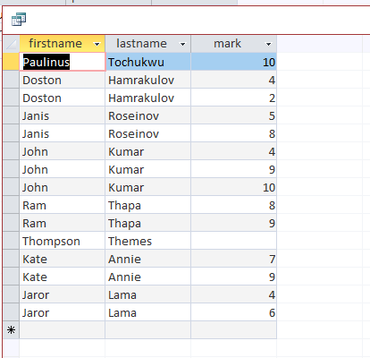

Analysis of results: LEFT JOIN performs a join starting with the first (left-most) table and then any matching second (right-most) table records. And we got what we expect from this left join.
4.11.2:
GOAL:
To show all faculties and students first name with that correspond faculty.
SQL code:
SELECT f.name AS facultyname, s.firstname
FROM faculty AS f LEFT JOIN student AS s ON s.facultyid = f.facultyid;

Result:
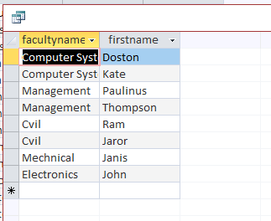

Analysis of results: We got as we expect, there we can see all faculties also which don’t have students on it.
4.11.3:
GOAL:
Display the faculty name and how many students are studying there.
SQL code:
SELECT f.name, count(s.studentid)
FROM faculty AS f LEFT JOIN student AS s ON f.facultyid = s.facultyid
GROUP BY f.name
ORDER BY count(s.studentid) DESC;

Result:
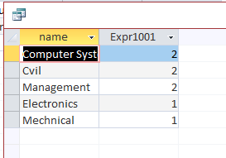
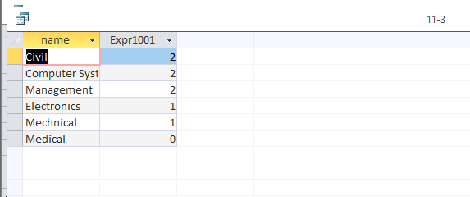
Analysis of results: WE got names of faculties and number of students on it.

at least 3 queries with RIGHT JOIN:
4.12.1:
GOAL:
To display first name, last name of teacher and subject which they teaches.
SQL code:
SELECT t.firstname, t.lastname, s.name AS subjectname
FROM teacher AS t RIGHT JOIN subject AS s ON t.subjectid=s.subjectid;

Result:
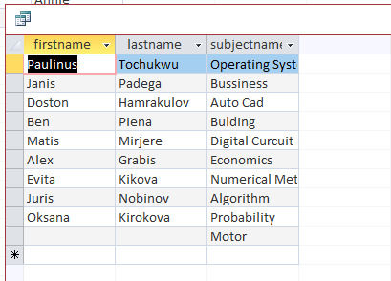

Analysis of results: In this query, we right join subject so, we got all subjects which are not taught by any of teacher. We can say our query is working as we want.

4.12.2:
GOAL:
To display first and last name of teacher and subject id.
SQL code:
SELECT firstname,lastname,subject.subjectid
FROM teacher teacher right JOIN subject subject
ON SUBJECT.SUBJECTID = TEACHER.SUBJECTID;
Result:
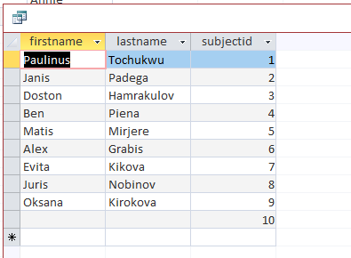

Analysis of results: We right join subject so, we got all subject id. Our query working as we expect it to work.
4.12.3:
GOAL:
To get faculty name and studentid of that faculty.
SQL code:
SELECT faculty.name, student.studentid
FROM faculty faculty right JOIN student student
ON student.facultyid = FACULTY.facultyid;

Result:
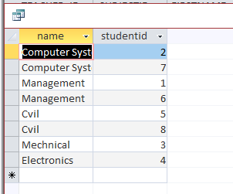
Analysis of results: we got our result as we require. This means here right join works properly.

Conclusions
[At least 500 words]
A database is an organized collection of data. It is the collection of schemas, tables, queries, reports, views, and other objects. It is something that can store data about different things like people, products, books, cars, etc. Here, the database I designed contains the information about university, which have five entities (Student, Teacher, Marks, Faculty, Subject) and one relationship table named as facultysubject (this shows relationship between entity faculty and subject.
In this assignment, we got to work with many types of SQL queries. While creating query we should keep in mind about data types primary key, foreign key and other factors. Which helps me to know more about various types of SQL queries. This assignment consists of various types of queries they are as follows and described shortly how it works:
- Query with two or more condition:
In my database, you can find many queries with two or more conditions. This is simple type of query, which is used more in my database.
- Query from two tables:
This is also one of the common query in general and for my database also, I used this in many queries.
- Query which use GROUP BY:
This is also frequently used query for me for example I used this in query 3, 4,6 and other more. This group by clause will gather all of the rows together that contain data in the specified column(s) and will allow aggregate functions to be performed on the one or more columns.
- Query using HAVING:
This type of query I used in query 4. This clause should be followed by group by clause if we want to use it. And query number 4 is one example of it. This clause allows us to specify, which rows should be selected will be based on the conditions we specify.
- Query with subquery in SELECT clause:
Example of select clause is query number 5 in my assignment. This clause is used to query the database and retrieve selected data that match the criteria that you specify. This clause has five clauses to choose but form is the main and required one.
- Query with subquery in FROM clause:
Query 6 and 7 are the examples of from clause. This is also one of most frequently used clause.
- Query with subquery WHERE clause:
Queries 7 and 9 can be taken as example of where clause.
- Query with UNION construction:
The UNION operator is used to combine the result-set of two or more SELECT statements. Query number 8 is perfect example of union. Where first name teacher and first name of student is united in one column.
- Query with EXISTS construction:
In query 9 this exists is used in my database.
- At least 3 queries with INNER JOIN:
10th number of query demonstrate about inner join. This Returns records that have matching values in both tables.
- At least 3 queries with LEFT JOIN:
Query number 11 shows the example of left join. This Return all records from the left table, and the matched records from the right table.
- At least 3 queries with RIGHT JOIN:
All three queries of number 12 belongs to right join. This Return all records from the right table, and the matched records from the left table.

Along with these types of queries I got to know also about Use of aggregation functions, Use of text functions, Use of datetime functions, use of predicates, etc.
At last, this assignment helps me a lot to gain more knowledge about database and queries, I tried some type of queries like EXISTS, TOP, UNION and ORDER BY for first time. For this task, I edit my database and rearrange data for many time. At last I succeed on what I want to get.

Criteria | Count of queries | Number of queries (see NN)
Query with 2 or more conditions | 2+ | 4.1
From with 2 or more tables | 10+
Use of Group by | 5 | 4.3
Use of Having | 1
Ordering of data | 1
query with subquery in SELECT clause; | 1
query with subquery in FROM clause; | 1 | 4.6
query with subquery in WHERE clause; | 2 | 4.7
query with UNION construction; | 1 | 4.8
query with EXISTS construction; | 1 | 4.9
at least 3 queries with INNER JOIN; | 6 | 4.3, 4.10[1], 4.10[2], 4.10[3], 4.4, 4.7
at least 3 queries with LEFT JOIN; | 3 | 4.11[1], 4.11[2], 4.11[3]
at least 3 queries with RIGHT JOIN; | 3 | 4.12[1], 4.12[2], 4.12[3]
Use of aggregation functions | 10
Use of text functions | 1 | 4.8
Use of datetime functions
Use of predicates | 2
Use of expressions (e.g. addition and subtraction)

<<Correspondence of results to the objectives set. Solved and unsolved problems. Analysis of steps during the work: changes in data structure, additional tables or columns created, suitability of tables for intended queries. Software used to create and execute queries. New things, problems discovered during the work>

References
      - https://blog.udemy.com
      - https://www.tutorialspoint.com/

