
RIGA TECHNICAL UNIVERSITY
FACULTY OF COMPUTER SCIENCE AND INFORMATION TECHNOLOGY
INSTITUTE OF APPLIED COMPUTER SYSTEMS

Practical assignment #4
“Database Management Systems”
Pivot Charts and Tables

Author: Paulinus Tochukwu
Course, group: 3, 1
Student card no.: XXXADBXXX

Checked: Andrejs Gaidukovs

Content

1 Task 3
2 Queries datasheet view 4
3 Pivot table and graphs 5
4 Conclusions 6

Task

- Get connection to MS Access from MS Excel (You can use queries created in HA2 or HA3 Access files);
- Create 2 different Pivot Tables and Pivot Charts, at including:
  - at least two levels of grouping;
  - time dimension grouping;
  - counted values;
  - summarized values;
  - average values;
- Show in your report, how pivot table and chart changes, if records are added or changed;
- Conclusions

Queries datasheet view

- Total number of students
SELECT COUNT(S.STUDENTID) AS STUDENT_COUNT, F.NAME AS FACULTY_NAME
FROM STUDENT AS S INNER JOIN FACULTY AS F ON S.FACULTYID = F.FACULTYID
GROUP BY F.NAME;
- Total subjects studied by students under faculties
SELECT s.*, f.name, (select count(subjectid) from facultysubjects where s.facultyid = facultysubjects.facultyid) AS total_study_subjects
FROM student AS s INNER JOIN faculty AS f ON s.FACULTYID = f.FACULTYID;

- Average marks obtained by students from different faculties.
SELECT s.firstname, s.lastname, m.mark, f.name
FROM faculty AS f, student AS s INNER JOIN marks AS m ON s.studentid = m.studentid
WHERE s.facultyid = f.facultyid;
- Date of birth and count
SELECT firstname + " " + lastname AS name, dob
FROM STUDENT;

Pivot table and graphs
- Total number of students from faculties:
Here, in excel sheet we can see pie-chart which shows the number of students who studies in correspond faculty.
- Total subjects studied by students under faculties
Here, we can see bar graph which shows total study subjects under each faculty.
- Average marks obtained by students from different faculties:
Here, we can see line graph which show average marks of students from different faculty.
- Date of birth and count
This bar graph shows the number of persons having DOB in months and year.

Here, I am posting some screenshot, how chart changes when we add faculty and student.

Before add
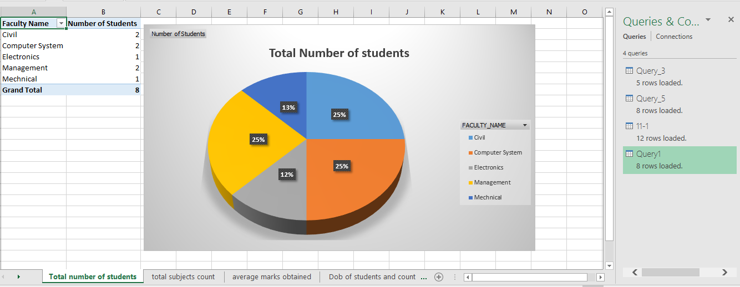

After add
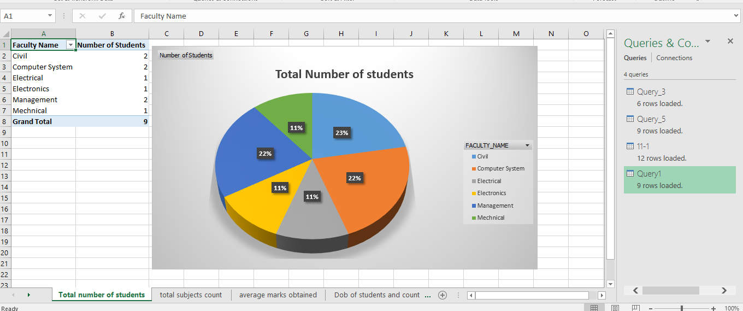

Conclusions
Here, I connect my database to excel, I develop some queries requiring to my work and generate pivot table and represent it in pie chart, line graph, bar graph. Pivot charts created in MS Excel can be more useful than ordinary charts, because they are more easily manipulated to show different information.

Generally, we can use PivotTable report to summarize, analyze, explore, and present summary data. Pivot Charts complement PivotTables by adding visualizations to the summary data in a PivotTable, and allow you to easily see comparisons, patterns, and trends. Both PivotTables and Pivot Charts enable us to make informed decisions about critical data in company/organization. We can also connect to external data sources such as SQL Server tables, SQL Server Analysis Services cubes, Azure Marketplace, Office Data Connection (.odc) files, XML files, Access databases, and text files to create PivotTables, or use existing PivotTables to create new tables.
We can also see the change if we update something on our database open excel and refresh all then we can see updated result on charts and also in tables. Because in my work queries are connected to pivot table and pivot table to chart. So, change in query changes all these things.

In conclusion, during this assignment I knew how to work with database connectivity in excel, designing charts, pivot table and about summarizing of data. From this assignment, I am more clear about pivot table, designing charts, implementation of other graphical diagrams and mainly about database connection.

