Практикум 2.3 Числовые ряды
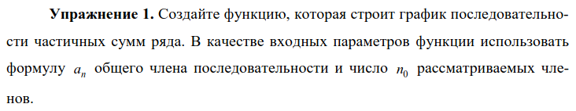

def part_sum(a, n):
s_i = [a(i) for i in range(1, n + 1)]
s_i = [sum(s_i[:i]) for i in range(len(s_i))]
plt.plot(range(n), s_i, 'o--')
plt.grid()
# return s_i

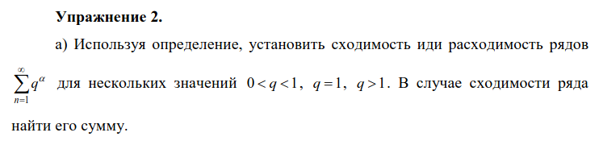

a)
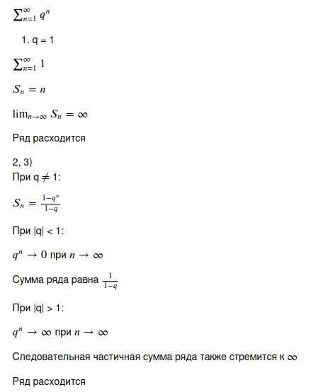

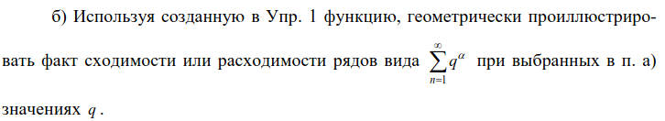

б)
# |q| < 1

part_sum(lambda n: 0.1**n, 1000)
plt.grid()
plt.axhline(1 / 0.9, color='red')

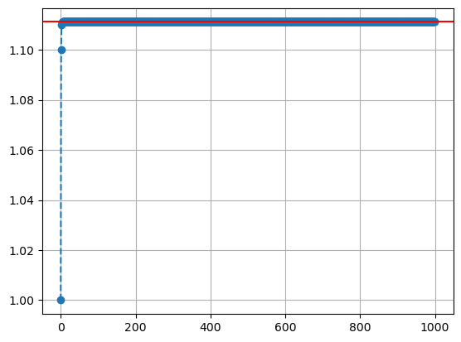

# q = 1

part_sum(lambda n: 1, 1000)
plt.grid()

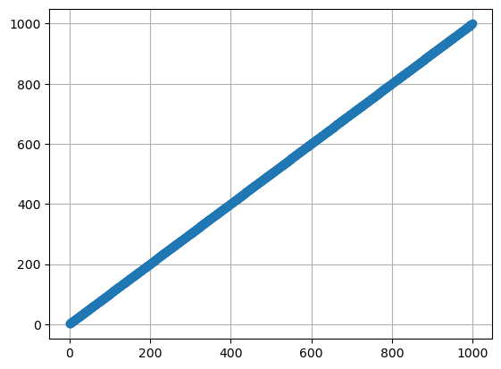

# |q| > 1

part_sum(lambda n: 1.5**n, 1000)
plt.grid()

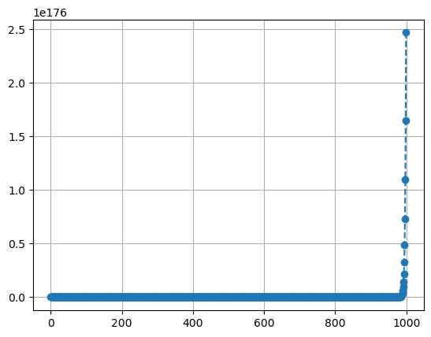

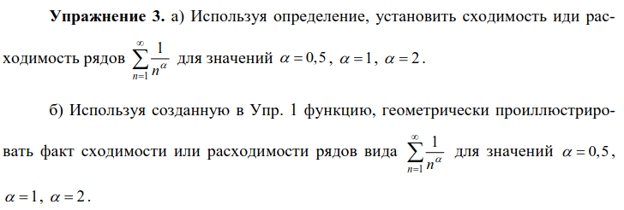

a)
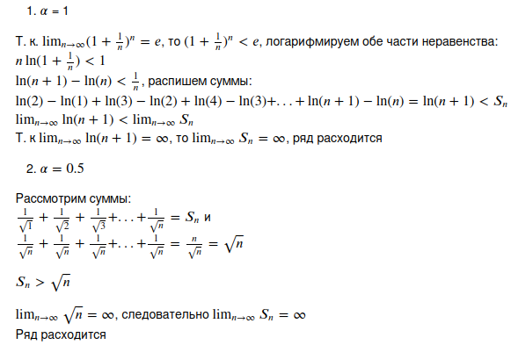

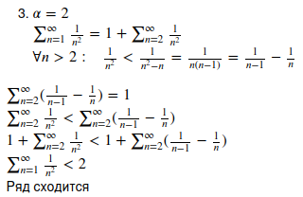

б)
# alpha = 0.5

part_sum(lambda n: 1 / n**0.5, 10000)
plt.grid()

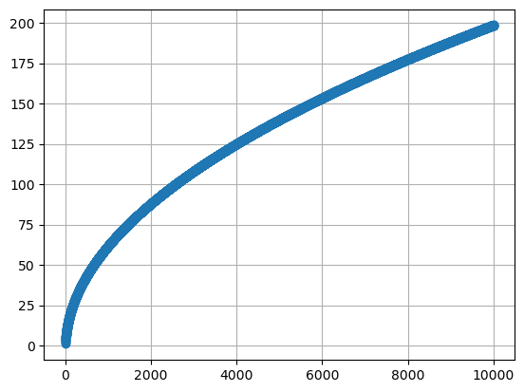

# alpha = 1

part_sum(lambda n: 1 / n, 100000)
plt.grid()

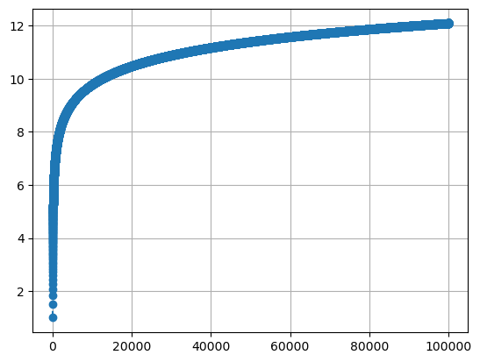

# alpha = 2

part_sum(lambda n: 1 / n**2, 10000)
plt.grid()
plt.axhline(2, color='red', label='2')
plt.axhline(np.pi**2 / 6, color='magenta', label='pi^2 / 6')
plt.legend()

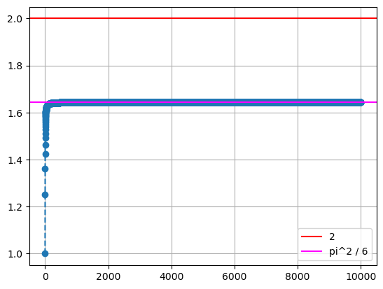

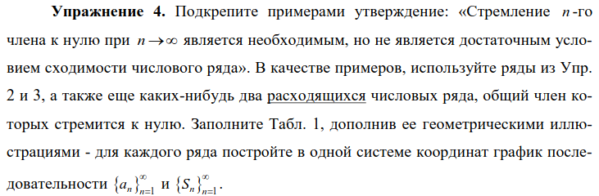

Ряд | Чему равен | Ряд сходится?
 | 0 | нет
 | 0 | да
 | 0 | да
 | 0 | нет
 | 0 | нет

# 1 / n

part_sum(lambda n: 1 / n, 1000)
plt.plot(range(1, 1000), [1 / i for i in range(1, 1000)], '*', label='a_n')
plt.title('1 / n')
plt.legend()
plt.grid()

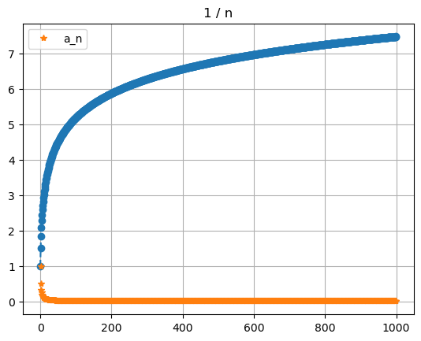

# 1 / n^2

part_sum(lambda n: 1 / n**2, 10000)
plt.plot(range(1, 10000), [1 / i**2 for i in range(1, 10000)], '*', label='a_n')
plt.title('1 / n^2')
plt.legend()
plt.grid()

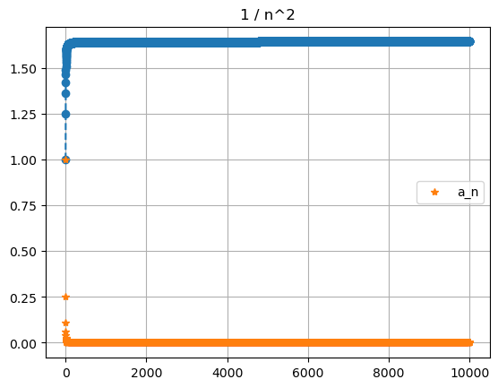

# 1 / 2^n

part_sum(lambda n: 1 / 2**n, 1000)
plt.plot(range(1, 1000), [1 / 2**i for i in range(1, 1000)], '*', label='a_n')
plt.title('1 / 2^n')
plt.legend()
plt.grid()

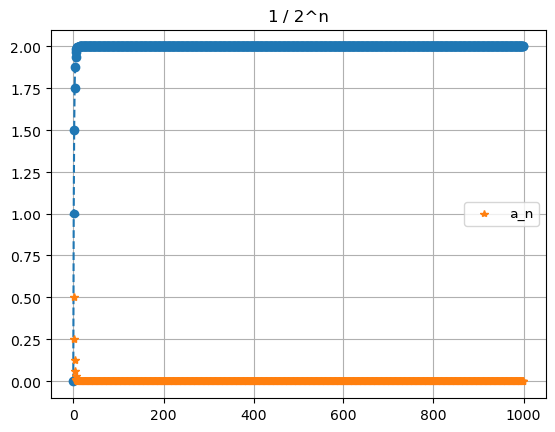

# 1 / (n + 1)

part_sum(lambda n: 1 / (n + 1), 1000)
plt.plot(range(1, 1000), [1 / (i + 1) for i in range(1, 1000)], '*', label='a_n')
plt.title('1 / (n + 1)')
plt.legend()
plt.grid()

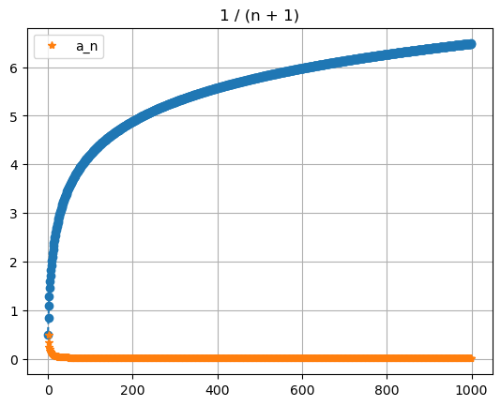

# 1 / (2n - 1)

part_sum(lambda n: 1 / (2 * n - 1), 1000)
plt.plot(range(1, 1000), [1 / (2 * i - 1) for i in range(1, 1000)], '*', label='a_n')
plt.title('1 / (2n - 1)')
plt.legend()
plt.grid()

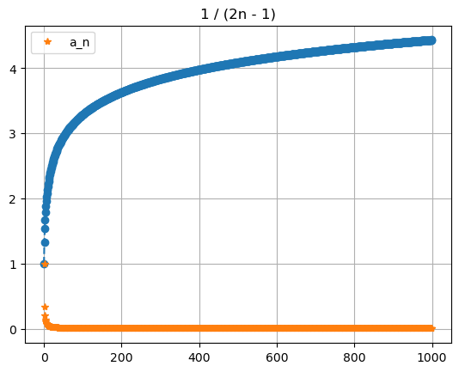

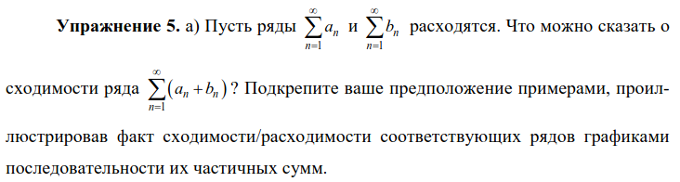

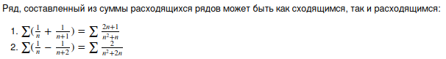

# 1.

part_sum(lambda n: (2 * n + 1) / (n**2 + n), 1000)
plt.plot(range(1, 1000), [(2 * i + 1) / (i**2 + i) for i in range(1, 1000)], '*', label='a_n')
plt.title('(2n + 1) / (n^2 + n)')
plt.legend()
plt.grid()

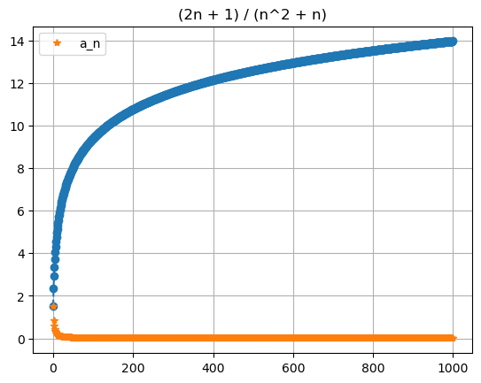

# 2.

part_sum(lambda n: 2 / (n**2 + 2 * n), 10000)
plt.plot(range(1, 10000), [2 / (i**2 + 2 * i) for i in range(1, 10000)], '*', label='a_n')
plt.title('2 / (n^2 + 2n)')
plt.legend()
plt.grid()

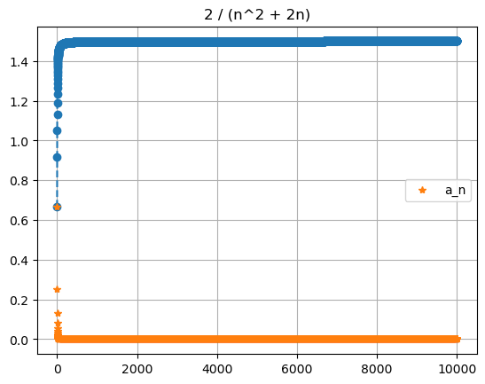

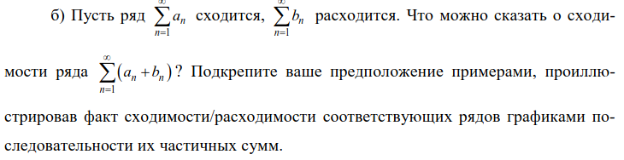

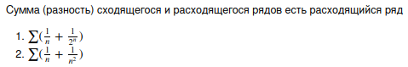

# 1.

part_sum(lambda n: 1 / n + 1 / 2**n, 10000)
plt.plot(range(1, 10000), [1 / i + 1 / 2**i for i in range(1, 10000)], '*', label='a_n')
plt.title('1 / n + 1 / 2^n')
plt.legend()
plt.grid()

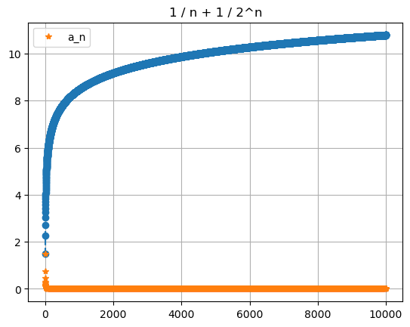

# 2.

part_sum(lambda n: 1 / n + 1 / n**2, 10000)
plt.plot(range(1, 10000), [1 / i + 1 / i**2 for i in range(1, 10000)], '*', label='a_n')
plt.title('1 / n + 1 / n^2')
plt.legend()
plt.grid()

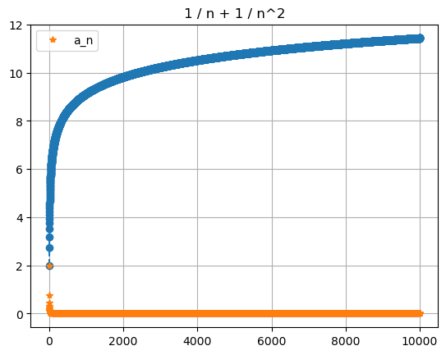

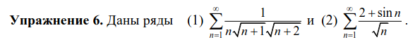

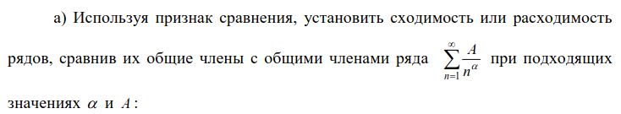

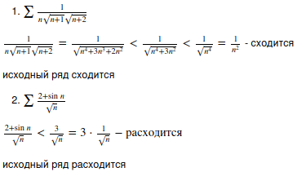

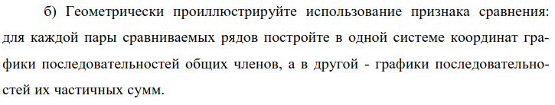

# 1.

plt.plot(range(1, 1000), [1 / i**2 for i in range(1, 1000)], '*', label='1/n^2')
plt.plot(range(1, 1000), [1 / (i * np.sqrt(i + 1) * np.sqrt(i + 2)) for i in range(1, 1000)], '*', label='1/n^2')
plt.title('a_n, b_n')
plt.legend()
plt.grid()

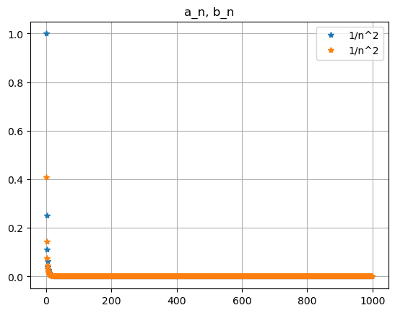

# 1.

def part_sum(a, n, l=None):
s_i = [a(i) for i in range(1, n + 1)]
s_i = [sum(s_i[:i + 1]) for i in range(len(s_i))]
plt.plot(range(n), s_i, 'o--', label=l)

part_sum(lambda n: 1 / (n * np.sqrt(n + 1) * np.sqrt(n + 2)), 1000, '1 / (sqrt(n + 1) * sqrt(n + 2) * n)')
part_sum(lambda n: 1 / n**2, 1000, '1 / n**2')
plt.title('S_n')
plt.legend()
plt.grid()

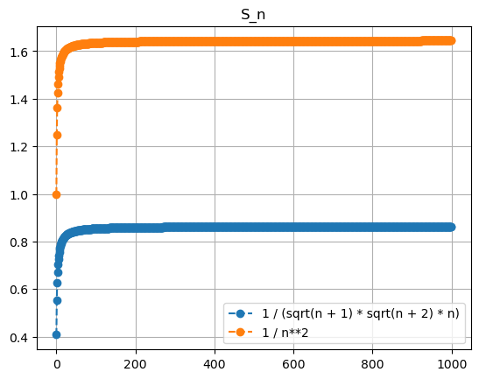

# 2.

plt.plot(range(1, 1000), [3 / np.sqrt(i) for i in range(1, 1000)], '*', label='3/sqrt(n)')
plt.plot(range(1, 1000), [(2 + np.sin(i)) / np.sqrt(i) for i in range(1, 1000)], '*', label='(2 + sin(n)) / (sqrt(n))')
plt.title('a_n, b_n')
plt.legend()
plt.grid()

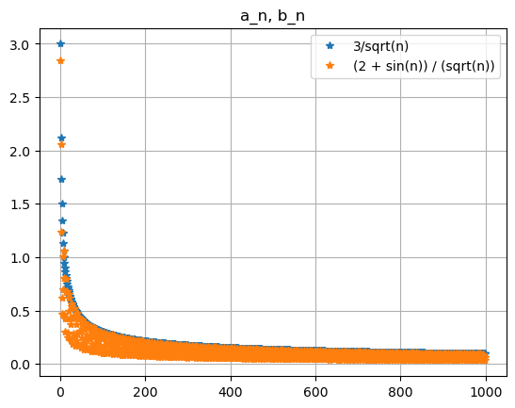

# 2.

part_sum(lambda n: 3 / np.sqrt(n), 10000, '3/sqrt(n)')
part_sum(lambda n: (2 + np.sin(n)) / np.sqrt(n), 10000, '(2 + sin(n)) / (sqrt(n))')
plt.title('S_n')
plt.legend()
plt.grid()

