Практикум 2.7. Дифференцирование функций многих переменных. Формула Тейлора

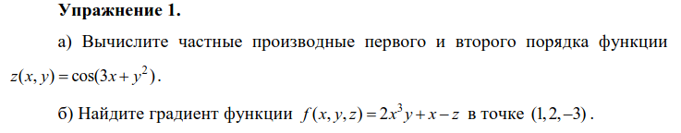

a)
x, y = sp.Symbol('x'), sp.Symbol('y')
z = sp.cos(3 * x + y**2)

dzdx = sp.diff(z, x, 1)
dzdy = sp.diff(z, y, 1)
d2zdxdy = sp.diff(dzdx, y, 1)
d2zdydx = sp.diff(dzdy, x, 1)
d2zdx2 = sp.diff(z, x, 2)
d2zdy2 = sp.diff(z, y, 2)
print('dzdx =', dzdx)
print('dzdy =', dzdy)
print('d2zdxdy =', d2zdxdy)
print('d2zdydx =', d2zdydx)
print('d2zdx2 =', d2zdx2)
print('d2zdy2 =', d2zdy2)

dzdx = -3*sin(3*x + y**2)
dzdy = -2*y*sin(3*x + y**2)
d2zdxdy = -6*y*cos(3*x + y**2)
d2zdydx = -6*y*cos(3*x + y**2)
d2zdx2 = -9*cos(3*x + y**2)
d2zdy2 = -2*(2*y**2*cos(3*x + y**2) + sin(3*x + y**2))
б)
x = sp.Symbol('x')
y = sp.Symbol('y')
z = sp.Symbol('z')
f = 2 * x**3 * y + x - z

grad_x = sp.diff(f, x).subs([(x, 1), (y, 2), (z, -3)])
grad_y = sp.diff(f, y).subs([(x, 1), (y, 2), (z, -3)])
grad_z = sp.diff(f, z).subs([(x, 1), (y, 2), (z, -3)])

print('grad{f}|(1, 2, -3) = (', grad_x, grad_y, grad_z, ')')

grad{f}|(1, 2, -3) = ( 13 2 -1 )

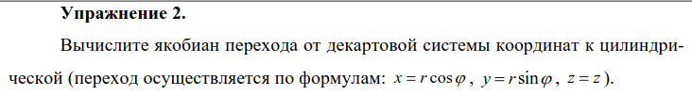

r, t = sp.symbols('r t')
x = r * sp.cos(t)
y = r * sp.sin(t)
z = z
A = sp.Matrix([[x, y, z]])
B = sp.Matrix([[sp.diff(A, r)], [sp.diff(A, t)], [sp.diff(A, z)]])
B

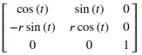

sp.pprint(sp.simplify(B.det()))

r

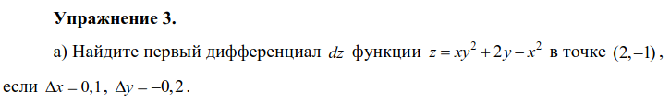

a)
x = sp.Symbol('x')
y = sp.Symbol('y')
dx = 0.1
dy = -0.2
z = x * y**2 + 2 * y - x**2
dz = sp.diff(z, x).subs([(x, 2), (y, -1)]) * dx
dz += sp.diff(z, y).subs([(x, 2), (y, -1)]) * dy
print(dz)

0.100000000000000

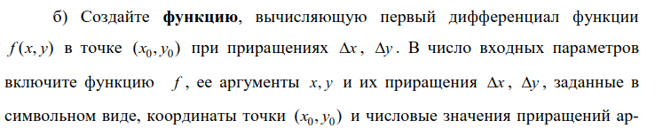

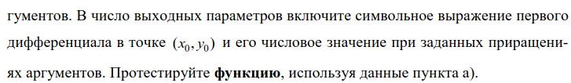

б)
dx = sp.Symbol('dx')
dy = sp.Symbol('dy')
x = sp.Symbol('x')
y = sp.Symbol('y')

def df(f, x, y, dx, dy, x0, y0, dx0, dy0):
df = sp.diff(f, x) * dx + sp.diff(f, y) * dy
df_0 = df.subs([(x, x0), (y, y0), (dx, dx0), (dy, dy0)])
return df, df_0

dx0 = 0.1
dy0 = -0.2
z = x * y**2 + 2 * y - x**2
df(z, x, y, dx, dy, 2, -1, dx0, dy0)

(dx*(-2*x + y**2) + dy*(2*x*y + 2), 0.100000000000000)

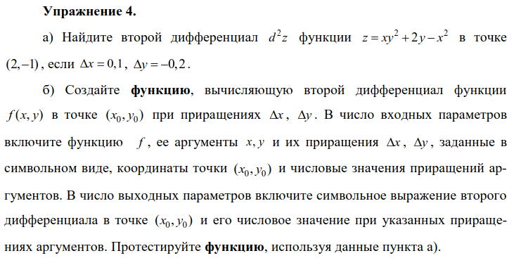

a)
x = sp.Symbol('x')
y = sp.Symbol('y')
dx = 0.1
dy = -0.2
z = x * y**2 + 2 * y - x**2
d2z = sp.diff(z, x, 2).subs([(x, 2), (y, -1)]) * dx**2
d2z += sp.diff(z, y, 2).subs([(x, 2), (y, -1)]) * dy**2
d2z += 2 * sp.diff(sp.diff(z, x), y).subs([(x, 2), (y, -1)]) * dx * dy
print(d2z)

0.220000000000000

б)
dx = sp.Symbol('dx')
dy = sp.Symbol('dy')
x = sp.Symbol('x')
y = sp.Symbol('y')

def d2f(f, x, y, dx, dy, x0, y0, dx0, dy0):
d2f = sp.diff(f, x, 2) * dx**2 + sp.diff(f, y, 2) * dy**2
d2f += 2 * sp.diff(sp.diff(f, x), y) * dx * dy
d2f_0 = d2f.subs([(x, x0), (y, y0), (dx, dx0), (dy, dy0)])
return d2f, d2f_0

dx0 = 0.1
dy0 = -0.2
z = x * y**2 + 2 * y - x**2
d2f(z, x, y, dx, dy, 2, -1, dx0, dy0)

(-2*dx**2 + 4*dx*dy*y + 2*dy**2*x, 0.220000000000000)
