Практикум 2.6 Графическое представление функции нескольких переменных

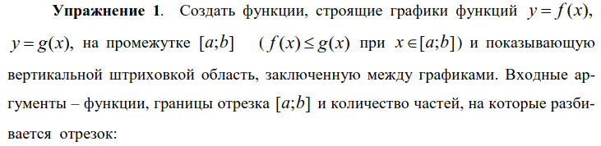

def plot_solid_fg(f, g, a, b, n):
dx = (b - a) / n
x = np.linspace(a, b)
plt.plot(x, f(x))
plt.plot(x, g(x))
for i in range(n + 1):
plt.plot(2 * [a + dx * i], [f(a + dx * i), g(a + dx * i)], 'g')

def plot_solid_f(f, g, a, b, n):
dx = (b - a) / n
x = np.linspace(a, b)
plt.plot(x, f(x))
plt.plot(x, g(x), '--')
for i in range(n + 1):
plt.plot(2 * [a + dx * i], [f(a + dx * i), g(a + dx * i)], 'g')

def plot_solid_g(f, g, a, b, n):
dx = (b - a) / n
x = np.linspace(a, b)
plt.plot(x, f(x), '--')
plt.plot(x, g(x))
for i in range(n + 1):
plt.plot(2 * [a + dx * i], [f(a + dx * i), g(a + dx * i)], 'g')

def plot_no_solid(f, g, a, b, n):
dx = (b - a) / n
x = np.linspace(a, b)
plt.plot(x, f(x), '--')
plt.plot(x, g(x), '--')
for i in range(n + 1):
plt.plot(2 * [a + dx * i], [f(a + dx * i), g(a + dx * i)], 'g')

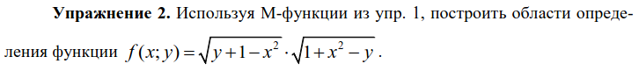

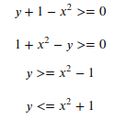

plot_solid_fg(lambda x: x**2 - 1, lambda x: x**2 + 1, -2, 2, 10)
plt.grid()

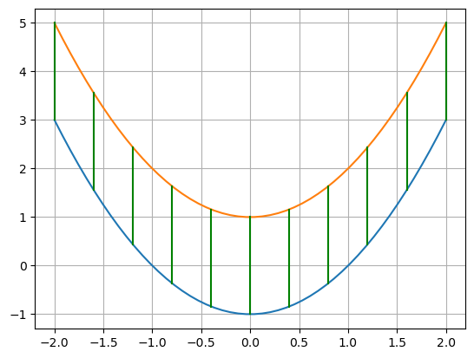

fig, ax = plt.subplots(subplot_kw={"projection": "3d"})
xs = np.linspace(0.1, 2)
ys = np.linspace(0.1, 2)
X, Y = np.meshgrid(xs, ys)
Z = 1 / X + 1 / Y
ax.plot_wireframe(X, Y, Z, rstride = 2, cstride = 2)
surf = ax.plot_surface(X, Y, Z, cmap=cm.cool, linewidth=0)
fig.colorbar(surf, shrink=0.5, aspect=5)
plt.show()
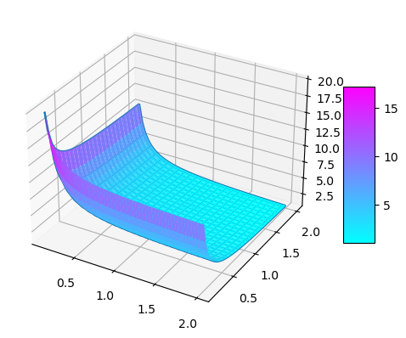

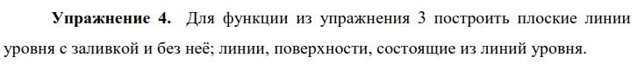

cs = plt.contourf(Z)
plt.colorbar(cs, shrink=0.9, aspect=5)

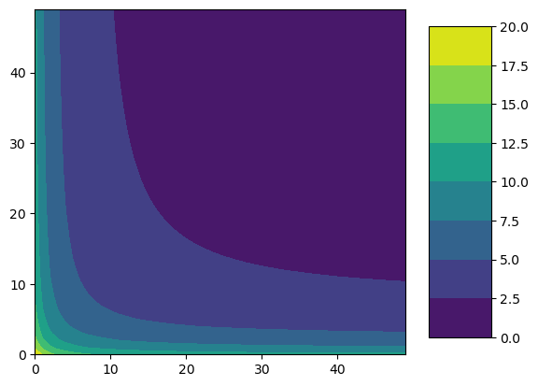

cs = plt.contour(Z)
plt.colorbar(cs, shrink=0.9, aspect=5)

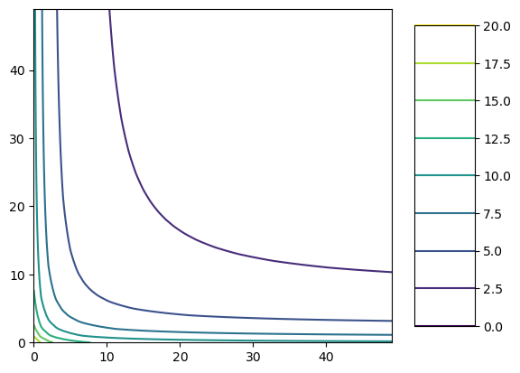

from matplotlib import cm
fig, ax = plt.subplots(subplot_kw={"projection": "3d"})
ax.contour(X, Y, Z)

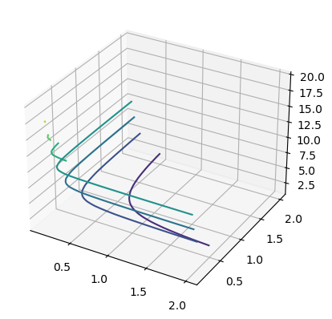

xs = np.linspace(0.1, 2, num=20)
print(xs)
ys = np.linspace(0.1, 2, num=20)
X, Y = np.meshgrid(xs, ys)
Z = 1 / X + 1 / Y
cs = plt.contour(Z)
plt.grid()
plt.show()
[0.1 0.2 0.3 0.4 0.5 0.6 0.7 0.8 0.9 1. 1.1 1.2 1.3 1.4 1.5 1.6 1.7 1.8
1.9 2. ]

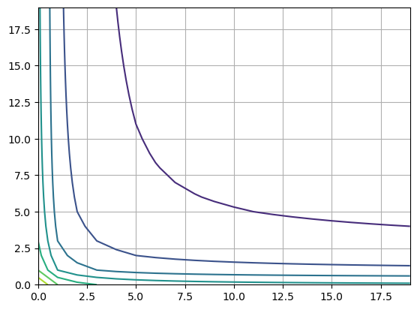

xs = np.linspace(0.1, 2, num=20)
print(xs)
ys = np.linspace(0.1, 2, num=20)
X, Y = np.meshgrid(xs, ys)
Z = 1 / X + 1 / Y
levels = np.arange(0.5, 3.5, 0.1)
cs = plt.contour(X, Y, Z, levels=levels)
plt.clabel(cs)
plt.grid()
plt.show()

[0.1 0.2 0.3 0.4 0.5 0.6 0.7 0.8 0.9 1. 1.1 1.2 1.3 1.4 1.5 1.6 1.7 1.8
1.9 2. ]
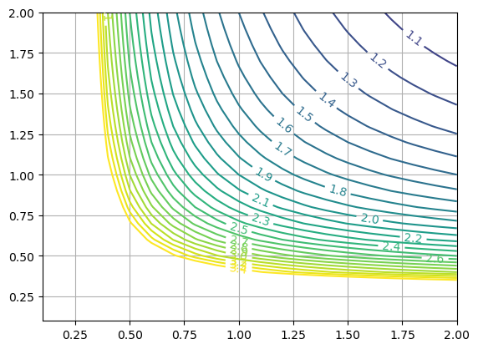

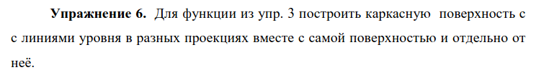

fig1 = plt.figure()
ax1 = fig1.add_subplot(231, projection='3d')
ax2 = fig1.add_subplot(232, projection='3d')
ax3 = fig1.add_subplot(233, projection='3d')
ax4 = fig1.add_subplot(234, projection='3d')
ax5 = fig1.add_subplot(235,projection='3d')
ax6 = fig1.add_subplot(236,projection='3d')

ax1.plot_surface(X, Y, Z, edgecolor='royalblue', lw=0.5, rstride=8, cstride=8, alpha=0.01)
ax2.plot_surface(X, Y, Z, edgecolor='royalblue', lw=0.5, rstride=8, cstride=8, alpha=0.01)
ax3.plot_surface(X, Y, Z, edgecolor='royalblue', lw=0.5, rstride=8, cstride=8, alpha=0.01)

ax1.contour(X, Y, Z, zdir='z', offset=-1, cmap='coolwarm')
ax2.contour(X, Y, Z, zdir='x', offset=-1, cmap='coolwarm')
ax3.contour(X, Y, Z, zdir='y', offset=1, cmap='coolwarm')

ax4.contour(X, Y, Z, zdir='z', offset=-1, cmap='coolwarm')
ax5.contour(X, Y, Z, zdir='x', offset=-1, cmap='coolwarm')
ax6.contour(X, Y, Z, zdir='y', offset=1, cmap='coolwarm')
plt.show()

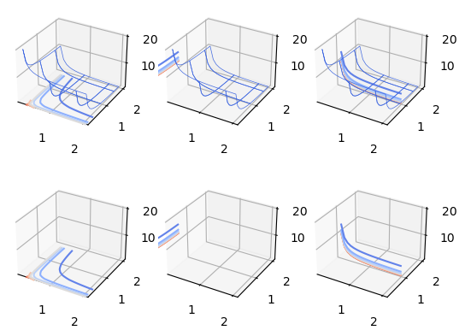

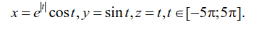

t = np.linspace(-5 * np.pi, 5 * np.pi)
x = np.exp(np.abs(t)) * np.cos(t)
y = np.sin(t)
z = t
fig1 = plt.figure()
ax = fig1.add_subplot(projection='3d')
ax.set_xlabel('x')
ax.set_ylabel('y')
ax.set_zlabel('z')
ax.plot(x, y, z, '--r')
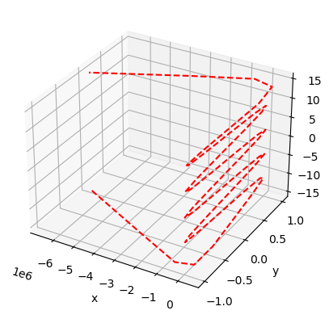

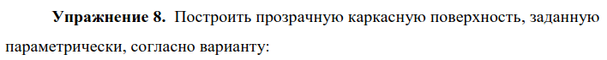

u = np.linspace(0, 2 * np.pi)
v = np.linspace(0, 2 * np.pi)
U, V = np.meshgrid(u, v)
XX = np.sin(U) * np.cos(V)
YY = 2 * np.sin(U) * np.sin(V)
ZZ = np.cos(U)
fig1 = plt.figure()
ax = fig1.add_subplot(projection='3d')
surf2 = ax.plot_wireframe(XX, YY, ZZ, rstride=3, cstride=3)

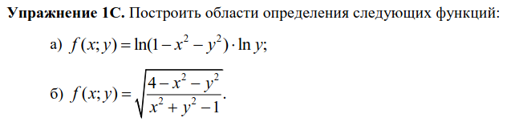

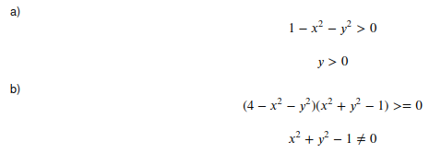

a)
plot_no_solid(lambda x: 0 * x, lambda x: (1 - x**2)**0.5, -1, 1, 15)
plt.grid()
plt.axis('equal')

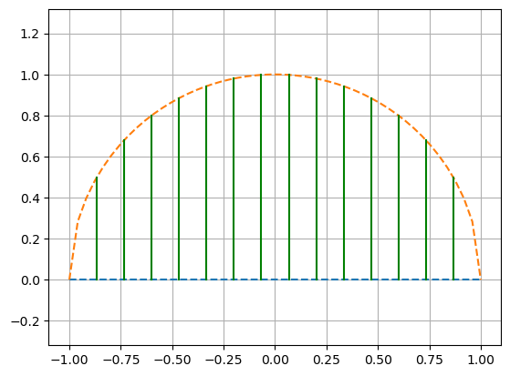

б)
plot_solid_g(lambda x: (1 - x**2)**0.5, lambda x: (4 - x**2)**0.5, -1, 1, 15)
plot_solid_g(lambda x: -(1 - x**2)**0.5, lambda x: -(4 - x**2)**0.5, -1, 1, 15)
plot_solid_fg(lambda x: 0 * x, lambda x: (4 - x**2)**0.5, -2, -1, 15)
plot_solid_fg(lambda x: 0 * x, lambda x: (4 - x**2)**0.5, 1, 2, 15)
plot_solid_fg(lambda x: -(4 - x**2)**0.5, lambda x: 0 * x, -2, -1, 15)
plot_solid_fg(lambda x: -(4 - x**2)**0.5, lambda x: 0 * x, 1, 2, 15)
plt.axis('equal')
plt.grid()

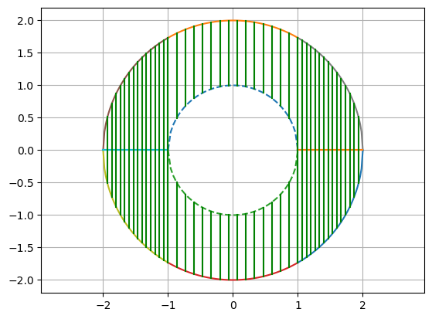

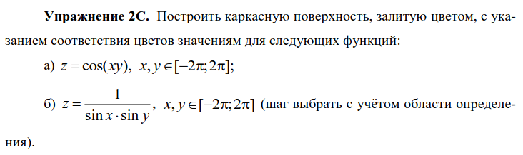

a)
fig, ax = plt.subplots(subplot_kw={"projection": "3d"})
xs = np.linspace(-2 * np.pi, 2 * np.pi)
ys = np.linspace(-2 * np.pi, 2 * np.pi)
X, Y = np.meshgrid(xs, ys)
Z = np.cos(X * Y)

surf = ax.plot_surface(X, Y, Z, cmap=cm.cool, linewidth=0)
fig.colorbar(surf, shrink=0.5, aspect=5)

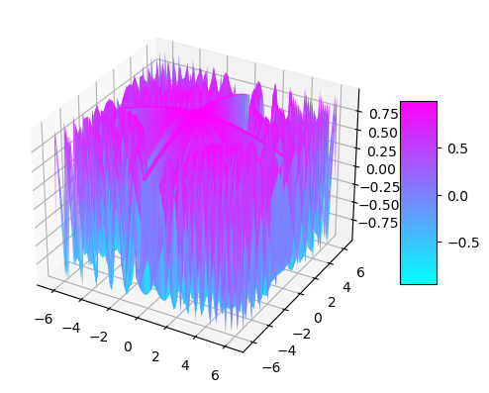

б)

fig, ax = plt.subplots(subplot_kw={"projection": "3d"})
xs = np.linspace(-2 * np.pi, 2 * np.pi)
ys = np.linspace(-2 * np.pi, 2 * np.pi)
X, Y = np.meshgrid(xs, ys)
Z = 1 / (np.sin(X) * np.sin(Y))
surf = ax.plot_surface(X, Y, Z, cmap=cm.cool, linewidth=0)
fig.colorbar(surf, shrink=0.8, aspect=5)

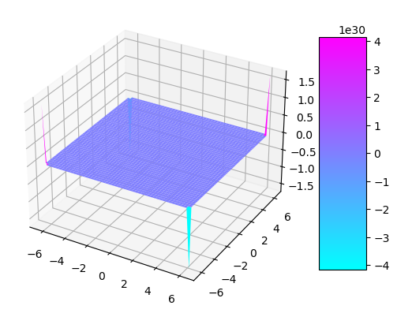

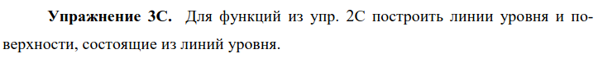

a)
xs = np.linspace(-2 * np.pi, 2 * np.pi)
ys = np.linspace(-2 * np.pi, 2 * np.pi)
X, Y = np.meshgrid(xs, ys)
Z = np.cos(X * Y)
plt.title(r'$z=cos(xy)$')
cs = plt.contour(Z)
plt.colorbar(cs, shrink=0.8, aspect=5)

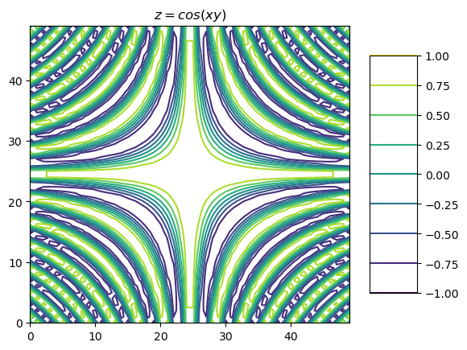

fig, ax = plt.subplots(subplot_kw={"projection": "3d"})
plt.title(r'$z=cos(xy)$')
ax.contour(X, Y, Z, cmap=cm.cool)

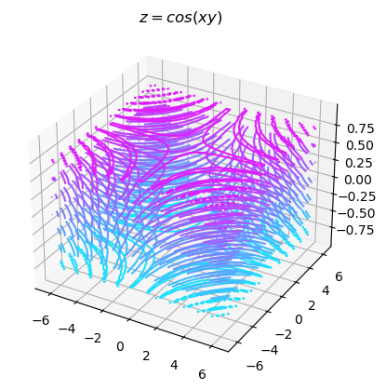

б)
xs = np.linspace(-2 * np.pi, 2 * np.pi)
ys = np.linspace(-2 * np.pi, 2 * np.pi)
X, Y = np.meshgrid(xs, ys)
Z = 1 / (np.sin(X) * np.sin(Y))
plt.title(r'$z=\frac{1}{sin(x)sin(y)}$')
cs = plt.contour(Z)
plt.colorbar(cs, shrink=0.8, aspect=5)

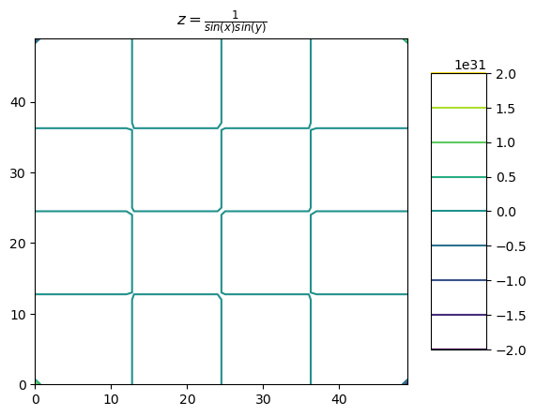

fig, ax = plt.subplots(subplot_kw={"projection": "3d"})
plt.title(r'$z=\frac{1}{sin(x)sin(y)}$')
ax.contour(X, Y, Z, cmap=cm.cool)

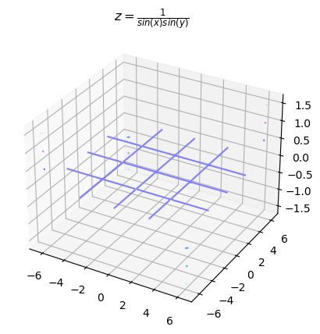

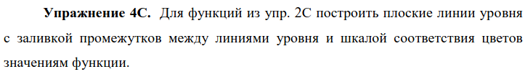

а)
xs = np.linspace(-2 * np.pi, 2 * np.pi)
ys = np.linspace(-2 * np.pi, 2 * np.pi)
X, Y = np.meshgrid(xs, ys)
Z = np.cos(X * Y)
cs = plt.contourf(Z)
plt.colorbar(cs, shrink=0.8, aspect=5)

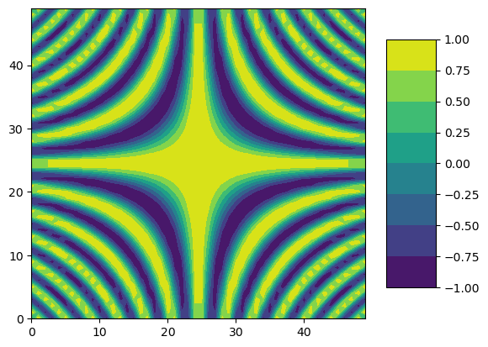

б)
xs = np.linspace(-2 * np.pi, 2 * np.pi)
ys = np.linspace(-2 * np.pi, 2 * np.pi)
X, Y = np.meshgrid(xs, ys)
Z = 1 / (np.sin(X) * np.sin(Y))
cs = plt.contourf(Z)
plt.colorbar(cs, shrink=0.8, aspect=5)

