Практикум 2.1. Интегрирование

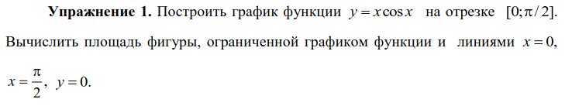

x = np.linspace(0, np.pi / 2, 1000)
plt.plot(x, x * np.cos(x))
plt.axvline(0)
plt.axvline(np.pi / 2)
plt.axhline(0)
plt.grid()
x = sp.Symbol('x')
print('S =', sp.integrate(x * sp.cos(x), (x, 0, sp.pi / 2)))

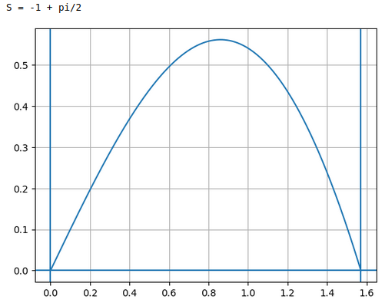

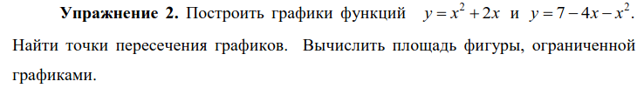

x1 = np.linspace(-10, 10)
f = x1**2 + 2 * x1
g = 7 - 4 * x1 - x1**2
plt.plot(x1, f)
plt.plot(x1, g, 'r')
plt.grid()
x = sp.Symbol('x')
sol = sp.solve(x**2 + 2 * x - 7 + 4 * x + x**2, x)
s = float(sp.integrate(7 - 4 * x - x**2 - (x**2 + 2 * x), (x, min(sol), max(sol))))
print(sol)
print('s =', s)

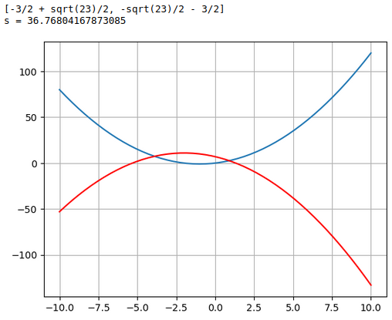

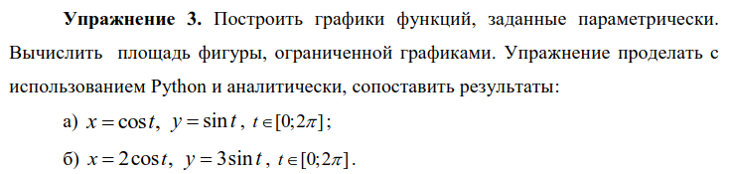

t1 = np.linspace(0, 2 * np.pi)
x = np.cos(t1)
y = np.sin(t1)
s1 = sp.integrate(sp.sin(t) * sp.diff(sp.cos(t), t), (t, sp.pi * 2, 0))
plt.plot(x, y, 'r')
plt.grid()
x = 2 * np.cos(t1)
y = 3 * np.sin(t1)
s2 = sp.integrate(3 * sp.sin(t) * sp.diff(2 * sp.cos(t), t), (t, sp.pi * 2, 0))
plt.plot(x, y, 'b')
s = s2 - s1
print('s =', s)

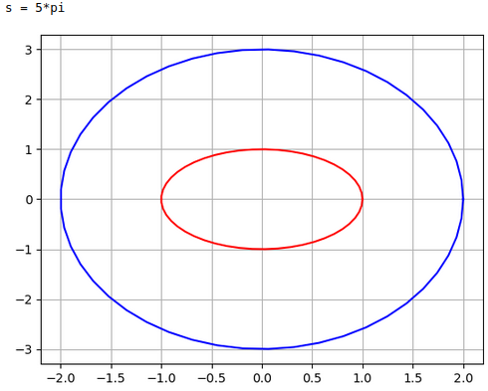

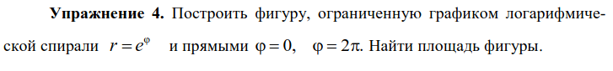

phi = np.linspace(0, np.pi * 2)
r = np.exp(phi)
x = r * np.cos(phi)
y = r * np.sin(phi)
plt.plot(x, y)
plt.axis('equal')
plt.grid()
p = sp.Symbol('p')
s = 0.5 * sp.integrate(sp.exp(p)**2, (p, 0, sp.pi * 2))
print('s =', s)

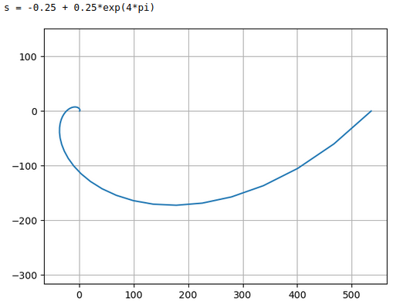

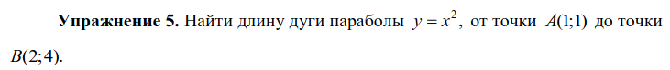

x = sp.Symbol('x')
y = x**2
l = sp.integrate(sp.sqrt(1 + sp.diff(y, x)**2), (x, 1, 2))
print('l = ', float(l))

l = 3.1678409048883385

t = sp.Symbol('t')
x = 2 * sp.cos(t)
y = 3 * sp.sin(t)
l = sp.integrate(sp.sqrt(sp.diff(x, t)**2 + sp.diff(y, t)**2), (t, 0, sp.pi * 2))
print('l =', float(l))

l = 15.86543958929059

p = sp.Symbol('p')
r = 4 * (1 + sp.cos(p))
l = sp.integrate(sp.sqrt(r**2 + sp.diff(r, p)**2), (p, 0, sp.pi * 2))
print('l =', float(l))

l = 32.0

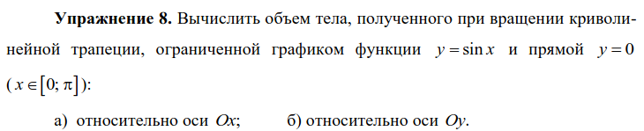

a)

x = sp.Symbol('x')
V_x = sp.pi * sp.integrate((sp.sin(x))**2, (x, 0, sp.pi))
print('V =', V_x)

V = pi**2/2

б)

V_y = 2 * sp.pi * sp.integrate(x * sp.sin(x), (x, 0, sp.pi))
print('V =', V_y)

V = 2*pi**2

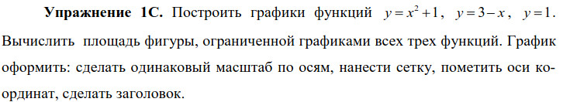

x = np.linspace(-3, 3)
plt.plot(x, x**2 + 1)
plt.plot(x, 3 - x)
plt.axhline(1)
plt.axis('equal')
plt.grid()
plt.xlabel('x')
plt.ylabel('y')
plt.title('1C')

x = sp.Symbol('x')
y1 = x**2 + 1
y2 = 3 - x
s = sp.integrate(y1, (x, 0, 1)) + sp.integrate(y2, (x, 1, 2)) - sp.integrate(1, (x, 0, 2))
print('s =', s)
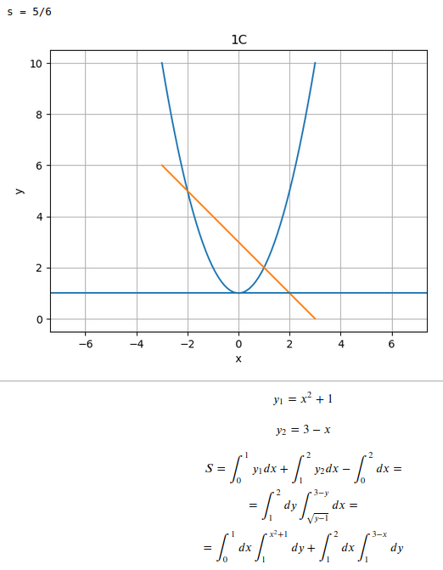

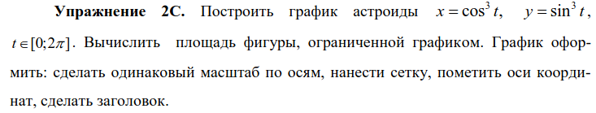

t = np.linspace(0, np.pi * 2)
x = np.cos(t)**3
y = np.sin(t)**3
plt.plot(x, y)
plt.grid()
plt.axis('equal')
plt.xlabel('x')
plt.ylabel('y')
plt.title('2C')

t = sp.Symbol('t')
x = sp.cos(t)**3
y = sp.sin(t)**3
s = sp.integrate(y * sp.diff(x, t), (t, sp.pi * 2, 0))
print('s =', s)

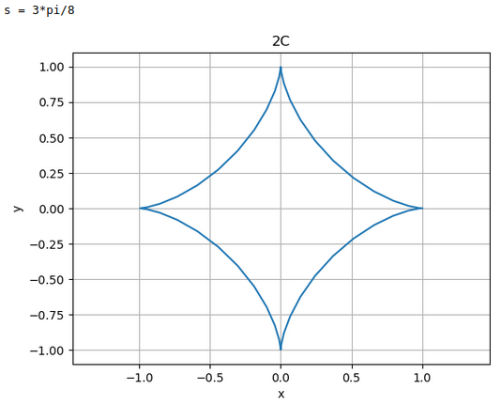

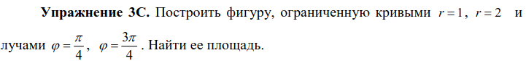

t = np.linspace(0, np.pi * 2)
plt.plot(np.cos(t), np.sin(t))
plt.plot(2 * np.cos(t), 2 * np.sin(t))
plt.plot([0, 2 * np.cos(np.pi / 4)], [0, 2 * np.sin(np.pi / 4)])
plt.plot([0, 2 * np.cos(3 * np.pi / 4)], [0, 2 * np.sin(3 * np.pi / 4)])

plt.axis('equal')
plt.grid()

p = sp.Symbol('p')
s = 0.5 * sp.integrate(4, (p, sp.pi / 4, 3 * sp.pi / 4)) - 0.5 * sp.integrate(1, (p, sp.pi / 4, 3 * sp.pi / 4))
print('s =', s)

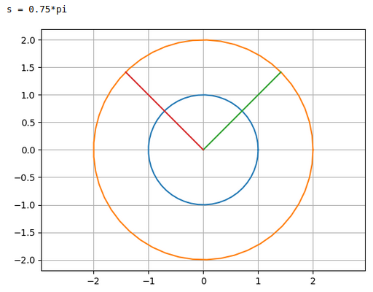

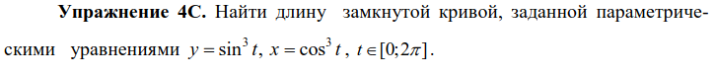

t = sp.Symbol('t')
x = sp.cos(t)**3
y = sp.sin(t)**3
l = sp.integrate(sp.sqrt(sp.diff(x, t)**2 + sp.diff(y, t)**2), (t, 0, sp.pi * 2))
print('L =', float(l))

L = 6.0

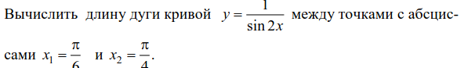

x = np.linspace(np.pi / 6, np.pi / 4)
y = 1 / np.sin(2 * x)
plt.plot(x, y)
plt.grid()

t = sp.Symbol('t')
x = sp.cos(t)**3
y = sp.sin(t)**3
l = sp.integrate(sp.sqrt(sp.diff(x, t)**2 + sp.diff(y, t)**2), (t, 0, sp.pi * 2))
print('L =', float(l))

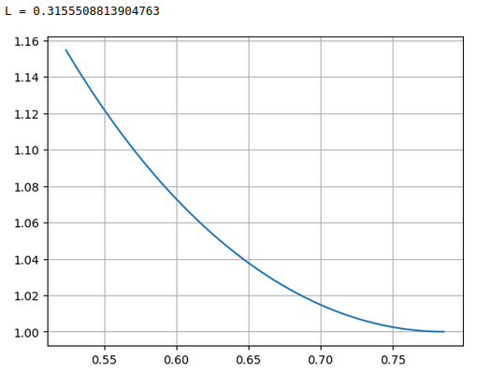

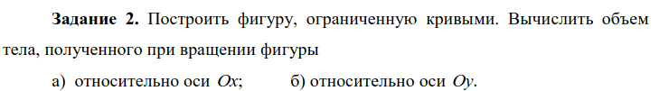

x = np.linspace(0, 1)
plt.plot(x, [math.asin(i) for i in x])
plt.grid()

x = sp.Symbol('x')
V_x = sp.pi * sp.integrate(sp.asin(x)**2, (x, 0, 1))
V_y = 2 * sp.pi * sp.integrate(x * sp.asin(x)**2, (x, 0, 1))
print('V относительно x:', V_x, 'V относительно y:', V_y)

