BUSINESS CASE STUDY · SQL
Target Brazil
E-commerce operations analysis, 2016-2018
SQL analysis of 99,441 orders across customers, sellers, products, payments, freight, delivery and reviews, with insights and actionable recommendations.
99,441  orders, Sep 2016 - Oct 2018 | 96,096  unique customers in 4,119 cities, 27 states | +137%  order value, Jan-Aug 2018 vs 2017 | 12.1 days  average delivery; 6.8% arrive late | 4.32 → 1.70  review score, early vs 8+ days late

Author: Guntuku Hariprasad
Context: Scaler business case study
Tools: Google BigQuery (Standard SQL) · DuckDB · Python (pandas, matplotlib)
Date: 31 October 2026
Repository: https://github.com/dot-hpg/Projects/tree/main/target-brazil-sql-case-study

Executive summary
- Growth is real and volume-driven. Orders in Jan-Aug 2018 were 135% higher than in Jan-Aug 2017 and payment value rose 137%, while the average order value barely moved (R$159.7 to R$161.0). Target Brazil won more customers; it did not sell them bigger baskets.
- Growth has plateaued. Monthly orders climbed from 800 (Jan 2017) to a Black Friday peak of 7,544 (Nov 2017; 1,176 orders on Black Friday, 24 Nov, alone) and then held at roughly 6,200-7,300 a month through 2018. Year-on-year value growth fell from +705% in January to +52% in August.
- Demand is concentrated in the South-East. SP, RJ and MG hold 66.5% of customers and SP alone 41.9%. 59.7% of sellers are also in SP, so the network is effectively a single hub.
- Distance from the hub drives cost, speed and satisfaction. SP customers get orders in 8.3 days and pay R$15.15 freight per item; Roraima (RR) waits 29.0 days and pays R$42.98. Same-state orders arrive in 7.5 days vs 14.6 cross-state, with 43% lower freight.
- Lateness, not slowness, destroys ratings. Orders delivered early average 4.2-4.3 stars; orders 8+ days late average 1.70 and 70% of them get 1 star. Late rates spike after demand peaks (12.4% in Nov 2017, 19.0% in Mar 2018), so the problem is capacity, not geography alone.
- Credit card is the payment backbone (76.9% of orders, average 3.5 installments). Half of all orders are single-payment, but 10-installment plans carry the biggest tickets (R$415 average).
- Retention is the biggest untapped lever: 96.9% of customers ordered only once.

Top recommendations
1. Fix reliability before speed. A late order loses 0.9-2.6 review stars; an early one gains almost nothing. Track on-time % as the headline logistics KPI, predict late orders and notify/compensate proactively. Start with RJ (13.5% late, second-largest market).
2. Recalibrate delivery estimates per state. Estimates are padded by 11 days on average and by up to 20 days in the North. Showing realistic dates at checkout improves conversion; adding buffer in AL and MA (20-24% late) protects reviews.
3. Localise supply: regional sellers and a North/North-East cross-dock. Same-state items arrive 2x faster with 43% lower freight. 60% of sellers sit in SP while BA, PE and RJ have 70-180 customers per seller. Recruit sellers there and pilot a cross-dock in the North-East.
4. Make freight affordable in remote states. Freight is 22-29% of the item price in the North/North-East vs 14% in SP. Bulk carrier contracts, subsidised shipping and free-shipping thresholds would unlock everyday purchases in markets that grew slowest.
All eight recommendations, with the evidence behind each, are in section 8.

Dataset, approach & assumptions
Eight tables (orders, customers, order_items, payments, order_reviews, products, sellers, geolocation) were loaded into BigQuery as dataset target and mirrored locally in DuckDB. Every query below is BigQuery Standard SQL; the identical DuckDB version and the full results are in the repository. Result screenshots show the first 10 rows, as required.
- SQL is written for BigQuery (dataset `target`) and mirrored for DuckDB; both produce identical results.
- Delivery metrics use orders with status 'delivered' and a non-null delivery date (96,470 orders).
- Days are whole 24-hour periods (BigQuery TIMESTAMP_DIFF ... DAY). An order is late when diff_estimated_delivery > 0, i.e. it arrived at least one day after the estimated date.
- 'Average freight value' and 'average delivery time' by state are averaged per item and per order respectively; per-order price and freight are also reported in 4.3-4.4.
- Customer counts use customer_unique_id (one person), not customer_id (one per order).
- Payment type 'UPI' is the label used in this version of the dataset.
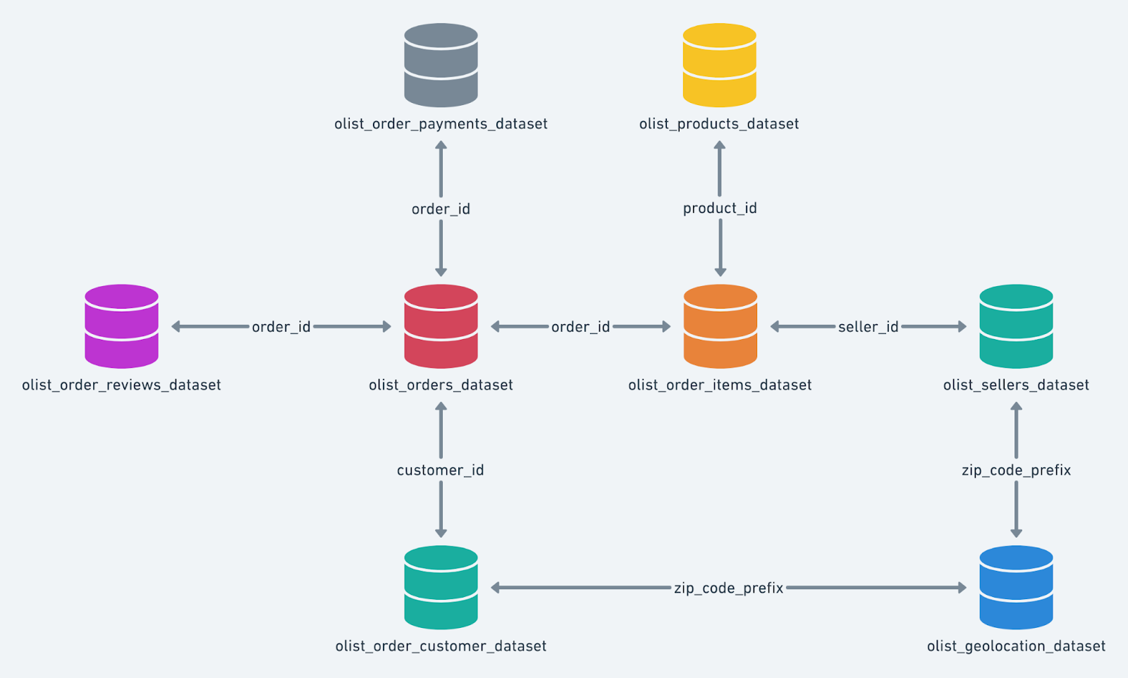
Dataset schema: orders is the hub; items link to products and sellers; customers and sellers link to geolocation by zip prefix.

1. Initial exploration: structure & characteristics

Q1.1 Data type of all columns in the customers table
Data type of all columns in the "customers" table.
Query
SELECT
column_name,
data_type
FROM target.INFORMATION_SCHEMA.COLUMNS
WHERE table_name = 'customers'
ORDER BY ordinal_position;
Result (first 10 rows)
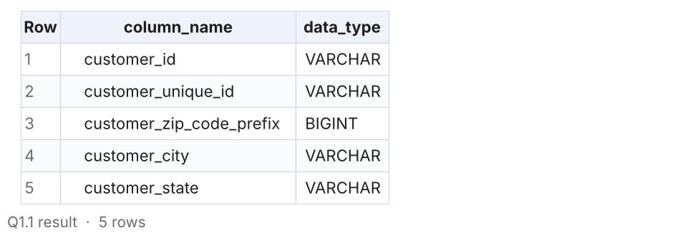
Insights
- The customers table has 5 columns. The two IDs, city and state are STRING; the zip code prefix is INT64 (stored as BIGINT locally).
- customer_id is unique per order, while customer_unique_id identifies the real person: 99,441 customer_ids map to 96,096 unique customers. Any customer count in this study uses customer_unique_id.
- Zip prefixes lose their leading zero as integers (01037 becomes 1037). They still join to geolocation correctly because both sides are integers.
Recommendations
- Keep zip prefixes as zero-padded STRING in the warehouse so they match postal formats when shared with logistics partners.

Q1.2 Time range between which the orders were placed
Get the time range between which the orders were placed.
Query
SELECT
MIN(order_purchase_timestamp) AS first_order_at,
MAX(order_purchase_timestamp) AS last_order_at,
TIMESTAMP_DIFF(MAX(order_purchase_timestamp), MIN(order_purchase_timestamp), DAY) AS span_in_days,
COUNT(*) AS total_orders
FROM target.orders;
Result (first 10 rows)
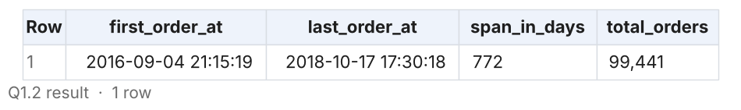
Insights
- Orders span 4 Sep 2016 21:15 to 17 Oct 2018 17:30, about 772 days (25 calendar months).
- The edges are thin: Sep-Dec 2016 has 329 orders (no orders at all in Nov 2016) and Sep-Oct 2018 has 20. Year-on-year comparisons should therefore use Jan-Aug, which the brief also asks for.
Recommendations
- Report trends on complete months (Jan 2017 - Aug 2018) so the partial edges do not distort growth rates.

Q1.3 Count of cities & states of customers who ordered
Count the Cities & States of customers who ordered during the given period.
Query
SELECT
COUNT(DISTINCT c.customer_city) AS num_cities,
COUNT(DISTINCT c.customer_state) AS num_states,
COUNT(DISTINCT c.customer_unique_id) AS num_unique_customers,
COUNT(DISTINCT o.order_id) AS num_orders
FROM target.orders AS o
JOIN target.customers AS c
ON o.customer_id = c.customer_id
WHERE o.order_purchase_timestamp BETWEEN
(SELECT MIN(order_purchase_timestamp) FROM target.orders)
AND (SELECT MAX(order_purchase_timestamp) FROM target.orders);
Result (first 10 rows)
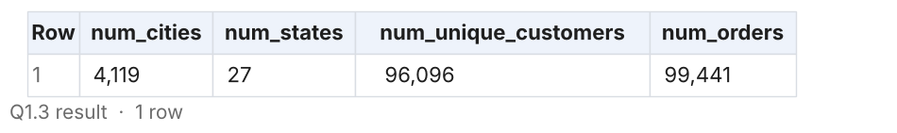
Insights
- Customers who ordered in the period come from 4,119 cities across all 27 Brazilian states (26 states + the Federal District).
- Those 99,441 orders were placed by 96,096 unique customers, i.e. 1.03 orders per customer.
Recommendations
- National reach already exists; the opportunity is deepening penetration outside the South-East, not opening new states.

Q1.4 Data profile: row counts and key coverage for every table
Supporting check: size of every table and how cleanly they join.
Query
SELECT 'orders' AS table_name, COUNT(*) AS row_count, COUNT(DISTINCT order_id) AS distinct_keys FROM target.orders
UNION ALL SELECT 'customers', COUNT(*), COUNT(DISTINCT customer_id) FROM target.customers
UNION ALL SELECT 'order_items', COUNT(*), COUNT(DISTINCT order_id) FROM target.order_items
UNION ALL SELECT 'payments', COUNT(*), COUNT(DISTINCT order_id) FROM target.payments
UNION ALL SELECT 'order_reviews', COUNT(*), COUNT(DISTINCT order_id) FROM target.order_reviews
UNION ALL SELECT 'products', COUNT(*), COUNT(DISTINCT product_id) FROM target.products
UNION ALL SELECT 'sellers', COUNT(*), COUNT(DISTINCT seller_id) FROM target.sellers
UNION ALL SELECT 'geolocation', COUNT(*), COUNT(DISTINCT geolocation_zip_code_prefix) FROM target.geolocation
ORDER BY row_count DESC;
Result (first 10 rows)
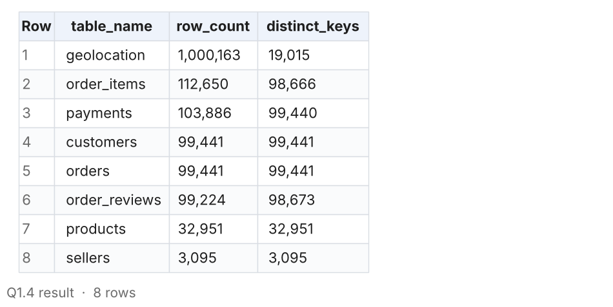
Insights
- Orders, customers and payments join almost 1:1 (99,441 orders, 99,440 with a payment). 775 orders have no items, mostly cancelled/unavailable ones.
- Geolocation has 1,000,163 rows for only 19,015 zip prefixes: many coordinates per prefix, so it must be aggregated to one row per prefix before joining.
- Reviews hold 99,224 rows for 98,673 orders, so a few orders have more than one review; review scores are averaged per order before joining.
Recommendations
- Publish a deduplicated geolocation view (one centroid per zip prefix) so analysts do not accidentally multiply rows.

Q1.5 Order status mix and missing delivery timestamps
Supporting check: which order statuses exist and how many orders lack delivery dates.
Query
SELECT
order_status,
COUNT(*) AS orders,
ROUND(100 * COUNT(*) / SUM(COUNT(*)) OVER (), 2) AS pct_of_orders,
SUM(CASE WHEN order_approved_at IS NULL THEN 1 ELSE 0 END) AS missing_approved_at,
SUM(CASE WHEN order_delivered_carrier_date IS NULL THEN 1 ELSE 0 END) AS missing_carrier_date,
SUM(CASE WHEN order_delivered_customer_date IS NULL THEN 1 ELSE 0 END) AS missing_customer_date
FROM target.orders
GROUP BY order_status
ORDER BY orders DESC;
Result (first 10 rows)
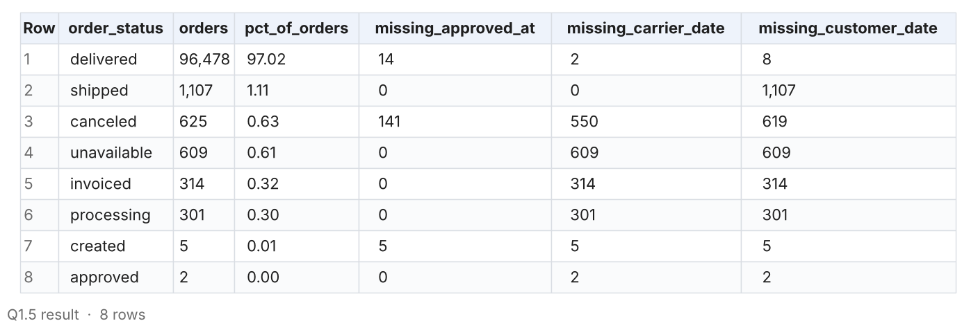
Insights
- 97.0% of orders were delivered; 1.1% shipped but not delivered, 0.6% cancelled and 0.6% unavailable.
- Only 8 delivered orders lack a delivery date, so delivery metrics cover 96,470 orders.
Recommendations
- Investigate the 609 'unavailable' orders: each one is a sale lost to stock-outs and a likely unhappy customer.

2. In-depth exploration

Q2.1 Is there a growing trend in orders over the years? (yearly view)
Is there a growing trend in the no. of orders placed over the past years?
Query
-- 2016 and 2018 are partial years, so the like-for-like comparison is Jan-Aug.
WITH yearly AS (
SELECT
EXTRACT(YEAR FROM order_purchase_timestamp) AS order_year,
COUNT(*) AS total_orders,
SUM(CASE WHEN EXTRACT(MONTH FROM order_purchase_timestamp) BETWEEN 1 AND 8 THEN 1 ELSE 0 END)
AS jan_aug_orders,
COUNT(DISTINCT EXTRACT(MONTH FROM order_purchase_timestamp)) AS active_months
FROM target.orders
GROUP BY order_year
)
SELECT
order_year,
active_months,
total_orders,
ROUND(total_orders / active_months, 0) AS avg_orders_per_active_month,
jan_aug_orders,
ROUND(100 * (jan_aug_orders - LAG(jan_aug_orders) OVER (ORDER BY order_year))
/ NULLIF(LAG(jan_aug_orders) OVER (ORDER BY order_year), 0), 2) AS jan_aug_yoy_growth_pct
FROM yearly
ORDER BY order_year;
Result (first 10 rows)
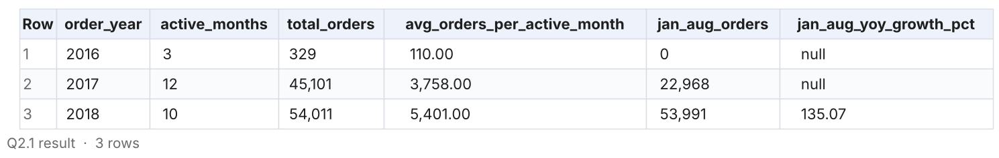
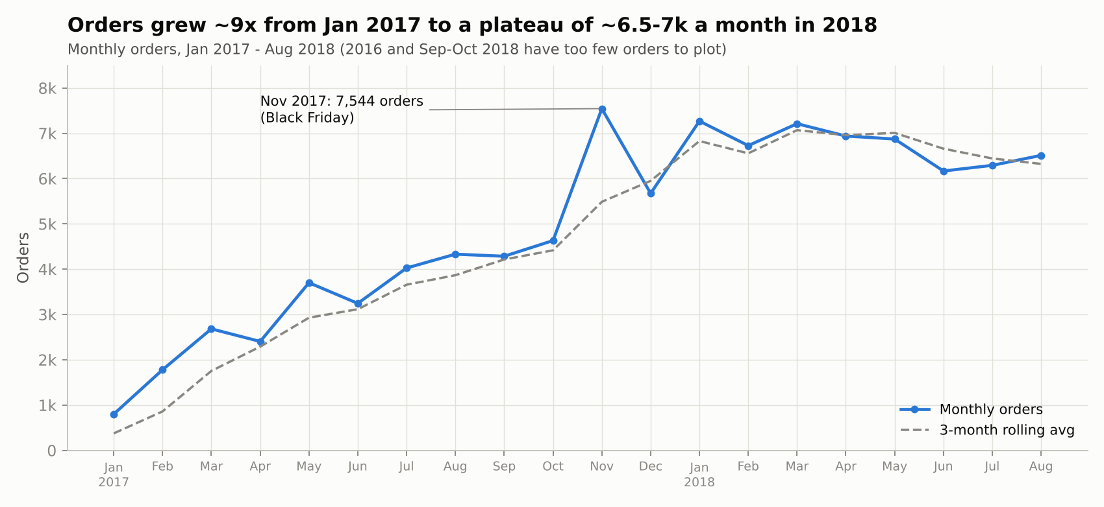
Insights
- Yes, there is a strong growth trend. Like-for-like (Jan-Aug), orders grew from 22,968 in 2017 to 53,991 in 2018: +135%.
- Average orders per active month rose from 3,758 in 2017 to 5,401 in 2018 (+44%), even though 2018 lacks the Nov-Dec holiday season.
Recommendations
- Use the 2018 run-rate (~6,700 orders a month) as the planning baseline for capacity and inventory, not the 2017 average.

Q2.2 Is there a growing trend in orders? (month-by-month series)
Is there a growing trend in the no. of orders placed over the past years? (monthly series with MoM change and 3-month rolling average)
Query
WITH monthly AS (
SELECT
FORMAT_TIMESTAMP('%Y-%m', order_purchase_timestamp) AS order_month,
COUNT(*) AS total_orders
FROM target.orders
GROUP BY order_month
)
SELECT
order_month,
total_orders,
total_orders - LAG(total_orders) OVER (ORDER BY order_month) AS mom_change,
ROUND(100 * (total_orders - LAG(total_orders) OVER (ORDER BY order_month))
/ NULLIF(LAG(total_orders) OVER (ORDER BY order_month), 0), 2) AS mom_change_pct,
ROUND(AVG(total_orders) OVER (ORDER BY order_month
ROWS BETWEEN 2 PRECEDING AND CURRENT ROW), 0) AS rolling_3m_avg
FROM monthly
ORDER BY order_month;
Result (first 10 rows)
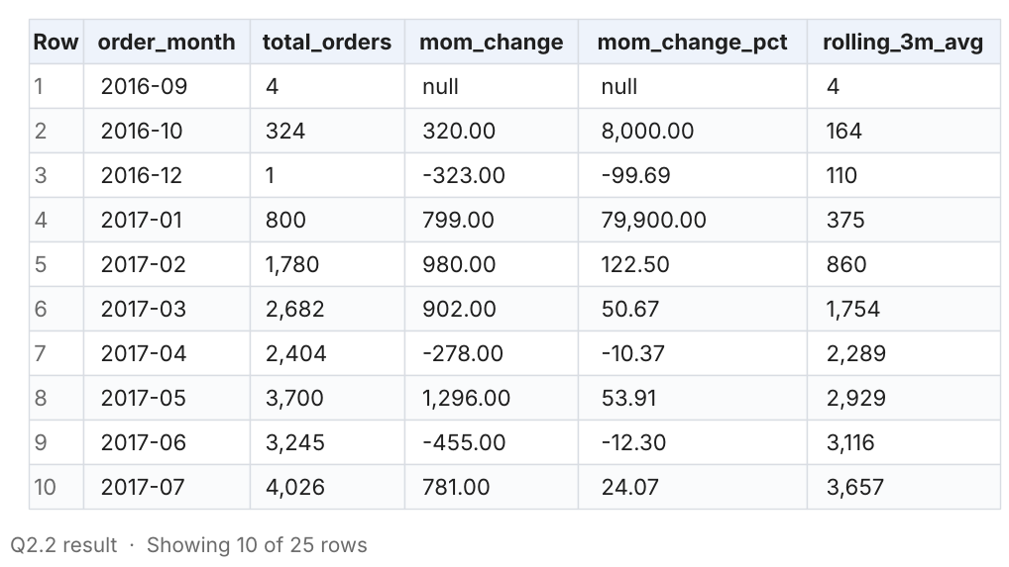
Insights
- Orders rose almost every month in 2017, from 800 in January to 4,631 in October.
- November 2017 jumped 62.9% month-on-month to 7,544 orders, the all-time peak; 24 Nov 2017 (Black Friday) alone had 1,176 orders, over 5x the average day that month.
- From January 2018 volume plateaued between 6,167 and 7,269 a month: the growth phase is over and the business is now in a scale phase.
Recommendations
- Re-ignite growth with acquisition campaigns in under-penetrated states, because organic momentum has flattened since Jan 2018.
- Treat Black Friday as the single largest operational event: pre-book carrier capacity and staff from October.

Q2.3 Monthly seasonality in the number of orders
Can we see some kind of monthly seasonality in terms of the no. of orders being placed?
Query
-- Calendar month on rows, year on columns, so the same month can be compared across years.
SELECT
EXTRACT(MONTH FROM order_purchase_timestamp) AS month_no,
SUM(CASE WHEN EXTRACT(YEAR FROM order_purchase_timestamp) = 2016 THEN 1 ELSE 0 END) AS orders_2016,
SUM(CASE WHEN EXTRACT(YEAR FROM order_purchase_timestamp) = 2017 THEN 1 ELSE 0 END) AS orders_2017,
SUM(CASE WHEN EXTRACT(YEAR FROM order_purchase_timestamp) = 2018 THEN 1 ELSE 0 END) AS orders_2018,
COUNT(*) AS total_orders,
ROUND(100 * COUNT(*) / SUM(COUNT(*)) OVER (), 2) AS pct_of_all_orders
FROM target.orders
GROUP BY month_no
ORDER BY month_no;
Result (first 10 rows)
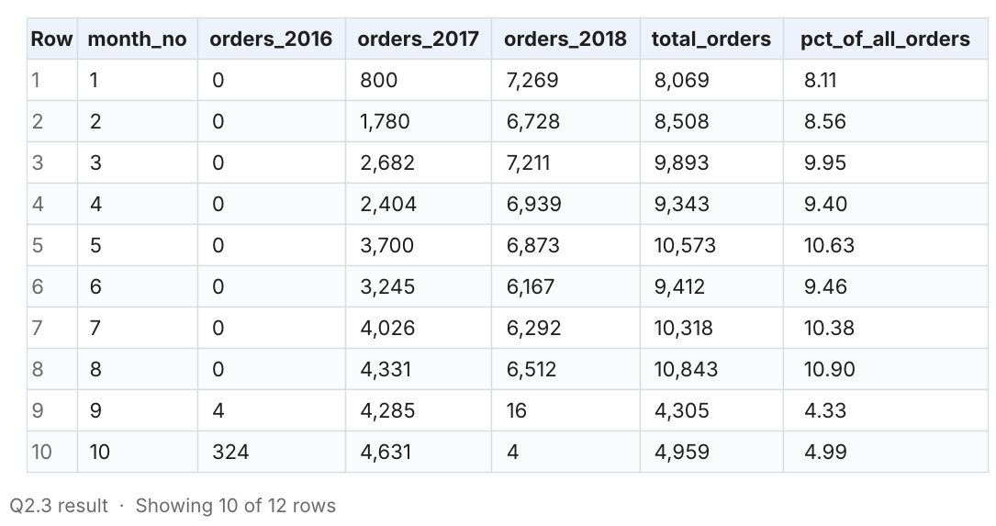
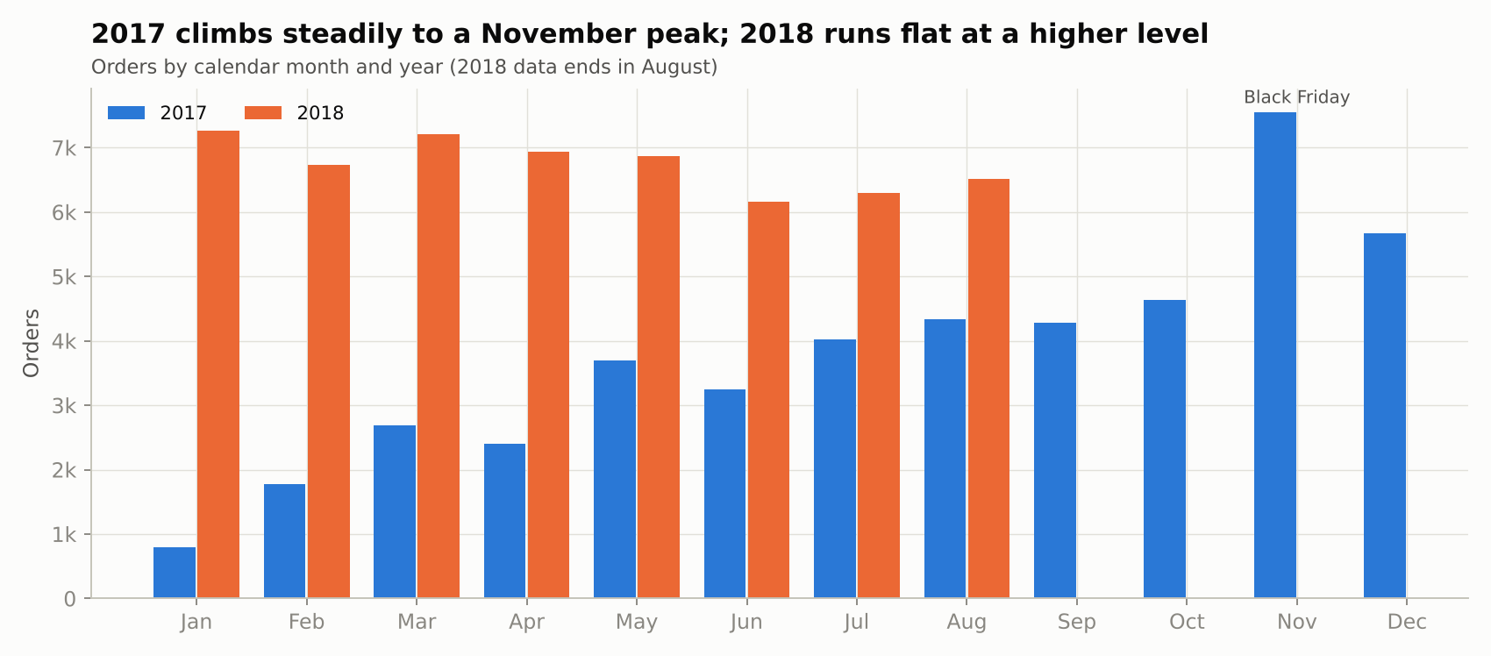
Insights
- Seasonality exists but is masked by growth. In 2017 orders rose steadily to a November peak (Black Friday) and eased in December.
- In 2018, Jan-Mar were the strongest months (7,269, 6,728, 7,211) and Jun-Jul the weakest (6,167, 6,292): post-holiday and new-year demand are strong, mid-year is soft.
- May, July and August have the highest share of all orders (10.6-10.9%) because they are covered by two full years of data.
Recommendations
- Run mid-year (June-July) promotions to fill the seasonal dip.
- Build inventory ahead of November and Q1, the two demand peaks.

Q2.4 Time of day when Brazilian customers place orders
During what time of the day do Brazilian customers mostly place their orders? (0-6 Dawn, 7-12 Morning, 13-18 Afternoon, 19-23 Night)
Query
SELECT
CASE
WHEN EXTRACT(HOUR FROM order_purchase_timestamp) BETWEEN 0 AND 6 THEN 'Dawn'
WHEN EXTRACT(HOUR FROM order_purchase_timestamp) BETWEEN 7 AND 12 THEN 'Morning'
WHEN EXTRACT(HOUR FROM order_purchase_timestamp) BETWEEN 13 AND 18 THEN 'Afternoon'
ELSE 'Night'
END AS time_of_day,
COUNT(*) AS total_orders,
ROUND(100 * COUNT(*) / SUM(COUNT(*)) OVER (), 2) AS pct_of_orders
FROM target.orders
GROUP BY time_of_day
ORDER BY total_orders DESC;
Result (first 10 rows)
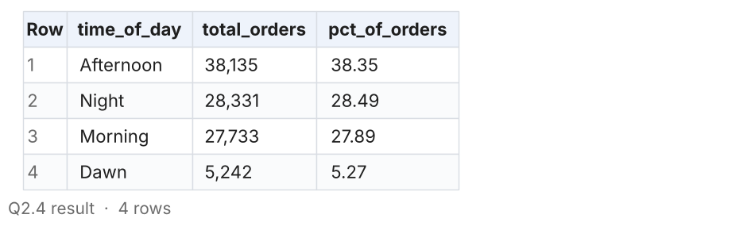
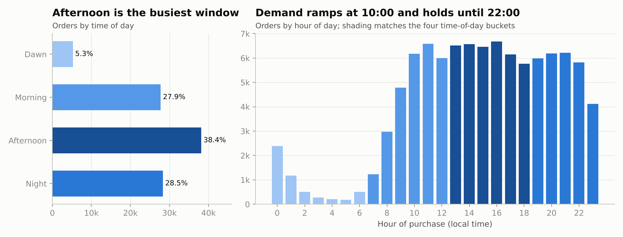
Insights
- Brazilian customers order mostly in the Afternoon (38.4%), then Night (28.5%) and Morning (27.9%). Dawn is quiet (5.3%).
- By hour, demand ramps from 10:00 and stays high until 22:00; the busiest hour is 16:00 (6,675 orders).
Recommendations
- Schedule flash sales, push notifications and paid-media bids for 13:00-22:00.
- Use 0:00-6:00 for site deployments and maintenance, when only 5% of orders arrive.

3. Evolution of e-commerce orders in the Brazil region

Q3.1 Month-on-month number of orders placed in each state
Get the month on month no. of orders placed in each state.
Query
WITH state_month AS (
SELECT
c.customer_state,
EXTRACT(YEAR FROM o.order_purchase_timestamp) AS order_year,
EXTRACT(MONTH FROM o.order_purchase_timestamp) AS order_month,
COUNT(o.order_id) AS total_orders
FROM target.orders AS o
JOIN target.customers AS c
ON o.customer_id = c.customer_id
GROUP BY c.customer_state, order_year, order_month
)
SELECT
customer_state,
order_year,
order_month,
total_orders,
total_orders - LAG(total_orders) OVER (
PARTITION BY customer_state ORDER BY order_year, order_month) AS mom_change
FROM state_month
ORDER BY customer_state, order_year, order_month;
Result (first 10 rows)
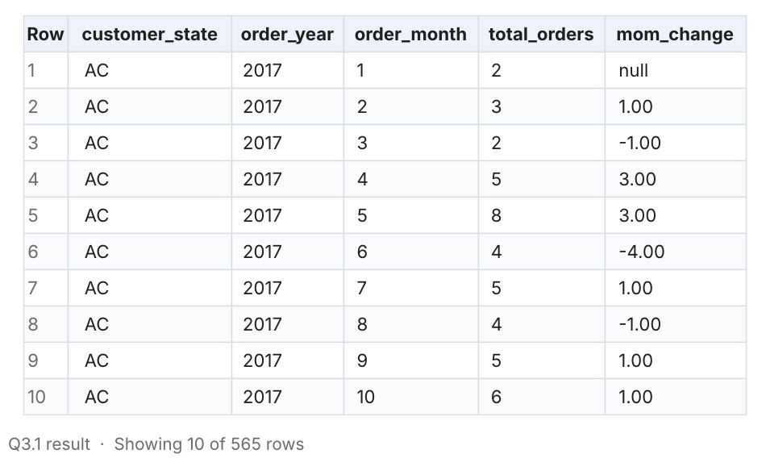
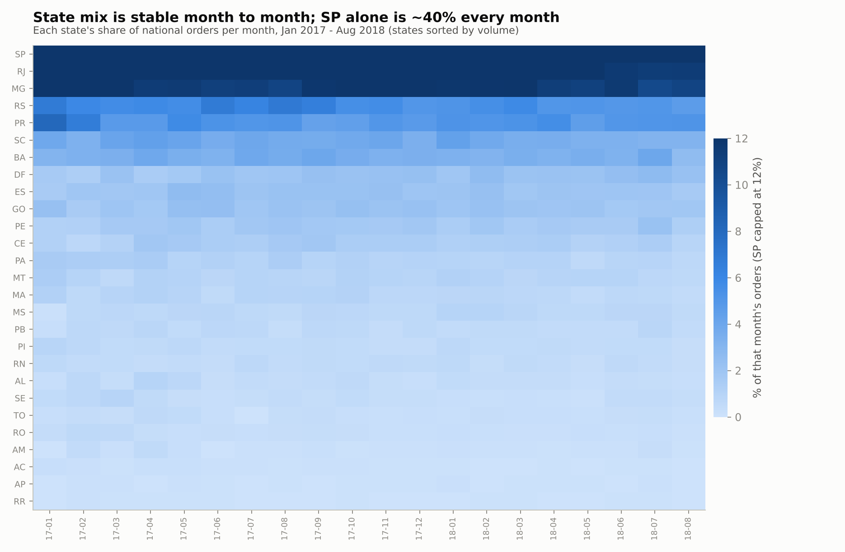
Insights
- Every state grew between Jan-Aug 2017 and Jan-Aug 2018 except Acre (AC, 33 to 27 orders).
- The fastest growers were DF (+184%), MS (+172%) and SP (+166%). The North and North-East grew slowest: SE (+43%), RO (+35%), AM (+55%), PA (+66%).
- Each state's share of monthly orders is very stable: SP is ~40% every month.
Recommendations
- Investigate why the North and North-East lag the national growth rate; delivery time and freight (sections 4-5) are the likely blockers.

Q3.2 How customers are distributed across states
How are the customers distributed across all the states?
Query
WITH by_state AS (
SELECT
customer_state,
COUNT(DISTINCT customer_unique_id) AS unique_customers,
COUNT(DISTINCT customer_city) AS cities_covered
FROM target.customers
GROUP BY customer_state
)
SELECT
customer_state,
unique_customers,
ROUND(100 * unique_customers / SUM(unique_customers) OVER (), 2) AS pct_of_customers,
ROUND(100 * SUM(unique_customers) OVER (ORDER BY unique_customers DESC, customer_state
ROWS BETWEEN UNBOUNDED PRECEDING AND CURRENT ROW)
/ SUM(unique_customers) OVER (), 2) AS cumulative_pct,
cities_covered
FROM by_state
ORDER BY unique_customers DESC;
Result (first 10 rows)
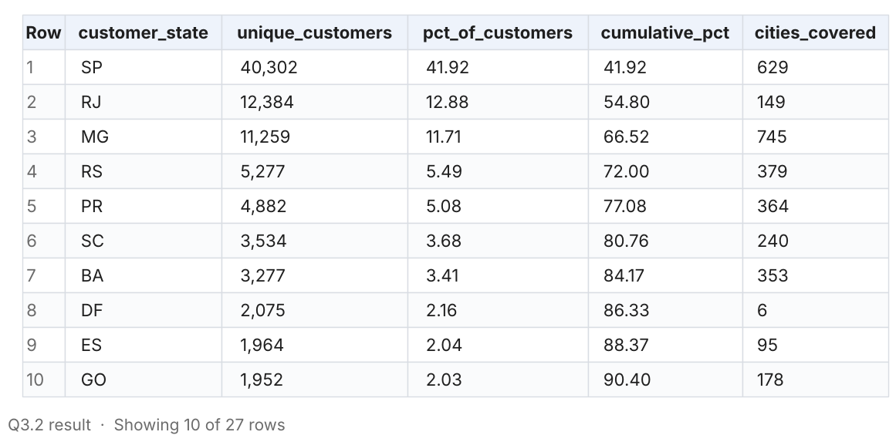
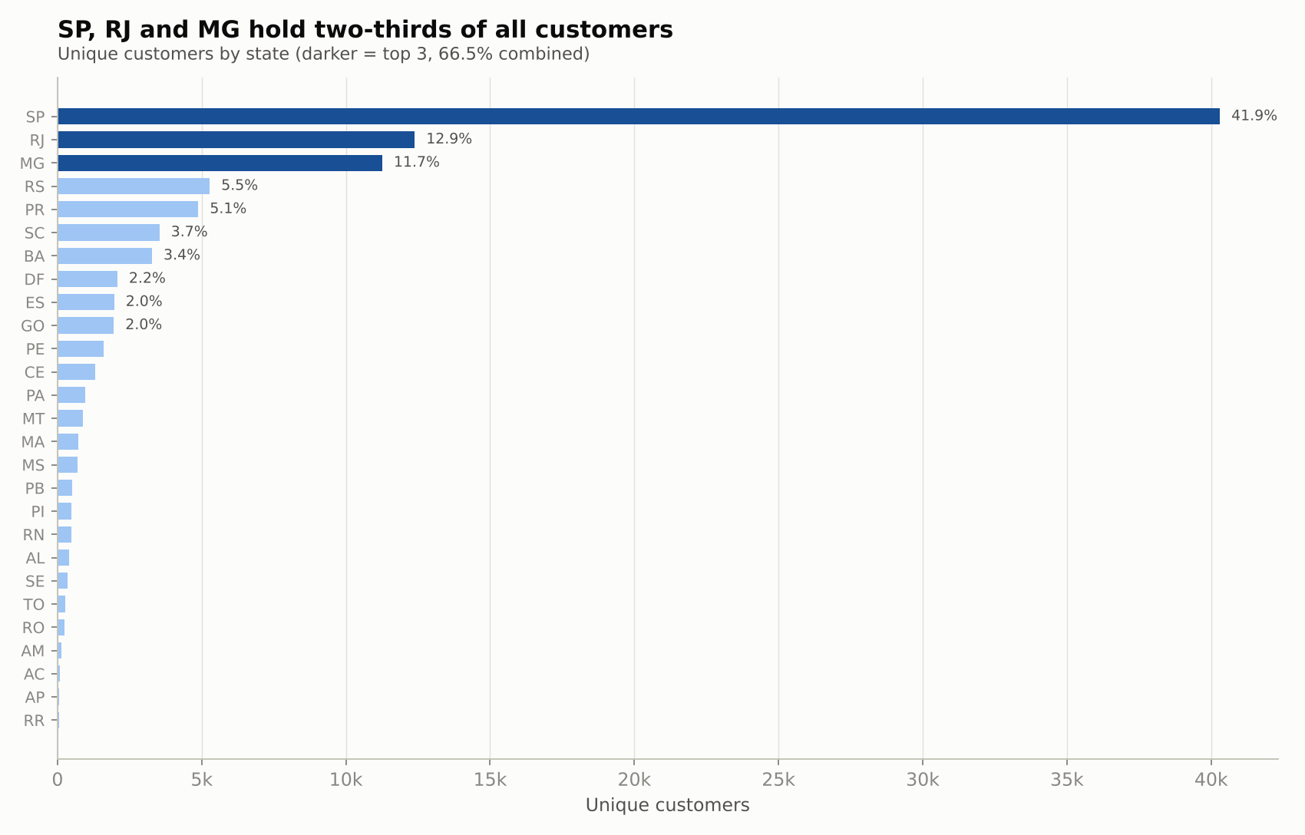
Insights
- Customers are highly concentrated: SP has 41.9%, RJ 12.9%, MG 11.7%. The top 5 states (SP, RJ, MG, RS, PR) hold 77.1% of all customers.
- The bottom 5 (RO, AM, AC, AP, RR) together hold only 0.6%. Roraima has just 45 customers.
- SP also covers the most cities in absolute terms after MG (629 vs 745).
Recommendations
- Defend the core (SP, RJ, MG) with loyalty programmes; grow the long tail with regional marketing and cheaper shipping, because each new customer there has low competition.

4. Impact on economy: money movement

Q4.1 % increase in cost of orders, 2017 vs 2018 (Jan-Aug)
Get the % increase in the cost of orders from year 2017 to 2018 (include months between Jan to Aug only), using payment_value.
Query
WITH yearly_cost AS (
SELECT
EXTRACT(YEAR FROM o.order_purchase_timestamp) AS order_year,
SUM(p.payment_value) AS total_cost
FROM target.orders AS o
JOIN target.payments AS p
ON o.order_id = p.order_id
WHERE EXTRACT(YEAR FROM o.order_purchase_timestamp) IN (2017, 2018)
AND EXTRACT(MONTH FROM o.order_purchase_timestamp) BETWEEN 1 AND 8
GROUP BY order_year
)
SELECT
ROUND(MAX(CASE WHEN order_year = 2017 THEN total_cost END), 2) AS cost_2017_jan_aug,
ROUND(MAX(CASE WHEN order_year = 2018 THEN total_cost END), 2) AS cost_2018_jan_aug,
ROUND(100 * (MAX(CASE WHEN order_year = 2018 THEN total_cost END)
- MAX(CASE WHEN order_year = 2017 THEN total_cost END))
/ MAX(CASE WHEN order_year = 2017 THEN total_cost END), 2) AS pct_increase
FROM yearly_cost;
Result (first 10 rows)
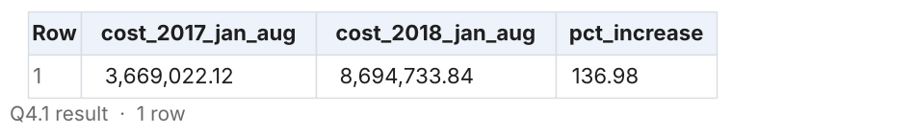
Insights
- The cost of orders (payment_value) grew from R$3.67M in Jan-Aug 2017 to R$8.69M in Jan-Aug 2018, an increase of 136.98%.
- Average order value was flat (R$159.7 vs R$161.0), so the increase comes from more orders, not higher prices.
Recommendations
- Add basket-building levers (bundles, free-shipping thresholds, cross-sell) to grow order value now that volume growth has slowed.

Q4.2 Cost of orders by month, 2017 vs 2018 (Jan-Aug)
Supporting view for 4.1: where in the year did the growth come from?
Query
SELECT
EXTRACT(MONTH FROM o.order_purchase_timestamp) AS month_no,
ROUND(SUM(CASE WHEN EXTRACT(YEAR FROM o.order_purchase_timestamp) = 2017 THEN p.payment_value END), 2) AS cost_2017,
ROUND(SUM(CASE WHEN EXTRACT(YEAR FROM o.order_purchase_timestamp) = 2018 THEN p.payment_value END), 2) AS cost_2018,
ROUND(100 * (SUM(CASE WHEN EXTRACT(YEAR FROM o.order_purchase_timestamp) = 2018 THEN p.payment_value END)
- SUM(CASE WHEN EXTRACT(YEAR FROM o.order_purchase_timestamp) = 2017 THEN p.payment_value END))
/ SUM(CASE WHEN EXTRACT(YEAR FROM o.order_purchase_timestamp) = 2017 THEN p.payment_value END), 2) AS yoy_pct
FROM target.orders AS o
JOIN target.payments AS p
ON o.order_id = p.order_id
WHERE EXTRACT(MONTH FROM o.order_purchase_timestamp) BETWEEN 1 AND 8
GROUP BY month_no
ORDER BY month_no;
Result (first 10 rows)
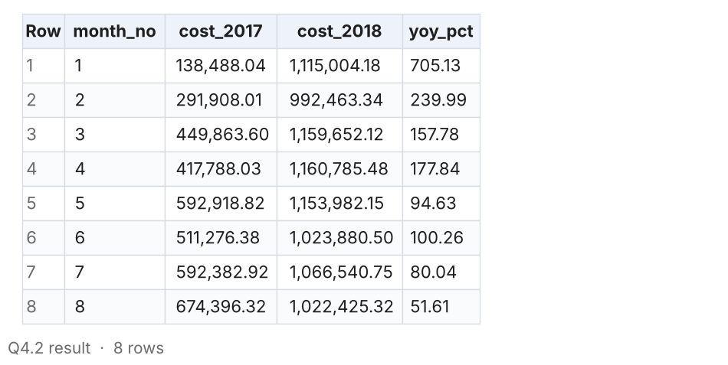
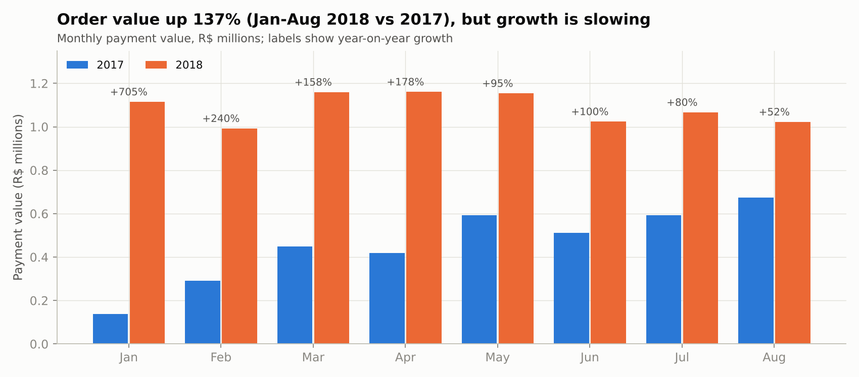
Insights
- Year-on-year growth decays month by month: +705% in January, +178% in April, +52% in August.
- 2018 monthly value is flat at R$1.0-1.16M, confirming the plateau seen in order counts.
Recommendations
- Set 2019 targets on a plateau-aware baseline; extrapolating early-2018 growth rates would overstate demand by a wide margin.

Q4.3 Total & average order price for each state
Calculate the Total & Average value of order price for each state.
Query
SELECT
c.customer_state,
ROUND(SUM(oi.price), 2) AS total_order_price,
ROUND(AVG(oi.price), 2) AS avg_price_per_item,
ROUND(SUM(oi.price) / COUNT(DISTINCT oi.order_id), 2) AS avg_price_per_order,
COUNT(DISTINCT oi.order_id) AS orders
FROM target.orders AS o
JOIN target.customers AS c ON o.customer_id = c.customer_id
JOIN target.order_items AS oi ON o.order_id = oi.order_id
GROUP BY c.customer_state
ORDER BY total_order_price DESC;
Result (first 10 rows)
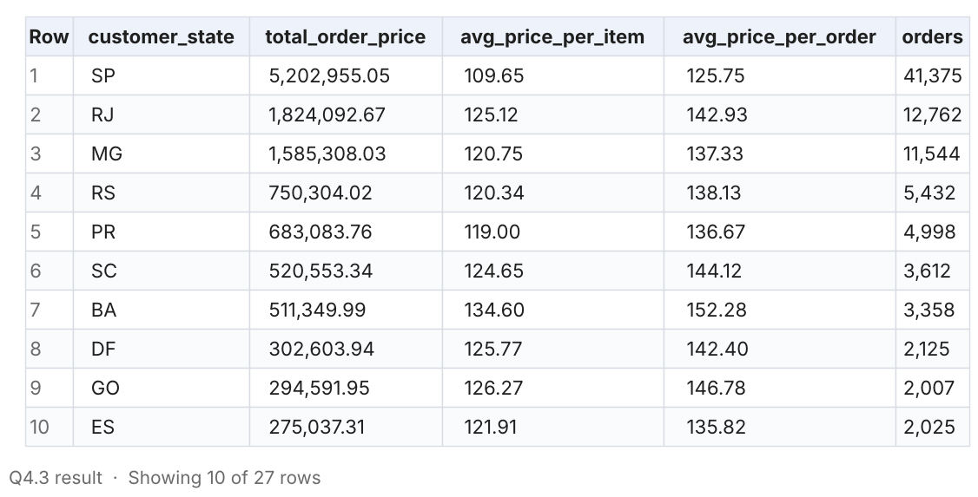
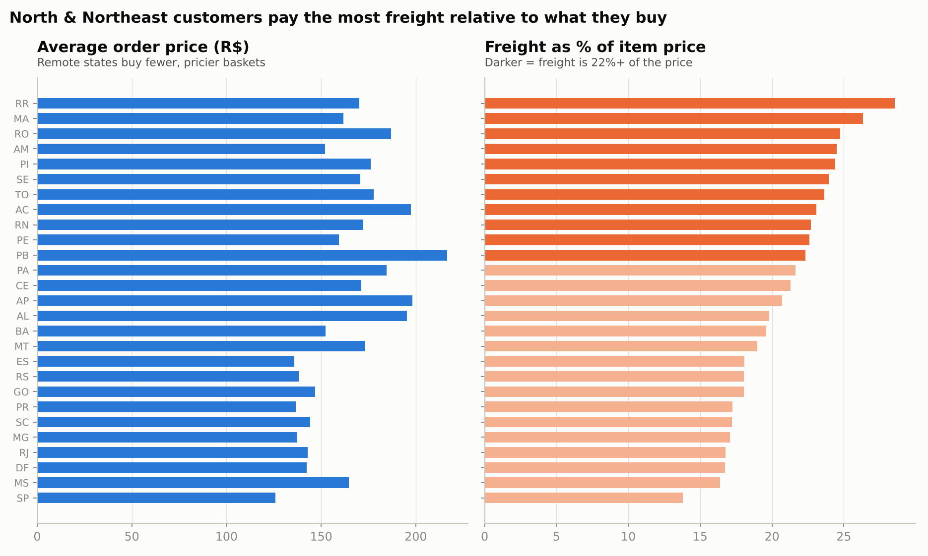
Insights
- SP generates the most revenue by far (R$5.20M, 38% of item value), followed by RJ (R$1.82M) and MG (R$1.59M).
- SP also has the lowest average order price (R$125.75 per order). Remote states buy fewer but pricier baskets: PB R$216.67, AP R$198.15, AC R$197.32 per order.
Recommendations
- In remote states, customers only buy when the item is valuable enough to justify the shipping. Lower freight would unlock everyday, lower-priced purchases there.

Q4.4 Total & average freight value for each state
Calculate the Total & Average value of order freight for each state.
Query
SELECT
c.customer_state,
ROUND(SUM(oi.freight_value), 2) AS total_freight_value,
ROUND(AVG(oi.freight_value), 2) AS avg_freight_per_item,
ROUND(SUM(oi.freight_value) / COUNT(DISTINCT oi.order_id), 2) AS avg_freight_per_order,
ROUND(100 * SUM(oi.freight_value) / SUM(oi.price), 2) AS freight_as_pct_of_price
FROM target.orders AS o
JOIN target.customers AS c ON o.customer_id = c.customer_id
JOIN target.order_items AS oi ON o.order_id = oi.order_id
GROUP BY c.customer_state
ORDER BY total_freight_value DESC;
Result (first 10 rows)
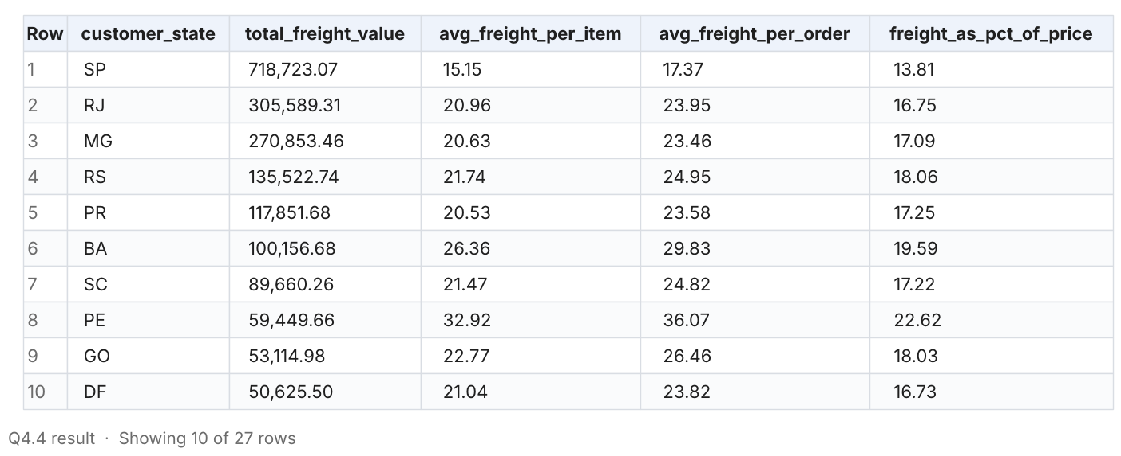
Insights
- Total freight is largest in SP (R$718.7K) because of volume, but SP's average freight per item is the lowest (R$15.15).
- Freight is a much heavier burden in the North and North-East: 28.6% of the item price in RR, 26.4% in MA and 24.7% in RO, vs 13.8% in SP.
Recommendations
- Introduce regional freight subsidies or free-shipping thresholds for states where freight exceeds 20% of the price.

5. Sales, freight & delivery time

Q5.1 Delivery time and estimated-vs-actual gap per order (single query)
Find the no. of days taken to deliver each order from the purchase date (time_to_deliver) and the difference in days between the actual & estimated delivery date (diff_estimated_delivery), in a single query.
Query
-- time_to_deliver = order_delivered_customer_date - order_purchase_timestamp
-- diff_estimated_delivery = order_delivered_customer_date - order_estimated_delivery_date
-- (negative = delivered BEFORE the estimate, positive = days late;
-- an order counts as late throughout this study when diff_estimated_delivery > 0)
SELECT
order_id,
order_purchase_timestamp,
order_delivered_customer_date,
order_estimated_delivery_date,
TIMESTAMP_DIFF(order_delivered_customer_date, order_purchase_timestamp, DAY) AS time_to_deliver,
TIMESTAMP_DIFF(order_delivered_customer_date, order_estimated_delivery_date, DAY) AS diff_estimated_delivery
FROM target.orders
WHERE order_status = 'delivered'
AND order_delivered_customer_date IS NOT NULL
ORDER BY order_purchase_timestamp;
Result (first 10 rows)
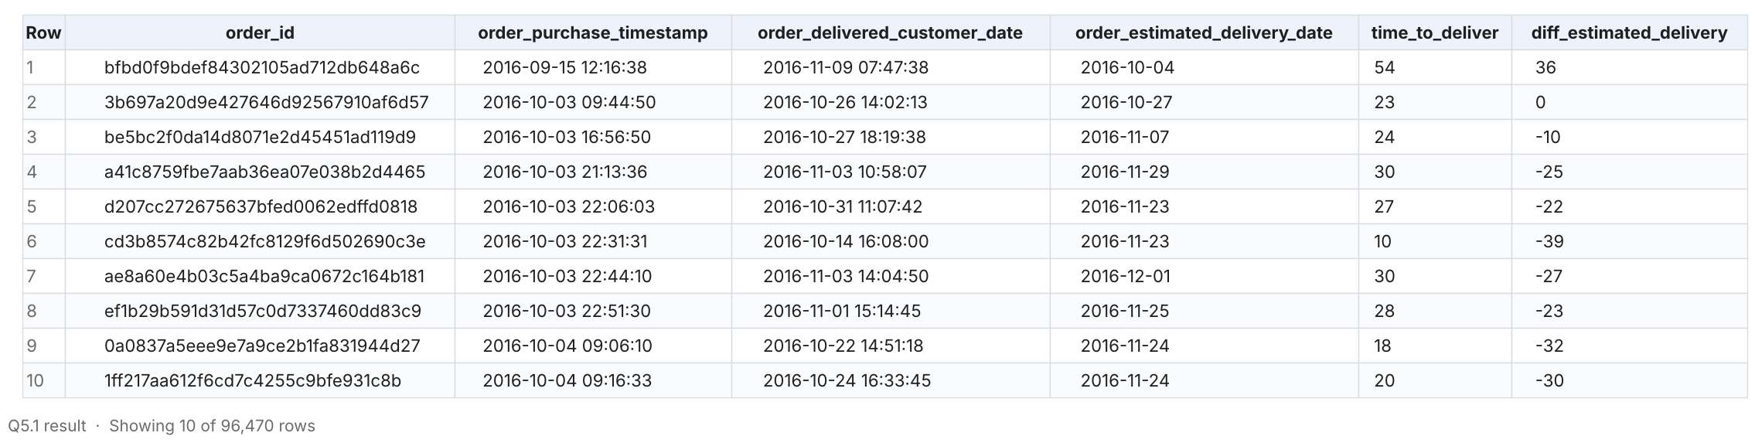
Insights
- The query returns one row per delivered order (96,470 rows) with time_to_deliver and diff_estimated_delivery, computed exactly as the brief's formulas.
- A negative diff_estimated_delivery means the order arrived before the estimate; the first rows show typical values of -22 to -39 days in late 2016.
Recommendations
- Store both metrics in a delivery fact table so operations can track them daily.

Q5.2 Delivery performance summary (supporting 5.1)
Supporting view: overall distribution of delivery time and lateness.
Query
WITH d AS (
SELECT
TIMESTAMP_DIFF(order_delivered_customer_date, order_purchase_timestamp, DAY) AS time_to_deliver,
TIMESTAMP_DIFF(order_delivered_customer_date, order_estimated_delivery_date, DAY) AS diff_estimated_delivery
FROM target.orders
WHERE order_status = 'delivered'
AND order_delivered_customer_date IS NOT NULL
)
SELECT
COUNT(*) AS delivered_orders,
ROUND(AVG(time_to_deliver), 2) AS avg_days_to_deliver,
MIN(time_to_deliver) AS min_days,
MAX(time_to_deliver) AS max_days,
ROUND(AVG(diff_estimated_delivery), 2) AS avg_days_vs_estimate,
SUM(CASE WHEN diff_estimated_delivery > 0 THEN 1 ELSE 0 END) AS late_orders,
ROUND(100 * SUM(CASE WHEN diff_estimated_delivery > 0 THEN 1 ELSE 0 END) / COUNT(*), 2) AS pct_late
FROM d;
Result (first 10 rows)
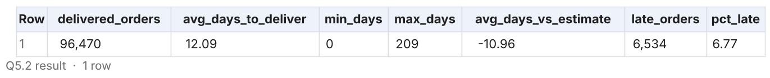
Insights
- Average delivery time is 12.09 days (0 to 209 days).
- On average orders arrive 10.96 days before the estimate, yet 6,534 orders (6.77%) still arrive at least one day late.
- SP (1,820) and RJ (1,495) account for 50.7% of late orders.
Recommendations
- Estimates are padded by ~11 days. Tightening them would make the site more competitive at checkout without changing logistics.

Q5.3 Top 5 states with the highest & lowest average freight value
Find out the top 5 states with the highest & lowest average freight value.
Query
WITH state_freight AS (
SELECT
c.customer_state,
ROUND(AVG(oi.freight_value), 2) AS avg_freight_value
FROM target.orders AS o
JOIN target.customers AS c ON o.customer_id = c.customer_id
JOIN target.order_items AS oi ON o.order_id = oi.order_id
GROUP BY c.customer_state
),
ranked AS (
SELECT
customer_state,
avg_freight_value,
ROW_NUMBER() OVER (ORDER BY avg_freight_value DESC) AS rank_high,
ROW_NUMBER() OVER (ORDER BY avg_freight_value ASC) AS rank_low
FROM state_freight
)
SELECT
h.rank_high AS rank_no,
h.customer_state AS highest_freight_state,
h.avg_freight_value AS highest_avg_freight,
l.customer_state AS lowest_freight_state,
l.avg_freight_value AS lowest_avg_freight
FROM ranked AS h
JOIN ranked AS l
ON h.rank_high = l.rank_low
WHERE h.rank_high <= 5
ORDER BY rank_no;
Result (first 10 rows)
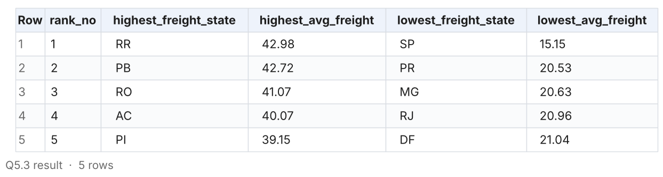
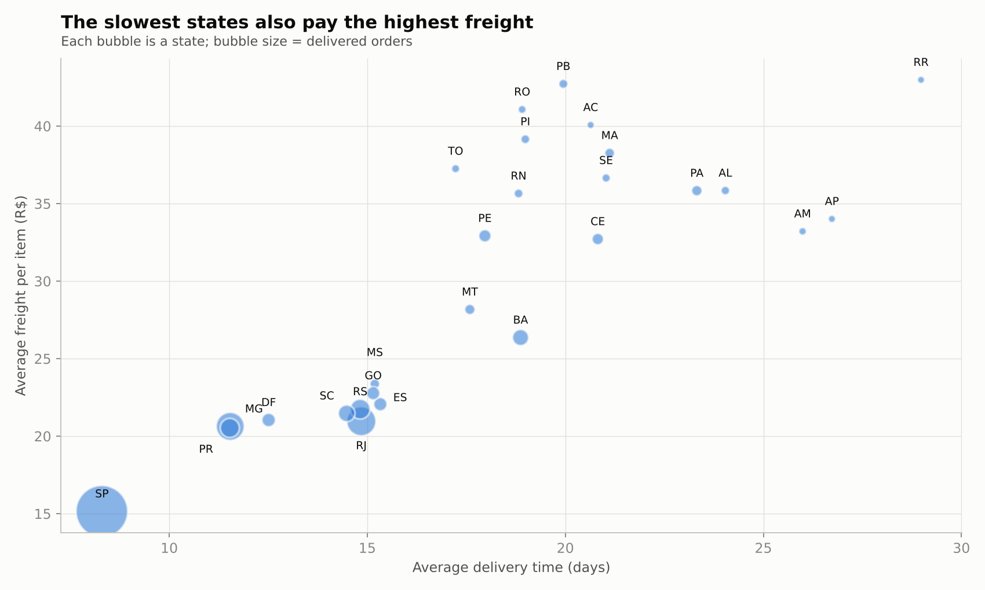
Insights
- Highest average freight: RR (R$42.98), PB (R$42.72), RO (R$41.07), AC (R$40.07), PI (R$39.15), all North/North-East states far from the SP hub.
- Lowest: SP (R$15.15), PR (R$20.53), MG (R$20.63), RJ (R$20.96), DF (R$21.04), the states with the most orders and sellers.
- Freight in RR is 2.8x that in SP.
Recommendations
- Negotiate consolidated (bulk) shipping contracts for the North and North-East, and open a regional cross-dock to shorten the line-haul.

Q5.4 Top 5 states with the highest & lowest average delivery time
Find out the top 5 states with the highest & lowest average delivery time.
Query
WITH state_delivery AS (
SELECT
c.customer_state,
ROUND(AVG(TIMESTAMP_DIFF(o.order_delivered_customer_date, o.order_purchase_timestamp, DAY)), 2)
AS avg_delivery_days
FROM target.orders AS o
JOIN target.customers AS c ON o.customer_id = c.customer_id
WHERE o.order_status = 'delivered'
AND o.order_delivered_customer_date IS NOT NULL
GROUP BY c.customer_state
),
ranked AS (
SELECT
customer_state,
avg_delivery_days,
ROW_NUMBER() OVER (ORDER BY avg_delivery_days DESC) AS rank_slow,
ROW_NUMBER() OVER (ORDER BY avg_delivery_days ASC) AS rank_fast
FROM state_delivery
)
SELECT
s.rank_slow AS rank_no,
s.customer_state AS slowest_state,
s.avg_delivery_days AS slowest_avg_days,
f.customer_state AS fastest_state,
f.avg_delivery_days AS fastest_avg_days
FROM ranked AS s
JOIN ranked AS f
ON s.rank_slow = f.rank_fast
WHERE s.rank_slow <= 5
ORDER BY rank_no;
Result (first 10 rows)
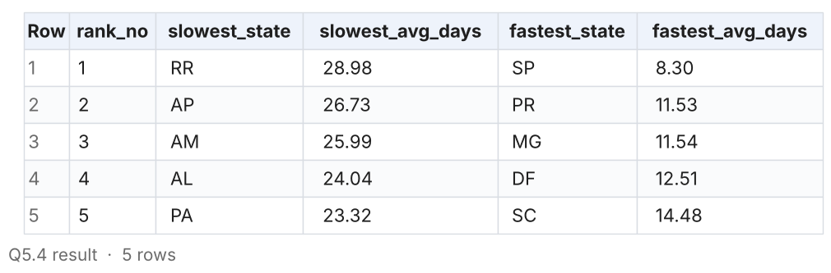
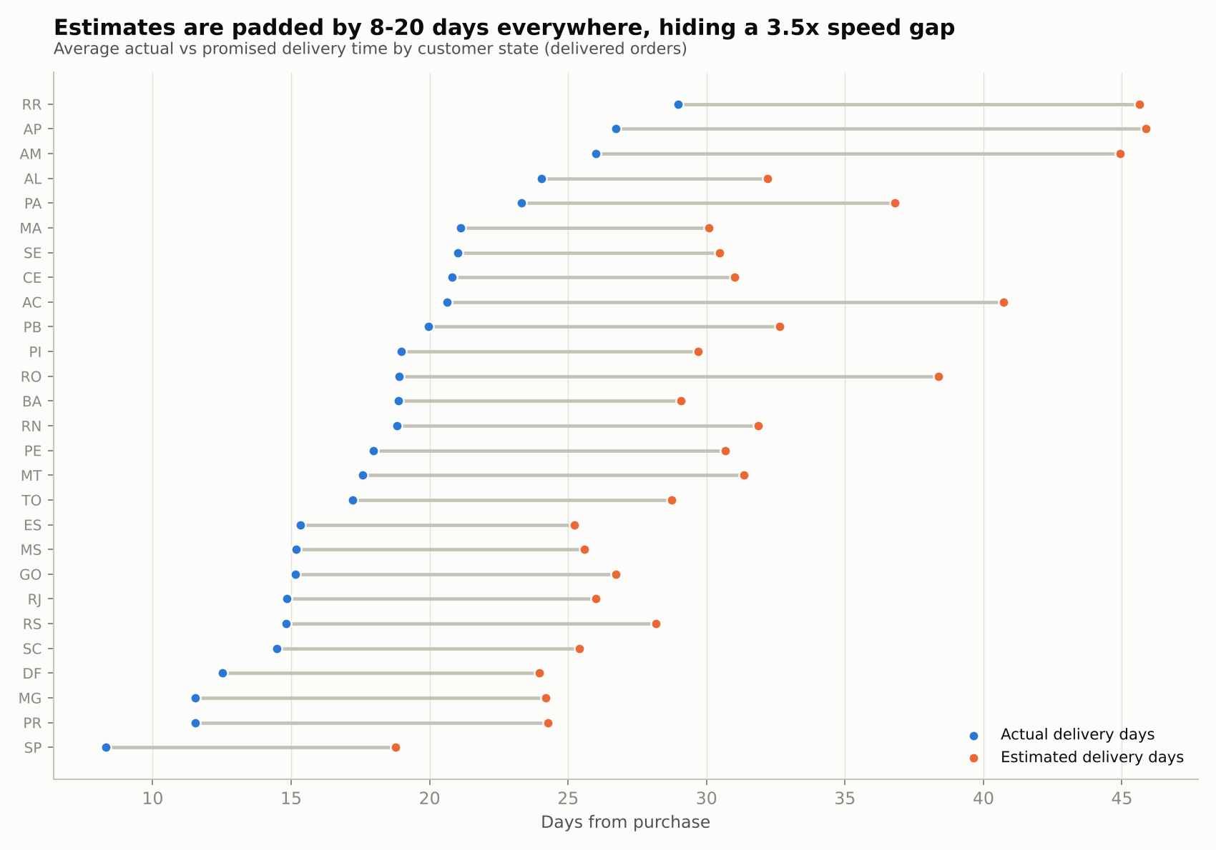
Insights
- Slowest deliveries: RR (29.0 days), AP (26.7), AM (26.0), AL (24.0), PA (23.3).
- Fastest: SP (8.3 days), PR (11.5), MG (11.5), DF (12.5), SC (14.5).
- A customer in Roraima waits 3.5x longer than one in São Paulo.
Recommendations
- Recruit sellers or place inventory in the North and North-East; same-state orders arrive in half the time (see 7.2).

Q5.5 Top 5 states where delivery is fastest compared to the estimate
Find out the top 5 states where the order delivery is really fast as compared to the estimated date of delivery (difference between the averages of actual & estimated delivery time).
Query
WITH d AS (
SELECT
c.customer_state,
TIMESTAMP_DIFF(o.order_delivered_customer_date, o.order_purchase_timestamp, DAY) AS actual_days,
TIMESTAMP_DIFF(o.order_estimated_delivery_date, o.order_purchase_timestamp, DAY) AS estimated_days,
CASE WHEN TIMESTAMP_DIFF(o.order_delivered_customer_date, o.order_estimated_delivery_date, DAY) > 0 THEN 1 ELSE 0 END AS is_late
FROM target.orders AS o
JOIN target.customers AS c ON o.customer_id = c.customer_id
WHERE o.order_status = 'delivered'
AND o.order_delivered_customer_date IS NOT NULL
)
SELECT
customer_state,
ROUND(AVG(actual_days), 2) AS avg_actual_days,
ROUND(AVG(estimated_days), 2) AS avg_estimated_days,
ROUND(AVG(estimated_days) - AVG(actual_days), 2) AS days_faster_than_estimate,
ROUND(100 * AVG(is_late), 2) AS pct_late
FROM d
GROUP BY customer_state
ORDER BY days_faster_than_estimate DESC
LIMIT 5;
Result (first 10 rows)
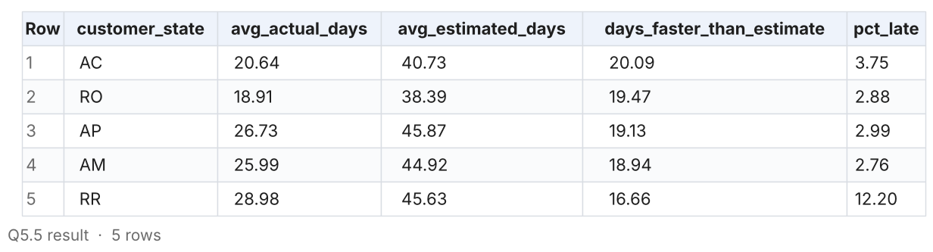
Insights
- Deliveries beat the estimate by the widest margin in AC (20.1 days early), RO (19.5), AP (19.1), AM (18.9) and RR (16.7).
- These are the slowest states. They look 'fast' only because their estimates are padded to 38-46 days.
- By contrast, AL (23.9% late) and MA (19.7% late) have the least reliable estimates.
Recommendations
- Recalibrate estimates per state. Over-promising by 20 days loses sales at checkout; under-promising in AL and MA damages reviews.

Q5.6 State delivery scorecard (all 27 states)
Supporting view: delivery speed, buffer vs estimate, lateness and freight side by side for every state.
Query
WITH d AS (
SELECT
c.customer_state,
o.order_id,
TIMESTAMP_DIFF(o.order_delivered_customer_date, o.order_purchase_timestamp, DAY) AS actual_days,
TIMESTAMP_DIFF(o.order_estimated_delivery_date, o.order_purchase_timestamp, DAY) AS estimated_days,
CASE WHEN TIMESTAMP_DIFF(o.order_delivered_customer_date, o.order_estimated_delivery_date, DAY) > 0 THEN 1 ELSE 0 END AS is_late
FROM target.orders AS o
JOIN target.customers AS c ON o.customer_id = c.customer_id
WHERE o.order_status = 'delivered'
AND o.order_delivered_customer_date IS NOT NULL
),
f AS (
SELECT c.customer_state, AVG(oi.freight_value) AS avg_freight
FROM target.orders AS o
JOIN target.customers AS c ON o.customer_id = c.customer_id
JOIN target.order_items AS oi ON o.order_id = oi.order_id
GROUP BY c.customer_state
)
SELECT
d.customer_state,
COUNT(*) AS delivered_orders,
ROUND(AVG(d.actual_days), 2) AS avg_actual_days,
ROUND(AVG(d.estimated_days) - AVG(d.actual_days), 2) AS days_faster_than_estimate,
ROUND(100 * AVG(d.is_late), 2) AS pct_late,
ROUND(MAX(f.avg_freight), 2) AS avg_freight_per_item
FROM d
JOIN f ON d.customer_state = f.customer_state
GROUP BY d.customer_state
ORDER BY avg_actual_days DESC;
Result (first 10 rows)
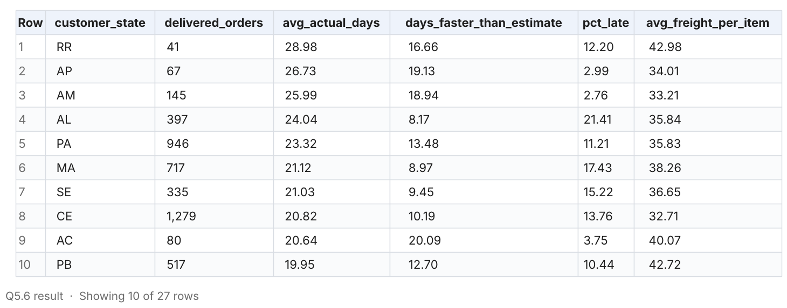
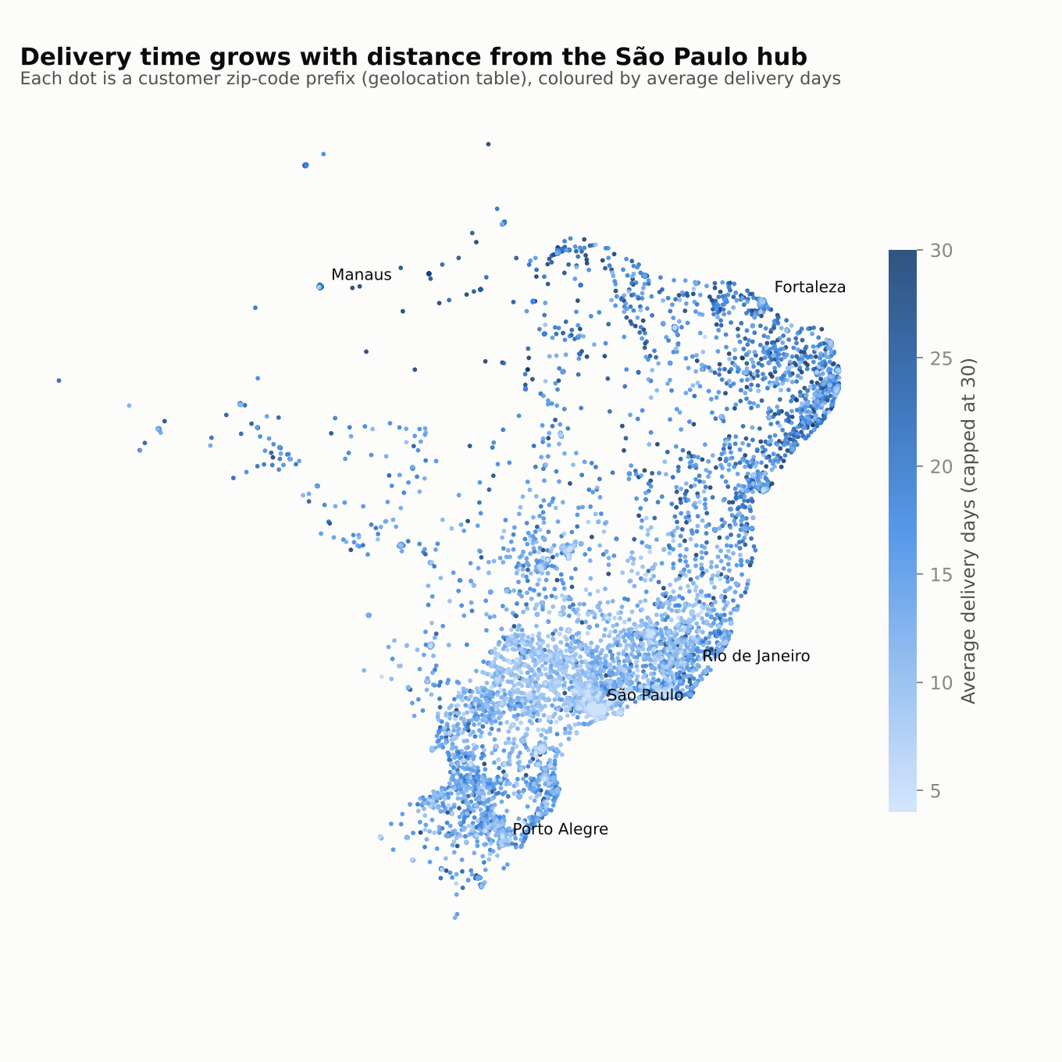
Insights
- Delivery time, freight and lateness move together: the North and North-East are slow, expensive and (in AL, MA, CE, SE, PI) often late.
- Among large states, RJ stands out with 13.5% late deliveries despite average speed, 2.3x SP's rate.
Recommendations
- Make RJ the first fix: it is the second-biggest market and has a lateness problem, not a distance problem.

6. Payments

Q6.1 Month-on-month orders by payment type
Find the month on month no. of orders placed using different payment types.
Query
SELECT
FORMAT_TIMESTAMP('%Y-%m', o.order_purchase_timestamp) AS order_month,
p.payment_type,
COUNT(DISTINCT o.order_id) AS total_orders
FROM target.orders AS o
JOIN target.payments AS p
ON o.order_id = p.order_id
GROUP BY order_month, p.payment_type
ORDER BY order_month, total_orders DESC;
Result (first 10 rows)
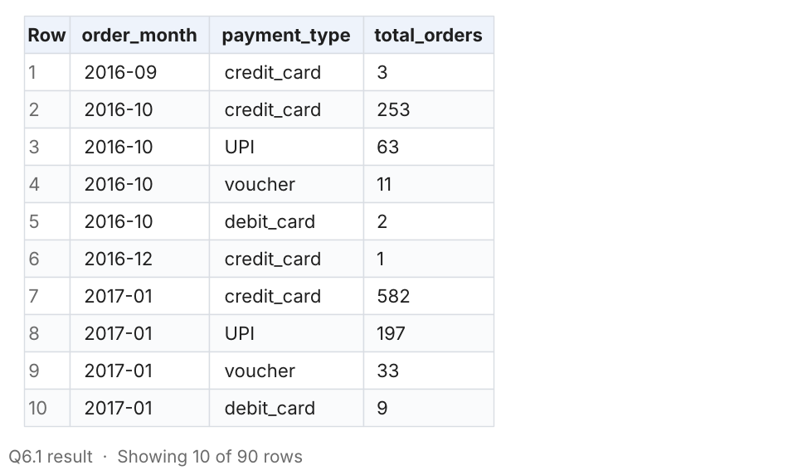
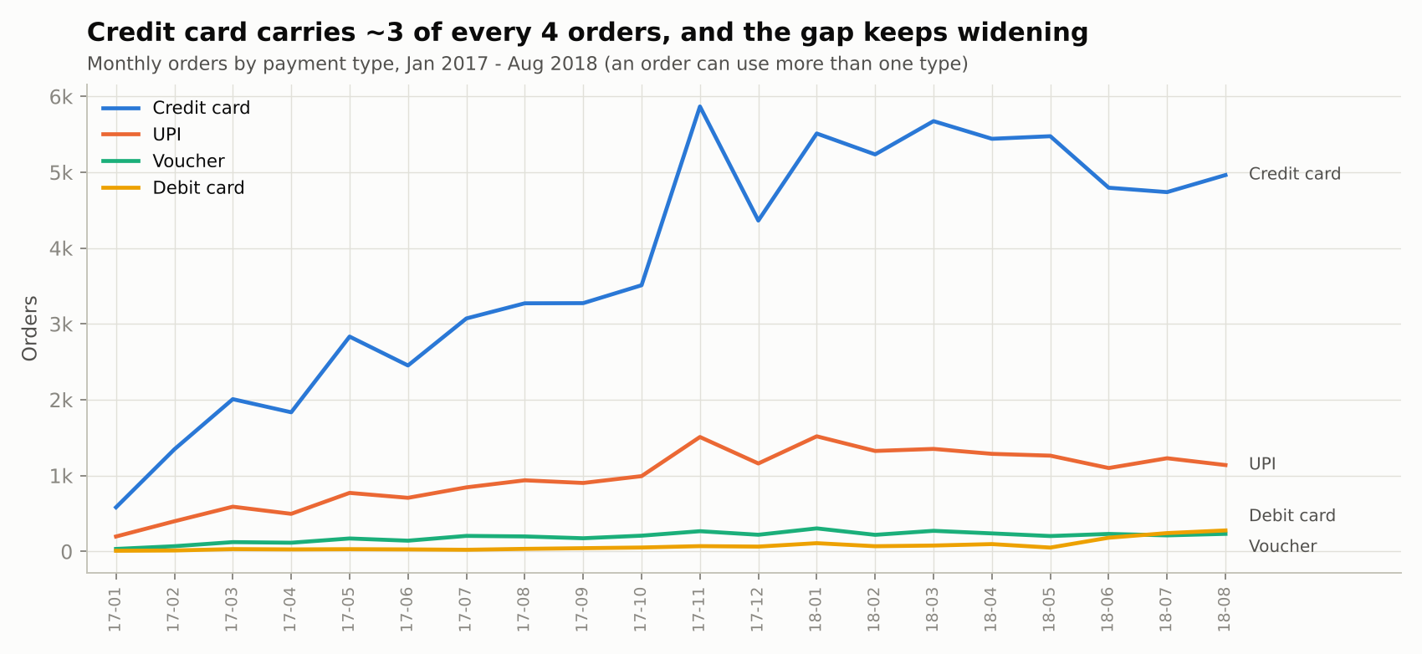
Insights
- Credit card is the dominant method every month and grew fastest, from 582 orders (Jan 2017) to ~5,000 a month in 2018.
- UPI is a steady second at ~1,100-1,500 orders a month. Voucher and debit card are small; debit card picked up in mid-2018.
- All methods peak together in November 2017.
Recommendations
- Partner with card issuers for interest-free installment campaigns around Black Friday, when card volume peaks.

Q6.2 Payment type share, value and installments (supporting 6.1)
Supporting view: share of orders and value by payment type.
Query
SELECT
payment_type,
COUNT(DISTINCT order_id) AS orders,
ROUND(100 * COUNT(DISTINCT order_id) / (SELECT COUNT(DISTINCT order_id) FROM target.payments), 2)
AS pct_of_orders,
ROUND(SUM(payment_value), 2) AS total_value,
ROUND(AVG(payment_value), 2) AS avg_payment_value,
ROUND(AVG(payment_installments), 2) AS avg_installments
FROM target.payments
GROUP BY payment_type
ORDER BY orders DESC;
Result (first 10 rows)
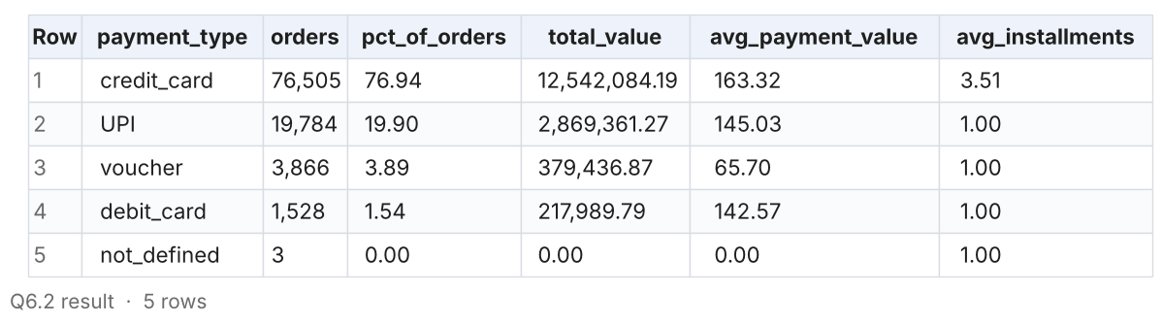
Insights
- Credit card is used in 76.9% of orders and carries R$12.5M of value (average R$163, 3.5 installments).
- UPI covers 19.9% of orders; vouchers 3.9% with the smallest average ticket (R$65.7).
Recommendations
- Offer a small UPI discount to shift volume from card (lower fees) on low-value baskets.

Q6.3 Number of orders by payment installments
Find the no. of orders placed on the basis of the payment installments that have been paid.
Query
SELECT
payment_installments,
COUNT(DISTINCT order_id) AS total_orders,
ROUND(100 * COUNT(DISTINCT order_id)
/ SUM(COUNT(DISTINCT order_id)) OVER (), 2) AS pct_of_orders,
ROUND(AVG(payment_value), 2) AS avg_payment_value
FROM target.payments
GROUP BY payment_installments
ORDER BY payment_installments;
Result (first 10 rows)
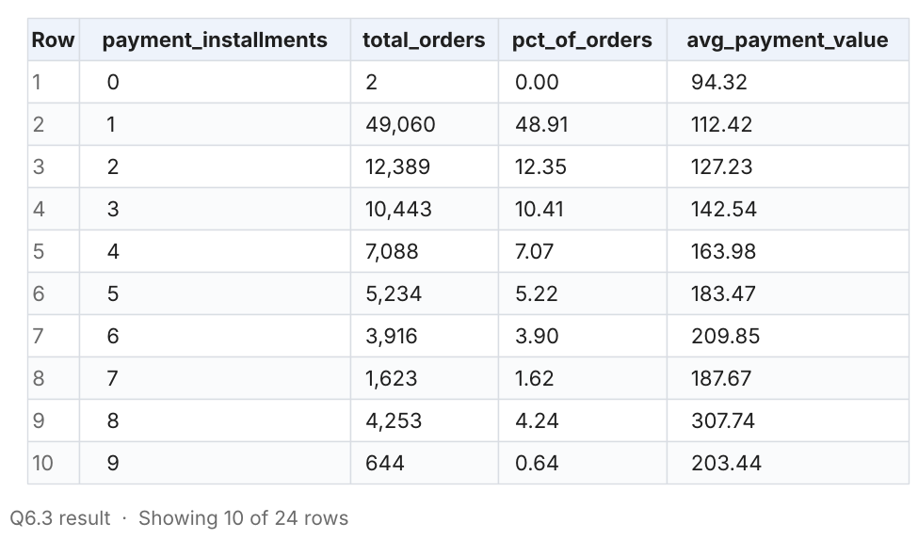
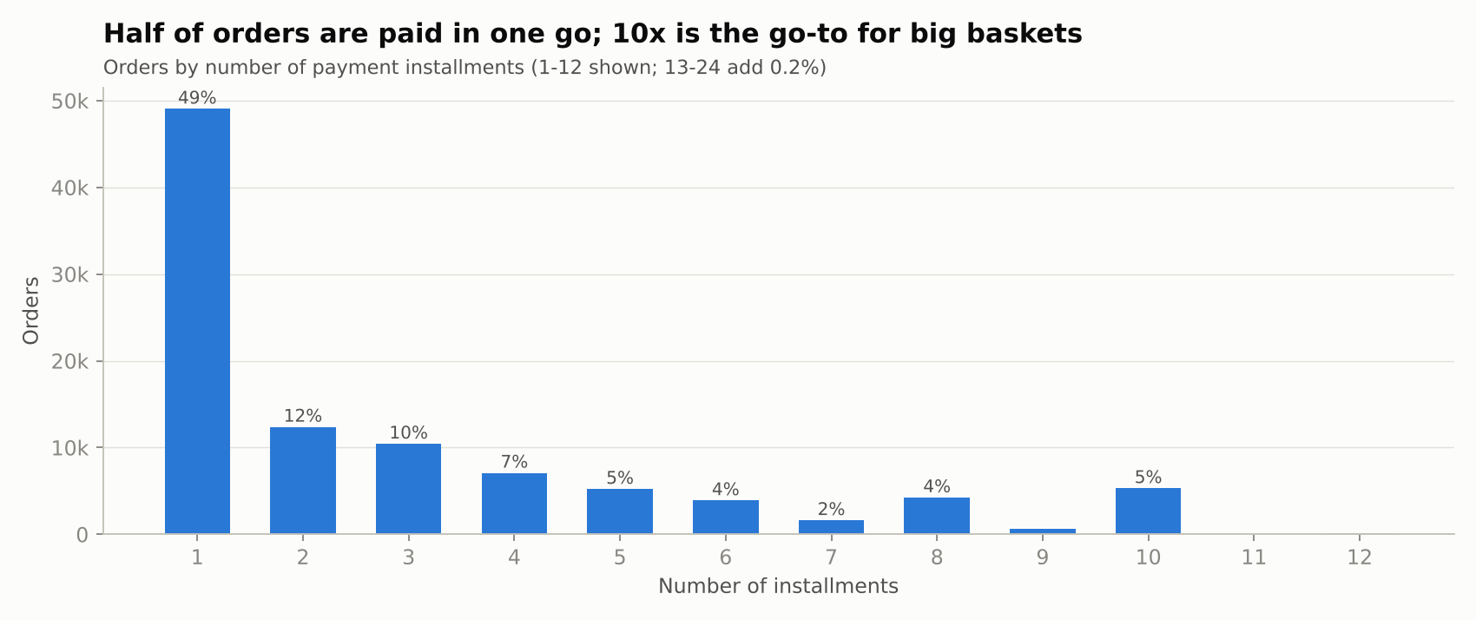
Insights
- 48.9% of orders are paid in a single installment, 12.4% in 2 and 10.4% in 3.
- The average payment rises with installments: R$112 for 1, R$308 for 8, R$415 for 10. Installments are what make expensive items affordable.
- 10 installments (5.3% of orders) is a clear spike, the usual 'interest-free 10x' offer in Brazil.
Recommendations
- Promote interest-free installments on high-ticket categories (watches, electronics, furniture) to grow basket size.

7. Bonus deep-dives (beyond the brief)

Q7.1 Does late delivery hurt review scores?
Bonus: average review score and share of 1-star reviews by how early or late the order arrived.
Query
WITH d AS (
SELECT
o.order_id,
TIMESTAMP_DIFF(o.order_delivered_customer_date, o.order_estimated_delivery_date, DAY) AS days_vs_estimate
FROM target.orders AS o
WHERE o.order_status = 'delivered'
AND o.order_delivered_customer_date IS NOT NULL
),
r AS (
SELECT order_id, AVG(review_score) AS review_score
FROM target.order_reviews
GROUP BY order_id
)
SELECT
CASE
WHEN d.days_vs_estimate <= -15 THEN '1. 15+ days early'
WHEN d.days_vs_estimate <= -8 THEN '2. 8-14 days early'
WHEN d.days_vs_estimate <= 0 THEN '3. 0-7 days early'
WHEN d.days_vs_estimate <= 3 THEN '4. 1-3 days late'
WHEN d.days_vs_estimate <= 7 THEN '5. 4-7 days late'
ELSE '6. 8+ days late'
END AS delivery_bucket,
COUNT(*) AS orders,
ROUND(AVG(r.review_score), 2) AS avg_review_score,
ROUND(100 * AVG(CASE WHEN r.review_score <= 1 THEN 1 ELSE 0 END), 2) AS pct_1_star,
ROUND(100 * AVG(CASE WHEN r.review_score >= 5 THEN 1 ELSE 0 END), 2) AS pct_5_star
FROM d
JOIN r ON d.order_id = r.order_id
GROUP BY delivery_bucket
ORDER BY delivery_bucket;
Result (first 10 rows)
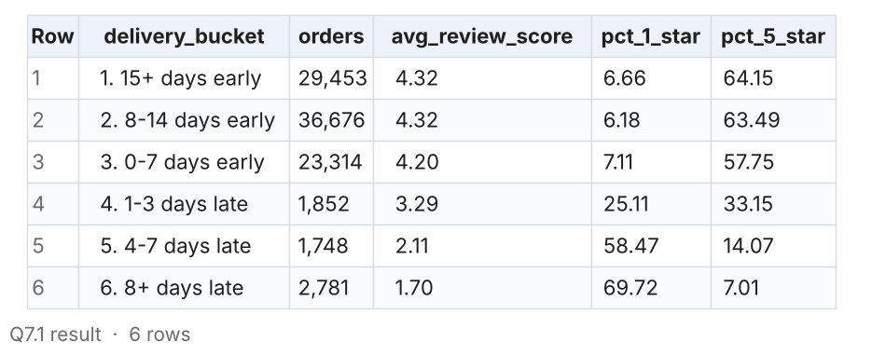
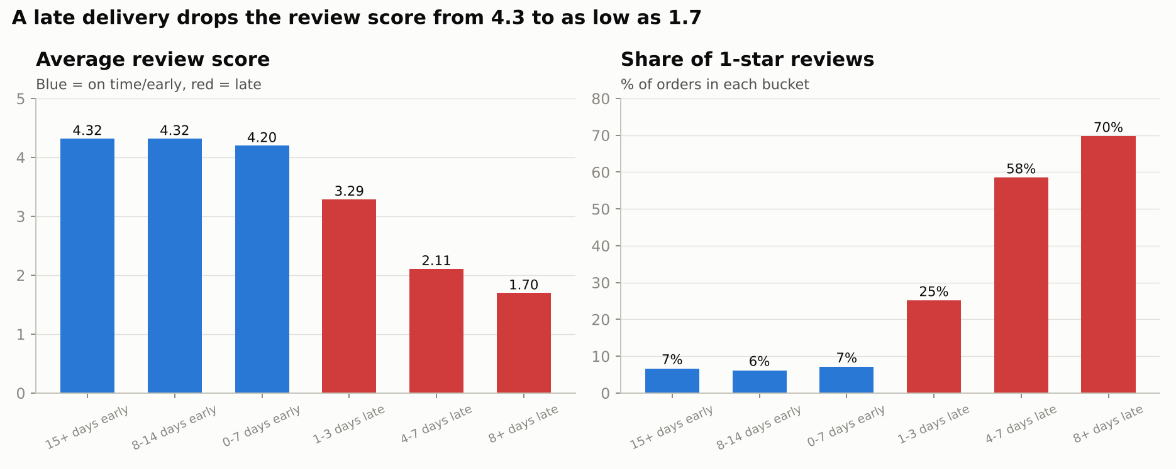
Insights
- Customers barely reward early delivery (4.32 stars at 15+ days early vs 4.20 at 0-7 days early), but they punish lateness hard: 3.29 at 1-3 days late, 2.11 at 4-7, 1.70 at 8+.
- 70% of orders delivered 8+ days late receive a 1-star review, vs 6-7% of on-time orders.
Recommendations
- Optimise for reliability (on-time %) rather than raw speed; it is the strongest single driver of ratings in the data.
- Proactively notify and compensate customers (voucher) when an order is predicted to be late.

Q7.2 Same-state vs cross-state fulfilment
Bonus: how much faster and cheaper is an order when the seller is in the customer's state?
Query
WITH item_level AS (
SELECT
o.order_id,
CASE WHEN s.seller_state = c.customer_state THEN 'Same state' ELSE 'Cross state' END AS route,
oi.freight_value,
oi.price,
TIMESTAMP_DIFF(o.order_delivered_customer_date, o.order_purchase_timestamp, DAY) AS actual_days,
CASE WHEN TIMESTAMP_DIFF(o.order_delivered_customer_date, o.order_estimated_delivery_date, DAY) > 0 THEN 1 ELSE 0 END AS is_late
FROM target.orders AS o
JOIN target.customers AS c ON o.customer_id = c.customer_id
JOIN target.order_items AS oi ON o.order_id = oi.order_id
JOIN target.sellers AS s ON oi.seller_id = s.seller_id
WHERE o.order_status = 'delivered'
AND o.order_delivered_customer_date IS NOT NULL
)
SELECT
route,
COUNT(*) AS items,
ROUND(100 * COUNT(*) / SUM(COUNT(*)) OVER (), 2) AS pct_of_items,
ROUND(AVG(actual_days), 2) AS avg_delivery_days,
ROUND(AVG(freight_value), 2) AS avg_freight,
ROUND(100 * SUM(freight_value) / SUM(price), 2) AS freight_pct_of_price,
ROUND(100 * AVG(is_late), 2) AS pct_late
FROM item_level
GROUP BY route
ORDER BY items DESC;
Result (first 10 rows)
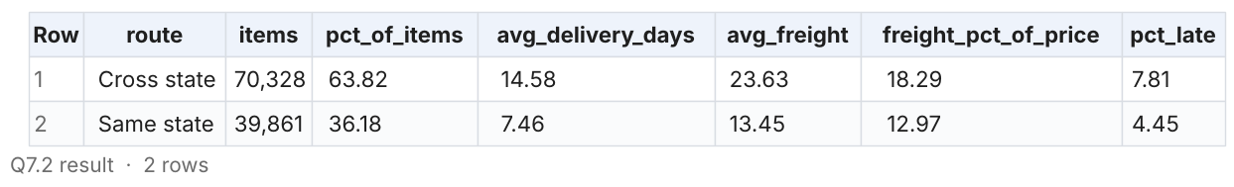
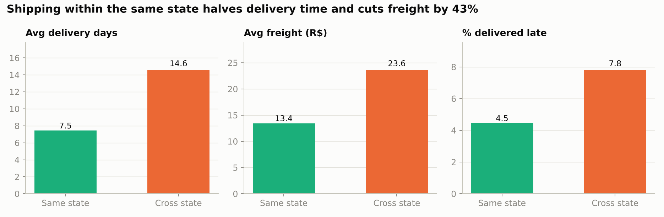
Insights
- 36.2% of items ship from a seller in the customer's own state.
- Those items arrive in 7.5 days vs 14.6 cross-state, pay R$13.45 vs R$23.63 freight (-43%), and are late 4.5% vs 7.8% of the time.
Recommendations
- Raising the same-state share is the single biggest logistics lever: recruit local sellers and prioritise local stock in search ranking.

Q7.3 Where are the sellers? Seller vs customer concentration
Bonus: share of sellers vs share of customers by state (supply-demand gap).
Query
WITH sellers_by_state AS (
SELECT seller_state AS state, COUNT(*) AS sellers
FROM target.sellers
GROUP BY seller_state
),
customers_by_state AS (
SELECT customer_state AS state, COUNT(DISTINCT customer_unique_id) AS customers
FROM target.customers
GROUP BY customer_state
)
SELECT
c.state,
c.customers,
COALESCE(s.sellers, 0) AS sellers,
ROUND(100 * c.customers / SUM(c.customers) OVER (), 2) AS pct_customers,
ROUND(100 * COALESCE(s.sellers, 0) / SUM(COALESCE(s.sellers, 0)) OVER (), 2) AS pct_sellers,
ROUND(c.customers / NULLIF(s.sellers, 0), 1) AS customers_per_seller
FROM customers_by_state AS c
LEFT JOIN sellers_by_state AS s ON c.state = s.state
ORDER BY c.customers DESC;
Result (first 10 rows)
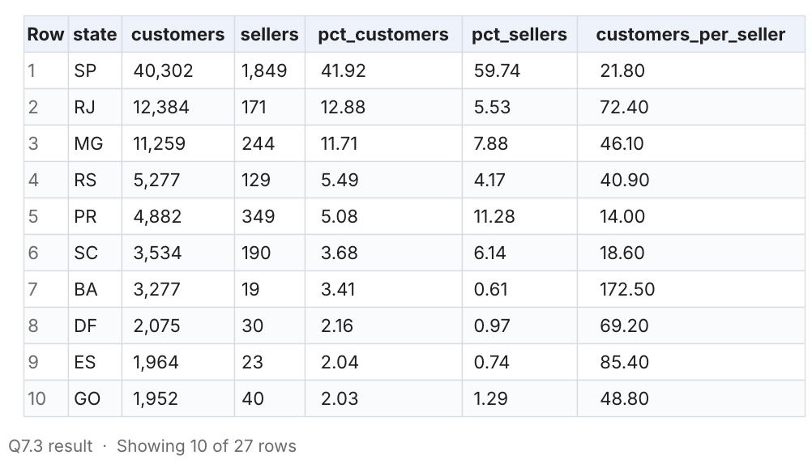
Insights
- 59.7% of sellers are in SP, which has 41.9% of customers.
- BA (172 customers per seller), PE (179) and RJ (72) are badly under-supplied, compared with 22 in SP.
Recommendations
- Run seller-acquisition drives in BA, PE, CE and RJ to localise supply for large, under-served markets.

Q7.4 Top product categories by revenue
Bonus: which categories drive revenue, and how satisfied are their buyers?
Query
WITH r AS (
SELECT order_id, AVG(review_score) AS review_score
FROM target.order_reviews
GROUP BY order_id
)
SELECT
COALESCE(p.product_category_name, 'unknown') AS category,
COUNT(DISTINCT oi.order_id) AS orders,
ROUND(SUM(oi.price), 2) AS revenue,
ROUND(100 * SUM(oi.price) / SUM(SUM(oi.price)) OVER (), 2) AS pct_revenue,
ROUND(AVG(oi.price), 2) AS avg_item_price,
ROUND(AVG(r.review_score), 2) AS avg_review_score
FROM target.order_items AS oi
LEFT JOIN target.products AS p ON oi.product_id = p.product_id
LEFT JOIN r ON oi.order_id = r.order_id
GROUP BY category
ORDER BY revenue DESC
LIMIT 15;
Result (first 10 rows)
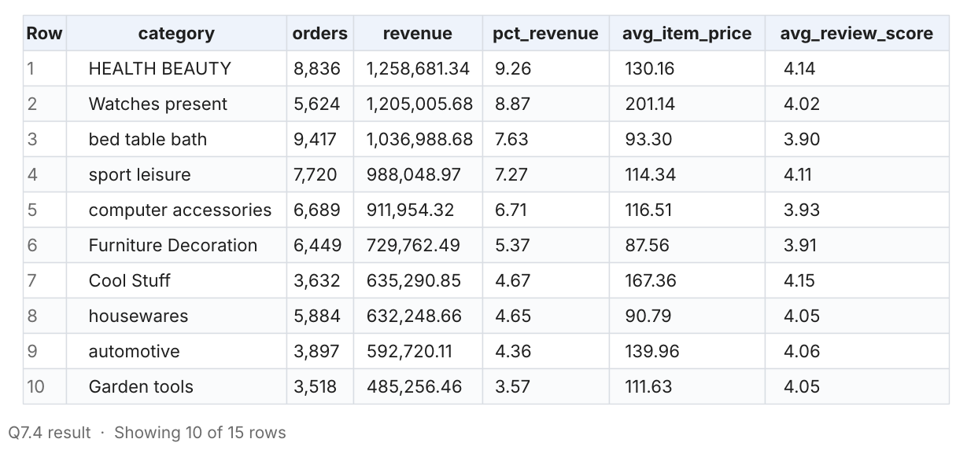
Insights
- Health & beauty (9.3% of revenue), watches & gifts (8.9%) and bed/table/bath (7.6%) lead revenue.
- Bed/table/bath, furniture/decor and computer accessories have the lowest ratings in the top 15 (3.90-3.93), pointing to quality or expectation gaps.
Recommendations
- Audit sellers and listings in low-rated, high-revenue categories (photos, size guides, packaging).

Q7.5 How many customers come back?
Bonus: distribution of customers by number of orders placed (uses customer_unique_id).
Query
WITH per_customer AS (
SELECT c.customer_unique_id, COUNT(DISTINCT o.order_id) AS orders
FROM target.orders AS o
JOIN target.customers AS c ON o.customer_id = c.customer_id
GROUP BY c.customer_unique_id
)
SELECT
CASE WHEN orders >= 4 THEN '4+' ELSE CAST(orders AS STRING) END AS orders_per_customer,
COUNT(*) AS customers,
ROUND(100 * COUNT(*) / SUM(COUNT(*)) OVER (), 2) AS pct_of_customers
FROM per_customer
GROUP BY orders_per_customer
ORDER BY orders_per_customer;
Result (first 10 rows)
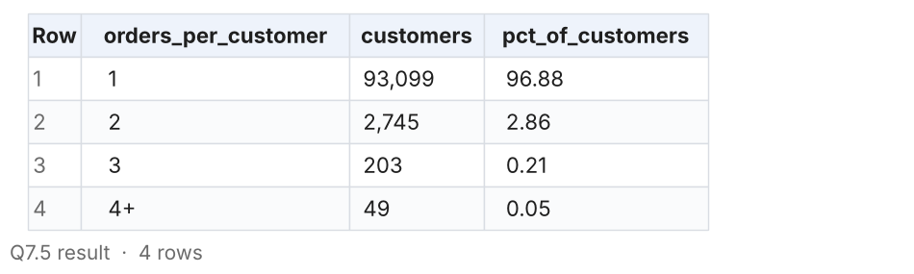
Insights
- 96.9% of customers ordered only once; 2.9% ordered twice and just 0.26% three or more times.
Recommendations
- Launch a retention programme (post-delivery coupons, loyalty points, personalised recommendations). Even a few points of repeat rate is worth thousands of orders.

Q7.6 Do peaks break the delivery network?
Bonus: monthly share of late deliveries and average delivery time (delivered orders, Jan 2017 - Aug 2018).
Query
SELECT
FORMAT_TIMESTAMP('%Y-%m', order_purchase_timestamp) AS order_month,
COUNT(*) AS delivered_orders,
ROUND(AVG(TIMESTAMP_DIFF(order_delivered_customer_date, order_purchase_timestamp, DAY)), 2) AS avg_delivery_days,
ROUND(100 * AVG(CASE WHEN TIMESTAMP_DIFF(order_delivered_customer_date, order_estimated_delivery_date, DAY) > 0
THEN 1 ELSE 0 END), 2) AS pct_late
FROM target.orders
WHERE order_status = 'delivered'
AND order_delivered_customer_date IS NOT NULL
AND order_purchase_timestamp >= '2017-01-01'
AND order_purchase_timestamp < '2018-09-01'
GROUP BY order_month
ORDER BY order_month;
Result (first 10 rows)
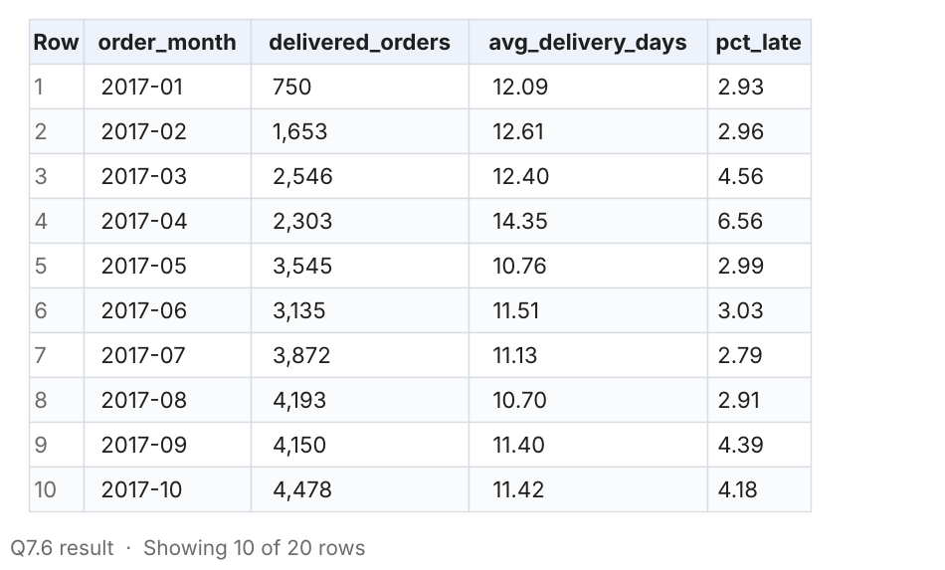
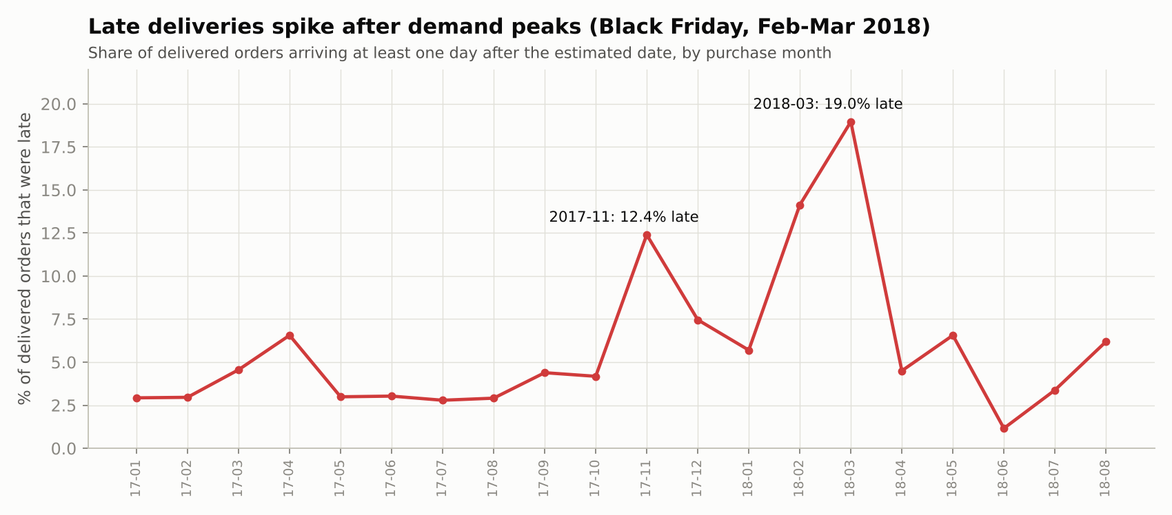
Insights
- Late deliveries are usually 3-5% of orders but jump after demand peaks: 12.4% in Nov 2017 and 14.1% / 19.0% in Feb / Mar 2018.
- Average delivery time improved to 7.7 days by Aug 2018, so the network can perform when it is not overloaded.
Recommendations
- Plan peak capacity (carriers, warehouse staff) 4-6 weeks ahead of Black Friday and the post-holiday surge, and widen estimates temporarily during peaks.

8. Actionable insights & recommendations
Ranked by expected impact on customer satisfaction and revenue. Each one is backed by the queries referenced above.
1. Fix reliability before speed
A late order loses 0.9-2.6 review stars; an early one gains almost nothing. Track on-time % as the headline logistics KPI, predict late orders and notify/compensate proactively. Start with RJ (13.5% late, second-largest market).
2. Recalibrate delivery estimates per state
Estimates are padded by 11 days on average and by up to 20 days in the North. Showing realistic dates at checkout improves conversion; adding buffer in AL and MA (20-24% late) protects reviews.
3. Localise supply: regional sellers and a North/North-East cross-dock
Same-state items arrive 2x faster with 43% lower freight. 60% of sellers sit in SP while BA, PE and RJ have 70-180 customers per seller. Recruit sellers there and pilot a cross-dock in the North-East.
4. Make freight affordable in remote states
Freight is 22-29% of the item price in the North/North-East vs 14% in SP. Bulk carrier contracts, subsidised shipping and free-shipping thresholds would unlock everyday purchases in markets that grew slowest.
5. Plan peak capacity ahead of Black Friday and Q1
Black Friday 2017 brought 5x a normal day's orders; late deliveries jumped to 12.4% that month and to 14-19% after the Q1 2018 surge. Pre-book carrier capacity and staff from October and temporarily widen estimates during peaks.
6. Grow basket size with installments and bundles
Average order value has been flat at ~R$160 for two years. 10x interest-free plans already carry R$415 tickets; promote them on high-ticket categories and add bundles and free-shipping thresholds.
7. Build retention
97% of customers buy once. A loyalty programme, post-delivery coupons and personalised recommendations target the cheapest growth available, especially now that acquisition-led growth has plateaued.
8. Time marketing to the afternoon and evening
38% of orders arrive 13:00-18:00 and 28% at night. Concentrate flash sales, push and paid-media budget in 13:00-22:00, and run maintenance at dawn.

Suggested KPIs to track
KPI | Current value | Target direction
On-time delivery rate | 93.2% (6.8% late) | ≥ 96%, and ≤ 8% in every month
Average delivery days | 12.1 (SP 8.3, RR 29.0) | ≤ 10 nationally; halve North gap
Estimate padding (est. - actual) | 11.0 days early on average | 3-5 days, per state
Same-state fulfilment share | 36.2% of items | ≥ 45%
Freight as % of price (North/NE) | 20-29% | ≤ 18%
Repeat-customer rate | 3.1% | ≥ 6%
Average review score | 4.09 | ≥ 4.3

Code, data, notebook and full results: https://github.com/dot-hpg/Projects/tree/main/target-brazil-sql-case-study

