Do-Dai, Jennifer

Professor Hester

CEPC 0911

August 7, 2020

**Abstract**

With concerns of a second wave of COVID-19, this paper aims to examine if there exists a correlation between the number of COVID-19 cases per capita at the time of reopening and number of daily cases per capita in the future (specifically at one week, two weeks, one month, and two months) in the United States. Currently, there are studies predicting how reopening would impact future daily cases using mathematical modeling and studies identifying the most vulnerable populations to take into account during reopening. However, there has yet to be a study that explores the reopening data that does exist. This study utilizes COVID-19 data collected from the Johns Hopkins University & Medicine Coronavirus Resource Center and the National Governors Association and local news sources to discover when each state first reopened. This study found that there appears to be an initial significant correlation between the number of cases at initial reopening and the number of daily cases at specific time points after the last state reopened.

1. **Introduction**

In the United States alone, the COVID-19 pandemic has affected the lives of over 4.7 million Americans and their families over the past five months. [1] As strict restrictions are lifted, and the economy is reopened, the fear of whether a second wave may occur due to reopenings occurring too early is at the forefront.

President Donald Trump’s plan for reopening America, titled “Opening Up America Again,” describes criteria for each state to reopen in a multi-phased approach. Before proceeding to his plan, states must have a decrease of influenza-like and COVID-like illnesses over a 14-day period, a decline in cases, a reduction in the positivity rate of tests over 14 days, enough testing, and lack of crisis in hospitals. [2] In phase one, the plan suggests that those who might be more susceptible to COVID-19 such as the elderly to continue staying at home, gatherings should be restricted to under ten people, and non-essential travel should be avoided. [2] While virtual work is recommended, some businesses and larger locations such as sit-down dining, movie theaters, places of worship, gyms, and sporting venues are allowed to reopen under strict social distancing in phase one of the plan. [2] This plan serves as a framework for governors, who have the ultimate authority in reopening their state. States have reopened as early as April 20 (Vermont) to as late as June 1 (Deleware), with some states even closing again and reversing the reopening process due to an uptake in cases. [3] In fact, as of August 2nd, 2020, 23 out of the 50 US states were marked “red” indicating an upward trend in cases on Johns Hopkins’ critical trends tracker. [4] This study aims to see if reopening “early”, or with a high number of daily cases per capita, has an impact on the daily cases in the future at different time intervals.

**Literature Review**

As of now, there is still much to learn and study about COVID-19. The search terms COVID-19 (and variations including coronavirus), United States, reopening (including reopening America, reopening the economy, reopen, reopening the country), and phased approach were used to filter down the large number of new publications while searching for articles and papers in Brown University’s library. Most of the current literature addresses predictions and suggestions for reopening (especially specific locations such as schools), rather than observing the actual effects of the reopening on the current status. One article looked into whether shutting down the economy was effective and if a reopening could occur safely, especially in relation to mobility restrictions. [5] They found that “lifting severe mobility restrictions and only retaining moderate mobility restrictions (at retail and transit locations), seems to effectively flatten the curve.” [5] Still, another paper used a Pontryagin Maximum Principle Approach to model the optimal post-pandemic reopening approach to guide policymakers. [6] Another article stressed the importance of non-pharmaceutical interventions and found mitigation strategies (slowing the spread while allowing the population to gain immunity which ultimately leads to a decrease in transmission) not to be viable and that instead, a suppression approach, which requires the strictest restrictions until the spread of the virus has been completely stopped is favorable despite the vast effects on the economy. [7] A May 2020 study suggests that governments should take into account that a certain 5% of the population is especially susceptible to COVID-19 due to certain risk factors and that the economy may be able to be reopened while still protecting the vulnerable population. [8] Similarly, another study found that being over 60 years old or having a history of diabetes or COPD serve as risk factors. [9] They concluded that these findings lend to the possibility of reopening for the general public while suggesting that the aforementioned vulnerable populations continue to remain at home. [9] While these papers suggest a wide array of possible approaches to reopening using modeling, they do not address the current COVID-19 data to measure the effectiveness of reopening. In this study, it is hypothesized that states with a higher number of daily cases per capita at reopening will also have a higher amount of daily cases a week after the last reopening, and this correlation will decrease over time.

1. **Methods**

This study utilizes COVID-19 data collected from the Johns Hopkins University & Medicine Coronavirus Resource Center. [3] Using information regarding policy actions from the National Governors Association along with various local news sources, dates of a first “phase one” reopening in each state were recorded. [10] In states that did not use a phased approach to reopening, the first date of reopening listed was used. Additionally, in some states, phase one consisted of maximum restrictions; in these cases, the date of entry in the first phase where restrictions were lifted was used. All states except South Dakota were able to be included in this analysis. South Dakota never shut down and businesses were never forced to close; therefore, while suggestions were enacted no reopening date could be recorded. Using the data from Johns Hopkins, the number of daily cases on the recorded reopening date was documented. This was repeated for the daily cases one week, two weeks, one month, and two months after June 1 (when the last state, Delaware, reopened).

Next, to account for differences in population across states, the data were standardized based on population. Population data was taken from the “Annual Estimates of the Resident Population for the United States, Regions, States, and Puerto Rico: April 1, 2010 to July 1, 2019 (NST-EST2019-01])” file for the 2019 population estimate on the United States Census Bureau Website and recorded to three significant figures per state to account for the margin of error. [11] The number of daily cases recorded earlier was then divided by the state population to find cases per million people.

The data collected was then plotted in a scatterplot, with the independent variable being the number of daily cases at the time of reopening per million. The dependent variables were the number of daily cases one week, two weeks, one month, and two months after reopening. To determine the strength of this correlation, a Pearson Coefficient was calculated (with assumptions homoscedasticity, two continuous variables, related pairs, absence of outliers, and linearity). A scatter plot was used to check the assumptions of homoscedasticity, linearity, and the absence of outliers. It was concluded that these assumptions were only met for the scatterplot comparing daily cases at reopening to the number of daily cases 1 week after reopening. The cor.test function in R was used to perform the correlation test, with a significance level of α = 0.05.

1. **Results**

The data collected supports the hypothesis that the positive correlation between daily cases per population at reopening and the number of daily cases one week after the last reopening, which will decrease over time. As seen in Figure 1 on the next page, there is a correlation (R2 = 0.516, Pearson’s correlation coefficient = 0.7181) between the daily cases at reopening and the number of daily cases one week after reopening. Since the p-value (p = 6.327e-09) is less than the significance level (α = 0.05), and 0 is not in the 95% confidence interval (0.5474043 to 0.8313925), the null hypothesis that there is no correlation between the number of cases at each state’s reopening and the number of COVID-19 cases one week after reopening can be rejected. This trend suggests that having a high amount of cases per capita at reopening will lead to a higher number of cases in the future; thus, states should be conservative when planning to reopen.

**Figure 1**

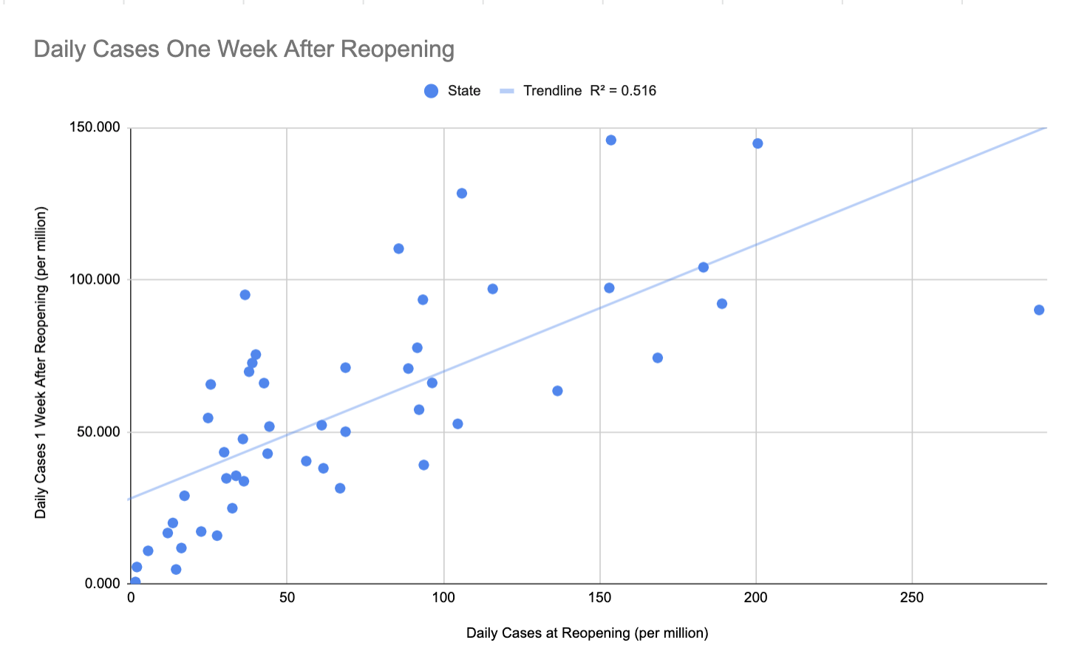

t = 7.0733, df = 47, p-value = 6.327e-09, 95 percent confidence interval: 0.5474043 0.8313925

pearson coefficient = 0.7180697

This scatterplot shows the correlation between the number of daily cases at the date of the last US state reopening (June 1st), to the number of daily cases one week after in each state. There is an observable strong positive correlation between the two variables.

Figure 2 on the next page shows that there does not appear to be any significant correlation between the number of daily cases at reopening and the number of cases two weeks, one month, and two months after reopening.

**Figure 2**

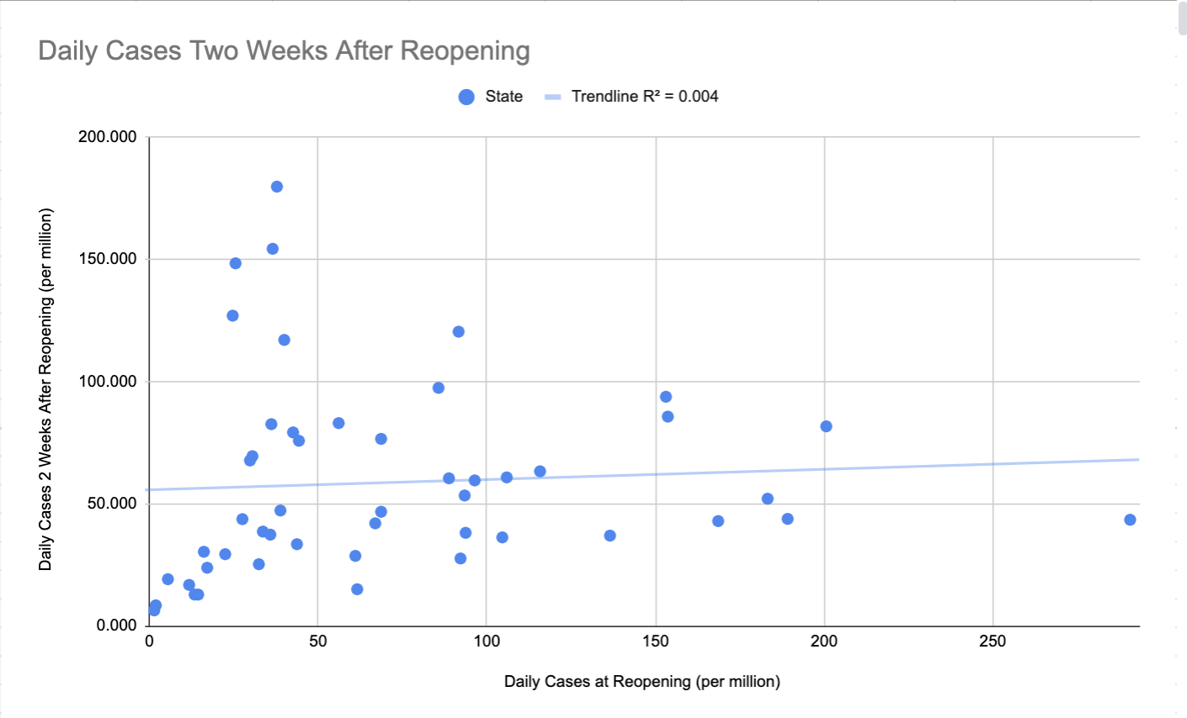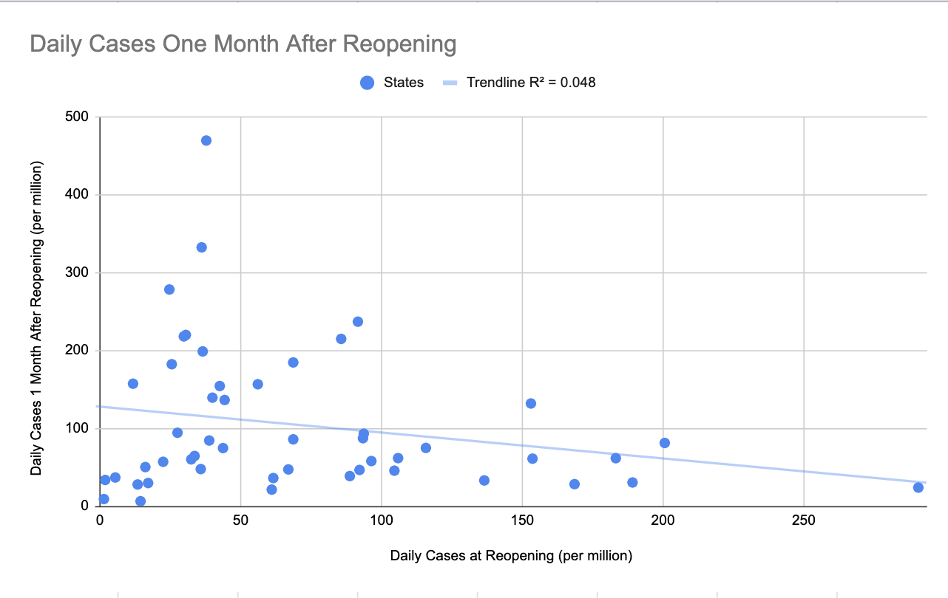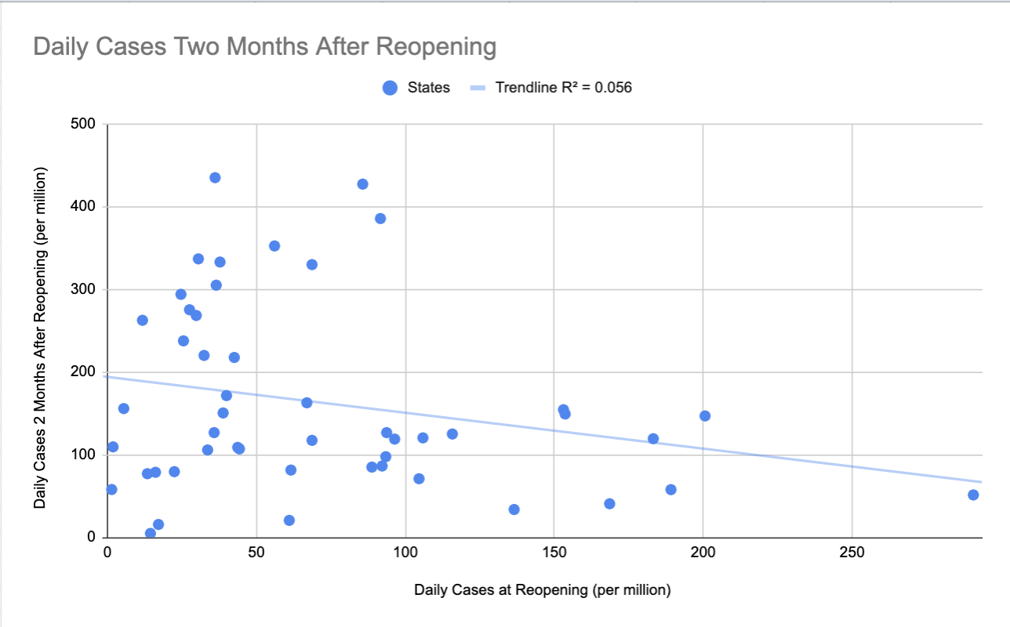

These scatterplots show the correlation between the number of daily cases on the date of the last reopening (June 1st) to the number of daily cases two weeks, one month, and two months, respectively, after reopening. While the first graph displaying two weeks appears to have a slight positive correlation and the second two graphs seem to have a small negative correlation, the conditions for calculating Pearson correlation were not met. Therefore, no association between the two variables after two weeks can be concluded.

**Conclusions**

The results imply that other variables should be taken into account over time and supports the idea that a multi-phase approach to reopening is optimal. Having a low daily case number at reopening can lead to a low number of daily cases later on. However, having a small number of cases at reopening would not lead to optimal recovery if the public immediately stops mitigation efforts such as social distancing and the usage of masks after restrictions are lifted, as indicated by the lack of correlation after a significant period. The results suggest that continuing some limitations and encouraging the public not to socialize immediately, especially if they present symptoms, is advisable.

While this study can conclude that there is a correlation between the number of daily cases at the time of reopening per capita on the number of daily cases per capita a week later and that this effect is discontinued over time, there is still much more to be determined. For example, each state’s first step into reopening varied - some took a much smaller step than others. Furthermore, in some states, only low-populated towns reopened at the scheduled reopening date while the most populated city would not begin reopening until weeks after. Additionally, the impact of other confounding variables that would impact the number of daily cases over time other than just the original reopening date, such as how strictly enforced a mask or social distancing order was enforced, or if a mask mandate was even implemented were not considered. Future studies with more time and data availability could perhaps address these fallbacks and possibly include other countries instead of just focusing on the United States’ actions.

1. **References**

**Footnotes**

1. “Coronavirus Disease 2019 (COVID-19) Situation Report - 199.” *World Health Organization*, 6 Aug. 2020, www.who.int/emergencies/diseases/novel-coronavirus-2019/

situation-reports.

1. “Opening Up America Again.” *The White House*, The United States Government, www.whitehouse.gov/openingamerica/.
2. “Impact of Opening and Closing Decisions by State.” *Johns Hopkins Coronavirus Resource Center*, www.coronavirus.jhu.edu/data/state-timeline/new-confirmed-cases/

alabama.

1. “America Is Reopening. But Have We Flattened the Curve?” *Johns Hopkins Coronavirus Resource Center*, coronavirus.jhu.edu/data/new-cases-50-states.
2. Agarwal, Anish, et al. “Two Burning Questions on COVID-19: Did Shutting down the Economy Help? Can We (Partially) Reopen the Economy without Risking the Second Wave?” *ArXiv:2005.00072 [Cs, Econ, Stat]*, May 2020. *arXiv.org*, http://arxiv.org/abs/2005.00072.
3. Mansilla, R. “How to Manage the Post Pandemic Opening? A Pontryagin Maximum Principle Approach.” *Applied Economics and Finance*, vol. 7, no. 4, June 2020, p. 121. *DOI.org (Crossref)*, doi:10.11114/aef.v7i4.4912.
4. Ferguson, N., et al. *Report 9: Impact of Non-Pharmaceutical Interventions (NPIs) to Reduce COVID19 Mortality and Healthcare Demand*. Imperial College London, 16 Mar. 2020. *DOI.org (Datacite)*, doi:10.25561/77482.
5. Preskorn, Sheldon H. “The 5% of the Population at High Risk for Severe COVID-19 Infection Is Identifiable and Needs to Be Taken Into Account When Reopening the Economy:” *Journal of Psychiatric Practice*, vol. 26, no. 3, May 2020, pp. 219–27. *DOI.org (Crossref)*, doi:10.1097/PRA.0000000000000475.
6. Smith, Aaron A., et al. “Identifying Patients at Greatest Risk of Mortality Due to COVID-19: A New England Perspective.” *Western Journal of Emergency Medicine*, vol. 21, no. 4, 2020, p. 6. *Zotero*, doi:10.5811/westjem.2020.6.47957.
7. “Coronavirus State Actions.” *National Governors Association*, www.nga.org/coronavirus-state-actions-all/.
8. “2019 National and State Population Estimates.” *The United States Census Bureau*, 30 Dec. 2019, www.census.gov/newsroom/press-kits/2019/national-state-estimates.html.

**Bibliography**

“2019 National and State Population Estimates.” *The United States Census Bureau*, 30 Dec.

2019, [www.census.gov/newsroom/press-kits/2019/national-state-estimates.html](http://www.census.gov/newsroom/press-kits/2019/national-state-estimates.html).

Agarwal, Anish, et al. “Two Burning Questions on COVID-19: Did Shutting down the Economy

Help? Can We (Partially) Reopen the Economy without Risking the Second Wave?”

*ArXiv:2005.00072 [Cs, Econ, Stat]*, May 2020. *arXiv.org*, http://arxiv.org/abs/

2005.00072.

“America Is Reopening. But Have We Flattened the Curve?” *Johns Hopkins Coronavirus*

*Resource Center*, coronavirus.jhu.edu/data/new-cases-50-states.

“Coronavirus Disease 2019 (COVID-19) Situation Report - 199.” *World Health Organization*, 6

Aug. 2020, www.who.int/emergencies/diseases/novel-coronavirus-2019/situation-reports.

“Coronavirus State Actions.” *National Governors Association*, www.nga.org/coronavirus

-state-actions-all/.

DeWitt, Ethan. “A Guide to 'Stay at Home 2.0'.” *Concord Monitor*, Concord Monitor, 2 May

2020, www.concordmonitor.com/reopening-explainer-34166307.

Ferguson, N., et al. *Report 9: Impact of Non-Pharmaceutical Interventions (NPIs) to Reduce*

*COVID19 Mortality and Healthcare Demand*. Imperial College London, 16 Mar. 2020.

*DOI.org (Datacite)*, doi:10.25561/77482.

“Governor Abbott Announces Phase One To Open Texas, Establishes Statewide Minimum

Standard Health Protocols.” *Office of the Governor | Greg Abbott*,

gov.texas.gov/news/post/governor-abbott-announces-phase-one-to-open-texas-establishes

-statewide-minimum-standard-health-protocols.

Hammel, Paul, and Martha Stoddard. “Ricketts Easing Nebraska Coronavirus Restrictions as of

May 4; Limited Reopening of Economy.” *Omaha.com*, 25 Apr. 2020, omaha.com/news/

state_and_regional/ricketts-easing-nebraska-coronavirus-restrictions-as-of-may-4-limited-reopening-of-economy/article_2abb7fce-5ca5-54d8-8ab0-1b968ff2aa1a.html.

“How Minnesota's Stay Safe Plan Changes from Phase 1 to Phase 4.” *FOX 9 Minneapolis-St.*

*Paul*, FOX 9 Minneapolis-St. Paul, 21 May 2020, www.fox9.com/news/how-minnesotas-

stay-safe-plan-changes-from-phase-1-to-phase-4.

“Impact of Opening and Closing Decisions by State.” *Johns Hopkins Coronavirus Resource*

*Center*, www.coronavirus.jhu.edu/data/state-timeline/new-confirmed-cases/

alabama.

Mansilla, R. “How to Manage the Post Pandemic Opening? A Pontryagin Maximum Principle

Approach.” *Applied Economics and Finance*, vol. 7, no. 4, June 2020, p. 121. *DOI.org*

*(Crossref)*, doi:10.11114/aef.v7i4.4912.

Nunes, Rachel. “What To Know About Phase One Of RI's Reopening.” *Cranston, RI Patch*,

Patch, 8 May 2020, patch.com/rhode-island/cranston/what-know-phase-one-ris-

reopening.

“Ohio's Phase 1: Here's What Reopens across the State Today.” *WLWT*, WLWT, 1 May 2020,

www.wlwt.com/article/ohios-phase-1-heres-what-reopens-across-the-state-today/

32343758#.

“Opening Up America Again.” *The White House*, The United States Government,

www.whitehouse.gov/openingamerica/.

Phillips, Riley. “Week 1 Phase of WV Reopening Plan Begins.” *WVNS*, WVNS, 30 Apr. 2020,

www.wvnstv.com/top-stories/week-1-phase-of-wv-reopening-plan-begins/.

Preskorn, Sheldon H. “The 5% of the Population at High Risk for Severe COVID-19 Infection Is

Identifiable and Needs to Be Taken Into Account When Reopening the Economy:”

*Journal of Psychiatric Practice*, vol. 26, no. 3, May 2020, pp. 219–27. *DOI.org*

*(Crossref)*, doi:10.1097/PRA.0000000000000475.

Schulz, Dana. “New York Reopening Guide: What's Open and What You Need to Know.” *6sqft*,

24 June 2020, www.6sqft.com/new-york-reopening-four-phases/.

“Sisolak: Nevada Will Enter Phase 1 of Reopening Plan May 9.” *KLAS*, KLAS, 8 May 2020,

www.8newsnow.com/news/local-news/phase-1-reopening-of-nevada-to-occur-

before-may-15/.

Smith, Aaron A., et al. “Identifying Patients at Greatest Risk of Mortality Due to COVID-19: A

New England Perspective.” *Western Journal of Emergency Medicine*, vol. 21, no. 4,

2020, p. 6. *Zotero*, doi:10.5811/westjem.2020.6.47957.

“South Dakota's Back to Normal Plan.” *COVID-19 in South Dakota*, covid.sd.gov/docs/COVID_

SDPlan_BackToNormal.pdf.

“Stage 2 - What's Opened, What's Closed.” *Back on Track Indiana*, backontrack.in.gov/files/

BackOnTrack-IN_WhatsOpen-Closed-stage2.pdf.

Swaby, Natalie. “Phase 1 of Reopening Washington's Economy Starts Tuesday.” *king5.Com*, 5

May 2020, www.king5.com/article/news/health/coronavirus/phase-1-of-inslees-safe-

start-washington-starts-tuesday-what-that-means-for-reopening-the-states-economy/281-484b90f0-4b1b-4393-b4c1-b6edc4efe8b3.

Thompson, Jeff. “Dissecting Phase 1 of Gov. Brown's Reopening Plan for Oregon.” *Kgw.com*, 12

May 2020, www.kgw.com/article/news/health/coronavirus/phase-1-of-gov-browns-

reopening-plan-for-oregon-explained/283-9de5a98f-1773-44bf-9840-ed97550c6880.

Turner, Jeff, et al. “COVID-19: US State Policy Report – June 10, 2020.” *Capital Thinking*, 31

July 2020, www.capitalthinkingblog.com/2020/06/covid-19-us-state-policy-report-

june-10-2020/.

“Utah to Move into 1st Phase of Reopening Friday.” *ABC4 Utah*, ABC4 Utah, 14 May 2020,

www.abc4.com/coronavirus/governor-herbert-might-release-the-state-from-stay-safe-

stay-home-directive-as-early-as-end-of-next-week/.

“Vermont: State-by-State COVID-19 Guidance.” *Husch Blackwell*, www.huschblackwell.com/

vermont-state-by-state-covid-19-guidance.

“Virginia Department of Health.” *Go to Virginia Department of Health.*, www.vdh.virginia.gov/  
 coronavirus/frequently-asked-questions/phase-1-safer-at-home/.

Weeks, Andrew. “Burgum Urges Caution with Businesses Set to Reopen May 1.” *The Dickinson*

*Press*, The Dickinson Press, 30 Apr. 2020, www.thedickinsonpress.com/newsmd/

coronavirus/6466745-Burgum-urges-caution-with-businesses-set-to-reopen-May-1.

“When and How Is New Jersey Lifting Restrictions? What Does a Responsible and Strategic

Restart of New Jersey's Economy Look like?: FAQ.” *When and How Is New Jersey Lifting Restrictions? What Does a Responsible and Strategic Restart of New Jersey's Economy Look like? | FAQ*, covid19.nj.gov/faqs/nj-information/reopening-guidance/

when-and-how-is-new-jersey-lifting-restrictions-what-does-a-responsible-and-strategic-restart-of-new-jerseys-economy-look-like.

Willetts, Mitchell, and Charles Duncan. “Coronavirus Live Updates: Here's What to Know in

South Carolina on April 21.” *Thestate*, The State, www.thestate.com/news/coronavirus/

article242162106.html.