Arrim Jung

Professor Hester

CEPC 0911

August 8, 2020

**Hurricane Intensity, Infectious Disease, and Climate Change**

**Abstract**

Question:

Are there associations between average temperature, hurricane frequency, and the number of infectious disease cases in the United States between 1990 and 2020?

Key Terms: Hurricane, Disease, Climate Change, United States, 1990-2020

As the intensity of hurricanes have been increasing, so has the level of population displacement, exposure to bacteria, and bursts of vectors. This has led to an increase of cases of infectious diseases throughout the United States. A factor in the rising intensity of hurricanes has been speculated to be climate change and rising temperatures. After a correlation test between hurricane frequency and average annual temperature (℉), the result showed weak positive trends and a weak positive correlation. Therefore, there seems to be an association between higher temperatures and the number of hurricanes that occured. From previous studies, hurricanes were shown to increase in intensity before landfall with the warming of the ocean surface. Hurricanes with high categorization have become more and more common as well as disease outbreaks that come with them. Future developments with hurricane and disease surveillance systems and quick medical actions for the sanitation, shelterization, and vaccination of victims is essential in decreasing the amount of harm inflicted by hurricanes.

1. **Introduction**

Over the years, hurricane forecasting has become more and more difficult. This is because it is becoming more common for hurricanes to increase in intensity as they grow nearer to shore and cause greater damage than anticipated. One example is Hurricane Patricia in 2015 Texas, which accelerated from a Category 1 hurricane to a Category 5 with an increased intensification of 103-kt rather than the 30-kt change predicted by the National Hurricane Center [1]. Studies have been conducted to find out exactly why this has become more prevalent. Now, it is believed that upper ocean thermal variability plays an important factor in hurricane intensity and change in hurricane intensity [1]. Thermodynamic disequilibrium between the ocean surface and the atmosphere due to the greenhouse effect causes large releases of enthalpy from high temperature tropical ocean surfaces. The releases are absorbed into tropical storms or hurricanes [2]. Just the increase of 1-2 degrees Centigrade above 27℃ (80.6℉) of the ocean surface was shown to cause an exponential increase in intensity [3]. Furthermore, the number of people affected by tropical cyclones globally tripled from 1970 to 2010. [1] Therefore, there is belief that human-induced climate change with ocean warming has been playing a major part in this problem.

In the United States, it was observed that disease cases were on the rise after natural disasters, especially hurricanes. Such examples are Tropical Storm Allison in 2001 and Hurricane Katrina in 2005 which had diarrheal illness arise subsequently. Evacuees of Hurricane Katrina, in particular, were confirmed of norovirus, salmonella, toxigenic V.cholerae, and nontoxigenic V. cholerae. The reason is because many diseases are linked with certain aspects of a hurricane, such as heavy rains and flooding: the lack of safe water and the increased contact with contaminated water can transmit Hepatitis A and E through fecal-oral routes, rodent urine in water spread Leptospirosis through human mucous membranes, and new mosquito-breeding sites in flood water increase prevalence of Malaria and Dengue [4]. Another factor in post-disaster illnesses is Nontuberculous Mycobacteria (NTM). NTM is commonly found in soil and is spread in various locations after a natural disaster, such as a hurricane, when ecosystems are disturbed and water-soil aerosolization comes in contact with more people. As the number of natural disasters is on the rise globally, the number of NTM related illnesses are also on the rise globally. According to the NOAA (National Oceanic and Atmospheric Administration), the number of natural disasters with over a billion dollars in damage are becoming more frequent within the United States. With the increasing severity and frequency of the disasters, there is an even greater risk of infectious disease spread [5].

Another applicable example is, Hurricane Katrina, a Category 5 hurricane which hit the area around Louisiana in 2005 and had an especially detrimental impact on the city of New Orleans. According to the Louisiana Department of Health and the New Orleans Public Health Response Team, there was an epidemic-scaled number of infectious disease cases around 12 days after Hurricane Katrina: 299 with non-infectious rashes, 188 with respiratory infections, 142 with vomiting, 98 with fevers, 87 dehydrationed, 55 with watery diarrhea, and 17 with vibrio infections. Vector-borne illness became problematic as well, with mosquitoes and ticks thriving in post-disaster environments [3]. The impacts of contaminated water, spoiled food, and destruction of shelter touched hundreds of people. However, though hurricanes do have direct impacts regarding diseases, researchers have noticed that the number of disease cases associated with disaster response in the area was much greater than merely those caused by contact with contamination from the hurricane.

Diseases that appear after natural disasters are usually indigenous, occurring as trauma 1 to 2 days after the disaster or from transmissions through water, food, or air 1 to 4 weeks after the disaster [5]. Power outages from storms shut off refrigerators and can cause many foodborne illnesses, such as diarrhea. However, disease transmission happens mostly through population displacement and crowding in shelters of those who were turned homeless from the storm. Measles, Neisseria Meningitidis, and acute respiratory infections are spread easily when large numbers of people live crowded together [4]. Hurricanes that caused more population displacement were recorded to cause much greater health issues than those that did not. Therefore, as we witness the increasing intensity of hurricanes over time, people are assuming disease cases will increase with it. Though there may be confounding variables within the studies, evidence over the years have shown that the rising temperatures from human induced climate change have an effect on the intensity of hurricanes which has an effect on disaster response and disease transmission.

1. **Solutions**

Still, today, forecasting hurricanes and infectious disease outbreaks is very difficult and not developed very far. However, many methods are being tested to aid people in their disaster response. There have been efforts to predict infectious diseases and health risks from data on observations of the environment and climate change: specifically observing how meteorological factors affect pathogens, vectors, and even their hosts [6]. Advances in remote satellite imaging for parameters of the ocean, vegetation, and soil is also promising for future predictions of disease outbreaks with data on environmental changes. As these methods advance, notification of the residents will become faster and people can take better emergency actions. Earlier notification of potential outbreaks can also help healthcare providers and officials to provide people with clean water, sanitation, shelter, and medical services. Established surveillance systems of precursor signals of disease and quick medical response with appropriate vaccination coverage will prevent a significant amount of harm from outbreaks. Studying situations and patterns in areas before a hurricane and after a hurricane will provide valuable information for health and government officials to have a prepared and efficient healthcare service response to decrease the number of outbreaks after hurricanes [4].

1. **Literature Review**

Many studies in the past have looked into relationships between natural disasters, hurricanes, and diseases. A previous study in the journal, “Virulence: Volume 6” by Anthony J. McMichael, focusses on “extreme weather events and infectious disease outbreaks” worldwide. The study looks into the increasing frequency of El Niño Southern Oscillation (ENSO) events and climate change’s impact on the number and severity of extreme weather events. Large disease outbreaks and current ones are mentioned as references to give future solutions and preventative measures [3]. In the “BAMS: Volume 98, Issue 3,” Kerry Emanuel focuses on explaining the factors that go into hurricane forecasting and the difficulty of forecasting due to ocean surface temperature warming. With analysis of historical data with the span of decades, the study explains intensification of hurricanes before landfall and predicts complications to come [1]. An IEEE study [6] and NCBI (PMC) [4] study both focus on virus and disease epidemics affected by weather and suggest forecasting or preventative solutions.

Though previous studies have covered information on the effect of climate change on the number of natural disasters and diseases, our particular study is narrowed down to effects in the United States from 1990 to 2020. Referring to studies in the past, we will observe the relationships between the factors with data from EM-DAT [11] and NOAA [7, 8, 9]. EM-DAT is an international disaster database that keeps records of all major disasters and their effects on the area. NOAA is the National Oceanic and Atmospheric Administration has been an agency within the U.S. Department of Commerce for 50 years. Both provided detailed data for this study.

1. **Methods**

We looked for data on all the hurricanes and disease epidemics that hit the United States between 1990 and 2020. We also looked for data on the average monthly temperatures between 1990 and 2020.

**Data Cleaning**

With EMDAT, we collected data under “natural disasters,” “the Americas,” and “1990 to 2020” and pulled out only information on hurricanes/tropical storms, extreme temperatures (cold wave, heat wave, droughts), and diseases (bacterial and viral). I also only left data about the United States. With NOAA, I collected the mean monthly temperatures for every year from 1990 to 2020.

Missing Value Treatment: Missing values are quite common in real-world data. The data from EMDAT had missing hurricane numbers, so additional information was supplemented with NOAA through its NHC, WPC, and National Weather Service. To further clean the data, the data set was run through R’s na.omit function.

**Tests/Methods**

Null Hypothesis - There is no association between hurricane frequency and average monthly temperature in the United States between 1990 and 2020.

Alternative Hypothesis - There is an association between hurricane frequency and average monthly temperature in the United States between 1990 and 2020.

We used R to check for a correlation (cor.test function to the scatterplot (ggplot2) of data) between hurricane frequency and average monthly temperature in the United States between 1990 and 2020 with Pearson’s product-moment correlation method and found the p-value of the probability that the correlation is not equal to 0 (Alternative Hypothesis). We also found the confidence interval with 95% significance.

**Variables**

Outcome variable: hurricane frequency in the United States from 1990 to 2020

Predictors: the average annual temperature in the United States from 1990 to 2020

**Assumptions**

The required assumptions for a Pearson correlation method are that both variables are approximately normally distributed, there are no significant outliers, each variable is continuous, the two variables have a linear relationship, the observations are paired observations, and the data needs to be homoscedastic (points need to lie equally on both sides of the line of best fit). Our data is not normally distributed, but we will continue with the test with caution. There are no significant outliers, each variable is reasonable to consider continuous, the two variables have a linear relationship, the observations are paired, and the data is approximately homoscedastic.

1. **Results**

Figure 1

The scatter plot displays the wind speed (knots) of the hurricanes in the United States from 1990 to 2020.

Hurricane Wind Speed in the US (1990-2020)

* 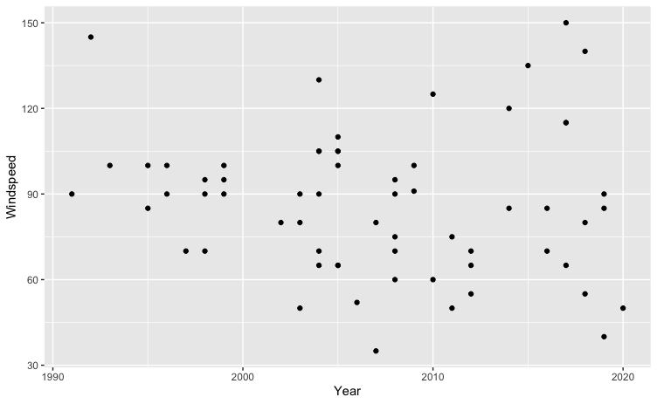

data: x = Year, y = Wind Speed (knots)

t = -0.86085, df = 61, p-value = 0.3927

alternative hypothesis: true correlation is not equal to 0

95 percent confidence interval: [-0.3478796, 0.1420637]

sample estimates: cor = -0.1095576

Since our p-value, 0.3927, is greater than our significance level of 0.05, we fail to reject Ho and do not have convincing evidence that the true correlation between years (1990-2020) and hurricane wind speed is not equal to 0. However, we can see an increase in variance of wind speed over time.

Figure 2

The scatter plot displays hurricane frequency in the United States from 1990 to 2020.

Hurricane Frequency in the US (1990-2020)

* 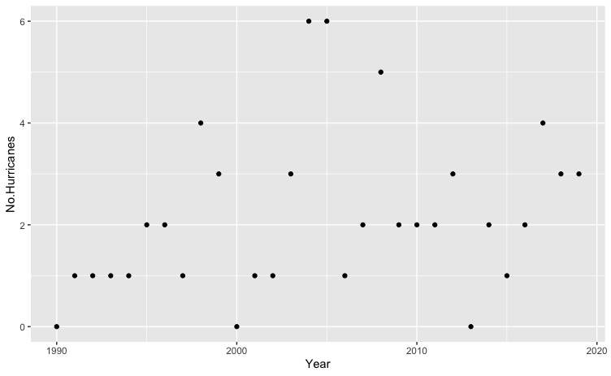

data: x= Years (1990-2020), y = Number of Hurricanes

t = 1.6494, df = 28, p-value = 0.1102

alternative hypothesis: true correlation is not equal to 0

95 percent confidence interval: [-0.07020343, 0.59415985]

sample estimates: cor = 0.2975925

Since our p-value, 0.1102, is greater than our significance level of 0.05, we fail to reject Ho and do not have convincing evidence that the true correlation between years (1990-2020) and hurricane frequency is not equal to 0.

Figure 3

The scatter plot displays average annual temperature (℉) in the United States from 1990 to 2020.

Average Annual Temperature (℉) in the US (1990-2020)

* 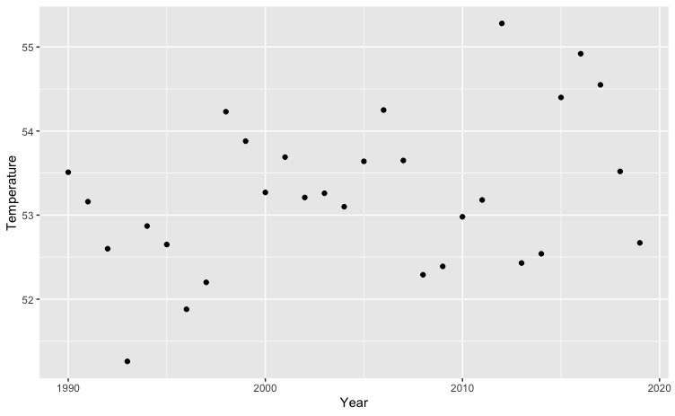

data: x = Year, y = Annual Average Temperature (℉)

t = 2.0535, df = 28, p-value = 0.04947

alternative hypothesis: true correlation is not equal to 0

95 percent confidence interval: [0.001749106, 0.638797476]

sample estimates: cor = 0.3617903

Since our p-value, 0.04947, is less than our significance level of 0.05, we reject Ho and have convincing evidence that the true correlation between years (1990-2020) and annual average temperature is not equal to 0.

Figure 4

The scatter plot compares average annual temperatures (℉) and hurricane frequency in the United States from 1990 to 2020.

Average Annual Temperatures (℉) vs. Hurricane Frequency in the US (1990-2020)

* 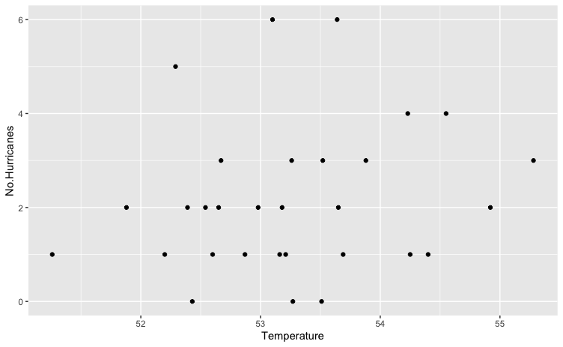

data: x = Temperature (℉), y = Number of Hurricanes

t = 0.98018, df = 28, p-value = 0.3354

alternative hypothesis: true correlation is not equal to 0

95 percent confidence interval: [-0.1906413, 0.5090065]

sample estimates: cor = 0.1821375

Since our p-value, 0.3354, is greater than our significance level of 0.05, we fail to reject Ho and do not have convincing evidence that the true correlation between average annual temperatures (℉) and hurricane frequency is not equal to 0.

1. **Conclusion**

The correlation for the frequency of hurricanes in the United States over time was not statistically significant while the correlation for the annual average temperature (℉) in the United States over time was statistically significant. The correlation between the annual average temperature (℉) and frequency of hurricanes was not statistically significant. From this data, we can conclude that hurricane frequency and temperature do not have a correlation.

Though this test did not support the hypothesis, previous studies do have evidence for it. From previous studies, we know that hurricanes are formed in warm, humid weather, so the rise in temperatures and climate change is likely to have an effect on hurricane frequency. We also know that hurricanes cause poor water quality, wounds, issues with vector control, population displacement, and difficult access to medical services. After hurricanes, there are high risks of gastrointestinal infectious diseases, wound infections, respiratory infectious diseases, and skin infections.

Some drawbacks of this research were data availability. If monthly data for the diseases from 1990 to 2020 were available, a line chart could have been made that accurately shows whether a hurricane is followed by a spike in a particular disease. General trends of all diseases are negative (downward) due to advances in medicine and vaccinations, so monthly data would be necessary. We could not carry out tests regarding the diseases due to this issue, however, in future studies, a test for correlation between diseases (norovirus, tuberculosis, hepatitis, measles, cholera, meningococcal disease, rubella, and shigellosis) and hurricanes may help show certain proof of how long after a hurricane there are peaks in disease cases and by how much.

If a future study has a longer duration of research, getting temperatures of a certain region during the three months around the event of a hurricane, a stronger correlation between hurricanes and temperature may be shown. The correlation is well known, but due to broad data collection, the result of our test was not significant.

1. **References**
2. ———. “Will Global Warming Make Hurricane Forecasting More Difficult?” *Bulletin of the American Meteorological Society* 98, no. 3 (March 1, 2017): 495–501. <https://doi.org/10.1175/BAMS-D-16-0134.1>.
3. Emanuel, Kerry. “Self-Stratification of Tropical Cyclone Outflow. Part II: Implications for Storm Intensification.” *Journal of the Atmospheric Sciences* 69, no. 3 (March 1, 2012): 988–96. <https://doi.org/10.1175/JAS-D-11-0177.1>.
4. McMichael, Anthony J. “Extreme Weather Events and Infectious Disease Outbreaks.” *Virulence* 6, no. 6 (August 18, 2015): 543–47. <https://doi.org/10.4161/21505594.2014.975022>.
5. Watson, John T., Michelle Gayer, and Maire A. Connolly. “Epidemics after Natural Disasters.” *Emerging Infectious Diseases* 13, no. 1 (January 2007): 1–5. https://doi.org/10.3201/eid1301.060779.

Accessed August 8, 2020. <https://public.emdat.be/data>

1. Honda, Jennifer R., Jon N. Bernhard, and Edward D. Chan. “Natural Disasters and Nontuberculous Mycobacteria: A Recipe for Increased Disease?” *Chest* 147, no. 2 (February 1, 2015): 304–8. <https://doi.org/10.1378/chest.14-0974>.
2. Makkar, Garima. “Real-Time Disease Forecasting Using Climatic Factors: Supervised Analytical Methodology.” In *2018 IEEE Punecon*, 1–5, 2018. <https://doi.org/10.1109/PUNECON.2018.8745369>.
3. “Climate at a Glance | National Centers for Environmental Information (NCEI).” Accessed August 8, 2020. <https://www.ncdc.noaa.gov/cag/divisional/mapping>.
4. “HURDAT Re-Analysis.” Accessed August 8, 2020. <https://www.aoml.noaa.gov/hrd/hurdat/All_U.S._Hurricanes.html>.
5. “Saffir-Simpson Hurricane Wind Scale.” Accessed August 8, 2020. <https://www.nhc.noaa.gov/aboutsshws.php>.
6. “Data Finder - Health, United States - Products,” March 31, 2020. <https://www.cdc.gov/nchs/hus/contents2018.htm>.
7. “EM-DAT | The International Disasters Database.” Accessed August 11, 2020. <https://www.emdat.be/>.
8. “Iniki1.Pdf.” Accessed August 8, 2020. <https://www.weather.gov/media/publications/assessments/iniki1.pdf>.
9. “AL012018_Alberto.pdf.” Accessed August 8, 2020. <https://www.nhc.noaa.gov/data/tcr/AL012018_Alberto.pdf>.
10. “Marilyn.Pdf.” Accessed August 8, 2020. <https://www.weather.gov/media/publications/assessments/marilyn.pdf>.
11. “AL031998_Charley.Pdf.” Accessed August 8, 2020. <https://www.nhc.noaa.gov/data/tcr/AL031998_Charley.pdf>.
12. “AL061998_Frances.Pdf.” Accessed August 8, 2020. <https://www.nhc.noaa.gov/data/tcr/AL061998_Frances.pdf>.
13. “AL051999_Dennis.Pdf.” Accessed August 8, 2020. <https://www.nhc.noaa.gov/data/tcr/AL051999_Dennis.pdf>.
14. “AL162000_Leslie.Pdf.” Accessed August 8, 2020. <https://www.nhc.noaa.gov/data/tcr/AL162000_Leslie.pdf>.
15. “AL012001_Allison.Pdf.” Accessed August 8, 2020. <https://www.nhc.noaa.gov/data/tcr/AL012001_Allison.pdf>.
16. “Tropical Storm Isidore - September 20-29, 2002.” Accessed August 8, 2020. <https://www.wpc.ncep.noaa.gov/tropical/rain/isidore2002.html>.
17. “AL032003_Bill.Pdf.” Accessed August 8, 2020. <https://www.nhc.noaa.gov/data/tcr/AL032003_Bill.pdf>.
18. “Tropical Storm Ernesto, September 1, 2006.” Accessed August 8, 2020. <https://www.weather.gov/mhx/Sep012006EventReview>.
19. “AL052007_Erin.Pdf.” Accessed August 8, 2020. <https://www.nhc.noaa.gov/data/tcr/AL052007_Erin.pdf>
20. “AL062008_Fay.Pdf.” Accessed August 8, 2020. <https://www.nhc.noaa.gov/data/tcr/AL062008_Fay.pdf>
21. “Hurricanes and Tropical Storms - September 2008 | State of the Climate | National Centers for Environmental Information (NCEI).” Accessed August 8, 2020. <https://www.ncdc.noaa.gov/sotc/tropical-cyclones/200809>.
22. “Hurricane Ida - November 10, 2009.” Accessed August 8, 2020. <https://www.weather.gov/mob/ida>.
23. “Hurricane BILL.” Accessed August 8, 2020. <https://www.nhc.noaa.gov/archive/2009/al03/al032009.public.025.shtml>.
24. “AL072010_Earl.Pdf.” Accessed August 8, 2020. <https://www.nhc.noaa.gov/data/tcr/AL072010_Earl.pdf>.
25. “AL102010_Hermine.Pdf.” Accessed August 8, 2020. <https://www.nhc.noaa.gov/data/tcr/AL102010_Hermine.pdf>.
26. “AL132011_Lee.Pdf.” Accessed August 8, 2020. <https://www.nhc.noaa.gov/data/tcr/AL132011_Lee.pdf>.
27. “AL042012_Debby.Pdf.” Accessed August 8, 2020. <https://www.nhc.noaa.gov/data/tcr/AL042012_Debby.pdf>.
28. “EP092014_Iselle.Pdf.” Accessed August 8, 2020. <https://www.nhc.noaa.gov/data/tcr/EP092014_Iselle.pdf>
29. “AL112015_Joaquin.Pdf.” Accessed August 8, 2020. <https://www.nhc.noaa.gov/data/tcr/AL112015_Joaquin.pdf>
30. “AL152017_Maria.Pdf.” Accessed August 8, 2020. <https://www.nhc.noaa.gov/data/tcr/AL152017_Maria.pdf>.
31. “AL012018_Alberto.Pdf.” Accessed August 8, 2020. <https://www.nhc.noaa.gov/data/tcr/AL012018_Alberto.pdf>“Tropical Storm Cristobal - June 2020.” Accessed August 8, 2020. https://www.weather.gov/mob/Cristobal.

Appendix

Table 1. Monthly temperature from 1990 to 2020 in the United States

Source : <https://www.ncdc.noaa.gov/cag/divisional/mapping>

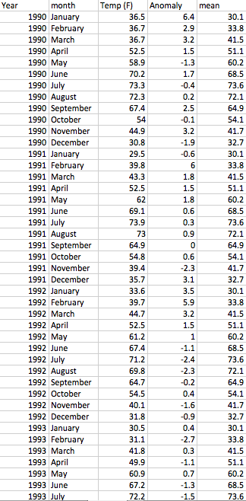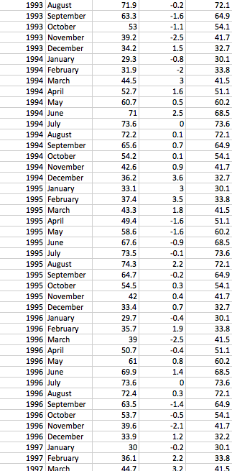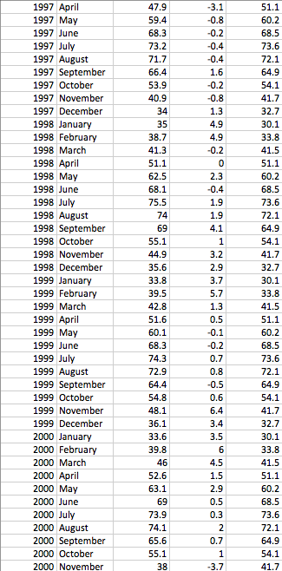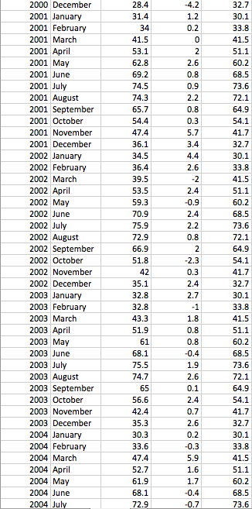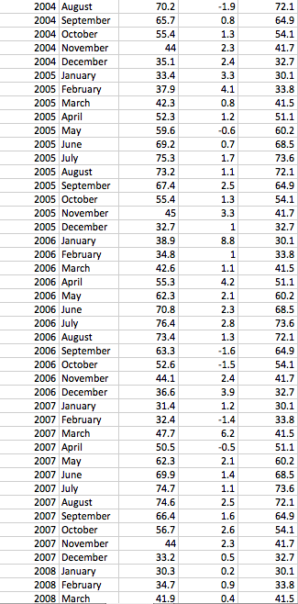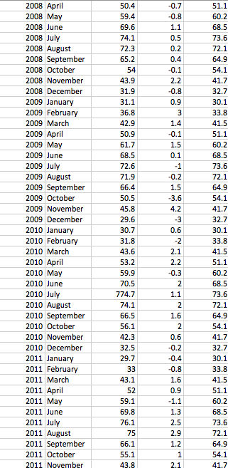

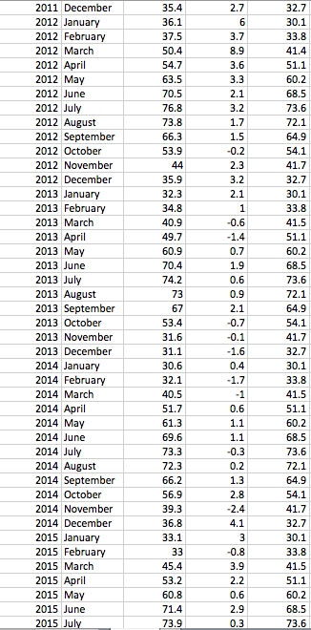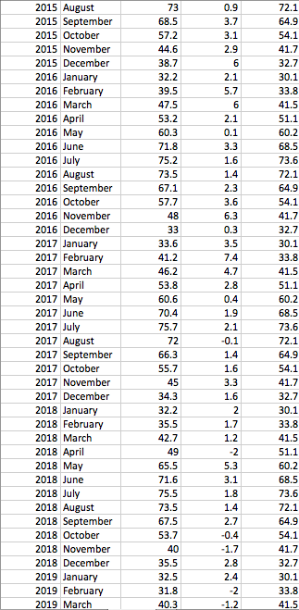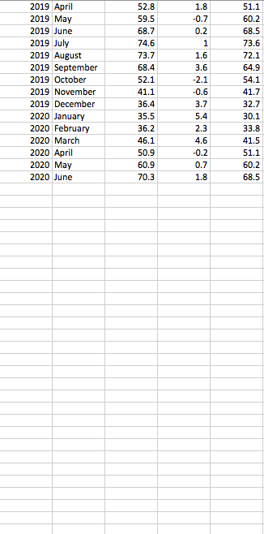

Table 2. Annual disease cases from 1990 to 2017 in the United States

Source : https://www.cdc.gov/nchs/hus/contents2018.htm#Table_010.

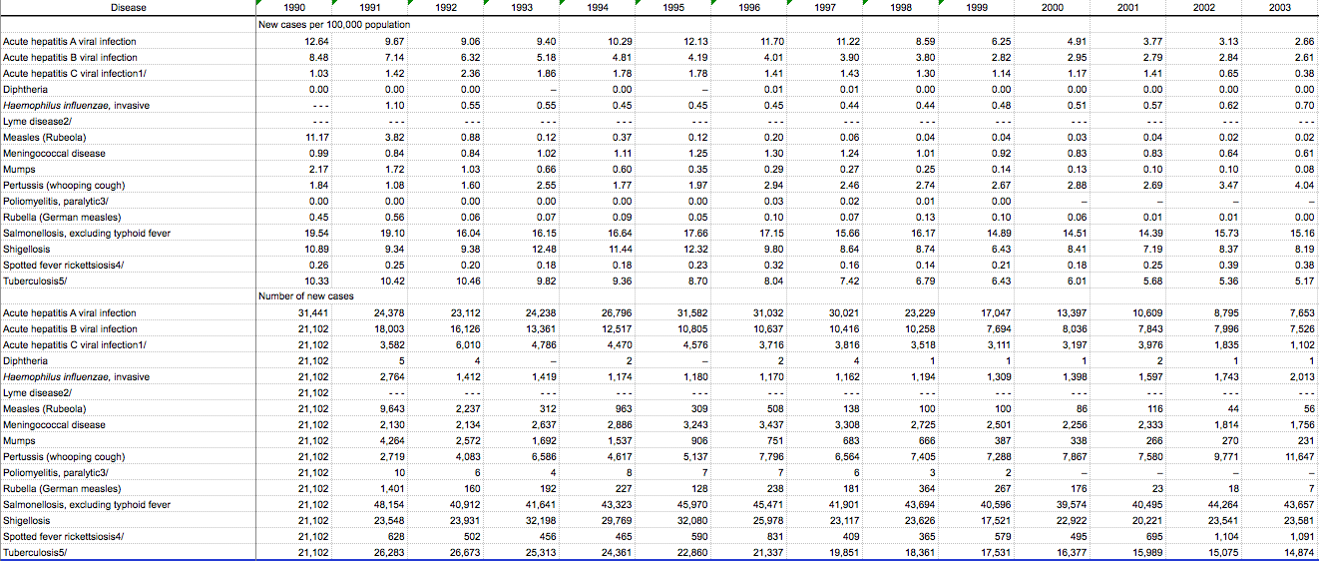

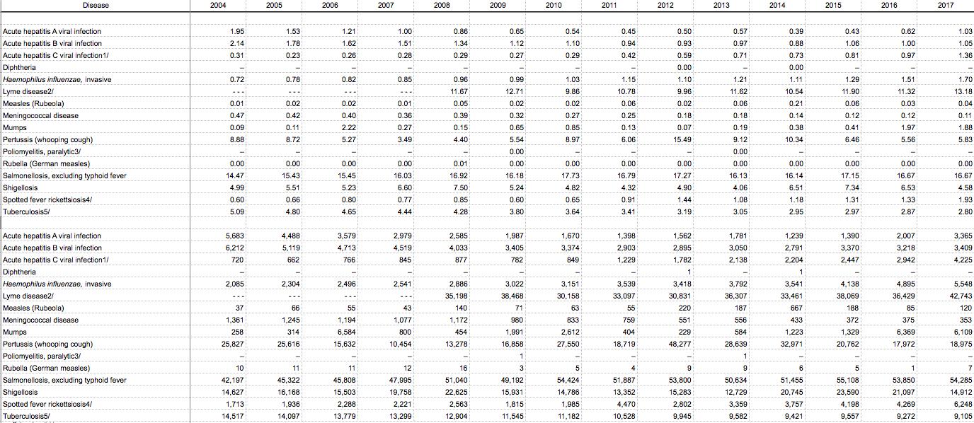

Table 3. Hurricanes in the United States from 1990 to 2020

Source : www.emdat.be / <https://www.aoml.noaa.gov/hrd/hurdat/All_U.S._Hurricanes.html>

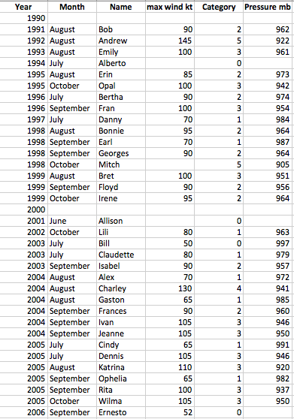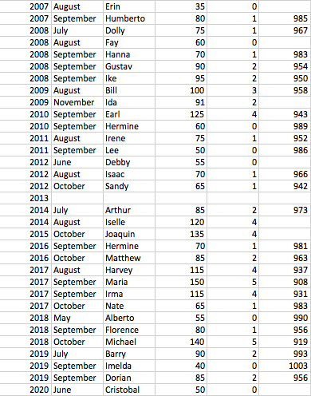

Table 4. Natural Disasters in the United States from 1990 to 2020

Source : EM-DAT, CRED / UCLouvain, Brussels, Belgium / www.emdat.be (D. Guha-Sapir)

Version : 2020-07-15

