
Cinema Ticket Reservation and Revenue Management System (CTRMS)
Phase 1: Proposal & Analysis
By (Group 102):
Noureddin Ghazal (202511039)
Yousef Kitaneh (202311043)
Ahmad Jahaf (202310390)
Instructor:
Dr. Khaled Al-Hashash
This project was submitted in Partial Fulfilment of the Requirements for the Microcomputer Systems and Assembly Language Course (1301224)
Applied Science Private University
Faculty of Information Technology
Amman - Jordan
November 2026
Table of Contents
Chapter One Project Proposal 1
1.1 Project Title 2
1.2 Problem Statement 2
1.3 Scope 2
1.4 Objectives 3
1.5 Success Criteria 3
Chapter Two Problem Analysis 5
2.1 Input Analysis 6
2.2 Output Analysis 7
2.3 Process Flow 9
2.3.1 Main program flow 9
2.3.2 Book New Ticket 10
2.3.3 Cancel Booking 13
2.3.4 Display Ticket 14
2.3.5 Display Seating Map 15
2.3.6 Booking and Revenue Statistics 16
2.3.7 Note on the repeated structures 17
2.4 Constraints 18
2.4.1 Memory 18
2.4.2 Registers against memory 18
2.4.3 Capacity 18
2.4.4 Integer arithmetic 19
2.4.5 Value ranges 19
2.4.6 Platform and course constraints 19
2.5 Assumptions 20
Chapter Three Requirements Specification 21
3.1 Functional Requirements 22
3.2 Non-Functional Requirements 22
3.3 CLO Mapping 23

List of Tables
Success criteria and how each is checked 4
Input analysis 6
Output analysis 8
Memory used by the main data structures 18
Functional requirements 22
Non-functional requirements 22

List of Figures
Main program flow: menu loop and dispatch to the six operations. 9
Book New Ticket, part 1: customer name and booking ID. 10
Book New Ticket, part 2: movie code, seat number, ticket category. 11
Book New Ticket, part 3: pricing and commit to the booking record. 12
Cancel Booking: linear search over 60 slots, then clear the active flag and free the seat. 13
Display Ticket: linear search over 60 slots, then print the matching record. 14
Display Seating Map: print each of the 20 seats as [O] or [X], then the totals. 15
Statistics, part 1: scan the 60 record slots and accumulate per-movie and per-category counts. 16
Statistics, part 2: derive overall totals, average, occupancy and print the report. 17

Chapter One
Project Proposal

1.1 Project Title
Cinema Ticket Reservation and Revenue Management System (CTRMS), built in x86 Assembly Language (MASM) with the Irvine32 library.

1.2 Problem Statement
A small cinema runs three halls. Each hall shows one movie (Movie A, B or C) and has 20 seats. If bookings are taken by hand, staff can sell the same seat twice, apply the wrong discount, lose track of cancellations, and only work out revenue and occupancy by hand at the end of the day.
CTRMS solves this with a console program. It takes and validates bookings, stops a seat from being reserved twice, works out the price from the movie and ticket category, handles cancellations, and prints tickets, seating maps and revenue statistics on demand. It keeps up to 60 active bookings in memory as fixed-size records.

1.3 Scope
Included
- A main menu with six options: Book New Ticket, Cancel Booking, Display Ticket, Display Seating Map, Booking & Revenue Statistics and Exit.
- Booking entry with validation:
  - Customer name: 1–20 characters, not empty.
  - Booking ID: unique, six digits (100000–999999).
  - Movie code: 1–3.
  - Seat: 1–20 and not already taken.
  - Ticket category: 1 = Adult, 2 = Student, 3 = Child.
- Ticket pricing with integer math only. The base prices are A = 8, B = 7 and C = 6 JOD. Students get 1 JOD off and children get 2 JOD off.
- Cancelling a booking by its ID, which marks the record inactive and frees its seat.
- A formatted ticket for any active booking, looked up by its ID.
- A seating map for each movie. It shows [O] for an available seat and [X] for a reserved one, followed by the reserved count and occupancy %.
- A statistics report with:
  - Bookings, revenue and occupancy for each movie.
  - Total bookings, overall revenue and the average ticket price.
  - The most and least booked movies.
  - An asterisk histogram of the ticket categories.
- Specific error messages for bad input, a duplicate ID, full capacity (60 bookings or 20 seats) and an already reserved seat.
Excluded
- Saving data to files or a database. All data is lost when the program exits.
- More than three movies, more than 20 seats per hall, or show times and dates.
- Online payment, receipts and printer output.
- Changing a booking. To change one, cancel it and book again.
- User accounts, logins and access roles.
- Fractional prices or floating-point math.
- A graphical interface. The program is console only.

1.4 Objectives
- Correct booking: accept a valid booking for any of the 3 movies and store it in a fixed-size record. The program must hold 60 active bookings at once and reject the 61st with a capacity message.
- No double booking: reject 100% of attempts to book a seat that is already reserved, or to reuse an active booking ID.
- Correct pricing: calculate the final price as the base price minus the category discount. All 9 movie and category combinations must give the expected values, from 8 JOD (Movie A, Adult) down to 4 JOD (Movie C, Child).
- Working cancellation: cancelling an active ID marks its record inactive and frees its seat, so the same seat can be booked again in the same run.
- Accurate reporting: produce the statistics report from the active records only. The counts, revenue, integer average, occupancy % and histogram must match a hand calculation of the same test data.
- Course outcomes: cover all of the required techniques, which are:
  - At least 8 procedures (12 or more is the target).
  - Two loop styles: LOOP and a JMP-based while loop.
  - IF, IF-ELSE and nested conditionals.
  - All of the required data types: strings, doublewords, bytes, characters and arrays.

1.5 Success Criteria
The project will be judged complete when all of the criteria in Table 1 hold.
Table 1: Success criteria and how each is checked
# | Criterion | How it is checked
1 | The program assembles and runs in MASM with Irvine32 without errors | Build and run on a lab machine
2 | All 6 menu options work, and an invalid choice shows an error and the menu again | Manual test of each option, plus the inputs 0, 7 and letters
3 | Every validation rule rejects bad input with its own error message | A test case per rule: empty or 21-character name, ID 99999 or 1000000, duplicate ID, movie 4, seat 0 or 21, reserved seat, category 4
4 | Prices are correct for all 9 movie and category combinations | A table of expected prices compared with the printed tickets
5 | Cancelled seats appear as [O] again and are left out of the statistics | Book, cancel, then check the seating map and the report
6 | Statistics match a hand calculation | Book the sample set (16 bookings, 101 JOD) and compare with the report format in the brief
7 | Capacity limits hold | Fill a hall to 20 seats, then try to fill the system past 60 bookings
8 | Output matches the formats in the brief | Compare the menu, ticket, seating map and statistics screens with section 2.3 of the brief
9 | The required techniques are present | A code review checklist of procedures, loop styles, conditionals and data types

Chapter Two
Problem Analysis

2.1 Input Analysis
The system reads input only from the console keyboard. There is no file input, no network input and no stored configuration. Nine distinct inputs exist across the six menu options.
Table 2: Input analysis
Input | Where entered | Data type and size | Valid range | Validation rule | Error response
Menu choice | Main menu | Unsigned byte | 1 to 6 | Must be an integer from 1 to 6 | Show Invalid choice and redisplay the menu
Customer name | Book New Ticket | ASCII string, 1 byte per character, stored in a 21-byte field (20 characters plus a null terminator) | 1–20 characters | Must not be empty and must not exceed 20 characters | Show a name error and re-prompt
Booking ID (new) | Book New Ticket | Unsigned doubleword | 100000–999999 | Must be exactly six digits in range, and must not match the ID of any active record | Out of range, re-prompt; duplicate, ERROR: Booking ID already exists!
Movie code | Book New Ticket | Unsigned byte | 1 to 3 | 1 = Movie A, 2 = Movie B, 3 = Movie C | Out of range, show a movie code error and re-prompt; full movie, ERROR: Movie is full! and return to the menu
Seat number | Book New Ticket | Unsigned byte | 1 to 20 | Must be in range and currently free in the seat map of the chosen movie | Out of range, re-prompt; taken, ERROR: Seat already reserved!
Ticket category | Book New Ticket | Unsigned byte | 1 to 3 | 1 = Adult, 2 = Student, 3 = Child | Show a category error and re-prompt
Booking ID (cancel) | Cancel Booking | Unsigned doubleword | 100000–999999 | Must match an active record | ERROR: Booking ID not found!
Booking ID (display) | Display Ticket | Unsigned doubleword | 100000–999999 | Must match an active record | ERROR: Booking ID not found!
Movie code (seat map) | Display Seating Map | Unsigned byte | 1 to 3 | 1 to 3 only | Show a movie code error and re-prompt

Why these data sizes
The sizes above follow directly from the integer storage sizes studied in Chapter One of the course:
- A byte stores an unsigned value from 0 to 255. This covers the menu choice (1 to 6), the movie code (1 to 3), the seat number (1 to 20), the ticket category (1 to 3) and the active flag (0 or 1) with a large margin, so a byte is the correct and cheapest choice for all five.
- A word stores an unsigned value from 0 to 65,535. This is too small for a booking ID, because the largest legal ID, 999,999, is far beyond 65,535 and would overflow the field.
- A doubleword stores an unsigned value from 0 to 4,294,967,295, which holds any six-digit booking ID comfortably. Prices and revenue totals are also kept in doublewords so that all arithmetic operands share one width.
- The customer name is stored as ASCII characters, one byte per character, as covered in the character-storage topic of Chapter One of the course. The name field is 21 bytes: 20 character codes plus one byte for the terminating null that marks the end of the string.
Stored inputs and transient inputs
The width of an input is decided by the range of values it must hold, and nothing else. A value is never given a wider field just because it is typed at the keyboard.
Five of the nine inputs are stored: the customer name, the booking ID, the movie code, the seat number and the ticket category are written into a booking record and must stay there for the life of the booking. Their widths add up to the record size, so every byte counts.
The remaining inputs are transient. The menu choice, the booking ID used to cancel or to display a ticket and the movie code used to pick a seating map are read, checked, acted upon and then discarded. None of them occupies space in a record. Even so, each is sized by its own range: the menu choice and the seat-map movie code fit in a byte, while a transient booking ID still needs a doubleword, because 999,999 overflows a word no matter how briefly the value is held.
Capacity checks before a booking is accepted
Two further conditions are tested during booking. They are not typed by the user, but a booking is rejected if either fails:
- System capacity: the system holds at most 60 active bookings. An attempt to create the 61st produces ERROR: Cinema capacity reached!.
- Hall capacity: each movie has 20 seats. When all 20 seats of a movie are reserved, that movie is full and no further seat in it can be chosen. Choosing a full movie produces ERROR: Movie is full! and the booking returns to the menu.
Non-numeric input
Every numeric prompt (menu choice, booking ID, seat number, movie code, ticket category) checks that the entered characters are digits before any range check runs. A prompt that receives a non-digit character shows the same error as an out-of-range value and re-reads the field, so a stray letter can never reach the range or lookup logic below it.

2.2 Output Analysis
All output is formatted console text. Each output is produced on demand from the data currently held in memory; nothing is written to a file.
Table 3: Output analysis
Output | Trigger | Format | Data source | Purpose
Main menu | Program start and after every completed operation | Banner line, six numbered options, input prompt | Fixed text | Lets the user choose an operation
Input prompts | During every operation | One short line per field, stating the legal range | Fixed text | Tells the user what to enter
Booking confirmation | A booking is accepted | Booking added successfully! followed by Final Ticket Price: n JOD | Final price just calculated | Confirms the booking and states its price
Cancellation confirmation | A booking is cancelled | One short success line | Fixed text | Confirms the booking is inactive and the seat is free
Formatted ticket | Menu option 3 with a valid active ID | Banner, customer name, booking ID, movie, seat, category, base price, discount, separator line, final price | One active booking record | Gives the full details and price of one ticket
Seating map | Menu option 4 with a valid movie code | Title, legend [O] Available [X] Reserved, 4 rows of 5 seats, reserved count, occupancy percentage | Seat map of the selected movie | Shows which seats of a movie are free
Per-movie statistics | Menu option 5 | One line per movie: bookings, revenue in JOD, occupancy percentage | Per-movie counters and revenue totals | Compares the three movies
Overall totals | Menu option 5 | Total active bookings, overall revenue, average ticket price | Totals accumulated over the active records | Summarises the whole cinema
Most and least booked movie | Menu option 5 | Two labelled lines naming one movie each | The three per-movie booking counts | Identifies the most and least popular movies
Category histogram | Menu option 5 | One row per category, a run of asterisks and the count in brackets | The three category counters | Shows the mix of ticket categories at a glance
Continue prompt | After an operation finishes | Press any key to continue... | Fixed text | Keeps the result on screen until the user is ready
Error messages | Any failed validation | A single line beginning ERROR: where specified, otherwise a short explanatory line, followed by a re-prompt | Fixed text | Explains why an input was rejected

All twelve outputs are plain console text produced through library calls, which is the highest of the four input-output levels studied in Chapter Two of the course. The program does not call BIOS routines and does not address hardware ports directly. This is what keeps the program portable across lab machines, and it is the reason graphics, colour control and printer output are excluded from the project scope.

2.3 Process Flow

2.3.1 Main program flow
The program initialises its data once, then repeats a menu cycle until the user chooses to exit.
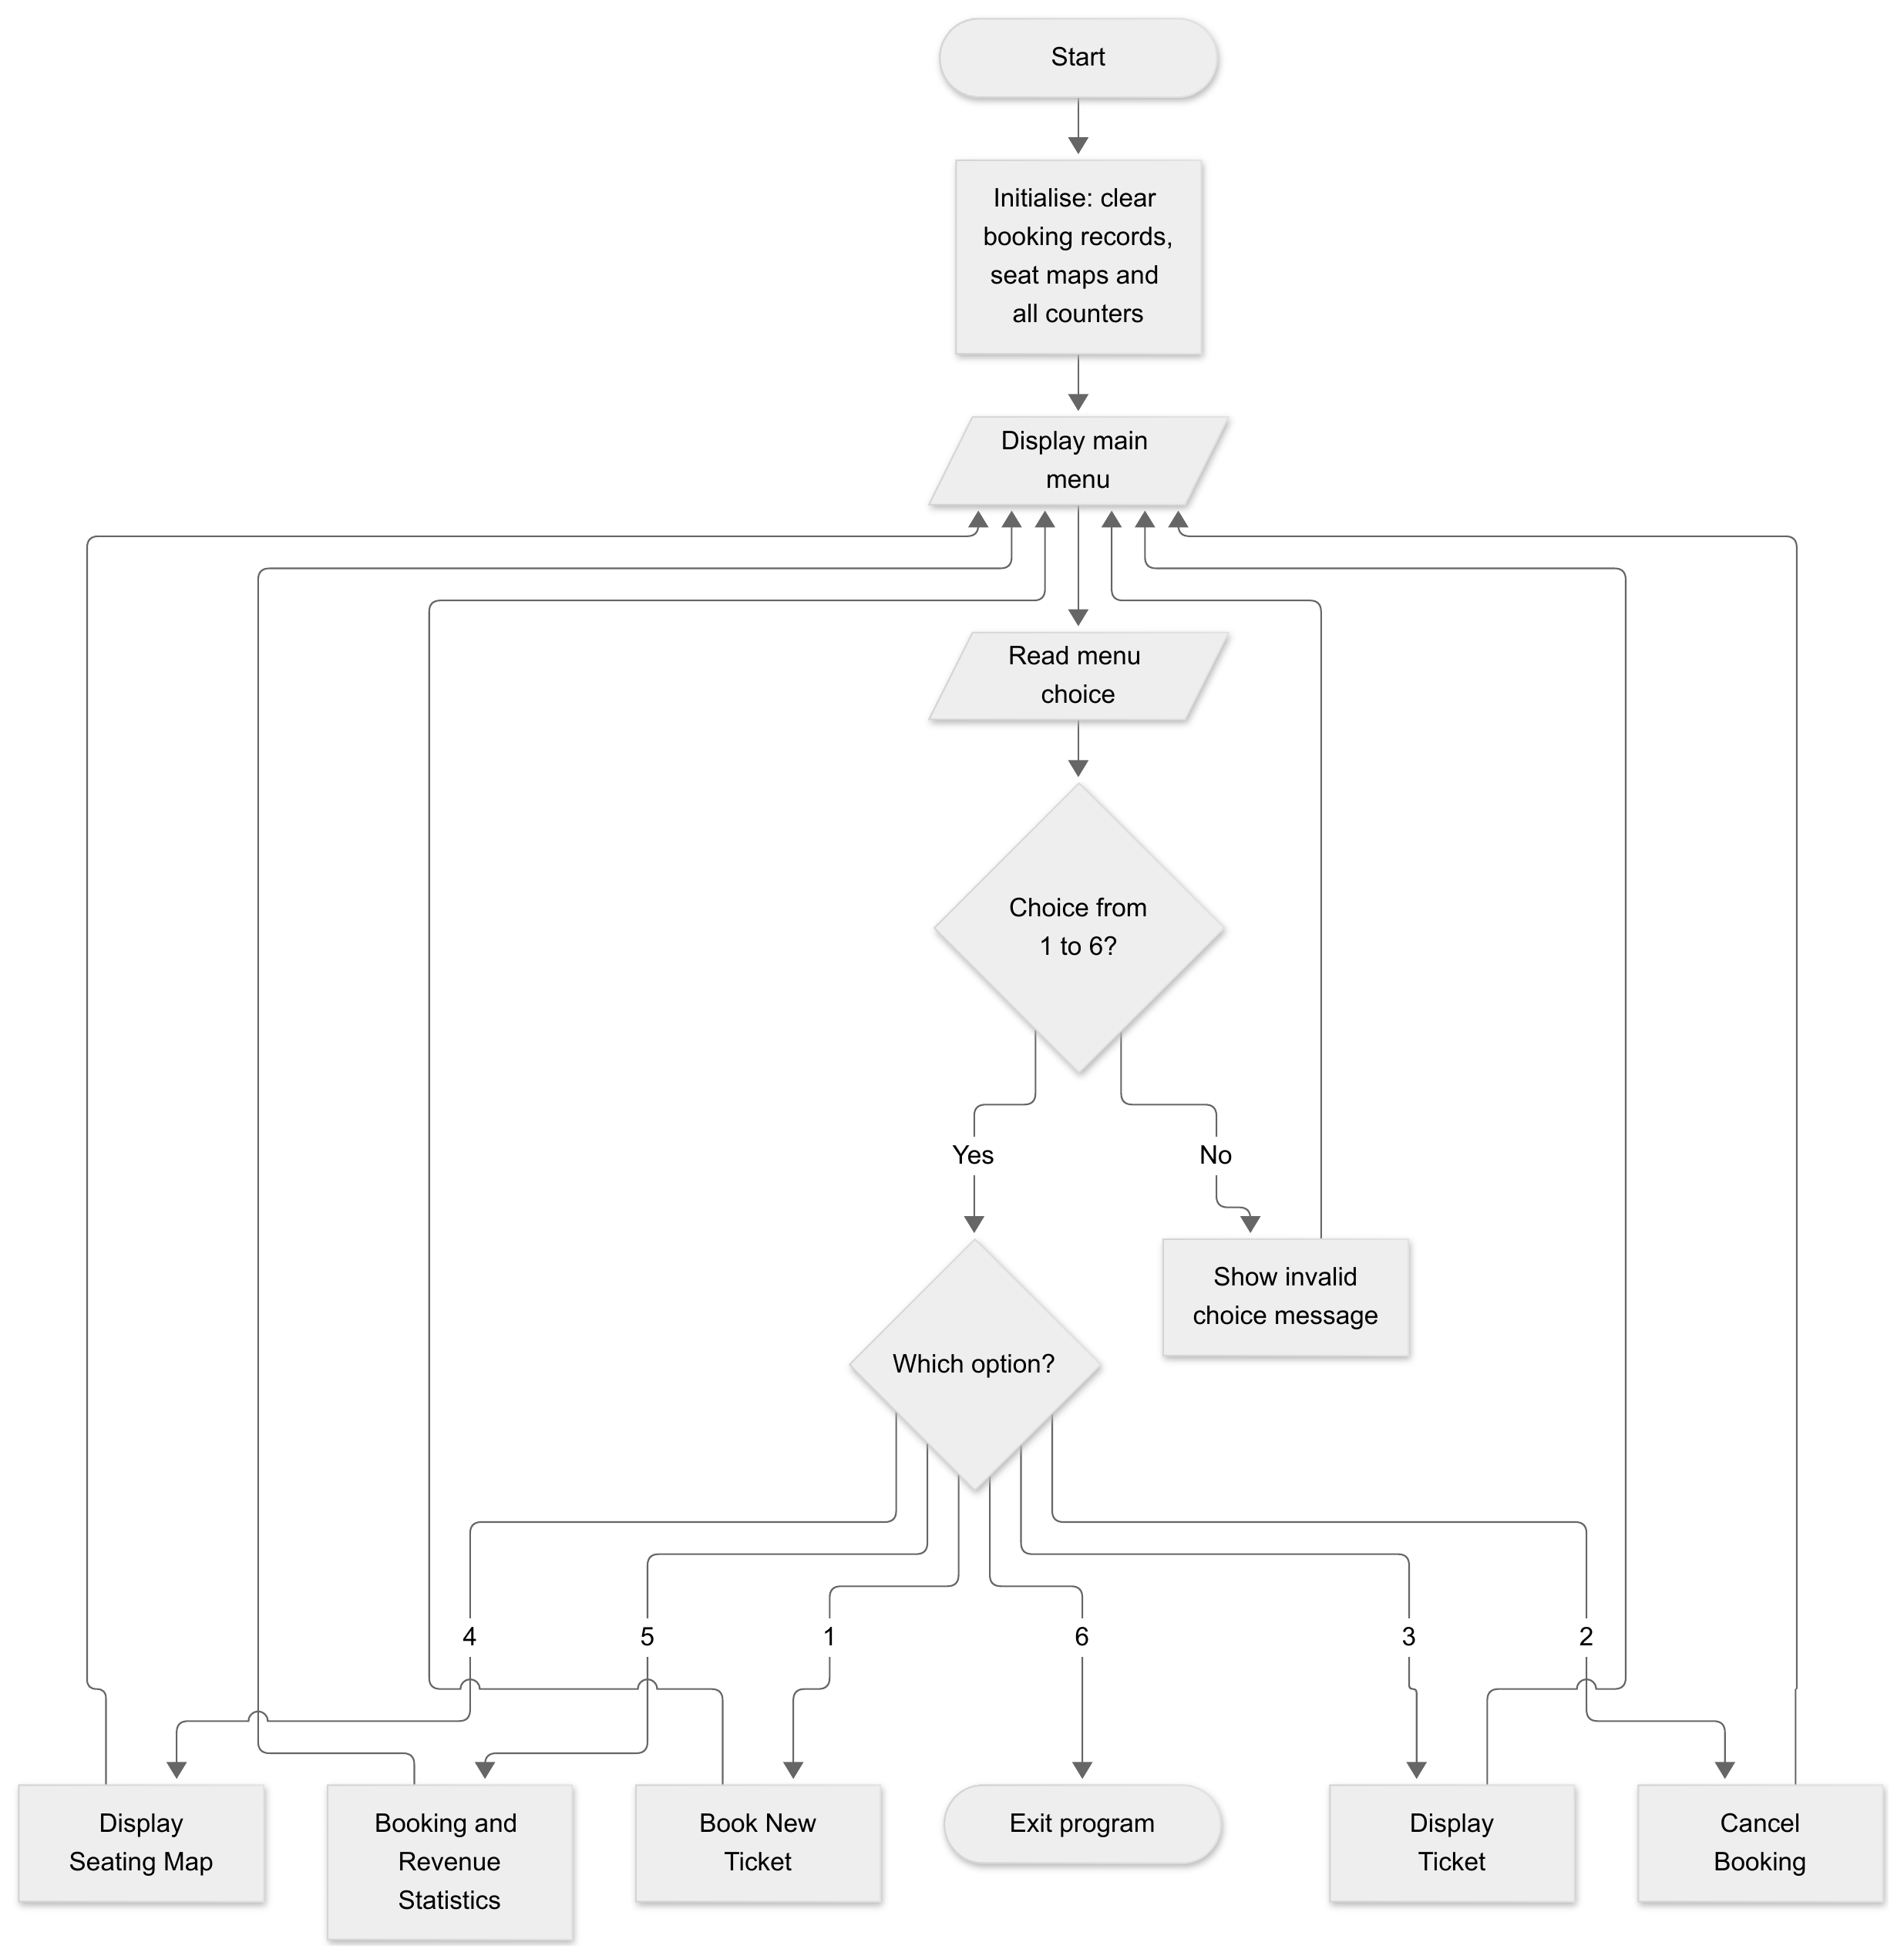
Figure 1: Main program flow: menu loop and dispatch to the six operations.
Options 3 and 4 are short read-only operations. Display Ticket reads a booking ID, searches the records for an active match, and either prints the formatted ticket or reports ERROR: Booking ID not found!. Display Seating Map reads a movie code and prints that movie’s 20 seats, each as [O] or [X], followed by the reserved count and the occupancy percentage. Their flows are shown in Figures 6 and 7.

2.3.2 Book New Ticket
Each field is validated as soon as it is entered, so an invalid value is rejected immediately and re-read rather than being carried forward. The flow is shown in three parts (Figures 2–4): identity fields, seat selection and pricing/commit.
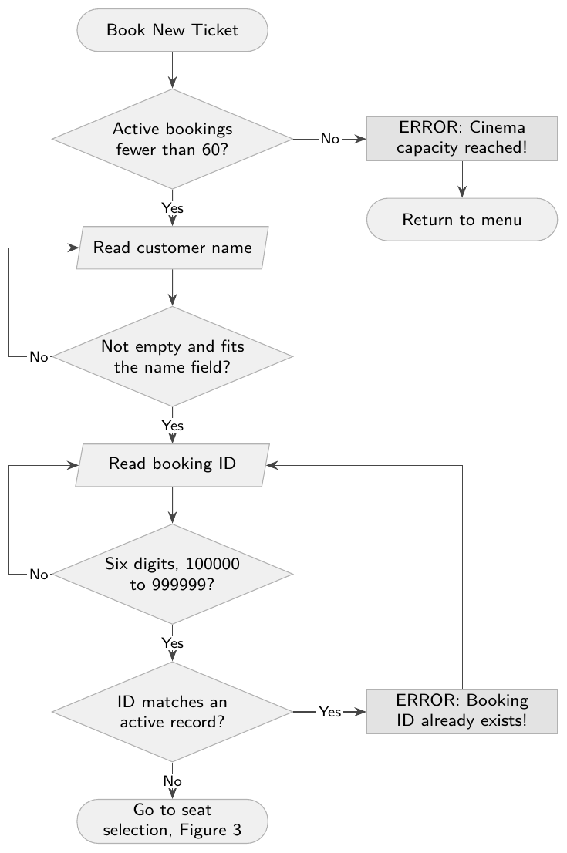
Figure 2: Book New Ticket, part 1: customer name and booking ID.
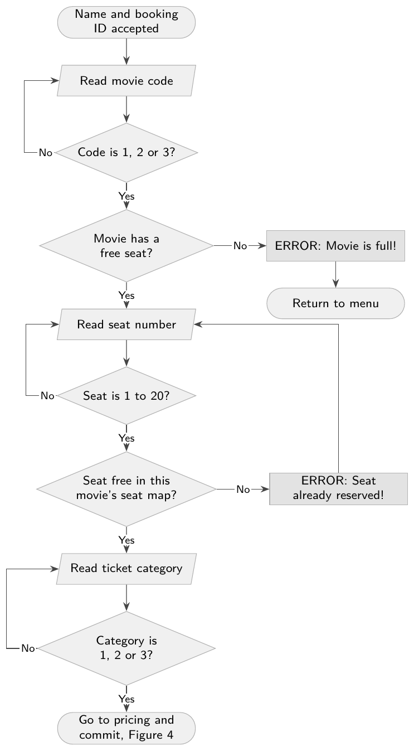
Figure 3: Book New Ticket, part 2: movie code, seat number, ticket category.
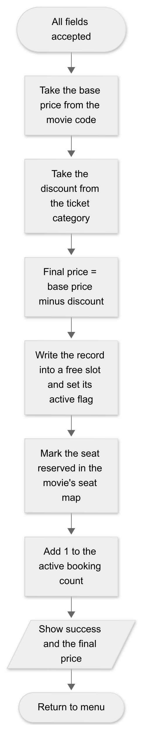
Figure 4: Book New Ticket, part 3: pricing and commit to the booking record.

2.3.3 Cancel Booking
Cancelling never deletes a record. It clears the record’s active flag and releases the seat, which is what allows the same seat to be sold again in the same run.
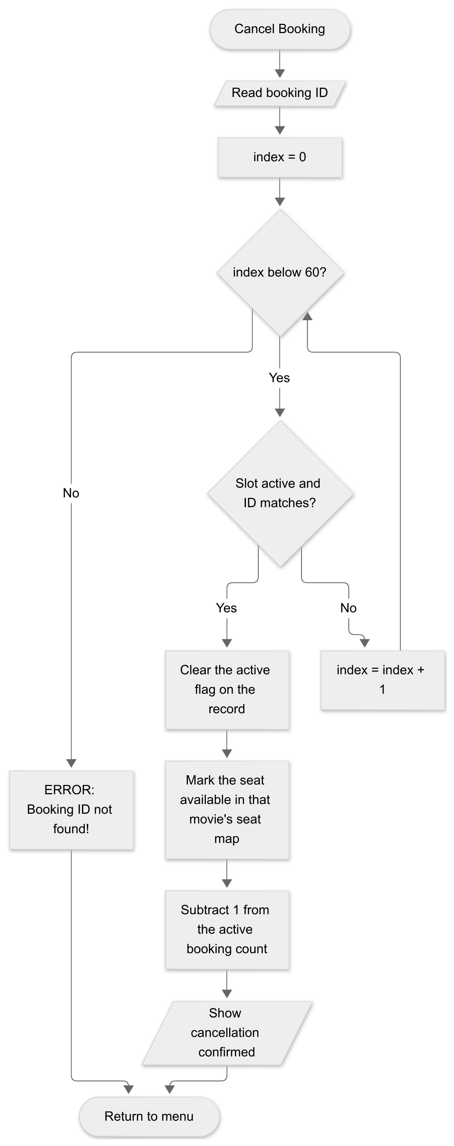
Figure 5: Cancel Booking: linear search over 60 slots, then clear the active flag and free the seat.

2.3.4 Display Ticket
Display Ticket uses the same linear search as Cancel Booking, but it only reads the record and changes nothing.
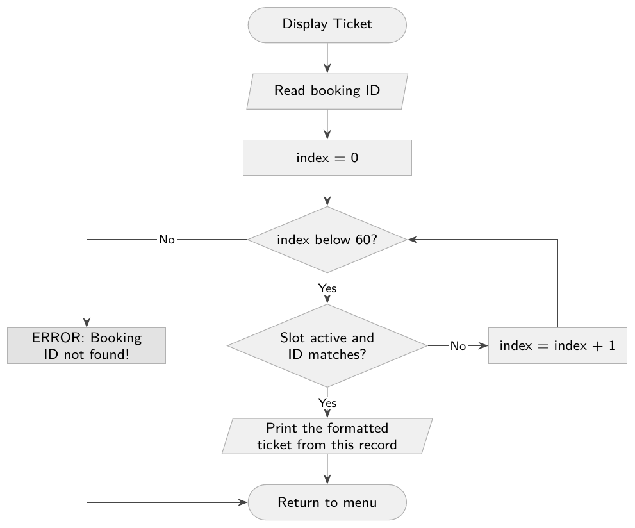
Figure 6: Display Ticket: linear search over 60 slots, then print the matching record.

2.3.5 Display Seating Map
Display Seating Map is also read-only. It prints the 20 seats of the chosen movie in 4 rows of 5, then the reserved count and the occupancy percentage.
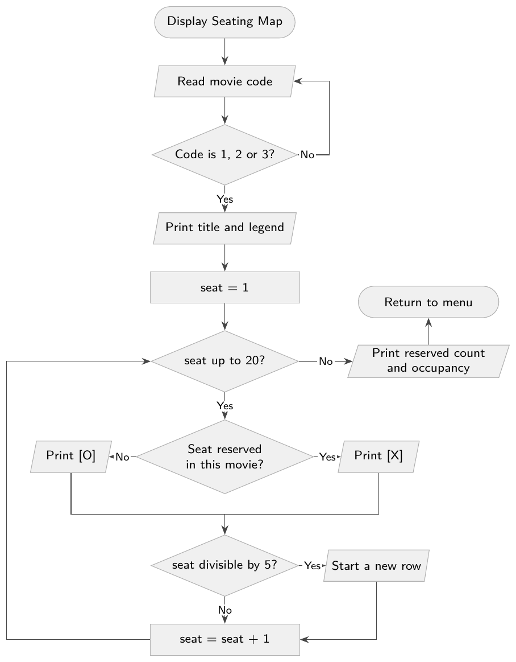
Figure 7: Display Seating Map: print each of the 20 seats as [O] or [X], then the totals.

2.3.6 Booking and Revenue Statistics
Every figure in the report is recalculated from the records at the moment the option is chosen, so the report is always current and inactive records never contribute to it. The flow is shown in two parts: the scan over all 60 slots (Figure 8), and the derived figures and report (Figure 9).
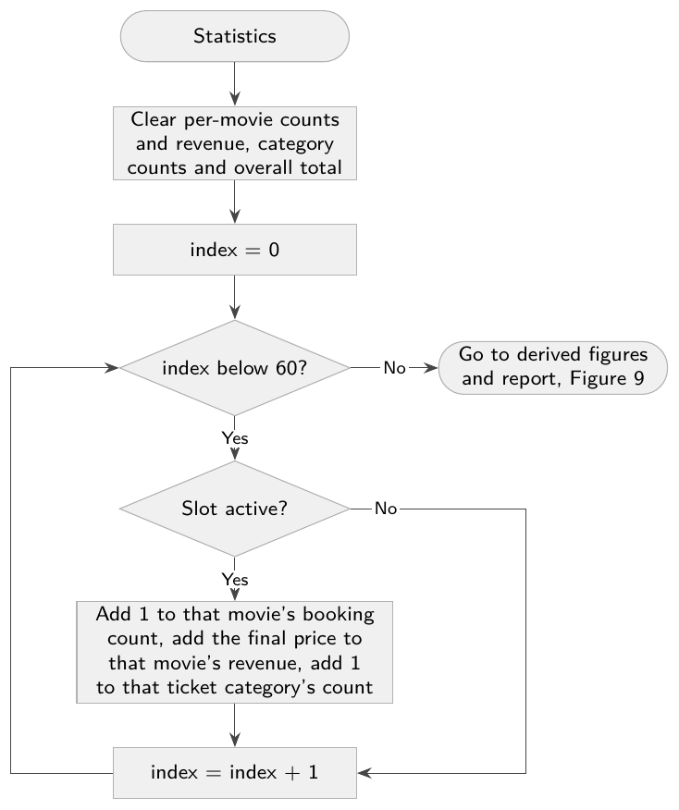
Figure 8: Statistics, part 1: scan the 60 record slots and accumulate per-movie and per-category counts.
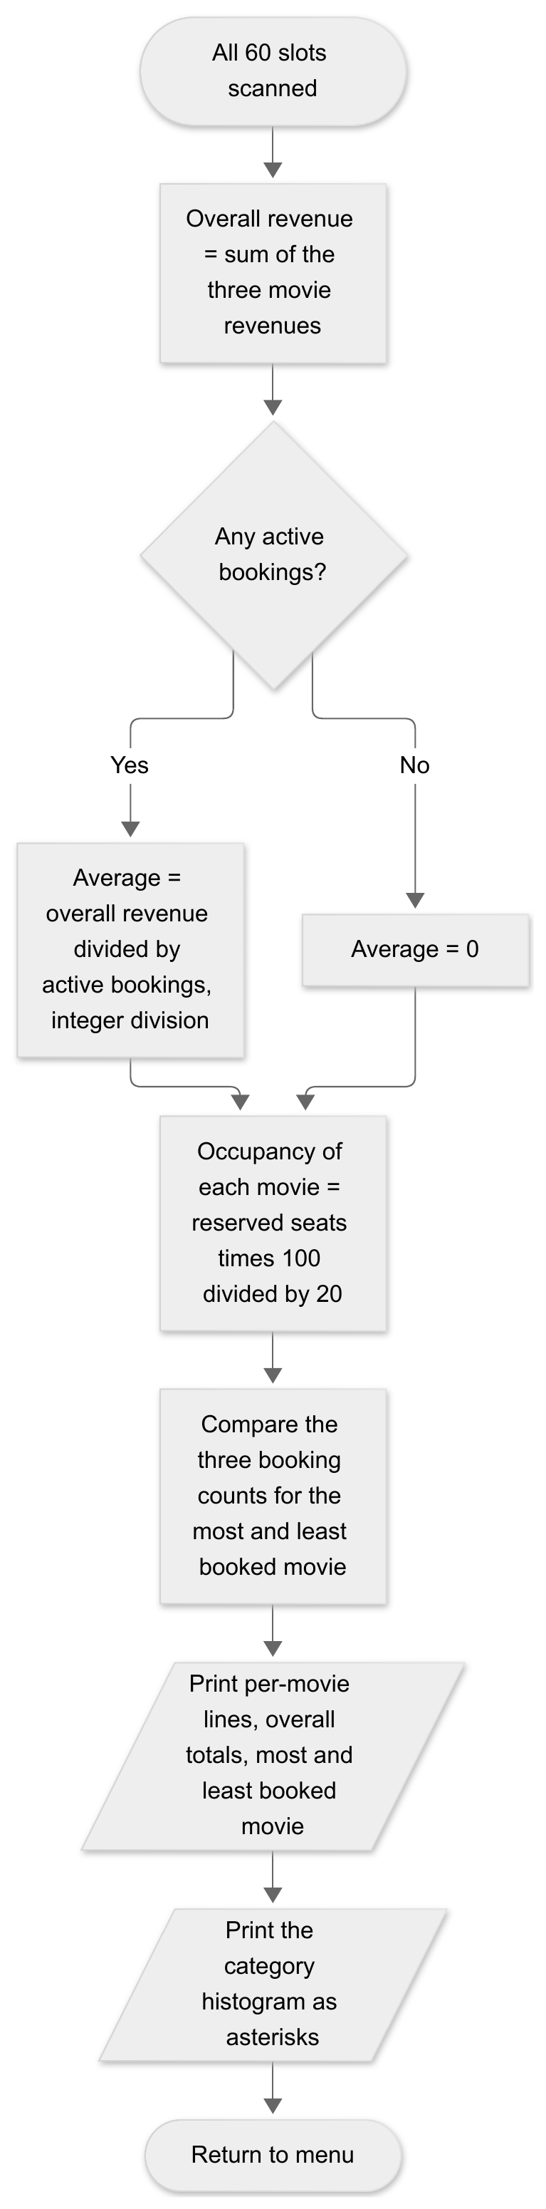
Figure 9: Statistics, part 2: derive overall totals, average, occupancy and print the report.

2.3.7 Note on the repeated structures
Several of the flows above repeat an action a known number of times over a fixed array: the duplicate-ID check and the record scans sweep 60 record slots, and the seating map prints 20 seats. Chapter Two of the course identified CX as the processor’s dedicated counter register, used by default for counted repetition, so the problem’s shape fits that register naturally. The validation branches are different in kind: each one repeats until the user supplies an acceptable value, so the number of repetitions is not known in advance. The project therefore requires both a counted repetition and a condition-controlled repetition, which satisfies the requirement for at least two loop structures.

2.4 Constraints

2.4.1 Memory
All storage is fixed in size and known before the program runs. Nothing is allocated while the program is running.
Each booking is stored as one fixed-size record: a single run of bytes holding every field for one ticket (name, ID, movie, seat, category, active flag, prices). The 60 records sit one after another in a fixed array, so a given booking is always found at the same offset: record index times record size. Table 4 breaks that record, and the system’s other arrays, down byte by byte.
Table 4: Memory used by the main data structures
Structure | Size calculation | Total
Booking records | 60 records, 37 bytes each | 2,220 bytes
Seat maps | 3 movies, 20 seats, 1 byte per seat | 60 bytes
Per-movie booking counts | 3 doublewords | 12 bytes
Per-movie revenue totals | 3 doublewords | 12 bytes
Ticket category counts | 3 doublewords | 12 bytes
Active booking count | 1 doubleword | 4 bytes
Total main data |  | about 2.3 KB

The 37-byte record is made up of a 21-byte name field (20 characters plus a null terminator), a 4-byte booking ID, three single bytes for movie code, seat number and category, one byte for the active flag and two doublewords for the base price and final price.

2.4.2 Registers against memory
Chapter Two of the course established that a processor has only a small, fixed set of registers, that they are fast but temporary and that program data lives in main memory. CTRMS holds roughly 2.3 KB of state, so the records, the seat maps and the counters must all live in memory. Registers can only ever hold what is being worked on at that instant: the current array index, a loop counter, an address, or the result of one arithmetic step. This is the reason the system is built around arrays indexed by position rather than around values kept permanently in registers.

2.4.3 Capacity
- At most 60 active bookings at any one time.
- Exactly 3 movies, fixed, not configurable.
- Exactly 20 seats per movie, so at most 60 seats in total across the cinema.
- Customer names limited to 20 characters, stored in a 21-byte field with the null terminator.
- Booking IDs limited to the 900,000 values from 100000 to 999999.

2.4.4 Integer arithmetic
The processor does provide floating-point registers, as covered in Chapter Two of the course, but the project specification forbids floating-point instructions. Every calculation is therefore integer arithmetic, with these consequences:
- Prices are exact. Base prices are 8, 7 and 6 JOD and discounts are 0, 1 and 2 JOD, so every final price is a whole number from 4 to 8 JOD. No rounding occurs.
- Occupancy is exact. Occupancy is reserved seats times 100 divided by 20, which is the same as reserved seats times 5. Every value from 0 to 20 seats therefore maps to an exact percentage from 0 to 100, and nothing is lost to truncation.
- The average ticket price is the only figure that loses precision. It is overall revenue divided by active bookings in integer division, so the remainder is discarded. For example, 26 JOD over 4 bookings gives 6 JOD, not 6.5 JOD. The report shows the truncated value, which is what the specification requires.

2.4.5 Value ranges
Three range limits act as hard constraints on the design:
- A booking ID can reach 999,999, which exceeds the 65,535 limit of a word, so IDs must occupy a doubleword.
- Movie codes, seat numbers, categories and the active flag all stay within 0 to 255 and therefore fit in a single byte each.
- The largest revenue the system can ever hold is 60 bookings at the top price of 8 JOD, which is 480 JOD. This is nowhere near the doubleword limit, so no overflow handling is needed for any total.
Every quantity in the system (identifiers, counts, prices, revenue, percentages) is non-negative. All values are therefore treated as unsigned, and the two’s-complement representation of negative numbers studied in Chapter One of the course does not arise anywhere in this project.

2.4.6 Platform and course constraints
- The program is written in x86 assembly for MASM with the Irvine32 library, and runs as a 32-bit Windows console application in protected mode, the native mode described in Chapter Two of the course.
- There is no persistence. All records live in memory only, so every booking is lost when the program exits.
- The program is console only. There is no graphical interface, no mouse input and no printing.
- The course imposes its own requirements that shape the design: at least 8 procedures, at least 2 different loop structures, IF, IF-ELSE and nested conditionals, and the use of all five required data types: strings, doublewords, bytes, characters and arrays.

2.5 Assumptions
- Seats belong to a movie, not to the cinema. Seat 5 of Movie A and seat 5 of Movie B are different seats. A seat is unavailable only when that same movie and seat number are already reserved.
- Cancelled records stay in the array. Cancelling clears the active flag; it does not erase the record or shift any other record. Only the active flag decides whether a record counts.
- Inactive records are invisible to every report. They are excluded from the active booking count, from all revenue, from occupancy and from the category histogram.
- A freed slot and a freed seat are both reusable. After a cancellation the record slot can hold a new booking and the seat can be sold again in the same run.
- A booking ID is unique among active bookings only. Once a booking is cancelled, its ID may be used again by a new booking.
- One booking is one seat, one ticket and one customer. There is no group booking and no multi-seat purchase in a single transaction.
- One user at a time. The program is a single console session with no concurrent access, so no two bookings can ever be made at the same instant.
- Prices are fixed constants. The three base prices and the three discounts are built into the program and are never entered or changed at runtime.
- All input arrives as ASCII text from the keyboard. Where a number is expected, anything that is not a valid number in range is treated as invalid input and the prompt is repeated.
- The user is cinema staff, not the public. The person at the keyboard is assumed to be trained in the menu, so prompts explain the legal range but no further help system is provided.
- All lab machines behave identically. Every machine runs the same MASM and Irvine32 setup in protected mode, so no machine-specific behaviour is relied upon.

Chapter Three
Requirements Specification

3.1 Functional Requirements
The system must fulfil the following functional requirements to meet the project objectives. Priorities are classified as High (H), Medium (M) or Low (L).
Table 5: Functional requirements
ID | Description | Pri
FR01 | The system shall display a main menu with six options: Book, Cancel, Display Ticket, Display Seating Map, Statistics and Exit. | H
FR02 | The system shall record new ticket bookings by accepting Customer Name, Booking ID, Movie Code, Seat Number and Ticket Category. | H
FR03 | The system shall validate that the 6-digit Booking ID is unique and falls between 100000 and 999999. | H
FR04 | The system shall calculate final ticket prices by subtracting the applicable ticket category discount from the movie’s base price. | H
FR05 | The system shall prevent duplicate seat reservations for the same movie hall. | H
FR06 | The system shall deactivate a booking and release its seat when a user cancels an active booking using its ID. | H
FR07 | The system shall format and display an individual ticket, including all pricing and discount details, when provided a valid active Booking ID. | M
FR08 | The system shall output a visual seating map for a specified movie, indicating available seats with [O] and reserved seats with [X]. | M
FR09 | The system shall calculate and display per-movie bookings, revenue and occupancy, total active bookings, overall revenue, the average ticket price, the most and least booked movies and a ticket category distribution histogram. | M
FR10 | The system shall restrict total active bookings to a maximum capacity of 60 reservations across the three movies. | H
FR11 | The system shall validate the customer name (1 to 20 characters), movie code (1 to 3), seat number (1 to 20) and ticket category (1 to 3), rejecting invalid or non-numeric input with an error message and a re-prompt. | H
FR12 | The system shall reject a booking for a movie whose 20 seats are all reserved, showing an error message and returning to the menu. | H

3.2 Non-Functional Requirements
The following constraints define the technical environment, structural quality and architectural standards of the system.
Table 6: Non-functional requirements
ID | Description
NFR01 | The software shall be implemented entirely in x86 Assembly Language using MASM.
NFR02 | The software shall utilise the Irvine32 library for all console input/output and string formatting operations.
NFR03 | The software shall rely exclusively on integer arithmetic for all pricing and statistical calculations; floating-point instructions are strictly forbidden.
NFR04 | The software shall use fixed-size memory records and arrays to manage the state of up to 60 active booking entries.

3.3 CLO Mapping
The specified requirements directly support the Course Learning Outcomes (CLOs) as defined in the project structure:
- S1: Develop assembly language programs for microcomputers to perform basic input/output operations.
  - Mapping: Supported by FR01, FR07, FR08, FR09 and FR11. The system fulfils this outcome by prompting the user for input, executing validation loops and rendering highly formatted reports (menus, tickets, seating maps and histograms) directly to the console.
- S2: Implement and debug assembly language programs that perform arithmetic, string operations, searching, and memory manipulation tasks.
  - Mapping: Supported by FR02, FR03, FR04, FR05, FR06, FR12 and NFR04. The logic explicitly requires iterating over arrays to perform searches (booking IDs, seat availability), reading strings (customer names) and executing integer arithmetic to calculate ticket pricing and cumulative statistics.
- C1: Distinguish between different processor registers and use them appropriately in assembly language programming.
  - Mapping: Supported by NFR01 and NFR03. The implementation mandates correct assignment and management of general-purpose registers (EAX, EBX, ECX, EDX, ESI, EDI) according to standard architectural conventions for calculations, pointers, loop counting and library parameter passing.

