**Prerequisites**

**Visual Studio Version**

SmartERP requires *Visual Studio 2022+* with most recent updates installed. You can download it free. [Visual Studio 2022 Community](https://visualstudio.microsoft.com/thank-you-downloading-visual-studio/?sku=Community&channel=Release&version=VS2022&source=VSLandingPage&cid=2030&passive=false)

.NET CORE 6.0 SDK is also only supported in Visual Studio 2022+.

**.NET Core SDK**

Please install .NET Core 6.0 SDK from:

<https://dotnet.microsoft.com/download>

**Visual Studio TypeScript Extension**

As of writing, the recommended version of TypeScript is 4.7.4. A recent version of Microsoft.TypeScript.MsBuild package and it is supposed to be used by Visual Studio 2019+ automatically.

You can get TypeScript extension for your Visual Studio version from <http://www.typescriptlang.org/#download-links>.

Latest version of TypeScript might probably work but keeping in sync with the version we currently use, can help you avoid compatibility problems that could come with them.

**NodeJS / NPM**

NodeJS / NPM for these:

* TypeScript typings (.d.ts) for libraries like jQuery, Bootstrap etc.
* TypeScript compiler itself (tsc)
* Less compilation (lessjs)

It requires NodeJS v6.9+ and NPM 3.10+

> npm -v

3.10.10

> node -v

6.9.4

If you get an error, they might not be installed or not in path. Please install LTS (long term support) versions from <https://nodejs.org/en/>

Current version might also work but is not tested.

**Visual Studio and External Web Tool Paths**

Even if you have correct Node / NPM installed, Visual Studio might still be trying to use its own integrated, and older version of NodeJS.

Click *Tools* => *Options*, and then under *Projects and Solutions* => *External Web Tools* add *C:\Program Files\nodejs* to the top of the list by clicking plus folder icon, typing *C:\Program Files\nodejs* and using *Up Arrow* to move it to the start:

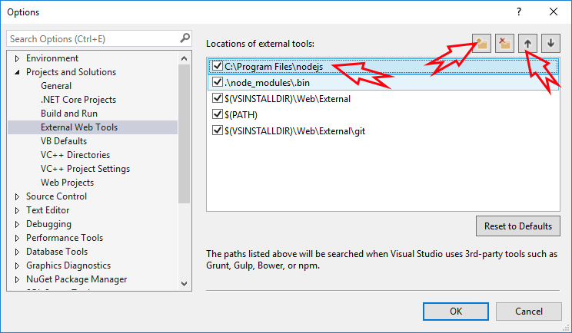

Your solution contains SmartERP.Web project, which is an ASP.NET Core application.

It includes server side code written in C# (.cs) and client side code that is written in TypeScript (.ts).

SmartERP.Web has references to Serenity NuGet packages, so you can update it using package manager console anytime necessary.

Serene automatically creates its database in SQL local db at first run, so just press F5 and you are ready to go.

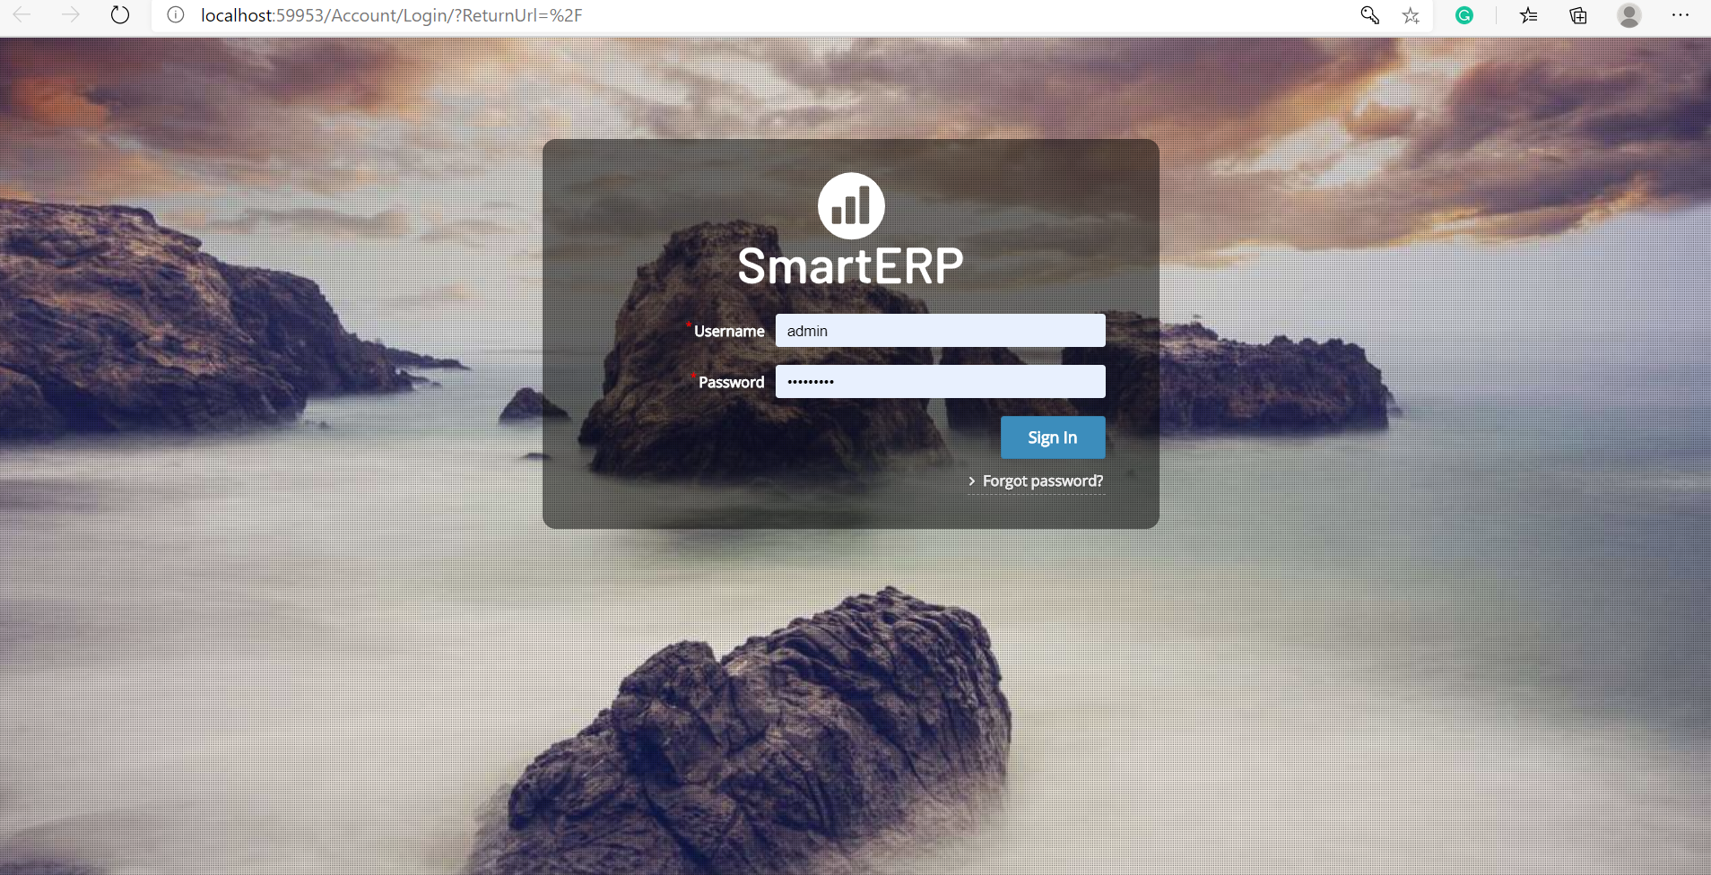

When application launches use admin user and admin1234 password to login. You can change password or create more users later, using *Administration / User Management* page.

### Troubleshooting Connection Problems

If you are getting a connection error like the following while starting SmartERP for first time:

> A network-related or instance-specific error occurred

> while establishing a connection to SQL Server.

> The server was not found or was not accessible.

> Verify that the instance name is correct...

This error might mean that you don't have SQL Server Local DB installed. This server comes preinstalled with Visual Studio.

#### ASP.NET Core

In appsettings.json file you'll find Default connection entries:

"Data": {

"Default": {

"ConnectionString": "Server=(localdb)\\MsSqlLocalDB;Database=SmartERP_Default_v1;Integrated Security=true",

"ProviderName": "System.Data.SqlClient"

}

}

#### Fixing Connection Strings

Visual Studio 2015+ comes with SQL Server 2014+ LocalDB. It's default instance name is MsSqlLocalDB by default.

If you have an error, open an administrative command prompt and type

> sqllocaldb info

This will list localdb instances like:

MSSqlLocalDB

test

If you don't have MsSqlLocalDB listed, you can create it:

> sqllocaldb create MsSqlLocalDB

If you have another SQL server instance, for example SQL Express, change data source to .\SqlExpress:

<**connectionStrings**>

<**add** name="Default" connectionString="Data Source=.\SqlExpress;

Initial Catalog=SmartERP_Default_v1; Integrated Security=True"

providerName="System.Data.SqlClient" />

</**connectionStrings**>

You can also use another SQL server. Just change the connection string.

# How to Install

Upload all files from Compiled folder to root directory at your hosting server.

* Run database script from db/db.sql file
* Change connection string to your live server connection
* Now access your domain and you will see login screen

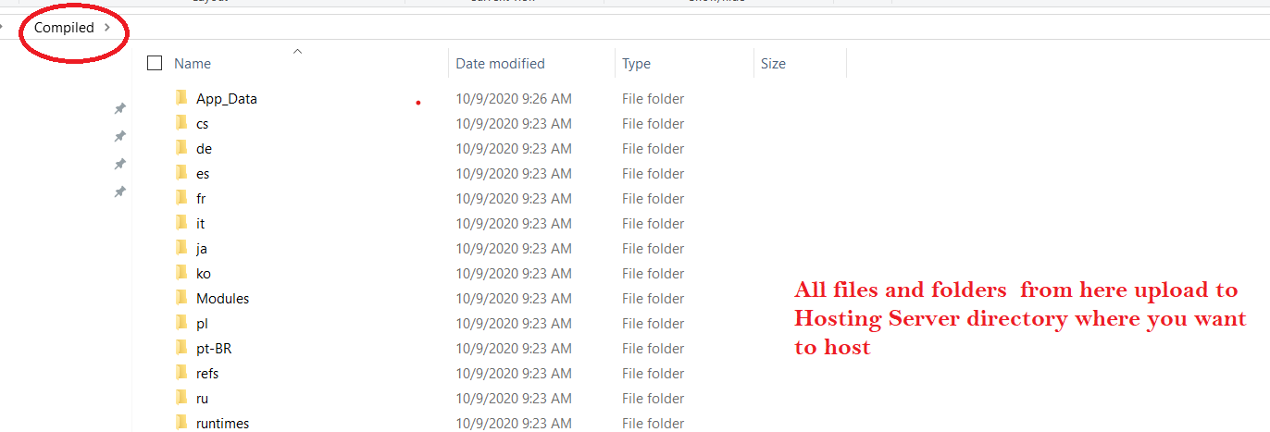

# Used Tools and Libraries

SmartERP project makes use of some valuable open source tools and libraries that are listed below (in alphabetic order)

**Serenity: (**[**https://github.com/volkanceylan/Serenity**](https://github.com/volkanceylan/Serenity)**)**

**SQL** Server **2019 Express**. [SQL Server 2019 Express](https://go.microsoft.com/fwlink/?linkid=866658)is a free edition of **SQL** Server, ideal for development and production for desktop, web, and small server applications