# IPM measurements in the Tevatron*

*Work supported by US DOE under contract DE-AC02-07CH11359

#jansson@fnal.gov

A. Jansson#, K. Bowie, T. Fitzpatrick, R. Kwarciany, C. Lundberg, D. Slimmer, L. Valerio, J. Zagel, Fermilab, Batavia, IL 60510, USA

Abstract

## Two Ionization Profile Monitors (IPMs) were installed in the Tevatron in 2006. The detectors are capable of resolving single bunches turn-by-turn. This paper presents recent improvements to the system hardware and its use for beam monitoring. In particular, the correction of beam size oscillations observed at injection is discussed.

## INTRODUCTION

The Tevatron Ionization Profile Monitors[1] were developed primarily to detect mismatch-induced beam size oscillations at injection, but also to measure emittance evolution during e.g. ramp and squeeze. The detectors are capable of measuring the profile of single proton and pbar bunches. This is achieved by continuously integrating the ionization signal from each anode strip in ~60ns intervals (7/2 times the RF period), using very sensitive electronics (2.9fC LSB). Since individual proton bunches are separated by 21 RF buckets and protons and pbars are separated by ~7 RF buckets at the location of the IPM, individual bunches may be studied by selecting the appropriate samples. This is useful e.g. to measure injection matching of bunches injected into a partially filled machine.

To achieve low noise, the integration is done in the tunnel and signals are sent to the service building in digital form on optical fibers. Each front end board handles eight channels, and up to 16 front end boards (128 channels) may be used per system. The front end boards all receive a common clock frequency and timing signals generated from the Tevatron Beam Sync Clock by a PC in the service building.

Each board returns data on a separate high-speed optical link. The data from the individual boards is then collected, synchronized and buffered in a Data Buffer Card in the same PC that hosts the timing card. The Buffer card can handle eight links, and two boards may be daisy-chained to handle the full 16 links. The total data rate may exceed to 20Gbps, depending on how many cards are installed, and the Buffer card is capable of storing 20000 turns of continuous data. Data can also be reduced on-the-fly to select only interesting samples, raising the total number of turns to 6 Million for a single bunch. However, when the full buffer memory is used, analysis time with the LabView software becomes prohibitive. However, in practice measurement are typically restricted to less than ~1000 turns, which is sufficient for most applications.

## RECENT IMPROVEMENTS

For the initial measurements[2], a LabView program was used to set up the measurement parameters. Data was then downloaded from the buffer card, saved to file and analyzed off-line using Mathematica. This analysis has now been incorporated into the LabView program, making the turnaround time for a measurement much shorter and the system more user-friendly.

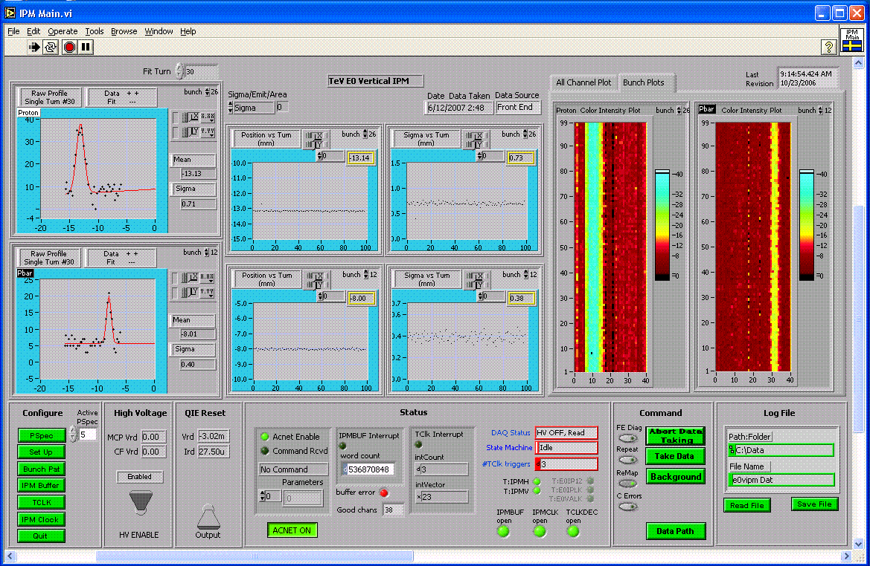

Figure 1. Screenshot from the Tevatron IPM Labview program. At low beta, the vertical system is capable measuring both protons and pbars simultaneously, without moving the detector.

The initial systems had five prototype front end boards each, for a total of 40 channels per system. At a channel pitch of ¼ mm, this corresponds to an active width of 1cm. These prototype systems were used to debug the firmware before the production run, since the front-end boards use one-time programmable FPGAs (for radiation hardness). While 1cm is sufficient to cover the vertical beam size, both at injection and flattop, it is too small to measure the horizontal beam size at injection. For this reason, the horizontal system was chosen to test the production front end boards. Recently, 10 boards (80 channels) with new firmware were installed in the horizontal system. This upgraded system is currently being tested.

## PROTON InJECTIon MATCHING

### Observation of mismatch

The primary purpose for the IPMs is to detect injection mismatch by measuring the beam size over the first few hundred turns following injection. Indeed, during proton injection a vertical beam size oscillation of about ± 20% was detected. The mismatch is clearly visible and consistent for all 36 proton bunch injections during shot setup. A beam size oscillation of this magnitude corresponds to an emittance blow-up of about 10%.



Figure 2. Vertical beam size for the first 85 turns following injection for proton bunches #5 (black), #11 (red), #15 (green) and #19 (blue), taken during the same collider shot. There is clear and consistent evidence of mismatch.

### Correction of mismatch

The evolution of the beam size (or rather the square of the beam size) when the beam is injected with small errors *Δβ* and *Δα* in the Courant-Snyder parameters, is given by

$$σ^{2}\left(n\right)=ε β \left(\frac{∆β}{β}\cos{2ω}+\left(∆α-α\frac{∆β}{β}\right)\sin{2ω}\right)$$

where υ is the betatron tune multiplied by 2π, and *n* is the turn number. A dimensionless mismatch vector *m={Δβ/β, Δα-α Δβ/β}* may therefore be defined, and its value determined by fitting a sinusoidal curve with a frequency *2*υ to the beam size data measured by the IPM. The mismatch vector may be viewed as the analog of a position-angle error in the case of injection steering. The effect of a transfer line quadrupole on the mismatch vector can be calculated analytically[3], but due to imperfect knowledge of the optics, it is often better to measure it. A correction to the observed mismatch may then be found by solving a system of linear equations. Figures 1-2 show the measured effect of two proton transfer line quadrupoles on the vertical mismatch vector. The effects of these quadrupoles are nearly orthogonal in the vertical plane, which simplifies correction.

Since quadrupoles affect both vertical and horizontal planes, both planes should be considered simultaneously when correcting the mismatch. As horizontal matching data is not yet available, the full correction has not been done. However, since the effect of a quadrupole is proportional to the local beta function, a partial correction of the observed vertical mismatch was made using quadrupoles in locations with small horizontal beta functions. This correction reduced the vertical mismatch to below the noise level.



Figure 3. Vertical mismatch vector for different settings of the Q701 quadrupole. Black is nominal current, red is -22A, green is -42A



Figure 4. Vertical mismatch for different settings of the Q711 quadrupole. Black is nominal current, red is +10A, green is +20A.

## Measurements oN pbars

The intensity of antiprotons is naturally lower than the intensity of protons, which translates into a smaller signal. However, for matching measurements this can be compensated to some degree because pbars are injected in groups of four. With the pbar intensities achieved recently, adding up the four pbar profiles yields signals almost as strong as for a single proton bunch. Furthermore, the pbar emittance is significantly smaller than the proton beam size at injection. This makes it easier to measure the pbar profile, since the signal is spread over fewer channels.

Injection matching measurements on pbars using the vertical IPM has indicated that the vertical plane is quite well matched. This conclusion is supported by reverse proton injection (protons being sent back into Main Injector from the Tevatron via the pbar transfer line) measurements using the Main Injector IPMs. Reverse proton measurements also indicate that there is a significant horizontal pbar mismatch, although due to the limited active width of the prototype system it has not yet been possible to verify this with pbars.



Figure 5. Vertical pbar bunch size, averaged over the four bunches in the transfer batch, for the first 175 turns following injection. No significant mismatch is apparent.

## Future plans

At the moment, the horizontal IPM with the production boards is still being tested. Some issues with synchronization between multiple boards have been identified. Once these problems are sorted out, the vertical system will be retro-fitted with new boards. This will allow the mismatch of both planes to be measured and corrected simultaneously.

## SUMMARY

The Tevatron IPMs are capable of measuring single bunches of protons and pbars turn-by-turn at injection and high energy. A significant vertical proton injection mismatch was observed and corrected. For pbars, no significant vertical injection was observed. Horizontal measurements should be available soon.

## References

[1] A. Jansson et al, The Tevatron Ionization Profile Monitors, 12th Beam Instrumentation Workshop, Fermilab, Batavia, IL, 2006.

[2] A. Jansson et al, Tevatron Ionization Profile Monitoring, 10th European Particle Accelerator Conference, Edinburgh, UK, 2006.

[3] B. Autin et al, “Emittance Preservation in the PS Complex”, PAC’07, Vancouver, CA.