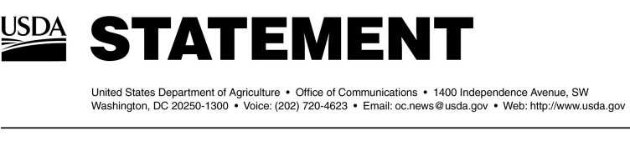

Release No. 0043.04
Office of Communications (202) 720-4623

BSE Update — January 27, 2004

Depopulation Activities

On Monday, Jan. 26, 2004, 18 animals of interest were euthanized and sampled from the Quincy, WA, facility. Four animals of interest were euthanized and sampled at the Tenino, WA, facility. In addition to these two facilities, USDA has previously conducted selective depopulation activities at these facilities:

- Bull calf premises - a total of 449 animals depopulated
- Mabton, WA (index premises) - a total of 131 animals depopulated
- Mattawa, WA - a total of 39 animals depopulated
- Connell, WA - a total of 15 animals depopulated
- Boardman, OR - a total of 20 animals depopulated

To date, all 170 samples from the index herd and the Mattawa herd have completed testing; results were negative for BSE. The final test results for the samples taken at Connell, WA; Boardman, OR; Quincy, WA; and Tenino, WA are not yet available.

Investigation Activities

At this time, 28 of the 81 animals that came from Canada have been located:
- 1 of the 81 is the BSE-positive cow and was located in the Index herd in Mabton, Washington.
- 9 of the 81 were located in the Index herd in Mabton, Washington.
- 3 were located at a facility in Tenino, Washington.
- 6 were located at a facility in Connell, Washington.
- 1 was located at a facility in Quincy, Washington.
- 3 were located at a facility in Mattawa, Washington.
- 1 is located at a facility in Moxee, Washington.
- 3 are located at a facility in Burley, Idaho.
- 1 is located at a facility in Othello, Washington.

Guidelines on bovine spongiform encephalopathy (BSE) issued by the World Organization for Animal Health (OIE), the international animal heath standard setting organization, state that animals born on a premises within one year (before or after) of a BSE-affected animal can be considered of significant interest to the country reporting the BSE detection. As such, USDA is focusing on 25 of the 81 animals also born into the birth herd of the index animal. Based on normal culling practices of local dairies, USDA’s Animal and Plant Health Inspection Service estimated that the Agency would be able to locate approximately 11 of these animals. APHIS has definitively located 14 of these animals.

USDA has also been investigating 17 additional cattle from the Canadian birth herd of the index cow. These cattle were mentioned by Dr. Brian Evans, Chief Veterinary Officer for Canada, in the Jan. 6, 2004, technical briefing. These heifers are not part of the original 81 animals and it is not known how many of the 17 actually entered the United States. To date, six animals have been identified in the United States:
- 3 were at a facility in Quincy, WA.
- 1 was at a facility in Boardman, OR.
- 1 is at a facility in Othello, WA.
- 1 is at a facility in Burley, ID.

Trade Issues

Specific trade information can be found at http://www.aphis.usda.gov/lpa/issues/bse/bse_trade_ban_status.html.

Other Issues

On Jan. 27, 2004, Secretary Ann M.Veneman testified before the Senate Committee on Agriculture, Nutrition and Forestry. Text of her testimony is available at
http://www.usda.gov/Newsroom/0042.04.html.

Additional information on BSE can be obtained by visiting the USDA website at http://www.usda.gov/BSE. Past BSE updates can also be found at http://www.aphis.usda.gov.

#

