Hurricane Ike Situation Report # 21

October 1, 2008 (12:00 PM EDT)

http://www.oe.netl.doe.gov/emergency_sit_rpt.aspx

Summary
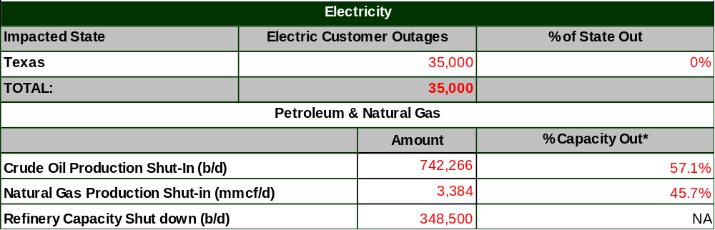
Notes:
Total state customers are based on 2006 EIA Customer Data.
Note: due to a large number of service providers, including investor owned utilities and cooperatives, the number of customer outages reported may not be comprehensive.
Source:
Crude Oil and Natural Gas Production Data from Minerals Management Service.
Refinery Status confirmed by company or on company web site and through various trade press sources.

* % capacity out represents percent of production capacity in the Gulf of Mexico.

Highlights:

- As of 6:00 AM EDT October 1, 35,000 customers remain without power in Texas. Power has been restored to over 119,380 customers since Ike Situation Report No.20 on Monday. All remaining outages are for customers served by CenterPoint.

Situation Report Detail

Petroleum & Gas Information
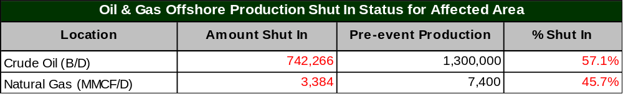
Source: Minerals Management Service

- As of September 30, the Minerals Management Service (MMS) reports 3.384 million cubic feet per day (MMcf/d) of the Gulf’s natural gas production remains shut-in, equivalent to 45.7 percent of the Gulf production. MMS reports 742,266 barrels/day of the Gulf’s crude production remains shut-in, equivalent to 57.1 percent of the Gulf’s crude production. A total of 111 production platforms, or 16.0 percent of the Gulf’s 694 manned platforms, remain evacuated. Personnel from 1 rig, representing 0.9 percent of the 116 operating in the region, remain evacuated.

- On September 29, MMS reported that 52 of the 3,800 offshore oil and natural gas production platforms have been destroyed. These platforms produced 13,300 barrels/day of oil and 90 MMcf/d. Additionally, MMS reported there were 32 platforms with extensive damage that may take up to three to six months to repair and 41 platforms sustained moderated damage which may take up to one to three months to repair..

- On September 30, the Louisiana’s Department of Natural Resources reports that 60,050 b/d or 39 percent of the normal Louisiana oil production has been restored. Operators in 17 parishes and in-State offshore areas normally produce 155,767 barrels/day (the numbers are in addition to MMS reports of Federal offshore production). Shut-in oil production is 67,793 b/d and the status of remaining 27,925 b/d is unknown. The estimated amount of restored gas production is 619 MMcf/d or 39 percent of the daily gas production capacity, which is 1,642 MMcf/d. The estimated amount of shut-in gas production is 721 MMcf/d; the status of the remaining 301 MMcf/d has not been confirmed.

- On September 30, DOE announced it is delivering 150,000 barrels of emergency exchange oil from the Strategic Petroleum Reserve (SPR) to Alon USA’s Krotz Springs, LA refinery. In September, DOE announced a total of 4.8 million barrels of SPR oil was being delivered to five different refineries affected by hurricanes Gustav and Ike.

- As of 10:00 AM EDT October 1, a number of petroleum product pipelines have resumed operations at levels normal before the arrival of Hurricane Gustav, including Colonial, Explorer, Longhorn, and Magellan. See table below for pipeline status.

- During the past couple of weeks, States in the Southeast region have experienced long lines and spot outages of gasoline at retail stations. While some outages continue, conditions are beginning to improve as refineries resume to normal production rates and pipeline make deliveries.
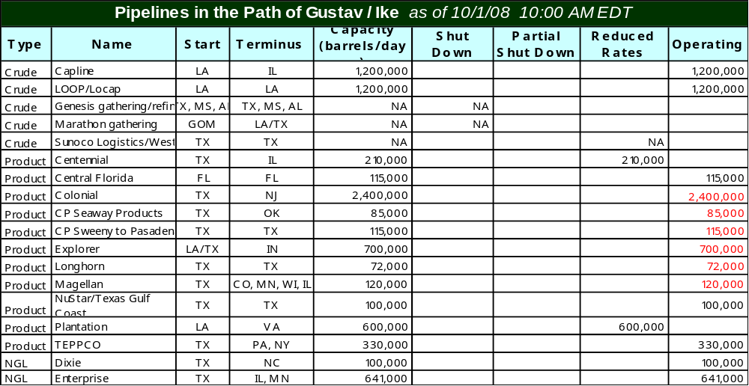Source: Status of pipelines from Association of Oil Pipe Lines; Capacity data from company web sites

- One refinery remains shut down as of 10:00 AM EDT October 1, ExxonMobil Beaumont with a total operable capacity of 0.3 million b/d. Valero reported late on September 29 that its Houston Refinery had to shutdown its fluid catalytic cracker for as long as three weeks to undertake repairs. In the aftermath of Hurricane Ike, the refinery has not been able to move beyond the restarting process. See table below for status of refineries.

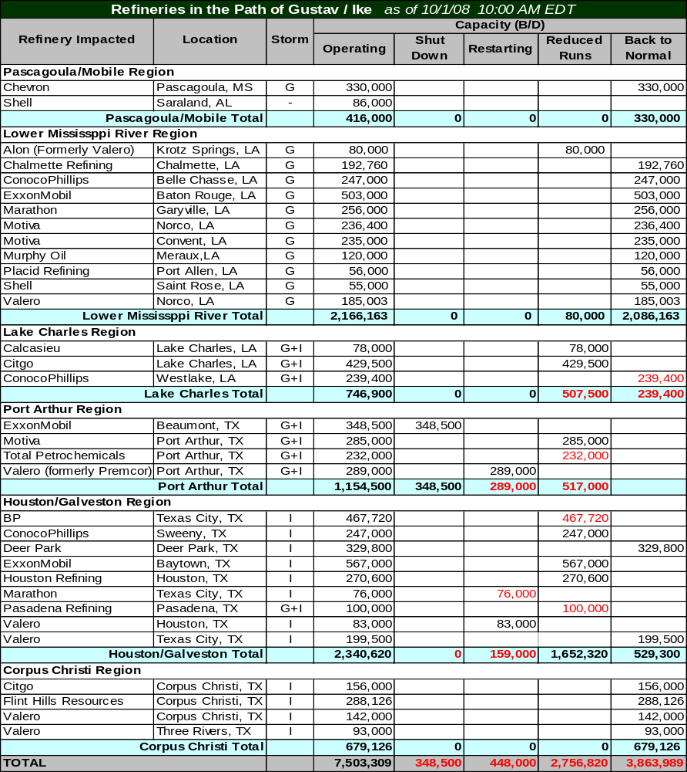
Note: The table does not include all refineries in the PADD III, Gulf Coast Region.
Storm column indicates hurricanes impacting refineries: G = Gustav; I = Ike, G+I = Both storms, and - = no impact.
Sources: Confirmed by company or on company web site. Various trade press sources.

- As of 10:00 AM EDT October 1, five major natural gas pipelines in the Gulf Coast area continue to report complete shut-in of their systems. Three of the five pipelines have notified their customers that the pipeline is ready to return to service; however, due to continued assessments of damage to interconnecting facilities and/or lack of upstream gas flow, these pipelines remain shut-in. The other two pipelines report that repairs to the damaged facilities are ongoing and the integrity of the line is being verified. See table below.
- As of 10:39 AM EDT October 1, Stingray Pipeline Company reported that initial assessment of the repairs needed to its onshore facilities are complete and it is estimated that it will take Stingray 4-8 weeks to have all repairs done. The Force Majeure declared by Stingray remains in effect.
- As of 11:30 AM EDT September 29, Nautilus Pipeline Company notifies its customers that all receipt points on its system are now available to flow gas to four delivery points: Louisiana Intrastate Gas, Gulf South Pipeline, Cypress Gas Pipeline and Acadian Gas Pipeline. Three delivery points remain unavailable at this time.
- As of 4:45 PM EDT September 29, Tennessee Gas Pipeline (TGP) declared a Force Majeure event due to a leak on a portion of offshore line as a result of damage from Hurricane Ike. All points along this portion of line are at zero gas flow until TGP can repair and confirm the operational integrity of the pipeline system.
- There are 39 major natural gas processing plants in the path of Hurricane Ike with a total operating capacity of 17.7 billion cubic feet per day (Bcf/d). As of 10:00 AM EDT October 1, the Energy Information Administration (EIA) has confirmed that 5 plants remain shut down which includes those plants still impacted from Gustav, totaling an operating capacity of 3.18 Bcf/d (18 percent of the capacity in Hurricane Ike’s path). In addition, EIA reports 28 plants have resumed operations at reduced or normal levels with a total operating capacity of 10.62 Bcf/d. Five plants report that they are capable to restart (totaling 3.66 Bcf/d operating capacity) once power is restored and/or upstream gas flow are sufficient. See table below.

Force Majeure / Critical Notice Posting by Natural Gas Pipelines as of 10/01/08 10:45 AM EDT
Pipeline Name | Time Stamp | Notice (Status)
ANR Pipeline Co. | 9/30/08 | ANR’s Southeast Area operation conditions are improving resulting in additional points and services being cleared to flow gas. All points upstream of Grand Chenier compressor station are available to flow gas. The Cameron Meadows lateral segment remains shut-in. Inspections continue on both offshore and onshore facilities.
Chandeleur Pipeline Co. | 9/30/08 | Operationally Scheduled Volumes indicates pipeline is flowing at almost 85% of pre hurricane levels.
Columbia Gulf Transmission | 9/30/08 | Flow from offshore points has been reduced to approximately 60% of normal operating capacity.
Destin Pipeline Co. | 9/18/08 | Pascagoula processing plant Force Majeure declared Sept. 15 now lifted and flows will resume to normal.
Discovery Gas Transmission | 9/26/08 | Updated customers on time frame of schedule to repair 30” mainline that could take up to 60+ days - Damage to offshore system that will prevent the receipt of all offshore gas. The damage has occurred on the 18” ST 200 lateral, which has been torn away from the 30” mainline at ST 231. Onshore delivery & receipt points will continue to accept flow.
Enbridge (UTOS) | 9/25/08 | All UTOS facilities remain under Force Majeure and are currently down and all points are shut-in. Crews are currently at the UTOS Station 44 clearing mud and debris and are assessing the damage. There is no time frame for restoration of service at this time.
Garden Banks Gas Pipeline | 9/25/08 | Garden Banks' pipeline facilities are essentially ready for return to service; however, the pipeline remains shut-in because there is no current availability of downstream outlets for condensate, which includes interconnects with ANR, Tennessee, Transco, and Sea Robin all of which are unavailable.
High Island Offshore System | 9/29/08 | Force Majeure from Sept 10 remains in effect - 42-inch diameter line on system has been severed and HIOS has the repair tools & pipe available to replace the damage section. A dive vessel expected to be onsite in 5 days. 3 points along a lateral not impacted can flow gas but all other offshore points remain shut-in. Two delivery points are now available – ANR & Tennessee.
KinderMorgan (Texas & Tejas) | 9/20/08 | All firm storage customers can resume injections at 100% of their firm injection rights. There is no interruptible space available at this time.
Manta Ray Offshore Gathering | 9/24/08 | Force Majeure is lifted as of Sept 24. Gas flow is available for delivery to Nautilus Pipeline but all other delivery points (ANR, Transco, & Trunkline) remain unavailable at this time. Only portion of receipts offshore can flow gas at this time.
Mississippi Canyon Pipeline | 9/30/08 | Force Majeure lifted – flow commenced on Sept 29 at reduced levels.
Natural Gas Pipeline Co of America | 9/24/08 | Power has been restored to Compressor Station 343 and the leaks discovered on the LA line have been repaired and is now in service. Force Majeure still in effect for Station 342 and Station 302.
Nautilus Pipeline Co. | 9/29/08 | Force Majeure has been lifted as of Sept 24. All receipt points are now available to flow gas to the following delivery points: Louisiana Intrastate Gas, Gulf South, Cypress, and Acadian.
Sabine Pipe Line (Henry Hub) | 9/22/08 | Force Majeure has been lifted for some additional points along the system. Henry Hub continues to operate on partial compression and the pipeline is closely monitoring its system.
Sea Robin Pipeline Co. | 9/30/08 | Sea Robin lifted the Operational Flow Order issued on August 30 for 25 receipt points on its system as a result of completion of the inspections.
Southern Natural Gas Co. | 9/24/08 | Southern has issued its final update. Six receipt points remain shut-in totaling 62 MMcf/d. The restart of these points is dependent on third parties repairing damage and it is unknown when these points will return.
Stingray Pipeline Co. | 10/1/08 | Force Majeure remains in effect and all receipt points remain shut-in. Assessments have been completed for all onshore facilities. Stingray estimates it will take 4-8 weeks to complete repairs to its onshore facilities including the separation facility.
Tennessee Gas Pipeline | 9/29/08 | Declared Force Majeure on Sept 29 for damage to subsea portion of line (500 line). All points on line are at zero until further notice from TGP.
Texas Eastern Transmission | 9/29/08 | Investigations of pipeline’s facilities are complete and have returned to operations. TE has restrictions on gas flow at delivery and receipt points along portions of the South TX and East TX zones.
Texas Gas Transmission | 9/17/08 | All systems on the pipeline are operational, but they are closely monitoring receipt points.
Transcontinental Gas Pipe Line | 9/23/08 | Further inspections are needed for the Southeast LA lateral resulting in shut-in gas flow from multiple points along this segment. Pipeline estimates that 575 MMcf/d remains shut-in due to Ike.
Trunkline Gas Pipeline | 9/24/08 | The Kaplan Compressor Station has one unit now available to flow gas raising the capacity to the Henry Hub. 30 receipt points have been cleared for flow.
Venice Gathering System | 9/30/08 | Venice Processing plant has informed pipeline that the plant’s Force Majeure has been lifted; however, plant start up is not expected until Monday, Sept 29. The Force Majeure will stay in effect, but will be lifted on a point by point basis. A limited volume of gas flow commenced Sept 29 and is expected to increase as points become available on the system.
Dauphin Island Gathering | 9/16/08 | Force Majeure lifted as Mobile Bay (Duke) processing plant completed maintenance. System will resume normal operations.
Black Marlin Pipeline | 9/15/08 | Force Majeure declared Friday, Sept 12. - No gas flow being accepted.
Gulf South Pipeline | 9/18/08 | Critical Period has been lifted as of gas day Sept 18.
Northern Natural | 9/22/08 | Matagorda Offshore Pipeline System accepting gas flow at normal levels.
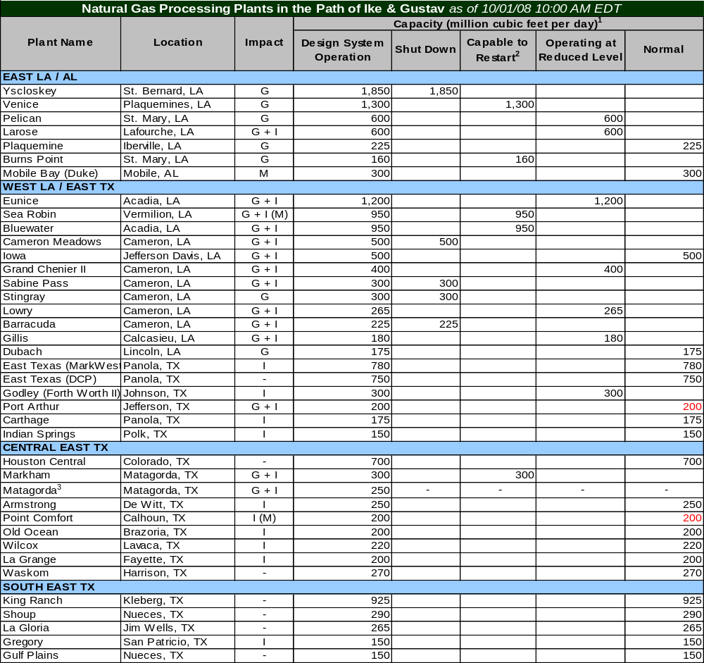Note: Storm column indicates hurricanes impacting processing plant: G = Gustav; I = Ike, G+I = Both storms, M = Maintenance, and - = no impact
“N/A” (Not Available or Confirmed) identifies those plants that are in the path of Ike that have not yet been confirmed of their status. ¹ The capacity represents the design capacity of the plants and does not represent the actual gas flow through these plants.
² Confirmed plants capable to restart after electricity is restored or when upstream gas flow commences service.
³ The Matagorda processing plants has been idle (mothballed) prior to Hurricane Gustav/Ike.
Sources: Confirmed by company or on company web site. Various trade press sources
Electricity Updates:

Texas:
As of: | 10/1/2008 6:00 AM EDT

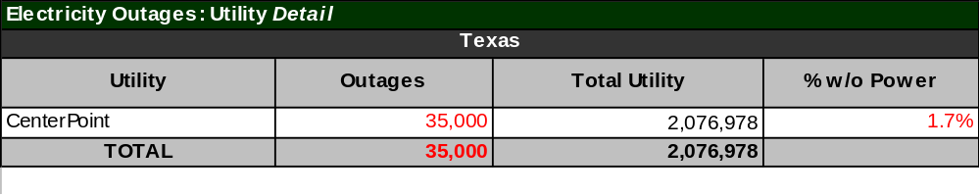Total utility customers are based on TXPUC outage reports.
Note: due to a large number of service providers, including investor owned utilities and cooperatives, the number of customer outages reported may not be comprehensive.

- As of 6:00 AM EDT October 1, there are 35,000 customers without power in Texas. Over 119,380 customers had power restored since Ike Situation Report No. 20.

- CenterPoint has restored power to nearly all of the 2.1 million customers that lost power due to Ike. CenterPoint reports that 8,400 mutual assistance crews plus 4,200 internal crews and contractors are involved in the restoration.

