ICES-401-SPEC-002
Version 1.1
Revision Date: 5-13-99

`

DRAFT

Mission Operations Requirements DOCUMENT (MORD)
FOR THE
ICE, CLOUD & LAND ELEVATION SATELLITE (ICESat)

Goddard Space Flight Center
Greenbelt, Maryland 20771
Signature Page

Prepared/Approved by:

__________________________
Mark Kowaleski,
ICESat Operations Manager

Approved by:

__________________________
Michael Tasevoli,
Mission Systems Engineer

__________________________
William Anselm
Observatory Manager

__________________________
Richard Cassell,
Spacecraft Operations Manager

__________________________
Joe Dezio,
ICESat Project Manager

__________________________
Dolly Perkins,
ESDIS Project Manager

__________________________
James Abshire,
Instrument Scientist

__________________________
Eleanor Ketchum,
Instrument Systems Manager

__________________________
Bob Schutz,
Science Team Leader

David Hancock,
Science Computing Facility Manager

__________________________
Bob Stelmaszek,
Ground Station Manager

__________________________
Timothy Rykowski,
EOS Data Operations System Manager

__________________________
Stan Scott,
Distributed Active Archive Systems Interface Manager

__________________________
Clayton Sigman,
Networks and Security Systems Manager

__________________________
Scott Mitchell,
Flight Dynamics System Manager

__________________________
Peggy Jester,
Instrument Support Facility Manager

Table of Contents
1. Introduction 6
1.1 Purpose 6
1.2 Document Control 6
1.3 Scope 6
1.4 Document Approach 6
1.5 Document Organization and Requirements Allocation 6
1.6 Applicable Documents 7
2. Mission Level Requirements 8
2.1 Mission Phases 8
2.2 Mission Data Flow 10
2.3 Mission Operations Documentation 12
2.4 Major Reviews 15
2.5 Mission Operations Development Support 15
2.6 Acceptance and Transition Roles and Responsibilities 15
3. EOS Polar Ground Stations 17
3.1 Interface Standards 17
3.2 Baseline Ground Station Contact Scenario 17
3.3 Emergency Commanding 18
3.4 Wallops Flight Facility Ground Network Scheduling System 18
3.5 McMurdo Ground Station Support 19
3.6 Doppler Ranging 20
3.7 S-band Command & Telemetry Command Processing 20
3.8 Compatibility Test Van Support 20
3.9 Communications Links Testing 20
4. Ground Communications 21
4.1 Mission Operations System Communications 21
4.2 Spacecraft Integration & Test Communications 21
4.3 Launch Pad Communications 21
4.4 TDRS Communications 21
4.5 Science Distribution Communications 21
4.6 Communications Testing 21
5. Mission Operations Center 22
5.1 Mission Communications Support Profile 22
5.2 Major Interfaces 22
5.3 Flight Systems 25
5.4 Facility 25
5.5 Operational Coverage 25
5.6 Database Compatibility 25
5.7 Planning and Scheduling 25
5.8 Real-time Observatory Telemetry Monitoring 25
5.9 Trending Analysis 25
5.10 Observatory Commanding 26
5.11 Remote Monitoring Terminal 26
5.12 Sustaining Engineering 26
5.13 Anomaly Resolution 26
5.14 MOC Data Archive 26
5.15 Laser Flight Safety Operations 26
5.16 Flight Operations Team 27
5.16.1 Staffing and Organization 27
5.16.2 Personnel Availability 27
5.16.3 Emergency and Anomaly Access 27
5.16.4 Training and Certification 27
5.16.5 Rehearsal Support 27
5.17 Reliability 27
5.18 Security 28
5.19 Observatory Integration and Testing Support 28
5.20 Documentation 28
5.21 Reviews and Status Reporting 29
6. Flight Dynamics System 30
6.1 Mission Characteristics 30
6.2 Software, Hardware, Personnel, and Facilities 31
6.3 Mission Phases Support 31
6.3.1 Maneuver Constraints 31
6.3.2 Pre-Launch Phase 31
6.3.3 Check-out Period Phase 31
6.3.4 Calibration and Validation Phase 32
6.3.5 Maneuver Planning 32
6.3.6 Ground-Track Monitoring and Prediction: 32
6.3.7 Mission Planning Support 32
6.4 Orbit & Attitude Determination 33
6.4.1 Operational Orbit Determination 33
6.4.2 Operational Attitude Support 33
6.5 Sensor Support 33
6.5.1 Sensor Uploadable Parameters Support 33
6.5.2 Sensor Calibration Support 34
6.6 Products Exchange 34
6.6.1 FDS Products to the Mission Operations Center 34
6.6.2 MOC Products to the Flight Dynamics System 34
6.6.3 Flight Dynamics Products to the Science Team 34
6.6.4 Data and Products Archive 35
7. Instrument Support Facility 36
7.1 Instrument Flight Systems 36
7.2 Facility 36
7.3 Operational Coverage 36
7.4 Planning and Scheduling 36
7.5 Trending Analysis 36
7.6 Sustaining Engineering 36
7.7 Anomaly Resolution 36
7.8 Instrument Operations Team 37
7.8.1 Staffing and Organization 37
7.8.2 Personnel Availability 37
7.8.3 Emergency and Anomaly Access 37
7.8.4 Training and Certification 37
8. Level Zero Data Processing 38
8.1 General Level Zero Data Processing Functions 38
8.2 EDOS ICESat Mission Performance Reqirements 39
8.3 Data Products Latency Requirements 40
8.3.1 Calibration & Validation Phase Expedited Data 40
8.3.2 Flight Dynamics X-band Data Products 40
9. Science Data Processing 41
10. Science Data Archival & Distribution 42
10.1 NSIDC DAAC 42
11. Spacecraft Contractor Requirements 43
11.1 Engineering Data Archive 43
11.2 Integration & Testing Activities 43
11.3 Sustaining Engineering Support 43
11.3.1 Anomaly Resolution 43
11.3.2 Trending & Analysis 43
11.3.3 Software Maintenance 44
11.3.4 Maintain Flight Software Test Bed 44
12. GLAS Instrument Developer Requirements 45
12.1 Instrument Operations Training 45
12.2 Documentation 45
12.3 Integration & Testing Activities 45
12.4 On-Orbit Check-out & Transition Activities 45
12.5 Calibration and Validation Support 45
12.6 Engineering Data Archive 46
12.7 Instrument Sustaining Engineering 46
12.7.1 Anomaly Resolution Support 46
12.7.2 Trending & Analysis 46
12.7.3 Software Maintenance 46
13. Science Team Requirements 47
14. Appendices 48
14.1 Acronyms 48
14.2 Critical Requirements Allocation Matrix 51

Introduction
This is the Mission Operations Requirements Document (MORD) for the
Ice, Cloud, & Land Elevation Satellite (ICESat). This section discusses the purpose, scope, document organization, and applicable documents of this document.

Purpose
This MORD is derived from the ICESat Mission Systems Requirements Document, February, 1998. It serves to complete the Ground System Requirements of the Requirements Document Hierarchy, Figure 1, page 1, in terms of mission operations and ground system requirements.

Document Control
This MORD is maintained under the Configuration Management System of the ICESat Project Office.

The latest version of this document shall be available at the ICESat Homepage at URL: http://icesat.gsfc.nasa.gov/

Contacts for changes & comments:
Mark M. Kowaleski, ICESat Operations Manager
PHONE: 301-286-7816
EMAIL: mark.kowaleski@gsfc.nasa.gov

Mike Tasevoli, ICESat System Engineer
PHONE: 301-286-2321
EMAIL: Michael.Tasevoli.1@gsfc.nasa.gov

Scope
This MORD details the project-level ICESat mission operations and ground system requirements and is the governing document for the ICESat mission operational development. This is the controlling document for mission operations and ground system requirements, as well as the operational interactions and agreements required between the major mission elements.

The information in this document encompasses the mission level end-to-end operational requirements and implementation plans and agreements considered necessary to achieve the ICESat mission operationally. Lower level requirements shall be derived from these requirements by each respective mission element.

Document Approach
To minimize documentation, this MORD will include requirements for GSFC institutional support traditionally covered in separate documents. Hence, this document replaces the Detailed Mission Requirements (DMR) document. In response to this document, the ICESat project shall expect detailed ground system requirements to be derived, documented, and flowed down to the respective subsystems by the organization that the requirements have been allocated to.

Document Organization and Requirements Allocation
This document is organized and requirements are allocated as shown in the following table:

MORD Section | Requirements | Allocated to: | Requirements Accepted By:
1 | Introduction | All Elements | All
2 | Mission Level Requirements | All Elements | All
3 | Ground Station Requirements | GSFC, Code 450 | Bob Stelmaszek
4 | Ground Communications | GSFC, Code 423 | Clayton Sigman
5 | Mission Operations Center | Ball Aerospace | Richard Cassell
6 | Flight Dynamics System | Ball Aerospace | Scott Mitchell
7 | Instrument Support Facility | Science Team | Peggy Jester
8 | Level Zero Data Processing | GSFC, Code 423 | Timothy Rykowski
9 | Science Data Processing | GSFC, Code 971 | David Hancock
10 | Science Data Archival & Distribution | GSFC, Code 423 | Stan Scott
11 | Spacecraft Contractor Requirements | Ball Aerospace | Richard Cassell
12 | GLAS Instrument Developer Requirements | GSFC, Code 924 | James Abshire
13 | Science Team Requirements | Science Team | Bob Schutz

Applicable Documents
The following are applicable documents to the MORD:

- ICESat Mission Systems Requirements Document, 2/98.
- Ground System Interface Control Document; Data, 12/10/98.
- Ground System Interface Control Document; Radio Frequency, 4/99,
- Operations Handbook for the ICESat Observatory.
- EOSDIS Architecture Description Document (latest version on WWW).
- GLAS Instrument Description Document
- GLAS I-SIPS Software Architectural Design Document, October, 1998 (Version 2.0)
- GLAS Science Computing Facility (SCF) Plan, February, 1998 (Version 0.4)

Mission Level Requirements

Mission Phases
The following flow chart describes the major ICESat Mission Phases that shall be supported.

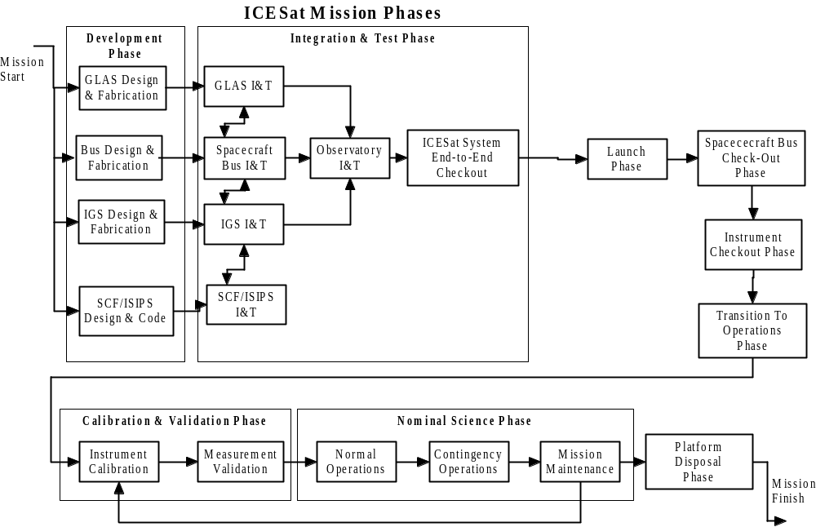

A description of each mission phase follows:
- Development Phase – the development and fabrication phases of each key mission element (GLAS, BUS, IGS, and SCF/SIPS)
- Integration & Test Phase – the I&T of each of the major mission elements as stand-alone elements, followed by a series of integration and test between the various mission elements. This phase culminates in a series of ICESat System End-to-End Check-out tests, including end-to-end data flow tests, simulations, and dress rehearsals.
- Launch Phase – these are all activities from packaging and shipment of the Observatory through launch and orbit insertion of the Observatory.
- Spacecraft Bus Check-out Phase – this is the time period from launch through acceptance of the spacecraft Observatory from Ball Aerospace by the government. This phase includes the activation and check-out of the spacecraft’s subsystems. This phase is expected to last ~ L + 30 days.
- Instrument Check-out phase – this phase coincides with the Spacecraft Bus Check-Out Phase and includes activation and check-out of the GLAS instrument’s subsystems. This phase begins ~ L + 5 days, immediately after key Spacecraft Bus subsystems have been activated.
- Transition to Operations Phase – this phase also coincides with the Spacecraft and Instrument Check-out Phases and culminates with transitioning flight operations control from the spacecraft contractor to the flight operations team ~ L + 30 days.
- Calibration & Validation Phase – this phase covers the time period from ~ L + 30 days to ~ L+ 120 days and includes the calibration and validation of the GLAS instrument’s subsystems and measurements.
- Nominal Science Phase – this is the operations phase of the ICESat mission beginning ~ L + 120 days. Normal operations includes activities such as orbit determination and maneuver planning/execution. Contingency operations includes operational responses to any anomalies that may occur. Mission maintenance includes any modification to GLAS or BUS flight software and any systems maintenance that may occur on the ground.
- NOTE: In addition, mission maintenance includes a periodic return (expected ~ L + 3 years) to the Calibration & Validation Phase resulting from the expected transition to back-up GLAS lasers due to expected laser deterioration.
- Platform Disposal Phase – this phases begins when the Observatory’s expendable resources have been depleted (L + 5 years). Note that the ICESat space segment has been designed for 3 years of operations with a goal of 5 years. Analysis indicates that the Observatory is expected to naturally reenter the earth’s atmosphere 25 years after EOL (~ L + 30 years).

Mission Data Flow
The following architecture diagram defines the top-level data flow to be supported by each of the ground system elements.
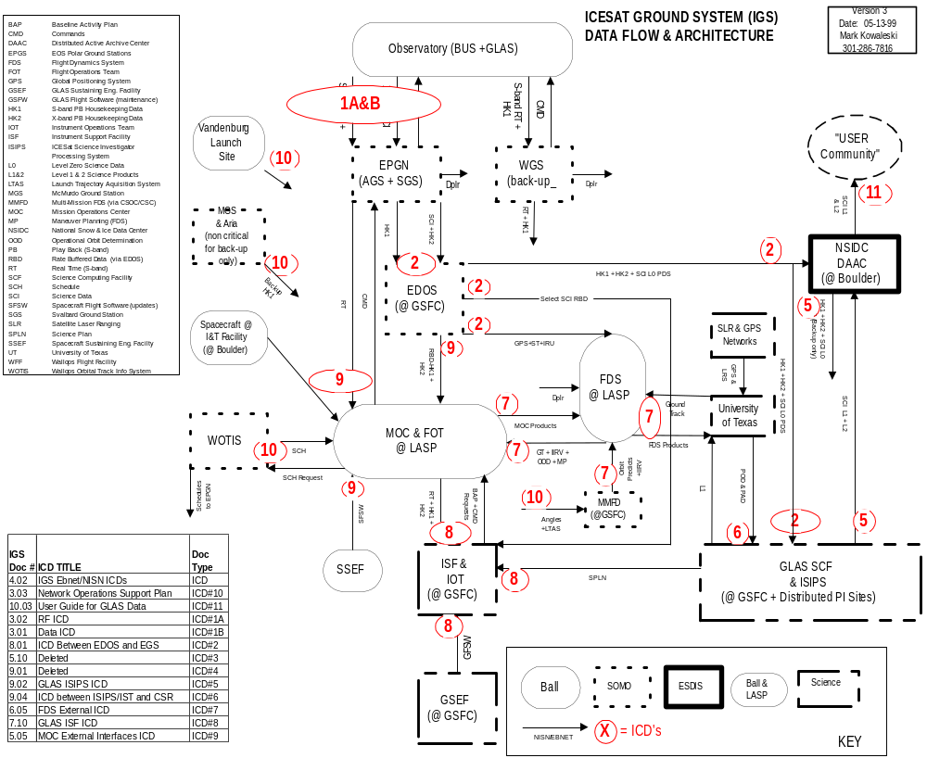

Mission Operations Documentation
Mission operations documentation is defined as those documents that are required to define, build, test, operate, and maintain the ICESat ground systems. The following table lists key documents and other media-based deliverables that are critical to the ICESat mission operations development. Some names and contents of documents are expected to change based on each element’s unique documentation system currently in place and these will be negotiated and documented as an update to this document. However, the intent, as is evident by the title of each document, shall be retained.

IGS Doc # | Document Title | Source | Actual DOC # | Comments/Trace
2.01 | IGS Master Schedule | All |  | IGS Requirement
2.02 | IGS Test Plan | TBD |  | Overall Test Plan for all IGS elements
2.03 | Mission System Requirements Document for ICESat Mission | Project
2.04 | Mission Operations Requirements Document (MORD) for ICESat, Versiom 1.0 | Project | ICES-401-SPEC-002
2.05 | Observatory Launch Site Operations and Test Plan | Ball |  | RSA CDRL 11
2.06 | Spacecraft Observatory Integration and Test Plan | Ball |  | RSA CDRL 6
2.07 | GLAS Instrument Laser Safety Analysis 11/1/98 | 924 | GLAS-924-ANYS-001
2.08 | Environmental Assessment | Project
2.09 | ICESat Mission Operations Concept Document | Project
2.10 | Project Support Level Agreement (PSLA) | Project
2.11 | MOC/FOT/FDS Procurement Package to SOMO/CSOC | Project |  | MOC requirements to SOMO
3.01 | Ground System Interface Control Document; Data | Ball |  | RSA CDRL 5B, See ICD # 1 in IGS Architecture
3.02 | RF ICD between the ICESat Spacecraft and the EPGS | Ball |  | RSA CDRL 5A, See ICD # 1 in IGS Architecture
3.03 | Network Operations Support Plan for the ICESat Mission | 450 |  | Similar approach used for QuikSCAT doc
3.04 | IGS CTV Support Plan | 450 |  | Similar approach used for QuikSCAT
3.05 | EPGS IGS Design Spec & Ops Plan | 450
3.06 | EPGS/WFF Test Plan | 450
4.01 | IGS Security Plan | 423
4.02 | IGS Ebnet/NISN ICDs | 423
4.03 | Ebnet/NISN Test Plan | 423
5.01 | ICESat T&C Handbook | Ball |  | RSA CDRL 5A
5.02 | Spacecrat Operations Description Manual for the ICESat Observatory | Ball |  | RSA CDRL 8
5.03 | Mission Requirements Document | Ball |  | RSA CDRL 18 (Mission requirements document for the spacecraft & ground system
5.04 | Spacecraft Operations Handbook for the ICESat Observatory | Ball |  | RSA CDRL 10
5.05 | MOC External Interfaces ICD | LASP |  | Similar approach used for QuikScat MOC ICD. See ICD # 9 in IGS Architecture
5.06 | Detailed MOC Requirements & Design Document | LASP |  | Include MOC Design, Staffing &Training Plans, Facility Plans
5.07 | MOC Operations Concept Document (MOCD) | LASP
5.08 | MOC Flight Operations Procedures | LASP |  | Detailed Operations Procedures and Contingencies
5.09 | MOC Operational Agreements with FDS, IOT, ST, and other mission elements (EPGS, WFF, etc.). | LASP
5.10 | EDOS to DAAC ICD (DELETED) | N/A | Deleted | See ICD # 3 in IGS Architecture
5.10 | MOC Test Plan | LASP
5.11 | Spacecraft Database (Electronic) | Ball
6.01 | FDS Detailed Requirements and Design Specification. | FDS |  | FDS design, staffing, facilities, etc.
6.02 | FDS Operations Procedures Handbook. | FDS
6.03 | FDS Test Plan (FDSTP). | FDS
6.04 | FDS Operational Agreements with FOT, IOT, ST, and other mission elements (EPGS, WFF, etc.). | FDS
6.05 | Flight Dynamics External Interfaces ICD | TBD |  | Serves as response to MORD. See ICD # 7 in IGS Architecture
7.10 | GLAS Instrument Support Facility (GISF) External Interfaces ICD | ISF |  | See ICD # 8 in IGS Architecture
7.20 | GLAS Operations Agreements | ISF
7.30 | GLAS Database (Electronic | GSEF |  | GLAS Database for MOC
8.01 | ICD Between EDOS and EGS Elements (Appendix to address ICESat Specifics) | EDOS |  | See ICD #2. This is EDOS CDRL B301. Replaces 5.10 and 9.01
8.02 | EDOS Detailed Design Specification | EDOS
8.03 | EDOS Test Plan | EDOS
9.01 | SCF to GSFC DAAC ICD (DELETED) | N/A | Deleted | See ICD # 4 in IGS Architecture
9.02 | GLAS ISIPS ICD (Appendix to existing generic ISIPS ICD) | SCF |  | See ICD # 5 in IGS Architecture
9.03 | GLAS ISIPS Softward Architecture Design Document | SCF
9.04 | ICD between ISIPS/IST and CSR | SCF |  | See ICD # 6 in IGS Architecture. Internal ICD to ISIPS/SCF.
9.05 | GLAS Level 0 Instrument Data Product Specification Ver 2.2 | SCF
9.06 | GLAS Level 0 Instrument Data Products Specification Level 1 Ver 1.2 | SCF
9.07 | GLAS Standard Data Products Specification Level 2 Ver 1.2 | SCF
10.01 | DAAC Design Document | DAAC
10.02 | DAAC Test Plan | DAAC
10.03 | User Guide for GLAS Data (Describes how users access GLAS data from NSIDS | NSIDC
11.01 | Spacecraft Engineering Data Archive | Ball
11.02 | Spacecraft Sustaining Engineering Support Plan | Ball
11.03 | Spacecraft Flight Software Maintenance Support Plan | Ball
11.03 | Spacecraft Simulator User's Manual | Ball
11.04 | Spacecraft Activation, Check-Out, and Transition Plan | Ball
11.05 | Spacecraft FMECA Analysis | Ball
12.01 | GLAS Engineering Data Archive | 924
12.02 | GLAS Sustaining Engineering Support Plan | 924
12.03 | GLAS Flight Software Maintenance Support Plan | 924
12.04 | GLAS Operations Manual | 924
12.05 | GLAS Fligth Software Manual | 924
12.06 | GLAS Training Plan & Materials | 924
12.07 | GLAS FMECA Analysis | 924
13.01 | GLAS Calibration & Validation Plan | ST

Major Reviews
The following are key operations and ground system reviews that shall be supported.

Review Name | Description & Relationship to Mission Operations and Ground Systems | Lead Element | Month/Year
IGS Critical Design Review | Overall Design Review of all Ground System elements (MOC, FOT, IOC, IOT, FDS, etc.). | BASD | December, 1999
Mission Operations Review (MOR) | Demonstration of mission operations readiness to support mission, including I&T support. Joint review with BASD, GLAS, ESDIS, CSOC, and Science. | BASD | December, 1999
Flight Operations Review | Demonstrate that all flight and ground systems and personnel reflect the deployed state of the system. Joint review with BASD, GLAS, ESDIS, CSOC, and Science. | BASD | April-01
Operations Readiness Review (ORR) | Focuses on networks support readiness for ICESat. Also supported by MOC, ESDIS, etc. | CSOC | May-99
Launch Readiness Review (LRR) | (also called FRR) Demonstrates readiness to launch the spacecraft by all mission elements. Joint review with BASD, GLAS, ESDIS, and Science. | BASD | June-01
Mission Activation Review | Review by all mission elements of successful activation, transition, and calibration events. | ICESat Project | August-01

Mission Operations Development Support
Each mission element shall support the definition, implementation, testing, and transition to operations of the ICESat This includes participation in working groups and planning sessions, preparing materials, and participating in activities such as working sessions, reviews, testing, status reporting, simulations, and dress rehearsals.

Acceptance and Transition Roles and Responsibilities
- From the time of launch to final spacecraft acceptance by the government, the BASD Flight Director shall bear full responsibility, in concert with a team of experts from NASA, Ball, and the Instrument Developer, for the health and safety of the ICESat Observatory.
- After acceptance by the government, the BASD, through the MOC/FOT organization shall have full responsibility for the health and safety of the ICESat Observatory for the life of the mission.

EOS Polar Ground Stations
The EPGS Project consists of three ground stations: Alaska Ground Station (AGS), Svalbard Ground Station (SGS), and Wallops Ground Station (WGS). These ground stations shall provide space-ground telecommunications services for the ICESat spacecraft. These services consist of S-band command, S-band telemetry, and X-band telemetry. The Ground Network Project Office shall provide the use of the EOS Polar Ground Stations in Alaska (AGS) and Norway (SGS) for the life of the mission. The Ground Network Project Office shall also provide the use of WGS for back-up S-band command and telemetry support, including contacts to confirm certain periodic maneuvers that occur over the equator on the ascending pass towards Wallops. Code 450 shall provide the use of the EOS Polar Ground Stations in Alaska (AGS) and Norway (NGS) for the life of the mission. The contact schedule is described in the next section.

Interface Standards
- Up-link and down-link data formats are CCSDS compatible and data interface standards adhere to Applicable Document #2.
- Radio frequency interface specifications are specified to be compatible with the EOS Polar Ground Stations, as stated in the Applicable Document #3.
- The EPGS technical experts or their designees shall participate in the development and maintenance of these ICDs.

Baseline Ground Station Contact Scenario
The EPGS shall support the following ground station contact scenario.

Contact Characteristics | X-band Down @ 40 Mbps | S-Band Down @ 264 Kbps | R/T S-band Down @ 16 Kbps | S-band Up @ 2 Kbps
Base-line ground station antenna elevation angle for AOS | 10 degrees | 5 degrees | 5 degrees | 5 degrees
Minimum Link Margin guaranteed by ICESat project at 10 degrees. | 3dB | > = 3dB | 3dB | > = 3dB
Minimum Scheduled Contacts from Launch Through Calibration  L + 120 days | Up to one contact every orbit | Up to one contact every orbit. | Up to one contact every available pass. | Up to one contact every available pass.
Minimum Scheduled Contacts for post-calibration normal operations from L+120 days to EOL | At least one contact every 6 hours | At least one contact every 6 hours | At least one contact every 6 hours | At least one contact every 6 hours
Contact Duration | Which ever comes first:  - time to dump SSR or  - time when contact terminates. | Which ever comes first:  - time to dump DSU or  - time when contact terminates. | Which ever comes first:  - time to dump DSU or  - time when contact terminates. | Which ever comes first:  - time to dump DSU or  - time when contact terminates.

After launch, the ground stations shall characterize the X-band communications links and determine a baseline contact scenario. This contact scenario will define the minimum ground antenna elevation angle for acquisition of signal (AOS). The baseline elevation angle for AOS is currently 10 degrees.

Emergency Commanding
Emergency commanding shall be made available within one orbit after the declaration of a flight system emergency by the flight operations team.

Wallops Flight Facility Ground Network Scheduling System
The Wallops Orbital Tracking Information System (WOTIS), located at the Wallops Flight Facility (WFF) is the central facility that the ICESat Mission Operations Center (MOC) interfaces with for scheduling ground station resources and obtaining post-pass reports. WOTIS will ingest the ICESat project schedule requests, employ de-confliction algorithms, and distribute the final schedules to ground stations and the ICESat MOC. WOTIS will provide scheduling support 24 hours per day, 7 days a week. Table 3-1 lists the typical transactions and transaction timing between the ICESat MOC and WOTIS.

Table 3-1. Typical WOTIS File Interchange Timeline

Step | File & Content | Action | Time Period
1 | Strawman Schedule  Contains initial supports at all GS using resources per the ICD | WOTIS generates initial schedule, using WOTIS generated Inviews, according to WOTIS/ICESat agreed scheduling rules. | T-3 weeks
2 | Update to Strawman Schedule  Contains only those supports needed by ICESat | MOC returns schedule to WOTIS with those supports needed, and may adjust times and activity codes; a new support may be requested, if needed. If Strawman is correct, no update needs to be returned. | T-3,2 weeks
3 | Operations Schedule Contains supports as they will be processed at each GS | WOTIS sends final Operations schedule to MOC, if desired. | T-1 week, usually Tuesday before Ops week
4 | Ephemeris | MOC sends IIRV or corrected NORAD 2-Line Elements, if needed; otherwise WOTIS automatically gets orbital elements from the Internet. | At least 3 days before pass to accommodate weekend and holiday operation. New data overwrites old data.
5 | GS Operations Schedule (AOTS Master) | WOTIS generates weekly and/or daily Operations Schedule (containing ephemeris) and forwards to GS via FTP. | Time span is for Operations week, generated on Thursday/Friday & updated daily as needed
6 | Post-Pass Summary File Contains the summary statistics from the support | WOTIS provides a summary of support results to MOC shortly after the completion of the support. | After each pass

.

McMurdo Ground Station Support
The McMurdo Ground Station (MGS) shall be available as a non-launch critical back-up resource for S-band RT and Playback telemetry and commanding of the ICESat Observatory. Under no circumstances shall ICESat be used as a driver for any development costs incurred by MGS. MGS is to be utilized only if available.

Doppler Ranging
The ground stations (AGS and, SGS, and WGS) shall provide two-way Doppler data for launch and early orbit check-out of the ICESat spacecraft, and for contingency operations in the event of on-board Global Positioning System (GPS) receiver failure.

S-band Command & Telemetry Command Processing
- All ground stations (AGS, SGS, and WGS) shall provide received Real-Time S-band telemetry data to the Mission Operations Center (MOC).
- All ground stations shall transmit commands received from the MOC to the ICESat spacecraft.
- All ground stations shall forward received S-band Playback telemetry data and all Real-Time S-band telemetry data to EDOS.
- AGS and SGS shall forward all received X-band data to the EDOS Ground Station Interface Facility (GSIF)
Spacecraft Raw Data Latency: The following data shall be made available for use by the FDS.:
a. X-band data packets that contain GPS raw data shall be available via EDOS at the FDS no later than 6 hours after the X-band ground station contact is completed.
b. S-band real-time data, including GPS on-board solutions data, shall be available at the FDS within 1 minute of ground station contact.
c. S-band playback data shall be available at the FDS via EDOS within 30 minutes of ground

Compatibility Test Van Support
- The Compatibility Test Van (CTV) shall be made available at the spacecraft contractor’s I&T facility for Radio Frequency testing of the ICESat spacecraft at the designated X-band and S-band frequencies.
- CTV Test Plans and Procedures, including facility and communications requirements, shall be provided.
- A CTV Test Report shall also be provided.
- The CTV shall also test at the WGS for compatibility, as required.

Communications Links Testing
Provisions shall be made such that the ground stations shall accept X-band and S-band test data as recorded from the spacecraft on CD-ROM media or direct transmission through commercial T-1 rate data links. This data shall be modulated and transmitted through the ground stations (only S-band for WGS) for simulated playback through the ground system.

Ground Communications
The ESDIS Project shall provide all ground communications infrastructure to support the mission requirements.

Mission Operations System Communications
ESDIS shall provide all ground communications networks and links required to support the ICESat mission operations, including long-haul data services from the polar ground stations to GSFC and inter-system communications that provide communications between all ground system elements and the Control Center, including voice loops, data lines, fax lines, and Internet connections.

Spacecraft Integration & Test Communications
ESDIS shall provide a data communications link between the spacecraft facility, Boulder, CO, and the EOC to be used for commanding and receiving telemetry from the spacecraft. The communications link shall be sized to support the S-band telemetry and command channels to/from the spacecraft.

Launch Pad Communications
ESDIS shall provide data communications link between the launch pad and the EOS Operations Center used for final check-out of the spacecraft and instrument prior to launch. The communications link shall be sized to support the S-band telemetry and command channels to/from the spacecraft.

TDRS Communications
TDRS communications services are not required for the ICESat mission, nor is it practical to close the Radio Frequency (RF) link due to low link margins.

Science Distribution Communications
ESDIS shall provide all network support services required to interconnect the data archive centers and the Science Computing Facilities. Specifically, support the exchange of processed science data from the SIPS to the NSIDC DAAC and ESDIS shall provide all external network connectivity to distribute science data products to the end user.

Communications Testing
ESDIS shall test and verify all communications links prior to interfacing with any ICESat mission element, the purpose of which is to mitigate risks due to unknown interface performance.

Mission Operations Center

Mission Communications Support Profile
The following chart shows the expected number of contacts expected to be supported by the MOC/FOT for the major mission phases shown.

Contact Characteristics | X-band Down @ 40 Mbps | S-Band Down @ 264 Kbps | S-band Up @ 2 Kbps | R/T S-band @ 16 Kbps
Minimum Scheduled Contacts from Launch Through Calibration  L + 120 days | Up to one contact every orbit | Up to one contact every orbit. | Up to one contact every available pass. | Up to one contact every available pass.
Minimum Scheduled Contacts for post-calibration normal operations L+ 120 days to EOL | At least one contact every 6 hours | At least one contact every 6 hours | At least one contact every 6 hours | At least one contact every 6 hours

Major Interfaces
The MOC shall interface with other elements of the ICESat Ground System. Refer to the data flow diagram on the following page.

A description of each external interface element is provided below.

- EOS Polar Ground Station (EPGS) in Alaska and Norway – EPGS’s are the primary ground stations for S-band command and telemetry and X-band data communications with the ICESat Observatory. The MOC shall interface with EPGS for real-time (R/T) housekeeping data and for command uploads.
- Wallops Ground Station (WGS) in Virginia – WGS provides back-up S-band command and telemetry interfaces. The MOC shall interface with WGS for backup command and control interfaces.
- Wallops Orbital Tracking Information System (WOTIS) in Virginia – the WOTIS provides planning and scheduling of ground station resources. The MOC shall interface with WOTIS to coordinate scheduling of the ground system.
- Earth Observing System (EOS) Data and Operations System (EDOS) at GSFC – EDOS provides the processing of Playback (PB) S-band housekeeping data and recorded X-band science data. The MOC shall interface with EDOS for receipt of the processed S-band data and for the exchange of scheduling information.
- GSFC Flight Dynamics System (GFDS) at GSFC – GFDS will primarily provide support during launch and early orbit (L&EO) and shall provide processing of the launch vehicle’s separation vector and provide acquisition data to the EPGS. The MOC shall interface with the GFDS and receive these GFDS products for command generation to adjust the Observatory’s orbit and attitude. GFDS may also be called upon to support emergency situations.
- EOSDIS Backbone Network (EBnet) and NASA Integrated Support Network (NISN) – Ebnet and NISN provide all communications networks that provide connectivity to all ground system elements. The MOC shall utilize these networks for all communications requirements external to the MOC.
- Instrument Support Facility (ISF) at GSFC – The ISF conducts long term instrument trending and analysis and contains the Instrument Operations Team (IOT). The MOC shall interface with the IST and receive science planning products and command requests generated by the IOT.
- ICESat Integration & Test (I&T) Facility at Ball Aerospace – The MOC shall interface with the Ball I&T facility during all phases of the I&T process. The I&T facility will also contain the Spacecraft Bus Simulator (SBS) to be used by the MOC when the spacecraft is not available for testing.
- ICESat Sustaining Engineering Facility (ISEF) at Ball Aerospace – The ISEF will contain the ICESat Flight Software Test Bed (FSTB). The MOC shall interface with the FSTB after launch to support testing of any software modifications and to receive software uploads generated by the FSTB. The ISEF includes personnel with which the MOC shall interface for anomaly resolution and trending analysis.

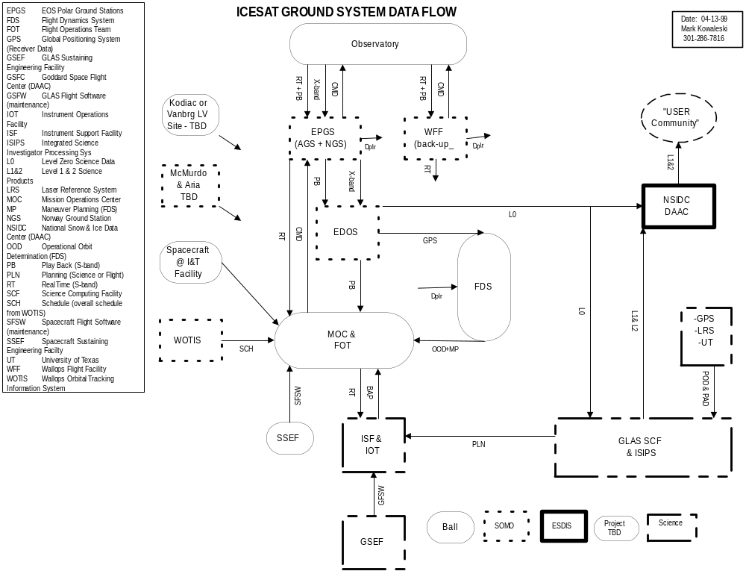Blank Page.

Flight Systems
- The contractor shall provide all MOC hardware and software systems.
- Only off-the-shelf or reusable control center software shall be proposed. No custom control center software solutions shall be proposed, except for unique scripts to code routine operations and monitoring, trending analysis, calculations, or display formats that may be necessary to meet unique requirements.

Facility
- The contractor shall provide all facilities necessary to house the systems and personnel that comprise the MOC, including floor space, Heating, Ventilation, and Cooling (HVAC), lighting, and physical security.
- Office space with a desk and internet connection for up to four project personnel (such as instrument engineers, project staff, etc.) shall be provided.

Operational Coverage
- The MOC shall operate on a basis consistent with the mission’s science requirements, schedule, and ground station contact scenarios. Autonomous (“lights out” or “brown out”) operations are encouraged as a means of reducing mission costs.
- All hardware and software systems shall operate on a 24 hour per day basis, 365 days per year.
- ICESat operations shall be conducted in coordination with the ICESat science objectives and plans as generated by the IOT and the science team (ST).

Database Compatibility
The MOC software shall be compatible with the Operations and Science Instrument Support (OASIS) database format. All ground systems to be implemented shall be compatible with the OASIS database and be driven by Integration & Test (I&T) database electronic files provided by Ball Aerospace.

Planning and Scheduling
- The MOC shall coordinate the planning and scheduling of all ground system resources and contacts.
- The MOC shall provide for the planning and scheduling of all flight related activities, including interfacing with the Instrument Operations Team for science maneuver planning.
- The MOC shall integrate the experiment command requests from the IOT.
- The MOC shall produce the spacecraft’s operation schedule and operations timelines.

Real-time Observatory Telemetry Monitoring
- The MOC shall monitor all real-time flight critical telemetry during all ground station contacts.

Trending Analysis
- The MOC shall conduct long term trending and analysis of the ICESat Observatory’s playback telemetry collected over the life of the mission. This includes critical spacecraft bus and instrument telemetry.
- The MOC shall provide predicted trends for critical Observatory parameters.
- The MOC shall deliver monthly trending curves and data reports shall be provided to Ball Aerospace for analysis and long term performance assessment.

Observatory Commanding
- The MOC shall provide for the real-time commanding of the ICESat Observatory.
- The MOC shall provide for the generation of stored command strings to be up-linked to the ICESat Observatory.
- The MOC shall provide the uploading of parameters (such as tables, software, etc.).

Remote Monitoring Terminal
- A monitor-only remote MOC terminal shall be provided to the ISF/IOT to support the monitoring of the ICESat Observatory by the IOT during all phases of the mission.
- Four monitor-only MOC terminals located at the MOC for use during launch and early orbit check-out operations by instrument and spacecraft bus engineering personnel shall be provided. These terminals shall be retained for the life of the mission.

Sustaining Engineering
The contractor shall maintain the MOC and perform sustaining engineering of all MOC hardware and software systems. This shall include the loading and testing of any software upgrades, hardware upgrades, and facility improvements required to sustain operations for the life of the ICESat Observatory.

Anomaly Resolution
- The MOC shall provide support for anomaly resolution of all Observatory anomalies. This includes coordinating such efforts with subsystem experts from Ball Aerospace and the GLAS instrument developer.
- Anomaly resolution includes interfacing with the GLAS developer and Ball Aerospace for the maintenance, correction, and uploading of flight software and other uploadable parameters.
- Monthly Anomaly reports shall be provided to the GSFC Reliability and Safety Office.

MOC Data Archive
- The MOC shall receive and permanently archive all S-band real-time and playback telemetry for the life of the mission.
- The MOC shall archive and make available to authorized users via File Transfer Protocol (or similar Internet connection) all products generated by the MOC, such as command files, maneuver planning files, trending data, schedules, etc. These files shall be maintained for the life of the mission.
- The MOC shall archive and make available to authorized users via File Transfer Protocol (or similar Internet connection) all products received by the MOC, such as maneuver planning products and orbit determination solutions received from the FDS. These files shall be maintained for the life of the mission

Laser Flight Safety Operations
There are no laser flight safety operational requirements for ICESat.

Flight Operations Team

Staffing and Organization
The contractor shall provide a flight team organization chart that at a minimum consists of a Flight Director and a FOT. A description of the roles and responsibilities of the Flight Director and each FOT member shall be provided.

Personnel Availability
- The contractor shall provide a dedicated Flight Director and at least one dedicated FOT member to support the development of the ICESat MOC/FOT. These individuals shall be referenced by name and shall be available to support the MOC/FOT development during all phases of the pre-launch period. The FD or a lead FOT member shall be made available to support MOC/FOT development upon contract award.
- These named individuals shall coordinate all activities directly with the ICESat Project’s Operations Manager.

Emergency and Anomaly Access
The contractor shall provide a system whereby members of the FOT shall be available on an on-call basis to provide anomaly resolution support in the event that a spacecraft emergency or anomaly situation occurs.

Training and Certification
Pre-launch training and post-launch continued training of the FOT personnel, including continued certification in flight operations of the ICESat Observatory shall be provided.

Rehearsal Support
The contractor shall support at least 3 Flight Operations Rehearsals for the purpose of training and developing flight operations proficiency. Each Rehearsal shall nominally be scheduled for a 5 day period at 24 hours each day. The Rehearsals to be supported are outlined as follows:
Rehearsal # | Purpose | Rehearsal Need Dates
Rehearsal # 1 | Basic Operations Training | L – 3 months
Rehearsal # 2 | Anomaly resolution and trouble-shooting. | L – 2 months
Rehearsal # 3 | Full Flight Dress Rehearsal | L – 2 months

Reliability
- The MOC shall be designed for an availability that meets the operational coverage requirements set forth in this MOPS. The contractor shall propose an availability calculation, along with supporting rationale, for the MOC/FOT system.
- No single point hardware or software failure points shall be implemented in the Real-Time telemetry and command processing system.
- Maintenance shall be scheduled during non-contact times and shall be conducted on only a non-operational functional string to ensure that a functioning string is always available to support telemetry monitoring and commanding.

Security
- Physical security shall be provided and demonstrated such that the MOC facility and systems shall be secured from unauthorized access. Unrestricted access to MOC facilities and computer systems is not acceptable.
- The MOC’s computer systems and supporting network interfaces shall be protected from unauthorized access.
- Flight Database access and updates shall be controlled.
- Security measure shall be taken to prevent database corruption and permanent database loss. At a minimum, a backup copy of all changed software, databases, and documentation shall be retained in a separate physical location other than the MOC.

Observatory Integration and Testing Support
The MOC/FOT shall interface with Ball Aerospace during all phases of the Observatory I&T process. This includes participating in all ground system simulations and rehearsals, including end-to-end science data flow tests, and interfacing with the Spacecraft Simulator and the Flight Software Test Bed (FSTB). The FSTB is the flight software development environment used by Ball Aerospace for the development, testing, and maintenance of flight software. In addition, the FSTB is used to simulate a high fidelity attitude control system.

In addition, the contractor shall interface with the Spacecraft Ground Support Equipment (GSE) to support integration & test activities. The contractor is encouraged to perform a site visit to fully understand these interface requirements.

Documentation
The contractor shall deliver the following documents to NASA/GSFC. If existing documentation structures used on other missions currently exist, these may be used in lieu of these documents provided they contain the necessary information.

Mission Operations Center Documentation:
- Integrated MOC/FOT/FDS Development Schedule.
- MOC External Interfaces Control Document (MEICD) that includes interfaces between all external MOC interfaces.
- Detailed MOC Requirements & Design Document (DMR&DD), that includes derived requirements, detailed design, staffing & training plans and facility plans.
- MOC Test Plan.
- MOC Flight Operations Procedures (MFOP).
- Operational Agreements with IOT, ST, and other major ground system elements (EPGS, WFF, EDOS, etc.).

Flight Dynamics Documentation:
The FDS contractor provide the following documentation:
- FDS External Interface Control Document (FEICD) (may be combined with the MOC External Interfaces ICD).
- FDS Detailed Requirements and Specification.
- FDS Test Plan (FDSTP).
- FDS Operations Procedures Handbook.
- Operational Agreements with the FOT, IOT, ST, and other mission elements (EPGS, WFF, etc.).

Reviews and Status Reporting
The contractor shall provide the following reviews and status reporting (note, some reviews likely to be combined with existing reviews base-lined in the ICESat contract):

- Status Reports to the ICESat Operations Manager (Monthly)
- Requirements/Design Review (~ L - 18 months)
- Flight Operations Review (~L - 4 months)
- Launch Readiness Review (~L - 1 months)
- The contractor shall provide a FDS Design Review (FDSDR) subject to a peer review approval of the design by a peer review team made up of the Goddard Space Flight Center’s Flight Guidance and Navigation personnel, Science Team personnel, and University of Colorado personnel.

Flight Dynamics System
The Flight Dynamics System (FDS) shall be that part of the MOC which provides overall Guidance & Navigation (G&N) for the ICESat mission. With the exception of the NASA-provided services described below, the contractor shall provide all the FDS functions described in Section 4.
NASA Provided Flight Dynamics Services
There are flight dynamics related services that will be provided by the GSFC Flight Dynamics (GFD) Guidance & Navigation Branch that will support the contractor provided FDS and will include the launch and early orbit (L&EO) support traditionally provided by GFD for other satellite projects. The GFDS will interface with the contractor provided FDS for this L&EO support.

The following L&EO functions will be provided by the GFD:
- Work with NASA ground stations to analyze and verify tracking system accuracy.
- Serve as the interface to the launch contractor for acquiring and processing launch trajectory predicts and initial post-separation spacecraft orbit predicts.
- Acquire LTAS data from launch site and process to generate initial orbit predict.
- Acquire NORAD tracking data and process to generate orbit predicts.
- Acquire UTDF angles tracking data from NASA ground stations after passes and process into orbit predicts.
- Generate initial orbit predict after spacecraft separation and distribute as IIRV to the MOC, WOTIS and to ground stations.
- Generate updated orbit predicts every four hours for the first 24 hours after launch and distribute as IIRVs to the MOC, WOTIS and ground stations.
- Generate updated orbit predicts every 24 hours, starting one day after launch and continuing through seven days after launch and distribute as IIRVs to the MOC and WOTIS.
- Orbit Determination based on Ground Station Doppler-ranging and X-Y angles data from the ground tracking stations (if GPS data is not available).

NOTE: The contractor shall provide all FDS functions described in the remaining sections of Section 4.

Mission Characteristics
The following are the top-level ICESat mission characteristics applicable to the FDS.
- Inclination = 94 degrees.
- Altitude = 600 km.
- Orbit = non-sun synchronous frozen orbit.
- 2 repeat orbits (183 days during mission and 8 days during calibration).
- +/- 800 meter ground track control at all latitudes.
- Spacecraft Raw Data Latency: The following data shall be made available for use by the FDS.
- X-band data packets that contain GPS raw data shall be available via EDOS at the FDS no later than 6 hours after the X-band ground station contact is completed.
- S-band real-time data, including GPS on-board solutions data, shall be available via the EPGS and WFF at the FDS within 1 minute of ground station contact.
- S-band playback data shall be available at the FDS via EDOS within 30 minutes of ground station contact.

Software, Hardware, Personnel, and Facilities
- The contractor shall provide all FDS software development and maintenance and all hardware systems and training required to operate the software for the life of the mission.
- The contractor shall provide all FDS personnel and facilities required to operate the flight dynamics systems for the life of the mission.

Mission Phases Support

Maneuver Constraints
- No maintenance maneuvers shall occur over Antarctica or at points above 60 degrees latitude that are coincident with Greenland over-flights except in special or emergency circumstances.
- Ground track maintenance shall be performed using only one maneuver when possible.
- Frozen orbit maintenance shall be done in conjunction with the ground track maintenance maneuver.
- Maneuvers shall be constrained to occur no more frequently than once daily to support the Precision Orbit Determination (POD).

Pre-Launch Phase
The Pre-launch period shall cover all time up to separation from the launch vehicle. The following FDS functions and services shall be provided:

- Mission Analysis and Design Delta Velocity (Delta V) Budget calculation and analysis.
- Injection Orbit Selection analysis.
- Reentry analysis (lifetime).
- Ground Station coverage analysis.
- Launch window analysis.
- Operations Planning, including participation in launch rehearsals and simulations.

Check-out Period Phase
The Check-out period is the time from launch vehicle separation to the time the spacecraft bus has been accepted by the government (approximately 30 days). The following FDS functions and services shall be provided:

- Ingest and process launch vehicle separation vector from GFDS.
- Planning and calibration of all orbit raising maneuvers.
- Planning and calibration of all routine ground track maintenance maneuvers.
- Planning and calibration of inclination maneuvers.
- Thruster calibration for the orbit attainment maneuvers.
- Thruster calibrations for the orbit maintenance maneuvers.
- Orbit determination and prediction based on GPS data from the flight receiver.
- On-board attitude validation support.
- Anomaly resolution support.
- Sensor calibration support.
- Provide Orbit Predictions in Improved Inter-Range Vector (IIRV) format to the ground station network.
- Convert Maneuver Plan into commands and table uploads for uplink to spacecraft.

Calibration and Validation Phase
The Calibration and Validation period covers all time from acceptance of the spacecraft by the government to the time that the GLAS instrument has been calibrated and validated and science data gathering begins. The following FDS functions and services shall be provided:

- Planning and calibration of the inclination and ground-track maintenance maneuvers.
- Support onboard orbit and attitude determination validation.
- Anomaly resolution support.
- Sensor calibration support.
- Generation of planning and scheduling data products used by the MOC.
- Provide Orbit Predictions in Improved Inter-Range Vector (IIRV) format to the ground station network.
- Convert Maneuver Plan into commands and table uploads for uplink to spacecraft.

Maneuver Planning
The contractor shall provide maneuver planning and maneuver calibration for all phases of mission operations. The FDS system shall be capable of designing three types of maneuvers:
- Drag Make-up Maneuvers - along track maneuvers to adjust the orbit semi-major axis shall be designed to change the ground-track drift rate relative to the exact repeat orbit.
- Inclination Maneuvers - across track maneuvers to adjust the orbit inclination shall be designed to change the ground-track offset at high latitudes relative to the exact repeat orbit.
- Orbit Change Maneuvers - two along track maneuvers to adjust the orbit semi-major axis shall be designed to switch between the calibration and mission orbits.

NOTE: The effect of these maneuvers on the mean orbit elements and ground-track offset shall be predicted and communicated to the MOC.

Ground-Track Monitoring and Prediction:
- The Ground-Track shall be monitored daily and compared to that of the calibration or mission orbit, whichever is appropriate. Such monitoring shall be valid for all latitudes.
- The Ground-Track evolution shall be predicted to aid in maneuver planning. Such predictions shall make use of solar activity predictions to anticipate atmospheric drag, and the effect of luni-solar gravity on the orbit inclination.
- The Ground-Track output shall consist of both a graphical display of predicted ground-track offset, and tables of predicted mean orbit element and ground-track offset evolution.

Mission Planning Support
- Determine coarse real-time ICESat attitude.
- Provide mission planning aids.
- Provide attitude sensor hardware performance monitoring.
- Determine predictive ICESat orbit ephemeris and perform maneuver prediction and planning.
- Provide near-real-time maneuver monitoring (temperature, pressure, etc.).
- Provide acquisition data products.
- Assess the post-maneuver spacecraft state.

Orbit & Attitude Determination

Operational Orbit Determination
The contractor shall provide Operational Orbit Determination (OOD) using GPS data from the flight receiver in combination with GPS data from a worldwide network of ground tracking sites. Accuracy and timeliness shall be as follows:

Orbit Monitoring and Maneuver Planning OOD:
- Along track position: Within 5 meters (1 sigma).
- Across track position: Within 5 meters (1 sigma).
- Radial position: Within 1.0 meters (1 sigma).
- ODD Latency: Within 2 hours after X-band data received at FDS.
- Comparison with POD: Flight Dynamics shall compare the OOD with the POD generated by the ST on a periodic basis in support of the onboard GPS validation.

Propagation Accuracy of the OOD solution after 1 day:
- Along track position: Within 1.0 kilometer (1 sigma).
- Across track position: Within 10 meters (1 sigma).
- Radial position: Within 10 meters (1 sigma).
- ODD Latency: Within 2 hours after X-band data received at FDS.

Propagation accuracy of the OOD solution for Antenna Pointing ODD after 24 hours of propagation and 24 hours after a maneuver:
- Along track position: Within 4 kilometers (1 sigma).
- Across track position: Within 4 kilometers (1 sigma).
- Radial position: Within 4 kilometers (1 sigma).
- ODD Latency: Within 2 hours after X-band data received at FDS.

Operational Attitude Support
The contractor shall provide the following Operational Attitude (OA) support:

- The FDS shall calculate and monitor off-nadir pointing by running the off-nadir pointing algorithm provided by the University of Colorado.
- The FDS shall generate the off-nadir quaternions and provide them to the MOC for uploading to the spacecraft.

Sensor Support
The contractor shall provide for the operation, maintenance, and calibration of various sensors used on the spacecraft.

Sensor Uploadable Parameters Support
The spacecraft contractor (Ball Aerospace) will provide periodic updates for the following sensors and subsystems. FDS shall support these updates.
- Star Catalog for spacecraft bus star tracker:
- Updates with respect to proper stellar motion (estimated annual upload of approximately 50 stars).
- Updates of a star Precession Quaternion (estimated weekly upload).
- GPS Initial Conditions Vector - Initialization of the GPS receiver whenever a Spacecraft Control Computer (SCC) reset takes place.
- Magnetic Field Tables – Table upload approximately annually.

GSFC shall provide star tracker updates for the GLAS star tracker.

Sensor Calibration Support
The contractor shall participate in the following calibration activities with support from the spacecraft contractor (Ball Aerospace) and science operations:
- Calibrate alignments of the Solid State Star Tracker (SSST), and Inertial Reference Units (IRU).
- Calibrate the star-tracker’s field-of-view (FOV) calibration coefficients.
- Calibrate the IRU scale factors and drift rate biases (3-axis calibration at varying rates).

Products Exchange

FDS Products to the Mission Operations Center
The contractor shall generate the following products for use by the MOC on a routine basis for all phases of the mission:

- Operational Orbit Determination and Propagated State Vectors.
- Maneuver Design (magnitude, attitude, and time).
- Ground Track Offset Plot and Table (actual versus predicted time).
- Plots and Tables to monitor the frozen orbit, including Inclination, Eccentricity, and Argument of Perigee parameters.
- Initial Condition Vector for the SCC and/or GPS, as needed.
- Generation of base time load to correlate the spacecraft clock (clock correlation code).
- Orbit & Attitude verification support.

MOC Products to the Flight Dynamics System
The MOC shall make available the following products to the FDS:

- Propulsion system data, including tank pressure and temperature.
- The MOC shall make available to the FDS by electronic file transfer all raw S-band real-time and playback data received and all products generated by the MOC.
- Solar Array Encoder Conversions.

Note: The spacecraft contractor (Ball Aerospace) will provide the equations for the spacecraft mass model and the propulsion model.

Flight Dynamics Products to the Science Team
The FDS shall make available the following products to the science team.
- Inertia & Mass Properties.
- Maneuver magnitudes and timelines.
- OOD solutions.
- CT-602 Star Tracker data.

Data and Products Archive
The FDS shall maintain a data archive with the following characteristics:
- The FDS shall permanently archive all data received and products generated by FDS for the life of the mission. In particular, all orbit elements and propulsion data shall be permanently archived.
- All data archives shall be readily accessible (via File Transfer Protocol, etc.) by authorized users external to the FDS for the life of the mission.

Instrument Support Facility

Instrument Flight Systems
All ISF hardware and software systems that are necessary to meet the instrument operations requirements shall be provided.

Facility
- All facilities necessary to house the ISF systems and personnel that comprise the ISF shall be provided. This includes floor space, lighting, and physical security.
- Office space with a desk and internet connection for up to two project personnel (such as an instrument engineer, project staff, etc.) shall be provided.

Operational Coverage
- The ISF/IOT shall be operated on a nominal 5 day, 8 hour per day schedule. Autonomous (lights out or brown) operations are encouraged as a means of reducing mission costs during non-normal working hours.
- All hardware and software systems shall operate on a 24 hour per day basis, 365 days per year.

Planning and Scheduling
- The ISF/IOT shall generate science plans, goals and objectives, and schedules for instrument operations that are in accord with the science plans and objectives.
- The ISF/IOT shall generate any unique planning and scheduling, such as for off-pointing for specific geographic areas.
- The ISF/IOT shall generate all instrument command requests and transmit them to the MOC/FOT for transmission to the Observatory.

Trending Analysis
- The ISF shall provide for the long term trending and analysis of the GLAS Instrument’s telemetry collected over the life of the mission. This includes critical related spacecraft bus telemetry.
- Trending requirements shall be provided by the GLAS Instrument Developer.
- Monthly trending curves and data reports shall be provided to the GLAS Instrument Developer for analysis and long term performance assessment.

Sustaining Engineering
The ISF/IOT shall provide for the maintenance of all ISF hardware and software systems. This includes the loading and testing of any software upgrades, hardware upgrades, and facility improvements required to sustain operations for the life of the ICESat Observatory.

Anomaly Resolution
- The ISF shall provide support for anomaly resolution of all Instrument anomalies and related spacecraft bus anomalies.
- The ISF shall interface with the GLAS Sustaining Engineering Facility (GSEF) and shall include interfacing with subsystem experts from the GLAS Instrument Developer.
- The GSEF shall include the GLAS Developer’s GLAS Software Maintenance Facility (GSMF) for the maintenance, correction, and uploading of instrument software and other uploadable parameters. The ISF shall accept GLAS software uploads from the GSMF/GSEF for transmission to the MOC/FOT for transmission to the Observatory.
- Monthly Anomaly reports shall be provided to the GSFC Reliability and Safety Office.

Instrument Operations Team

Staffing and Organization
An Instrument Operations Team (IOT) shall be provided sufficient to meet the GLAS instrument’s operational requirements. A staffing profile sufficient to meet the requirements of the ICESat mission shall be provided. At a minimum, an IOT organization chart that consists of an Instrument Director and an IOT member shall be provided.

Personnel Availability
- The ISF shall provide a dedicated Instrument Operations Director (IOD) and at least one dedicated IOT member to support the development of the ICESat IST/IOT. These individuals shall be referenced by name and shall be available to support the IST/IOT development during all phases of the pre-launch period.
- The IOD shall coordinate all activities directly with the ICESat Project’s Operations Manager.

Emergency and Anomaly Access
A system shall be provided whereby members of the IOT shall be available on an on call basis to provide anomaly resolution support in the event that a spacecraft or instrument emergency or anomaly situation occurs.

Training and Certification
Pre-launch training and post-launch continued training of the IOT personnel, including continued certification in flight operations of the GLAS instrument and overall ICESat Observatory shall be provided.

Level Zero Data Processing
Level Zero Data Processing (LZDP) shall be done on the X-band down-link data.

General Level Zero Data Processing Functions
1.1 | EDOS shall provide a safe backup of all ICESat GLAS Level 0 data sets produced by EDOS.
1.2 | EDOS shall support ICESat pre-launch activities (e.g., operational readiness tests and simulations).
1.3 | EDOS shall maintain/assure the integrity of all ICESat data received, stored, and transmitted.
1.4 | EDOS shall support ICESat operations 24 hours per day, 7 days per week on a continuous basis.
1.5 | EDOS shall support the CCSDS AOS Grade of Service 2 and 3.
1.6 | EDOS shall provide the capability for capture of all ICESat X-band high rate return link data on separate, non-volatile, physical media, and for storage for 30 days after receipt.
1.7 | EDOS shall provide Reed-Solomon (Grade of Service II) decoding on the ICESat high rate return link data as required.
1.8 | EDOS shall provide AOS CCSDS Path and Virtual Channel Data Unit services on ICESat return link data.
1.9 | EDOS shall provide processing support to produce Level 0 data sets (production data sets) [PDSs] and expedited data sets [EDSs] for the GLAS instrument packets.
1.10 | EDOS shall provide Customer Operations Data Accounting (CODA) reports to the ICESat Flight Operations Segment located in Boulder, CO every 5 seconds.
1.11 | EDOS shall provide SCS (spacecraft summary session) summary reports to the ICESat Flight Operations Segment located in Boulder, CO after each spacecraft contact.
1.12 | EDOS shall deliver a data file containing Star Tracker, IRU, LRS, and GPS packets to Flight Dynamics Facility (FDF) within 6 hours of receipt of downlink at a GSIF
1.13 | EDOS shall distribute physical media containing archived GLAS PDSs to the ISIPS located at the Wallops Flight Facility upon request(D3 tapes).
1.14 | EDOS shall provide processing support for ICESat low rate data that are played back from the spacecraft recorder.
1.15 | EDOS shall provide Reed-Solomon (Grade of Service III) decoding on the ICESat low rate return link data as required.
1.16 | EDOS shall provide rate buffered delivery service for ICESat low rate return link data.
1.17 | EDOS shall receive schedules for downlink support from the ICESat Control Center located in Boulder, CO
1.18 | EDOS shall receive, create, and deliver all external data products including schedules, rate buffered data, EDSs, PDSs, CODA reports, and SCS summary reports, in conformance with the EDOS-EGS Elements ICD.
1.19 | EDOS shall deliver PDSs and EDSs to the ISIPS system located at the Wallops Flight Facility.
1.20 | EDOS shall archive all GLAS Production Data Sets (PDSs) on physical media (D3 tapes) at the Data Archive Facility (DAF) located at White Sands, New Mexico.

EDOS ICESat Mission Performance Reqirements
2.1 | EDOS shall provide frame synchronization for ICESat high rate return link data at rates up to 40 Mbps from one physical channel.
2.2 | EDOS shall provide processing support to produce GLAS PDSs from single spacecraft contact sessions at the average incoming data rate of 500 kbps per orbit.
2.3 | EDOS shall provide processing support to produce GLAS EDSs from single spacecraft contact sessions for selected data at the average data volume of 2% of production data set volume.
2.4 | EDOS shall deliver GLAS PDSs to the GSFC DAAC, within 24 hours of receipt of all appropriate input data at GSFC.
2.5 | EDOS shall deliver GLAS EDSs to the GSFC DAAC, within 3 hours of receipt of all appropriate input data at GSFC.
2.6 | EDOS shall provide frame synchronization for ICESat low rate return link playback data at rates up to 262.144 kbps from one physical channel.
2.7 | The LZPF shall initiate the transfer of rate buffered data to a destination within 5 minutes after receipt of all of the data for the rate buffering session.
2.8 | The LZPF shall have an MTTRes of 2 hours or less for all functionality required to support non-real-time mission data handling.
2.9 | The LZPF shall have an operational availability of 0.998 or greater to support non-real-time mission data handling.

Data Products Latency Requirements
The following table summarizes the latency requirements for S-band and X-band data.
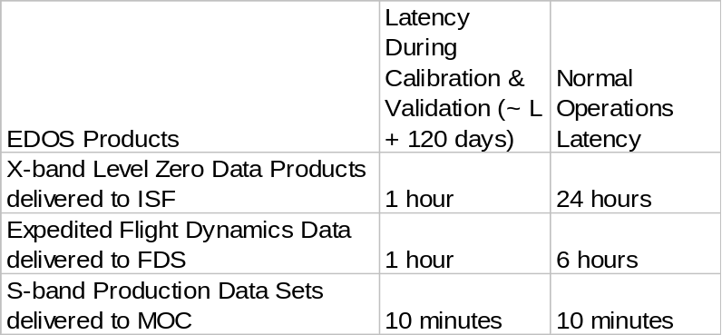

Calibration & Validation Phase Expedited Data
During the calibration & validation phases (~L+120 days), select science products shall be delivered to the ISF within 1 hour of receipt at the ground station.

Flight Dynamics X-band Data Products
The EDOS shall extract and deliver to the FDS the GPS data packets within 6 hours of X-band contact to the Flight Dynamics Facility.

Science Data Processing
Perform Science Data Processing in accordance with the GLAS Science Software Requirements Document.

- Receive Level Zero Data Products from the LZDP facility.
- Produce Level 1 and Level 2 Standard Data Products.
- Deliver Level 1 and Level 2 Standard Data Products to the Science Data Archive & Distribution Facility.

Science Data Archival & Distribution

NSIDC DAAC
- Accept Level 0 production data sets from EDOS.
- Accept Level 1 and Level 2 Standard Data Products from the ISIPS Facility.
- Provide a permanent archive of Level 0, Level 1 and Level 2 data products.
- Maintain a Database of all data products in the Archive.
- Update the Archive and the Database when reprocessed products are delivered.
- Accept requests from the user community for specific data products.
- Distribute data products to the user community as requested.

Spacecraft Contractor Requirements

Engineering Data Archive
BASD shall maintain a permanent archive of all spacecraft engineering data, including schematics, specifications, operations manuals and drawings that are necessary to trouble-shoot and maintain the spacecraft during on-orbit operations. This data archive is to be maintained at BASD under configuration management for the life of the mission.

Integration & Testing Activities
BASD shall schedule support for the following major ground system tests.

GSCT # | S/C Activity – ICEsat | Approximate Month/Year
#1: Basic Tlm, command | S/C Bus performance Test | 4/00
#2: RF Tlm, CMD | Transmitter, SSR  with CTV | 6/00
#3: Instrument Ops | Post electrical Integration CPT/APT | 12/00
#4: Full ETE Dry Run | Post Thermal Vac | 1/01
#5: Full ETE | Post Thermal Vac | 2/01 and 4/01
#6: Launch Site ETE | Align SFF | 6/01
#7: Pad ETE | Payload Aliveness and ESDIS | 7/00

Sustaining Engineering Support

Anomaly Resolution
BASD shall provide anomaly resolution support to resolve any Observatory anomalies that may occur from launch through mission end-of-life (EOL). This includes supporting the development of any Observatory operating contingencies resulting from unplanned changes in the mission operations baseline (e.g., changes in orbit, power, subsystem degradation, etc.) and to support the resolution of anomalies such as software errors, out of tolerance parameters, etc., and providing expert consultation to the FOT.

Trending & Analysis
BASD shall provide capabilities to trend and analyze key Observatory parameters. This includes any trending or analysis of the Observatory’s operating and health & safety conditions, especially when needed in support of anomaly resolution. This also includes trending and analysis to support planned Observatory flight configuration changes, including raising from calibration to mission orbit, transition to first full eclipse season, and executing required yaw transitions.

Software Maintenance
BASD shall provide FSW maintenance. This shall include the maintenance of development and test beds and providing expertise to modify, test, and deliver any uploadable FSW or parameters that may be required during mission life.

NOTE: Although FSW source code shall be delivered to the government, the government shall not modify any FSW code.

Maintain Flight Software Test Bed
The provisions for the Flight Software Test Bed (FSTB) shall be as follows:
- The FSTB shall remain resident at BASD to EOL.
- The FSTB shall be dedicated to the ICESat mission to EOL, meaning that the ICESat FSTB shall not be used for any other spacecraft developments.
- The FSTB shall be accessible for off-line FOT training and FSW validation purposes with the MOC on a scheduled basis to EOL.
- BASD shall maintain the FSTB to EOL.
- BASD shall remain technically cognizant and technically competent in the operation of the ICESat FSW and the FSTB to EOL.

GLAS Instrument Developer Requirements
Code 924, the GLAS Instrument Developer, shall provide the following functions and services to support the ICESat operations.

Instrument Operations Training
Code 924 shall provide training for the Instrument Operations Team (IOT) and Flight Operations Team (FOT) personnel in instrument operations and maintenance. This shall include the development of written training materials, providing formal classroom training, and on-the-job training (OJT) during instrument and observatory Integration & Test (I&T) to a level deemed sufficient by the organizations to be trained to transfer operational knowledge of the GLAS Instrument to these operations personnel.

Classroom Training
Code 920 shall provide formal classroom training to the IOT and the FOT. This shall include a video taped session, training materials, and documentation.

On the Job Training (OJT)
At the GLAS I&T facility at GSFC, the IOT and FOT shall have access to the GLAS instrument in an observation capacity during key phases of the GLAS I&T process. These observation sessions shall serve to familiarize the IOT/FOT with the flight hardware.

Documentation
Code 920 shall provide operations documentation that includes:
- GLAS Operations Manual
- GLAS Flight Software Manual

Integration & Testing Activities
Code 924 shall participate in end-end science data flow tests with the ground system prior to launch. This includes supporting any simulations and dress rehearsals for the analysis of instrument science and engineering data, and to support the development of the Science Computing Facility (SCF) for instrument operations and science data processing, and to support the development of the MOC/FOT for nominal observatory level operations.

On-Orbit Check-out & Transition Activities
- Code 924 shall support the on-orbit check-out and transition phases.
- Code 924 shall provide personnel to be resident at the MOC to support the FOT/IOT during on-orbit check-out of the ICESat bus and the GLAS instrument.
- Code 924 personnel shall monitor telemetry and approve all commands sent to the Observatory during this phase.

Calibration and Validation Support
Code 924 shall support the Calibration and Validation (C&V) Phase. C&V support includes analysis and evaluation of on-orbit GLAS performance.

Engineering Data Archive
- Code 924 shall maintain a GLAS Engineering Data Archive to includes all schematics, specifications, operations manuals, drawings, and test results that are necessary to trouble-shoot and maintain the instrument during on-orbit operations.
- This archive shall to be maintained under configuration management for the life of the mission.

Instrument Sustaining Engineering
Code 924 shall provide the following sustaining engineering functions for the life of the ICESat mission.

Anomaly Resolution Support
Code 924 shall provide Anomaly Resolution Support to resolve any GLAS Instrument anomalies that may occur from launch through mission end-of-life (EOL). This includes supporting the development of any instrument operating contingencies resulting from unplanned changes in the mission operations baseline (e.g., changes in orbit, power, subsystem degradation, etc.) and to support the resolution of anomalies such as software errors, out of tolerance parameters, etc., and providing expert consultation to the IOT/FOT.

Trending & Analysis
Code 924 shall provide Trending & Analysis of key GLAS parameters. This includes any trending or analysis of GLAS operating and health & safety conditions, especially when needed in support of anomaly resolution. This also includes trending and analysis to support planned GLAS flight configuration changes (such as laser switching or altimetry detector switching) and any calibration and validation support required to support these activities.

Software Maintenance
Code 924 shall provide GLAS Flight Software (GFSW) Maintenance. This includes maintaining GFSW development and test beds and providing expertise to modify, test, and deliver any uploadable FSW or parameters that may be required during mission life.

Science Team Requirements
Calibration & Validation
MODIS Overflights
Need inputs from Science Team…

Appendices

Acronyms
AD Attitude Determination
AGS Alaska Ground Station
AOS Acquisition of Signal
BAP Baseline Activity Plan
BASD Ball Aerospace Systems Division
C&V Calibration & Validation
CCSDS Consultive Committee for Space Data Systems
CMD Command
CTV Compatibility Test Van
DAAC Distributed Active Archive Center
Delta V Delta Velocity (budget)
DMR Detailed Mission Requirements
DSU Data Storage Unit
Ebnet EOSDIS Backbone Network
EDOS EOS Data and Operations System
EOC EOS Operations Center
EOL End-of-Life
EOS Earth Observing System
EOSDIS EOS Data Information System
EPGS EOS Polar Ground Station
ESDIS Earth Sciences Data Information Systems
ETE End-to-End
FDR FDS Design Review
FDS Flight Dynamics System
FDSTP FDS Test Plan
FEICD FDS External Interface Control Document
FMECA Failure Modes and Effect Analysis
FOT Flight Operations Team
FOV Field of View
FRR Flight Readiness Review
FSTB Flight Software Test Bed
FSW Flight Software
FTP File Transfer Protocol
G&N Guidance & Navigation
GFSW GLAS Flight Software
GLAS Geoscience Laser Altimeter System
GPS Global Positioning System
GSCT Ground System Compatibility Test
GSEF GLAS Sustaining Engineering Facility
GSFC Goddard Space Flight Center
GSMF GLAS Software Maintenance Facility
HVAC Heating, Ventilation, and Cooling
I&T Integration & Test
ICD Interface Control Document
ICESat Ice, Cloud, and Land Elevation Satellite
IGS ICESat Ground System
IOT Instrument Operations Team
IRU Inertial Reference Unit
ISF Instrument Support Facility
ISF Instrument Support Facility
ISIPS ICESat Science Investigator Processing System
Kbps Kilo Bits Per Second
km Kilometers
LASP Laboratory for Astronomy and Solar Physics
LRR Launch Readiness Review
LZDP Level Zero Data Processing
Mbps Mega Bits Per Second
MDR Mission Design Review
MOC Missions Operations Center
MODIS
MOR Mission Operations Review
MORD Mission Operations Requirements Document
MOSR Mission Operations Status Review
NASA National Aeronautics & Space Administration
NISN NASA Integrated Support Network
NSIDC National Snow & Ice Data Center
OA Operational Attitude
OASIS Operations and Science Instrument Support
OD Orbit Determination
OJT On-the-Job Training
OOD Operational Orbit Determination
ORR Operations Readiness Review
PB Playback (data)
PDS Production Data Sets (EDOS)
POD Precision Orbit Determination
R/T Real Time (data)
RF Radio Frequency
S/C Spacecraft
SCC Spacecraft Control Computer
SCF Science Computing Facility
SLR Satellite Laser Ranging
SOMO Space Operations Management Office
SSEF Spacecraft Sustaining Engineering Facility
SSR Solid State Recorder
SSST Solid State Star Tracker
ST Science Team
TBD To be Determined
Tlm Telemetry
TT&C Tracking, Telemetry & Control
UT University of Texas
WFF Wallops Flight Facility
WGS Wallops Ground Station
WOTIS Wallops Orbital Tracking Information System

Critical Requirements Allocation Matrix
