B1: Add nuget Microsoft.AspNet.WebApi.Cors

* Install-Package Microsoft.AspNet.WebApi.Cors -Version "5.2.7" // run from Package manager console

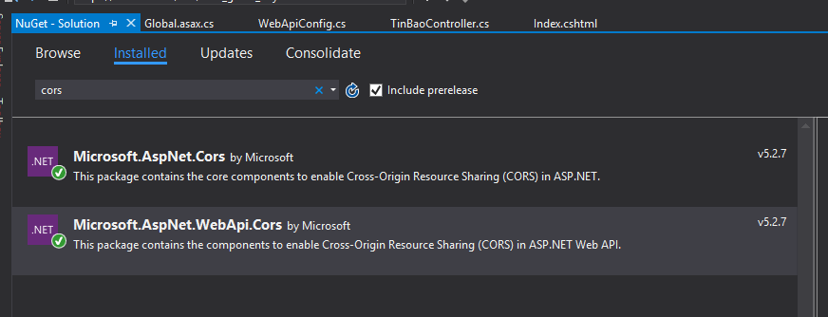

B2:

* In Global.asax, add the following line: **BEFORE ANY MVC ROUTE REGISTRATIONS**

GlobalConfiguration.Configure(WebApiConfig.Register);

B3:

* In the WebApiConfig Register method, have the following code:

public static void Register(HttpConfiguration config)

{

config.EnableCors();

config.MapHttpAttributeRoutes();

}

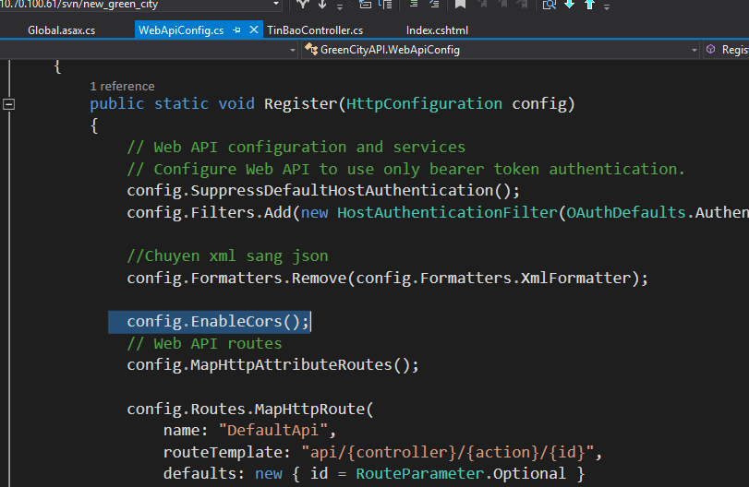

B4:

* using System.Web.Http.Cors; in controller

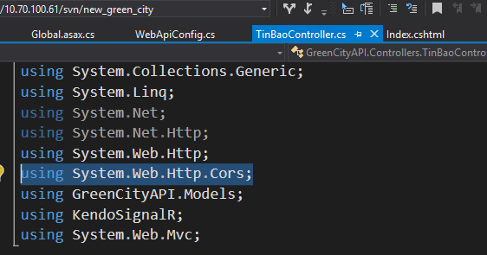

B5:

* [EnableCors(origins: "*", headers: "*", methods: "*", exposedHeaders: "X-My-Header")]

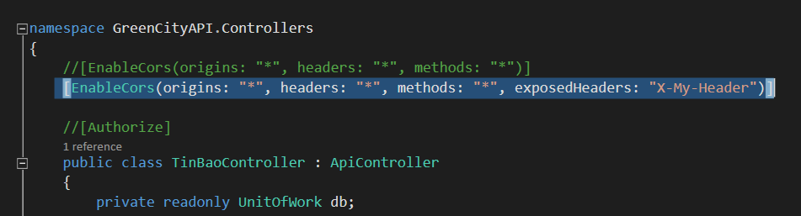

Tài liệu tham khảo:

<https://stackoverflow.com/questions/18619656/enable-cors-in-web-api-2>