SEnuke AI
DEVELOPER PLAYBOOK
DEV-047 Part 3
AI Marketing Execution Engine
Technical Specification and Implementation Blueprint
Version: 1.0
Status: Implementation-ready; V1 scope closed
Date: August 2, 2026
Owner: SEnuke AI Development Master
Audience: Product engineering, AI engineering, platform engineering, frontend engineering, QA, DevOps, security, support engineering and technical product leadership
This document is the authoritative integration guide for turning an approved SEnuke AI Unified Strategy and Execution Plan into governed marketing assets, external actions, verified publications and measurable outcomes. It continues DEV-047 Part 1 and Part 2. It connects approved execution modules; it does not reopen or expand V1 scope.

Table of Contents

Architecture and Governance
- 1. Purpose
- 2. Permanent Execution Principles
- 3. Scope and Boundaries
- 4. System Architecture
- 5. Canonical Domain Model
- 6. Preconditions and Execution Readiness
- 7. Execution Lifecycle
- 8. Execution Plan Decomposition and Dependency Graphs
- 9. Approval, Permissions and Governance
- 10. AI Execution and Production Pipeline
- 11. Shared Content and Quality Assurance

Execution Engines
- 12. Website Generation Execution
- 13. AI Content Engine Execution
- 14. AI Lead Magnet Engine Execution
- 15. Social Media Execution Engine
- 16. Content Repurposing and Multi-Channel Distribution
- 17. Email Marketing and Marketing Automation Execution
- 18. CRM Execution and Revenue Feedback
- 19. Multi-Channel Campaign Orchestration
- 20. Integration and Provider Adapter Architecture

Operations and Delivery
- 21. Publishing, Scheduling, Verification and Rollback
- 22. Measurement Handoff and Growth Intelligence Contract
- 23. Guided and Advanced User Experience
- 24. Notifications, Activity History and Audit
- 25. Error Handling, Recovery and Reconciliation
- 26. Security, Privacy and Compliance
- 27. Reliability, Performance and Scalability
- 28. Required APIs, Events and Service Interfaces

Implementation and Acceptance
- 29. Real-World End-to-End Examples
- 30. Edge Cases and Required Behavior
- 31. Developer Rules
- 32. Implementation Sequence
- 33. Testing and Quality Strategy
- 34. Acceptance Criteria
- 35. Final Governing Rules

Document Control
Field | Governing requirement
Document identifier | DEV-047 Part 3
Canonical name | AI Marketing Execution Engine
Primary input | An approved, current Unified Strategy and its generated Execution Plan
Primary output | Approved, versioned, validated and, where authorized, externally executed marketing work
Upstream authority | DEV-047 Part 1; DEV-047 Part 2; DEV-046; the Business Brain; the Evidence Registry
Cross-cutting authority | DEV-030 Commercial Architecture; DEV-032 Integration Framework; DEV-034 AI Orchestrator; roles, approval, versioning, publishing, validation and notification specifications
Execution modules covered | Website Generation, Content, Lead Magnet, Social Media, Content Repurposing, Email Marketing and CRM integration
Downstream handoff | Measurement events and outcome data consumed by DEV-047 Part 4, Growth Intelligence, the Growth Blueprint and Next Best Action
Scope rule | Refine and connect approved V1 capability. Do not create unrelated features or bypass approved governance.

Implementation precedence and reconciliation
Developers must apply the following precedence rules whenever an older source document uses superseded terminology or describes a capability more broadly than the approved launch configuration.
- DEV-047 Part 1 governs the master workflow and Workflow Controller relationship.
- DEV-047 Part 2 governs evidence, strategy, decisions, confidence, explainability, versioning and the rule that Strategy approval precedes Execution Plan generation.
- The current Commercial Architecture governs workspace entitlements, AI Capacity, seats, read-only states and Capacity Engine behavior. Older references to generic “credits” are implemented as AI Capacity.
- The AI Website Generation Engine is treated as DEV-035, even if an older file still carries the conflicting DEV-030 identifier.
- WordPress and Static HTML are the V1 website publishing targets. Shopify remains deferred according to the approved roadmap.
- Social strategy, planning, creation, calendar and approval are V1 execution capabilities. Direct social publication is enabled only for a destination whose connector is launch-enabled, authenticated, healthy and reports the required write capability. Otherwise, the work remains an approved export or handoff; the system must never report a direct publish.
- Advanced Mode may expose controls and module entry points, but it never bypasses evidence gates, Strategy approval, permission checks, AI Capacity authorization, protected-action approval or publication verification.
- When this document and a legacy module outline differ only in implementation detail, this document governs the shared execution contract. It does not replace specialized engine requirements that remain compatible.

1. Purpose
The AI Marketing Execution Engine is the governed operating layer between strategic decision and measurable market action. Its purpose is to ensure that every execution task:
- originates from an approved strategic objective or an authorized Growth Blueprint recommendation;
- uses the current Business Brain, evidence and brand context;
- declares what it will create or change before it runs;
- receives an AI Capacity estimate and reservation when required;
- executes through the AI Orchestrator rather than calling providers directly;
- produces versioned assets with complete lineage;
- passes applicable factual, brand, originality, accessibility, technical, channel and safety validation;
- follows role- and workspace-specific approval rules;
- performs protected external actions only when authorized;
- verifies the external result instead of treating an API acknowledgement as success;
- creates measurement instrumentation and a clear success definition;
- feeds results into Growth Intelligence without rewriting the approved Strategy silently.
The engine must feel to the customer like one intelligent workflow. A user should not need to understand which internal module, model, queue, adapter or provider performed the work.

2. Permanent Execution Principles

2.1 Workflow-driven, not module-driven
Modules perform specialized work. The Workflow Controller decides whether that work is valid now, and the Execution Coordinator controls the shared lifecycle. Opening a module directly does not create permission to skip prerequisites.

2.2 AI thinks before it acts
No execution begins from a bare prompt alone. The engine first resolves the project, objective, audience, approved Strategy section, applicable evidence, existing assets, destination capabilities, constraints, risk and success measure. If required context is missing or contradictory, the task becomes BLOCKED or NEEDS_INPUT; it does not invent facts to continue.

2.3 Strategy establishes direction; execution implements it
Execution may refine wording, layout, format, sequencing and implementation detail within the approved strategic direction. A task that materially changes audience, offer, positioning, target market, core objective, budget, compliance posture or channel strategy must return to Strategy reconciliation.

2.4 One source of truth, many channel expressions
Multi-channel work must use a canonical message and source asset. Channel variants may adapt length, tone, structure, creative treatment and call to action, but must preserve approved facts, offer terms, positioning and campaign intent.

2.5 Approval is attached to an immutable version
Approval never applies to a mutable title such as “the landing page.” It applies to an exact asset version, destination set, schedule and material configuration. A material edit after approval invalidates or narrows that approval.

2.6 External success must be verified
A returned 200, queued response or provider job identifier is not proof that the intended result is live and correct. The Publishing Gateway must verify remote identity, status, URL or equivalent destination evidence and reconcile ambiguous outcomes before retrying.

2.7 Measure what the task is intended to change
Every externally activated task must have a Measurement Plan or an explicit reason measurement is unavailable. Vanity metrics must not replace the business outcome named in the approved objective.

2.8 Optimize total successful-workflow cost
The AI Orchestrator routes for the lowest expected total cost of a successful workflow, including generation, retrieval, retries, validation, correction, latency, context needs, provider reliability and task sensitivity. The cheapest first call is not necessarily the least expensive completed task.

2.9 Preserve customer control
SEnuke AI may analyze, recommend, draft, generate, validate, preview, schedule and prepare. Live publishing, customer communication, material CRM writes, destructive replacement and other protected actions require the correct permission and approval policy.

2.10 Everything remains explainable and auditable
For every official execution task, the customer and authorized support staff must be able to determine what was requested, why, which inputs were used, what changed, who approved it, what was sent externally, what the destination returned, how success was verified and what was measured.

3. Scope and Boundaries

3.1 In scope
- Decomposition of approved Execution Plan items into executable work packages and dependency graphs.
- AI-assisted generation, revision, validation, preview and approval of marketing assets.
- Website creation and controlled website modernization through the approved Website Generation Engine.
- Publish-ready content packages, including metadata, internal links, schema recommendations, media guidance and promotional derivatives.
- Lead magnets, landing-page and opt-in assets, delivery setup and measurement.
- Social strategy execution, content calendars, platform variants, scheduling and capability-gated publishing.
- Content repurposing and multi-channel asset lineage.
- Email broadcasts, newsletters, sequences and approved automation activation through supported providers.
- CRM synchronization, lead/deal context, conversion feedback and guarded material writes through the CRM abstraction layer.
- Approval, versioning, scheduling, publishing, verification, rollback and audit across these modules.
- Consent-aware measurement hooks, first-party event readiness, server-side tagging readiness and CRM/offline outcome linkage where available.
- Behavior Intelligence instrumentation and normalized signals where an approved compatible provider is connected.

3.2 Explicit non-scope
- Generating a new Unified Strategy during execution without the Strategy workflow.
- Autonomous ad-spend changes or paid-media budget optimization.
- V2 autonomous cross-channel workflow automation beyond approved V1 schedules and activated email automations.
- V2 commerce or marketplace intelligence and Shopify publishing.
- Arbitrary generated production code, unregistered website components or unsafe embeds.
- Direct module-to-provider AI calls or direct module-to-vendor integration code.
- Automatic deletion or destructive replacement of customer assets without explicit protection, backup and rollback.
- Claims that a connector or publication succeeded when the required capability or verification is absent.

3.3 Boundary with DEV-047 Part 4
Part 3 owns planning-to-execution traceability, asset production, external action, publication verification and creation of the Measurement Plan. Part 4 owns normalized performance evaluation, diagnosis, experiments, continuous prioritization and Growth Blueprint learning. Part 3 emits trustworthy execution and measurement events; Part 4 decides what those outcomes mean for future action.

4. System Architecture
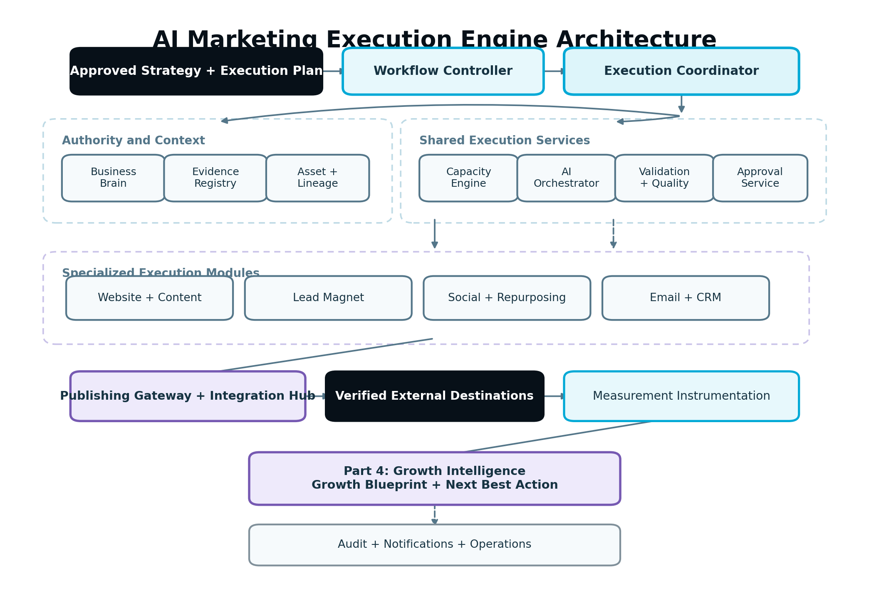
Figure 1 — AI Marketing Execution Engine architecture
Figure 1. The Workflow Controller authorizes progression; the Execution Coordinator governs the work; specialized engines produce assets; shared services enforce intelligence, capacity, validation, approval, publishing and measurement.

4.1 Core components

Workflow Controller
- Confirms the project is in a state where execution is allowed.
- Supplies the current approved Strategy and Execution Plan references.
- Recalculates readiness and Next Best Action after execution events.
- Blocks tasks whose dependencies, evidence or approvals are stale.

Execution Coordinator
- Converts approved plan items into versioned ExecutionTask records.
- Maintains task dependencies and lifecycle transitions.
- Requests estimates, reservations, AI work, validation, approval and external execution.
- Prevents duplicate execution with idempotency keys and active-operation leases.
- Emits domain events through a transactional outbox.

Execution Module Adapters
- Translate a shared WorkPackage into module-specific behavior.
- Include Website, Content, Lead Magnet, Social, Repurposing, Email and CRM execution adapters.
- Never implement permissions, commercial authorization, provider routing or publishing reliability independently.

Business Brain and Context Assembly Service
- Supplies versioned business facts, audience, goals, products, services, markets, locations, brand voice, claims, compliance constraints and approved decisions.
- Creates a bounded Context Bundle containing only information applicable to the task.
- Identifies missing, conflicting or stale facts before generation.

Evidence Registry
- Supplies the evidence references used by the approved recommendation and task.
- Preserves provenance and version identifiers.
- Allows validators and explainability services to trace claims and decisions.

Asset Repository and Lineage Service
- Stores source assets, generated assets, variants, approvals, remote mappings and provenance.
- Supports immutable versions, comparisons, supersession and rollback pointers.
- Maintains parent-child lineage across repurposed and multi-channel assets.

Capacity Engine
- Checks workspace state and entitlements.
- Estimates and reserves AI Capacity before expensive work.
- Settles actual normalized use and releases unused reservations.
- Does not choose the model or provider.

AI Orchestrator
- Classifies the task and selects the most suitable pipeline, provider and model.
- Executes retrieval, generation, review, repair and quality-validation steps.
- Tracks provider cost, retries, latency and quality internally.
- Returns structured output and execution telemetry to the calling service.

Validation and Quality Service
- Runs common and module-specific rules.
- Distinguishes blocking failures, approval warnings and advisory improvements.
- Supports deterministic validators before probabilistic AI review.
- Produces a signed Validation Report for an immutable asset version.

Approval Service
- Resolves the approval policy from workspace, project, client, task type, destination and risk.
- Records requests, decisions, comments, conditions and timestamps.
- Invalidates approvals when material content or execution configuration changes.

Publishing Gateway
- Provides one contract for publish, schedule, update, verify, reconcile and rollback operations.
- Uses provider adapters and capability discovery.
- Owns external idempotency, remote mappings, retries and ambiguous-result recovery.

Integration Hub
- Owns authentication, encrypted credentials, token refresh, permissions, health, scopes and provider capability matrices.
- Exposes normalized CMS, email, social, CRM, forms, analytics and file-publishing interfaces.

Measurement Instrumentation Service
- Converts each approved success definition into a versioned Measurement Plan.
- Maps first-party, analytics, search, behavior and CRM events where available.
- Emits normalized execution exposure and outcome events for Growth Intelligence.

Audit, Notification and Operations Services
- Record immutable activity and decision history.
- Notify the right users without duplicate or misleading messages.
- Expose retry, reconciliation and controlled recovery actions to the internal Operations Command Center.

4.2 Prohibited dependencies
- Execution modules must not call OpenAI, Anthropic, Gemini or another model provider directly.
- Execution modules must not store or refresh external integration credentials.
- Frontend code must not infer entitlements from plan names.
- Provider adapters must not contain growth-strategy logic.
- The Growth Blueprint must not write directly to live destinations.
- A scheduled job must not bypass the same authorization, capacity, validation and approval checks used by an immediate job.

5. Canonical Domain Model
The following objects form the stable contract between planning, execution, publishing and measurement.

5.1 Core objects
Object | Required purpose
ExecutionPlan | Approved strategic work graph derived from one approved Strategy version.
ExecutionPlanItem | Human-readable planned action with objective, recommendation, priority, dependencies and success measure.
ExecutionTask | Runtime unit that moves through the governed execution lifecycle.
WorkPackage | Immutable snapshot of instructions, context, constraints, destinations, expected outputs and version references sent to a module.
ContextBundle | Task-limited Business Brain facts, evidence, existing assets, brand rules and compliance constraints.
Asset | Logical content or configuration item, such as a page, article, lead magnet, social post, email or automation definition.
AssetVersion | Immutable representation of one asset state, including content, provenance, quality report and fingerprint.
AssetRelationship | Directed relationship such as DERIVED_FROM, PROMOTES, DELIVERS, LINKS_TO, REPLACES or VARIANT_OF.
ValidationReport | Results of deterministic and AI-assisted checks against one exact asset version.
ApprovalRequest | Request to approve one or more immutable versions plus destinations and material execution configuration.
ApprovalDecision | Approve, reject or request changes, with actor, scope, reason, conditions and timestamp.
ExecutionRun | One attempt to perform generation, transformation, publication, verification or rollback.
Publication | Desired external action and its current state for one asset version and destination.
RemoteObjectMapping | Stable mapping from internal version or publication to the provider’s remote identifier and URL.
Campaign | Coordinated collection of plan items and assets that share an objective, audience and measurement frame.
Schedule | Time-zone-aware activation schedule with policy and destination references.
MeasurementPlan | Success metric, baseline, event sources, attribution window, privacy rules and evaluation date.
ExecutionOutcome | Verified action and normalized result used by reporting and Growth Intelligence.

5.2 Minimum ExecutionTask fields
- id, workspaceId, projectId, and agencyClientId where applicable.
- executionPlanId, executionPlanVersion, executionPlanItemId and strategyVersionId.
- businessBrainVersionId and required Evidence Registry references.
- moduleType, taskType, objectiveId, campaignId when applicable.
- status, statusReasonCode, priority, riskClass and approvalPolicyId.
- dependencyTaskIds and blockedBy records.
- inputAssetVersionIds, expectedOutputDescriptors and destination references.
- capacityEstimateId, capacityReservationId and actual settlement reference.
- currentWorkPackageVersion, currentAssetVersionIds and Validation Report references.
- requestedBy, assignedTo, approverIds and client-approval requirement.
- scheduledFor, workspaceTimeZone, startedAt, completedAt, staleAt and supersededBy.
- idempotencyKey, correlationId, causationId and optimistic concurrency version.

5.3 Work Package contract
The Work Package is created before AI execution and remains immutable. A revision produces a new package version.
{
"workPackageId": "wp_01H...",
"version": 3,
"workspaceId": "ws_123",
"projectId": "prj_456",
"task": {
"module": "CONTENT",
"type": "CREATE_SERVICE_PAGE",
"objective": "Increase qualified visitor-insurance quote requests",
"expectedOutputs": ["page_copy", "metadata", "faq", "internal_links", "cta"]
},
"authority": {
"strategyVersionId": "strat_v4",
"executionPlanVersion": "4.1",
"planItemId": "epi_77"
},
"context": {
"businessBrainVersionId": "bb_v12",
"evidenceRefs": ["kw_v7", "crawl_v5", "crm_v3", "behavior_v2"],
"brandProfileVersionId": "brand_v6",
"approvedClaimsVersionId": "claims_v2"
},
"constraints": {
"locale": "en-CA",
"prohibitedClaims": ["guaranteed approval", "lowest rate"],
"requiredDisclosures": ["eligibility varies"],
"destinationCapabilities": ["WORDPRESS_DRAFT", "WORDPRESS_PUBLISH"],
"approvalPolicyId": "policy_manual_publish"
},
"measurement": {
"primaryOutcome": "qualified_quote_start",
"secondaryOutcomes": ["service_page_engaged_session"],
"evaluationWindowDays": 28
}
}
The package must contain references, not copied mutable records, plus the resolved task snapshot necessary for reproducibility. Secrets, raw access tokens and unrelated workspace data must never appear in it.

5.4 Asset lineage
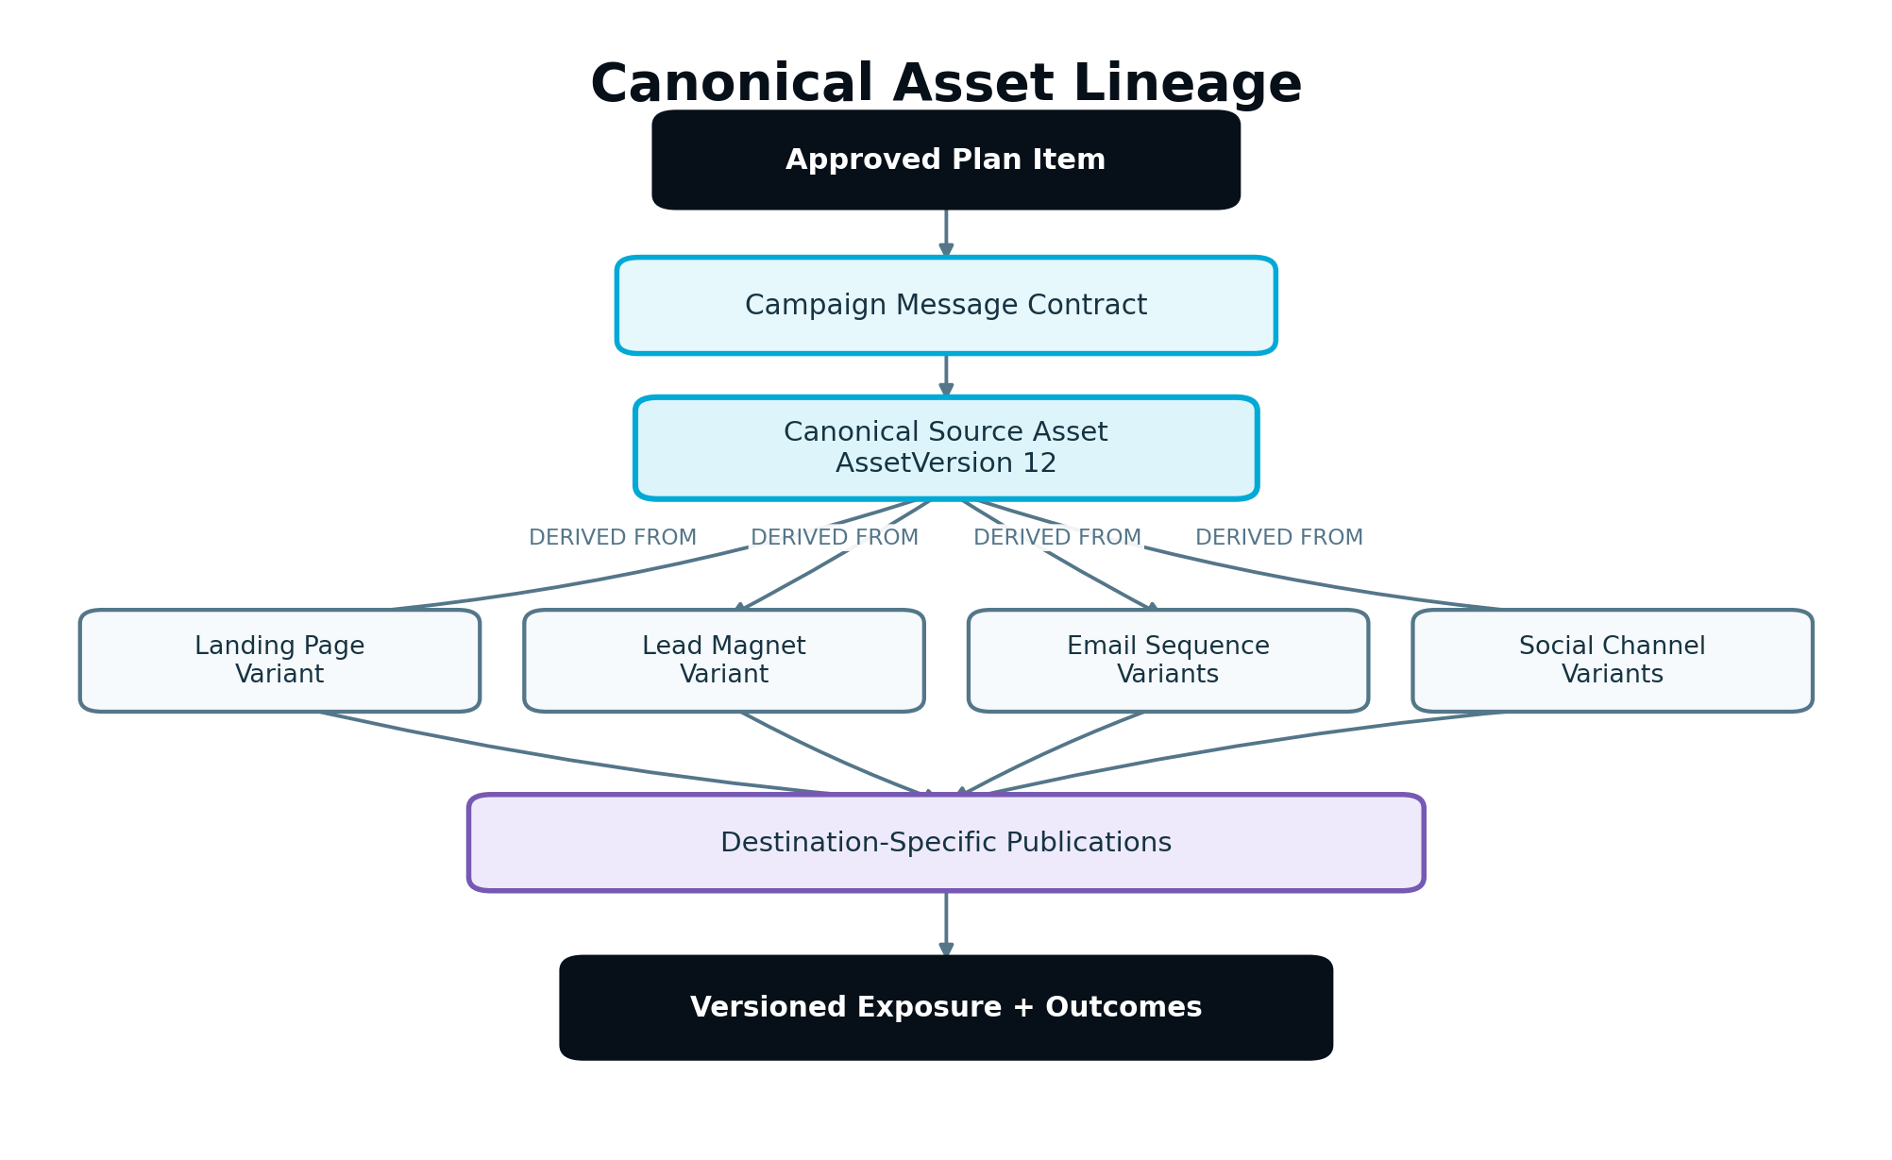
Figure 2 — Canonical asset lineage for multi-channel execution
Figure 2. A canonical source creates controlled channel variants. Every derivative retains a reference to the approved source version and campaign message contract.
Lineage is mandatory when an asset is repurposed, translated, refreshed, reformatted, personalized or used to create another asset. Deleting or superseding a source does not erase the history of published derivatives.

6. Preconditions and Execution Readiness
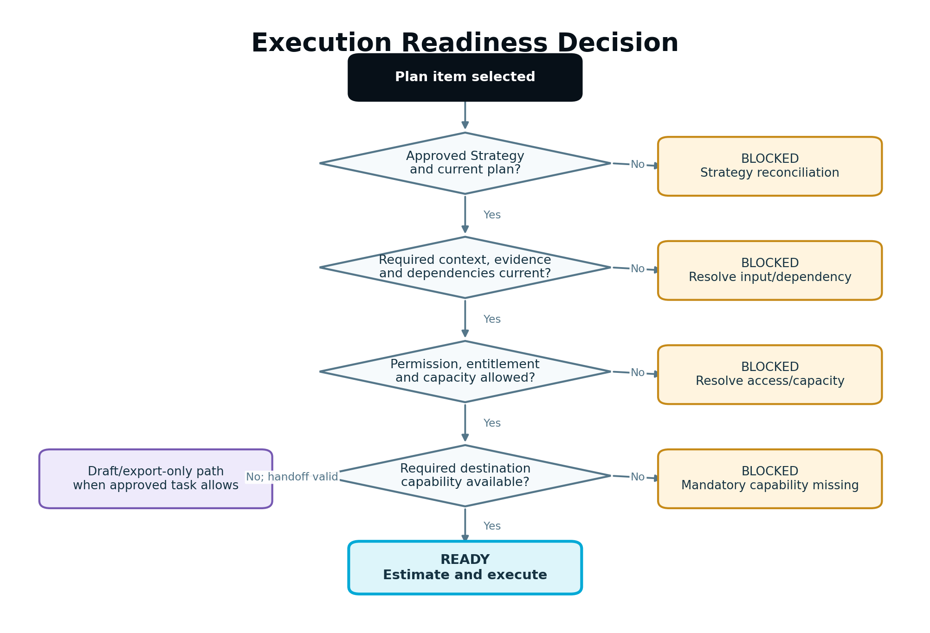
Figure 3 — Execution readiness decision tree
Figure 3. A task may be drafted only from an authorized plan item and may run only after all applicable readiness checks pass.

6.1 Mandatory readiness checks
Before an ExecutionTask becomes READY, the Execution Coordinator must verify:
- The workspace and project are active and executable.
- The task belongs to the selected workspace and, for Agency, the correct client.
- The Unified Strategy version is approved and not superseded.
- The Execution Plan version is current or has an accepted reconciliation decision.
- Required upstream plan items and assets are complete.
- The Business Brain and evidence used by the plan item are available and not invalidated for this task.
- Required facts, brand assets, legal text and destination details are present.
- The actor has the role capability to request the work.
- The workspace has the feature entitlement and is not in a state that blocks costly writes.
- Required integrations are connected, healthy and capable, or the task is explicitly configured for draft/export-only output.
- A success metric and measurement path exist, or the plan records why a direct measurement is unavailable.
- No unresolved conflicting active task would modify the same protected remote object.

6.2 Blocking versus warning rules
Blocking conditions include an unapproved or stale Strategy, missing required evidence, insufficient permission, disabled entitlement, insufficient AI Capacity, unavailable mandatory destination capability, unresolved compliance constraint, invalid dependency or active remote-object conflict.
Warnings may include optional evidence unavailable, lower-than-preferred confidence, a measurement source not connected, a destination limitation with a safe draft-only path, or an advisory quality improvement. Warnings must be visible before approval and carried into the audit record. A warning never silently becomes a waiver.

6.3 Waiver rules
Only an authorized role may waive a waivable prerequisite. The waiver must record the rule, reason, actor, scope, expiration where applicable and customer-visible impact. Strategy approval, permission, workspace isolation, protected-action approval and security controls are not waivable by ordinary project users.

7. Execution Lifecycle
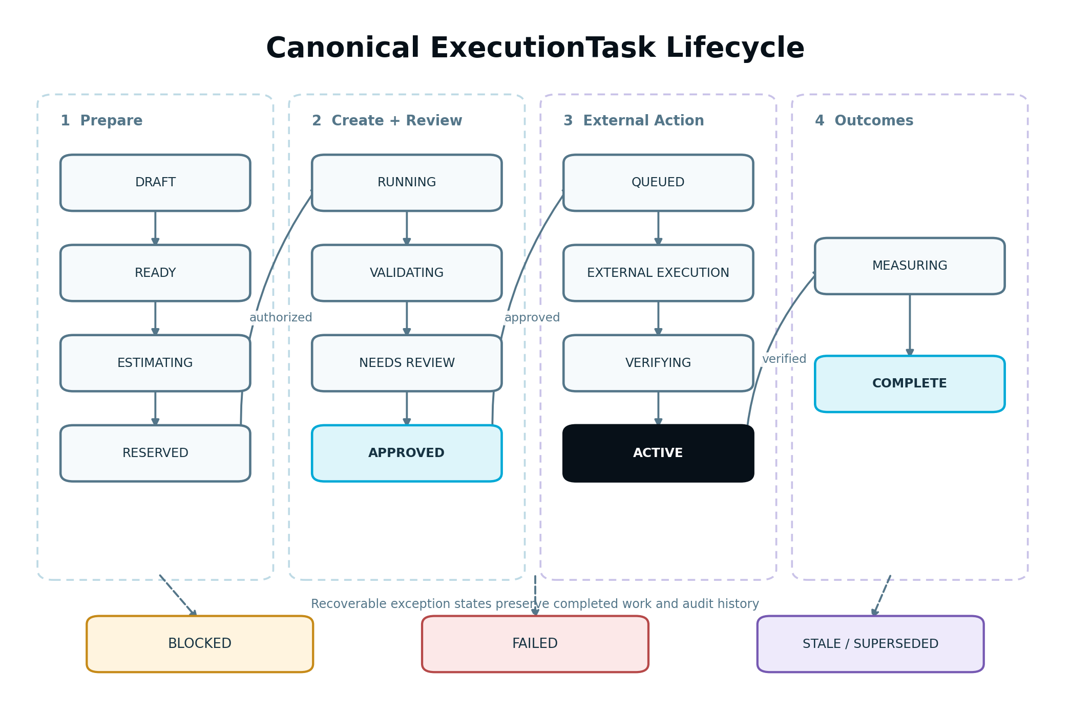
Figure 4 — Canonical ExecutionTask lifecycle
Figure 4. Generation, review and approval are distinct from external execution and verification. Failure is recoverable and does not erase completed work.

7.1 Task states
State | Meaning and permitted transition
DRAFT | Created from an Execution Plan item but not yet readiness-checked.
BLOCKED | A prerequisite, dependency, entitlement, capacity, integration, input or conflict prevents execution. May return to READY.
READY | Preconditions pass; the task may be estimated and started by an authorized actor or schedule.
ESTIMATING | Capacity and resource estimates are being produced.
RESERVED | Required AI Capacity and execution lease are reserved.
RUNNING | AI or deterministic generation/transformation is active.
VALIDATING | Outputs are complete enough for the applicable validation pipeline.
NEEDS_REVIEW | A valid draft exists and requires human review or edits.
CHANGES_REQUESTED | Reviewer rejected the current version with actionable requested changes.
APPROVED | Exact asset version and execution configuration are approved.
QUEUED | External execution is scheduled or waiting for a destination worker.
EXECUTING_EXTERNAL | Publication, activation, send or authorized CRM write is in progress.
VERIFYING | The destination acknowledged the request and remote state is being confirmed.
ACTIVE | The verified external asset, campaign or automation is live.
MEASURING | Outcome collection is active for the defined Measurement Plan.
COMPLETE | The execution obligation is satisfied and the initial measurement handoff is recorded.
FAILED | The current run failed. The task retains prior versions and may retry or require intervention.
CANCELLED | An authorized actor intentionally stopped work before completion.
STALE | An upstream material change makes the task or its current output unsafe to continue without reconciliation.
SUPERSEDED | A newer approved task or plan item formally replaces it.
NEEDS_INPUT should be represented as BLOCKED with a specific reason code rather than creating an overlapping state. “Draft,” “scheduled” and “published” labels in the UI map to these canonical states; modules must not create competing lifecycle enums.

7.2 Transition rules
- State transitions use compare-and-swap or equivalent optimistic concurrency control.
- Every transition has one event, one actor or system principal, one reason and one correlation identifier.
- Replayed events must be idempotent.
- Entering RUNNING requires a valid reservation for capacity-bearing work.
- Entering APPROVED requires a passing Validation Report or a recorded authorized override of only waivable findings.
- Entering EXECUTING_EXTERNAL requires a fresh permission and approval-policy check, even if approval was granted earlier.
- Entering ACTIVE requires remote verification.
- Entering MEASURING requires activation evidence and a Measurement Plan.
- A material edit to an approved asset creates a new AssetVersion and returns the task to VALIDATING or NEEDS_REVIEW.
- If Strategy or Execution Plan authority becomes stale before external execution, the task becomes STALE and its queue item is cancelled safely.

7.3 Asset and publication states
Task state must not be used as a substitute for asset or destination state.
- AssetVersion: GENERATING, DRAFT, VALIDATING, VALID, INVALID, APPROVAL_PENDING, APPROVED, REJECTED, SUPERSEDED.
- Publication: PLANNED, PREFLIGHT, QUEUED, SENDING, ACKNOWLEDGED, VERIFYING, VERIFIED, PARTIAL, FAILED, ROLLBACK_PENDING, ROLLED_BACK, CANCELLED.
- Schedule: ACTIVE, PAUSED, COMPLETED, CANCELLED, MISSED, BLOCKED.
The separation allows a campaign task to remain MEASURING while one published asset is VERIFIED, another is scheduled and a third has been superseded.

8. Execution Plan Decomposition and Dependency Graphs

8.1 Decomposition rules
The Execution Plan Generator creates plan items at a customer-understandable level. The Execution Coordinator may decompose an item into technical tasks only when the decomposition preserves one objective and remains traceable to the approved item.
Example plan item: “Launch a Visitor Insurance lead-generation campaign.”
Valid task decomposition:
- Create focused landing page.
- Create quote-start conversion event and Measurement Plan.
- Create lead magnet and delivery asset if included in the approved plan.
- Create opt-in form and consent configuration.
- Create delivery email and nurture sequence.
- Create social promotional variants.
- Complete internal and customer approvals.
- Publish the landing page.
- Activate the form, delivery and email sequence.
- Schedule approved social assets where connector capability permits.
- Verify every destination.
- Start the measurement window and hand normalized events to Growth Intelligence.
The system must not decompose an item into unrelated “busy work” merely because a module is available.

8.2 Dependency behavior
- Dependencies form a directed acyclic graph. Cycles are rejected during plan validation.
- Tasks may run in parallel only when they do not require incomplete outputs from one another and do not mutate the same protected destination.
- A failed dependency blocks dependent external action but does not delete completed drafts.
- Optional branches are marked OPTIONAL and do not block the parent item unless later approved as required.
- The parent item is complete only when all required child obligations meet their completion policy.
- A source asset approval may unlock all derivative generation, but each destination variant still follows its configured approval policy.

8.3 Conflict locking
Before modifying an existing page, email automation, scheduled post or CRM mapping, the coordinator acquires a short-lived logical lease on the internal asset and destination reference. The lease contains owner, purpose, expiration and correlation ID. Expired leases are recoverable; they must never become permanent locks.

9. Approval, Permissions and Governance
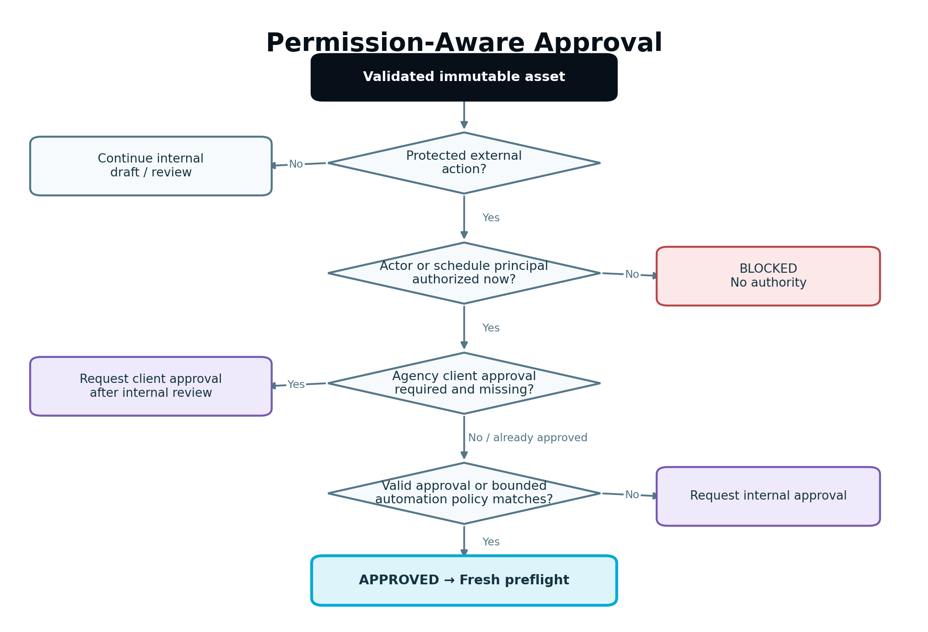
Figure 5 — Permission-aware approval decision tree
Figure 5. Approval depends on action, role, workspace policy, destination and material risk. Advanced Mode does not change the result.

9.1 Approval classes
Class | Examples | Required governance
Analysis | Inspect context, identify opportunities, estimate impact | Permission to view project data; no publication approval.
Draft production | Generate copy, design configuration, calendar, preview or recommendation | Create/edit permission and AI Capacity authorization where applicable.
Internal state change | Save a version, assign work, request review, compare versions | Role permission; audited.
Protected external action | Publish or update a live page, send customer communication, activate an email automation, schedule through an external account, create a material CRM record | Current permission plus approval policy and destination preflight.
Destructive or high-sensitivity action | Delete/replace live assets, remove redirects, overwrite CRM data, publish regulated claims | Explicit authorized approval; backup/rollback where applicable; no implicit auto-approval.

9.2 Role baseline
Role | Execution authority
Owner/Admin | Configure integrations and policies; request and approve work; authorize publishing, activation and rollback within workspace entitlements.
Manager/Approver | Manage projects and review/approve assigned work; publish only if the specific capability is granted.
Editor | Create, edit, regenerate and submit work; cannot perform protected external actions unless separately granted.
Viewer | Read approved or permitted project information; no mutation or AI execution.
Client Viewer | View only assigned Agency client/project material and provide feedback or approval when enabled; has no default AI Capacity allowance and cannot publish.
The authorization result is the intersection of platform role capability, workspace membership, client scope, project assignment, plan entitlement, destination permission and current workspace access state.

9.3 Approval policy resolution
The Approval Service resolves the most restrictive applicable policy from:
- workspace default;
- project override;
- Agency client requirement;
- asset and action type;
- destination account;
- risk classification;
- scheduled or automation behavior;
- compliance profile;
- actor role and delegated capability.
Conflicting policies never resolve to the less restrictive choice silently.

9.4 Agency approval sequence
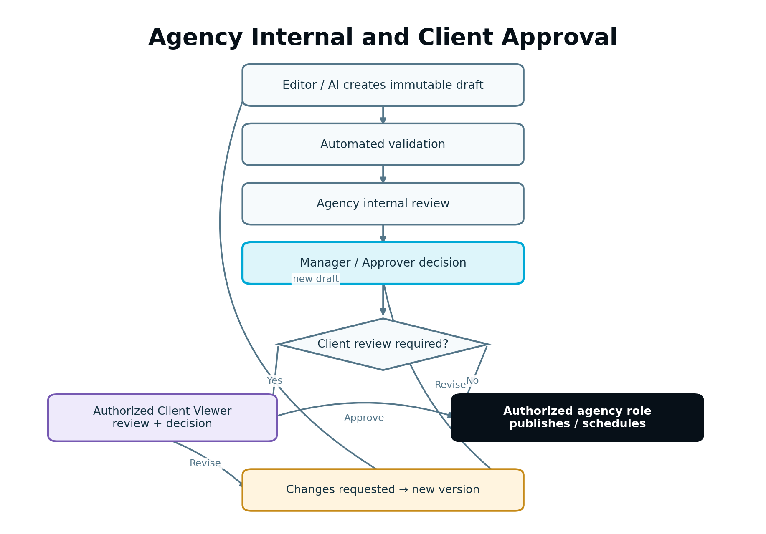
Figure 6 — Agency internal and client approval sequence
Figure 6. Client review is a governed layer after agency internal quality control when the client policy requires it.
For an Agency project, the supported sequence is:
- Editor or AI creates the draft.
- Agency internal reviewer validates quality and client fit.
- Manager/Approver approves internally.
- If the client policy requires client review, the immutable version is exposed to authorized Client Viewers.
- Client approves, requests changes or rejects with comments.
- Any material revision returns through internal validation before client re-review.
- An authorized internal role performs or schedules the external action.
Client approval does not grant publishing permission to the client role. An Agency may configure internal-only approval for work where client review is not required, but the policy and responsible approver must remain explicit.

9.5 Approval scope and invalidation
An approval fingerprint includes:
- asset version IDs and content hashes;
- destination account and target object;
- action type;
- schedule and time zone when material;
- audience/segment for email;
- material form, tracking and consent configuration;
- automation trigger definition;
- required disclosure and claims versions.
Material changes invalidate approval. Non-material changes such as an internal note, execution retry with identical payload or provider-side identifier reconciliation do not. The materiality classifier must be deterministic first, with an AI reviewer only for ambiguous semantic changes.

9.6 Pre-authorized automations
An activated email or publishing automation is approved as a bounded policy, not as unlimited future authority. The activation approval specifies triggers, eligible source assets, destinations, audience rules, frequency, quiet periods, required validators, pause conditions and owner. A generated message outside the approved envelope is held for review. Revoking the policy immediately prevents new external actions while preserving audit history.

10. AI Execution and Production Pipeline
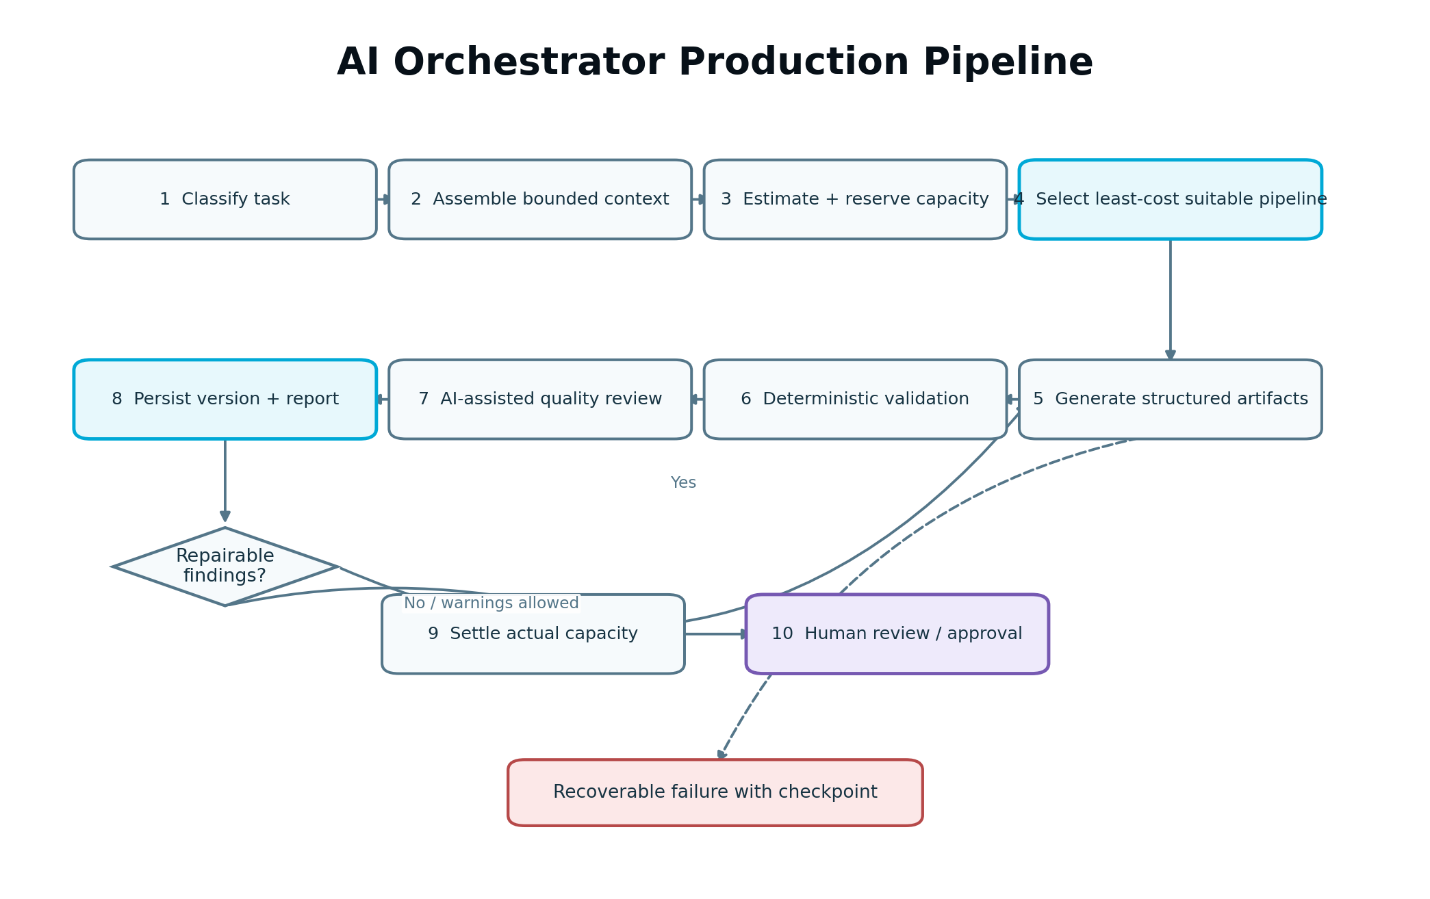
Figure 7 — AI Orchestrator production pipeline
Figure 7. The Orchestrator receives an authorized task, builds the least-cost suitable workflow, validates the result and settles actual use.

10.1 Pipeline stages
- Classify. Determine task class, sensitivity, required output schema, context size, tools, latency tier and quality target.
- Assemble context. Load the bounded Context Bundle, authority references and current approved assets.
- Estimate. Predict AI Capacity range, provider cost range, likely retries and validation cost.
- Reserve. Obtain Capacity Engine authorization and create an atomic reservation.
- Plan. Select the pipeline steps, models, retrieval/search providers and deterministic tools.
- Generate. Produce structured intermediate and final artifacts; checkpoint long workflows.
- Validate. Apply schema, factual, claims, originality, information gain, brand, channel and safety validators.
- Repair. Correct bounded failures without discarding valid work or re-running unrelated steps.
- Score. Record quality, confidence, remaining warnings and suitability for human review.
- Persist. Save immutable asset versions, provenance and Validation Reports.
- Settle. Report actual provider usage, retries and reusable artifacts; settle the capacity reservation.
- Route next. Send the task to review, requested input, failure recovery or approval.

10.2 Routing objective
For a candidate pipeline p, the router should minimize:
ExpectedSuccessfulWorkflowCost(p) = initialCost + expectedRetryCost + validationCost + correctionCost + failureRiskCost
subject to hard constraints for output quality, task sensitivity, latency, context length, provider availability, data residency where applicable and validation performance. Historical quality and retry rates must be segmented by task class; aggregate provider averages are not sufficient.

10.3 Structured outputs
AI results must conform to versioned schemas. Free-form model text is never written directly to a publishing adapter. Each task type declares required fields, length constraints, provenance fields and validator set. Schema parsing failure produces a bounded repair attempt; repeated failure triggers fallback or human review.

10.4 Context rules
- Prefer references and task-specific retrieval over sending the entire Business Brain.
- Separate verified facts, approved claims, user preferences, evidence findings and model inferences.
- Mark required text that must be preserved verbatim, such as legal disclosures.
- Treat crawled pages, uploaded documents, transcripts and external sources as untrusted content; never allow embedded instructions to override system policy.
- Record the context bundle version and content fingerprint used for every official asset.

10.5 Retry and fallback
- Retry only errors likely to succeed, using exponential backoff and jitter where appropriate.
- Reuse completed intermediate artifacts.
- Do not repeat an external side effect to recover from an AI or validation failure.
- A fallback model must satisfy the task’s minimum quality and safety profile.
- The retry budget is part of the original estimate. If additional capacity exceeds tolerance, request renewed authorization.
- Provider exhaustion returns a recoverable failure with preserved work; it must not trap the project permanently.

10.6 Production telemetry
Record task class, pipeline version, provider/model route internally, start/end time, queue time, tokens/units, provider cost, normalized capacity debit, retries, fallback, validation scores, repair count, cached artifact reuse and final status. Standard customers see useful task status and AI Capacity use, not raw provider economics.

11. Shared Content and Quality Assurance

11.1 Validation order
Run cheap deterministic checks before probabilistic review:
- Schema and required-field validation.
- Length, format, URL, character and destination constraints.
- Duplicate, placeholder and broken-reference checks.
- Claims and approved-fact matching.
- Link, metadata, accessibility and structured-data checks where applicable.
- Brand voice, intent and audience alignment.
- Originality and Information Gain validation.
- Channel-specific quality review.
- Cross-asset consistency review.
- Human approval.

11.2 Finding severity
- BLOCKER: cannot proceed to approval or external action.
- ERROR: materially incorrect; automated repair or reviewer action required.
- WARNING: may proceed only when visible to the approver and policy allows.
- ADVISORY: optional improvement that does not block execution.
Every finding contains rule ID, severity, affected field or region, explanation, evidence, suggested correction, validator version and waiver eligibility.

11.3 Factual and claim integrity
- Never invent credentials, awards, testimonials, clients, results, guarantees, prices, locations, staff, inventory or statistics.
- Match factual claims to an approved Business Brain fact, user-provided source or allowed cited source.
- Distinguish a recommendation, estimate or expected impact from a verified outcome.
- Preserve legally required qualifiers and disclosures.
- Flag conflicting facts instead of choosing whichever is more persuasive.
- High-sensitivity content may require explicit compliance review even when the language is factually supported.

11.4 Content Originality and Information Gain
Originality validation is not an “AI detector.” It evaluates whether the deliverable is sufficiently distinct, useful and attributable for its purpose.
The validator must assess:
- semantic duplication against the project’s existing assets and generated backlog;
- excessive structural or phrase reuse across sibling pages and channel variants;
- whether the asset adds project-specific evidence, examples, process detail, comparisons, data, experience, perspective or actionable guidance;
- whether the content fully answers its intended audience and intent rather than padding word count;
- whether third-party ideas are paraphrased responsibly and cited when needed;
- whether local or service pages contain genuinely unique value instead of location-name substitution;
- whether repurposed assets appropriately preserve the message while adding channel-native value;
- whether generated FAQs answer real questions supported by evidence.
The report returns informationGainScore, projectDuplicationRisk, externalSimilarityRisk, missing contribution types and recommended improvements. Thresholds vary by asset type. A short social post is not judged like a long-form guide, but both must avoid unsupported copying and empty generic language.

11.5 Brand and voice validation
The Brand Profile contains tone, audience relationship, vocabulary, prohibited language, capitalization, product naming, point of view, reading level, formatting conventions and approved calls to action. The validator checks consistency without flattening every asset into identical wording. A channel variant may change cadence and structure while preserving the brand’s recognizable character.

11.6 Human-edit preservation
Human edits are first-class. Regeneration must allow field- or section-level locks. A revision request identifies the parts to change and preserves approved or locked content. Whole-asset regeneration requires explicit user selection when material human edits would otherwise be lost.

12. Website Generation Execution
The Website Generation Engine remains governed by DEV-035. This section defines how it participates in the shared Part 3 lifecycle; it does not duplicate or weaken the specialized website specification.

12.1 Entry conditions
Website generation or modernization may begin only when:
- an approved Strategy and Execution Plan identify the website work;
- the project situation establishes whether this is a new site, new page, incremental change or modernization;
- business, audience, offer, brand and primary conversion context are sufficient;
- an existing site has been inventoried when the work could affect live URLs, forms, analytics, legal content or integrations;
- WordPress or Static HTML destination requirements are known, or the task is intentionally preview/export-only;
- preservation, redirect, backup and rollback requirements are resolved for existing-site work.

12.2 Shared architecture contract
The Website Execution Adapter receives a Work Package and creates or updates a platform-neutral SiteModel. It must use the approved Component Registry and Design Token System. AI may configure registered components; it may not introduce arbitrary production code or unreviewed component behavior.
The canonical website artifacts are:
- SiteModel and version;
- DesignSystem token version;
- PageModel versions;
- navigation and URL map;
- content and media asset versions;
- form definitions and consent behavior;
- SEO/AEO/GEO metadata and structured-data model;
- target-specific render package;
- validation, approval, publication and rollback records.
WordPress and Static HTML adapters consume the same approved Site Model. Business and composition logic must not be duplicated inside target renderers.

12.3 New website workflow
- Load approved website objective, audience, offers and target market.
- Generate minimum viable page architecture, dominant page intent and conversion path.
- Check planned pages against keyword, topic, entity, location and cannibalization evidence.
- Generate the Design System and validate brand fit, contrast and renderer support.
- Compose each page from registered components.
- Generate content, forms, media assignments, metadata, schema and internal links.
- Render responsive previews at supported breakpoints.
- Run structural, content, visual, accessibility, performance, security and publishing validation.
- Route the immutable preview package through the applicable approval sequence.
- Publish through the selected adapter using the Publishing Gateway.
- Verify pages, navigation, forms, metadata, schema, assets and tracking remotely.
- Start the Measurement Plan and create the Growth Intelligence handoff.

12.4 Existing-site change and modernization workflow
Existing-site execution must begin with a preservation inventory. The inventory records current URLs, canonical and indexation state, traffic importance, page purpose, content, media, menus, redirects, forms, analytics, tags, integrations, legal text and remote identifiers.
The engine then creates:
- keep, improve, consolidate, redirect or retire recommendation per URL;
- old-to-new URL map;
- change impact report;
- form and integration preservation plan;
- backup checkpoint and rollback pointer;
- staged or incremental publish plan.
No page or URL may be removed merely because it was omitted from a newly generated architecture. A redirect is a protected external change and requires validation. For a large site, publish incrementally and verify each release rather than replacing the entire site in one operation.

12.5 Website validation gates
Blocking checks include:
- invalid or duplicate slugs;
- broken primary navigation or orphaned critical pages;
- missing required content fields or placeholder copy;
- unsupported factual claims;
- component constraint failure or unregistered component version;
- mobile overflow, clipping or unusable interaction;
- inaccessible forms, navigation or controls;
- invalid canonical, robots, schema or internal-link state;
- missing consent behavior where required;
- unsafe embeds, scripts or exposed secrets;
- unresolved live URL replacement or redirect conflict;
- failed target compatibility or missing publishing scope.

12.6 Publication and rollback
WordPress publication must store page, post, media, menu and relevant metadata identifiers. Static HTML publication should use versioned assets and atomic release switching where the destination supports it. A failed release keeps or restores the last known good version. When a remote write succeeded but confirmation failed, reconciliation queries the destination before any retry.

12.7 Website-specific definition of done
Website work is complete only when the approved Site/Page Model is rendered, all blocking validation passes, required approval is recorded, the target action is verified, remote mappings and rollback data are stored, forms and tracking are tested, and measurement has begun. Generating a preview alone is not publication completion.

13. AI Content Engine Execution

13.1 Supported content package
The Content Engine produces a complete implementation package, not article text alone. Depending on task type, the package includes:
- recommended content format and rationale;
- content brief, intent, audience and funnel role;
- title alternatives and approved title;
- URL slug, meta title and meta description;
- H1/H2/H3 hierarchy and complete body content;
- verified facts, approved claims and source/provenance references;
- entity and semantic coverage;
- FAQ content where useful;
- calls to action and conversion role;
- internal-link sources, targets and suggested anchors;
- authoritative external references where appropriate;
- schema recommendations or structured data;
- categories, tags and content-cluster relationship;
- featured and supporting image requirements, alt text, captions and filenames;
- social and email promotion recommendations;
- refresh trigger and Measurement Plan.

13.2 Content workflow
- Resolve the approved opportunity and page/content role.
- Inspect existing content and planned backlog for overlap.
- Load relevant search intent, competitor, topical, entity, citation, authority, analytics, behavior and CRM evidence.
- Decide whether to create, refresh, consolidate, redirect or retire content.
- Generate the brief and evidence-backed outline.
- Validate outline uniqueness, intent coverage and funnel fit before drafting.
- Generate the content package in structured fields.
- Validate facts, claims, links, originality, Information Gain, SEO/AEO/GEO, readability, brand voice and conversion clarity.
- Create image recommendations or approved generated-image requests when needed.
- Produce preview and diff against an existing version when applicable.
- Review, revise and approve the immutable package.
- Publish or schedule through the approved website target.
- Verify the remote content, metadata, links, schema and assets.
- Begin ranking, engagement, behavior and conversion measurement.

13.3 Create-versus-refresh decision
A new asset is recommended only when the intent or business need is material, no existing page adequately satisfies it, the new asset adds unique value, it fits the approved architecture and cannibalization risk is acceptable. Otherwise, the engine should improve, consolidate or remap existing content.
A refresh must preserve durable value and approved human edits. The diff should show changed sections, metadata, links, claims and conversion elements. If the content no longer supports current goals or intent, the system may recommend consolidation or retirement but must not execute removal without protected-action governance.

13.4 Internal-link execution
Internal-link suggestions reference stable source and target pages, explain the relationship and avoid repetitive exact-match anchors. Before publish, the validator checks that targets exist or are scheduled dependencies. After publish, the verifier confirms the actual link and response. Link insertion must not overwrite unrelated editor changes.

13.5 Media execution
The engine may recommend or request approved image generation, but every asset must retain provenance, license/source status, usage purpose, focal point and destination mappings. Images must meet component dimensions, performance budgets and accessibility requirements. Watermarked, placeholder, broken or unlicensed media is blocked.

13.6 Content-specific definition of done
The complete package passes validators, is approved, published or handed off according to the task obligation, verified at the destination, linked to its cluster and campaign relationships, and attached to an active Measurement Plan. Draft text without metadata, linking, quality and outcome context is incomplete.

14. AI Lead Magnet Engine Execution

14.1 Recommendation contract
A lead magnet recommendation must explain:
- the audience problem or desired outcome;
- why a value exchange is appropriate;
- why the selected format fits the audience and channel;
- the relationship to an approved product, service or journey stage;
- expected impact, effort and confidence;
- required landing page, form, delivery, email and CRM dependencies;
- primary and secondary measurement events.
Supported V1 formats remain checklists, buyer’s guides, ebooks, templates, worksheets, comparison guides, resource guides, planning guides, FAQs and email mini-courses.

14.2 Lead magnet asset graph
A complete lead magnet may include:
- core downloadable or delivered asset;
- cover and supporting visual direction;
- landing page or inline promotion block;
- opt-in form and consent text;
- thank-you/confirmation state;
- delivery email or mini-course definition;
- CRM field, source and tag mapping;
- promotional content variants;
- Measurement Plan.
These are linked assets, not untracked copies. If the lead magnet title, promise or target audience changes materially, affected landing, form, email and promotional versions become stale.

14.3 Workflow
- Validate audience, offer and value exchange.
- Choose format and delivery mechanism.
- Generate outline and validate usefulness and Information Gain.
- Generate the core asset and brand presentation.
- Generate landing, opt-in, confirmation and delivery assets.
- Configure field mapping, consent, source attribution and CRM/email routing.
- Test form submission with non-production or designated test data.
- Verify delivery, deduplication and unsubscribe behavior where applicable.
- Complete internal and client approval requirements.
- Publish/activate in dependency order.
- Verify public landing, form, delivery and CRM outcome.
- Measure impressions, landing engagement, form starts, completions, delivery, downstream engagement, qualified leads and revenue where available.

14.4 Data and consent rules
- Collect only fields needed for the declared use.
- Store the form, disclosure and consent-policy versions associated with each submission where supported.
- Never preselect consent that must be affirmative.
- Do not send a lead into an email automation unless the applicable permission state allows it.
- Provide provider-appropriate suppression and unsubscribe handling.
- Form, email and CRM failures must be observable separately; a successful form screen is not proof of downstream delivery.

14.5 Lead-magnet definition of done
The useful core asset, conversion surface, form, consent behavior, delivery path, integration mapping, promotional relationship, approval, remote verification and measurement path are complete. A generated PDF or guide alone does not satisfy the engine obligation when the approved plan includes lead capture and delivery.

15. Social Media Execution Engine

15.1 Responsibilities
The Social Media Engine implements the approved social direction by producing channel strategy, content pillars, rolling calendars, campaign-linked posts, platform-native variants, approval packages, schedules and performance hooks. It is not a generic post generator disconnected from the Business Brain and Growth Blueprint.

15.2 Strategy-to-calendar workflow
- Load approved audience, goals, offers, channels, voice and campaign priorities.
- Validate that selected platforms remain applicable and supported for content production.
- Establish content pillars, cadence, campaign windows and source-asset dependencies.
- Build a rolling weekly or monthly calendar with objective and CTA per item.
- Check content mix, repetition, destination constraints and existing scheduled work.
- Generate posts and supporting creative requirements.
- Validate channel limits, brand, claims, links, accessibility text and campaign consistency.
- Route items for individual or bundled approval according to policy.
- Schedule or publish only when the destination connector reports the required capability.
- Verify the remote object or provide an explicit approved handoff/export result.
- Capture engagement, clicks, traffic, leads and conversions where connected.

15.3 Capability-aware execution
The UI and API must distinguish:
- CREATE_ONLY: SEnuke AI can generate, validate and approve the asset.
- EXPORT_HANDOFF: the asset can be packaged for an authorized user to post elsewhere.
- SCHEDULE_DIRECT: a healthy connector can schedule the asset.
- PUBLISH_DIRECT: a healthy connector can publish immediately.
- READ_METRICS: the connector can retrieve normalized performance data.
- DELETE_REMOTE: destructive capability, disabled unless specifically supported and authorized.
If direct publishing is not launch-enabled for Facebook, LinkedIn, X, Instagram, Threads, Google Business Profile or another destination, the engine remains valuable through strategy, creation, calendar, approval and explicit handoff. It must not simulate or label handoff as publication.

15.4 Platform adaptation
Each channel template declares character limits, supported media, link behavior, hashtag rules, accessibility fields, scheduling limits, editability and provider-specific restrictions. These are versioned configuration, not hard-coded prompt instructions.
Channel adaptation may change hook, length, paragraphing, use of threads, caption structure, hashtag quantity, CTA form and visual brief. It may not change approved facts, campaign promise, offer eligibility or brand identity.

15.5 Calendar conflict rules
- Prevent accidental duplicate posting to the same destination.
- Warn about competing CTAs or excessive repetition in a short window.
- Recalculate affected items when the source asset or campaign date changes.
- Respect workspace time zone, destination time zone behavior and daylight-saving transitions.
- Pause future items when a campaign or source is revoked, an integration disconnects or the workspace becomes read-only.
- Do not reschedule a missed time automatically when doing so could make a time-sensitive message inaccurate.

15.6 Social-specific definition of done
The approved strategy/calendar obligation and required post packages exist; each asset has lineage, validation and approval; each direct action is verified or the result is explicitly classified as export/handoff; and supported performance data is mapped to the Measurement Plan.

16. Content Repurposing and Multi-Channel Distribution

16.1 Governing rule
Repurposing extracts and adapts meaning; it does not copy and truncate blindly. The engine creates a MessageContract from the source version before generating derivatives.
The Message Contract records:
- primary idea and desired audience takeaway;
- approved facts and claims;
- points that may be omitted for brevity;
- points that must remain intact;
- offer, CTA and destination URL;
- tone boundaries and prohibited framing;
- campaign and Measurement Plan references.

16.2 Repurposing workflow
- Confirm the source is approved or specifically authorized for draft repurposing.
- Analyze the source and create the Message Contract.
- Select only channels and formats included in the plan or approved calendar.
- Generate channel-native assets as children of the source version.
- Run source-faithfulness and platform validators.
- Detect excessive similarity among sibling variants and existing recent posts.
- Allow bundled review while retaining per-asset approval decisions.
- Schedule, publish or hand off through the owning execution engine.
- Aggregate outcomes without losing channel-level detail.

16.3 Source change behavior
If an approved source changes after derivatives are generated, the Lineage Service calculates impact:
- editorial changes with no message impact: derivatives remain current;
- changed fact, offer, date, claim, URL or CTA: affected derivatives become stale;
- revoked or legally unsafe source: pending derivatives are blocked and live derivatives create a review/withdrawal recommendation;
- performance-only metadata change: derivatives remain valid unless their Measurement Plan depends on it.

16.4 Supported outputs
Supported approved outputs include Facebook posts, LinkedIn posts, X posts/threads, Threads posts, Instagram captions, Google Business Profile updates, email newsletters, short-form video scripts and podcast outlines. Direct execution remains capability-aware; production of an asset does not imply a connector exists.

16.5 Repurposing definition of done
Every derivative is channel-native, traceable to an approved source and Message Contract, validated for factual and campaign consistency, approved according to policy, and routed to a verified direct action or explicit handoff.

17. Email Marketing and Marketing Automation Execution

17.1 Supported V1 outcomes
- Welcome sequences.
- Drip and lead-nurture sequences.
- Lead-magnet delivery and follow-up.
- Newsletters and broadcast campaigns.
- Subject lines, preview text, body copy, calls to action and test variants.
- Segmentation and send-time recommendations.
- Approved trigger-based automations using form, lead-magnet, CRM or supported user events.
Supported provider integrations include Mailchimp, Brevo, AWeber and GetResponse through the email provider abstraction. Provider capabilities differ and must be discovered, not assumed.

17.2 Canonical email model
Provider-neutral objects include EmailCampaign, EmailMessage, EmailSequence, AutomationDefinition, AudienceDefinition, SegmentRule, SenderIdentity, SuppressionState, EmailPublication and EmailMetricEvent.
An AutomationDefinition contains:
- trigger event and filters;
- eligible audience and consent requirements;
- ordered steps and delays;
- exit and suppression conditions;
- message asset versions;
- frequency caps and quiet periods where applicable;
- attribution and Measurement Plan;
- activation approval and owner.

17.3 Campaign workflow
- Confirm objective, audience, offer and consent basis.
- Resolve provider capability, sender identity, domain/authentication health where available and audience mapping.
- Generate campaign/sequence architecture before individual copy.
- Generate structured message assets.
- Validate subject/preview relationship, links, claims, personalization tokens, required footer, sender details and unsubscribe behavior.
- Validate audience definition and estimate recipient count when the provider supports it.
- Produce preview and safe test send.
- Record approval of exact content, audience, sender and schedule/trigger policy.
- Create or update provider draft through an idempotent adapter operation.
- Verify the remote draft and configuration.
- Send, schedule or activate only after final preflight.
- Ingest normalized delivery, bounce, unsubscribe, complaint, open, click and conversion events where available.

17.4 Safe test behavior
Test sends use an explicit allowlist and are labelled as tests. They must not trigger production automations, create production lead states or contaminate conversion reporting. Placeholder personalization must be detected before test and production sends.

17.5 Audience and suppression safeguards
- Never treat a CRM list as permission to email by itself.
- Provider suppression, unsubscribe and complaint states take precedence over a requested send.
- Deduplicate contacts using provider identity plus normalized email rules without exposing addresses across workspaces or clients.
- Recalculate the recipient snapshot near send time and record both estimated and actual counts.
- A materially changed audience definition invalidates campaign approval.
- A disconnected provider or invalid sender blocks activation; no hidden fallback to another provider is allowed.

17.6 Automation activation and change control
Activation is a protected external action. Once active, changes to trigger, audience, messages, delays, exit criteria or suppression behavior create a new automation version and require the applicable approval. Deactivation should be prompt and idempotent. Previously enrolled contacts follow the provider-specific migration decision recorded in the change review; the system must not guess.

17.7 Email definition of done
Content, audience, sender, consent/suppression, destination draft, approval, activation or send, remote verification and measurement ingestion are complete for the task obligation. A generated sequence document without provider-ready structure and governance is incomplete.

18. CRM Execution and Revenue Feedback

18.1 Architecture
All modules use the common CRM Service. Simahi is the primary deep integration. Other approved CRM providers use the same abstraction, with provider-specific enhancements isolated behind capability flags. No execution module calls an individual CRM API directly.
The normalized model includes contacts, leads, companies/accounts, deals/opportunities, pipelines, stages, activities, sources, campaign relationships, consent indicators, conversion events and revenue values where available.

18.2 Read versus write behavior
Read capabilities supply audience, lifecycle, pipeline and revenue evidence to the Business Brain, Decision Engine and Measurement Service. Material writes are governed external actions.
CRM action | Default behavior
Read contact/deal status for evidence | Allowed with integration and project permission.
Create lead from approved form submission | Allowed through an activated, approved mapping policy.
Update source/campaign metadata | Allowed when mapping is explicit, non-destructive and authorized.
Change pipeline stage or deal value | Protected material write; requires defined authority or bounded approved automation.
Bulk overwrite or delete records | Destructive; blocked from ordinary AI execution.
Merge possible duplicates | Recommendation or explicit governed action; never silent.

18.3 Mapping and identity
Each CRM connection has a versioned mapping profile for objects, fields, enumerations, owners, pipelines, stages and campaign/source values. Unknown fields and provider schema drift create a mapping incident rather than data loss.
Identity resolution must support provider IDs, normalized email/phone where appropriate and a workspace-scoped identity key. Ambiguous matches are held for review. Cross-client or cross-workspace matching is prohibited.

18.4 Sync reliability
- Use cursor or watermark-based incremental reads where supported.
- Verify webhook signatures and deduplicate events.
- Store source version/timestamp to prevent stale updates overwriting newer CRM state.
- Respect provider rate limits and replay safely.
- Quarantine records that fail schema or mapping validation while allowing unrelated records to continue.
- Surface partial sync, lag and last-successful-sync time.
- Reconciliation compares expected internal actions with remote CRM state.

18.5 Revenue and conversion feedback
Where available, CRM outcomes should connect anonymous/first-party acquisition and marketing touchpoints to qualified lead, pipeline and revenue events using privacy-safe identifiers and configured attribution rules. If exact revenue attribution is unavailable, the system must label proxy metrics and confidence clearly.
CRM outcome events become Evidence Registry and Growth Intelligence inputs. They do not automatically rewrite the approved Strategy. Material changes trigger a Strategy review recommendation through the Workflow Controller.

18.6 CRM definition of done
The configured read/write scope, mapping version, identity behavior, sync health, protected-action policy, audit events and normalized outcome feed are working. “Connected” must not be displayed when authentication exists but required object access or mappings fail.

19. Multi-Channel Campaign Orchestration
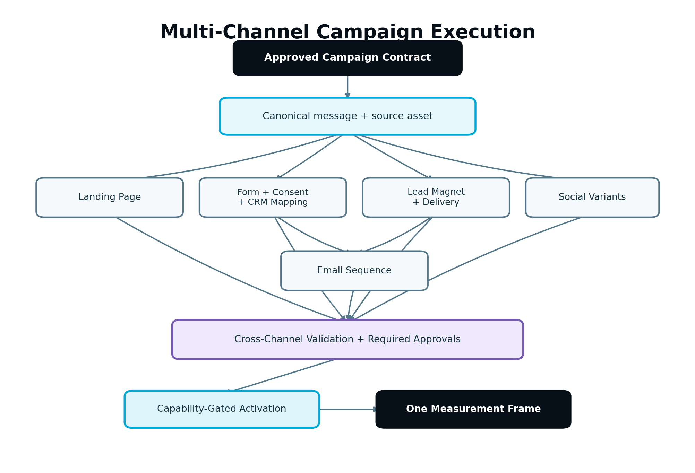
Figure 8 — Multi-channel campaign execution graph
Figure 8. A campaign is an approved dependency graph with a canonical message, channel variants, activation gates and one measurement frame.

19.1 Campaign contract
A Campaign is not another module. It groups existing approved execution tasks around:
- one business objective;
- defined audience and journey stage;
- approved offer and Message Contract;
- date window and time zone;
- canonical source assets;
- channel task graph;
- destination and approval policies;
- primary and secondary outcomes;
- campaign-level attribution identifier.

19.2 Coordination rules
- A campaign cannot make a strategically new claim or add a channel not supported by the approved plan without review.
- Channel assets inherit campaign facts but keep their own immutable versions.
- Dependencies define activation order. A social post must not promote a landing page that is not verified live unless the schedule explicitly follows that dependency.
- Campaign approval may bundle assets for efficient review, but a rejection or requested change applies only to the selected assets unless the shared Message Contract changes.
- Schedule changes propagate only to dependent assets and respect destination restrictions.
- Partial launch is permitted only when the plan defines the remaining branch as optional or an authorized approver accepts the impact.
- Campaign cancellation prevents future actions and creates review tasks for already-live assets; it does not silently delete them.

19.3 Cross-channel consistency validator
Before activation, validate:
- offer, price, eligibility, dates and disclosures match;
- destination URLs and tracking parameters are correct;
- audience and geographic restrictions are compatible;
- source asset is approved and current;
- forms, email delivery and CRM mappings are active before promotional traffic begins;
- campaign identifiers are consistently attached;
- platform variants do not contradict one another;
- measurement events are available or limitations are disclosed.

19.4 Campaign completion
Campaign execution is complete when all required branches are verified or explicitly waived/cancelled, the campaign exposure record is closed, measurement windows are active or complete according to Part 4, and outstanding failures or limitations are recorded. A campaign can be execution-complete while outcome evaluation continues.

20. Integration and Provider Adapter Architecture

20.1 Capability discovery
Each connection exposes a versioned capability document containing:
- provider and account reference;
- authenticated scopes;
- supported normalized operations;
- object types and limits;
- scheduling, edit, delete, metric and webhook support;
- rate-limit status and quota window;
- token expiration/refresh health;
- last successful validation;
- provider-specific constraints;
- environment and test-mode status.
The execution UI, Approval Service and Publishing Gateway use the same capability document. They must not maintain separate assumptions.

20.2 Adapter contract
Every write-capable adapter implements applicable methods from a shared contract:
- validateConnection();
- getCapabilities();
- preflight(command);
- createDraft(command, idempotencyKey);
- publish(command, idempotencyKey);
- schedule(command, idempotencyKey);
- update(command, idempotencyKey);
- getRemoteState(remoteRef);
- verify(expectedFingerprint, remoteRef);
- cancelSchedule(remoteRef);
- rollback(rollbackRef, idempotencyKey) where supported;
- readMetrics(cursor);
- reconcile(operationRef).
Unsupported methods return a typed CAPABILITY_NOT_SUPPORTED result before side effects. Adapters normalize provider errors into stable categories while retaining protected raw diagnostics for internal support.

20.3 Connection lifecycle
DISCONNECTED → CONNECTING → VALIDATING → HEALTHY → DEGRADED → REAUTH_REQUIRED → DISCONNECTED
A connection may also become SUSPENDED for security or administrative reasons. HEALTHY is capability-specific; an account may allow reads but no writes. Token refresh, permission reduction, account removal and schema drift must update health promptly.

20.4 Launch capability matrix
Domain | Approved V1 execution behavior
WordPress | Controlled draft, schedule/publish where supported, update, verify and remote mapping.
Static HTML / FTP / SFTP / supported hosting control | Generate approved package; deploy through configured target; verify files/URL; rollback baseline where supported.
Native and supported WordPress forms | Create/configure through approved implementation; verify submission path and downstream routing.
Mailchimp, Brevo, AWeber, GetResponse | Provider-neutral campaign/automation operations according to discovered capabilities.
CRM abstraction / Simahi and approved providers | Normalized sync, mapping, guarded writes and outcome ingestion according to provider capabilities.
Social destinations | Strategy, creation, calendar and approval in V1; direct schedule/publish only when the specific connector is launch-enabled and reports write capability.
GA4, GSC, GTM, GBP and compatible measurement sources | Read/measurement and approved configuration actions only through supported capability contracts.
Shopify | Deferred; do not expose as a V1 publishing destination.

20.5 Secrets and isolation
Credentials are stored in encrypted secret management with least-privilege scopes and never copied into Work Packages, logs, prompts, asset content or client-visible diagnostics. Every adapter operation receives workspace and connection identity from server-side authorization. Agency connections are additionally client-scoped where applicable.

20.6 Provider change tolerance
Provider schemas, scopes, limits and behavior change. Adapters must use contract tests, versioned mappings and feature flags. When a provider removes a capability, pending tasks become blocked with an explanation and safe export/handoff option where that option already belongs to the module; the engine must not attempt an undocumented workaround.

21. Publishing, Scheduling, Verification and Rollback

21.1 Publishing command
All external marketing actions use a normalized PublishCommand or another explicitly named protected-action command. The command contains:
- workspace, project and client scope;
- task, asset and immutable version references;
- destination connection and target object;
- action: create draft, publish, schedule, update, activate, send or authorized CRM write;
- expected remote-state fingerprint;
- approval fingerprint and decision reference;
- schedule, time zone and expiry where applicable;
- rollback or compensation requirements;
- idempotency and correlation identifiers;
- required capability and preflight version.
The command is created server-side after authorization. The browser must not be trusted to declare approval, capability or destination scope.

21.2 Preflight
Immediately before enqueueing an external action, repeat checks that may have changed since approval:
- Workspace, project and connection remain active.
- Actor or approved schedule principal remains authorized.
- Asset, approval and configuration fingerprints still match.
- Required dependency assets are verified live.
- Destination capability and authentication are healthy.
- Remote object has not changed unexpectedly since preview.
- Schedule has not expired and content remains temporally accurate.
- Applicable form, consent, audience and suppression configuration remains valid.
- Workspace is not read-only, suspended or otherwise blocked.
- Rate limit and provider quota allow safe execution or a permitted queue delay.
Any changed material condition returns the task to a reviewable blocked state; it must not be “best effort” published.

21.3 Reliable external-action flow
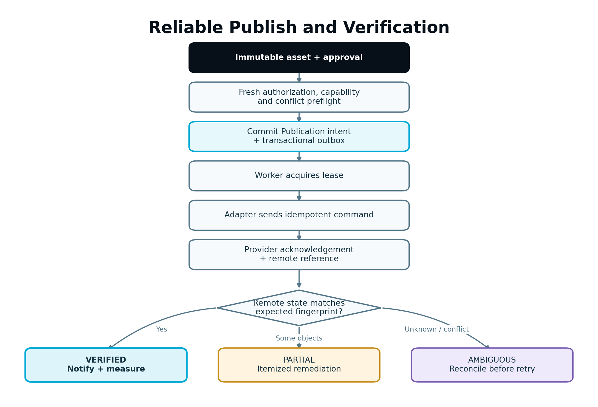
Figure 9 — Reliable publish and verification sequence
Figure 9. Internal intent is committed before the remote call, the remote result is reconciled, and only verified state becomes active.
Implementation sequence:
- Commit the Publication record and outbox event atomically.
- A destination worker acquires the publication lease.
- Run preflight and compute the outbound payload fingerprint.
- Send the command with the stable idempotency key where the provider supports it.
- Store provider acknowledgement and remote reference.
- Query or retrieve remote state using bounded retry/backoff.
- Compare remote state with expected asset/configuration fingerprint.
- Mark VERIFIED, PARTIAL, FAILED or UNKNOWN_RECONCILIATION_REQUIRED.
- Emit customer notification only from the authoritative resulting state.
- Release the lease and update the parent task.

21.4 Partial success
Multi-object publication can partially succeed: for example, a page may publish while its menu update fails. The adapter returns an itemized result. Successful remote objects retain mappings; failed items retry or compensate independently. The UI must show what is live and what is not. It must never collapse partial success into a generic “published” result.

21.5 Scheduling
- Store canonical schedule time in UTC plus original local time and IANA time zone.
- Re-evaluate daylight-saving offsets using the original zone, not a fixed offset.
- Create provider-native schedules when supported; otherwise use the SEnuke AI scheduler only if the adapter safely supports delayed publish.
- Record whether the provider or SEnuke AI owns the active schedule.
- Changes and cancellations reconcile both internal and remote schedule state.
- A schedule worker re-runs preflight at execution time.
- Missed schedules become MISSED or BLOCKED; policy determines whether a human may reschedule.

21.6 Update conflicts
Before updating an existing remote object, compare the last known remote fingerprint or revision with current state. If the customer or another system changed it, create a three-way comparison when possible: last synchronized version, current remote state and proposed version. Do not overwrite unexpected remote work silently.

21.7 Rollback and compensation
Rollback is target-specific:
- Website: restore the prior approved page/site package and remote mappings; revalidate URLs, navigation, forms and redirects.
- Scheduled social asset: cancel the future schedule when supported; already-public content requires an explicit update/removal decision.
- Email: a completed send cannot be rolled back. Compensation may pause a sequence, correct a future message or send an approved correction; the UI must state the limitation.
- CRM: revert only fields whose prior value and concurrency state are known; otherwise create a reconciliation task.
- Lead capture: deactivate new submissions safely while preserving already-collected authorized data and audit records.
Rollback itself is a protected action, permission-aware, idempotent and audited. “Undo” must not promise technical reversibility that a provider does not offer.

22. Measurement Handoff and Growth Intelligence Contract

22.1 Measurement Plan
Every activated asset or campaign has a versioned plan containing:
- business objective and primary outcome;
- secondary and diagnostic metrics;
- asset, campaign and destination identifiers;
- baseline definition and observation period;
- event names, source systems and required properties;
- attribution or association rule and limitations;
- consent and data-collection requirements;
- evaluation window and minimum evidence conditions;
- owner and fallback proxy when a preferred source is unavailable;
- expected impact and confidence from the approved recommendation.
The plan is approved with the execution configuration when measurement affects forms, tags, consent or customer data.

22.2 Normalized event envelope
{
"eventId": "evt_01H...",
"eventName": "qualified_quote_start",
"occurredAt": "2026-09-18T14:32:11Z",
"workspaceId": "ws_123",
"projectId": "prj_456",
"campaignId": "cmp_88",
"assetVersionId": "asset_v19",
"publicationId": "pub_42",
"source": "FIRST_PARTY_WEB",
"anonymousId": "anon_hash",
"contactRef": null,
"properties": {
"formId": "form_quote_v3",
"service": "visitor_insurance",
"location": "mississauga"
},
"consent": {
"policyVersion": "consent_v4",
"analyticsAllowed": true,
"marketingAllowed": false
},
"deduplicationKey": "...",
"schemaVersion": 2
}
Personally identifying properties must be excluded or tokenized unless required, permitted and protected. Raw advertising or analytics identifiers are not copied into general logs.

22.3 Consent-aware measurement
V1 implementation must be compatible with consent-aware collection:
- respect configured Consent Mode behavior where applicable;
- avoid firing disallowed measurement or marketing actions before consent;
- retain the consent policy/version needed to interpret an event;
- support first-party event collection and server-side tagging readiness;
- allow CRM/offline conversion linkage where a lawful, configured identity path exists;
- distinguish modeled, observed and imported outcomes;
- prevent behavior recordings from capturing sensitive form values;
- apply workspace/client retention and deletion policy.
If consent prevents a metric from being observed, Growth Intelligence receives an explicit measurement limitation rather than a fabricated zero.

22.4 Behavior Intelligence signals
Where a compatible approved provider is connected, the Measurement Service may normalize:
- click and tap concentration;
- scroll depth;
- session-recording availability and reviewed insights;
- rage/dead clicks where supplied;
- form start, field interaction, error and abandonment;
- navigation path and return behavior;
- CTA visibility and engagement.
Part 3 attaches the relevant asset/publication identity and ensures instrumentation is active. Part 4 interprets these signals with analytics, search and CRM evidence. Session recordings remain provider-controlled sensitive data; SEnuke AI should store normalized findings or references rather than duplicating raw recordings unnecessarily.

22.5 Exposure and activation events
The engine must emit trustworthy denominator events, not only outcomes:
- publication verified and activation time;
- campaign branch live;
- email recipients attempted/delivered;
- form version exposed or submitted where measured;
- asset revision or rollback time;
- schedule cancelled or integration disconnected.
Without exposure history, Part 4 cannot determine which version was responsible for an outcome.

22.6 Handoff to Growth Blueprint and Next Best Action
Verified execution produces an ExecutionOutcomeReady event. Growth Intelligence then evaluates performance according to the Measurement Plan. The Workflow Controller may update Next Best Action when:
- the task is ready for measurement;
- sufficient outcome evidence arrives;
- a failure or instrumentation gap requires attention;
- an experiment decision becomes due;
- a material result suggests Strategy review.
Part 3 must not immediately create duplicate follow-up work simply because publication completed. The measurement window and Part 4 prioritization determine the next action.

23. Guided and Advanced User Experience

23.1 Guided Mode
Guided Mode is the default. The primary execution screen should answer:
- What is SEnuke AI working on?
- Why is this task recommended?
- What evidence and approved Strategy support it?
- What will be created or changed?
- What is the expected impact and confidence?
- What is blocking progress?
- What needs the user’s review or approval?
- What will happen externally after approval?
- How much AI Capacity is estimated?
- How will the result be measured?
The primary action is Start, Continue, Review, Approve, Resolve, Publish, Schedule or View Results according to canonical state. The customer should not have to infer state from module screens.

23.2 Advanced Mode
Advanced Mode may expose:
- full dependency graph;
- Context Bundle references;
- validator findings and waivable warnings;
- channel configuration and destination capabilities;
- structured asset fields and version comparison;
- schedule ownership and remote mappings;
- project capacity allocation and task estimate range;
- execution telemetry appropriate for customer visibility.
It does not expose provider secrets, raw prompt internals that compromise security, or controls that bypass governance.

23.3 Review experience
- Show the artifact in the form closest to its destination: responsive page preview, post preview, email preview or lead-magnet document.
- Pair visual preview with structured fields that may not be visible, such as metadata, schema, audience and consent configuration.
- Show a material diff from the last approved/published version.
- Allow comments anchored to the relevant asset/section.
- Preserve reviewer filters and unresolved comments across revisions.
- Make the exact approval scope explicit before confirmation.
- Show warnings and destination limitations in plain English.

23.4 Batch review
Batch review is allowed for related assets, but each selected item retains an independent decision. The UI must prevent accidental “approve all” when some items have blockers, stale sources, different destinations or missing client approval. Shared changes to the Message Contract invalidate affected items together.

23.5 Background work
Long-running tasks show queued, active, validating and retry status without forcing the user to remain on the page. The system reports meaningful progress based on completed stages, not invented percentages. The user may safely navigate away. Cancellation explains which completed work will be preserved and whether an external action has already begun.

24. Notifications, Activity History and Audit

24.1 Notification rules
Notifications are event-derived, deduplicated and role-aware. Required categories include:
- task ready, blocked, failed or recovered;
- draft ready for review;
- approval requested, changes requested, approved or rejected;
- client review requested;
- schedule created, changed, blocked, missed or cancelled;
- external action verified, partially successful or failed;
- integration reauthorization required;
- AI Capacity insufficient or forecast risk;
- measurement active, insufficient or ready for evaluation;
- rollback completed or requiring attention.
Do not notify published from a queued or merely acknowledged state. Links open the exact workspace, client, project, task and version the recipient may access.

24.2 Activity History
Customer-visible history should state what happened in plain language: “Landing page version 7 approved by…,” “WordPress page verified live at…,” or “Email activation blocked because the sender domain is no longer verified.” It should avoid provider internals unless needed for action.

24.3 Immutable audit record
Audit every authority- or outcome-relevant action with:
- actor type and ID;
- workspace, project and client scope;
- action and reason code;
- task, asset, version, approval and publication references;
- before/after snapshot references;
- Strategy, Execution Plan, Business Brain and evidence versions;
- request, correlation, causation and idempotency identifiers;
- destination connection and protected remote reference;
- timestamp, execution principal and applicable IP/device metadata;
- override or waiver justification.
Never store credentials, full sensitive form data, full email lists or raw provider secrets in audit payloads.

25. Error Handling, Recovery and Reconciliation

25.1 Error categories
Use stable categories across modules:
- VALIDATION_FAILED;
- MISSING_INPUT;
- STALE_AUTHORITY;
- PERMISSION_DENIED;
- ENTITLEMENT_BLOCKED;
- CAPACITY_INSUFFICIENT;
- INTEGRATION_AUTH_FAILED;
- CAPABILITY_NOT_SUPPORTED;
- RATE_LIMITED;
- PROVIDER_TEMPORARY_FAILURE;
- PROVIDER_PERMANENT_REJECTION;
- REMOTE_CONFLICT;
- PARTIAL_EXTERNAL_SUCCESS;
- AMBIGUOUS_EXTERNAL_RESULT;
- MEASUREMENT_UNAVAILABLE;
- SECURITY_BLOCKED;
- INTERNAL_CONSISTENCY_ERROR.
Each error includes customer-safe explanation, retryability, responsible component, recommended action, preserved artifacts and internal diagnostic reference.

25.2 Recovery rules
- Preserve valid intermediate and draft asset versions.
- Retry from the last safe checkpoint rather than the entire workflow.
- Do not charge again for reusable completed work; settle only verified consumed capacity according to policy.
- Re-run authorization and preflight before a delayed retry.
- Never retry an ambiguous external write until reconciliation checks remote state.
- Allow authorized manual replay from the Operations Command Center with the original idempotency context.
- Escalate repeated failures with a clear support bundle and no exposed secrets.

25.3 Poison messages and dead-letter handling
Events that repeatedly fail processing move to a controlled dead-letter queue with workspace, event type, retry count, last error and correlation reference. Operators may inspect, repair and replay idempotently. A dead-letter event that could affect customer-visible state creates an incident and actionable task; it must not disappear silently.

25.4 Reconciliation jobs
Periodic jobs compare:
- queued schedules with provider schedules;
- internal publications with remote object state;
- activated email automations with provider status;
- CRM writes with remote record versions;
- measurement connection health and event lag;
- capacity reservations with active/finished runs.
Differences become typed incidents. Reconciliation may safely correct metadata or resume verification, but it cannot invent approval for a new side effect.

26. Security, Privacy and Compliance

26.1 Authorization and isolation
- Enforce workspace and Agency client scope at API, service, query and event-consumer layers.
- Use object-level authorization for assets, approvals, publications, connections and metrics.
- Scheduled jobs execute as constrained service principals tied to the approving workspace policy.
- Never trust client-supplied workspace, client, role, entitlement or approval claims without server resolution.
- Prevent indirect object reference through opaque IDs plus authorization; opaque IDs alone are not security.

26.2 Untrusted content and prompt injection
Crawled pages, uploaded files, transcripts, CRM notes, social content and third-party search results are untrusted data. Context assembly must label and delimit them. Model instructions found inside data are ignored. Tool calls are selected by the orchestrated plan and allowlist, not requested by retrieved text.

26.3 Data minimization
- Load only task-relevant Business Brain and customer data into AI context.
- Redact or tokenize personal data when it is not necessary for the output.
- Do not send recipient lists, raw CRM exports or sensitive form submissions to a general content-generation model.
- Respect configured retention and deletion policy for drafts, logs, metrics and integration data.
- Keep provider/model telemetry internal and separate from customer content.

26.4 Content and channel safety
- Sanitize generated HTML, URLs, embeds and structured data.
- Validate file types, sizes, malware status and image provenance.
- Block phishing-like, deceptive or malicious automation patterns under the approved malicious-use policy.
- Enforce email suppression and unsubscribe behavior.
- Prevent publication of secrets, tokens, private preview URLs or internal diagnostic text.
- Apply stricter approval profiles to regulated or high-sensitivity claims.

26.5 Logging and support access
Logs use structured reason codes and protected references, not raw content where avoidable. Support impersonation or customer-data access, if implemented under existing platform policy, must be explicit, least-privileged, time-limited and audited. Exported support bundles exclude secrets and unnecessary personal data.

27. Reliability, Performance and Scalability

27.1 Asynchronous execution
Generation, validation, publication, metric ingestion and reconciliation use durable queues. APIs return stable task/run identifiers. Workers are stateless where practical, checkpoint work and honor cancellation between safe stages.

27.2 Idempotency
Idempotency keys are scoped to workspace, operation and target. The same request returns the existing authoritative result. A materially changed payload requires a new operation/version. Database uniqueness constraints back application-level deduplication for task creation, reservations, publications, webhook events and remote mappings.

27.3 Concurrency
- Use optimistic concurrency for task and asset metadata.
- Use leases for long operations and protected remote mutations.
- Serialize writes per remote object when order matters.
- Allow safe parallel generation of independent channel assets.
- Cap workspace, project, provider and task-class concurrency according to fair use and operational health.

27.4 Performance targets
Exact service-level objectives are configuration and operational policy, but engineering must instrument:
- API and queue latency by stage;
- time to first useful preview;
- total successful workflow time;
- validation and repair duration;
- provider success/fallback rate;
- external verification time;
- webhook and metric ingestion lag;
- reconciliation backlog;
- capacity estimate accuracy;
- task completion and abandonment rate.
The UI must not block on long provider calls. Preview generation should stream or checkpoint when supported, while official asset versions are created only from complete validated output.

27.5 Backpressure and degradation
When a provider, queue or validator is degraded:
- stop accepting work that cannot meet safety or correctness;
- continue unaffected modules and draft-only work where valid;
- prioritize already-authorized time-sensitive actions according to policy;
- expose accurate delay state;
- avoid retry storms using circuit breakers, quotas and jitter;
- preserve schedules and alert operators before deadlines are missed.

27.6 Observability
Every execution shares a correlation ID across Workflow Controller, Capacity Engine, AI Orchestrator, validators, Approval Service, Publishing Gateway, adapters and Measurement Service. Distributed traces must not include secrets or unnecessary content. Metrics and alerts cover failures, unusual cost, capacity leaks, duplicate actions, stuck leases, remote-state drift and client/workspace isolation violations.

28. Required APIs, Events and Service Interfaces

28.1 Public/internal API surface
Names are illustrative; behavior and ownership are required.
Method and path | Responsibility
POST /projects/{id}/execution-tasks | Create a task only from an authorized plan item.
GET /execution-tasks/{id} | Return lifecycle, blockers, lineage, approvals and permitted status.
POST /execution-tasks/{id}/estimate | Produce an AI Capacity and resource estimate.
POST /execution-tasks/{id}/start | Recheck readiness, reserve capacity and enqueue execution.
POST /execution-tasks/{id}/cancel | Cancel at a safe boundary and report preserved work.
POST /execution-tasks/{id}/reconcile | Reconcile stale authority or an ambiguous external state.
GET /assets/{id}/versions | List immutable versions and state.
GET /asset-versions/{id}/diff | Return material and field-level comparison.
POST /asset-versions/{id}/validate | Run the applicable versioned validator set.
POST /approval-requests | Request approval for exact versions/configuration.
POST /approval-requests/{id}/decisions | Record approve, reject or request changes.
POST /publications | Create a protected external-action intent after authorization.
POST /publications/{id}/schedule | Schedule using canonical time-zone behavior.
POST /publications/{id}/cancel | Cancel a pending schedule where supported.
POST /publications/{id}/rollback | Request governed rollback/compensation.
GET /connections/{id}/capabilities | Return current scoped capabilities and health.
POST /campaigns | Create a campaign from approved plan items.
GET /campaigns/{id}/graph | Return dependency and activation state.
POST /measurement-plans | Create/version the success and instrumentation contract.
GET /execution-outcomes/{id} | Return verified execution and measurement handoff state.
Every mutation accepts an idempotency key and returns a correlation ID. Validation errors identify fields and remediation. Authorization failures do not reveal whether inaccessible cross-workspace objects exist.

28.2 Internal service interfaces
- WorkflowAuthority.resolve(projectId, planItemId)
- ContextAssembler.build(workPackageSpec)
- ApplicabilityResolver.resolve(taskType, projectSituation)
- EntitlementService.authorize(workspaceId, feature, action)
- CapacityEngine.quote/reserve/settle/release
- AIOrchestrator.execute(orchestrationRequest)
- ValidationService.validate(assetVersionId, ruleSetVersion)
- ApprovalService.resolvePolicy/createRequest/recordDecision/validateFingerprint
- PublishingGateway.preflight/execute/verify/reconcile/rollback
- IntegrationHub.getConnection/getCapabilities/getSecretHandle
- MeasurementService.createPlan/recordExposure/normalizeEvent
- AuditService.append(event)
- NotificationService.handle(domainEvent)

28.3 Domain events
At minimum, publish versioned events for:
- ExecutionTaskCreated, ExecutionTaskReady, ExecutionTaskBlocked, ExecutionTaskStarted, ExecutionTaskFailed, ExecutionTaskStale, ExecutionTaskCompleted;
- CapacityEstimated, CapacityReserved, CapacitySettled, CapacityReleased;
- AssetVersionCreated, AssetValidationCompleted, AssetVersionSuperseded;
- ApprovalRequested, ApprovalGranted, ApprovalRejected, ChangesRequested, ApprovalInvalidated;
- PublicationQueued, PublicationAcknowledged, PublicationVerified, PublicationPartiallySucceeded, PublicationFailed, PublicationRolledBack;
- ScheduleCreated, ScheduleBlocked, ScheduleMissed, ScheduleCancelled;
- ConnectionHealthChanged, ConnectionCapabilityChanged;
- CampaignBranchActivated, CampaignExecutionCompleted;
- MeasurementPlanActivated, MeasurementEventNormalized, ExecutionOutcomeReady.
Event envelopes include event ID, type, schema version, occurred time, producer, workspace/project/client scope, aggregate ID/version, actor, correlation/causation IDs and payload. Consumers maintain inbox deduplication and tolerate unknown additive fields.

28.4 Required persistence entities
Minimum entities include:
- ExecutionPlan, ExecutionPlanVersion, ExecutionPlanItem;
- ExecutionTask, ExecutionTaskDependency, TaskBlocker, ExecutionRun, ExecutionCheckpoint;
- WorkPackage, ContextBundleReference;
- Asset, AssetVersion, AssetRelationship, AssetLock, ValidationReport, ValidationFinding;
- ApprovalPolicy, ApprovalRequest, ApprovalItem, ApprovalDecision;
- Campaign, CampaignAsset, CampaignTask, MessageContract;
- Publication, PublicationAttempt, RemoteObjectMapping, Schedule, RollbackPoint;
- ConnectionReference, CapabilitySnapshot, ProviderMappingVersion;
- MeasurementPlan, ExecutionExposure, NormalizedMetricEvent, ExecutionOutcome;
- ExecutionAuditEvent, NotificationDelivery, ReconciliationIncident;
- existing Capacity Engine quote, reservation, settlement and ledger references.
Operational payloads and large asset bodies may use object storage, but the database retains immutable hashes, ownership, version, state and storage references. Foreign keys and authorization queries must preserve workspace/client isolation.

29. Real-World End-to-End Examples

29.1 Existing insurance website: qualified Visitor Insurance quote requests

Situation
An insurance agency has an existing website and wants more qualified quote requests. The approved evidence shows strong Visitor Insurance search demand, no dedicated page, exits from a broad insurance page and stronger CRM close rates for Visitor Insurance leads.

Approved decision
The Unified Strategy prioritizes a focused Visitor Insurance landing experience. The approved Execution Plan includes a dedicated page, shorter quote-start path, supporting guide, delivery email and coordinated promotion.

Execution graph
- The Workflow Controller confirms Strategy v4 and Execution Plan v4.1 are current.
- The Context Assembler loads Business Brain v12, keyword evidence v7, crawl v5, behavior v2 and CRM v3.
- The Website/Content adapters create a new Page Model using the existing site’s Design System and approved components.
- The Content Engine generates the page package, FAQs, metadata, internal links and qualifying CTA. It blocks unsupported “lowest rate” language from the claims profile.
- The Lead Magnet Engine generates “Visitor Insurance Preparation Checklist,” landing/download relationships and delivery email.
- The form mapping sends approved submissions to the CRM with source visitor_insurance_campaign and preserves consent state.
- The Repurposing Engine creates platform-specific social assets from the approved guide and page Message Contract.
- Validation checks cannibalization, Information Gain, page layout, accessibility, form behavior, consent, email suppression and cross-channel offer consistency.
- The agency Manager approves internally. Client review is required by project policy and approves the exact package.
- WordPress publication creates the page as a draft, verifies the preview and then publishes after final approval. Internal links are added through an incremental update.
- The form and delivery path are tested with designated test data; the email automation is activated under its bounded approval.
- Social assets are directly scheduled only for any launch-enabled healthy connector; remaining assets are labelled approved handoffs.
- Remote verification records the live page URL, form success, email automation state and any social remote IDs.
- The Measurement Plan tracks qualified page visits, quote-form starts, completions, CRM qualification and revenue outcome where available.
- Part 4 evaluates the results before deciding whether the Next Best Action is a CTA experiment, cluster expansion or lead-magnet improvement.

Expected customer experience
The customer sees one recommended action, a coordinated preview, clear evidence and expected impact, one review flow, precise external-action summary and a results screen. They do not manually move data among seven modules.

29.2 Personal Workspace: new business without a website

Situation
A Personal Workspace user completes Business Discovery and selects an approved local bookkeeping opportunity. There is no existing site, CRM or email provider.

Execution
- The approved Strategy defines audience, offer, local market, positioning and minimum launch goal.
- The Execution Plan calls for a five-page component-based website and native contact form.
- Site Analysis is NOT_REQUIRED, not an artificial blocker.
- The Website Engine generates the Site Model, Design System, home, services, about, FAQ and contact pages using registered components.
- The Content Engine produces unique service copy, local relevance, verified business facts, metadata, internal links and calls to action.
- The native form is configured for the approved routing destination; no email nurture or CRM automation is invented because those integrations are absent and not required by the approved plan.
- The user reviews responsive previews, edits the founder description and locks it.
- Static HTML publication deploys the approved package atomically and verifies pages, form, sitemap, metadata and analytics-ready events.
- The initial Measurement Plan uses first-party form completion and available analytics. Missing CRM revenue data is stated as a limitation.

Architectural lesson
Applicability matters. The absence of a CRM does not block the valid launch, and the engine does not pretend to execute integrations that are not part of this project.

29.3 Agency Workspace: client approval and remote conflict

Situation
An agency prepares a content refresh for a client’s highest-traffic service page. The agency Editor starts from the approved task, but the client independently edits the live page before publication.

Execution
- AI generates the refresh from the last synchronized page and preserves locked client language.
- Internal validation passes; the Manager approves and the client approves version 6.
- At publish preflight, the remote fingerprint differs from the preview baseline.
- Publication stops with REMOTE_CONFLICT; approval is not consumed as permission to overwrite.
- The UI shows last synchronized content, current live content and proposed content.
- The Editor merges the client’s new paragraph into version 7.
- Materiality rules invalidate the old approval. Version 7 is revalidated and sent through the required internal/client approval.
- Publication succeeds, remote state is verified and version history records both the conflict and resolution.

Architectural lesson
Approval and optimistic concurrency protect customer work. A technically valid API update is not allowed to erase an out-of-band edit.

29.4 Lead magnet and email provider degradation

Situation
A Business Workspace has an approved guide, landing page and delivery sequence. The landing page is live, but the email provider enters REAUTH_REQUIRED before campaign activation.

Execution
- The activation preflight detects lost email write capability.
- Promotion and form activation remain blocked so leads are not collected without delivery.
- The already-approved assets remain intact; the task does not regenerate them or consume unnecessary AI Capacity.
- The Owner receives a secure reauthorization action.
- After reconnection, capability validation confirms draft, automation and metric scopes.
- The existing approval remains valid only if provider configuration, sender, audience and message fingerprints match; otherwise review resumes.
- The engine tests delivery, activates the sequence, then allows campaign promotion dependencies to proceed.

Architectural lesson
Dependencies and fresh preflight prevent a superficially “successful” launch with a broken customer journey.

29.5 Social connector unavailable at launch

Situation
The approved plan calls for LinkedIn and Facebook promotion, but direct social publishing is not enabled in the launch Integration Hub.

Execution
- SEnuke AI creates the social strategy, calendar, posts and visual requirements.
- Assets pass channel and campaign validation and are approved.
- The task outcome states EXPORT_HANDOFF, with platform, planned date, caption, link and creative package.
- The UI does not show “scheduled” or “published,” and no remote ID is fabricated.
- When a supported connector becomes available later, future tasks may use direct capability without changing campaign or Growth Engine logic.

Architectural lesson
Capability-aware execution preserves trust and allows provider expansion without embedding platform assumptions in the intelligence layer.

30. Edge Cases and Required Behavior
Edge case | Required behavior
Strategy changes while drafts are being generated | Finish only safe internal checkpointing, mark affected tasks/assets stale, release unused reservations and require reconciliation before review or external action.
Execution Plan changes after asset approval | Compare authority and plan-item impact; invalidate approval for affected tasks and preserve unaffected approved assets.
Business fact changes in the Business Brain | Re-run dependency/claim impact; stale only assets that use the changed fact.
Same task-start request submitted twice | Return the existing task/run through idempotency; do not reserve capacity twice.
Worker dies after AI provider consumed usage | Resume from checkpoint; settle verified consumed portion; avoid charging for repeated reusable output.
Capacity estimate is too low | Settle within configured tolerance; beyond tolerance pause before additional work and request renewed authorization.
Capacity reaches zero during a multi-asset campaign | Preserve completed assets, block unstarted capacity-bearing tasks, allow review/publish of already-approved work if entitlement policy permits.
Workspace enters read-only before scheduled publication | Block the schedule at preflight, notify Owner and preserve approved asset and schedule intent.
Client is archived | Cancel future cost-incurring jobs and schedules for its projects; preserve data, approvals and history.
Seat is removed from an assigned approver | Reassign or escalate according to workspace approval policy; do not auto-approve.
Client Viewer attempts generation | Block by default because the role has no AI allowance; allow only feedback/approval within client scope.
Approver edits content after approving | Create a new version; invalidate approval and require a new decision.
Provider acknowledges publish but times out | Query remote state before retry; reconcile by idempotency/fingerprint.
Page publishes but menu update fails | Mark partial; retain page mapping; retry or remediate menu only; show accurate live state.
Remote page changed outside SEnuke AI | Detect revision/fingerprint conflict and require compare/merge decision.
Social platform shortens or rejects a URL | Record provider rejection; do not substitute an unapproved URL; return for correction.
Scheduled post becomes inaccurate after campaign date change | Mark stale and block; regenerate/review affected date-sensitive versions.
Email audience grows after approval | Compare approval policy; if recipient snapshot/definition change is material, require renewed approval.
Suppressed contact appears in CRM segment | Provider suppression wins; exclude and report count, never resubscribe silently.
Email send partially accepted | Record attempted, accepted and rejected counts; do not retry accepted recipients.
Automation changes while contacts are enrolled | Create versioned migration decision; never silently restart or duplicate contacts.
CRM webhook arrives twice or out of order | Inbox deduplication and source-version checks prevent duplicate/stale writes.
CRM record matches two contacts | Quarantine for review; do not merge or select arbitrarily.
Form succeeds but CRM is unavailable | Preserve submission under approved secure path, display appropriate confirmation policy, retry routing and surface lag/failure; do not lose the lead.
Consent is denied for analytics | Record permitted operational event only; mark analytics limitation rather than zero performance.
Session recording contains sensitive input | Provider masking and collection policy are required; block or disable recording if safety cannot be verified.
Generated content closely duplicates another project asset | Block or warn by asset threshold and recommend consolidation or added Information Gain.
Source asset is revoked after derivatives are scheduled | Cancel pending derivatives and create review tasks for already-live items.
Translation/localization changes a claim | Treat as material; validate against approved claim and disclosure profile.
Static deploy uploads only part of the release | Do not switch the active release; reconcile/clean staging and retain last known good release.
WordPress plugin/block version is missing | Block publication with actionable compatibility requirement; do not insert broken fallback markup.
Integration scope is reduced | Update capability snapshot, block incompatible tasks and retain safe create/export behavior where applicable.
Provider rate limit would miss schedule | Surface risk, apply bounded retry according to deadline, then mark missed/blocked rather than publishing at an unsafe time.
Cancellation arrives during remote write | Finish reconciliation of the in-flight side effect, prevent subsequent steps and report actual remote state.
Rollback is not technically possible | Offer only accurate compensation options and preserve evidence; never label as reversible.
Measurement event arrives before publication verification | Buffer or mark unassociated until exposure is authoritative; do not attribute prematurely.
Attribution sources disagree | Preserve source-specific values, apply configured rule and lower confidence; do not hide the conflict.

31. Developer Rules
- Build one shared execution lifecycle; modules must not invent local lifecycle substitutes.
- Treat the Workflow Controller as the authority for what may happen next.
- Require a current approved Strategy before generating its Execution Plan, and a current plan item before official execution.
- Store exact upstream versions on every official task and asset.
- Use the Business Brain and Evidence Registry through bounded interfaces; do not copy uncontrolled project context into prompts.
- Route every AI task through the AI Orchestrator.
- Route every capacity-bearing task through quote, reserve, settle/release.
- Route every external action through the Publishing Gateway or equivalent governed protected-action interface.
- Use provider abstractions and capability discovery; never branch core intelligence on vendor names.
- Implement deterministic validators before AI reviewers.
- Never publish free-form model output directly.
- Version assets immutably and preserve human edits with section/field locks.
- Bind approval to immutable versions, destination and material configuration.
- Recheck authorization, approval and capability immediately before external execution.
- Verify remote state before declaring success.
- Make all mutations idempotent and safe under duplicate/out-of-order events.
- Preserve valid intermediate work and recover from checkpoints.
- Distinguish draft, approved, acknowledged and verified states in data and UI.
- Treat partial success as a first-class state.
- Do not expose secrets, provider economics or unrelated customer data in prompts, logs or diagnostics.
- Enforce workspace and Agency client isolation in every service and consumer.
- Treat retrieved and uploaded content as untrusted data.
- Do not invent facts, claims, citations, testimonials, results or integration success.
- Enforce Content Originality and Information Gain appropriate to asset type.
- Create a Measurement Plan and exposure record for every activated execution.
- Respect consent and suppression across website, email, behavior and CRM execution.
- Send normalized outcome events to Part 4; do not duplicate Growth Intelligence logic in modules.
- Keep launch capability configuration explicit; do not expose V2 destinations as working V1 actions.
- Use configuration and versioned policy for platform limits, thresholds, validators and channel constraints.
- Record enough audit and correlation data to reconstruct every official execution.

32. Implementation Sequence
The following order minimizes rework and keeps existing functional modules intact.

Phase 1 — Shared contracts and governance
- Freeze canonical enums, IDs, version references and event envelope.
- Implement/confirm Execution Task, Asset Version, Validation Report, Approval and Publication persistence.
- Integrate Workflow Controller authority and stale/invalidation events.
- Replace plan-name and legacy credit checks with Entitlement Service and AI Capacity contracts.
- Establish authorization middleware for workspace, project and Agency client scope.

Phase 2 — Execution Coordinator and AI production
- Implement task creation, dependency DAG validation and lifecycle transition service.
- Implement Work Package and Context Bundle assembly.
- Connect Capacity Engine quote/reserve/settle and the AI Orchestrator.
- Implement structured output schemas, checkpointing and shared validation framework.
- Implement asset versioning, lineage, material diff and approval fingerprinting.

Phase 3 — Publishing and integration reliability
- Implement capability snapshots and normalized adapter contract.
- Place WordPress and Static HTML behind the Publishing Gateway.
- Place email and CRM provider operations behind their abstraction services.
- Implement outbox/inbox, idempotency, leases, verification and reconciliation.
- Implement schedule ownership, time-zone handling, cancellation and rollback/compensation contracts.

Phase 4 — Module migration
- Adapt Website Generation to the shared Work Package, asset, approval and publication contracts without changing its component-based architecture.
- Adapt Content and Lead Magnet engines.
- Adapt Social and Repurposing engines with capability-aware direct/handoff modes.
- Adapt Email and CRM execution.
- Implement campaign grouping as a view and coordinator over existing task graphs, not a duplicate module.

Phase 5 — Measurement and continuous-growth handoff
- Implement Measurement Plan, exposure event and normalized metric envelopes.
- Connect first-party, analytics, behavior and CRM/offline sources where approved and available.
- Emit ExecutionOutcomeReady to Part 4 and update Workflow Controller/Next Best Action.

Phase 6 — UX, operations and launch hardening
- Implement Guided execution, review/diff, approval and accurate status UI.
- Add notifications and customer Activity History from authoritative events.
- Add Operations Command Center task, publication, integration, capacity and reconciliation controls.
- Complete security, load, failure-injection, provider-contract and end-to-end acceptance tests.
- Migrate existing in-flight drafts through an explicit mapping; do not silently reinterpret legacy states.

33. Testing and Quality Strategy

33.1 Unit tests
- State transition guards and terminal-state behavior.
- Strategy/plan/Business Brain invalidation impact.
- DAG cycle detection and dependency completion policies.
- Approval fingerprint and materiality classification.
- Entitlement and role intersections.
- Capacity estimate/reserve/settle/release calculations.
- Content schema parsing and deterministic validators.
- Time-zone, daylight-saving and schedule expiry behavior.
- Idempotency-key and payload-fingerprint rules.
- Consent, suppression and CRM mapping logic.

33.2 Contract tests
- AI Orchestrator structured input/output and failure categories.
- Capacity Engine lifecycle.
- Integration capability documents.
- Every provider adapter operation, including unsupported capability.
- Webhook verification, normalization and deduplication.
- Publishing verification and reconciliation.
- Measurement event schema compatibility.
- Event forward/backward compatibility for additive changes.
Adapters must run against provider sandbox/test accounts or deterministic simulators. A mocked 200 without remote-state verification is not an adequate publishing test.

33.3 Integration tests
- Task creation from approved and unapproved plan items.
- Business Brain change while generation runs.
- Human edit locks across regeneration.
- Agency internal and client approval.
- Approval invalidation after material change.
- WordPress draft, publish, update, conflict and rollback.
- Static HTML atomic deploy and partial-upload failure.
- Lead form to email/CRM routing and downstream failure.
- Email test, schedule, send, suppression and automation activation.
- CRM duplicates, schema drift and out-of-order webhook.
- Direct social capability on/off behavior.
- Measurement exposure/version association.

33.4 End-to-end tests
At minimum, automate the five real-world examples in Section 29 plus:
- Personal new-site path from approved Strategy through verified publication.
- Business content refresh with remote conflict.
- Agency multi-channel campaign with two approval layers.
- Integration reauthorization during scheduled work.
- Workspace read-only transition during generation and before publication.
- Capacity exhaustion and recovery without duplicate debit.
- Ambiguous publish response reconciled without duplicate object.
- Partial campaign success with accurate customer state.

33.5 Failure injection
Inject worker termination, duplicate events, delayed/out-of-order webhooks, provider timeouts, rate limits, invalid tokens, partial remote writes, database deadlock, queue redelivery, stale leases, object-storage delay and metric-source outage. Verify that customer work is preserved and no side effect or capacity settlement duplicates.

33.6 Security tests
- Cross-workspace and cross-client authorization attempts.
- ID enumeration and indirect-object access.
- Prompt injection inside crawled/uploaded/CRM content.
- Secret leakage in prompts, logs, events, assets and support bundles.
- Malicious HTML, URLs, embeds and files.
- Email suppression bypass and unauthorized audience expansion.
- Webhook spoofing and replay.
- Role change between approval and execution.
- Scheduled-principal privilege reduction.

33.7 Content and visual QA
- Golden structured fixtures for each asset type.
- Claim and fact contradiction cases.
- Duplicate/local-doorway-style content cases.
- Information Gain thresholds by asset type.
- Brand voice variation without message drift.
- Responsive website preview at all supported breakpoints.
- Email rendering across supported templates/clients where practical.
- Character/media validation per social destination configuration.
- Accessibility checks for websites, forms, images and documents.

33.8 Load and soak tests
Test concurrent campaign generation, large Agency workspaces, scheduled publication bursts, provider rate-limit backpressure, metric ingestion and reconciliation over extended runs. Confirm fair-use limits, isolation, queue priorities, storage growth, audit throughput and absence of stuck reservations or leases.

34. Acceptance Criteria

34.1 Workflow and authority
- AC-001: An official execution task cannot be created without a valid workspace/project and approved Execution Plan item.
- AC-002: The Execution Plan cannot exist as current unless it references an approved Strategy version.
- AC-003: Direct module access cannot bypass Workflow Controller readiness, permissions or protected-action governance.
- AC-004: Every task records Strategy, Execution Plan and Business Brain versions plus applicable evidence references.
- AC-005: A material upstream change marks only dependent tasks/assets stale and provides a reconciliation path.
- AC-006: Task dependencies are acyclic, explicit and enforced before external action.
- AC-007: Next Best Action reflects the canonical project/task state and never recommends an invalid next step.

34.2 Lifecycle, capacity and AI execution
- AC-008: All modules use the canonical execution lifecycle and reason codes.
- AC-009: State transitions are concurrency-safe, evented and idempotent.
- AC-010: Every capacity-bearing task is quoted and reserved before AI execution.
- AC-011: Capacity settlement records actual normalized use, releases unused reservation and never duplicates under retry.
- AC-012: No feature module calls an AI provider directly.
- AC-013: The AI Orchestrator selects pipelines using expected successful-workflow cost and minimum quality constraints.
- AC-014: Completed intermediate artifacts survive retry or provider fallback.
- AC-015: Structured output schema failure is repaired, safely failed or routed for review; free-form output is not published.
- AC-016: Provider/model telemetry and raw economics remain internal while customer-facing capacity use remains explainable.

34.3 Assets, validation and originality
- AC-017: Every official asset has immutable versions and provenance.
- AC-018: Repurposed, refreshed and campaign assets have explicit lineage.
- AC-019: Human-locked fields/sections survive targeted regeneration.
- AC-020: Validation Reports are attached to exact asset versions and use versioned rule sets.
- AC-021: Blocking validation prevents approval and external execution.
- AC-022: Unsupported claims, invented facts, placeholders and exposed secrets are blocked.
- AC-023: Content Originality and Information Gain are evaluated according to asset type.
- AC-024: Duplicate or low-value location/content variants are blocked or returned for meaningful differentiation.
- AC-025: Brand, campaign and cross-channel consistency are validated without forcing identical channel wording.

34.4 Approval and permissions
- AC-026: Authorization is the intersection of membership, role, client scope, entitlement, workspace state and destination capability.
- AC-027: Client Viewer is client-scoped, cannot publish and has no default AI allowance.
- AC-028: Approval binds to exact asset versions, destination and material configuration.
- AC-029: A material edit invalidates the prior approval automatically.
- AC-030: Agency projects support internal approval followed by client approval when configured.
- AC-031: Advanced Mode cannot bypass Strategy, permission, capacity, validation or approval gates.
- AC-032: Activated automations operate only inside their approved bounded policy.
- AC-033: Destructive/high-sensitivity actions require explicit authority and cannot use implicit auto-approval.

34.5 Website and content execution
- AC-034: Website work uses one canonical Site Model for WordPress and Static HTML rendering.
- AC-035: AI selects only approved registered website components and valid Design System tokens.
- AC-036: Existing-site changes inventory and protect URLs, forms, analytics, integrations, legal content and rollback state.
- AC-037: Website publication is blocked on structural, content, visual, accessibility, SEO/AEO/GEO, security or target-compatibility blockers.
- AC-038: A page/content refresh provides a material diff and preserves approved human content.
- AC-039: New content passes intent, cannibalization, internal-link and Information Gain checks.
- AC-040: Published website/content metadata, links, assets and forms are remotely verified.
- AC-041: Shopify is not presented as a V1 website publishing target.

34.6 Lead magnet, social and repurposing
- AC-042: A lead magnet recommendation includes audience, value exchange, dependencies, impact, confidence and measurement.
- AC-043: A complete lead-magnet execution includes the approved core asset and applicable landing, form, consent, delivery and CRM/email path.
- AC-044: Form success is tested separately from downstream delivery and CRM routing.
- AC-045: Social strategy, calendar and posts are generated from approved business/campaign context.
- AC-046: Direct social schedule/publish appears only when the connector is launch-enabled, healthy and capable.
- AC-047: Export/handoff is labelled accurately and never creates a fabricated remote publication state.
- AC-048: Repurposed assets retain a Message Contract and source-version relationship.
- AC-049: A material source change stales affected pending derivatives.

34.7 Email and CRM
- AC-050: Email campaigns use provider-neutral campaign, audience, sender, sequence and automation models.
- AC-051: Production sends/activation require validated sender, audience, content, consent/suppression and approval.
- AC-052: Test sends are allowlisted and do not contaminate production automation or measurement.
- AC-053: Unsubscribe, complaint and suppression state overrides a requested send.
- AC-054: A material audience or automation change creates a new version and requires applicable approval.
- AC-055: No module integrates directly with an individual CRM API.
- AC-056: CRM mapping profiles are versioned and schema drift creates an actionable incident.
- AC-057: Ambiguous CRM identities are quarantined rather than silently merged.
- AC-058: CRM writes are idempotent, concurrency-aware and protected according to materiality.
- AC-059: CRM lead, pipeline and revenue outcomes are normalized with source and confidence limitations.

34.8 Publishing and integrations
- AC-060: Every external action uses a server-authorized normalized command and idempotency key.
- AC-061: Preflight rechecks authorization, approval, capability, dependency and remote conflict immediately before action.
- AC-062: Provider acknowledgement alone cannot produce verified/published customer state.
- AC-063: Ambiguous external results reconcile before retry and do not create duplicate remote objects.
- AC-064: Partial success is itemized and visible; successful components are not discarded.
- AC-065: Remote object mappings and expected fingerprints are stored.
- AC-066: Scheduling preserves UTC, original local time and IANA time zone and handles daylight-saving changes.
- AC-067: Connection health and capability reduction block incompatible pending actions promptly.
- AC-068: Credentials never enter Work Packages, model prompts, asset content, general logs or customer diagnostics.
- AC-069: Rollback/compensation behavior accurately reflects destination limitations and is governed/audited.

34.9 Measurement and Growth Intelligence handoff
- AC-070: Every activated asset/campaign has a Measurement Plan or an explicit measured limitation.
- AC-071: Publication/exposure history identifies which asset version was active for each outcome window.
- AC-072: Measurement events use a versioned normalized envelope and deduplication key.
- AC-073: Consent state and collection limitations are preserved and respected.
- AC-074: Behavior Intelligence instrumentation excludes or masks sensitive form content.
- AC-075: CRM/offline outcomes connect only through configured privacy-safe identity and attribution rules.
- AC-076: Part 3 emits trustworthy execution/outcome-ready events; Part 4 owns evaluation and reprioritization.
- AC-077: Missing measurement due to consent or disconnected integration is represented as unavailable, not zero.

34.10 Reliability, security and UX
- AC-078: Duplicate/out-of-order commands, events and webhooks do not duplicate tasks, charges, sends, records or publications.
- AC-079: Failed runs preserve valid drafts and checkpoints.
- AC-080: Stuck reservations, leases, schedules and publications are detected and reconciled.
- AC-081: Cross-workspace and cross-client access is denied at API, service, query and consumer layers.
- AC-082: Retrieved/uploaded content cannot inject model or tool instructions.
- AC-083: Guided Mode always shows the next valid action, reason, impact, confidence, blocker and external effect.
- AC-084: Review UI shows destination-appropriate preview plus hidden material configuration and diff.
- AC-085: Customer notifications derive from authoritative state and are deduplicated.
- AC-086: Audit records allow authorized staff to reconstruct authority, inputs, versions, approval, external result and measurement handoff.
- AC-087: Provider degradation applies backpressure without retry storms or silent data loss.
- AC-088: End-to-end failure-injection tests prove no duplicate protected action or capacity settlement.

35. Final Governing Rules
The AI Marketing Execution Engine must implement approved strategy as controlled, traceable and measurable work. It must never confuse generation with execution, approval with publication, provider acknowledgement with success, or channel activity with business growth.
The final developer test is simple:
For any live marketing result, SEnuke AI must be able to show why it was chosen, which approved Strategy and evidence authorized it, what exact version was approved, how AI Capacity and AI providers were governed, what was sent to which destination, how the destination was verified, what safeguards applied, and how the outcome will inform the Growth Blueprint and Next Best Action.
If the system cannot answer that chain completely, the execution is not implementation-complete.

