SEnuke AI
DEVELOPER PLAYBOOK
DEV-047 Part 4
Growth Intelligence &
Continuous Optimization
Technical Specification and Implementation Blueprint
Version: 1.0
Status: Implementation-ready; V1 scope closed
Date: August 2, 2026
Owner: SEnuke AI Development Master
Audience: Product engineering, data engineering, AI engineering, analytics engineering, platform engineering, frontend engineering, QA, DevOps, security, support engineering and technical product leadership
This document is the authoritative integration guide for turning verified execution, measurement and live business evidence into trustworthy diagnosis, governed experiments, a continuously updated Growth Blueprint and one highest-value Next Best Action. It continues DEV-047 Parts 1, 2 and 3. It connects and refines approved V1 capabilities; it does not reopen or expand V1 scope.

Table of Contents

Architecture and Measurement
- 1. Purpose
- 2. Permanent Growth Intelligence Principles
- 3. Scope and Boundaries
- 4. System Architecture
- 5. Canonical Domain Model
- 6. Activation and Readiness
- 7. Measurement and Data Architecture
- 8. Metrics, Baselines and Evaluation Windows
- 9. Data Quality, Freshness and Limitations
- 10. Identity, Consent and Attribution Boundaries
- 11. Performance Evaluation Lifecycle

Intelligence and Optimization
- 12. Growth Engine Product Model
- 13. Funnel Intelligence
- 14. CRO, CTA and Landing Page Intelligence
- 15. Lead Intelligence and CRM Outcome Signals
- 16. Search, Content and Growth Opportunity Signals
- 17. Behaviour Intelligence
- 18. Diagnosis Engine
- 19. Opportunity Generation and Prioritization
- 20. Next Best Action Selection
- 21. Growth Blueprint
- 22. Experiment Intelligence and Governance
- 23. Experiment Design, Assignment and Exposure
- 24. Experiment Analysis and Learning

Operations and Delivery
- 25. SEnuke AI Intelligence and AI Orchestration
- 26. Approval and Part 3 Execution Integration
- 27. Reporting and Explainability
- 28. Guided and Advanced User Experience
- 29. Notifications, Audit and Operations
- 30. Error Handling, Recovery and Reconciliation
- 31. Security, Privacy and Compliance
- 32. Reliability, Performance and Scalability
- 33. Required APIs, Events and Persistence

Implementation and Acceptance
- 34. Real-World End-to-End Examples
- 35. Edge Cases and Required Behaviour
- 36. Developer Rules
- 37. Implementation Sequence
- 38. Testing and Quality Strategy
- 39. Acceptance Criteria
- 40. Final Governing Rules

Document Control
Field | Governing requirement
Document identifier | DEV-047 Part 4
Canonical name | Growth Intelligence & Continuous Optimization
Primary input | Current Business Brain and Strategy authority; versioned Measurement Plans; verified exposures; normalized measurement, search, website, behaviour, lead, CRM and experiment evidence
Primary output | Versioned evaluations, diagnoses, opportunities, experiment results, Learning Records, Growth Blueprint revisions and one valid Next Best Action
Upstream authority | DEV-047 Parts 1-3; DEV-036; DEV-046; the Business Brain; Evidence Registry; approved Unified Strategy; verified execution and Measurement Plans
Cross-cutting authority | Commercial Architecture; Integration Framework; AI Orchestrator; roles, approval, versioning, publishing, privacy, validation and notification specifications
Growth Engine modules covered | Overview, Diagnosis, Funnel, Experiments, Tracker and Report
Intelligence covered | Funnel, CRO, CTA, Landing Page, Lead, Experiment and Growth Opportunity Intelligence
Downstream handoff | Authorized recommendations return through the Workflow Controller and DEV-047 Part 3 for planning, approval, execution, publication and measurement
Scope rule | Improve and connect approved V1 capability. Do not add V2 autonomy, claim unsupported causality or bypass Strategy and execution governance.

Implementation precedence and reconciliation
Developers must apply these precedence rules when older source documents use superseded terms or describe a broader future state.
- DEV-047 Part 1 governs the master workflow and the Workflow Controller.
- DEV-047 Part 2 governs evidence, decision scoring, confidence, explainability, versioning and the relationship between the approved Unified Strategy and the Growth Blueprint.
- DEV-047 Part 3 governs execution, protected external actions, publishing verification, exposure identity and the Measurement Plan handoff.
- DEV-036 governs the approved V1 Growth Intelligence domains and the loop: Detect, Diagnose, Prioritize, Recommend, Execute or Guide, Measure, Learn, Update Growth Blueprint and Next Best Action.
- The current Commercial Architecture governs workspace entitlements, read-only behaviour and AI Capacity. Older references to credits are implemented as AI Capacity.
- “SEnuke AI Intelligence” is the customer-facing proprietary intelligence term. Provider names and raw model economics remain internal.
- Basic email and CRM performance signals may contribute to a V1 Measurement Plan and opportunity. Dedicated Email Intelligence, Revenue Intelligence and Customer Journey Intelligence remain V2.
- V1 may evaluate current search, content, local and AI-citation evidence in support of a growth decision. Journey-stage search and AI-visibility reporting across the full customer lifecycle, and expanded Brand Demand & Reputation Intelligence, remain V2.
- V1 experiment analysis may evaluate controlled tests and clearly labelled observational comparisons. Advanced incrementality, causal measurement and cross-channel attribution remain V2.
- Advanced Mode exposes detail; it does not bypass evidence, consent, permission, approval, Strategy, experiment-safety or protected-action rules.

1. Purpose
Growth Intelligence is the evidence-to-action layer of the SEnuke AI Growth Operating System. It observes what happened after execution, determines whether the evidence is trustworthy, diagnoses likely causes, compares valid opportunities, recommends one highest-value action and learns from the result.
The implementation must ensure that every official growth recommendation:
- supports a current business goal and approved strategic direction;
- uses versioned evidence with known provenance, freshness, scope and consent limitations;
- distinguishes an observed result from an inference and an inference from a causal conclusion;
- evaluates the exact asset, campaign, experiment variant and exposure window responsible for the observation;
- includes expected impact, recommendation confidence, effort, risk, urgency and measurement readiness;
- identifies contradictory or missing evidence rather than hiding it;
- avoids creating duplicate work while an action or measurement window is already active;
- becomes executable only through the Workflow Controller, approval policy and Part 3;
- records what the system learned, including inconclusive and negative results;
- updates the Growth Blueprint without silently rewriting the approved Unified Strategy;
- results in one primary Next Best Action that the customer can understand and act on.
The customer should experience one continuous growth workflow, not an analytics dashboard that leaves them to interpret disconnected charts.

2. Permanent Growth Intelligence Principles

2.1 Business outcomes before activity
Traffic, impressions, rankings, opens and clicks may be useful leading or diagnostic indicators. They are not automatically the business outcome. Each evaluation begins with the objective and primary success measure in the Measurement Plan.

2.2 Evidence before explanation
SEnuke AI must validate provenance, scope, freshness, completeness and exposure identity before generating a diagnosis. AI narrative cannot repair missing measurement or convert a weak signal into strong evidence.

2.3 One denominator, one meaning
A numerator without its eligible denominator is not a reliable rate. “Fifty form starts” has different meaning after 500 eligible page views than after 50,000. Metric definitions must state population, denominator, filters and aggregation.

2.4 Missing is not zero
Disconnected integrations, denied consent, delayed sources, filtered events and failed instrumentation produce explicit limitations. They never become zero performance.

2.5 Exposure identity is mandatory
Growth Intelligence evaluates the version that was actually active. A publication date, rollback, schedule, experiment assignment or remote edit must divide measurement into correct exposure windows.

2.6 Diagnose before prescribing
The same visible symptom can have different causes. A low form-completion rate may reflect a broken field, poor mobile usability, low-intent traffic, an unclear offer or an overly long form. Recommendations must follow diagnosis, not metric thresholds alone.

2.7 Confidence comes from evidence
Recommendation confidence is calculated from evidence quality, coverage, freshness, consistency, sample sufficiency, prior learning and conflicting signals. It is not a model’s self-reported certainty and it is not the same as statistical confidence in an experiment.

2.8 Practical value matters
A statistically detectable change may be too small to matter. An attractive idea may be too costly, risky or unmeasurable to run now. Prioritization includes business impact, goal alignment, effort, risk, reach, urgency, learning value and readiness.

2.9 No forced winners
An experiment may improve, harm, show no material difference, remain inconclusive or become invalid. The system must never manufacture a winner to keep the workflow moving.

2.10 Learning includes failure
Negative, neutral and inconclusive results reduce repeated waste when their context and limitations are preserved. The Growth Blueprint records what not to repeat as carefully as what worked.

2.11 Growth Blueprint operates the Strategy
The approved Unified Strategy establishes direction. The Growth Blueprint continuously reprioritizes work inside that direction. Evidence that suggests a material change in audience, offer, market, positioning, business objective or compliance posture creates a Strategy Review Request; it does not silently modify Strategy.

2.12 AI thinks before it acts
SEnuke AI may calculate, synthesize, diagnose, propose, explain and draft an experiment. It may not independently publish a variation, contact customers, alter a live funnel or make another protected external change. Those actions return through Part 3.

2.13 One Next Best Action
The Workflow Controller exposes one primary valid next action. Background collection, active experiments and pending measurements may continue, but the customer is not given a competing list of equally urgent commands.

2.14 Everything is versioned and auditable
Metric definitions, baselines, evaluations, diagnoses, opportunities, experiment plans, results, learning and Growth Blueprint changes retain exact upstream versions and an explainable change history.

3. Scope and Boundaries

3.1 In scope for V1
- Growth Engine Overview, Diagnosis, Funnel, Experiments, Tracker and Report experiences.
- Measurement Plan resolution and normalized measurement evaluation.
- Funnel, CRO, CTA, Landing Page, Lead, Experiment and Growth Opportunity Intelligence.
- GA4, Google Search Console, first-party events, website/publication exposure, supported rankings, forms, basic email metrics and CRM/offline conversion outcomes where connected and permitted.
- Consent-aware measurement, Consent Mode compatibility, first-party event collection and server-side tagging readiness.
- Behaviour Intelligence using heatmaps, click/tap maps, scroll depth, form interaction and abandonment, session-recording findings, rage/dead clicks, CTA visibility and navigation signals where an approved compatible provider is available.
- Data-quality scoring, freshness, event deduplication, measurement limitations and source conflict handling.
- Descriptive attribution or association rules declared in the Measurement Plan.
- Funnel leakage detection, conversion diagnosis and opportunity generation.
- ICE and PIE support plus the canonical cross-domain Opportunity Score.
- Controlled A/B experiments when the execution surface and volume support them.
- Clearly labelled pre/post or time-window comparisons when controlled assignment is unavailable.
- Experiment backlog, approval, activation handoff, tracking, analysis, result classification and Learning Records.
- Versioned Growth Blueprint updates and Strategy Review Requests.
- One Next Best Action selected from all currently valid candidates.
- Customer and Agency reporting with evidence, confidence, limitations and expected or observed impact.

3.2 Explicit V2 or non-scope
- Advanced incrementality, causal inference, causal graphs, media-mix modelling and cross-channel causal attribution.
- Journey-stage search and AI-visibility reporting across the entire customer lifecycle.
- Expanded Brand Demand & Reputation Intelligence, including branded-search growth, digital PR, expert-authority development and reputation intelligence across external platforms.
- Dedicated Email Intelligence, Revenue Intelligence and Customer Journey Intelligence modules.
- Google Ads, Meta Ads, LinkedIn Ads or other paid-media optimization and budget changes.
- Cross-channel budget optimization, revenue forecasting and autonomous growth execution.
- Multi-armed bandits, adaptive traffic allocation or unapproved continuous experimentation.
- Autonomous live variation generation or publication outside a bounded, approved execution policy.
- Copying raw session recordings or sensitive form values into SEnuke AI storage or model context.
- Presenting correlation, last-touch association or a before/after change as proven causality.
- Replacing the approved Unified Strategy with an automatically generated Growth Blueprint revision.

3.3 Boundary with Parts 2 and 3
Part 2 determines how official recommendations are evidence-based, scored and explained. Part 4 specializes those rules for live performance and continuous optimization.
Part 3 owns asset creation, approval, publishing, protected external action, remote verification, exposure recording and instrumentation. Part 4 consumes those verified records, evaluates outcomes and returns an authorized recommendation request. It does not publish directly.

3.4 Boundary with analytics providers
Analytics, search, CRM, email and behaviour providers remain sources, not decision authorities. Provider dashboards may calculate their own sessions, conversions, attribution or modelled outcomes. SEnuke AI preserves those semantics and limitations; it does not silently merge incompatible values into a single invented truth.

4. System Architecture
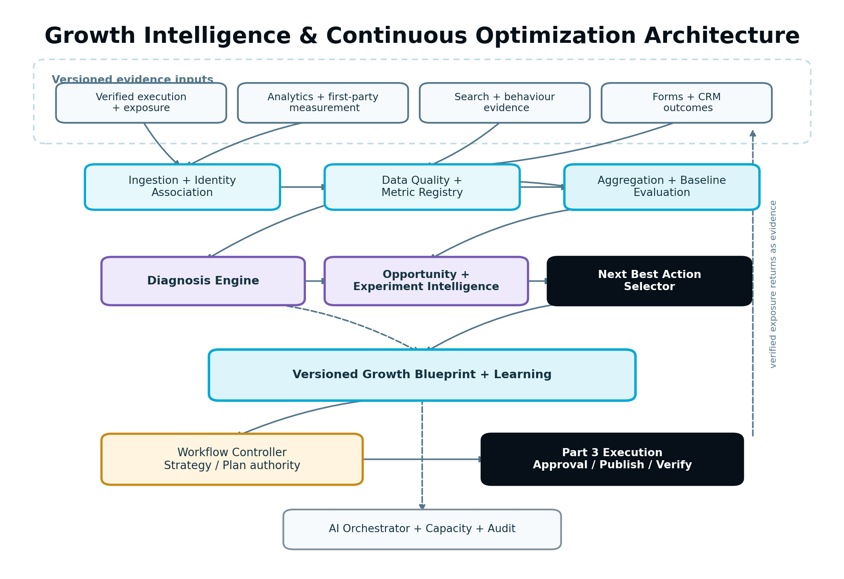
Figure 1 — Growth Intelligence and Continuous Optimization architecture
Figure 1. Verified execution and governed data flow through measurement, quality, evaluation, diagnosis, prioritization, learning and the Workflow Controller before any new execution.

4.1 Core components

Growth Intelligence Coordinator
- Receives qualifying workflow, execution, measurement and experiment events.
- Opens and advances evaluation lifecycles.
- Coordinates deterministic aggregation, diagnosis, opportunity generation, Blueprint updates and Next Best Action recalculation.
- Prevents duplicate evaluation through stable evaluation keys.
- Does not own external integration credentials or perform protected actions.

Measurement Plan Resolver
- Loads the exact active Measurement Plan version from Part 3.
- Resolves primary, secondary, diagnostic and guardrail metrics.
- Confirms activation, exposure, baseline and evaluation-window requirements.
- Creates explicit limitations when a required source is missing or unavailable.

Metric Registry
- Stores versioned, provider-neutral metric definitions.
- Defines numerator, denominator, unit, direction, population, aggregation, filters, acceptable sources and source precedence.
- Prevents modules from creating conflicting meanings for the same customer-facing metric.

Measurement Ingestion Gateway
- Receives first-party events, verified exposure events, provider pulls, webhooks and scheduled imports.
- Validates schema, scope, event time, source, consent metadata and deduplication identifiers.
- Writes accepted events through an inbox/outbox or equivalent durable pattern.
- Quarantines malformed or unauthorized events without contaminating aggregates.

Identity and Association Service
- Resolves permitted relationships among anonymous visitors, sessions, contacts, leads, deals, assets, campaigns and experiment assignments.
- Uses privacy-safe references and source-specific confidence.
- Never treats uncertain identity as a confirmed person or conversion path.

Data Quality and Freshness Service
- Scores completeness, freshness, validity, consistency, consent coverage, sample sufficiency, identity coverage and source reliability.
- Detects instrumentation changes, schema drift, event loss, duplicate spikes and source disagreement.
- Produces typed Data Quality Incidents and Measurement Limitations.

Metric Store and Aggregation Service
- Preserves immutable raw or minimally normalized events according to retention policy.
- Builds versioned aggregate snapshots by project, asset, version, campaign, funnel stage, segment and evaluation window.
- Supports late-arriving data, correction and reproducible re-evaluation.

Baseline and Evaluation Service
- Selects the baseline policy declared by the Measurement Plan.
- Determines when sufficient evidence exists.
- Compares observed performance with baseline, expected range and guardrails.
- Produces structured Performance Evaluations before any AI narrative is generated.

Diagnosis Engine
- Builds an evidence graph of observations, possible causes, supporting signals, counter-evidence and limitations.
- Applies deterministic diagnostic rules before AI-assisted synthesis.
- Produces ranked, explainable Diagnostic Findings rather than a single unsupported guess.

Opportunity and Prioritization Service
- Converts supported findings into candidate Growth Opportunities.
- Merges duplicates and excludes actions already active, invalid, out of scope or blocked.
- Calculates ICE, PIE and the canonical Opportunity Score from versioned scoring policy.

Experiment Service
- Creates governed hypotheses, experiment plans, assignment definitions, exposure records and analysis specifications.
- Detects overlap, sample-ratio mismatch, contamination and guardrail harm.
- Produces structured Experiment Results and never performs the live change directly.

Learning Service
- Converts evaluated actions and experiments into versioned Learning Records.
- States where the learning applies, where it does not and how strong the evidence is.
- Prevents weak or context-specific results from becoming universal rules.

Growth Blueprint Service
- Maintains the live, versioned optimization layer.
- Applies typed patches for priority, status, evidence, learning and Strategy-review proposals.
- Preserves the approved Strategy boundary and complete change history.

Next Best Action Selector
- Requests valid candidates from workflow, execution, measurement and Growth Blueprint sources.
- Applies hard validity gates before scoring.
- Returns one primary action plus non-competing background status.

Report and Explainability Service
- Builds customer-facing explanations from structured facts.
- Separates what happened, what it may mean, confidence, limitations, action and measurement.
- Produces project- and client-scoped read models for Overview, Tracker and Report.

AI Orchestrator
- Routes approved AI analysis and explanation tasks using lowest total successful-workflow cost.
- Supplies structured results and telemetry.
- Does not calculate authoritative metrics, p-values, assignment or permission decisions.

4.2 Prohibited dependencies
- Source adapters must not contain growth-prioritization logic.
- Product modules must not query individual provider APIs directly.
- AI models must not calculate authoritative aggregates or experiment statistics from prose summaries.
- The Growth Blueprint must not mutate live assets, CRM records, audiences or integrations.
- The Next Best Action Selector must not infer permissions or entitlements from UI state or plan names.
- A provider-specific metric must not be relabelled as a provider-neutral metric without a declared mapping.
- Raw Behaviour Intelligence recordings must not be copied into the general event store or prompts.
- A report generator must not upgrade a correlation to a causal claim.

5. Canonical Domain Model

5.1 Core objects
Object | Required purpose
MeasurementPlan | Versioned success, instrumentation, source, baseline, window and privacy contract created by Part 3.
MetricDefinition | Provider-neutral meaning of a metric, including numerator, denominator, unit, population, direction and aggregation.
SourceSnapshot | Connection, capability, schema, health and permission state used for an evaluation.
NormalizedMetricEvent | Versioned event envelope with source, scope, event time, consent and deduplication identity.
ExposureRecord | Proof that an asset, campaign or experiment version was eligible and active during a time range.
AggregateSnapshot | Reproducible calculated metric set for a defined scope and window.
Baseline | Versioned reference period, cohort or expected range used for comparison.
EvaluationWindow | Time and sufficiency rules for collecting and evaluating evidence.
MeasurementLimitation | Explicit reason a value is unavailable, partial, modelled, delayed or not comparable.
DataQualityIncident | Typed issue affecting trust in events, identity, source or aggregates.
PerformanceEvaluation | Structured comparison of observed, baseline and expected outcomes plus limitations.
DiagnosticFinding | Evidence-supported symptom, likely cause, counter-evidence, confidence and affected scope.
Hypothesis | Testable explanation and predicted change linking an intervention to an outcome.
GrowthOpportunity | Candidate action with evidence, value, effort, risk, readiness, scoring and success measure.
ExperimentPlan | Immutable hypothesis, variants, population, assignment, metrics, guardrails, duration and analysis policy.
ExperimentRun | Runtime state for one approved experiment-plan version.
ExperimentExposure | Assignment and verified eligibility/exposure of a subject or unit to a variant.
ExperimentResult | Versioned analysis, effect, uncertainty, practical significance, validity and classification.
LearningRecord | Bounded conclusion from an evaluated action or experiment with applicability and evidence strength.
GrowthBlueprint | Versioned operating projection of priorities, actions, experiments, measurements, learning and review needs.
BlueprintPatch | Typed, auditable change to a Growth Blueprint version.
NextBestAction | One valid selected action with reason, impact, confidence, blockers and destination workflow.
StrategyReviewRequest | Evidence-backed request to reconsider material strategic direction.

5.2 Minimum GrowthOpportunity fields
{
"id": "opp_visitor_quote_form",
"workspaceId": "ws_123",
"projectId": "prj_456",
"objectiveId": "obj_qualified_quotes",
"type": "CRO_FORM_SIMPLIFICATION",
"title": "Test a shorter Visitor Insurance quote form",
"problem": "Mobile form starts are healthy but completion falls at two optional fields.",
"evidenceRefs": ["eval_91", "finding_44", "behaviour_17"],
"strategyVersionId": "strategy_v4",
"businessBrainVersionId": "brain_v12",
"expectedImpact": {
"metric": "qualified_quote_completion_rate",
"direction": "INCREASE",
"range": {"low": 0.05, "high": 0.14},
"isGuarantee": false
},
"scores": {
"impact": 0.82,
"confidence": 0.76,
"goalAlignment": 1.0,
"reach": 0.61,
"urgency": 0.54,
"learningValue": 0.70,
"ease": 0.67,
"readiness": 0.91,
"risk": 0.18,
"opportunityScore": 78.4,
"policyVersion": "growth_score_v2"
},
"recommendedMethod": "CONTROLLED_EXPERIMENT",
"successMetricDefinitionId": "metric_qualified_quote_completion_rate_v3",
"requiredActionClass": "PROTECTED_EXTERNAL_CHANGE",
"status": "RECOMMENDED",
"createdAt": "2026-09-29T13:00:00Z"
}
Scores are stored at full internal precision for reproducibility but displayed as understandable labels or rounded values. An expected range is an estimate, not a promise.

5.3 Minimum ExperimentPlan fields
{
"id": "exp_plan_77",
"version": 3,
"hypothesisId": "hyp_77",
"opportunityId": "opp_visitor_quote_form",
"unitOfAssignment": "anonymous_visitor",
"eligiblePopulation": "visitor-insurance page visitors not already assigned",
"variants": [
{"key": "CONTROL", "assetVersionId": "form_v3", "allocation": 0.50},
{"key": "SHORT_FORM", "assetVersionId": "form_v4", "allocation": 0.50}
],
"primaryMetric": "qualified_quote_completion_rate",
"secondaryMetrics": ["quote_form_start_rate"],
"guardrails": ["form_error_rate", "lead_disqualification_rate"],
"minimumPracticalEffect": 0.05,
"analysisPolicyVersion": "binary_fixed_horizon_v1",
"minimumSample": 1200,
"minimumDurationDays": 14,
"maximumDurationDays": 42,
"exclusionGroup": "visitor_quote_surface",
"consentPolicyVersion": "consent_v4",
"approvalFingerprint": null,
"status": "DRAFT"
}

5.4 Provenance requirement
Every official object stores workspace, project and Agency client scope; source object IDs and versions; Strategy, Business Brain and scoring/analysis policy versions; actor or system principal; correlation and causation IDs; created/effective timestamps; current/superseded status; and a content or configuration fingerprint where material.

6. Activation and Readiness
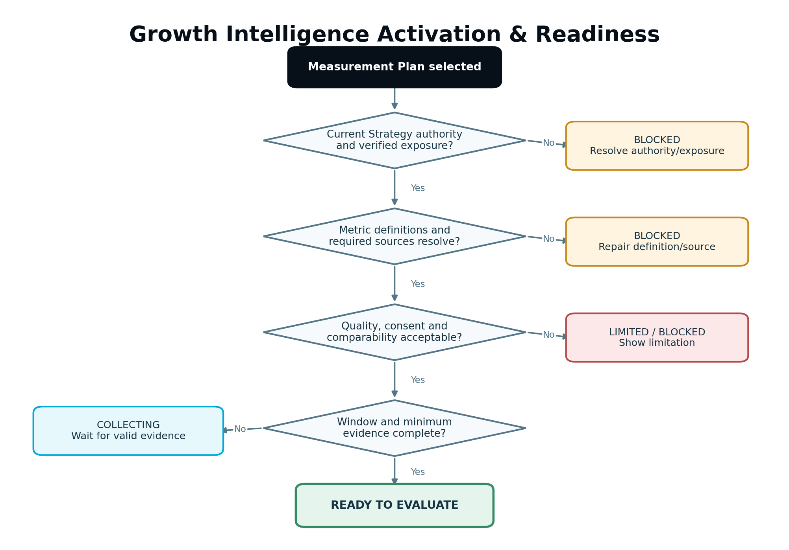
Figure 2 — Growth Intelligence activation and readiness decision
Figure 2. A project may enter continuous growth incrementally, but each evaluation must pass its own authority, exposure, data and comparability gates.

6.1 Project activation
The Growth Blueprint may have an initial baseline derived from the approved Unified Strategy. It becomes active when at least one approved execution has a verified exposure and its Measurement Plan has begun collecting evidence.
The Workflow Controller moves the project from EXECUTION toward MEASUREMENT and CONTINUOUS_GROWTH based on authoritative events. The project does not need every planned asset to be live before the first valid measurement begins; activation is objective- and plan-specific.

6.2 Mandatory evaluation readiness checks
- Workspace and project are accessible for analysis.
- The objective and approved Strategy authority are current enough for the planned evaluation.
- The Measurement Plan exists, is active and identifies the evaluated scope.
- Verified exposure records identify the active asset/campaign/variant and effective time.
- Required Metric Definitions resolve successfully.
- Source snapshots show required access, schema and capability.
- Events or aggregates fall inside the correct evaluation window.
- Data quality meets the metric’s minimum policy or is explicitly limited.
- Baseline and observed populations are comparable under the declared method.
- The evaluation has not already completed for the same plan, exposure and data watermark.
- No material external change makes the comparison invalid.
- Consent, privacy and retention rules allow the intended aggregation and identity association.

6.3 Blocking, limiting and warning outcomes
- BLOCKED: evaluation cannot begin, such as no verified exposure, invalid metric definition or unauthorized source.
- COLLECTING: activation is valid but the window or minimum evidence is incomplete.
- LIMITED: evaluation may proceed, but a known limitation materially narrows interpretation.
- WARNING: evidence is usable and the issue must be shown, but it does not materially invalidate the conclusion.
A limitation is part of the official result. It cannot be hidden in a log or dropped when the report is regenerated.

6.4 Re-evaluation key
The stable key should include workspaceId, projectId, measurementPlanVersionId, evaluated exposure fingerprint, evaluation-window identity, metric-definition versions and data watermark. The same key returns the current evaluation. Corrected or later data produces a new evaluation revision linked to the prior one.

7. Measurement and Data Architecture
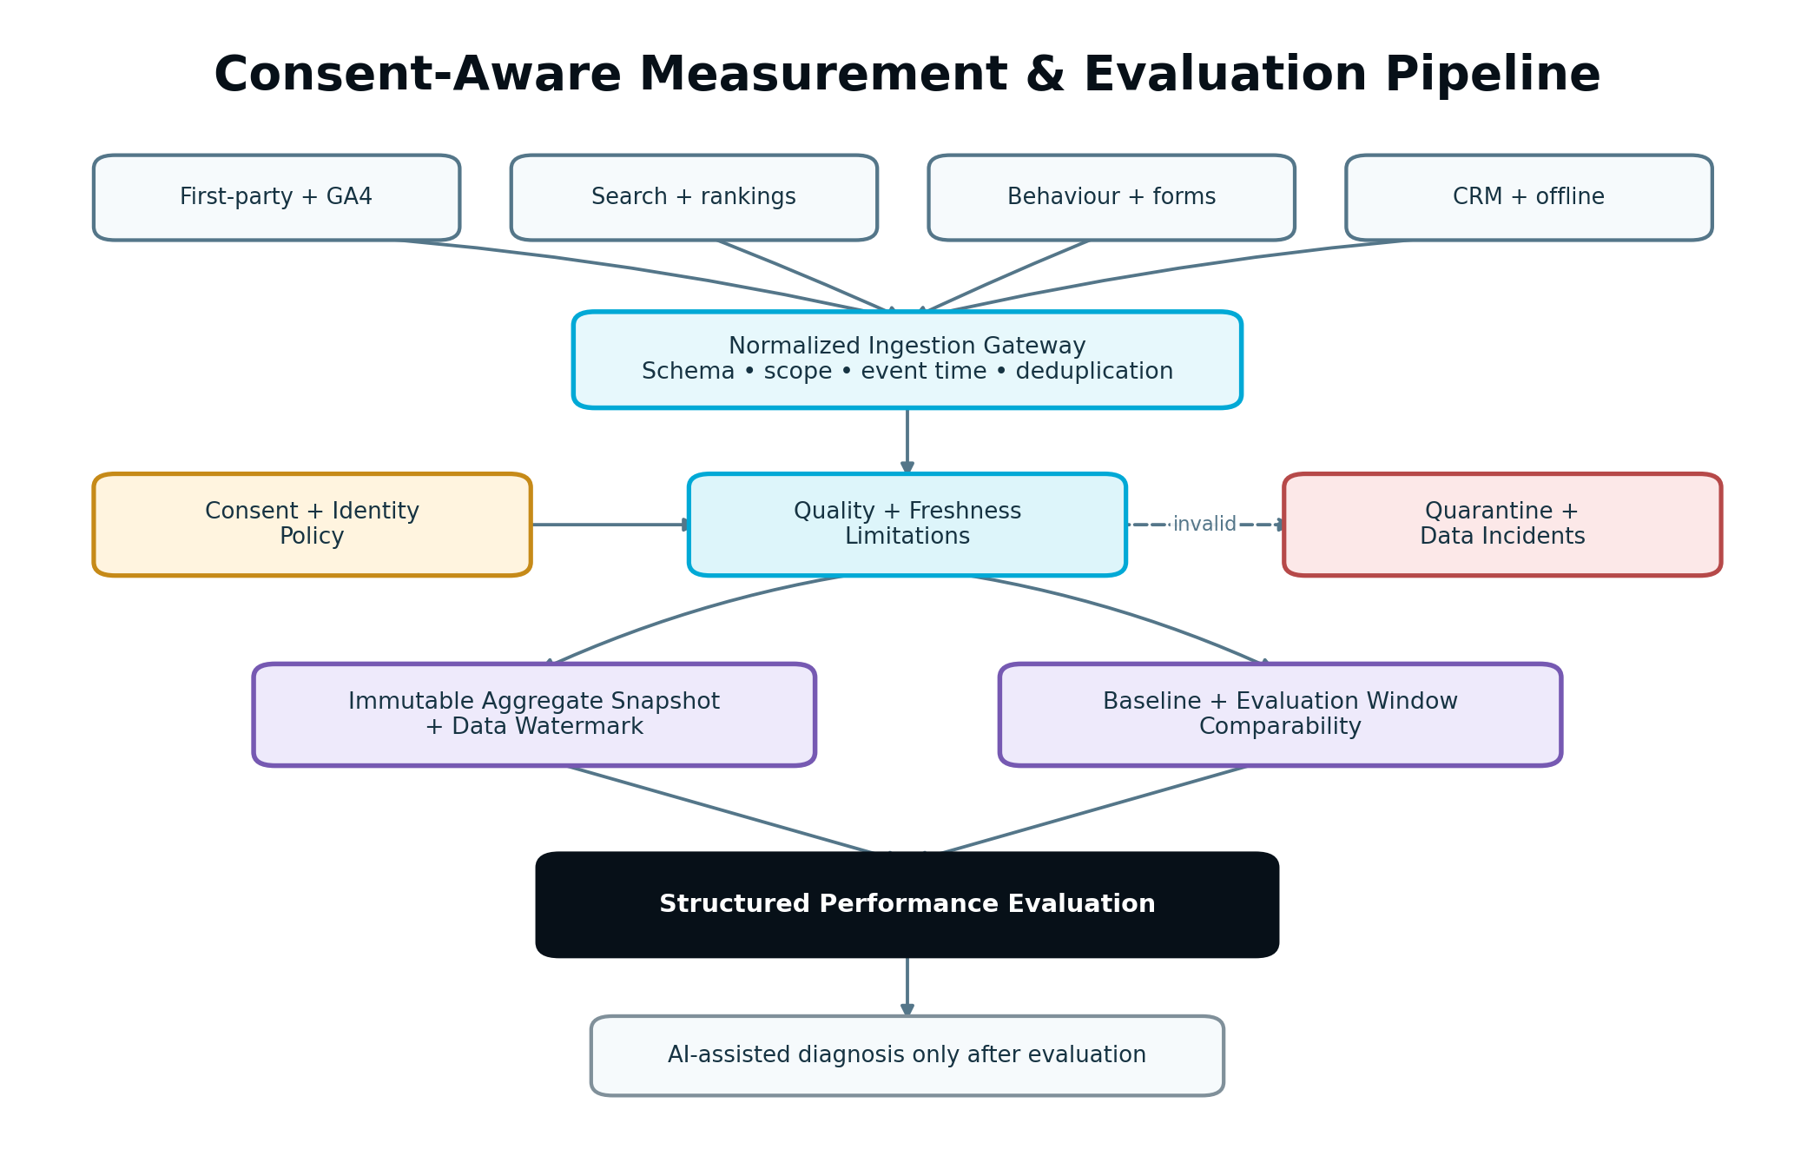
Figure 3 — Consent-aware measurement and evaluation pipeline
Figure 3. Source evidence is normalized and quality-scored before aggregation. Deterministic evaluation precedes AI-assisted diagnosis and explanation.

7.1 Source classes
Source class | V1 examples | Primary use | Required caution
Verified execution | Publication, activation, rollback, schedule and asset-version exposure | Establish what was live and when | Provider acknowledgement is insufficient; use verified state
First-party web | Page view, CTA view/click, form start/error/submit, content engagement | Funnel, CTA, landing page and conversion analysis | Respect consent and prevent sensitive-value capture
Analytics | GA4 observed or modelled metrics | Traffic, engagement, paths and configured conversions | Preserve provider semantics and modelled/observed distinction
Search | Google Search Console and supported rank evidence | Query/page visibility, clicks, CTR, position and content change | Query privacy thresholds, lag and sampling may limit detail
Forms | Native and supported form providers | Starts, validation errors, abandonment and submissions | A submission is not automatically a qualified lead
CRM/offline | Contact, lead, qualification, deal stage, value and closed outcome | Lead quality and business-outcome linkage | Identity, delay, duplicate and attribution limitations
Email | Delivered, open where supplied, click, unsubscribe and configured conversion | Campaign measurement and supporting signals | Opens may be privacy-inflated; dedicated Email Intelligence is V2
Behaviour | Click maps, scroll, rage/dead clicks, reviewed recording findings | Friction diagnosis and qualitative support | Do not store raw sensitive recordings or infer intent from one session
Site/search intelligence | Crawl, content decay, technical, authority, local and AI-citation evidence | Detect changing opportunity or execution effect | Do not confuse structural score change with business outcome

7.2 Event-time rules
- Store occurredAt separately from receivedAt and source processing time.
- Aggregate by event time using source-specific lateness watermarks.
- Retain the source event or immutable normalized representation needed for reproducibility.
- Do not move an event into a different exposure merely because it arrived late.
- Corrections and deletions create a new aggregate/evaluation revision; they do not silently rewrite an approved report.
- Convert display time using the project/workspace IANA time zone while preserving UTC.

7.3 Normalization rules
- Validate schema version and required scope fields.
- Verify webhook signature or trusted import identity.
- Enforce workspace/project/client ownership before acceptance.
- Map provider fields through versioned adapter mappings.
- Preserve source-native metric or event identity.
- Apply a stable deduplication key and source cursor/version.
- Label observed, modelled, imported, inferred and user-entered values.
- Tokenize or exclude personal data not required for measurement.
- Quarantine events whose source, consent or scope cannot be established.

7.4 Aggregation model
Aggregate snapshots are immutable records keyed by metric definition, scope, segment, time window, source set and data watermark. A current read model may point to the latest snapshot, but historical evaluations retain the exact snapshot IDs they used.
Precompute common daily/hourly rollups where useful, then derive evaluation windows from those rollups when mathematically valid. Distinct counts, attribution windows and experiment assignment may require dedicated state and must not be reconstructed from incompatible totals.

7.5 Data lineage
For every displayed metric, authorized users must be able to trace:
- Customer-facing metric and definition version.
- Evaluated scope, segment and time window.
- Aggregate snapshot and source set.
- Source mapping and connection snapshot.
- Exposure, consent and limitation state.
- Evaluation and recommendation that used it.

8. Metrics, Baselines and Evaluation Windows

8.1 Metric Definition contract
Each MetricDefinition contains:
- stable code, version and customer-facing name;
- business meaning and supported objective types;
- type: count, rate, ratio, duration, currency, rank, score or categorical outcome;
- numerator and denominator event/set definitions where applicable;
- eligible population and exclusion rules;
- aggregation and distinct-count rule;
- direction of improvement and valid range;
- default segmentation dimensions;
- accepted sources and source precedence;
- identity requirements;
- freshness and minimum-sufficiency policy;
- consent requirements;
- whether modelled/imported values are allowed;
- display precision and safe suppression threshold;
- owner, effective version and deprecation mapping.
Metric meanings are configuration and code-reviewed policy, not AI-generated at runtime.

8.2 Outcome hierarchy
Metric class | Purpose | Example
Primary outcome | Decides whether the objective improved | Qualified quote completion rate
Secondary outcome | Adds context or detects a supporting effect | Quote-form start rate
Diagnostic | Helps explain the mechanism | Error rate on the date-of-birth field
Guardrail | Prevents a local win from causing material harm | Lead disqualification rate or page performance
Exposure/denominator | Establishes eligible volume | Verified eligible Visitor Insurance page sessions
An experiment has one pre-declared primary outcome unless the analysis policy explicitly supports a controlled family of primary metrics. Reports may show other metrics but may not move the decision goalposts after results arrive.

8.3 Baseline types
Baseline | Use | Required safeguards
Fixed pre-period | Compare with a defined period before change | Similar day mix, sufficient duration, no known incompatible campaign/site change
Rolling baseline | Detect ongoing deviation from recent performance | Exclude current exposure and prevent the comparison target from absorbing the change too quickly
Seasonal comparison | Compare with equivalent prior period | Confirm business, tracking and market conditions remain sufficiently comparable
Control variant | Controlled experiment | Stable assignment, verified exposure, sample-ratio and contamination checks
Expected range | Monitor against a forecast or approved target | Clearly label estimate and model/version; do not treat as observed control
No baseline | New asset or insufficient history | Evaluate absolute evidence and learn a baseline; do not invent percentage lift

8.4 Evaluation window
The Measurement Plan defines:
- activation start and eligibility delay;
- minimum and maximum collection duration;
- minimum sample or event requirements;
- conversion-lag allowance;
- source lateness watermark;
- seasonality/day-of-week requirements;
- planned evaluation date;
- early guardrail review rules;
- treatment of late conversions after the main window;
- refresh or finalization policy.
The UI may estimate when evidence will be ready, but it must not display an invented countdown if source lag or traffic makes the date uncertain.

8.5 Comparability check
Before comparison, evaluate exposure definition, traffic/source mix, device, location, audience, offer, pricing, seasonality, tracking schema, integration health and concurrent changes. Material incompatibility changes the result to LIMITED or INVALID, even when the arithmetic difference is large.

9. Data Quality, Freshness and Limitations

9.1 Quality dimensions
The Data Quality Service produces component scores and typed findings for:
- completeness;
- freshness and ingestion lag;
- validity and schema conformance;
- deduplication and uniqueness;
- source consistency;
- exposure coverage;
- consent coverage;
- identity-match coverage where needed;
- sample/event sufficiency;
- bot, spam, internal and test-traffic exclusion;
- instrumentation continuity;
- provider health and known modelling/sampling.
The overall score is a policy result, not a simple average that allows a critical failure to be hidden by strong unrelated dimensions. Hard failures override the numeric score.

9.2 Freshness states
- CURRENT: inside the source/metric freshness target.
- DELAYED: outside target but within a usable grace range.
- STALE: too old for the intended official evaluation.
- UNKNOWN: source has not supplied a reliable cursor or timestamp.
- DISCONNECTED: required connection is unavailable.
Freshness is evaluated at the metric/source level. A healthy GA4 connection does not make delayed CRM outcomes current.

9.3 Measurement Limitations
Each limitation includes code, severity, affected metrics/scope, first observed time, cause, customer-safe explanation, evidence effect, permitted uses, resolution action and whether re-evaluation is expected.
Examples include CONSENT_RESTRICTED, IDENTITY_MATCH_PARTIAL, SOURCE_DELAYED, SCHEMA_CHANGED, BASELINE_NOT_COMPARABLE, LOW_SAMPLE, MODELLED_SOURCE_VALUE, CONCURRENT_CHANGE, EXPOSURE_UNKNOWN and CRM_OUTCOME_LAG.

9.4 Source disagreement
When two sources disagree:
- Preserve each source-native value and definition.
- Check scope, time zone, filtering, attribution, modelled values, bot rules and latency.
- Apply the Metric Definition’s source precedence only for its declared use.
- Display the disagreement when material.
- Lower confidence or block the evaluation if the difference remains unexplained.
The platform must not average incompatible provider numbers to make the conflict disappear.

9.5 Instrumentation change
A tag, event name, form version, consent rule or source mapping change creates an instrumentation boundary. Evaluation windows cannot cross that boundary unless a reviewed compatibility mapping exists. The change is visible on Tracker and Report timelines.

10. Identity, Consent and Attribution Boundaries
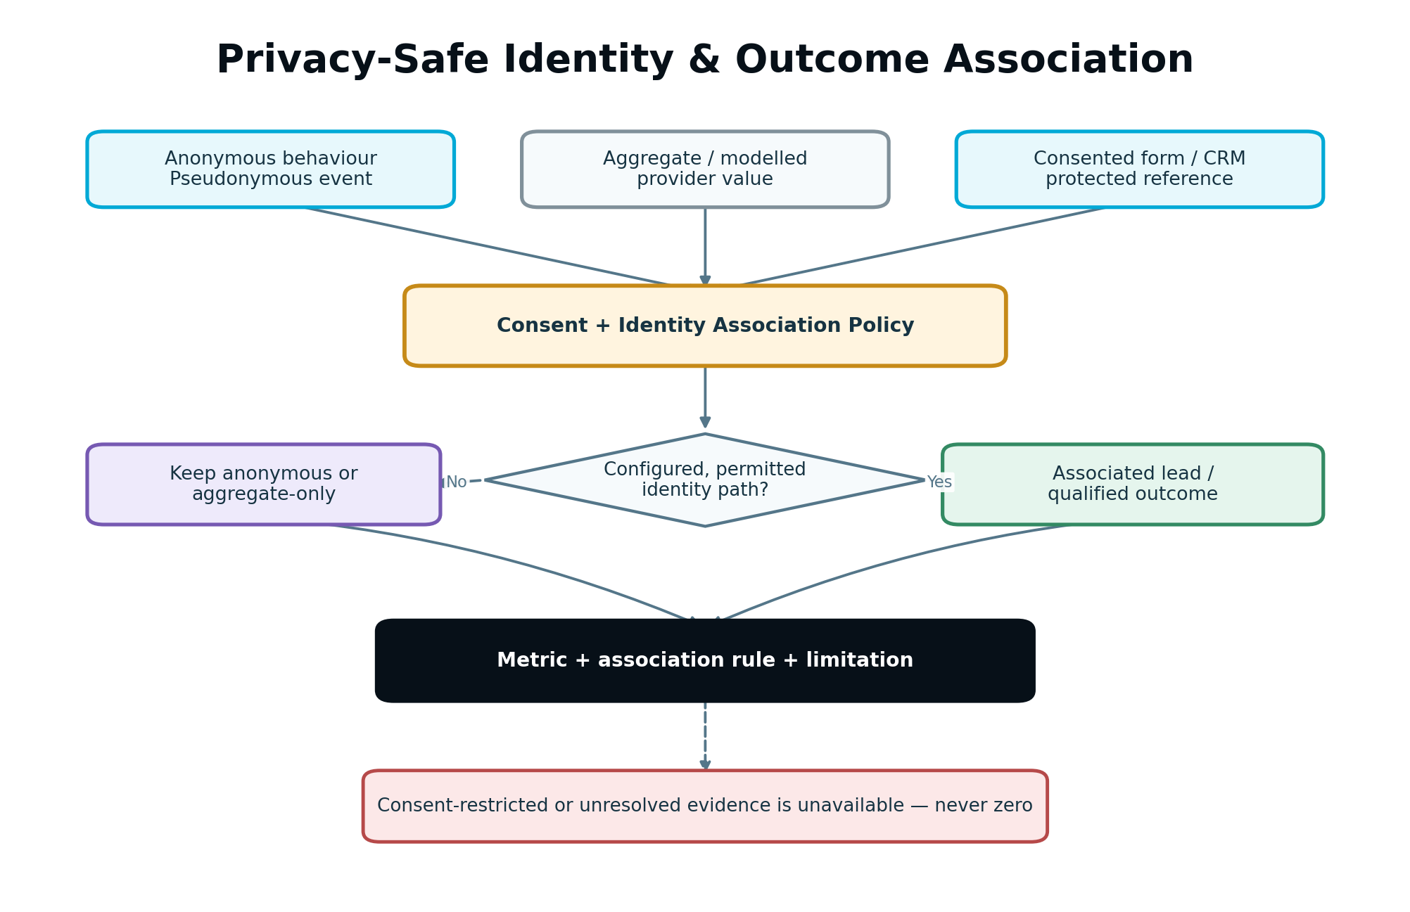
Figure 4 — Privacy-safe identity and outcome association
Figure 4. Anonymous behaviour, consented identity and CRM outcomes remain separate until a configured, permitted association path exists.

10.1 Identity levels
- ANONYMOUS: pseudonymous browser/device/session reference with no confirmed person.
- CONSENTED_CONTACT: permitted form/CRM association to an internal protected contact reference.
- LEAD: normalized lead identity and status from the CRM/form path.
- OPPORTUNITY: permitted deal/pipeline relationship.
- AGGREGATE_ONLY: source supplies totals or modelled values without person-level linkage.
- UNRESOLVED: possible identities conflict or cannot be safely joined.
The system stores confidence and method on every association. It never upgrades an anonymous or ambiguous reference to a confirmed person based only on similar attributes.

10.2 Consent-aware processing
- Read consent state and policy version at event time when available.
- Do not collect or join marketing/analytics identifiers beyond the configured consent policy.
- Preserve whether an outcome is observed, modelled or imported.
- Treat consent-restricted absence as unavailable, not as non-conversion.
- Support server-side tagging readiness without using server-side collection to bypass consent.
- Allow first-party and CRM/offline linkage only through configured lawful identity paths.
- Apply retention, access and deletion requests across derived identity mappings and eligible events.

10.3 Attribution versus association
V1 supports declared descriptive rules such as direct form-to-lead linkage, campaign parameter association, configured last-known source, or provider-reported attribution. Every result names the rule and its limitations.
V1 does not claim incremental causality across channels. Language must say “associated with,” “observed after,” “provider-attributed,” or “measured in the controlled experiment” as appropriate.

10.4 Conversion lag
Lead qualification, deal outcome and revenue may arrive after the initial web evaluation. Store provisional and matured evaluations separately. A later CRM result may revise impact and learning, but the system preserves the earlier version and explains what changed.

10.5 Agency isolation
An Agency workspace may aggregate across its own clients only in an explicitly authorized internal operational view. Client Viewer and client-scoped reports never include another client’s events, benchmarks, identity, opportunities or learning. Cross-client learning, if ever permitted by policy, must be de-identified, aggregated and outside the client-visible evidence chain.

11. Performance Evaluation Lifecycle
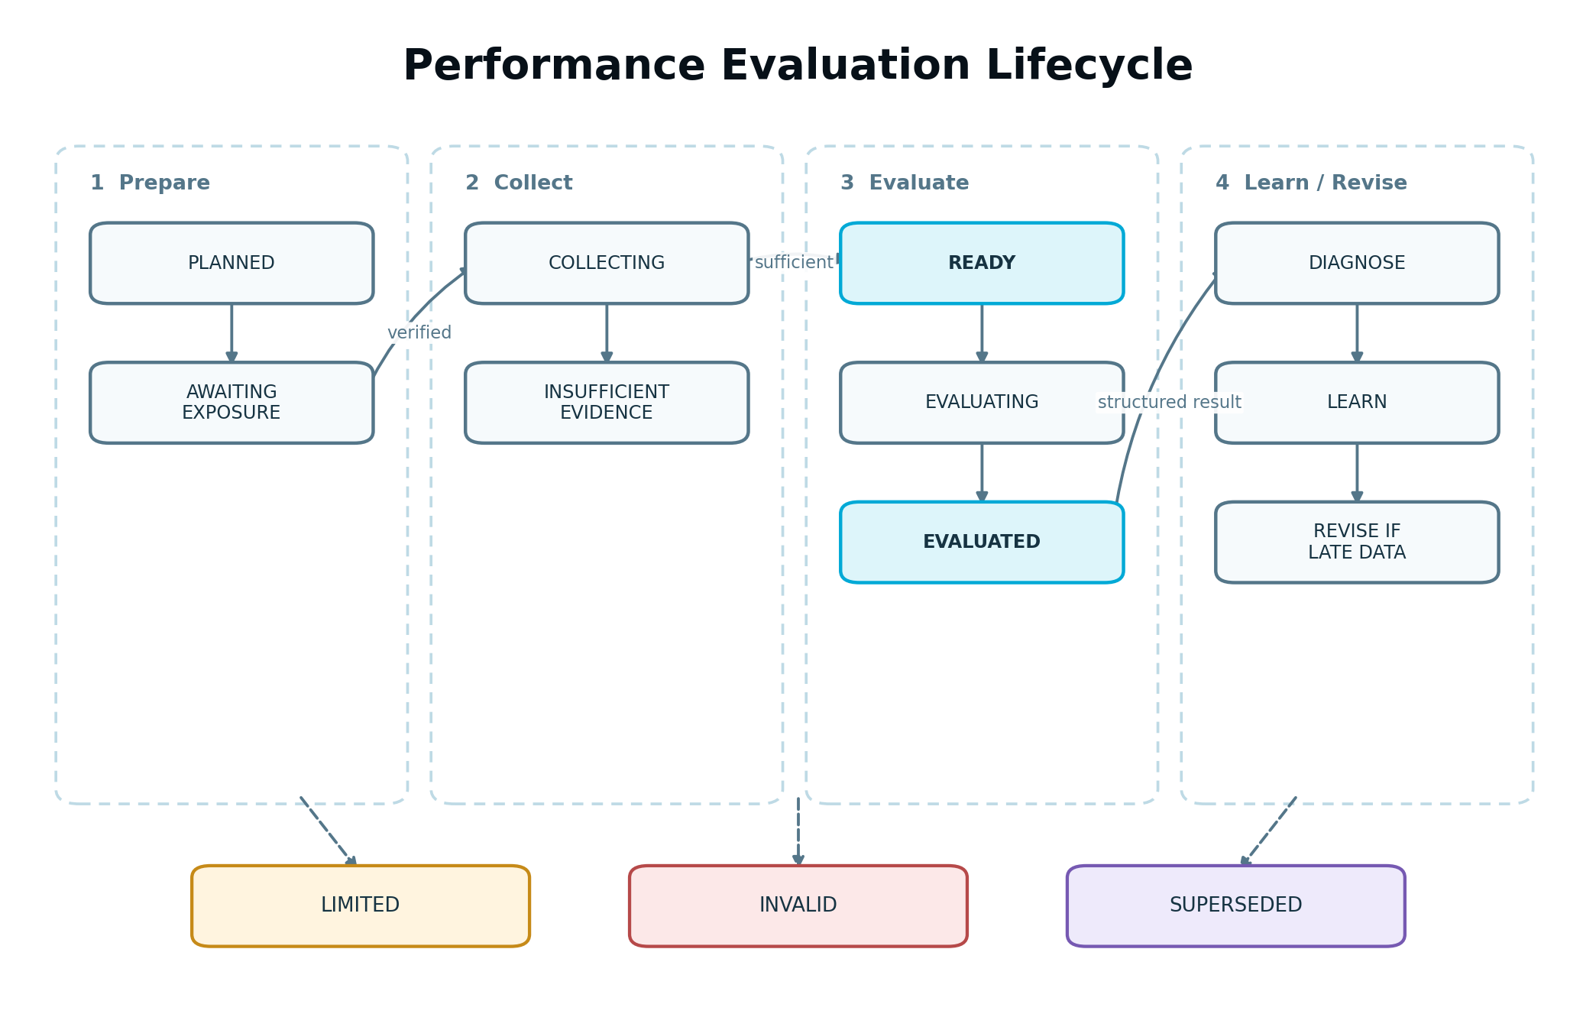
Figure 5 — Performance evaluation lifecycle
Figure 5. Evaluation waits for trustworthy exposure and evidence, then produces a versioned result that may be revised by late or corrected data.

11.1 States
State | Meaning
PLANNED | Measurement Plan exists but activation is not verified.
AWAITING_EXPOSURE | Instrumentation may be ready, but no authoritative live exposure exists.
COLLECTING | Exposure is active and evidence is accumulating.
INSUFFICIENT_EVIDENCE | Planned review occurred but minimum evidence or comparability is not met.
READY | Required evidence and watermark satisfy evaluation policy.
EVALUATING | Deterministic aggregation and evaluation are running.
EVALUATED | Structured result is complete and available for diagnosis/learning.
LIMITED | A result exists but material limitations narrow interpretation.
INVALID | Exposure, instrumentation, assignment or comparison failure prevents a valid conclusion.
SUPERSEDED | A newer official evaluation revision replaces this version.
CANCELLED | Authorized cancellation ended collection; preserved data may still be reported descriptively.

11.2 Result classifications
- IMPROVED: primary outcome improved beyond the configured practical threshold with acceptable guardrails.
- DECLINED: primary outcome worsened materially or a critical guardrail was harmed.
- STABLE: change remained inside the practical no-material-change region with sufficient evidence.
- MIXED: primary/secondary/guardrail evidence points in materially different directions.
- INCONCLUSIVE: evidence cannot distinguish meaningful outcomes.
- INVALID: data or execution defect prevents interpretation.
- NO_BASELINE: valid observations exist but no comparable lift can be calculated.
For observational evaluations, classification describes the observed comparison. It is not proof that the execution caused the result.

11.3 Transition rules
- State changes are compare-and-swap or equivalently concurrency-safe.
- Every transition records reason, data watermark, actor/system principal and correlation ID.
- Duplicate qualifying events return the existing run.
- READY requires all hard readiness gates.
- AI explanation runs only after a structured evaluation exists.
- A source correction produces a new revision and may supersede the prior result.
- A material Strategy or Measurement Plan change stales future collection but does not erase completed historical evaluation.
- When an exposure ends, the evaluator observes the configured conversion-lag period before finalization.

11.4 Continuous growth loop
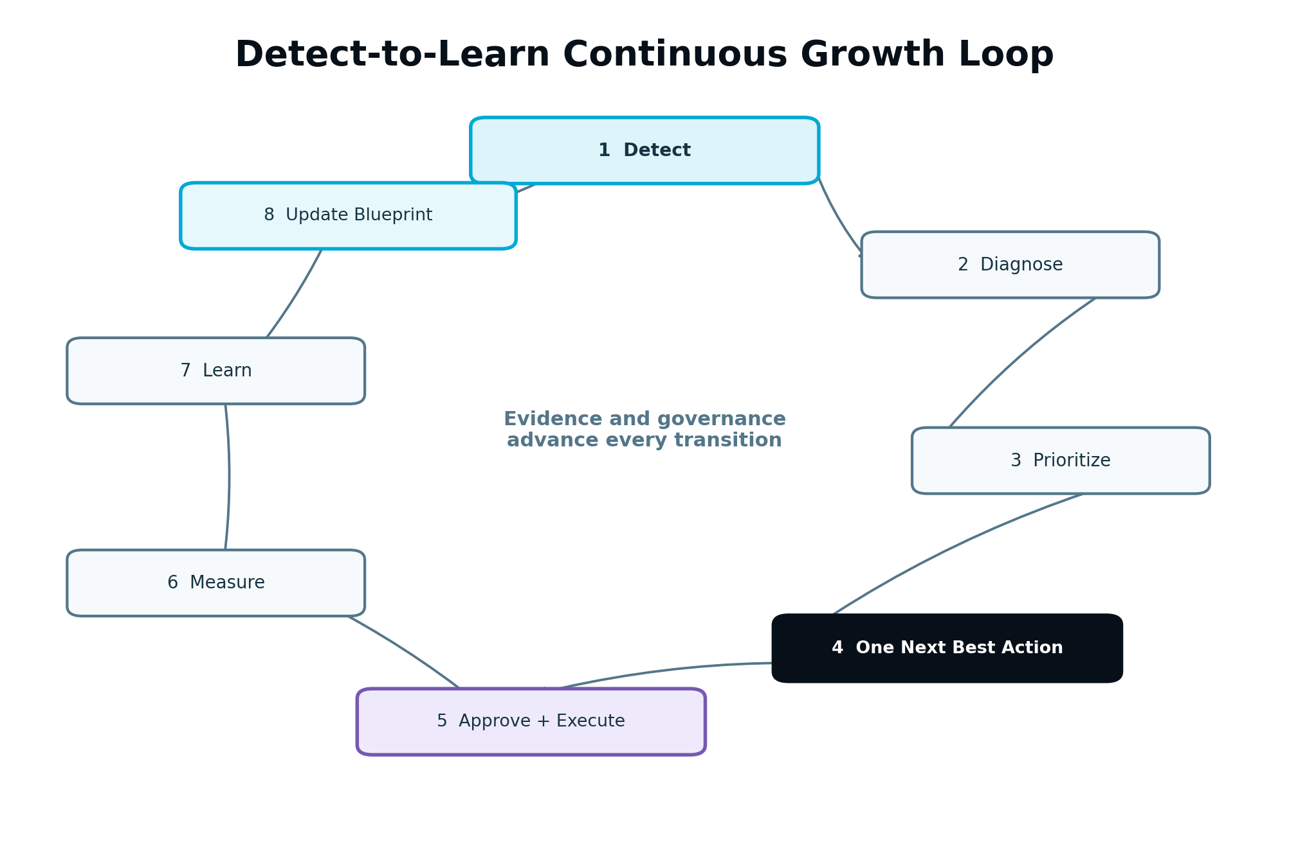
Figure 6 — Detect-to-learn continuous growth loop
Figure 6. The loop advances only when each evidence and governance gate is satisfied; publication completion alone does not create another task.
The canonical loop is:
- Detect an outcome, anomaly, change or opportunity.
- Validate measurement quality and scope.
- Diagnose likely causes and counter-evidence.
- Generate valid candidate opportunities.
- Prioritize across the project, not within one module.
- Select and explain one Next Best Action.
- Obtain review, approval and a Part 3 execution path.
- Verify live exposure and begin the Measurement Plan.
- Evaluate the result after sufficient evidence.
- Create a bounded Learning Record.
- Patch and version the Growth Blueprint.
- Recalculate the next valid action.

12. Growth Engine Product Model
The Growth Engine is the customer-facing operating surface for Part 4. Its modules are coordinated views over shared Growth Intelligence records; they are not separate decision systems.

12.1 V1 module responsibilities
Module | Primary customer question | Authoritative records
Overview | What is happening, what matters now and what should I do next? | Objective status, measurement health, active work, Next Best Action and recent learning
Diagnosis | What is helping or blocking growth, and why? | Performance Evaluations, Diagnostic Findings, evidence graph and limitations
Funnel | Where is the defined conversion path losing or gaining eligible people? | Funnel Definition, stage aggregates, transition rates and segment comparisons
Experiments | What are we testing, why, and what did we learn? | Hypotheses, Experiment Plans, runs, exposures, results and Learning Records
Tracker | What changed, what is running, and when will evidence be ready? | Execution exposure, evaluation windows, incidents, decisions and timeline events
Report | What happened, what does the evidence support, and what comes next? | Versioned report snapshots composed from structured results

12.2 Overview requirements
Overview must show:
- the current primary business objective and its Measurement Plan status;
- one Next Best Action with reason, expected impact, confidence, effort and required approval;
- what is active in execution, measurement or experiment states;
- current data health and material limitations;
- funnel or outcome movement that is supported by sufficient evidence;
- recent completed learning and resulting Blueprint change;
- the next expected evaluation milestone;
- an explanation when no valid action can be recommended yet.
Overview must not become a wall of vanity metrics. Supporting charts are secondary to the current objective, evidence and action.

12.3 Shared filter and scope behaviour
Workspace, Agency client, project, objective, asset/campaign, date, segment and source filters resolve through a shared query contract. A module may suggest a useful default scope, but it cannot silently change metric meaning. The UI displays active filters and data freshness.

12.4 Guided Mode principle
The default path is status -> finding -> recommendation -> approval/execution -> measurement -> result. Advanced analysis is available without requiring a customer to build their own dashboard or understand provider taxonomy.

13. Funnel Intelligence
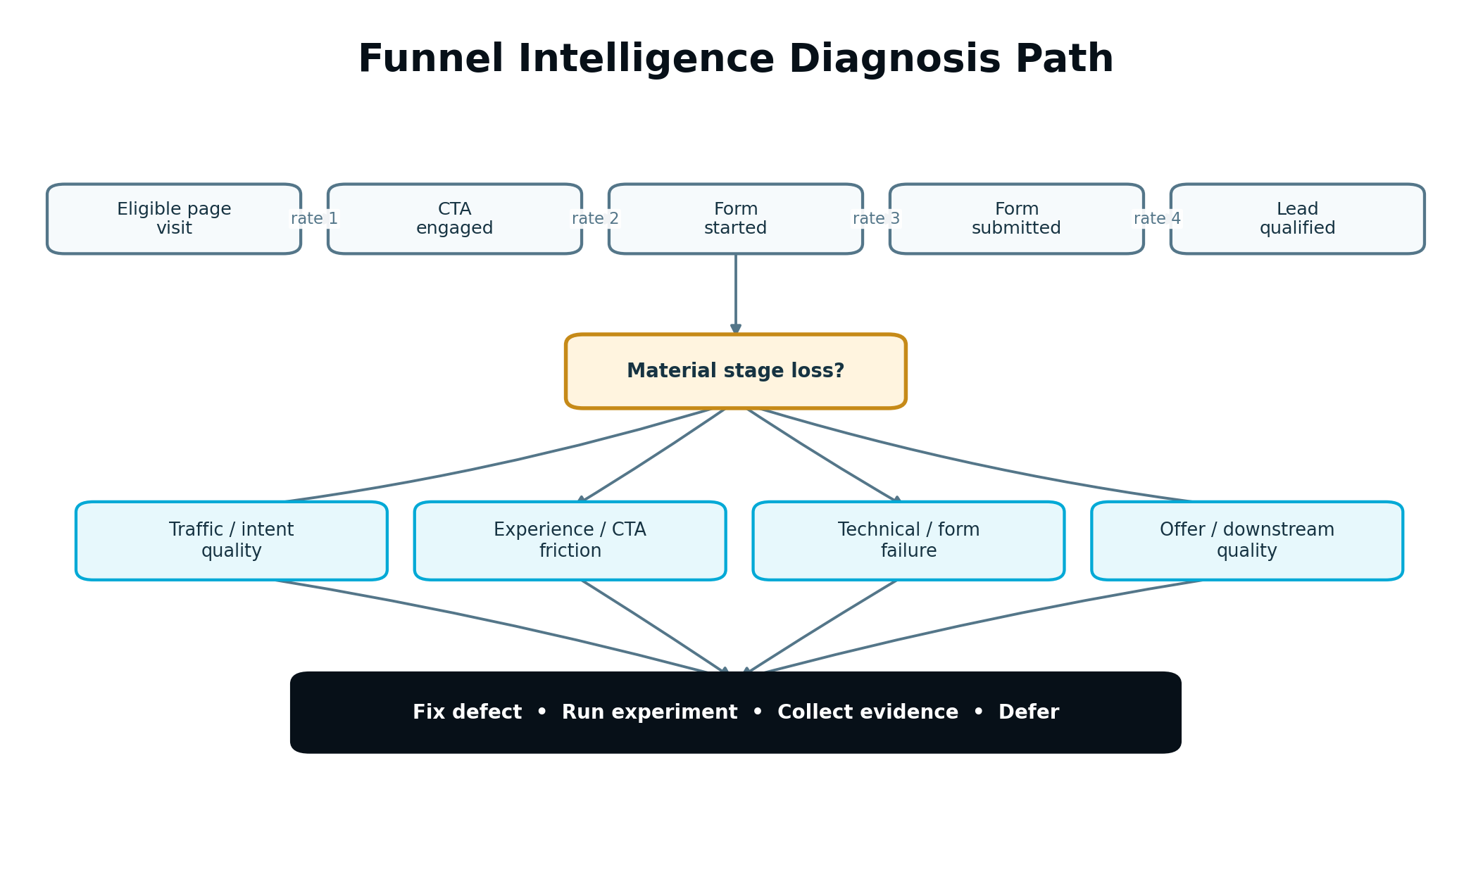
Figure 7 — Funnel Intelligence diagnosis path
Figure 7. Funnel Intelligence detects a stage loss, validates the denominator and segments, then asks whether the cause is traffic quality, experience friction, technical failure or offer mismatch.

13.1 Funnel Definition
A funnel is a versioned project-specific sequence of measurable stages, not a universal list. Each stage contains:
- stage code and customer-facing name;
- entry event or eligible set;
- completion event;
- identity/session rule;
- allowed transition direction and time limit;
- inclusion and exclusion filters;
- source and consent requirements;
- optional value/quality field;
- required exposure relationship;
- version and effective period.
Example for Visitor Insurance:
- Eligible landing-page visit.
- Quote CTA engaged.
- Quote form started.
- Quote form submitted.
- CRM lead qualified.
- Opportunity or policy outcome where available.
V1 Funnel Intelligence evaluates a defined conversion path. Full cross-channel Customer Journey Intelligence remains V2.

13.2 Stage calculations
For adjacent stages A and B:
transitionRate(A,B) = eligible units reaching B within the transition window / eligible units at A
stageLoss(A,B) = 1 - transitionRate(A,B)
The eligible unit may be a session, anonymous visitor, contact, lead or other declared unit. The system must not combine units inside one rate. Distinct-count method and conversion window are part of the Metric Definition.

13.3 Detection rules
Funnel Intelligence may detect:
- material stage loss compared with baseline or target range;
- new deterioration after a verified execution;
- segment-specific loss by device, source, location or audience where sample and privacy rules allow;
- increased time between stages;
- technical error or abandonment concentration;
- high volume with poor downstream quality;
- low top-of-funnel volume despite healthy conversion;
- inconsistent stage counts caused by tracking or identity defects.
The largest percentage loss is not automatically the best opportunity. The service considers eligible volume, business value, quality, effort, evidence and reach.

13.4 Funnel diagnosis sequence
- Confirm stage definitions and data health.
- Check exposure and instrumentation boundaries.
- Compare absolute volume and rate with the declared baseline.
- Segment only on policy-approved dimensions with sufficient evidence.
- Check traffic/intent quality, technical reliability, content/offer alignment and interaction friction.
- Trace downstream lead quality so a local conversion increase does not hide worse business outcomes.
- Create Diagnostic Findings with supporting and conflicting evidence.
- Generate an action, experiment, further-observation or instrumentation recommendation.

13.5 Funnel configuration changes
A material stage, identity or conversion-window change creates a new Funnel Definition version and comparison boundary. Historic reports retain the earlier funnel. The UI must not draw one uninterrupted trend across incompatible definitions.

14. CRO, CTA and Landing Page Intelligence

14.1 Combined diagnostic model
CRO, CTA and Landing Page Intelligence share evidence but maintain distinct findings:
- Landing Page Intelligence evaluates intent match, clarity, relevance, trust, content progression, performance and conversion path.
- CTA Intelligence evaluates visibility, wording, hierarchy, destination, interaction and relationship to user intent.
- CRO Intelligence evaluates the end-to-end conversion surface, friction, form behaviour, technical reliability and guardrails.
A single page may produce several findings, but the Opportunity Service merges them when one intervention addresses the same root cause.

14.2 Evidence used
- verified Page/Asset Version and exposure;
- traffic source, query and intent context;
- viewport/device and performance evidence;
- CTA visible, clicked and destination events;
- scroll and interaction depth;
- form start, field focus, validation error, abandonment and submit;
- navigation and return behaviour;
- heatmap or reviewed recording findings;
- copy, offer, trust and content structure from the approved asset;
- downstream lead quality and CRM status where available;
- accessibility, technical and security findings from Part 3 validation.

14.3 Direct fix versus experiment
The engine must recommend a direct governed fix, not an experiment, when the issue is an objective defect such as:
- broken CTA link or form submission;
- missing required event caused by failed instrumentation;
- inaccessible control or severe contrast/keyboard failure;
- security issue or exposed sensitive value;
- incorrect price, eligibility, legal disclosure or approved fact;
- mobile layout defect that prevents completion.
An experiment is appropriate when two safe, strategically valid alternatives exist and the preferred choice is uncertain, such as CTA wording, form length, proof placement or page structure.

14.4 CTA hierarchy rules
- Measure primary and secondary CTA exposure separately.
- Distinguish visibility from interaction; a low click rate is not meaningful when the CTA was rarely visible.
- Detect competing CTAs and destination mismatch.
- Preserve CTA label, target and placement version.
- Do not recommend manipulative urgency, deceptive controls or hidden consent.
- Evaluate downstream quality, not only clicks.

14.5 Low-volume behaviour
When controlled testing is not feasible, the engine may recommend a well-supported direct improvement within Strategy, a longer collection window, an instrumentation correction or a higher-reach action first. It may create an observational pre/post plan, but the result is labelled observational and confidence is limited.

15. Lead Intelligence and CRM Outcome Signals

15.1 V1 responsibility
Lead Intelligence connects acquisition and conversion surfaces to permitted lead-quality outcomes. It answers whether the system is producing the right leads, not merely more form submissions.
V1 may use:
- valid form submission;
- deduplicated lead creation;
- source/campaign association;
- qualification status and reason;
- pipeline stage and stage time;
- deal/opportunity value where available;
- closed outcome and imported offline conversion;
- invalid, spam or disqualified lead signals.
Dedicated predictive Revenue Intelligence remains V2.

15.2 Normalized lead lifecycle
Provider-specific stages map through a versioned profile to normalized states such as SUBMITTED, ACCEPTED, CONTACTED, QUALIFIED, OPPORTUNITY, WON, LOST, INVALID and UNKNOWN. The source-native value is preserved.
Mapping ambiguity lowers confidence or creates a Data Quality Incident. A provider stage named “Converted” must not be assumed to mean revenue without configuration.

15.3 Lead-quality guardrails
An optimization that increases submissions but materially increases spam, invalid contact data, disqualification or low-value leads is MIXED or DECLINED according to the Measurement Plan. The primary outcome may be qualified completion rate rather than raw submission rate.

15.4 CRM lag and maturity
The system supports provisional and matured views:
- initial web/form result after the main window;
- qualification result after the configured CRM lag;
- later opportunity/closed outcome where available.
Each maturity revision cites newly available evidence. The Next Best Action may change after qualification matures, but earlier action history remains intact.

15.5 Identity and write boundary
Part 4 reads normalized CRM evidence through the common CRM Service. It does not write contacts, deals or stages. Any recommended CRM or automation change is a protected Part 3 action.

16. Search, Content and Growth Opportunity Signals

16.1 Purpose
Growth Opportunity Intelligence may combine search, site, content, authority, local, AI-citation and conversion evidence to detect opportunities beyond a single funnel screen. This supports the V1 Growth Blueprint without creating a separate competing SEO workflow.

16.2 Supported V1 patterns
- qualified search visibility or clicks decline for a current priority page;
- query impressions rise but CTR or intent match remains weak;
- rankings or search demand indicate an approved content gap;
- content decay coincides with outdated information, weaker engagement or reduced conversion;
- a high-value page lacks internal-link support or semantic coverage identified by current evidence;
- a local location cluster has uneven visibility or conversion evidence;
- an AI-citation or entity-readiness improvement remains part of the approved strategic direction;
- a new page is gaining visibility but needs more evidence before expansion;
- a content action improved traffic without improving the intended business outcome.

16.3 Create, refresh, consolidate or wait
Before recommending new content, the engine checks:
- Business and search demand.
- Current intent coverage and existing page responsibility.
- Cannibalization and duplication risk.
- Information Gain potential.
- Authority and internal-link role.
- Expected conversion contribution.
- Current active work and measurement windows.
- Capacity, effort and evidence readiness.
The valid result may be create, refresh, consolidate, redirect, improve links, observe longer or take no action. Growth Intelligence must not equate every keyword opportunity with a new page.

16.4 Search and AI-visibility boundary
V1 may evaluate supported current visibility and citation-readiness evidence attached to approved goals. It does not implement the V2 journey-stage search and AI-visibility reporting system across the complete lifecycle.

16.5 Brand and reputation boundary
Basic branded-query evidence may remain a source signal when already present in search data. Expanded Brand Demand & Reputation Intelligence, digital PR, expert authority and reputation monitoring are V2 and must not appear as completed V1 modules.

17. Behaviour Intelligence

17.1 Role
Behaviour Intelligence strengthens diagnosis by showing how eligible users interact with a verified asset version. It is supporting evidence, not surveillance and not a replacement for business outcomes.

17.2 Normalized signals
- CTA visibility and engagement;
- click/tap concentration by element and viewport;
- dead clicks and rage clicks where provider-defined;
- scroll-depth distribution;
- form start, focus, validation error, field abandonment and submit;
- repeated navigation, backtracking and return behaviour;
- reviewed session-recording finding and provider reference;
- element visibility and interaction timing;
- page/device performance context.
Every signal includes provider, provider definition, asset/exposure version, time window, segment, eligible volume, sample/coverage, consent state and freshness.

17.3 Session-recording governance
- Prefer provider-controlled playback and store a protected reference rather than a copied recording.
- Do not send raw recordings to a general model.
- Mask or exclude form inputs, authentication, payment, health, financial and other sensitive regions.
- Store reviewer/AI findings as structured observations with timestamps or element references where supported.
- Require enough sessions to establish a pattern before presenting a generalized finding.
- Label a single-session observation as anecdotal.
- Restrict recording access by workspace, project, client and role.

17.4 Heatmap interpretation
Heatmaps are affected by page version, responsive layout, traffic mix and sample. The service must not combine incompatible desktop/mobile layouts or pre/post asset versions into one finding. A visually prominent click area may reflect navigation rather than intent; diagnosis uses event and outcome context.

17.5 Form abandonment
Never store field values for abandonment analysis. Record allowed field identifier, focus, validation category, duration bucket and exit/submit outcome. If a field is sensitive, even its interaction telemetry may require stricter policy or exclusion.

17.6 Behaviour finding confidence
Confidence considers coverage, repeated pattern, affected share, cross-signal support, technical reproducibility, version consistency and downstream outcome relationship. Provider labels such as “rage click” are evidence inputs, not automatic root causes.

18. Diagnosis Engine
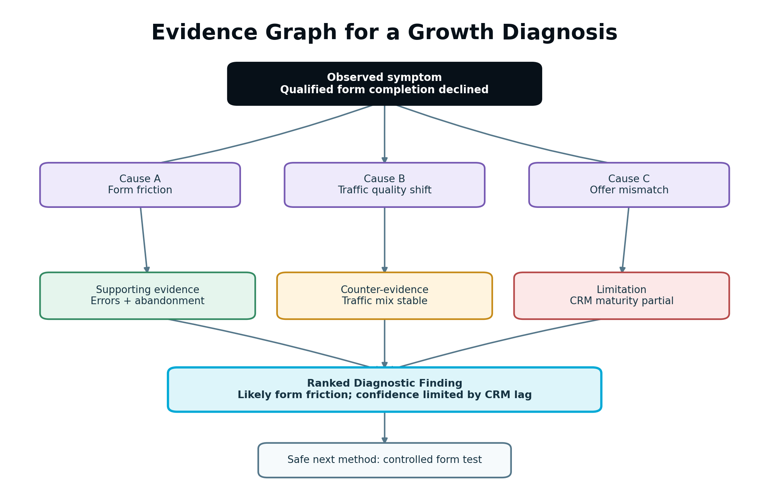
Figure 8 — Evidence graph for a growth diagnosis
Figure 8. A diagnosis preserves observations, possible causes, supporting signals, counter-evidence and limitations before it proposes an intervention.

18.1 Diagnostic stages
- Frame the symptom. Name the affected objective, metric, scope, direction and period.
- Validate the observation. Confirm definition, exposure, baseline, quality and practical magnitude.
- Generate possible causes. Use deterministic rules and approved AI synthesis.
- Gather supporting and conflicting evidence. Search across funnel, behaviour, asset, technical, search and lead sources.
- Test for simpler explanations. Check instrumentation, traffic mix, seasonality and concurrent change.
- Rank causes. Score evidence strength, consistency, specificity and actionability.
- State uncertainty. Preserve alternatives and missing evidence.
- Generate appropriate next method. Fix, experiment, collect evidence, monitor, defer or request Strategy review.

18.2 Minimum DiagnosticFinding content
- objective, metric and affected scope;
- exact observed result and baseline;
- practical magnitude;
- likely cause statement;
- evidence references and versions;
- counter-evidence or alternative explanations;
- data-quality and consent limitations;
- recommendation confidence and reason;
- affected assets/funnel stages/segments;
- safe next methods;
- stale/superseded status.

18.3 Deterministic-first rules
Rules detect known conditions such as missing denominator, broken event sequence, CTA never visible, high validation-error concentration, sample-ratio mismatch, traffic-source shift, page-version crossover and CRM mapping drift. AI may synthesize relationships after these checks; it cannot override a blocking defect.

18.4 Contradictory evidence
The engine may report “likely but not confirmed” with competing explanations. Example: scroll depth and CTA visibility improved, but form starts fell while paid referral traffic increased. The system should investigate traffic quality and page change together rather than confidently blaming the CTA.

18.5 Diagnosis invalidation
A corrected source, changed metric mapping, new exposure boundary or matured CRM outcome may supersede a diagnosis. The new version states what evidence changed. Any not-yet-executed opportunity that depended on the old finding becomes stale and is rescored.

19. Opportunity Generation and Prioritization

19.1 Candidate generation
Candidates may originate from:
- a Performance Evaluation or Diagnostic Finding;
- current Strategy or Growth Blueprint item;
- content/search decay or gap evidence;
- experiment result or Learning Record;
- instrumentation or data-quality incident;
- Workflow Controller blocker;
- user-submitted idea that passes evidence review.
Every candidate must state the problem, objective, evidence, expected result, method, success measure, dependencies and execution class.

19.2 Hard validity gates
Exclude or block a candidate when:
- it conflicts with current Strategy or business constraints;
- the underlying evidence is stale, invalid or out of scope;
- the same effective action is already approved, executing or measuring;
- a dependency or required capability is unavailable;
- it requires a V2 capability;
- it violates consent, safety, compliance or malicious-use policy;
- it cannot be measured and has no authorized qualitative/operational success condition;
- a lower-level defect must be repaired first;
- the workspace/project state or role cannot support the action.

19.3 Scoring components
Normalize each component to 0..1 under a versioned policy:
- impact: expected material business effect;
- goalAlignment: direct support for the current objective;
- confidence: evidence support for the recommendation;
- reach: eligible volume or affected business scope;
- urgency: time sensitivity, decay or cost of delay;
- learningValue: ability to reduce an important uncertainty;
- ease: inverse implementation effort and operational complexity;
- readiness: context, measurement, integration and approval readiness;
- risk: customer, compliance, technical, brand and opportunity risk.

19.4 Canonical Opportunity Score
V1 reference policy:
Value = 0.30*impact + 0.25*goalAlignment + 0.15*confidence + 0.10*reach + 0.10*urgency + 0.10*learningValue
OpportunityScore = 100 * Value * (0.5 + 0.5*ease) * (0.5 + 0.5*readiness) * (1 - 0.5*risk)
Weights and thresholds are versioned configuration. Hard gates run before the formula. The formula helps compare valid candidates; it never turns an invalid action into a valid one.

19.5 ICE and PIE support
- ICE = Impact * Confidence * Ease
- PIE = Potential * Importance * Ease
Use a consistent configured scale, normally 1-10 for customer-facing worksheets. Store raw components and policy version. ICE and PIE are alternate views, not independent decision authorities. The canonical Opportunity Score resolves cross-domain prioritization.

19.6 Avoid false precision
Display score bands and key reasons, for example “High priority: strong goal alignment and evidence; moderate implementation effort.” Do not imply that 78.4 is objectively superior to 77.9 when inputs are estimates. Tie-breaking uses governance rules, not decimal theatre.

19.7 Duplicate and conflict resolution
Use a semantic action fingerprint based on target, intended change, objective, asset/funnel scope and measurement. Merge evidence into one candidate where appropriate. Mutually exclusive candidates remain separate and receive a conflict group so only one can proceed.

20. Next Best Action Selection
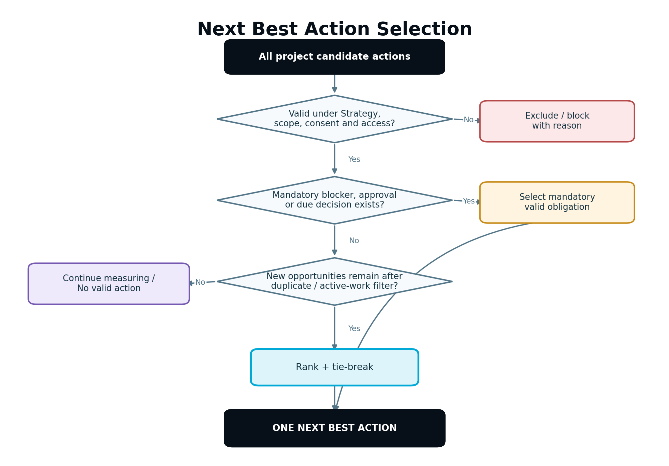
Figure 9 — Next Best Action selection decision tree
Figure 9. Validity and workflow authority are applied before priority. One primary action is returned; active background work is acknowledged, not duplicated.

20.1 Candidate sources
The selector considers:
- mandatory Workflow Controller step or blocker;
- urgent data/instrumentation repair;
- approval or review awaiting the current user;
- active execution needing resolution;
- measurement or experiment decision due;
- valid Growth Opportunities;
- Strategy Review Request;
- no-action/continue-collecting state.

20.2 Selection order
- Resolve safety, permission, stale-authority and critical data defects that block valid operation.
- Surface an action already awaiting this user’s review or approval when it is the highest valid obligation.
- Resolve failed/partial protected execution before starting conflicting new work.
- Complete a due experiment or measurement decision.
- Rank new valid opportunities by canonical score and tie-breakers.
- If evidence is not ready, return CONTINUE_MEASURING with reason and expected milestone rather than inventing work.

20.3 Tie-breakers
When scores are effectively equivalent, prefer:
- mandatory or risk-reducing action;
- stronger direct support for the primary objective;
- higher evidence confidence;
- lower effort/risk;
- action that unlocks more dependent value;
- higher learning value;
- older valid deferred opportunity, to prevent starvation.

20.4 Next Best Action contract
The returned action states:
- what to do;
- why it matters now;
- finding and evidence summary;
- expected impact and confidence;
- effort, risk, AI Capacity estimate if applicable and required role;
- blocker or dependency;
- what will happen after approval;
- how success will be measured;
- why higher-looking alternatives were not selected when useful;
- active background measurement/experiment status.

20.5 Stability and fatigue controls
- Do not change the primary action for small score movement inside a configured stability band.
- Recalculate on meaningful events, not every dashboard refresh.
- Apply cooldown after dismissal unless new material evidence arrives.
- Do not recommend the same ineffective action again without explaining new evidence or a materially different implementation.
- Do not create a follow-up while the same target is still executing or inside its measurement window.

20.6 No valid action
NO_VALID_ACTION is a legitimate result. The UI explains whether the project is collecting evidence, waiting for approval, blocked by a connection, complete for the current objective or requires strategic input. It never fills the space with low-value busy work.

21. Growth Blueprint
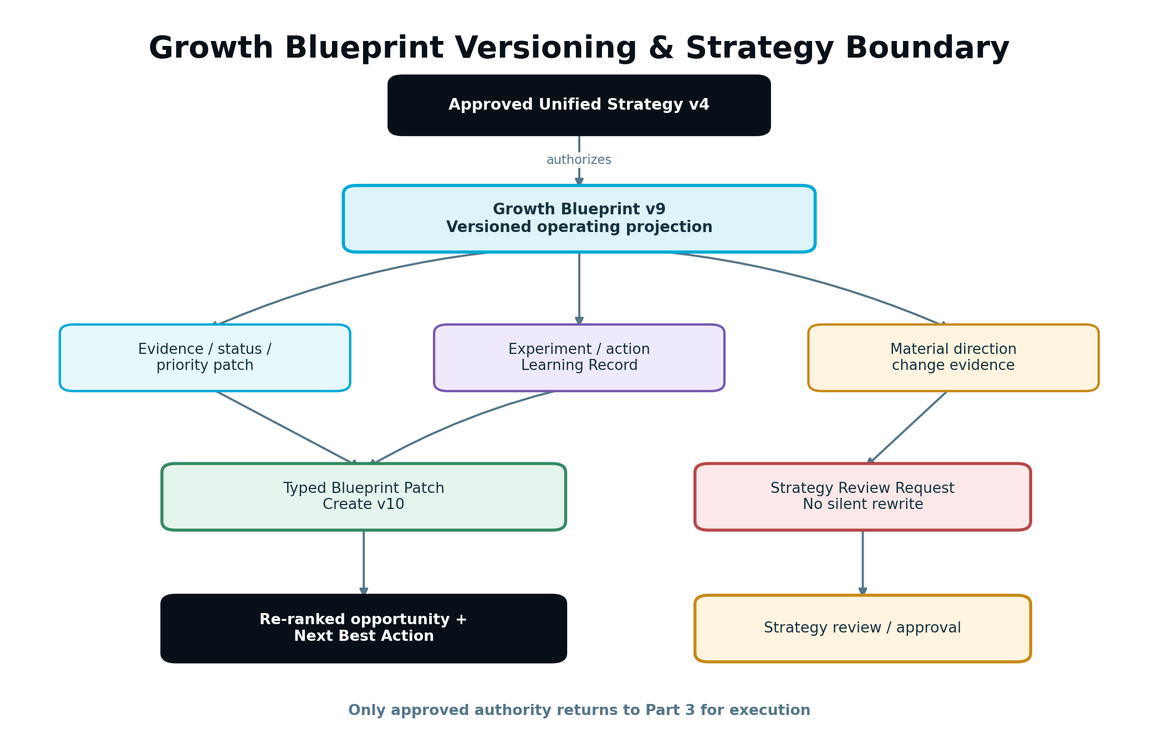
Figure 10 — Growth Blueprint versioning and Strategy boundary
Figure 10. The Blueprint evolves through typed evidence patches inside approved direction. Material direction changes become Strategy Review Requests.

21.1 Purpose
The Growth Blueprint is the live optimization layer that operates the approved Unified Strategy after execution and measurement begin. It combines current priorities, active execution, measurement windows, experiments, learning, constraints and future opportunities into one versioned operating view.
It is not a second Strategy, a static report or an unbounded AI-generated to-do list.

21.2 Logical structure
- current objective and KPI/metric references;
- approved Strategy and Business Brain versions;
- active priorities and their evidence;
- approved/executing/measuring work;
- opportunity backlog with score policy;
- experiments and exclusion groups;
- completed Learning Records;
- data-quality and integration constraints;
- deferred, dismissed, stale and superseded items;
- Strategy Review Requests;
- next scheduled evaluation/review milestones.

21.3 Persistence model
Implement the Blueprint as a versioned projection over authoritative records plus immutable BlueprintPatch history. Persist periodic materialized snapshots for fast reads and reproducibility. Do not make a single mutable JSON document the only source of truth.
This architecture preserves auditability, supports incremental updates, prevents concurrent overwrite and allows a historical report to reconstruct the Blueprint as it existed at a decision time.

21.4 Patch classes
Patch class | Example | Approval effect
Evidence/status | Measurement became ready; integration became delayed | Automatic versioned update; no Strategy change
Priority/confidence | Opportunity score changed after valid new evidence | Automatic versioned update within current Strategy
Learning | Experiment produced a bounded result | Automatic record and re-ranking; no live action
Proposed action | Add an optimization recommendation inside approved direction | Creates review/plan path; does not execute
Material direction | Change audience, offer, market, objective, positioning or compliance posture | Create Strategy Review Request; do not patch Strategy
Administrative | Authorized dismissal, defer-until date or owner assignment | Audited; permission-aware

21.5 Blueprint item states
OBSERVED, PROPOSED, RECOMMENDED, APPROVED, PLANNED, EXECUTING, MEASURING, LEARNED, DEFERRED, DISMISSED, BLOCKED, STALE and SUPERSEDED.
These reference authoritative workflow/execution states; they do not replace Part 3 lifecycle records.

21.6 Update rules
- Apply optimistic concurrency using expected Blueprint version.
- Rebase non-conflicting patches; require review for material conflicts.
- Record before/after summary, reason, evidence and actor/system principal.
- Never delete prior learning because a newer result differs.
- Supersede invalid learning with explanation.
- Recalculate only affected opportunities and Next Best Action.
- Preserve user dismissals and defer rules unless new material evidence meets the re-open policy.
- Prevent one event from applying the same patch twice.

21.7 Strategy review threshold
Create a Strategy Review Request when evidence suggests a material change to primary objective, target audience, market/location, offer, positioning, business model, material budget, compliance posture or channel direction. The request includes evidence, impact, urgency, alternatives and affected current work. Existing safe work may continue unless the Workflow Controller determines it has become stale.

22. Experiment Intelligence and Governance

22.1 Experiment decision
Use this order:
- Is there a valid material opportunity?
- Is the underlying system functioning and measurement trustworthy?
- Are at least two safe alternatives consistent with Strategy?
- Is the outcome measurable with an eligible unit and exposure?
- Is sufficient volume likely inside a reasonable maximum duration?
- Can variants be isolated without unacceptable overlap or contamination?
- Are risk and effort appropriate?
If “no,” choose direct fix, observe, improve instrumentation, defer or request Strategy review. Do not create an experiment merely to make the product appear intelligent.

22.2 Supported V1 methods
- two-variant controlled A/B test where the surface supports stable assignment;
- limited multi-variant test only when preflight demonstrates adequate volume and analysis policy;
- controlled message/CTA/form/page-component variation through approved Part 3 assets;
- time-boxed observational pre/post evaluation when controlled assignment is unavailable, clearly labelled non-causal;
- monitored direct change with guardrails when the decision is an obvious fix rather than an uncertain alternative.
Adaptive allocation, multi-armed bandits and advanced causal designs remain out of V1.

22.3 Risk classes
Class | Example | Governance
Low | Minor CTA wording within approved claims | Normal approval; pre-declared metrics and rollback
Moderate | Form length, proof placement, page structure | Explicit approval, guardrails, technical QA and monitored rollout
High | Price/eligibility, regulated claim, material lead routing, destructive replacement | Do not run without enhanced authorized review; some changes are unsuitable for experimentation
Prohibited | Deceptive pattern, hidden consent, unsafe claim, unauthorized audience or identity use | Block

22.4 Hypothesis contract
A hypothesis states:
- observed problem/opportunity;
- proposed intervention and mechanism;
- affected population and surface;
- primary expected outcome and practical effect;
- guardrails and risks;
- evidence and counter-evidence;
- confidence and remaining uncertainty;
- experiment/direct-change recommendation;
- success, harm, no-material-difference and inconclusive rules.
“Change the button to blue and see what happens” is not an adequate hypothesis.

22.5 Approval boundary
AI may draft the plan and variants. The Experiment Service may validate assignment and analysis configuration. Part 3 creates, validates, approves, publishes and verifies the actual variation. Experiment activation is bound to exact asset versions, population, allocation, duration, metrics, guardrails and rollback configuration.

22.6 Overlapping experiments
Each plan declares target surface and exclusion groups. Conflicting experiments cannot assign the same eligible unit concurrently unless an explicitly supported factorial design exists; V1 should normally serialize them. The scheduler considers active campaigns and external site changes that could contaminate results.

23. Experiment Design, Assignment and Exposure

23.1 Preflight
Before approval, validate:
- current Strategy, opportunity and asset authority;
- stable unit of assignment;
- eligible population and exclusions;
- identity/consent compatibility;
- variant allocation totals and asset readiness;
- primary, secondary and guardrail metric definitions;
- baseline rate/variance estimate and expected volume;
- minimum practical effect;
- sample and duration estimate;
- conversion-lag allowance;
- experiment overlap/exclusion group;
- technical performance and accessibility parity;
- rollback/pause path;
- analysis-policy version.

23.2 Stable assignment
Use a deterministic keyed hash or equivalent service over experiment ID, assignment unit and secret salt to assign eligible units. Assignment must be stable across sessions when the unit and policy require it. Do not expose a reversible identity in client code.
When cookies or identifiers are unavailable because of consent or browser behaviour, either use a permitted alternative assignment method or mark the unit ineligible. Do not pretend unstable assignment is controlled.

23.3 Exposure definition
Assignment alone is not exposure. Record exposure only when the unit is eligible and the assigned variant was actually rendered or delivered sufficiently to affect the outcome. The exposure event contains experiment/run/variant, asset version, unit reference, occurred time, eligibility, source, consent and deduplication key.

23.4 Sample policy
V1 analysis policies are versioned. The initial controlled binary-conversion policy should use:
- pre-test baseline estimate;
- two-sided 95% confidence interval;
- 5% significance level;
- 80% target power;
- pre-declared minimum practical effect;
- fixed minimum duration covering normal day-of-week variation;
- fixed target sample or maximum duration;
- no routine winner calls before the planned analysis point;
- separate conservative guardrail-harm monitoring.
Exact values may be changed only through a new reviewed policy version, not per-result convenience. The report shows practical magnitude and uncertainty, not only a threshold label.

23.5 Sample-ratio mismatch
Compare observed eligible exposure allocation with the approved allocation. A material mismatch creates an incident and normally invalidates or pauses analysis until assignment, caching, bot or instrumentation causes are resolved.

23.6 Contamination
Detect, where possible:
- the same stable unit receiving multiple variants;
- remote edits to a variant after activation;
- campaign/source mix changing asymmetrically;
- experiment code missing on a material part of eligible traffic;
- another experiment changing the same surface;
- conversions assigned before valid exposure.
Contamination is part of the result and may invalidate the run.

23.7 Pause, stop and rollback
A pre-authorized safety policy may pause new assignments when a critical guardrail, security, accessibility or technical threshold is breached. The pause is audited and not a winner decision. Other early stops require an authorized user. Part 3 executes rollback or remote changes.

24. Experiment Analysis and Learning

24.1 Deterministic analysis
Use a reviewed statistical library/service. Do not ask a language model to calculate authoritative experiment results. The analysis service receives immutable aggregates and returns effect, uncertainty, sample, duration, validity checks and classification.
Initial V1 policy guidance:
- binary conversion: difference and relative lift with confidence interval under the approved fixed-horizon policy;
- continuous outcome: policy-selected robust mean/median analysis with distribution diagnostics;
- rate/count outcome: policy-selected exposure-adjusted method;
- multiple variants/primary outcomes: reviewed multiplicity control or block unsupported design;
- segments: exploratory unless pre-declared and adequately powered;
- missing/late outcomes: follow declared censoring and maturity rules.

24.2 Practical significance
Classify an observed effect against the pre-declared minimum practical effect and guardrails. A tiny effect can be statistically detectable but operationally not worthwhile. A promising effect with wide uncertainty remains inconclusive.

24.3 Result classifications
- WINNER: a variant produces a practically meaningful supported improvement with acceptable guardrails.
- HARMED: primary outcome or critical guardrail materially worsens.
- NO_MATERIAL_DIFFERENCE: sufficient evidence places the effect inside the practical equivalence region.
- INCONCLUSIVE: evidence remains too uncertain at maximum duration/sample.
- INVALID: assignment, exposure, contamination, instrumentation or analysis validity failed.
- CANCELLED: authorized stop without a valid final decision.
The system does not choose the numerically highest variant when the evidence is inconclusive.

24.4 Recommendation confidence versus statistical evidence
Keep these fields separate:
- recommendationConfidence: how well evidence supported running the experiment or action;
- analysisEvidenceStrength: how strongly the completed data supports the result;
- effectUncertainty: interval/range around observed effect;
- learningApplicability: how broadly the result may be used.

24.5 Learning Record
Every finalized valid result creates a LearningRecord containing:
- question and hypothesis;
- experiment/action and exact versions;
- population, surface and period;
- primary/guardrail results;
- classification and practical magnitude;
- evidence strength and limitations;
- conclusion in plain language;
- applicability and non-applicability conditions;
- recommended Blueprint effect;
- whether follow-up, rollout, rollback, observation or no action is appropriate.
Inconclusive and invalid runs also create records so the same flawed design or unsupported assumption is not repeated.

24.6 Rollout after a winner
A winner does not publish itself permanently. The result creates a rollout recommendation. An authorized user approves the exact winning version and Part 3 verifies the permanent external state. Continue guardrail monitoring after rollout according to the Measurement Plan.

24.7 Learning invalidation
If later evidence reveals a source defect, sample-ratio mismatch or incompatible population, supersede the Learning Record with a reason. Dependent Blueprint priorities and recommendations become stale and are recalculated. Historical audit and reports remain available.

25. SEnuke AI Intelligence and AI Orchestration

25.1 Division of responsibility
Deterministic services calculate events, aggregates, data quality, scoring components, assignment and experiment statistics. SEnuke AI Intelligence synthesizes applicable evidence, proposes possible diagnoses/hypotheses, explains structured results and helps generate customer-understandable recommendations.
AI cannot:
- invent a missing metric or denominator;
- change a Metric Definition at runtime;
- override a blocking quality or consent finding;
- determine permission, entitlement or approval;
- declare statistical significance from prose;
- convert observational evidence into causality;
- make a protected external change.

25.2 AI task classes
- evidence summarization from a bounded structured bundle;
- diagnostic cause generation and counter-evidence review;
- hypothesis and safe alternative generation;
- expected-impact range support using approved historical/context evidence;
- plain-language explanation and report narrative;
- semantic duplicate detection across opportunities and learning;
- reviewer assistance for Behaviour Intelligence findings;
- Strategy Review Request drafting.

25.3 Context Bundle
The Growth Intelligence Coordinator sends only the information required for the task:
- objective, current Strategy and Business Brain references;
- structured metric/evaluation facts;
- Diagnostic Findings and source limitations;
- relevant asset/version excerpts or summaries;
- previous applicable Learning Records;
- scoring/risk/approval constraints;
- required output schema.
Raw personal data, credentials, recipient lists, unrestricted CRM notes and session recordings are excluded.

25.4 Structured output
AI responses use versioned schemas for DiagnosisSynthesis, HypothesisDraft, OpportunityNarrative, ReportNarrative and StrategyReviewDraft. Every claim references supplied evidence IDs or is labelled inference. Schema failure, unsupported evidence reference or policy violation triggers bounded repair, fallback or human review.

25.5 Routing objective
The AI Orchestrator minimizes expected total successful-workflow cost:
initial provider cost + expected retry cost + validation cost + correction cost + failure-risk cost
subject to minimum quality, sensitivity, latency, context and availability constraints. Task-class historical quality and retry performance are used; feature modules never select a provider directly.

25.6 AI Capacity
- Capacity-bearing AI analysis is quoted/reserved before execution and settled afterward.
- Reuse structured evaluations and prior valid summaries instead of repeatedly sending the same evidence.
- Incremental change should trigger targeted re-analysis, not regeneration of the whole Blueprint.
- Deterministic ingestion and metric computation remain platform services; any customer-facing capacity treatment follows the Commercial Architecture and Capacity Engine, not ad hoc module charges.
- A Client Viewer has no default AI Capacity allowance and cannot initiate new AI analysis unless explicitly permitted by governing entitlements.

25.7 Validation
Validate AI output for schema, evidence references, numerical consistency with the structured result, causal wording, unsupported certainty, protected claims, privacy leakage, Strategy alignment and duplication. The authoritative numeric result always wins over narrative text.

26. Approval and Part 3 Execution Integration

26.1 Recommendation-to-execution boundary
An official Growth Opportunity or experiment plan is not an Execution Task. The transition is:
- Part 4 produces the recommendation and evidence package.
- Workflow Controller confirms the action is valid for the current project state.
- If the action is inside approved Strategy, create or reconcile an Execution Plan item/proposal.
- If the action materially changes direction, create a Strategy Review Request first.
- Part 3 estimates AI Capacity, produces assets/configuration, validates, requests approval and executes protected actions.
- Part 3 verifies the external state and activates a versioned Measurement Plan.
- Part 4 consumes the new exposure and resumes the loop.

26.2 Approval classes
Part 4 action | Governance
View aggregate/evaluation | Project view permission and scope
Run deterministic re-evaluation | Authorized system or analysis permission; audited when official result changes
Request AI diagnosis/report | Create/analyze permission plus applicable AI Capacity authorization
Dismiss/defer opportunity | Manage-growth permission; reason required for durable dismissal
Approve experiment/recommendation | Manager/Approver or Owner/Admin under workspace/client policy
Publish variant, change form/page, activate automation | Part 3 protected-action permission and exact-version approval
Roll out winner or rollback harm | New Part 3 protected action; experiment result alone grants no authority
Change Strategy | Strategy review and approval workflow

26.3 Agency approval
Agency projects may require internal review and client approval before execution. Part 4 shows the evidence and proposed experiment/action to authorized Client Viewers, but client approval does not grant publishing authority. Results and learning remain client-scoped.

26.4 Material change
Changing hypothesis, primary metric, eligible population, variant content, allocation, duration, minimum practical effect, guardrail or consent behaviour after approval creates a new Experiment Plan version and invalidates the prior approval as policy determines.

26.5 Pre-authorized safety actions
An experiment may have a narrowly approved automatic pause on critical guardrail harm or technical failure. The policy specifies thresholds, monitoring cadence, owner and recovery. It may stop new exposure; it may not silently declare a winner, roll out another variant or broaden authority.

26.6 Read-only workspace
When the workspace becomes read-only, collection and view-only reporting may continue according to retention and provider policy, but new AI analysis, experiment creation, publication, activation and protected changes are blocked. Already scheduled external actions follow the Commercial Architecture and Part 3 preflight rules.

27. Reporting and Explainability

27.1 Report structure
Every official result report answers:
- What objective and action were evaluated?
- What exact version was active, and when?
- What happened to the primary outcome?
- What happened to supporting and guardrail metrics?
- How trustworthy and complete is the evidence?
- What can and cannot be concluded?
- What did SEnuke AI learn?
- How did the Growth Blueprint change?
- What is the Next Best Action, and why now?

27.2 Evidence language
Use language that matches the design:
- controlled valid experiment: “The test measured…” or “Variant B produced an estimated… within this experiment.”
- observational comparison: “Performance improved after the change; other concurrent factors may have contributed.”
- provider attribution: “GA4 attributed…” or “The CRM associated…”
- modelled value: “The provider supplied a modelled estimate…”
- insufficient evidence: “There is not enough reliable evidence to determine…”

27.3 Expected versus observed impact
Show the original expected range, observed effect, difference, confidence/evidence strength and material limitations. Do not rewrite the original forecast after results arrive. Forecast calibration may be improved through a new policy version using historical learning.

27.4 Report snapshots
An official Report is an immutable snapshot of structured records and narrative version. Later source corrections create a new report version with a visible change note. Exports and client views retain the original scope and permission boundary.

27.5 No cherry-picking
Reports include the pre-declared primary metric and critical guardrails even when the result is unfavourable. Exploratory segment findings are labelled exploratory. The system must not select whichever secondary metric makes the action appear successful.

27.6 Confidence explanation
Explain confidence using concrete factors: “High confidence because the exposure was verified, both analytics and first-party events agree, the sample met policy and CRM quality matured. Revenue remains unavailable.” Avoid opaque “AI confidence” labels.

28. Guided and Advanced User Experience

28.1 Guided Mode
Guided Mode should show a simple operating sequence:
- current goal and outcome status;
- what SEnuke AI found;
- why the finding matters;
- one recommended action;
- expected impact and confidence;
- what approval or work is required;
- what is currently collecting or running;
- when the system expects the next reliable decision;
- data limitations in plain language.
The primary button is Fix Measurement, Review, Approve, Start, Continue Measuring, View Result, Roll Out, Rollback, Revisit Strategy or another canonical action derived from state.

28.2 Advanced Mode
Advanced Mode may expose:
- metric definitions, source precedence and aggregate details;
- data-quality dimensions and watermarks;
- funnel stage/segment matrices;
- full evidence graph and counter-evidence;
- scoring components, ICE/PIE and policy versions;
- experiment allocation, sample planning, validity checks and effect intervals;
- Blueprint patch history and dependency relationships;
- evaluation/report revisions.
It does not expose provider secrets, raw protected identity, unrestricted session recordings or a control that bypasses governance.

28.3 Diagnosis experience
- Lead with the symptom and business impact.
- Show a compact evidence chain: observation -> likely cause -> supporting/counter evidence -> limitation.
- Allow the user to inspect source values without requiring provider expertise.
- Distinguish “confirmed defect,” “likely cause,” “possible cause” and “unknown.”
- Provide a direct route to resolve instrumentation when measurement is the problem.

28.4 Funnel experience
Show volume and transition rate together. A stage card includes metric definition, freshness and denominator. Segment comparison appears only when eligible. Funnel versions and boundaries are visible. Do not imply that anonymous stages form a person-level journey unless identity evidence supports it.

28.5 Experiment experience
Before approval, show hypothesis, variants, eligible audience, primary/guardrail metrics, estimated sample/duration, risks, required external changes and rollback. While running, show verified exposure, health and planned decision milestone without declaring a leader prematurely. After analysis, show result, practical magnitude, uncertainty, guardrails and recommended next step.

28.6 Tracker experience
Tracker is a chronological view of Strategy/Blueprint decision, execution, verified exposure, instrumentation boundary, measurement window, incident, evaluation, learning and Blueprint update. Timeline items link to exact versions and are filtered by permission.

28.7 Background work
The customer may leave the page while ingestion, evaluation or AI analysis runs. Status reflects completed stages, not invented percentages. Collection displays evidence progress such as window elapsed, eligible volume and known source lag without promising a fixed completion date when traffic is uncertain.

29. Notifications, Audit and Operations

29.1 Notification rules
Notify the appropriate user when:
- measurement cannot start because exposure/instrumentation is missing;
- a required source disconnects or becomes materially stale;
- evidence is ready for evaluation;
- a material decline or guardrail harm requires attention;
- a recommendation or experiment is ready for approval;
- an experiment is paused, invalid, complete or ready for rollout decision;
- a report/result is revised after corrected or matured data;
- a Strategy Review Request is created;
- the Next Best Action changes materially.
Do not notify on every event or minor score fluctuation. Deduplicate by recipient, object, state and reason. A notification opens the exact scoped record the user may access.

29.2 Activity History
Customer-visible history uses plain language, for example:
- “Visitor Insurance landing page version 7 began measurement.”
- “CRM qualification data is delayed; submission results remain available but limited.”
- “The CTA experiment ended inconclusive after the maximum 42-day window.”
- “The Growth Blueprint moved form simplification above content expansion.”

29.3 Decision audit
Every official evaluation, diagnosis, opportunity, experiment decision, learning and Blueprint patch records:
- actor/system principal and reason;
- workspace, client, project and objective;
- Business Brain, Strategy, Execution Plan and Measurement Plan versions;
- exposure, metric, aggregate and data watermark references;
- source snapshots and limitations;
- scoring/analysis/AI pipeline versions;
- before/after state and result;
- approval/dismissal/waiver details;
- correlation, causation and idempotency IDs;
- timestamps and appropriate access metadata.
Do not put credentials, raw sensitive form data, unrestricted CRM notes or session recordings in audit payloads.

29.4 Operations Command Center
Launch operations must support:
- search by workspace/project/evaluation/experiment/correlation ID;
- source health, cursor, lag, schema and incident view;
- event quarantine, deduplication and replay status;
- aggregate/evaluation revision chain;
- stuck evaluation/AI run/Blueprint patch detection;
- experiment exposure health and sample-ratio incidents;
- controlled idempotent retry/reprocess from a safe watermark;
- permission-scoped report regeneration;
- audit and customer-safe support bundle;
- feature/policy version visibility without direct unsafe data edits.
Operator correction must create an auditable new record. It must not rewrite historical evidence silently or grant approval.

30. Error Handling, Recovery and Reconciliation

30.1 Error categories
- MEASUREMENT_PLAN_INVALID;
- EXPOSURE_MISSING;
- METRIC_DEFINITION_MISSING;
- SOURCE_AUTH_FAILED;
- SOURCE_DELAYED;
- SCHEMA_DRIFT;
- EVENT_REJECTED;
- DATA_QUALITY_BLOCKED;
- CONSENT_RESTRICTED;
- IDENTITY_UNRESOLVED;
- BASELINE_NOT_COMPARABLE;
- INSUFFICIENT_EVIDENCE;
- CONCURRENT_CHANGE;
- ASSIGNMENT_FAILURE;
- SAMPLE_RATIO_MISMATCH;
- EXPERIMENT_CONTAMINATED;
- ANALYSIS_FAILED;
- STALE_AUTHORITY;
- PERMISSION_DENIED;
- ENTITLEMENT_BLOCKED;
- CAPACITY_INSUFFICIENT;
- AI_PROVIDER_FAILURE;
- BLUEPRINT_CONFLICT;
- INTERNAL_CONSISTENCY_ERROR.
Each error includes customer-safe explanation, affected scope, retryability, responsible component, preserved evidence, next action and internal diagnostic reference.

30.2 Recovery rules
- Preserve accepted events, aggregates, structured evaluations and completed AI stages.
- Retry from the last safe checkpoint.
- Reuse deterministic results when only narrative generation failed.
- Do not duplicate an official evaluation, Learning Record or Blueprint patch.
- Re-run permission, entitlement and AI Capacity authorization after a material delay.
- Do not reprocess past a known schema boundary without a versioned mapping.
- Quarantine invalid events; do not discard them silently or mix them into metrics.
- Return a limited result when policy permits rather than pretending full evidence.

30.3 Late and corrected data
Source-specific watermarks determine when a result is provisional or mature. Accepted late events create a new Aggregate Snapshot and evaluation revision. If the classification changes materially, dependent diagnosis, opportunity, report, Learning Record and Blueprint state are invalidated or superseded through events.

30.4 Reconciliation jobs
Periodic jobs compare:
- active Measurement Plans with verified exposures;
- source cursors with ingestion watermarks;
- event volume with recent expected ranges;
- source connection health with scheduled pulls;
- experiment assignments with observed exposures;
- experiment allocations with sample ratio;
- evaluation state with window/sufficiency state;
- Blueprint projection with authoritative opportunities/experiments/tasks;
- report current pointer with latest official evaluation revision;
- AI Capacity reservations with completed/failed analysis runs.
Reconciliation may repair derived read models or resume safe processing. It cannot invent missing exposure, consent, identity or approval.

30.5 Poison events and dead letters
Repeatedly failing events move to a controlled dead-letter path with workspace scope, type, schema, retry count, last error and correlation reference. Material customer-state impact creates an incident. Authorized replay is idempotent and starts from a known mapping/policy version.

31. Security, Privacy and Compliance

31.1 Authorization and isolation
- Enforce workspace, Agency client and project scope at API, query, aggregate, queue and worker layers.
- Use object-level authorization for metrics, experiments, reports, recordings/references and Blueprint versions.
- Never trust client-supplied workspace, role, entitlement, consent or approval fields without server resolution.
- Prevent indirect-object access through authorization, not opaque IDs alone.
- Scheduled/system principals are bounded to the owning workspace and approved operation.

31.2 Data minimization
- Ingest only properties declared by a versioned event schema.
- Exclude or tokenize personal identifiers not required for the objective.
- Store aggregate findings instead of raw Behaviour Intelligence content where possible.
- Keep identity mappings in a protected service separate from general analytics queries.
- Use safe minimum-count suppression for small segments.
- Apply retention and deletion to raw, normalized, aggregate, identity and derived records as required.

31.3 Sensitive interaction data
Prevent collection or review of passwords, payment data, authentication tokens, health/financial details and sensitive free text. Form field values are unnecessary for abandonment analysis. Record allowed interaction metadata only.

31.4 Prompt injection and untrusted data
CRM notes, page content, uploaded reports, session annotations and third-party source text are untrusted. Context assembly labels and delimits them. Embedded instructions cannot change system policy or select tools. AI sees protected references or approved summaries, not credentials or broad exports.

31.5 Consent and subject rights
Consent policy is enforced at collection and downstream use. A later withdrawal or deletion request propagates according to policy and may revise aggregates where required. Reports preserve lawful audit while removing or de-identifying subject data as applicable.

31.6 Experiment ethics
Block deceptive patterns, hidden consent, discriminatory targeting, exploitative vulnerability, unsafe claims and experiments that materially deny a necessary service. Segmentation and exclusion must have a legitimate approved purpose and comply with platform policy.

31.7 Secrets and logs
Integration credentials remain in encrypted secret management. They never enter metric events, prompts, reports, experiment assets, audit payloads or support bundles. Logs prefer reason codes, counts and protected references over raw content.

32. Reliability, Performance and Scalability

32.1 Asynchronous architecture
Ingestion, aggregation, evaluation, AI analysis, report generation and reconciliation use durable queues and checkpointed workers. APIs return stable operation IDs. Workers are stateless where practical and use leases for long-running work.

32.2 Idempotency
Back application deduplication with database uniqueness for source events, exposure events, evaluation runs, experiment assignments, results, Learning Records and Blueprint patches. Duplicate or out-of-order delivery must not duplicate counts, analysis, AI Capacity settlement or Next Best Action transitions.

32.3 Event watermarks
Track per-source and per-partition cursor, latest event time, latest received time, allowed lateness and last successful aggregation. A global “data current” flag is insufficient. Watermark regressions and gaps create incidents.

32.4 Incremental computation
- Recompute only affected metric/scope/window partitions.
- Cache immutable Aggregate Snapshots and structured evaluations.
- Update the Blueprint projection through patches.
- Re-run AI only when its input fingerprint changes materially.
- Batch low-priority source pulls and use provider backpressure.
- Bound segment cardinality and prevent unreviewed high-dimensional queries.

32.5 Concurrency
- Optimistic concurrency for evaluations, opportunities and Blueprint versions.
- One active official evaluation per re-evaluation key.
- Stable lease for scheduled pull/aggregation partition.
- Serialize conflicting experiment/asset-surface state changes.
- Allow independent projects/clients to process in parallel with workspace fairness.

32.6 Degradation behaviour
- If AI providers fail, preserve structured metrics/evaluation and delay narrative; do not lose the result.
- If one measurement source fails, evaluate permitted remaining metrics with explicit limitation.
- If required exposure or primary metric fails, block official conclusion.
- If reporting read models lag, show last updated time and avoid presenting stale state as current.
- Apply exponential backoff, jitter, circuit breakers and provider/source rate limits.

32.7 Required service telemetry
Instrument:
- ingestion acceptance/rejection/duplicate rate and lag by source;
- watermark and source freshness;
- aggregate duration and partition backlog;
- evaluation ready-to-result latency;
- data-quality incident rate;
- AI route, retry, validation and cost by task class;
- experiment assignment/exposure and sample-ratio health;
- Blueprint patch conflict/retry rate;
- Next Best Action recalculation and stability;
- cross-workspace/client authorization failures;
- stuck leases, runs, reservations and dead letters.
Exact SLO thresholds are operational configuration. Customer UI queries should use read models so ordinary Overview, Funnel and Tracker views do not synchronously scan raw events or call external providers.

32.8 Retention and storage
Use tiered retention for raw/minimally normalized events, aggregates, identity mappings, recordings/references, audit and official results. Official evaluations, experiment results, Learning Records and Blueprint versions retain enough immutable evidence references for reconstruction while respecting deletion and privacy policy.

33. Required APIs, Events and Persistence

33.1 API surface
Method and path | Responsibility
GET /projects/{id}/growth/overview | Current objective, data health, active work, learning and Next Best Action read model
GET /projects/{id}/growth/diagnosis | Findings, evidence graph and limitations
GET /projects/{id}/growth/funnels | Funnel definitions, versions and summary
GET /funnels/{id}/performance | Stage volume, transition and eligible segments for a window
GET /measurement-plans/{id}/status | Exposure, collection, source and evaluation readiness
GET /metric-definitions/{id} | Versioned customer/provider-neutral metric semantics
GET /evaluations/{id} | Structured evaluation, versions and limitations
POST /evaluations/{id}/reprocess | Authorized idempotent re-evaluation after source/policy correction
GET /projects/{id}/opportunities | Valid, deferred, dismissed, stale and active opportunities
POST /opportunities/{id}/decision | Approve-for-planning, defer or dismiss with reason
GET /projects/{id}/next-best-action | One primary action plus background state
GET /projects/{id}/growth-blueprint | Current Blueprint projection and version
GET /growth-blueprints/{id}/versions | Patch/version history
POST /growth-blueprints/{id}/patches | Authorized administrative patch; system patches use internal interface
POST /experiments | Create a draft plan from an authorized opportunity
GET /experiments/{id} | Plan, run, health, exposure and result
POST /experiments/{id}/request-execution | Hand approved plan to Workflow Controller/Part 3; no direct publish
POST /experiments/{id}/decision | Authorized pause/cancel/rollout/rollback request
GET /projects/{id}/growth/reports | Versioned report list
GET /growth-reports/{id} | Immutable report snapshot
POST /strategy-review-requests | Create evidence-backed Strategy review proposal
All mutations require server-resolved workspace/client/project scope, role, entitlement, expected version and idempotency key.

33.2 Internal service interfaces
- MeasurementPlanResolver.resolve(planVersionId, exposureFingerprint)
- MetricRegistry.resolve(metricCode, effectiveAt)
- IngestionGateway.accept(envelope, sourceSnapshot)
- IdentityService.associate(subjectRefs, policyVersion)
- DataQualityService.evaluate(scope, window, sourceSnapshots)
- AggregationService.snapshot(metricDefinitions, scope, window, watermark)
- BaselineService.resolve(plan, scope, activation)
- EvaluationService.createOrGet(key)/evaluate/revise
- DiagnosisService.build(evaluationId, contextBundle)
- OpportunityService.generate/merge/score/invalidate
- ExperimentService.preflight/assign/recordExposure/analyze
- LearningService.create/supersede
- GrowthBlueprintService.applyPatch/rebuildProjection
- NextBestActionService.select(projectId, actorContext)
- WorkflowController.requestPlanOrStrategyReview(recommendation)
- CapacityEngine.quote/reserve/settle/release
- AIOrchestrator.execute(taskEnvelope)
- ReportService.compose(snapshotRefs)
- AuditService.append(event)
- NotificationService.handle(domainEvent)

33.3 Domain events
- MeasurementPlanActivated, ExposureVerified, ExposureEnded, ExposureCorrected.
- MetricEventAccepted, MetricEventRejected, SourceWatermarkAdvanced.
- SourceDelayed, SourceRecovered, SchemaDriftDetected, DataQualityIncidentOpened, DataQualityIncidentResolved.
- EvaluationCollecting, EvaluationReady, EvaluationCompleted, EvaluationLimited, EvaluationInvalidated, EvaluationRevised.
- DiagnosticFindingCreated, DiagnosticFindingSuperseded.
- GrowthOpportunityCreated, GrowthOpportunityRescored, GrowthOpportunityDeferred, GrowthOpportunityStale.
- ExperimentPlanCreated, ExperimentApproved, ExperimentExposureRecorded, ExperimentPaused, ExperimentCompleted, ExperimentInvalidated.
- LearningRecordCreated, LearningRecordSuperseded.
- GrowthBlueprintPatched, StrategyReviewRequested.
- NextBestActionChanged, GrowthReportCreated, GrowthReportRevised.
Every event uses the versioned normalized platform envelope with workspace, project/client scope, event ID, occurred time, schema version, correlation/causation and idempotency identity.

33.4 Required persistence entities
- MetricDefinition, MetricSourceMapping, SourceSnapshot, SourceCursor;
- NormalizedMetricEvent, EventQuarantine, EventDeduplicationKey;
- ExposureRecord, ExperimentAssignment, ExperimentExposure;
- AggregateSnapshot, AggregatePartition, DataWatermark;
- Baseline, EvaluationWindow, MeasurementLimitation, DataQualityIncident;
- PerformanceEvaluation, EvaluationRevision, DiagnosticFinding, FindingEvidenceLink;
- GrowthOpportunity, OpportunityScore, OpportunityConflictGroup;
- Hypothesis, ExperimentPlan, ExperimentVariant, ExperimentRun, ExperimentResult;
- LearningRecord, LearningApplicability;
- GrowthBlueprintSnapshot, BlueprintPatch, StrategyReviewRequest;
- NextBestActionDecision, GrowthReportSnapshot;
- GrowthAuditEvent, GrowthOperation, GrowthNotificationState.
Foreign keys and service authorization must preserve workspace/project/client ownership. Append-only histories use supersession rather than destructive update.

34. Real-World End-to-End Examples

34.1 Existing insurance website: qualified Visitor Insurance quotes

Situation
The approved Strategy prioritizes qualified Visitor Insurance quote requests. Part 3 publishes and verifies a dedicated landing page with a quote form. The Measurement Plan defines qualified completion rate as primary, form starts and field errors as diagnostic, and CRM disqualification rate as a guardrail.

Evidence
After the minimum collection window:
- qualified page traffic is inside the expected range;
- CTA visibility is high and CTA engagement is healthy;
- 38% of form starters abandon at two optional fields on mobile;
- Behaviour Intelligence shows repeated validation errors and backtracking at those fields;
- first-party submit events and GA4 agree within tolerance;
- CRM qualification is available for 82% of submitted leads and shows no traffic-quality decline.

Decision and execution
- Evaluation classifies the funnel as MIXED: acquisition is healthy, completion is weak.
- Diagnosis ranks optional-field friction above offer mismatch; traffic quality is counter-evidence against the latter.
- Opportunity Service proposes a shorter form, checks no equivalent task is active and scores it above content expansion.
- Next Best Action is “Review a shorter quote-form experiment.”
- The Manager approves a 50/50 controlled experiment with completion as primary and disqualification/error rate as guardrails.
- Part 3 creates, validates, approves, publishes and verifies the variant.
- Part 4 records stable assignment and exposure, then waits for the fixed-horizon analysis point.

Result and learning
The shorter form produces a practically meaningful supported improvement in qualified completion with stable disqualification. A WINNER result creates a bounded Learning Record: removing these two optional fields improved this mobile Visitor Insurance flow for the tested audience. Permanent rollout returns through Part 3. The Blueprint raises rollout above cluster expansion; it does not generalize that every insurance form should be shorter.

34.2 Low-volume local service business: do not force an A/B test

Situation
A local plumbing service page receives 180 eligible visits per month. The broad CTA is visible, but the page has no dedicated emergency-service proof and only six monthly form submissions. The system estimates that a controlled test would exceed the maximum useful duration.

Required behaviour
- Funnel Intelligence confirms the low volume and usable tracking.
- Diagnosis finds weak emergency-intent alignment, supported by query evidence and page content.
- Experiment preflight fails volume readiness.
- The engine does not start an underpowered A/B test or promise a winner.
- It compares valid actions: add evidence-supported emergency-service clarity as a governed direct improvement, build the approved local authority cluster, or collect longer.
- The highest score is the approved content/landing improvement because it directly addresses intent and can be measured observationally.
- Report language states that a before/after improvement would be associated, not proven causal.

Architectural lesson
Experiment Intelligence decides when not to experiment. Low traffic changes the method, not the requirement for evidence, approval and measurement.

34.3 Content decay: refresh instead of creating another page

Situation
A Business workspace has an established Travel Insurance guide. Google Search Console shows a sustained decline in qualified queries and clicks. The crawl finds outdated eligibility details, missing internal links from newer service pages and declining engagement. A keyword module also identifies related demand.

Required behaviour
- Growth Opportunity Intelligence checks whether an existing page already owns the intent.
- Cannibalization and duplication rules block a proposed second guide.
- Diagnosis links decline to outdated information and weaker semantic/internal-link coverage, with a warning that external SERP changes may also contribute.
- The recommended action is a versioned refresh with verified facts, Information Gain and internal-link improvements.
- Part 3 preserves human content, validates claims and publishes the approved refresh.
- Part 4 evaluates search visibility, engaged visits and qualified quote contribution after the declared lag/window.

Architectural lesson
Growth Intelligence uses search evidence to choose create, refresh, consolidate or wait. It does not turn every new keyword into a new page.

34.4 Agency client: consent gap and cross-client isolation

Situation
An Agency manages two unrelated clients. For Client A, a landing-page campaign begins while the consent configuration suppresses analytics for a material share of visitors. First-party aggregate form submissions remain available, but Behaviour Intelligence coverage is partial. Client B has strong comparable traffic but is outside Client A’s authorization scope.

Required behaviour
- The system marks analytics and behaviour metrics CONSENT_RESTRICTED; they are not reported as zero.
- It evaluates permitted first-party submission totals with an explicit denominator limitation.
- It does not use Client B’s raw or client-visible data to fill the gap.
- Client A’s report states that the campaign outcome is limited and cannot support a confident CRO diagnosis.
- Next Best Action is to review measurement/consent configuration only if the configuration is incorrect; if it is intentional, the action is continue permitted collection or use a valid aggregate proxy.
- Client Viewers see only Client A records and cannot initiate AI work by default.

Architectural lesson
Privacy limitations change the conclusion. They are never treated as permission to bypass consent or borrow another client’s evidence.

34.5 Lead magnet and email: provisional web win, matured CRM warning

Situation
A lead magnet campaign increases opt-ins and initial email clicks. Two weeks later, CRM qualification shows that the new acquisition source produces more invalid or poorly matched leads than the prior source.

Required behaviour
- Initial report is marked provisional because the Measurement Plan includes CRM maturity.
- The first evaluation may show improved opt-in rate without declaring full business success.
- When CRM outcomes arrive, a new evaluation revision changes the classification to MIXED or DECLINED according to the guardrail.
- The prior report remains visible with a revision notice.
- The Learning Record says the campaign increased acquisition activity but reduced lead quality for this source/audience.
- The Blueprint rescoring may prioritize audience/message alignment over another opt-in test.

Architectural lesson
Downstream quality can overturn a local funnel win. Continuous optimization must wait for the outcome promised by the Measurement Plan.

34.6 Instrumentation drift during an active experiment

Situation
A form provider update changes the submit event schema midway through a CTA experiment. Control events continue; variant events lose the qualification property.

Required behaviour
- Schema drift creates a Data Quality Incident and instrumentation boundary.
- The experiment is paused or marked invalid under its policy; missing variant qualifications are not zeros.
- Accepted pre-boundary data remains preserved.
- Part 3 repairs and verifies instrumentation.
- Experiment Service determines whether a clean restart/new run is required.
- No winner or Learning Record is inferred from the broken period.

35. Edge Cases and Required Behaviour
Edge case | Required behaviour
Measurement event arrives before exposure verification | Buffer/unassociated state until authoritative exposure exists; never attribute early.
Same source event arrives twice | Deduplicate by stable source/event key; do not increment aggregates twice.
Events arrive out of order | Aggregate by event time and watermark; preserve source version/cursor.
Late CRM win arrives after report | Create matured evaluation/report revision and recalculate affected learning/priority.
Consent prevents analytics | Mark restricted/unavailable; use only permitted sources and never fabricate zero.
GA4 reports modelled conversions | Preserve MODELLED label and provider meaning; do not merge as observed person-level outcomes.
First-party and GA4 counts disagree | Compare definitions/scope; apply declared precedence and show material conflict.
GSC query data is privacy-limited | Evaluate available aggregate/page evidence and disclose missing query detail.
Source disconnects mid-window | Preserve collected evidence; delay, limit or block according to primary-metric policy.
Source reconnects with a historical backfill | Accept idempotently, advance watermark and revise evaluation if material.
Event schema changes without mapping | Quarantine new events, open incident and block cross-boundary comparison.
Asset changes without Part 3 exposure event | Detect remote/exposure conflict; stop official evaluation until reconciled.
Customer edits live page during collection | End prior exposure at detected change; reconcile new version and invalidate mixed window.
Rollback occurs during experiment | Stop new exposure, close run under policy and classify based on validity, not desired outcome.
Same user receives both variants | Record contamination; invalidate affected units or run under pre-declared policy.
Experiment allocation is 50/50 but exposure is 70/30 | Open sample-ratio incident; do not declare winner before resolution.
Conversion happens without known assignment | Exclude from controlled analysis or treat under declared unattributed policy.
Bots create clicks/forms | Apply validated bot/spam rules and record exclusions; do not hide large filtering changes.
Internal staff/testing contaminates data | Use allowlisted test identities/traffic filters and audit changes.
Page traffic is too low | Extend within maximum policy, choose other method, defer or remain inconclusive.
Statistical threshold met but effect is trivial | Do not recommend rollout unless practical significance/effort policy supports it.
Large effect with wide uncertainty | Classify inconclusive unless policy supports a reliable decision.
Primary improves but guardrail harms | Classify mixed/declined; surface harm before local win.
Secondary improves but primary does not | Do not claim success; report supporting signal only.
Segment appears to win after result inspection | Label exploratory; do not create a targeted winner without new pre-declared validation.
Baseline includes holiday/promotion | Mark non-comparable or choose reviewed seasonal/control baseline.
Campaign source mix changes sharply | Add concurrent-change limitation and reassess diagnosis.
Two opportunities target same page | Merge if same action; otherwise create conflict group and select one.
Recommended action already executing | Exclude duplicate and show existing task status.
Opportunity dismissed by user | Respect dismissal/cooldown; reopen only on material new evidence under policy.
Blueprint patch races with another patch | Rebase non-conflicting changes; require resolution for material conflict.
Strategy changes while experiment runs | Workflow Controller evaluates staleness; safely pause/cancel if no longer authorized.
Workspace enters read-only | Continue permitted viewing/collection; block new AI/protected execution.
AI provider fails after evaluation | Preserve structured result; retry narrative only without recalculation/duplicate charge.
AI narrative contradicts numeric result | Validation rejects narrative; structured evaluation remains authoritative.
AI suggests V2 capability | Scope validator blocks or reframes as deferred roadmap, not executable V1 action.
Client Viewer requests cross-client benchmark | Deny; preserve Agency/client scope and no default AI execution.
Behaviour recording includes sensitive value | Prevent/mask collection; restrict access and open privacy incident if captured.
Heatmap spans desktop and mobile layouts | Segment by compatible layout/version; do not combine into misleading finding.
One session shows severe friction | Record anecdotal finding; confirm technical defect or repeated pattern before generalizing.
Revenue data is missing | Use declared qualified-lead or conversion proxy and state limitation; no invented revenue.
CRM stage mapping changes | Create mapping version/boundary; re-evaluate compatible periods only.
Provider revises historic data | Create aggregate/evaluation revision; preserve earlier official result and change reason.
Next Best Action scores fluctuate slightly | Hold current action inside stability band unless a mandatory/urgent condition changes.
No valid action exists | Return explicit no-action/collecting/blocker state; do not create busy work.

36. Developer Rules
- Treat the Workflow Controller as authority for project stage and the one Next Best Action.
- Treat the approved Unified Strategy as direction and the Growth Blueprint as its evolving operating layer.
- Never let the Blueprint silently rewrite Strategy.
- Require a versioned Measurement Plan and verified exposure for official outcome evaluation.
- Preserve exact asset/campaign/experiment versions across every measurement window.
- Implement one versioned Metric Registry; modules must not redefine shared metrics.
- Store numerator, denominator, eligible population and aggregation for every rate.
- Represent missing, delayed, consent-restricted and unavailable separately from zero.
- Preserve observed, modelled, imported, inferred and user-entered value types.
- Use source-specific event time, cursor and lateness watermarks.
- Make ingestion, aggregation, evaluation, assignment and Blueprint patches idempotent.
- Quarantine malformed or unauthorized events; never contaminate aggregates.
- Evaluate data quality before diagnosis.
- Apply deterministic rules and calculations before AI synthesis.
- Never use an AI model as the authoritative statistics or aggregation engine.
- Route every AI task through the AI Orchestrator.
- Route capacity-bearing AI work through Capacity Engine quote/reserve/settle/release.
- Keep recommendation confidence separate from experiment statistical evidence.
- Do not claim causality from observational, provider-attributed or before/after evidence.
- Require practical significance, not only statistical threshold, for rollout decisions.
- Never force an experiment winner.
- Record negative, neutral, inconclusive and invalid learning.
- Pre-declare primary metrics, guardrails, population and analysis policy.
- Treat assignment and actual exposure as separate records.
- Detect sample-ratio mismatch, contamination and concurrent changes.
- Recommend direct governed fixes for objective defects instead of testing broken behaviour.
- Block controlled experiments that lack stable assignment or sufficient volume.
- Treat Behaviour Intelligence as supporting evidence and minimize sensitive data.
- Never copy raw recordings or form values into general storage or prompts.
- Use the common CRM and Integration services; do not integrate modules directly with providers.
- Enforce workspace and Agency client isolation in source, event, aggregate, report and AI paths.
- Use safe segment suppression and prevent unbounded high-cardinality exploration.
- Merge duplicate opportunities and exclude work already executing or measuring.
- Apply hard validity gates before any opportunity score.
- Return one primary Next Best Action and acknowledge non-competing background work.
- Preserve dismissal, defer and cooldown decisions with material-evidence reopen rules.
- Route all protected changes, experiments, rollouts and rollbacks through Part 3.
- Bind approvals to immutable plan/asset/configuration fingerprints.
- Store Blueprint changes as typed patches plus materialized versioned projections.
- Recalculate only affected evidence, opportunities and read models.
- Preserve official report/evaluation revision history when late or corrected data arrives.
- Make limitations visible in Guided Mode, reports and audit records.
- Do not expose V2 intelligence or autonomy as implemented V1 capability.
- Instrument every decision chain so authorized staff can reconstruct evidence to action to learning.

37. Implementation Sequence
The order below preserves current functional modules and minimizes rework.

Phase 1 — Contracts, authority and source boundaries
- Freeze canonical IDs, enums, Metric Definition schema, measurement/evaluation envelopes and version rules.
- Confirm Part 3 Measurement Plan, exposure and normalized-event contract compatibility.
- Implement workspace/project/client authorization and Entitlement/Capacity interfaces.
- Implement Metric Registry and provider mapping versioning.
- Establish domain-event envelope, inbox/outbox and idempotency constraints.

Phase 2 — Ingestion, quality and aggregation
- Implement source snapshots, cursors, watermarks and normalized event ingestion.
- Implement quarantine, deduplication, schema drift and controlled replay.
- Implement privacy-safe identity/association service and consent metadata.
- Implement Data Quality/Freshness Service and limitation taxonomy.
- Implement immutable aggregate snapshots, partitioning and baseline service.
- Add first-party, GA4, GSC, form and verified exposure adapters through the Integration Hub.
- Add supported CRM/offline, basic email and Behaviour Intelligence normalization where available.

Phase 3 — Evaluation, diagnosis and Growth Engine reads
- Implement evaluation lifecycle, readiness and revision rules.
- Implement Funnel Definitions, stage calculations and version boundaries.
- Implement deterministic CRO/CTA/Landing Page/Lead/search/behaviour diagnostic rules.
- Implement bounded Context Bundles and AI-assisted diagnosis through the Orchestrator.
- Implement Overview, Diagnosis, Funnel and Tracker read models.
- Implement structured report snapshots and causal-language validation.

Phase 4 — Opportunities, Blueprint and Next Best Action
- Implement Growth Opportunity schema, duplicate/conflict groups and hard validity gates.
- Implement versioned ICE, PIE and canonical Opportunity Score policy.
- Implement Blueprint patch log, materialized projection and Strategy Review Request boundary.
- Implement Next Best Action selection, tie-breakers, stability band and cooldown.
- Connect Workflow Controller and Part 3 recommendation-to-plan handoff.

Phase 5 — Experiments and learning
- Implement hypothesis/plan preflight, risk, overlap and approval fingerprints.
- Implement stable assignment and verified exposure integration for supported surfaces.
- Implement sample planning, sample-ratio/contamination checks and versioned analysis policies.
- Implement Experiment Result, Learning Record, rollout recommendation and invalidation.
- Implement Experiments UI and Operations Command Center health controls.

Phase 6 — Launch hardening
- Implement notification deduplication and customer Activity History.
- Add reconciliation for sources, evaluations, experiments, Blueprint projections and AI Capacity.
- Complete privacy/retention/deletion and cross-client isolation testing.
- Run source-contract, statistical-fixture, failure-injection, load, soak and end-to-end tests.
- Backfill/migrate existing measurement and experiment records through explicit mapping; do not silently reinterpret incompatible history.
- Verify every V2 capability remains feature-flagged/hidden from V1 execution paths.

38. Testing and Quality Strategy

38.1 Unit tests
- Metric Definition validation, numerator/denominator and distinct-count rules.
- Event deduplication, event-time/watermark and late-event handling.
- Consent state, identity confidence and source precedence.
- Data-quality hard-failure and limitation policies.
- Baseline selection and comparability boundaries.
- Funnel stage/transition calculations.
- Opportunity hard gates, formulas, tie-breakers and stability band.
- Blueprint patch concurrency, idempotency and projection rebuild.
- Experiment assignment determinism and exclusion groups.
- Sample-ratio, contamination, practical-significance and result classification.
- Causal-language and narrative numerical consistency validators.

38.2 Statistical golden fixtures
Maintain reviewed fixtures for binary conversion, continuous and rate outcomes; null, positive, negative, equivalence, low-sample, high-variance, missing-data and guardrail-harm cases. Expected results include effect, interval, validity and classification. Policy upgrades run regression comparisons and create new versions; they do not rewrite old results.

38.3 Contract tests
- Part 3 Measurement Plan, exposure and outcome event compatibility.
- GA4, GSC, first-party, form, CRM/email and behaviour adapter mappings.
- Source cursor/backfill and schema-change behaviour.
- AI Orchestrator structured diagnosis/report output.
- Capacity Engine estimate/reservation/settlement.
- Workflow Controller plan/Strategy review handoff.
- Event backward/forward compatibility for additive schema changes.
Search/analytics/provider simulators must model lag, duplicates, corrections, modelled values, auth failure and rate limits. A mocked successful response alone is insufficient.

38.4 Integration tests
- Verified exposure starts the correct Measurement Plan window.
- Event arrives before, during and after exposure.
- Consent-restricted and aggregate-only sources.
- Identity link from form to CRM qualification with lag.
- Instrumentation boundary during active collection.
- Duplicate/out-of-order provider webhook and historical backfill.
- Behaviour heatmap/recording finding attached to exact asset version.
- Opportunity merge/conflict and currently-active-task exclusion.
- Strategy change stales dependent recommendation/experiment.
- Agency internal/client approval and cross-client access denial.
- Read-only transition during collection and before AI/protected action.
- AI provider failure after deterministic evaluation.
- Blueprint rebuild exactly matches patch history.

38.5 End-to-end tests
Automate all Section 34 examples plus:
- new website with no initial baseline;
- CTA controlled test from recommendation through verified rollout;
- form technical defect routed to direct fix, not experiment;
- content refresh evaluated across search lag and CRM outcome;
- source disconnect, limited report and later revised report;
- inconclusive maximum-duration experiment with no winner;
- harmful guardrail triggering approved pause and rollback request;
- Strategy Review Request from material market/objective evidence;
- no-valid-action state while measurement continues;
- competing module opportunities resolving to one Next Best Action.

38.6 Failure injection
Terminate workers during ingestion, aggregation, evaluation, AI narrative, experiment exposure and Blueprint patch. Inject duplicate events, queue redelivery, database deadlock, stale leases, clock skew, provider timeout, schema drift, cursor rollback, partial backfill and read-model delay. Verify no duplicate count, result, Learning Record, Blueprint patch, notification or AI Capacity settlement.

38.7 Security and privacy tests
- cross-workspace/client event, aggregate, report and recording access;
- forged workspace/consent/assignment fields;
- webhook spoofing and replay;
- identity enumeration and indirect object access;
- sensitive form values and recording-mask failure;
- prompt injection in page, CRM note and behaviour annotation;
- deletion/retention propagation through derived records;
- small-segment suppression and unauthorized segment exploration;
- role or entitlement change between recommendation and AI/protected execution.

38.8 UX and accessibility tests
- Guided Mode always shows objective, finding, limitation and one valid action.
- Missing is visually distinct from zero.
- Funnel volume/rate and definition/freshness are readable.
- Experiment running view avoids premature leader language.
- Result view exposes primary and guardrail outcomes, practical magnitude and uncertainty.
- Keyboard, screen-reader, contrast, responsive layout and plain-language error behaviour.
- Client Viewer receives only authorized client-scoped content.

38.9 Load and soak tests
Test high event volume, large Agency workspaces, many concurrent measurement windows, source backfills, segment queries, experiment exposure bursts, report generation and projection rebuild over extended periods. Confirm fair queueing, bounded cardinality, predictable storage, source backpressure and absence of stuck cursors, leases, reservations or read models.

39. Acceptance Criteria

39.1 Workflow, authority and scope
- AC-001: Growth Intelligence cannot create an official evaluation without a valid workspace, project and objective scope.
- AC-002: A current Growth Blueprint references the approved Unified Strategy and Business Brain versions it operates.
- AC-003: The Growth Blueprint cannot silently change a material Strategy decision.
- AC-004: A material direction change creates a Strategy Review Request and follows Strategy approval before dependent execution.
- AC-005: Part 4 cannot publish, activate, roll out, rollback or perform another protected external action directly.
- AC-006: Every approved growth recommendation returns through the Workflow Controller and Part 3 execution governance.
- AC-007: Advanced Mode cannot bypass Strategy, permission, entitlement, consent, approval, measurement or experiment-safety gates.
- AC-008: Direct module access cannot create a second competing workflow or Next Best Action authority.
- AC-009: V2 intelligence, paid-media optimization and autonomous execution are not exposed as functional V1 actions.
- AC-010: Every official Part 4 record preserves workspace, project and Agency client scope through APIs, services, events and persistence.

39.2 Measurement activation and ingestion
- AC-011: A Measurement Plan cannot enter active official evaluation until its required verified exposure exists.
- AC-012: The evaluated asset/campaign/experiment version and effective exposure range are stored with every official result.
- AC-013: Measurement events conform to a versioned normalized envelope with event time, source, scope, consent and deduplication identity.
- AC-014: Duplicate event delivery cannot increment counts or create multiple exposure records.
- AC-015: Out-of-order events are processed by event time and source watermark without moving them to an incorrect exposure.
- AC-016: Events received before exposure are buffered/unassociated or rejected according to policy and are not prematurely attributed.
- AC-017: Invalid, unauthorized or unmapped events are quarantined and excluded from aggregates.
- AC-018: Source cursors, schema versions, connection capabilities and health are recorded in Source Snapshots.
- AC-019: Late accepted events create a reproducible aggregate/evaluation revision when material.
- AC-020: A source backfill is idempotent and cannot double-count an already accepted source event.
- AC-021: An instrumentation schema or mapping change creates a visible compatibility boundary.
- AC-022: No evaluation crosses an incompatible exposure/instrumentation boundary without an approved versioned mapping.

39.3 Metric semantics, baselines and data quality
- AC-023: Every customer-facing metric resolves to a versioned Metric Definition.
- AC-024: Every rate/ratio stores numerator, denominator, eligible population, distinct-count and aggregation rules.
- AC-025: Metric Definition changes create a new version and do not rewrite historic results.
- AC-026: Primary, secondary, diagnostic, guardrail and exposure metrics remain distinguishable in data and UI.
- AC-027: The original pre-declared primary outcome remains visible after results arrive.
- AC-028: Baseline type, reference scope and comparability checks are stored on every comparative evaluation.
- AC-029: A new asset with no valid baseline is reported as NO_BASELINE; the system does not invent lift.
- AC-030: Material seasonality, source-mix or concurrent-change differences limit or invalidate the comparison according to policy.
- AC-031: Data quality evaluates completeness, freshness, validity, duplication, exposure, consent, identity and sufficiency as applicable.
- AC-032: A critical quality failure cannot be hidden by a high average quality score.
- AC-033: Missing, delayed, stale, disconnected, modelled and consent-restricted states are distinct from observed zero.
- AC-034: Material disagreement between sources is preserved, explained and reflected in confidence or validity.

39.4 Identity, consent and privacy-safe association
- AC-035: Anonymous, consented contact, lead/opportunity, aggregate-only and unresolved identity states are represented separately.
- AC-036: Identity associations store method and confidence and cannot silently confirm an ambiguous person.
- AC-037: Consent state and policy version are respected at collection and downstream association.
- AC-038: Server-side tagging readiness cannot be used to bypass consent restrictions.
- AC-039: CRM/offline outcomes link only through configured permitted identity and association rules.
- AC-040: Observed, modelled, imported, inferred and provider-attributed outcomes remain labelled.
- AC-041: Behaviour/form measurement excludes sensitive values and masks or blocks protected regions.
- AC-042: Retention/deletion policy applies to eligible raw, normalized, identity, aggregate and derived data.

39.5 Evaluation and diagnosis
- AC-043: Evaluation readiness checks authority, exposure, metric definitions, sources, quality, baseline, comparability and consent before READY.
- AC-044: The same evaluation key returns one authoritative run under duplicate triggers.
- AC-045: Every official evaluation references immutable Aggregate Snapshots and data watermarks.
- AC-046: Evaluation classifications distinguish improved, declined, stable, mixed, inconclusive, invalid and no-baseline outcomes.
- AC-047: Observational evaluation language cannot claim causal proof.
- AC-048: AI narrative is generated only after a structured deterministic evaluation exists.
- AC-049: Numeric/narrative consistency validation blocks explanations that contradict authoritative results.
- AC-050: Diagnosis records observations, possible causes, supporting evidence, counter-evidence and limitations.
- AC-051: Deterministic instrumentation/technical checks run before AI cause synthesis.
- AC-052: A diagnosis may remain uncertain and preserve multiple ranked explanations.
- AC-053: New material evidence can supersede a diagnosis and stale dependent unexecuted opportunities.
- AC-054: A provider or AI failure cannot erase a completed structured evaluation.

39.6 Growth Intelligence domains
- AC-055: Growth Engine Overview, Diagnosis, Funnel, Experiments, Tracker and Report use shared authoritative records.
- AC-056: Funnel Definitions are versioned and identify stage events, eligible unit, transition window and filters.
- AC-057: Funnel rates display eligible volume and denominator, not percentage alone.
- AC-058: Funnel version changes create visible comparison boundaries.
- AC-059: Funnel Intelligence considers downstream quality and cannot prioritize solely by largest percentage loss.
- AC-060: Objective technical, accessibility, security, instrumentation or factual defects are routed to a direct governed fix rather than an unnecessary experiment.
- AC-061: CTA analysis distinguishes visibility, engagement, destination and downstream quality.
- AC-062: Form abandonment analysis records allowed interaction metadata and never requires field values.
- AC-063: Lead Intelligence distinguishes raw submissions from normalized qualified/invalid/opportunity outcomes.
- AC-064: Search/content opportunity logic checks existing intent ownership, duplication, cannibalization and Information Gain before new-page recommendation.
- AC-065: Behaviour Intelligence signals reference exact asset/version, viewport/segment, coverage, consent and provider definition.
- AC-066: One anecdotal recording cannot be presented as a generalized behaviour pattern without corroboration.

39.7 Opportunity scoring and Next Best Action
- AC-067: Every Growth Opportunity references a current objective, evidence, expected impact, success measure, method and required action class.
- AC-068: Hard validity gates run before ICE, PIE or Opportunity Score.
- AC-069: A candidate conflicting with Strategy, scope, consent, safety or current workflow cannot be selected because of a high numeric score.
- AC-070: Opportunity scoring stores component values and scoring-policy version.
- AC-071: ICE and PIE are supported as explainable alternate views while the canonical score resolves cross-domain priority.
- AC-072: Duplicate effective actions are merged or grouped; active/executing/measuring work is not recommended again.
- AC-073: The selector returns one primary Next Best Action plus non-competing background state.
- AC-074: Mandatory blockers, approvals and due decisions are resolved before starting lower-priority new work.
- AC-075: Minor score movement inside the stability band does not thrash the Next Best Action.
- AC-076: When no valid action exists, the system returns a reasoned no-action/collecting/blocker state rather than busy work.

39.8 Growth Blueprint and learning
- AC-077: The Blueprint is persisted as a versioned projection with immutable typed patch history.
- AC-078: Projection rebuild from authoritative records and patches produces the same current Blueprint state.
- AC-079: Duplicate events cannot apply the same Blueprint patch twice.
- AC-080: Concurrent non-conflicting patches rebase safely; material conflicts require resolution.
- AC-081: Evidence/status/priority/learning patches remain distinct from material Strategy-change requests.
- AC-082: Negative, neutral, inconclusive and invalid results remain in learning/history and are not deleted to favour successful outcomes.
- AC-083: Learning Records state applicability, non-applicability, evidence strength and limitations.
- AC-084: Superseded learning stales/recalculates dependent recommendations while preserving historic audit.

39.9 Experiment design, exposure and analysis
- AC-085: Experiment preflight validates opportunity, function/measurement health, safe alternatives, stable assignment, volume, risk and isolation.
- AC-086: Low-volume or unstable-assignment conditions block controlled-test claims and recommend another valid method.
- AC-087: Every experiment has an immutable hypothesis, eligible population, variants, primary metric, guardrails, practical effect and analysis policy.
- AC-088: Material plan/configuration edits create a new version and invalidate/narrow prior approval.
- AC-089: Variant asset creation, approval, publication, rollout and rollback occur through Part 3.
- AC-090: Stable assignment is deterministic for the declared unit and does not expose reversible identity.
- AC-091: Assignment and actual exposure are stored separately.
- AC-092: A conversion without valid eligible exposure cannot be silently included in controlled analysis.
- AC-093: Conflicting overlapping experiments are blocked by exclusion groups unless a supported reviewed design exists.
- AC-094: Sample-ratio mismatch and contamination checks run before result classification.
- AC-095: Authoritative experiment statistics are calculated by a reviewed deterministic analysis service, not a language model.
- AC-096: The report includes effect magnitude, uncertainty, sample, duration, validity and guardrails, not only a significance label.
- AC-097: Practical significance is required for a WINNER/rollout recommendation.
- AC-098: An inconclusive experiment cannot be assigned a winner based on the numerically highest variant.

39.10 AI, reports and user experience
- AC-099: Every Growth Intelligence AI task routes through the AI Orchestrator with a bounded structured Context Bundle.
- AC-100: Capacity-bearing AI analysis is quoted/reserved/settled idempotently through the Capacity Engine.
- AC-101: Client Viewer cannot initiate new AI analysis by default and cannot access another Agency client.
- AC-102: AI outputs use versioned schemas and cite supplied evidence IDs or label inference.
- AC-103: Causal-language validation blocks unsupported causality in diagnoses, recommendations and reports.
- AC-104: Official Reports are immutable snapshots with visible revision history.
- AC-105: Reports include the original expected range, observed result, primary metric, critical guardrails and limitations.
- AC-106: Guided Mode shows the goal, finding, limitation, one valid action, expected impact/confidence and measurement path.
- AC-107: Experiment-running UI does not declare or visually imply a premature leader.
- AC-108: Missing/unavailable values are visually and semantically distinct from numeric zero.

39.11 Reliability, security and operations
- AC-109: Durable queues and checkpoints preserve accepted evidence and completed stages under worker failure.
- AC-110: Duplicate/out-of-order messages cannot duplicate aggregates, evaluations, assignments, Learning Records, patches, notifications or capacity settlement.
- AC-111: Source rate limiting/backpressure cannot create uncontrolled retry storms or silent event loss.
- AC-112: Reconciliation detects stuck cursors, evaluations, experiment runs, Blueprint projections and capacity reservations.
- AC-113: Cross-workspace/client access is denied at API, query, event, aggregate, report, AI and Operations layers.
- AC-114: Small sensitive segments are suppressed according to versioned policy.
- AC-115: Credentials, raw sensitive form data and unrestricted recordings never enter prompts, reports, audit payloads or support bundles.
- AC-116: Retrieved page/CRM/behaviour content cannot inject system or tool instructions.
- AC-117: Operations replay/reprocess is authorized, idempotent and uses an explicit source/policy watermark.
- AC-118: Operator corrections create auditable new records and cannot rewrite historical evidence silently.
- AC-119: Load and soak tests show fair workspace/client processing and no stuck leases, cursors, reservations or projection drift.
- AC-120: End-to-end failure injection proves that no protected action is authorized from invalid measurement and no official result is duplicated or falsely upgraded.

40. Final Governing Rules
Growth Intelligence is complete only when SEnuke AI can move from verified action to trustworthy evidence, from evidence to diagnosis, from diagnosis to one valid priority, and from the result to bounded learning without losing customer control or overstating what the data proves.
The final developer test is:
For any Next Best Action, SEnuke AI must be able to show which business objective and approved Strategy authorize it, what exact version was exposed, how the metric and denominator were defined, which sources and consent limitations applied, how data quality and baseline comparability were assessed, why the diagnosis and priority are supported, what approval and execution path is required, how the outcome will be evaluated, and how the resulting learning will change the Growth Blueprint.
If that chain is incomplete, the recommendation is not implementation-complete.
Part 4 must never confuse activity with growth, association with causality, model confidence with measurement evidence, statistical detection with practical value, an experiment result with publishing authority, or a continuously evolving Growth Blueprint with permission to rewrite Strategy.

