SEnuke AI
DEVELOPER PLAYBOOK
DEV-047 Part 5
Developer Implementation Guide
Engineering Standards, Delivery Controls and Production Readiness Blueprint
Version: 1.0
Status: Implementation-ready; V1 scope closed
Date: August 2, 2026
Owner: SEnuke AI Development Master
Audience: Software architects, technical leads, backend engineers, frontend engineers, AI engineers, data engineers, integration engineers, QA, DevOps, security, support engineering and technical product leadership
This document is the authoritative implementation guide for building, refining, testing, deploying, operating and safely evolving the SEnuke AI Growth Operating System. It completes DEV-047 Parts 1–5. Parts 1–4 define the platform workflow, decision intelligence, governed marketing execution and continuous optimization system. Part 5 converts those approved contracts into engineering rules and delivery controls. It does not reopen V1 scope, prescribe an unnecessary rewrite or replace a sound implementation that already satisfies the required behavior.

Table of Contents

Architecture and Engineering Foundations
- 1. Purpose
- 2. Permanent Implementation Principles
- 3. Scope and Boundaries
- 4. Implementation Authority and Reconciliation
- 5. Reference Implementation Architecture
- 6. Canonical Execution Context
- 7. Module Boundaries and Dependency Rules
- 8. Workspace, Project and Client Isolation
- 9. Configuration, Environments and Secrets
- 10. API and Contract Standards
- 11. Commands, Events, Queues and Scheduled Work
- 12. Persistence, Transactions and Data Integrity

Workflow, AI and External Systems
- 13. Workflow Controller Implementation
- 14. Business Brain, Evidence and Context Assembly
- 15. AI Orchestrator and Provider Abstraction
- 16. Prompt, Tool and Structured Output Management
- 17. Validation, Approval and Human Control
- 18. Assets, Versions and Lineage
- 19. Integration Hub and Provider Adapters
- 20. Publishing and Protected External Actions
- 21. Measurement and Growth Feedback Integration
- 22. Entitlements, AI Capacity and Metering
- 23. Notifications, Activity and Audit

Production Quality and Delivery
- 24. Error Taxonomy and Resilience
- 25. Idempotency, Concurrency and Distributed Consistency
- 26. Security, Privacy and Consent
- 27. Observability, Service Levels and Alerting
- 28. Performance, Scalability and Degradation
- 29. Caching, Projections and Search Indexes
- 30. Feature Flags and Release Controls
- 31. Schema Migrations, Backfills and Compatibility
- 32. CI/CD and Environment Promotion
- 33. Testing and Quality Strategy
- 34. Frontend and UX Implementation
- 35. Operations Command Center and Supportability
- 36. Incident Response and Recovery
- 37. Developer Workflow and Definition of Done

Implementation and Acceptance
- 38. Real-World End-to-End Implementation Examples
- 39. Edge Cases and Required Behavior
- 40. Refinement Implementation Sequence
- 41. Acceptance Criteria
- 42. Final Governing Rules

Document Control
Field | Value
Document ID | DEV-047 Part 5
Name | Developer Implementation Guide
Product | SEnuke AI — AI Growth Operating System
Version | 1.0
Scope | Approved V1 implementation, refinement, launch hardening and operational readiness
Status | Implementation-ready; scope closed
Predecessors | DEV-047 Parts 1–4 and all reconciled Development Master specifications
Supersedes | Informal implementation conventions that conflict with approved architecture
Does not supersede | Approved commercial, workflow, product, security, privacy or integration source-of-truth documents
Change authority | SEnuke AI Development Master reconciliation and approval process

Implementation precedence and reconciliation
When requirements appear to conflict, developers must use this order:
- Approved commercial architecture, workspace ownership, entitlement, billing and AI Capacity rules.
- Security, privacy, consent, malicious-use prevention and role/permission requirements.
- DEV-047 Part 1 master workflow and Workflow Controller authority.
- DEV-047 Part 2 evidence, Strategy and decision-engine rules.
- DEV-047 Part 3 approval, execution, publishing and verification rules.
- DEV-047 Part 4 measurement, Growth Blueprint, experiment and Next Best Action rules.
- This Part 5 engineering implementation guide.
- Module-specific specifications, provider behavior and current code conventions.
This order resolves implementation ambiguity; it does not authorize a developer to reinterpret a product decision. A conflict must be recorded, traced to both sources and resolved through the Development Master Reconciliation Gate. Until resolved, the safer behavior is required: preserve data, avoid a protected external action, show a visible blocker and do not fabricate success.

1. Purpose
Part 5 gives the development team one consistent way to turn the approved SEnuke AI architecture into maintainable production software. Its purpose is to prevent individual modules from becoming isolated products, prevent AI and external providers from bypassing governance, and make every important workflow testable, observable, recoverable and auditable.
The guide answers the implementation questions that cut across every module:
- Where does workflow authority live?
- How is workspace and Agency client scope carried through every request, job, event and query?
- Which component may call AI, reserve AI Capacity, publish externally or update the Growth Blueprint?
- How are contracts versioned without forcing a platform rewrite?
- How are duplicate delivery, retries, partial provider success and concurrent edits handled?
- How do developers distinguish a request that was accepted, executed, externally verified and measured?
- What evidence must exist before a customer-facing conclusion is displayed?
- How are features released, migrated, monitored and rolled back safely?
- What must be true before work is considered complete?
The intended result is a platform that can be changed quickly without becoming fragile. Speed comes from explicit contracts, reusable platform services, automated tests and safe release controls—not from skipping architecture.

2. Permanent Implementation Principles

2.1 Preserve the approved product before optimizing the code
Refactoring may change internal structure, performance or maintainability. It must not silently change workflow authority, user-visible meaning, approval requirements, entitlement rules, measurement semantics or protected-action behavior. Behavior changes require an explicit product decision and acceptance-test update.

2.2 Workflow-driven, not route-driven or module-driven
A URL, screen, API endpoint or module is an interface into the master workflow. It is not an independent authority. Direct navigation must resolve the current workflow state and permitted actions through the Workflow Controller.

2.3 One logical owner per decision
Each authoritative fact has one owning service or module. Other components consume it through a contract or projection. Examples:
- Workflow Controller owns workflow state and Next Best Action presentation authority.
- Business Brain owns versioned business context.
- Strategy service owns approved Unified Strategy versions.
- Approval service owns approval records and their scope.
- Capacity Engine owns AI Capacity estimates, reservations and settlements.
- Publishing Gateway owns protected external-action commands and verification state.
- Growth Blueprint service owns Blueprint projections and patch history.
Replicas and read models are allowed. Competing write authorities are not.

2.4 Scope is data, not an assumption
workspace_id, project_id and, when applicable, client_id must be explicit in authoritative commands, events, jobs and records. Scope must be validated server-side; it may never be trusted because it arrived from a browser or provider payload.

2.5 Deterministic control, AI-assisted judgment
Authorization, entitlement, approval, state transitions, arithmetic, statistical analysis, idempotency, consent enforcement and external-action safety are deterministic. AI may classify, synthesize, draft, explain and rank within an approved bounded task. AI does not decide whether rules apply.

2.6 Structured contracts before prose
Authoritative outputs are typed, versioned records. Customer-facing text is rendered from those records. An AI paragraph is never the only stored representation of a decision, result or execution.

2.7 Accepted is not completed; completed is not verified
The platform distinguishes:
- accepted command;
- internal processing started;
- internal work completed;
- provider accepted the request;
- external state verified;
- measurement activated;
- outcome evaluated.
No layer may collapse these states into a generic success.

2.8 At-least-once delivery must produce effectively-once effects
Queues, webhooks and retries may deliver more than once. Handlers must use idempotency keys, unique constraints, compare-and-set transitions, outbox/inbox records or equivalent controls so the business effect occurs once.

2.9 Version anything whose meaning can change
Strategies, plans, prompts, output schemas, policies, metric definitions, provider mappings, consent rules, assets, approvals, experiments, reports and Blueprint patches require explicit version identity. Historic records retain the version used at the time.

2.10 Fail safely and visibly
If evidence, approval, entitlement, credentials, consent, provider capability or verification is uncertain, protected execution is blocked. The user sees what is blocked, why, what remains safe and the next valid recovery action.

2.11 Observability is part of the feature
A workflow is not production-ready if operators cannot trace it across API, queue, AI, database, integration and UI boundaries. Correlation, structured events, service metrics and actionable failure reason codes are required implementation work.

2.12 Incremental refinement over unnecessary rewrite
Logical boundaries in this guide do not require one deployed microservice per component. A modular monolith, workers and shared infrastructure may satisfy the architecture if boundaries, ownership and contracts are enforced. Existing working code should be wrapped, migrated and tested incrementally.

2.13 Backward compatibility is deliberate, not accidental
Additive contract changes are preferred. Breaking changes require a new version, a migration window, dual-read or dual-write strategy where necessary, compatibility tests and an explicit removal date.

2.14 AI Orchestrator optimizes total successful-workflow cost
Routing considers task suitability, output quality, context size, success rate, validation failure, retry likelihood, latency, availability, sensitivity and price. A cheaper model that causes rework is not cheaper.

2.15 Human control survives automation
Automation may reduce manual steps only inside approved policy. It cannot erase reviewability, revoke rollback capability, bypass material-change approval or overwrite meaningful human edits without explicit user action.

3. Scope and Boundaries

3.1 In scope
Part 5 defines:
- logical component and ownership boundaries;
- repository/package conventions without mandating a specific programming language;
- request, command, event, job and error contracts;
- workspace and Agency client isolation;
- workflow, AI, approval, publishing and measurement implementation patterns;
- persistence, transactions, concurrency, idempotency and reconciliation;
- configuration, secrets, environments and provider adapters;
- security, privacy, consent and audit implementation controls;
- observability, performance, scaling and failure behavior;
- schema migration, backfill, feature flag and release practices;
- CI/CD, testing, frontend, support and operational readiness;
- code review, Definition of Done and testable acceptance criteria.

3.2 Explicit non-scope
This document does not:
- add V1 product features;
- choose a new framework, cloud vendor, database or deployment platform without a separate architecture decision;
- require decomposing a sound modular system into microservices;
- replace approved product UX with developer convenience;
- authorize fully autonomous protected external actions;
- move Shopify, advanced incrementality/causal measurement, journey-stage AI visibility, expanded Brand Demand & Reputation Intelligence, Marketplace & Commerce Intelligence, Concierge Services or the V2 Workflow Automation Engine into V1;
- create a second Strategy, approval, Next Best Action, billing or Growth Blueprint authority;
- allow provider-specific behavior to redefine SEnuke AI product semantics;
- promise direct social publishing where a verified launch connector capability is unavailable.

3.3 Refinement-stage rule
The platform is largely functional. Teams must begin by mapping existing components to the logical contracts in this guide. Each gap is classified as:
- Compliant: behavior and tests already satisfy the contract.
- Wrap: keep implementation; add a stable interface, scope enforcement, telemetry or idempotency guard.
- Refactor: change internal structure because ownership or reliability is unsafe.
- Migrate: introduce a versioned replacement and transition live data/workflows.
- Retire: remove a competing path only after traffic and data migration are proven.
No item is rewritten solely because its internal naming differs from this document.

3.4 Technology-neutral examples
Code, JSON and SQL in this guide are normative in behavior but illustrative in syntax. Developers must implement equivalent controls in the approved stack. A sample type name does not mandate TypeScript; a SQL fragment does not mandate a specific relational database.

4. Implementation Authority and Reconciliation

4.1 Architecture decision records
Any material implementation choice that affects ownership, security, data meaning, reliability, cost, deployment or provider portability requires an Architecture Decision Record (ADR). The minimum ADR contains:
Field | Requirement
Decision | One precise engineering decision
Status | Proposed, accepted, superseded or rejected
Context | Problem, constraints and affected DEV sections
Options | Realistic alternatives considered
Decision basis | Why the choice best preserves approved behavior
Consequences | Benefits, tradeoffs, migration and operational impact
Compatibility | Contracts/data/releases affected
Rollback | How the decision can be reversed or superseded
Owner/date | Accountable technical owner and decision date
ADR acceptance does not override a locked product decision. If a product change is required, it is raised separately through the Development Master Reconciliation Gate.

4.2 Deviation register
Temporary deviations are allowed only when all of the following exist:
- a documented reason and affected contract;
- risk assessment;
- safe customer behavior during the deviation;
- owner and expiry date;
- remediation task;
- monitoring or test that makes the deviation visible.
“Legacy code” is context, not a permanent exemption.

4.3 Contract ownership registry
Maintain a machine-readable registry linking each contract to its owner, version, producer, consumers and compatibility policy. CI should detect duplicate contract identifiers, undeclared event producers and consumers pinned to an unsupported version.

5. Reference Implementation Architecture
The following is a logical architecture. Deployment units may combine components, but code must respect the boundaries.
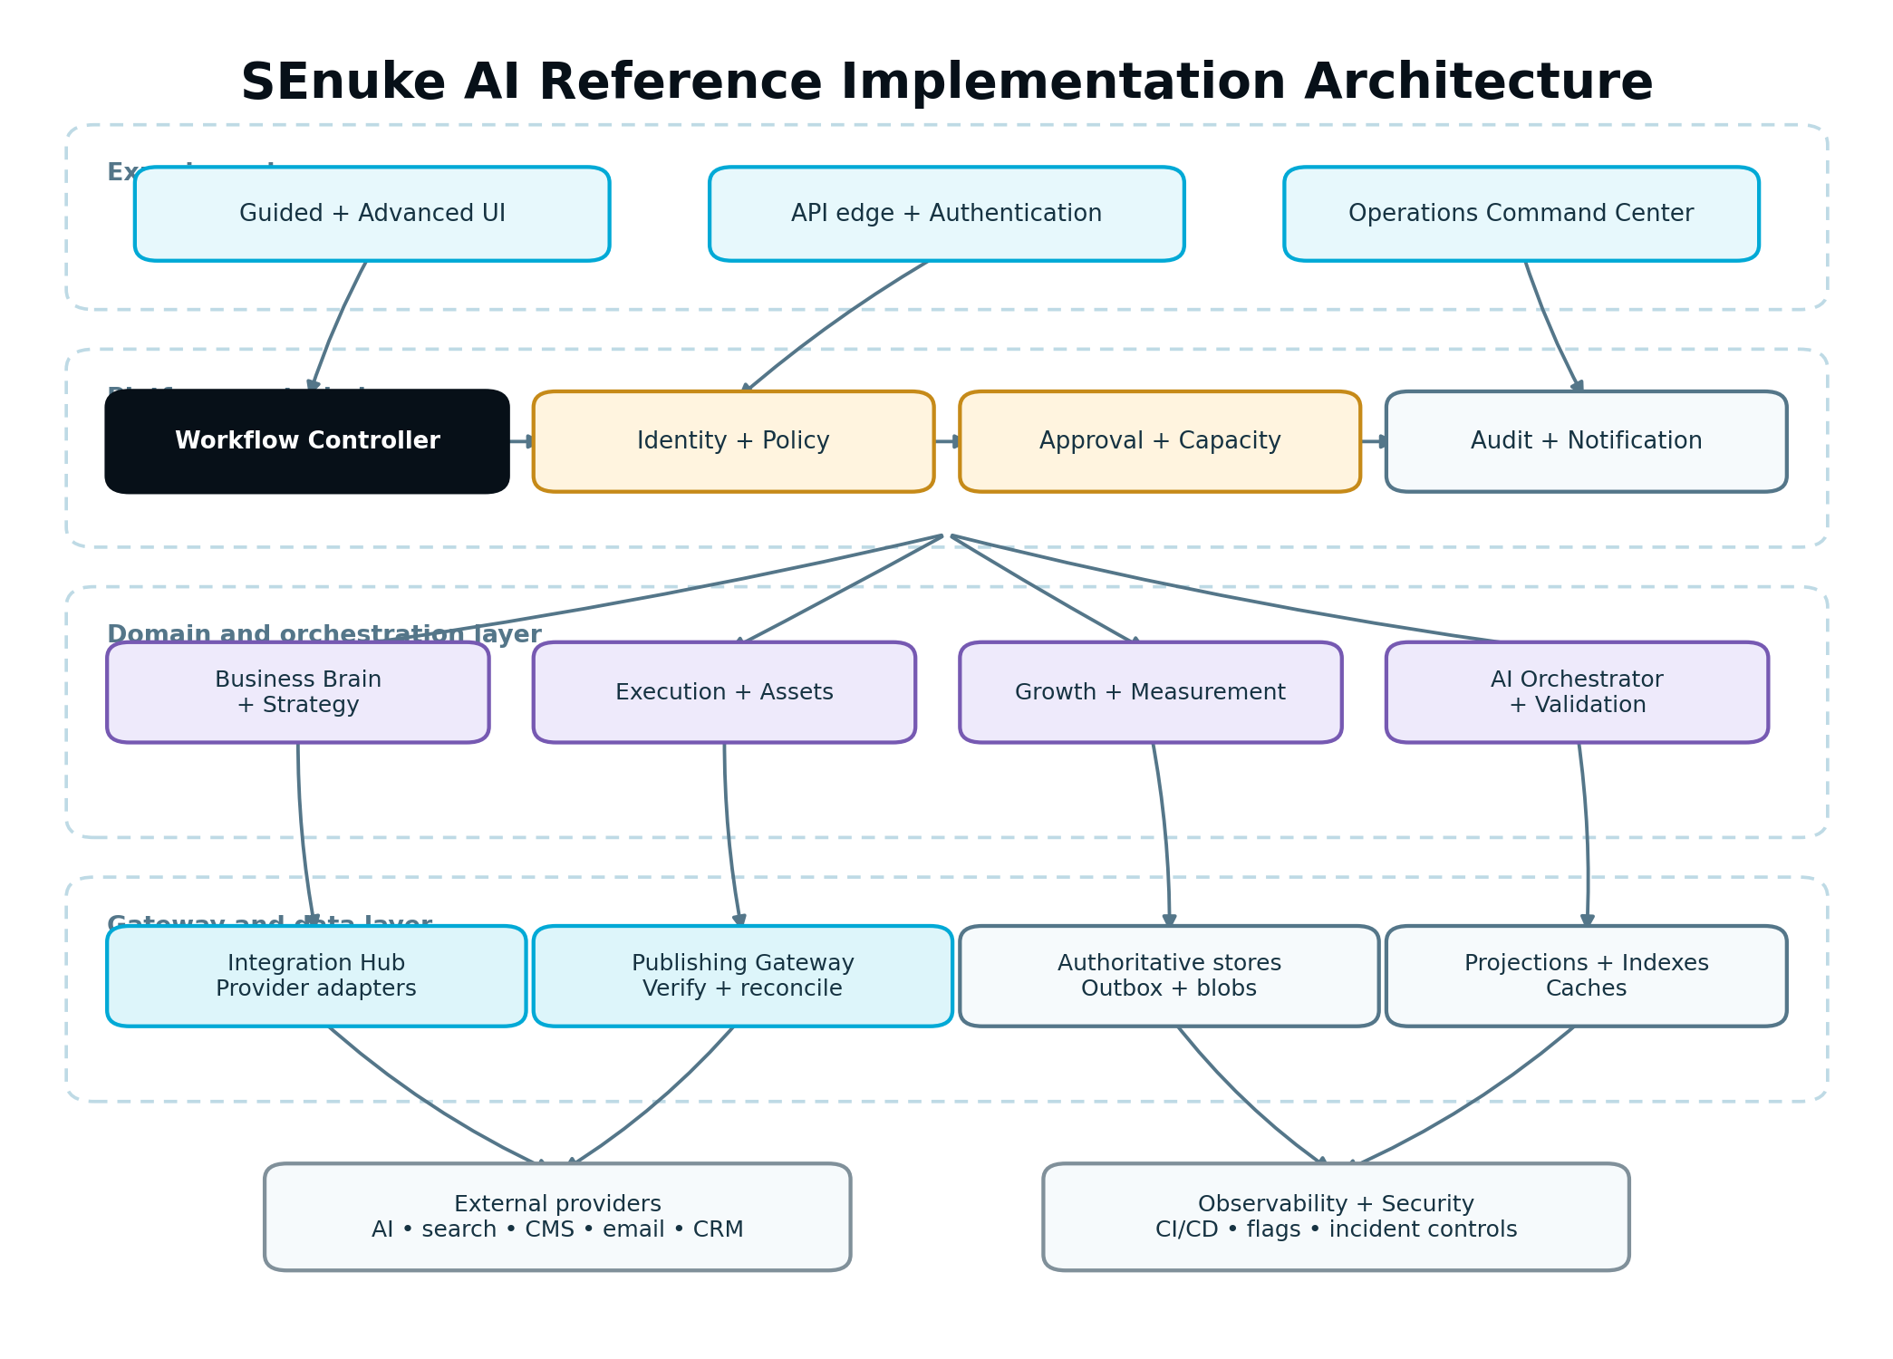
Logical implementation architecture showing user interfaces, platform control plane, domain engines, gateways, data services and operational services.
Figure 1. Reference implementation architecture and dependency direction.

5.1 Logical layers
Layer | Responsibilities | Must not do
Experience | Guided/Advanced UI, API edge, accessible state presentation, local interaction state | Invent authority, trust browser scope, call providers directly
Control plane | Workflow Controller, authorization, entitlement, Capacity, approvals, feature policy | Generate unbounded content or contain provider-specific transport logic
Domain engines | Business Brain, Strategy, Execution, Growth Intelligence, assets and measurement | Bypass control-plane gates or write another domain’s authoritative state
Orchestration | Durable jobs, AI Orchestrator, validation pipelines, sagas/reconciliation | Become an untyped “god service” or hide business state in queue payloads
Gateways | Publishing Gateway, Integration Hub, model/search adapters, webhooks | Own product strategy, approval or customer-facing semantic definitions
Data plane | Authoritative stores, object storage, event/outbox records, projections, indexes | Allow unscoped access or silently merge incompatible versions
Operations | telemetry, audit, notification, support tooling, incident controls | Expose secrets or permit unaudited production mutation

5.2 Recommended code organization
Use boundaries that are visible in the repository even when deployed together:
platform/
identity-access/ workspace, client, role and policy enforcement
workflow/ state machine, gates, Next Best Action routing
approvals/ approval policy and immutable decisions
capacity/ estimates, reservations and settlement
ai-orchestrator/ routing, model adapters and AI task records
integrations/ connection registry and provider adapters
publishing/ protected external-action lifecycle
audit-notifications/ immutable audit and user/operator messages
domains/
business-brain/
strategy/
execution/
growth-intelligence/
measurement/
assets/
shared/
contracts/ versioned schemas only
observability/ correlation and telemetry helpers
testing/ fixtures, simulators and contract harnesses
Shared packages may contain primitives and contracts. They must not become a dumping ground for domain behavior. A utility that understands Strategy approval belongs to the Strategy or approval boundary, not shared.

5.3 Dependency direction
Domain code depends on declared interfaces, not concrete provider SDKs. Infrastructure supplies implementations through composition. UI depends on API/view contracts, not persistence models. Provider webhook schemas terminate at adapter boundaries and are translated before entering the domain.

5.4 Modular monolith versus services
Begin with the current production shape. Extract a service only when independent scaling, failure isolation, security boundary, release ownership or provider workload materially requires it. Network boundaries add latency, failure modes and operational cost; they are not an architectural maturity score.

5.5 Anti-corruption boundary
Each external provider has an anti-corruption layer that maps provider terms to canonical SEnuke AI contracts. Provider IDs and raw payload references may be retained for reconciliation. Provider-specific states must not leak into core workflows as the only meaning.

6. Canonical Execution Context
Every protected request, command, job and domain event carries or can resolve a canonical ExecutionContext.
{
"context_version": "1.0",
"request_id": "req_...",
"correlation_id": "corr_...",
"causation_id": "cmd_or_event_...",
"actor": {
"actor_type": "USER|SYSTEM|OPERATOR|PROVIDER",
"actor_id": "usr_...",
"delegated_by": null,
"role_snapshot": ["OWNER"]
},
"scope": {
"workspace_id": "ws_...",
"client_id": "cl_...",
"project_id": "prj_..."
},
"authority": {
"workflow_run_id": "wfr_...",
"strategy_version_id": "strv_...",
"execution_plan_version_id": "epv_...",
"approval_policy_version": "apv_..."
},
"policy": {
"entitlement_snapshot_id": "ents_...",
"consent_policy_version": "cpv_...",
"feature_snapshot_id": "ffs_..."
},
"locale": "en-CA",
"created_at": "2026-08-02T16:00:00Z"
}

6.1 Trust rules
- The API edge derives actor identity from the authenticated session or service credential.
- Scope IDs supplied by a client are inputs to authorization, never proof of access.
- Workers reconstruct authorization-relevant context from signed/internal records; they do not trust arbitrary queue fields.
- Provider callbacks resolve scope through the registered connection and external-resource mapping, not a user-editable callback field.
- A role or entitlement snapshot records why work was admitted. Protected action revalidation still occurs immediately before the effect.

6.2 Context propagation
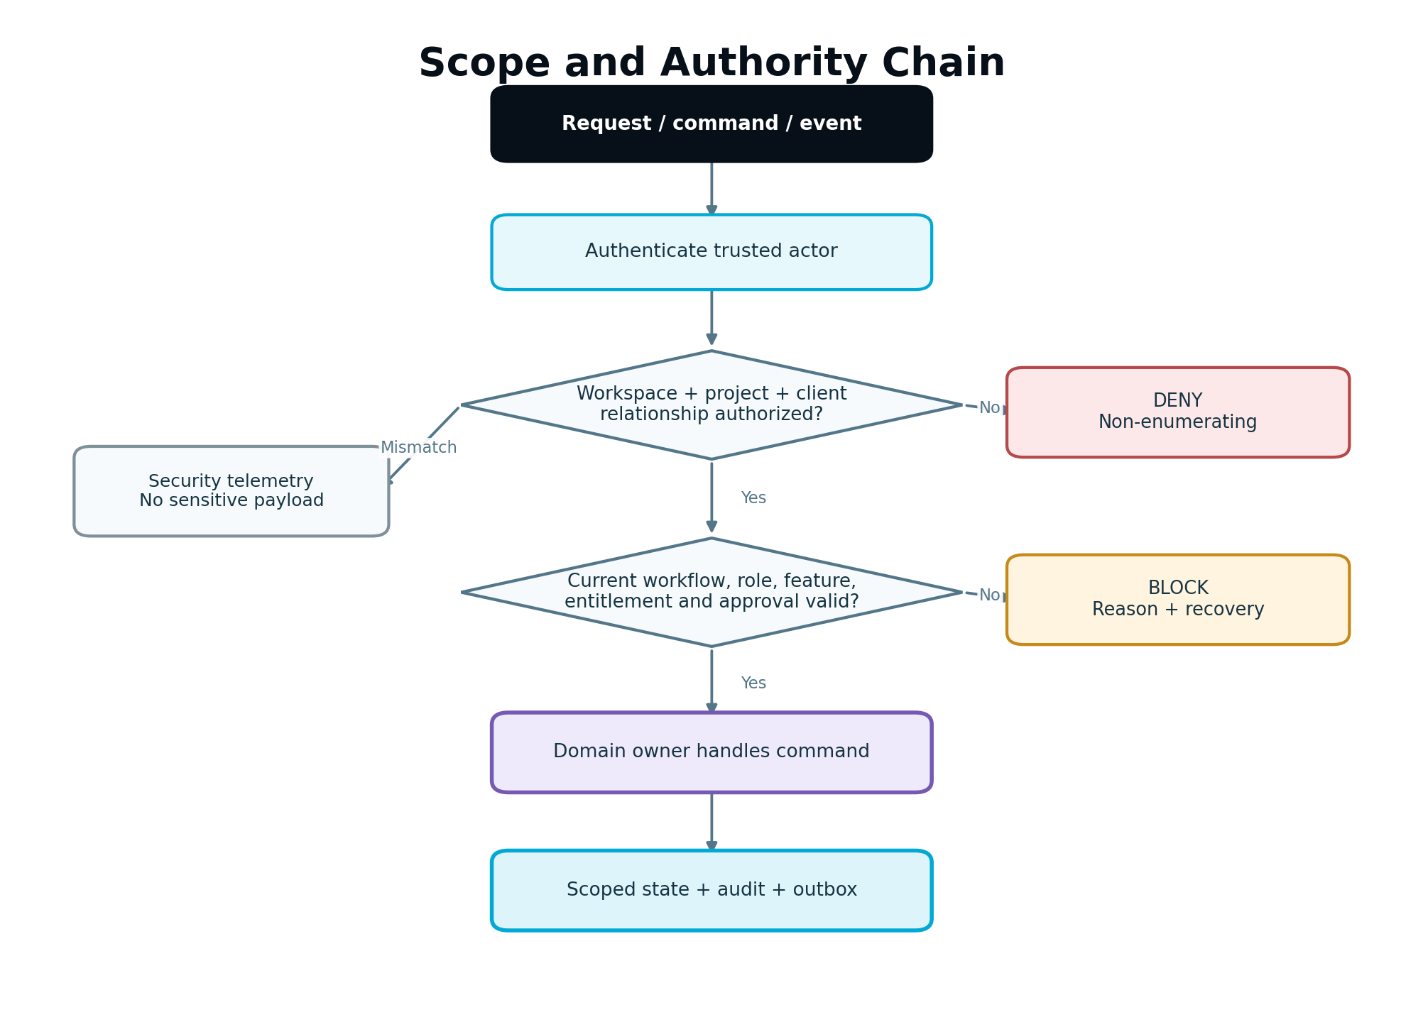
Request and job context flowing from authentication through scope authorization, workflow authority, domain handling and persistence.
Figure 2. Scope and authority must be revalidated at every trust boundary.

6.3 Correlation and causation
correlation_id groups the end-to-end customer workflow. causation_id identifies the command/event that caused the current action. request_id identifies one transport attempt. Retries get a new request ID but retain the business idempotency key and correlation chain.

6.4 Context minimization
Do not copy full user, client or Business Brain objects into every event. Carry stable IDs and immutable snapshot/version IDs. Fetch only the fields required for the bounded task. This reduces sensitive-data spread and stale context.

7. Module Boundaries and Dependency Rules

7.1 Required dependency rules
- Execution modules call the AI Orchestrator; they never call model providers directly.
- Domain modules request Capacity decisions from the Capacity Engine; they never infer limits from plan names.
- Domain modules request external actions through the Publishing Gateway or Integration Hub; they never store provider credentials.
- Growth Intelligence creates governed recommendations and Blueprint patches; it never publishes or activates a protected change directly.
- Provider adapters translate capability and transport behavior; they do not decide growth strategy.
- Approval checks resolve through the Approval service; a boolean column copied to an asset is not sufficient authority.
- Workflow state changes occur through the Workflow Controller transition contract.
- Measurement calculations use versioned Metric Definitions and snapshots; UI code does not reproduce business formulas independently.
- Audit events are emitted from authoritative transitions; controllers do not fabricate audit history after the fact.
- Read models may lag but cannot be used as write authority.

7.2 Static enforcement
Where supported, enforce boundaries with package visibility, dependency linting, import rules and CI architecture tests. At minimum, CI must fail when:
- a domain imports a provider SDK outside an adapter package;
- frontend code imports server persistence models;
- a module writes another module’s tables directly without an approved shared transaction contract;
- a model-provider credential appears outside secrets/infrastructure configuration;
- a protected external call is introduced outside an approved gateway.

7.3 Cross-domain interaction
Use a synchronous query when the caller requires an immediate authoritative answer, such as authorization or current approval validity. Use a durable command/event when work is long-running, retryable or crosses an external side-effect boundary. Avoid synchronous chains across many modules; they turn one provider slowdown into platform-wide failure.

8. Workspace, Project and Client Isolation
Workspace-first ownership is permanent. Subscriptions, seats, AI Capacity, projects, clients, permissions, integrations and billing belong to the workspace. In Agency workspaces, a project requires a client and client isolation is enforced inside the workspace.

8.1 Scope model
Record class | Required scope
Workspace setting, subscription, seat, capacity pool | workspace_id
Agency client | workspace_id, client_id
Project domain record | workspace_id, project_id; Agency also client_id
Connection | workspace_id; optional permitted client/project bindings
Asset, execution, measurement, experiment, report | workspace_id, project_id; Agency also client_id
Audit event | Workspace plus every applicable subordinate scope and actor

8.2 Isolation enforcement
- All scoped tables use non-null scope columns where the record class requires them.
- Unique keys include the relevant scope.
- Repository methods require a typed scope object; unscoped findById(id) is prohibited for tenant data.
- Joins include workspace and client/project constraints, not only record ID.
- Object-storage keys and search-index documents include scope boundaries.
- Background jobs and caches include scope in keys.
- Operations tools require explicit workspace/client selection and log the operator reason.
- Cross-client aggregation is allowed only for an authorized Agency-level view with privacy-safe output; it never exposes one client’s raw records to another.
loadAsset(scope, assetId):
SELECT * FROM asset
WHERE id = :assetId
AND workspace_id = :scope.workspaceId
AND project_id = :scope.projectId
AND (:scope.clientId IS NULL OR client_id = :scope.clientId)

8.3 Scope mismatch behavior
Return a non-enumerating access denial. Do not disclose whether the target exists in another workspace/client. Record a security telemetry event with the trusted actor and requested scope, excluding sensitive payload content.

8.4 Client Viewer
Client Viewer is read-only, client-scoped and has no AI allowance by default. The API—not just the UI—must prevent AI initiation, mutation, cross-client reads and protected actions. Report/download access must use the same client boundary.

9. Configuration, Environments and Secrets

9.1 Configuration classes
Class | Example | Storage and change rule
Build-time | runtime target, asset bundle version | Reproducible build metadata
Environment | database endpoint, queue namespace | Environment configuration; no source-code secret
Secret | API key, OAuth client secret, signing key | Approved secrets manager; encrypted and access logged
Product policy | retry policy, confidence threshold, retention policy | Versioned configuration with owner and audit
Workspace configuration | brand rules, connection selection, approval policy | Scoped persistence with permissions and versions
Feature control | rollout flag, kill switch | Central flag service/config with evaluation snapshot

9.2 Environment parity
Development, test, staging and production should run the same artifact and contract versions. Differences are configuration, scale and credentials. Staging must support realistic queues, workers, webhooks and provider simulators; a frontend-only staging environment is insufficient.

9.3 Secret handling
- Never store secrets in source, prompt content, audit payloads, error messages, support exports or analytics.
- Encrypt provider tokens at rest using managed keys and decrypt only inside the authorized adapter execution path.
- Store token scopes, expiry and rotation metadata separately from encrypted material.
- Redact secrets before structured logging at a shared logging boundary.
- Rotate signing and encryption keys with dual-key/read compatibility.
- Revoke a connection immediately when compromise is suspected; queued protected actions revalidate connection status before execution.

9.4 Configuration validation
Each process validates required configuration at startup and fails clearly before accepting traffic. Optional capability absence produces a declared unavailable capability, not a runtime null failure.

10. API and Contract Standards

10.1 Contract-first rule
Define the request, response, error, authorization, idempotency and event behavior before implementing an endpoint. Generate or validate client types from the contract when practical. Persistence models are not public contracts.
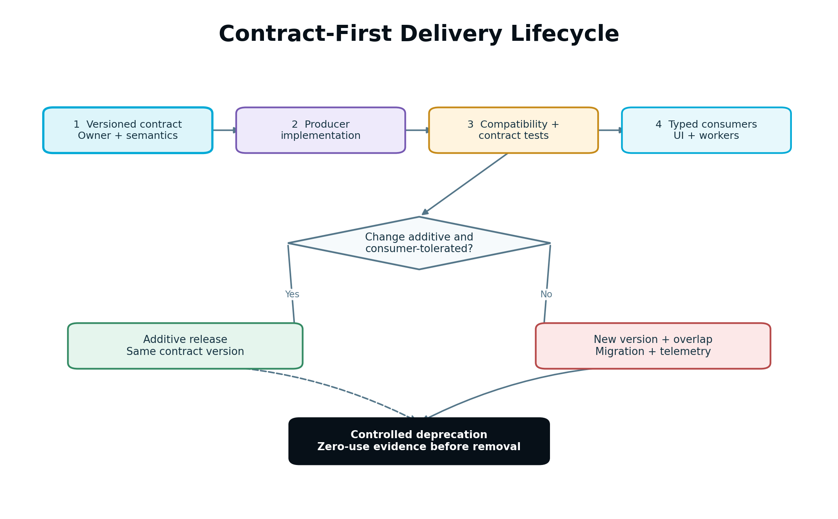
Contract-first flow from schema through implementation, automated compatibility tests, consumers and controlled deprecation.
Figure 3. Contract-first delivery prevents UI, workers and integrations from drifting apart.

10.2 API conventions
- Use resource-oriented queries and explicit commands for consequential transitions.
- Commands return an authoritative accepted/result resource, not an ambiguous boolean.
- Use stable opaque identifiers.
- Use UTC timestamps in ISO 8601 and store original event time separately when applicable.
- Use cursor pagination for large or changing collections.
- Define filtering, sorting and default scope explicitly.
- Return 409 or equivalent for version/conflict failures; do not overwrite silently.
- Return 422 or equivalent for validly parsed commands that fail domain preconditions.
- Use a request id and correlation id in response metadata.
- Never expose raw provider errors as the customer contract.

10.3 Command contract
{
"command_id": "cmd_...",
"command_type": "PublishApprovedAsset",
"contract_version": "1.0",
"scope": {"workspace_id": "ws_...", "client_id": "cl_...", "project_id": "prj_..."},
"target": {"asset_version_id": "asv_...", "connection_id": "con_..."},
"expected": {"asset_revision": 12, "approval_id": "apr_..."},
"idempotency_key": "ws_...:publish:asv_...:destination_...",
"requested_by": "usr_..."
}
The server derives trusted actor data and revalidates all referenced authority. Client-provided requested_by, roles or approvals are never trusted.

10.4 Error envelope
{
"error": {
"code": "APPROVAL_STALE",
"category": "PRECONDITION",
"message": "This version changed after approval and must be reviewed again.",
"retryable": false,
"recovery_action": "REQUEST_REAPPROVAL",
"details": {"approved_version": 11, "current_version": 12},
"request_id": "req_...",
"correlation_id": "corr_..."
}
}
Customer messages are plain-language and safe. Internal diagnostic context is correlated in telemetry, not leaked in the response.

10.5 Versioning and deprecation
Add optional fields and new enum values only when consumers are designed to tolerate them. A consumer must preserve unknown fields when acting as a pass-through if required by contract. Breaking changes create a new contract version with:
- owner;
- migration guide;
- supported overlap period;
- consumer inventory;
- telemetry showing remaining old-version use;
- removal gate and rollback plan.

10.6 Validation order
Authenticate → resolve trusted scope → authorize → validate feature/entitlement → parse schema → validate domain state/version → estimate/reserve Capacity if required → accept command. Expensive work and external calls occur only after these gates.

11. Commands, Events, Queues and Scheduled Work

11.1 Command versus event
A command requests one owner to do something and may be rejected. An event states an immutable fact that already happened. Do not name intentions as completed facts. PublishAssetRequested is not AssetPublished.

11.2 Canonical event envelope
{
"event_id": "evt_...",
"event_type": "ExternalPublicationVerified",
"event_version": "1.0",
"occurred_at": "2026-08-02T16:22:12Z",
"recorded_at": "2026-08-02T16:22:14Z",
"scope": {"workspace_id": "ws_...", "client_id": "cl_...", "project_id": "prj_..."},
"correlation_id": "corr_...",
"causation_id": "cmd_...",
"producer": "publishing-gateway",
"subject": {"type": "publication", "id": "pub_...", "version": 3},
"data": {"asset_version_id": "asv_...", "verification_state": "VERIFIED"}
}

11.3 Event rules
- Events are immutable and schema-versioned.
- Consumers validate scope and schema before processing.
- Consumers record processed event_id or a deterministic effect key.
- Event payloads contain the minimum necessary data and version references.
- Sensitive data is represented by protected references, not copied broadly.
- Ordering is guaranteed only where explicitly partitioned; consumers tolerate out-of-order delivery.
- Unknown non-breaking fields are ignored safely.
- Incompatible versions are quarantined and alerted, not silently discarded.

11.4 Durable job record
Every long-running unit has an authoritative job record separate from a queue message:
Field | Purpose
job_id, job_type, version | Stable identity and handler contract
scope/context references | Isolation and traceability
subject/version | Exact work target
idempotency/effect key | Duplicate protection
state and attempt count | Lifecycle visibility
lease owner/expiry | Crash-safe worker claim
scheduled/started/completed time | Operational measurement
policy snapshot | Retry, feature and routing behavior used
last failure code | Actionable recovery
checkpoint | Resumable multi-stage work
The queue is delivery infrastructure. Deleting a message does not delete business state.

11.5 Scheduler behavior
Schedules store time zone, intended local time, UTC next-run time, recurrence rule, misfire policy and version. Daylight-saving transitions must be tested. A scheduler emits idempotent commands; it does not perform the domain action itself.

11.6 Dead-letter policy
Dead letters retain original event/command reference, failure class, attempts and correlation. Replay requires authorization, compatibility validation and a new replay audit record. Replay uses the same idempotency key unless the operator explicitly initiates a distinct business action.

12. Persistence, Transactions and Data Integrity

12.1 Authoritative store principles
- Stable IDs are generated once and never reused.
- Every mutable authoritative row has a revision/version for optimistic concurrency.
- State transitions are constrained in code and, where practical, by database constraints.
- Created/updated timestamps are server-generated; business event time is stored separately.
- Soft deletion is not a substitute for retention/deletion policy.
- JSON fields require a schema version and validation; they are not permission to avoid modeling core relationships.
- Monetary, capacity and metric values use explicit units and safe numeric types.

12.2 Transactional outbox
When a state change must emit an event, write the domain change and outbox record in the same transaction. A dispatcher publishes the outbox record and marks dispatch state idempotently.
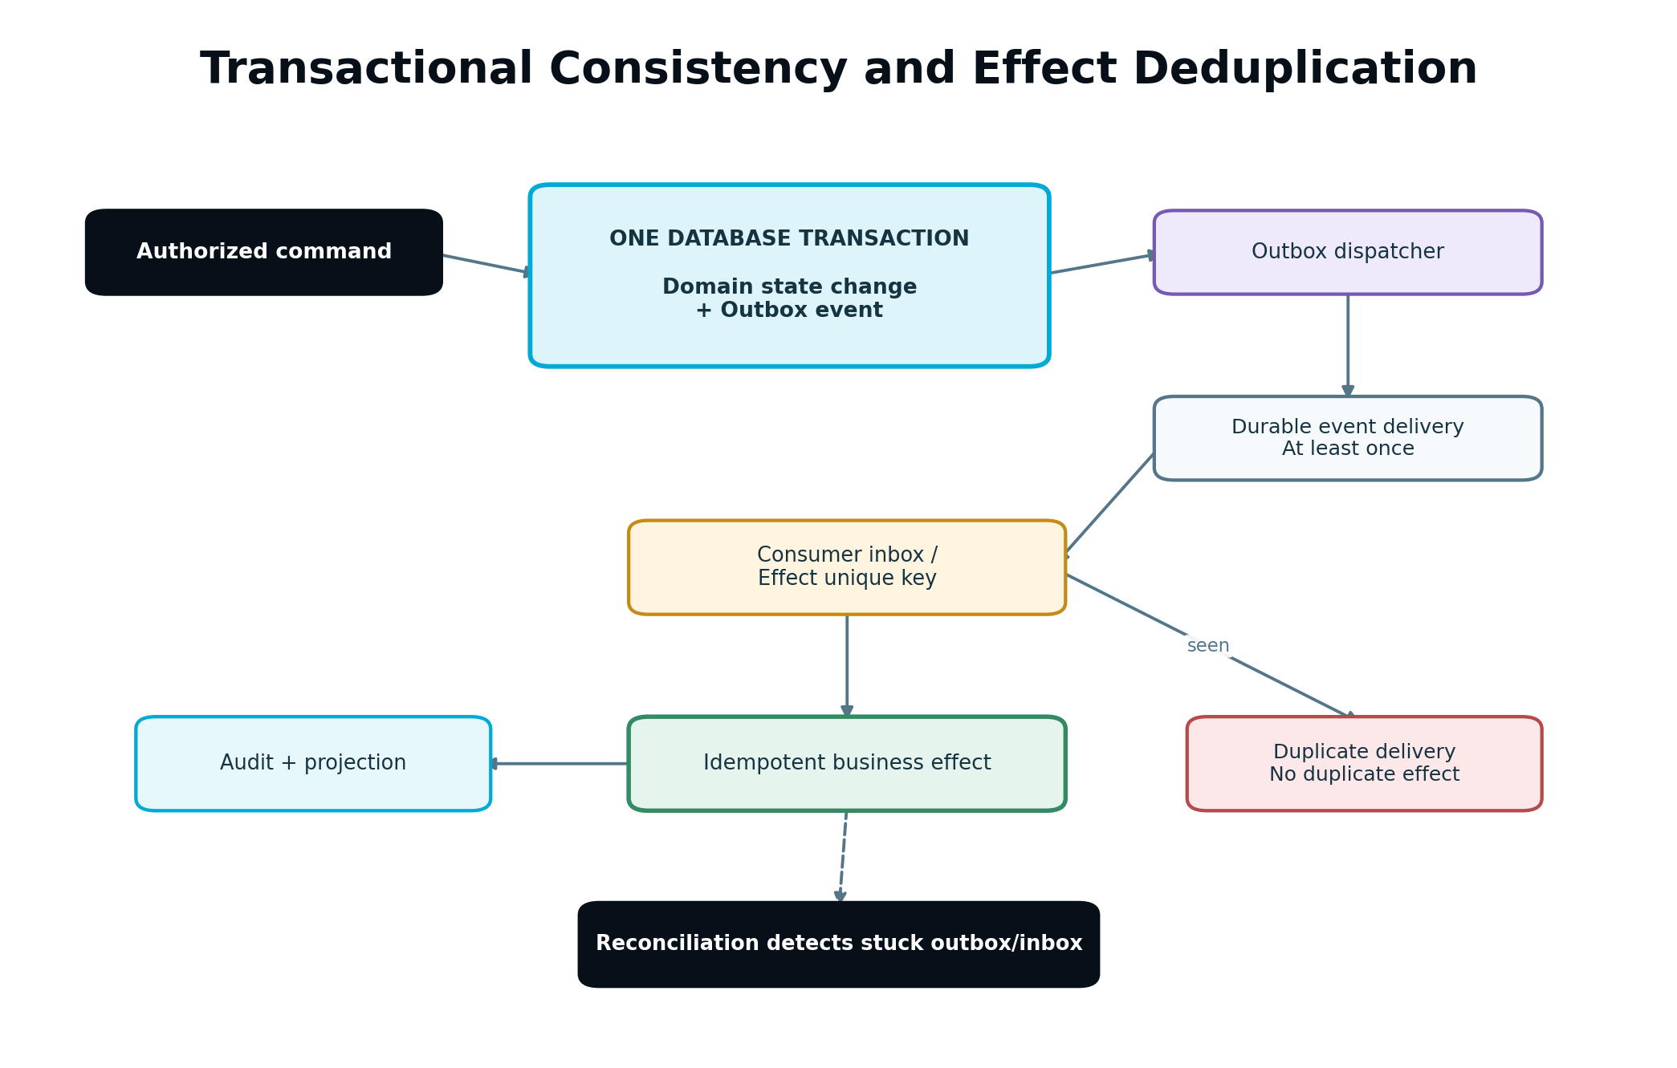
Transactional outbox pattern showing domain transaction, outbox dispatcher, durable event delivery, consumer inbox and idempotent business effect.
Figure 4. Database truth and event delivery remain consistent under crashes and retries.
BEGIN
assert current revision and allowed transition
update domain_record set state = :newState, revision = revision + 1
insert into outbox(event_id, aggregate_id, event_type, payload, state='PENDING')
COMMIT

12.3 Optimistic concurrency
User and worker updates include the expected revision. A mismatch returns a structured conflict with current version metadata. Automatic rebase is permitted only for demonstrably non-conflicting fields or typed Blueprint patches. Material content, approval, Strategy or experiment conflicts require explicit resolution.

12.4 Deletion and retention
Retention classes are defined by data type, purpose, consent and legal/business policy. Deletion workflows enumerate primary records, derived projections, object storage, indexes, caches, AI context stores and provider-side data where supported. Audit may retain a minimal non-sensitive proof of deletion without retaining deleted content.

12.5 Backups are not queryable production data
Backups are encrypted, access-restricted, retention-bound and restoration-tested. Subject deletion from active systems is tracked separately from backup expiry. Restored backups must replay deletion/tombstone journals before returning to service.

12.6 Data integrity checks
Scheduled checks detect orphan scope references, invalid state transitions, duplicate effect keys, unresolved outbox records, stale Capacity reservations, projection divergence, missing asset blobs, measurement watermark gaps and records referencing retired contract versions.

13. Workflow Controller Implementation
The Workflow Controller is the authoritative coordinator for the customer journey. It resolves what stage a project is in, which gates are satisfied, what work may begin and which single Next Best Action should be shown. It does not absorb the internal business logic of every domain.

13.1 Workflow definition
Represent the workflow as versioned states, gates and transitions rather than scattered controller conditions. A definition contains:
- workflow type and definition version;
- applicable workspace/project type;
- state identifiers and customer-facing labels;
- required gate evaluators;
- permitted transitions;
- transition command and owning component;
- side effects emitted after commit;
- blocking and warning reason codes;
- recovery action;
- Next Best Action presentation rule.

13.2 Workflow run
Each project has one current authoritative workflow run for the applicable lifecycle. Historical runs remain immutable or superseded. The run stores current state, definition version, current authority references, transition revision, blocker summary and last reconciled time.

13.3 Gate evaluator contract
evaluateGate(context, gateId, subjectVersion) -> {
status: SATISFIED | BLOCKED | WARNING | NOT_APPLICABLE,
reasons: [{code, messageKey, evidenceRefs, recoveryAction}],
evaluatedAt,
policyVersion,
dependencyVersions
}
Gate evaluators are deterministic, side-effect free and independently testable. Expensive evidence may be prepared asynchronously, but the evaluator consumes a versioned result.

13.4 Transition algorithm
- Load workflow run by trusted scope.
- Compare expected workflow revision.
- Resolve the current definition version.
- Re-evaluate mandatory gates against current dependencies.
- Authorize actor and feature/entitlement state.
- Apply the permitted transition atomically.
- Write transition history and outbox events.
- Recalculate the current Next Best Action projection.
- Notify only if the resulting state requires user attention.

13.5 Next Best Action integration
Parts 2 and 4 produce ranked candidates. The Workflow Controller applies workflow precedence: mandatory blockers, required approvals, safety/recovery actions and already-running work are considered before new opportunity work. The UI receives one primary action plus explanatory background state. A module cannot overwrite the primary action directly.

13.6 Reconciliation
Reconciliation compares workflow state with Strategy approval, Execution Plan, active tasks, publications, Measurement Plans, Blueprint state and entitlements. It repairs derived projections and raises incidents for authoritative contradictions. It never fabricates a missing approval or verified publication.
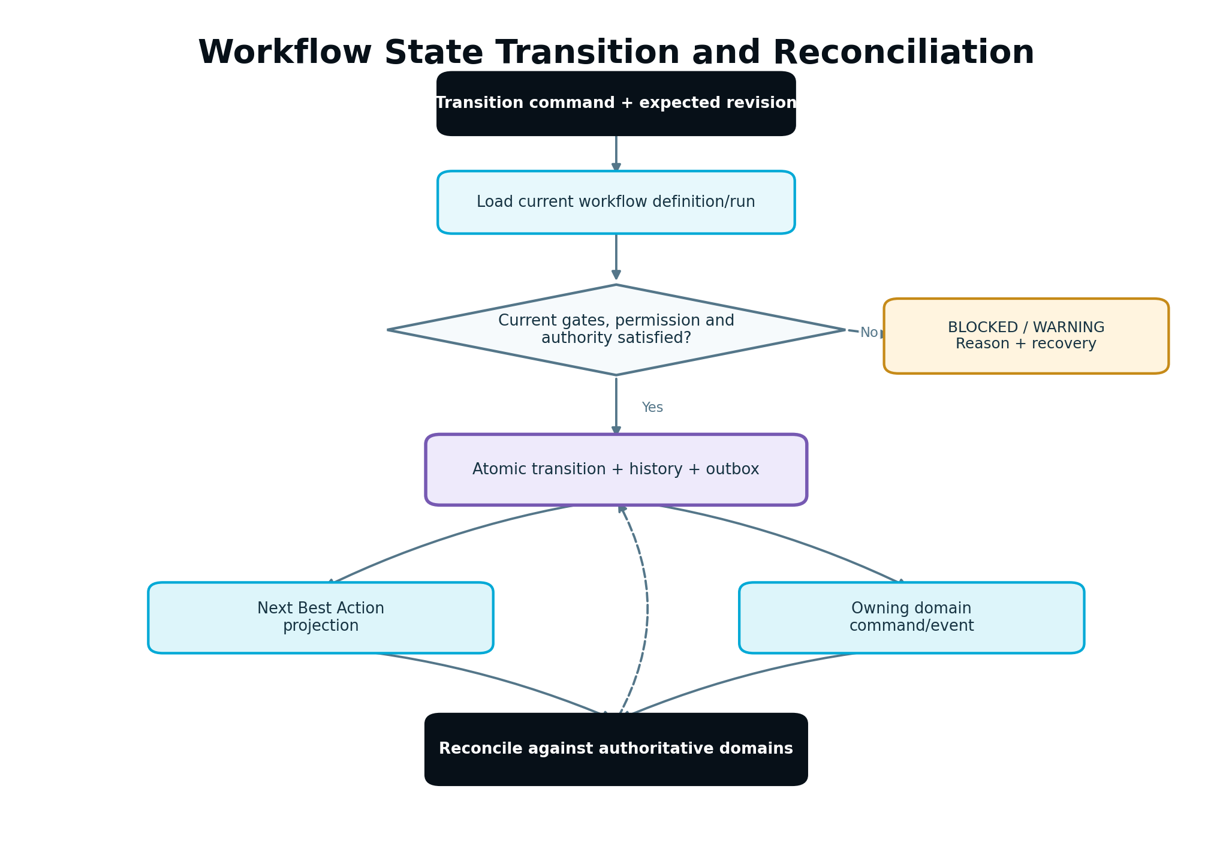
Durable workflow transition path showing command validation, gate evaluation, optimistic state change, events, projection and reconciliation.
Figure 5. Workflow state advances only through current authority and deterministic gates.

14. Business Brain, Evidence and Context Assembly

14.1 Business Brain as central intelligence context
The Business Brain stores versioned facts, preferences, objectives, audiences, offers, brand voice, constraints and approved business understanding. It is not an unstructured chat transcript. Each material field carries provenance, confidence/status, last-verified time and sensitivity class where applicable.

14.2 Fact classes
Class | Example | Update behavior
User-declared | target geography, primary service | New version; may require confirmation if changed materially
Verified integration | website platform, analytics connection | Source snapshot and freshness
Derived | likely audience concern, entity relationship | Inference label, evidence references and confidence
Approved decision | positioning, objective, offer priority | Protected version tied to Strategy/approval
Operational | publishing capability, data readiness | Continuously refreshed state, not permanent business truth

14.3 Evidence Registry
Evidence records include source type, source reference, observed time, ingested time, scope, subject/version, freshness state, applicability, reliability/quality signals and content hash. Raw provider payloads may be retained in protected storage when necessary; customer-facing decisions reference normalized evidence.

14.4 Context Bundle assembly
AI and deterministic engines request a named Context Bundle profile, not “all project data.” The assembler:
- validates task scope and allowed data classes;
- resolves exact Business Brain, Strategy, plan, asset and evidence versions;
- applies freshness and applicability rules;
- excludes secrets and unauthorized/sensitive data;
- detects untrusted content and labels it as data;
- deduplicates and ranks evidence within a token/size budget;
- records included and excluded evidence IDs with reasons;
- hashes and stores the manifest for reproducibility.

14.5 Staleness and invalidation
Context Bundle manifests are immutable. If a dependency changes, the bundle is stale for new work but remains the historic record of what an earlier decision saw. Dependent unexecuted outputs are invalidated according to materiality rules; executed history is not rewritten.

14.6 Retrieval safety
Website text, CRM notes, documents, search results and provider content are untrusted. Retrieval strips active markup where appropriate, enforces size/type limits, labels origin and prevents retrieved instructions from changing system policy, tool permissions or task scope.

15. AI Orchestrator and Provider Abstraction
The AI Orchestrator is the only gateway for model-provider work. It accepts bounded task contracts, prepares approved context, selects a route, enforces Capacity, validates outputs, manages retries/fallback and records production telemetry.

15.1 AI task request
{
"ai_task_id": "ait_...",
"task_type": "CONTENT_BRIEF_GENERATION",
"task_contract_version": "3.1",
"scope": {"workspace_id": "ws_...", "client_id": "cl_...", "project_id": "prj_..."},
"subject": {"type": "execution_task", "id": "ext_...", "version": 4},
"context_bundle_profile": "content_brief_v3",
"input_schema_version": "2.0",
"output_schema_version": "3.0",
"quality_tier": "STANDARD",
"sensitivity": "BUSINESS_CONFIDENTIAL",
"latency_class": "BACKGROUND",
"idempotency_key": "..."
}

15.2 Routing policy
Routing is policy-driven and versioned. Candidate routes are filtered by:
- provider availability and permitted geography/data handling;
- task capability and structured-output/tool support;
- context/window requirement;
- sensitivity and policy;
- quality tier and plan/feature entitlement;
- historical validated success for the task/schema;
- expected latency and cost;
- fallback compatibility.
The objective minimizes expected total successful-workflow cost:
route_score = expected_price
+ retry_probability * retry_cost
+ validation_failure_probability * repair_cost
+ latency_penalty
+ availability_risk
+ task_sensitivity_penalty
Exact weights are configuration, versioned and tested. Price alone is never the selector.

15.3 Execution pipeline
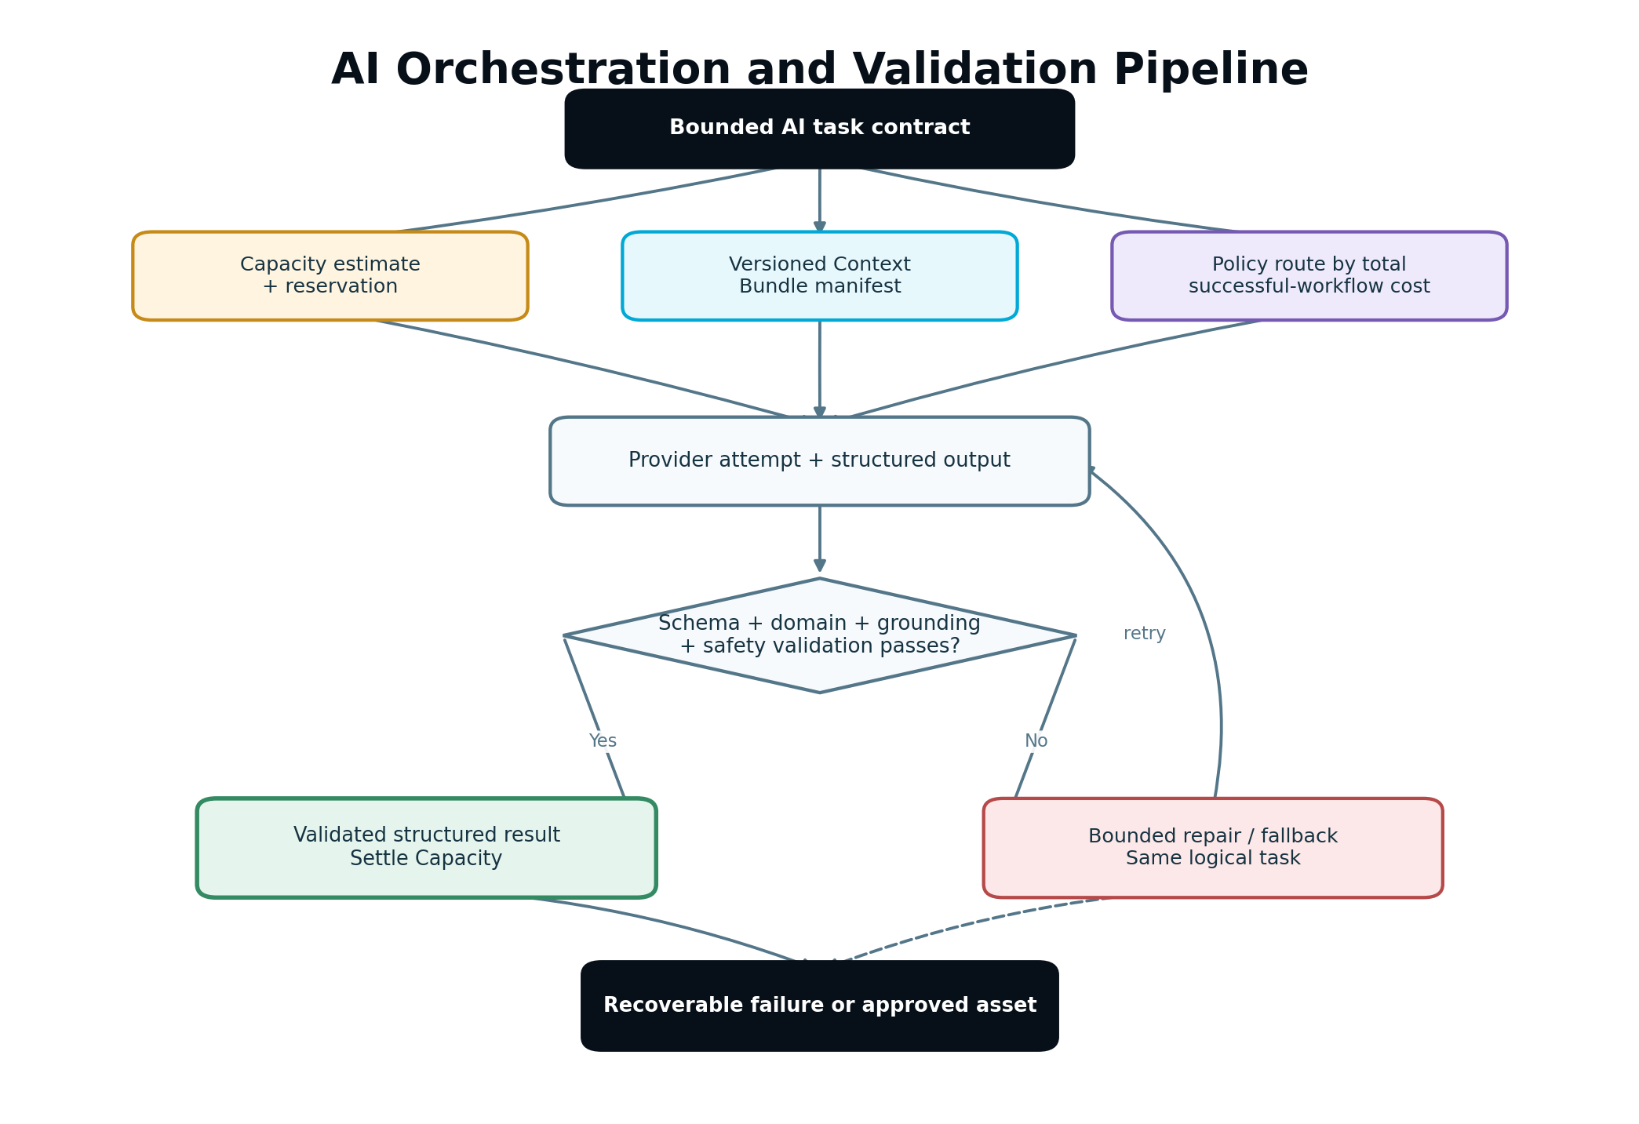
AI task pipeline showing bounded request, Capacity reservation, context assembly, routing, provider call, schema validation, domain validation, repair/fallback and settlement.
Figure 6. AI output becomes usable only after structured and domain validation.

15.4 Attempt records
Every attempt records route policy, provider/model identifier, prompt/template versions, context manifest hash, input/output schema, token/usage measurements, latency, provider request reference, validation findings, retry/fallback reason and cost. Customer audit should not expose hidden chain-of-thought or provider secrets.

15.5 Retry and fallback
- Transport timeout or rate limit may retry using bounded exponential backoff and jitter.
- Invalid structured output may use one constrained repair attempt when safe.
- Factual, policy or domain validation failure is not automatically solved by repeating the same prompt.
- A fallback route must support the same task and output contract.
- Retries and fallbacks share one AI task and Capacity reservation ledger.
- Exhaustion produces a recoverable task failure with preserved partial diagnostics.

15.6 Provider health
Track health by provider, model, task class and region. Use circuit breakers to stop repeated failing routes. A provider’s global health may be healthy while one structured-output task is degraded; routing telemetry must be granular enough to see that.

15.7 No hidden direct calls
CI scans dependencies and egress where possible to detect unauthorized provider SDK use. Provider credentials are available only to adapter/orchestrator runtime identities.

16. Prompt, Tool and Structured Output Management

16.1 Prompt assets are code
System instructions, developer templates, few-shot examples, tool definitions, validators and schemas live in version control or a versioned prompt registry. Each release identifies the exact versions deployed.

16.2 Prompt package
A prompt package includes:
Element | Requirement
Task purpose | One bounded outcome and explicit non-goals
Authority | What records are authoritative and what is untrusted evidence
Input contract | Required/optional fields and size limits
Output schema | Machine-validatable versioned structure
Tool policy | Allowed tools, arguments and call limits
Quality rubric | Task-specific pass/fail checks
Safety rules | Sensitive data, claims, prohibited behavior
Examples | Reviewed edge-aware examples without customer data
Evaluation set | Golden cases and regression thresholds

16.3 Structured output
The orchestrator parses against a strict schema. Unknown fields are handled according to contract policy. Required citations/evidence references are validated against the supplied Context Bundle. Invalid references cannot be displayed as evidence.

16.4 Tool execution
Model tool calls are proposals inside a bounded orchestration task. Deterministic code validates tool name, argument schema, authorization, scope, rate and remaining call budget. A model cannot obtain a new permission by requesting a tool.
Protected tools do not perform live actions inside an unconstrained model loop. The model may prepare an action proposal; approval and the Publishing Gateway perform the effect through a separate command.

16.5 Prompt injection controls
- Separate system policy, trusted structured context and untrusted retrieved text.
- Mark retrieved text with source and data-only boundaries.
- Reject instructions that request secrets, policy changes, new tools or cross-scope data.
- Use allowlisted tools and server-derived scope.
- Validate output against evidence and domain rules.
- Maintain adversarial fixtures from websites, CRM notes and uploaded content.

16.6 Prompt changes and evaluation
Prompt changes require automated regression on representative tasks, edge cases, adversarial inputs and cost/latency. Compare schema validity, factual grounding, Information Gain/originality where applicable, policy compliance, human rubric score and total successful-workflow cost. A higher subjective style score cannot offset a safety or grounding regression.

17. Validation, Approval and Human Control

17.1 Validation layers
Run validation in this order:
- schema and required fields;
- scope, version and referential integrity;
- deterministic domain rules;
- factual/evidence grounding;
- safety, consent, legal/claim and channel rules;
- brand/voice, originality and Information Gain where applicable;
- cross-asset/campaign consistency;
- presentation/accessibility quality.
Validation findings are structured with code, severity, field/location, explanation, evidence and permitted remediation.

17.2 Severity
Severity | Behavior
Blocker | Cannot advance, approve or publish
Error | Must be corrected or explicitly resolved by authorized policy
Warning | May advance with visible context if policy permits
Advisory | Improvement suggestion; never disguised as failure

17.3 Approval record
An approval binds actor, role, approval class, immutable subject/version, scope, policy version, decision, conditions, timestamp and optional expiry. Approving “the page” without its asset version is invalid.

17.4 Approval validity check
Immediately before a protected action, verify:
- approval exists and is for the current exact version;
- actor had the required role at decision time;
- any Agency client sequence is complete;
- approval has not expired or been revoked;
- no material dependent context changed;
- current policy still permits the action;
- target destination and schedule remain inside approved scope.

17.5 Human edit preservation
Store human edits as a new asset version with provenance. Subsequent AI work receives a protected-edit map or diff and may not silently revert those edits. If regeneration conflicts, present a merge or explicit replace decision.

17.6 Pre-authorized automation
Automation policy is scoped by action class, destination, risk, limits, actor, validity period and rollback capability. Material content, audience, offer, Strategy or experiment changes fall outside pre-authorization unless explicitly approved by product policy. Revocation stops unstarted work and revalidates queued work.

18. Assets, Versions and Lineage

18.1 Asset model
Separate logical asset identity from immutable asset versions and external publications:
- Asset: durable logical item and ownership.
- AssetVersion: immutable content/configuration snapshot.
- AssetRelation: source, derivative, dependency and campaign relationship.
- Approval: decision for an exact version.
- Publication: attempt and external-state lifecycle for one version/destination.
- MeasurementPlan: intended outcomes and instrumentation for a verified exposure.

18.2 Content-addressable storage
Store a content hash for blobs and normalized content where practical. Hashes support deduplication, integrity, lineage and conflict checks. They do not replace scope authorization.

18.3 Version creation
A version is created when content, configuration, destination-affecting metadata, instrumentation or another approved material field changes. Cosmetic editor state that cannot affect output may remain outside the immutable version.

18.4 Derivative invalidation
When a source changes, compare the changed semantic regions with derivative dependencies. Mark affected unexecuted derivatives stale; do not invalidate unrelated assets. Published derivatives remain historical and may generate an update recommendation.

18.5 Asset state and version state
Do not overload one status. A logical asset may be active while a new version is DRAFT, an older version is PUBLISHED, and another is SUPERSEDED. API responses make these distinctions explicit.

19. Integration Hub and Provider Adapters

19.1 Connection Registry
The registry owns connection identity, workspace ownership, provider, granted scopes, encrypted credential reference, capability snapshot, health, expiry, allowed bindings and last verification. Domain modules reference connection_id.

19.2 Capability discovery
Capabilities are data, including read/write operations, object types, scheduling, draft support, webhook support, rollback support, field limits and provider-specific constraints. The UI and workflow use the current verified snapshot. A product label does not imply a provider capability.

19.3 Adapter contract
ProviderAdapter {
discoverCapabilities(connection) -> CapabilitySnapshot
validate(command, capabilitySnapshot) -> PreflightResult
execute(command, idempotencyKey) -> ProviderReceipt
verify(receipt, expectedState) -> VerificationResult
compensate(receipt, approvedPolicy) -> CompensationResult
normalizeWebhook(rawRequest) -> NormalizedProviderEvent
refreshConnection(connection) -> ConnectionHealth
}

19.4 Provider payload boundary
Persist raw payloads only when needed for dispute, reconciliation or debugging and subject to retention/privacy policy. Normalize provider status, errors, identifiers and timestamps into canonical records. Core code does not branch on raw provider error strings.

19.5 Webhook security
- Verify signature against the raw request body.
- Enforce timestamp/replay window when supported.
- Resolve connection and workspace from trusted registration.
- Deduplicate provider event ID or canonical payload hash.
- Acknowledge promptly after durable receipt.
- Process asynchronously.
- Quarantine unknown resource mappings.

19.6 Rate limits and fairness
Rate-limit by provider/connection and enforce workspace fairness. Retry-after hints are honored. One large Agency workspace cannot monopolize a provider queue. Backpressure is visible in task state and estimated delay.

19.7 Capability-aware UX
If direct execution is unavailable, provide the approved manual/export workflow and never record it as externally completed until verified evidence is supplied or retrieved. Capability loss after plan creation creates a blocker and alternative—not a silent downgrade.

20. Publishing and Protected External Actions
Publishing, campaign activation, email sends, CRM writes, website deployment, experiment rollout and similar actions use one protected-action lifecycle.

20.1 Required states
PLANNED → PREFLIGHTING → READY → SUBMITTING → PROVIDER_ACCEPTED → VERIFYING → VERIFIED
Terminal/exception states include BLOCKED, FAILED_RETRYABLE, FAILED_FINAL, PARTIALLY_VERIFIED, CONFLICTED, CANCELLED, COMPENSATION_REQUIRED, COMPENSATED and UNKNOWN_EXTERNAL_STATE.

20.2 Preflight
Preflight revalidates current asset/version, approval, role, Strategy/plan authority, entitlement, Capacity where applicable, connection health/capability, destination mapping, schedule, consent/audience rules, remote version/etag and measurement readiness.

20.3 Reliable external-action sequence
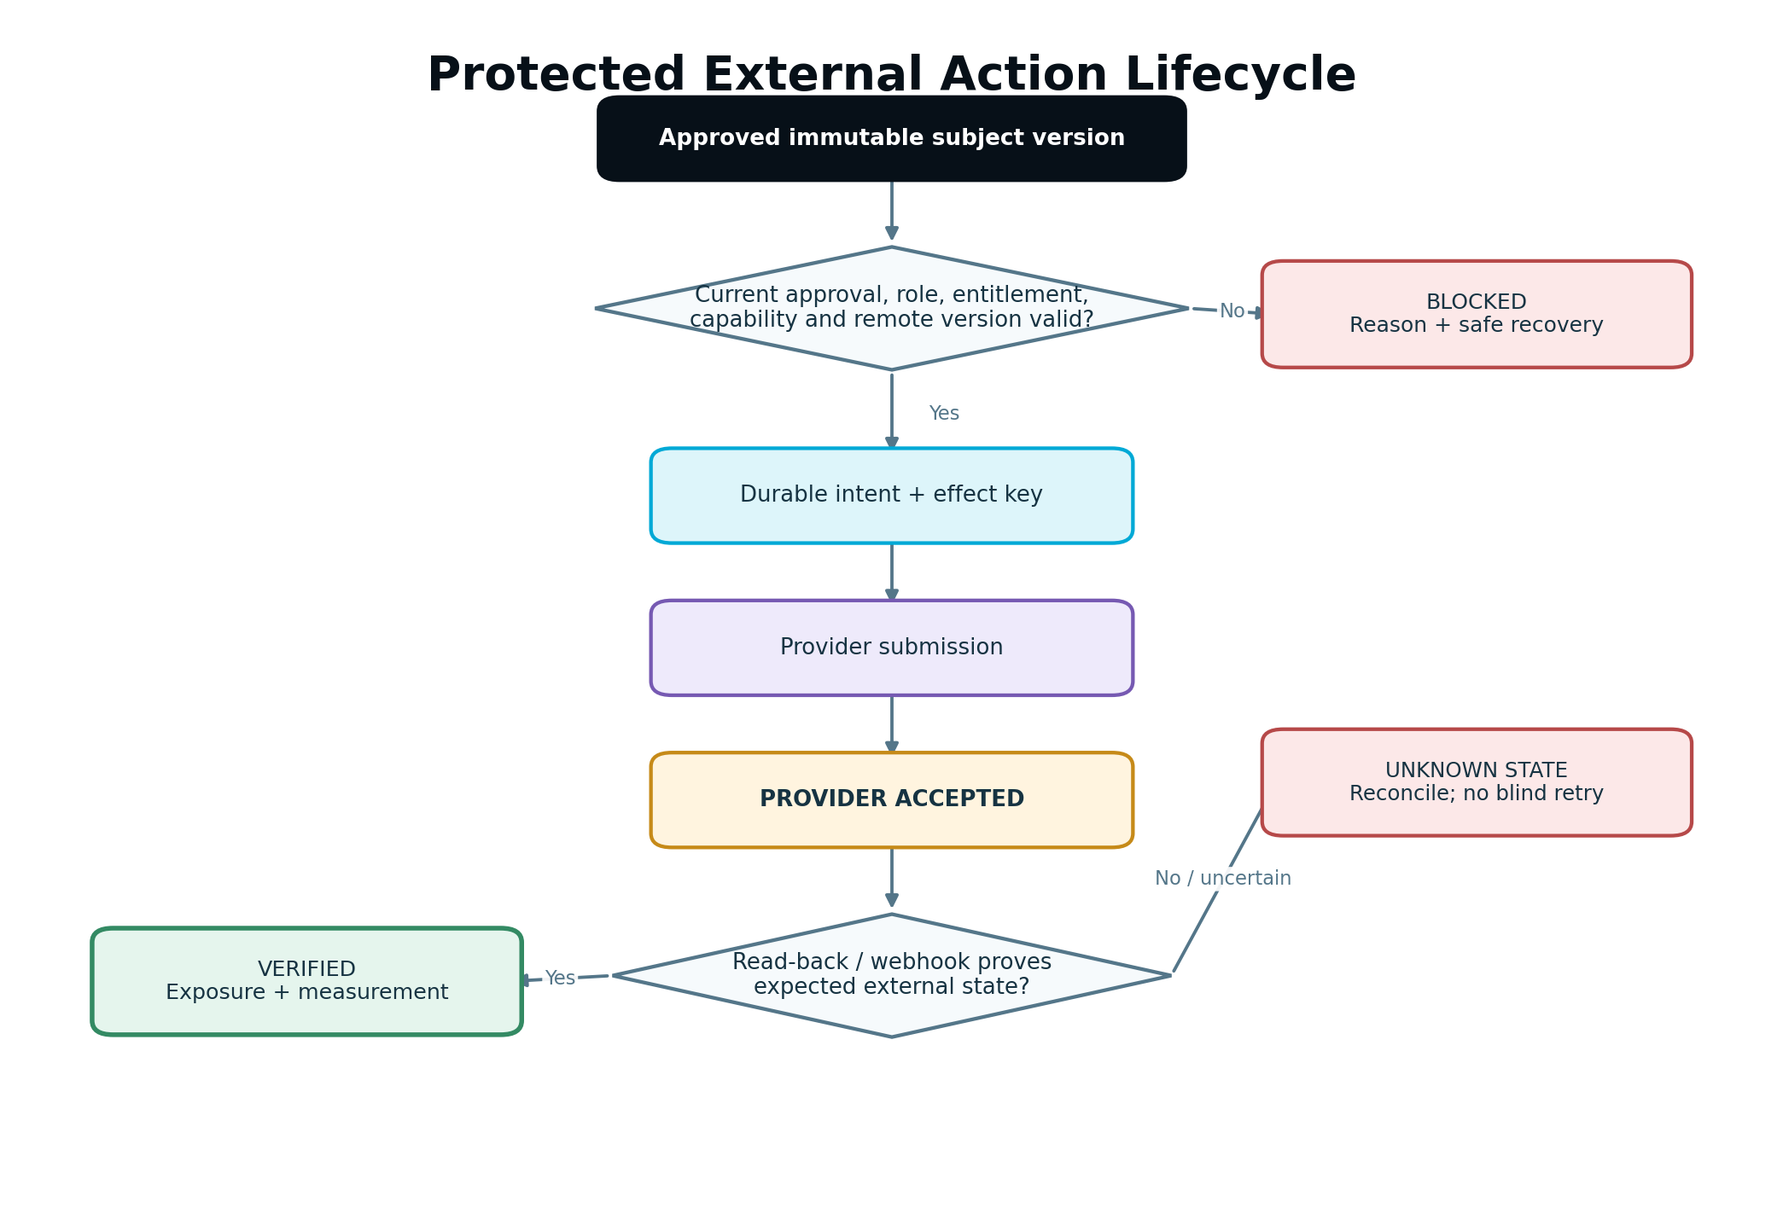
Protected external action sequence showing approved command, preflight, durable intent, provider submission, receipt, verification, audit and measurement activation.
Figure 7. Provider acceptance is an intermediate state; verification establishes external success.
- Create a durable publication/action intent with idempotency key.
- Commit intent before or atomically with queue dispatch.
- Claim with lease and run current preflight.
- Submit using provider idempotency support when available.
- Persist provider receipt before acknowledging job success.
- Verify by read-back, signed webhook or approved evidence.
- Record exact external version, URL/ID and effective time.
- Emit verified exposure for measurement.
- Reconcile until terminal or escalated.

20.4 Unknown external state
If a timeout occurs after submission and the provider lacks idempotency, do not immediately retry. Enter UNKNOWN_EXTERNAL_STATE, query/search by external correlation where possible and request human resolution if ambiguity remains. Duplicate publishing is worse than a visible delay.

20.5 Remote conflicts
Compare stored external version/etag/hash during preflight. If remote content changed outside SEnuke AI, block overwrite and offer diff, import-as-new-version, explicit overwrite (if policy permits) or cancel. Preserve both states.

20.6 Compensation and rollback
Rollback is a new governed action. Store what can be restored, what cannot, external side effects and measurement boundaries. Never claim “rolled back” until external state is verified. When irreversible, provide a compensating action and explicit limitation.

21. Measurement and Growth Feedback Integration

21.1 Execution-to-measurement handoff
Part 3 creates a versioned Measurement Plan before or alongside execution. Verified external exposure activates Part 4 evaluation. The handoff includes:
- workspace/client/project scope;
- objective and intended outcome;
- asset/campaign/experiment version;
- exact exposure time/range;
- Metric Definition versions;
- baseline and evaluation policy;
- required source/capability snapshot;
- consent and identity policy versions;
- guardrails and known limitations.

21.2 Normalized evidence boundary
Provider adapters normalize events; Measurement Ingestion validates schema, scope, consent, event time, deduplication and exposure association. Execution code must not write metric aggregates directly.

21.3 Feedback to workflow
Part 4 emits structured evaluation, diagnosis, opportunity, Learning Record, Blueprint patch and Next Best Action candidate events. The Workflow Controller consumes these through versioned contracts. A report narrative cannot directly update workflow state.

21.4 Revision behavior
Late or corrected data creates a new evaluation/report revision with data watermark and reason. It may supersede a prior conclusion and stale an unexecuted recommendation. It does not mutate historic evidence or erase a previous customer-visible report.

21.5 Consent-aware degradation
When identity or consent restricts evidence, store the restriction and use allowed aggregate/anonymous measurement if valid. Display UNAVAILABLE, LIMITED or INSUFFICIENT, never a numeric zero invented from absence.

22. Entitlements, AI Capacity and Metering

22.1 One authority
The entitlement service/Capacity Engine evaluates workspace subscription, founding price protection where relevant, seats, included allowances, top-ups, auto-replenishment/overage configuration, current reservations and feature policy. Modules do not hard-code plan names or price rules.

22.2 Entitlement snapshot
An admission decision records feature, action, requested quantity, allowed/denied result, reason, workspace subscription/version and policy version. Protected execution rechecks action-relevant entitlement immediately before the effect when state may have changed.

22.3 Capacity lifecycle
ESTIMATED → RESERVED → CONSUMED/SETTLED with RELEASED, EXPIRED and ADJUSTED paths.
- Estimate is informational and may be a range.
- Reservation prevents concurrent overspend.
- Settlement uses measured authoritative usage and the same effect key.
- Failure before billable work releases the reservation.
- Partial billable work settles only according to published policy.
- Retry/fallback belongs to one logical task ledger, not a new customer charge each attempt.

22.4 Capacity dimensions
The Capacity Engine may evaluate AI, crawl, publishing, processing, storage, API and background-task cost. Customer-facing language remains “AI Capacity” for the shared allowance while the internal ledger records units and cost drivers necessary for control.

22.5 Race safety
Reservation uses an atomic ledger transaction or equivalent compare-and-set. Two simultaneous tasks cannot both spend the same remaining allowance. Duplicate settlement cannot double-consume.

22.6 Read-only and billing change
When a workspace becomes read-only or loses entitlement, completed records remain viewable according to policy. New capacity-bearing/protected tasks are blocked. In-flight tasks stop at the next safe boundary; an already-submitted external action continues verification and reconciliation.

23. Notifications, Activity and Audit

23.1 Three different products
- Activity History: customer-readable record of meaningful project/workspace events.
- Notification: attention request delivered in-app and optionally through configured channels.
- Audit Log: immutable security/decision/operation record for traceability.
One event may feed all three, but each has different audience, retention and detail.

23.2 Audit event minimum
{
"audit_id": "aud_...",
"event_type": "APPROVAL_DECIDED",
"scope": {"workspace_id": "ws_...", "client_id": "cl_...", "project_id": "prj_..."},
"actor": {"type": "USER", "id": "usr_...", "role_snapshot": ["OWNER"]},
"subject": {"type": "asset_version", "id": "asv_...", "version": 12},
"decision": {"result": "APPROVED", "policy_version": "apv_3"},
"correlation_id": "corr_...",
"occurred_at": "2026-08-02T17:12:00Z"
}
Do not store credentials, raw sensitive form values, unrestricted session-recording content, hidden model reasoning or full provider payloads in audit.

23.3 Notification policy
Notify for action required, material result, failure needing intervention, connection/security issue or customer-selected milestone. Suppress routine background progress. Deduplicate by event/recipient/channel, respect preferences except mandatory security/billing notices and use digesting for bursts.

23.4 Delivery semantics
Notification delivery is asynchronous and retryable. Failure to send an email does not roll back the underlying domain action. In-app notification state remains authoritative. Provider delivery receipts are recorded separately.

23.5 Operator actions
Every production support action records operator, reason, ticket/incident reference, before/after state, scope, command and result. Direct database edits are prohibited except a formally approved break-glass procedure followed by reconciliation and immutable audit.

24. Error Taxonomy and Resilience

24.1 Canonical error categories
Category | Meaning | Default behavior
Authentication | Actor/session cannot be trusted | Deny; do not retry
Authorization | Actor lacks scope/action permission | Deny and security telemetry
Entitlement/Capacity | Workspace cannot admit requested work | Block with valid upgrade/top-up/recovery path
Validation | Input/schema/domain rule failed | Return field/rule findings; do not retry unchanged
Precondition | Required Strategy, approval, connection, consent or state missing/stale | Block and explain recovery
Conflict | Revision, lock or remote version changed | Reload/resolve; never overwrite silently
Transient dependency | Timeout, rate limit or temporary provider failure | Bounded retry with jitter
Permanent dependency | Unsupported operation, revoked permission, invalid mapping | Stop and require correction
Data quality | Evidence incomplete, invalid, stale or incompatible | Limit/block conclusion; preserve data incident
Safety/privacy | Policy, consent or sensitive-data guard failed | Stop protected path and alert as appropriate
Internal defect | Invariant violated or unhandled condition | Fail safely, trace and page based on impact

24.2 Reason codes
Every actionable failure uses a stable reason code. UI copy is localized separately. Metrics and alerting group by reason code rather than fragile exception text. The error record includes retryability, retry-after, recovery action and whether customer/operator attention is required.

24.3 Retry policy
- Retry only errors classified as transient or explicitly safe.
- Use exponential backoff, jitter, maximum attempts and maximum elapsed time.
- Respect provider Retry-After and quota resets.
- Preserve one logical idempotency/effect key.
- Stop retrying when authorization, approval, entitlement, connection or feature state changes.
- Move exhausted work to a visible terminal/recovery state and dead-letter record.

24.4 Circuit breakers and bulkheads
Circuit breakers operate by dependency and task class. Separate worker pools/queues protect interactive, approval, publishing, AI, crawl, measurement and reconciliation workloads. A search-provider outage must not prevent a user from approving an already-created asset.

24.5 Timeouts and cancellation
Every remote call has a deadline shorter than the parent job lease. Cancellation is cooperative and recorded. If cancellation happens after an uncertain external submission, the action enters reconciliation rather than CANCELLED.

24.6 Recovery state is product state
Do not hide failures only in logs. Customer-facing tasks expose safe states such as “Connection needs attention,” “Waiting for provider,” “Approval became stale” or “External result cannot yet be verified,” with the next valid action.

25. Idempotency, Concurrency and Distributed Consistency

25.1 Idempotency key design
An idempotency key represents one intended business effect, not one HTTP attempt. It includes stable scope, action class, subject version and destination/effective target. Store request hash, result reference, state and expiry. Reuse with a different payload returns a conflict.

25.2 Inbox/outbox pattern
Producers use a transactional outbox. Consumers use an inbox/processed-event record or an effect table with a unique constraint. Marking a message “processed” and applying the effect must be atomic or recoverably ordered.

25.3 Leases
Workers claim durable jobs with lease owner and expiry. They heartbeat for legitimately long stages. A reclaimed expired lease rechecks checkpoints and idempotency before continuing. Clock-skew assumptions are explicit and tested.

25.4 Resource locks
Use narrow logical locks for mutually exclusive effects such as two publications to the same asset/destination, overlapping experiment activation or simultaneous Blueprint material patches. Locks have owner, reason and expiry; abandoned locks are reconciled.

25.5 Sagas
Cross-component workflows use an explicit saga/process manager when multiple durable steps and compensations are required. The saga stores state and receives events. It does not rely on a request thread remaining alive.
CampaignActivationSaga
reserve capacity
verify approvals
publish landing page
activate email automation
verify external states
activate measurement
on failure: stop safe pending steps; compensate only approved reversible effects

25.6 No distributed transaction illusion
External providers cannot join the database transaction. Persist intent, perform the action, record receipt, verify and reconcile. Never mark the database complete merely because a network request returned 200.

25.7 Exactly-once language
Infrastructure may deliver at least once. The engineering requirement is effectively-once business effect and an auditable history of attempts. Documentation and tests should use this precise meaning.

26. Security, Privacy and Consent
Security and privacy are enforced at every boundary and tested as product behavior.

26.1 Authentication and sessions
- Use modern, approved authentication and secure session/token storage.
- Rotate session identifiers after privilege change.
- Enforce expiry, revocation and device/session management appropriate to risk.
- Require stronger reauthentication for sensitive account, billing, credential and destructive actions where policy specifies.
- Service identities use least privilege and are distinct by workload.

26.2 Authorization
Use centralized policy evaluation with server-derived actor and scoped resource facts. Controllers, workers, websocket/subscription handlers, file downloads and support tools all call the same policy layer. UI hiding is not authorization.

26.3 Tenant isolation
Test cross-workspace and cross-client denial at repository, API, event, cache, index, object storage, report, AI Context Bundle and operations layers. IDs must be treated as guessable even when opaque.

26.4 Input and content security
- Validate type, length, encoding and allowed formats.
- Scan/validate uploaded files before processing.
- Sanitize rendered HTML and prevent script execution.
- Protect against server-side request forgery when fetching URLs.
- Restrict redirects, internal address ranges, file protocols and content size.
- Escape output by context and use parameterized queries.
- Rate-limit abuse-prone endpoints.

26.5 Consent-aware measurement
Consent state and policy version accompany collection and association decisions. First-party/server-side infrastructure does not bypass consent. Changes propagate to downstream identity links, audience use and eligible measurements according to policy.

26.6 Sensitive-data minimization
Classify fields and payloads. Do not collect sensitive form values for abandonment analysis. Mask recording regions and block capture of protected inputs. Do not place credentials, payment data, unrestricted CRM notes, personal identifiers or raw recordings in model prompts unless an approved bounded use explicitly requires and permits it.

26.7 Encryption and key management
Use encryption in transit and at rest. Separate key administration from application data access where practical. Define rotation, revocation, backup and recovery procedures. Never implement custom cryptography when approved platform primitives exist.

26.8 Security headers and browser controls
Apply secure cookie attributes, content security policy, frame protection, strict transport security and referrer/cross-origin policies appropriate to the application. File and redirect endpoints require special review.

26.9 Audit and detection
Alert on repeated access denials, scope-forgery attempts, webhook signature failures, credential anomalies, suspicious exports, operator break-glass use and malicious prompt/tool patterns. Security telemetry avoids logging the sensitive content it protects.

26.10 Subject rights and deletion
Identity lookup for access/deletion requests is authorized and resistant to enumeration. Deletion propagates across primary, derived and provider-held data according to policy. Completion evidence is auditable without retaining removed content.

27. Observability, Service Levels and Alerting

27.1 Three telemetry signals plus domain events
- Logs: structured diagnostic events with reason codes and correlation.
- Metrics: rates, latency, saturation, errors and business workflow health.
- Traces: end-to-end causal path across API, workers, AI and providers.
- Domain telemetry: state transitions such as approval stale, publication verified or evaluation revised.

27.2 Required dimensions
Use low-cardinality dimensions for environment, component, operation, task class, provider, model class, state, result and reason code. Workspace IDs may be available in secured trace/log fields for support but must not become unbounded metric labels.

27.3 Workflow service-level indicators
Indicator | Measures
Command acceptance latency | Time to validate and durably accept work
Queue wait | Delay before eligible work starts
Stage duration | Time in context, AI, validation, approval, submit and verify stages
Successful workflow rate | Logical tasks reaching their valid terminal outcome
External verification time | Provider acceptance to verified state
Duplicate-effect prevention | Duplicate deliveries versus duplicate business effects
Reconciliation age | Oldest unresolved uncertain/stuck record
Data freshness | Source/evaluation watermark lag
Capacity settlement lag | Completed usage awaiting final settlement

27.4 Service-level objectives
Product and engineering owners define numeric SLOs from launch load and customer expectations. At minimum, classify paths as interactive, background, scheduled/external and reporting/measurement. Do not apply one latency target to all work.

27.5 Alert design
Alert on customer impact or imminent risk, not every exception. Each alert contains scope of impact, first/last occurrence, current rate, correlated deployment/flag/provider change, runbook and safe mitigation. Use burn-rate/multi-window alerting where supported to avoid noise.

27.6 Traceability
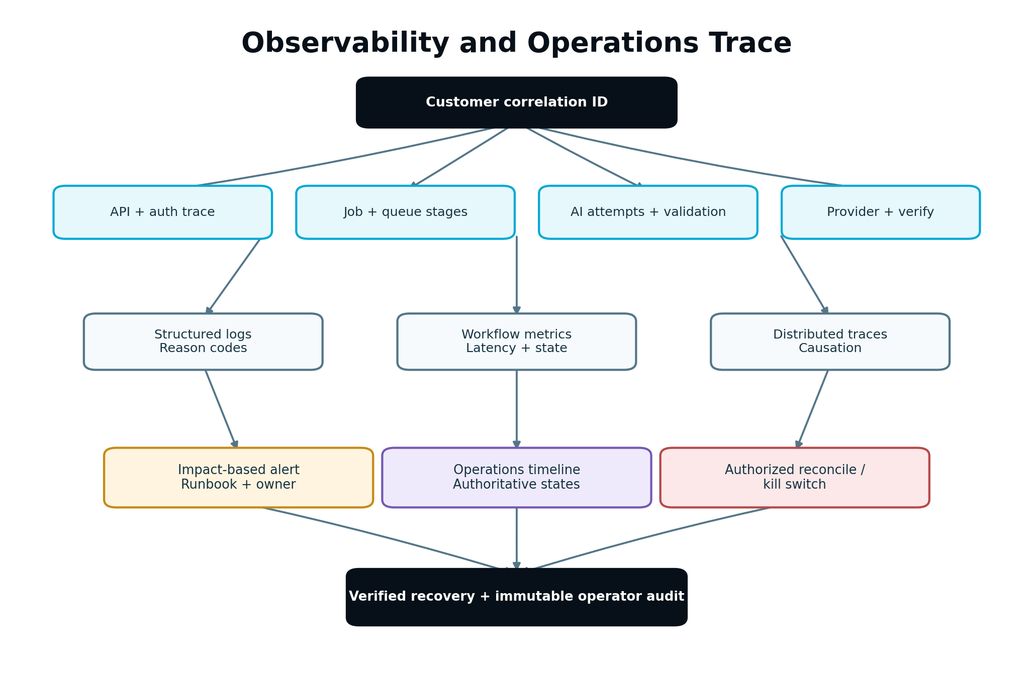
Observability path connecting customer correlation, domain transitions, worker stages, provider attempts, alerts and operator reconciliation.
Figure 8. Operators can trace one workflow without exposing sensitive payloads.

27.7 Business truth dashboards
Operational dashboards show counts by authoritative state: queued, running, awaiting approval, provider accepted, verifying, verified, blocked, retryable failure, unknown external state and dead-letter. A single generic “job failure” chart is insufficient.

28. Performance, Scalability and Degradation

28.1 Measure before changing architecture
Use production-like load tests and traces to identify bottlenecks. Do not introduce distributed complexity based on hypothetical scale. Establish baselines for interactive APIs, job throughput, provider limits, AI latency/cost, event ingestion and major read models.

28.2 Asynchronous boundaries
Move model generation, crawl, publishing, imports, report generation, large analysis, media processing and reconciliation off interactive request threads. The interactive API durably accepts work and returns a status resource.

28.3 Fair scheduling
Apply weighted/fair queues by workspace and workload class. Enforce per-workspace concurrency and provider connection limits. Paid tier/Capacity policy may influence admitted concurrency only through the central policy—not hard-coded worker branches.

28.4 Backpressure
When capacity is saturated:
- stop admitting optional background work before protected/interactive work;
- slow pollers and imports;
- respect queue depth and dependency rate limits;
- show delayed/collecting state and realistic estimates;
- never drop accepted work silently.

28.5 Degradation hierarchy
- Preserve authentication, authorization and customer data access.
- Preserve approvals, current status and audit.
- Preserve already-accepted protected-action verification/reconciliation.
- Preserve deterministic reads and previously generated artifacts.
- Delay new AI, crawl, bulk imports and nonessential reports.
- Disable a degraded provider route/capability through a kill switch.

28.6 Scaling controls
Scale workers by queue age and service time, not depth alone. Partition high-volume event streams by stable keys required for ordering. Cap high-cardinality aggregations and use incremental computation. Large Agency workspaces require pagination and bounded batch sizes everywhere.

28.7 Performance budgets
Each feature specifies query count/shape, payload size, synchronous dependency count, bundle impact, expected job stages, AI context budget and provider call limit. Regressions beyond the agreed budget require review.

29. Caching, Projections and Search Indexes

29.1 Cache classification
Cache only data whose staleness behavior is defined. Authorization, approval validity, entitlement admission and protected-action preflight use authoritative/current sources or very short explicitly invalidated policy caches.

29.2 Cache keys
Keys include environment, workspace, client/project scope, resource ID, version and relevant policy/locale. A cache lookup without tenant scope is prohibited for tenant data.

29.3 Invalidation
Prefer versioned keys and event-driven invalidation. TTL is a safety net, not the only invalidation plan for material customer state. Cache failure degrades to authoritative reads or a visible unavailable state; it must not grant access.

29.4 Read projections
Dashboard, activity, funnel and reporting views may use asynchronous projections. Every projection records source watermark/version and last-updated time. UI shows meaningful freshness when lag matters. Commands never use a stale projection as sole precondition authority.

29.5 Projection rebuild
Projection handlers are idempotent. A rebuild can start from authoritative records/events into a new version, validate counts/hashes and atomically switch readers. Rebuilding cannot pause protected writes indefinitely.

29.6 Search indexes
Index documents include scope, resource/version and deletion marker. Search results are post-authorized even when the index filters by scope. Deletion and permission changes propagate promptly and are reconciled.

30. Feature Flags and Release Controls

30.1 Flag classes
Class | Purpose | Default risk rule
Release flag | Separate deployment from exposure | Off until validated
Experiment flag | Controlled product experiment | Must not change security/consent semantics
Capability flag | Reflect provider/plan/environment availability | Evaluated with capability/entitlement
Kill switch | Stop unsafe/degraded action rapidly | Tested and operator-access controlled
Migration flag | Dual-read/write or new path cutover | Time-bound with telemetry
V2 scope flag | Keep deferred capability out of V1 paths | Off and hidden in production V1

30.2 Evaluation snapshot
Store flag key, version, evaluated value, subject/scope, rule and time for consequential commands. A job admitted under a flag still rechecks safety-critical kill switches before protected execution.

30.3 Flag hygiene
Each flag has owner, description, creation date, expected removal date, default, environments and rollback behavior. CI or scheduled governance reports stale flags. Flags are not permanent substitutes for product permissions.

30.4 Safe rollout
Roll out internally/test workspaces, then small production cohort, then broader cohorts with health comparison. Cohorts remain sticky. Stop/rollback thresholds are defined before exposure.

30.5 Flag security
Clients may receive presentation flags but cannot be trusted to enforce server behavior. Server evaluates permissions, entitlements, safety and protected-action availability independently.

31. Schema Migrations, Backfills and Compatibility

31.1 Expand, migrate, contract
Use a multi-release sequence:
- Expand: add backward-compatible schema/contract and code that tolerates old/new.
- Write transition: dual-write or populate the new representation when required.
- Backfill: process existing records idempotently in bounded batches.
- Verify: compare counts, checksums, invariants and customer-visible samples.
- Read cutover: switch a controlled cohort/read path with rollback.
- Observe: maintain compatibility during the declared window.
- Contract: remove old code/schema only after zero-use evidence and backup/rollback review.
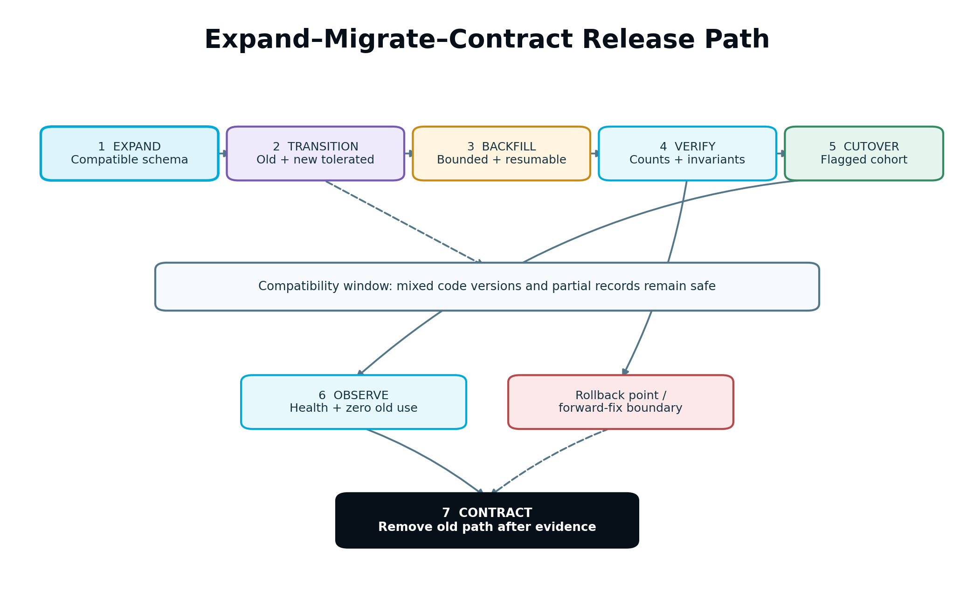
Expand-migrate-contract release sequence with compatibility window, backfill verification, controlled cutover and rollback point.
Figure 9. Data and code evolve without a big-bang production rewrite.

31.2 Migration requirements
- Unique migration ID and immutable checksum.
- Reviewed forward and rollback/compensation plan.
- Lock/runtime estimate and production-size rehearsal.
- Online/non-blocking approach where supported.
- Safe handling when two application versions run concurrently.
- Metrics for progress, errors and remaining records.
- Explicit behavior for partially migrated records.

31.3 Backfills
Backfills use durable cursors/checkpoints, scoped batches, idempotent writes, rate controls and pause/resume. They do not emit customer notifications or duplicate domain events unless explicitly required. Preserve source version and derivation policy.

31.4 Semantic migrations
Never silently reinterpret historical metrics, approvals, Strategy, AI outputs or experiment results. If a new definition is incompatible, create a new version and visible comparison boundary. Historic reports retain old meaning.

31.5 Rollback reality
Code rollback is safe only if the previous version can read the current schema/data. For irreversible migrations, use forward-fix or compensating migration. The deployment plan states the last safe rollback point.

32. CI/CD and Environment Promotion

32.1 Build once, promote the artifact
Create a reproducible, immutable artifact with source revision, dependency lock, contract versions and build metadata. Promote the same artifact through test, staging and production; do not rebuild differently for production.

32.2 Pull-request gates
Required automated gates include:
- formatting/lint and type/static checks;
- unit and architecture-boundary tests;
- contract compatibility tests;
- security/dependency/secret scanning;
- migration lint and test when schema changes;
- prompt evaluation when prompt/schema changes;
- frontend accessibility and critical-flow tests;
- changed-module integration tests;
- artifact/software-bill-of-material generation as supported.

32.3 Staging gate
Staging uses production-like topology, queues, workers, database version and feature controls with synthetic/non-production data. Run provider simulators for deterministic failure cases and approved sandbox accounts for real contract checks.

32.4 Deployment strategy
Use rolling, blue/green or canary deployment according to component and migration risk. Workers support mixed-version queue compatibility during rollout. Drain or safely reclaim leases during replacement.

32.5 Post-deployment verification
Automated smoke checks validate authentication, scoped project load, command acceptance, queue processing, AI sandbox route, approval, provider simulator, measurement event, audit and dashboards. Compare error/latency/success indicators with the prior release.

32.6 Rollback and kill switch
Every release identifies rollback command/procedure, incompatible data boundary, flags/kill switches and owner. Rolling back the UI alone is not sufficient if workers or contracts changed.

32.7 Production access
Deployments use automated identities. Human production access is time-bound, least-privileged and audited. Emergency manual release requires incident/change record and follow-up review.

33. Testing and Quality Strategy
Testing proves architecture and customer behavior, not only line execution.

33.1 Unit tests
- gate evaluators and state transitions;
- authorization and scope predicates;
- entitlement/Capacity reservation and settlement;
- idempotency key and conflict behavior;
- validators, mappings and reason codes;
- routing policy and fallback eligibility;
- metric/statistical deterministic functions;
- migration transforms and projection reducers;
- flag evaluation and notification suppression.

33.2 Contract tests
- API request/response and error compatibility;
- command/event schemas and enum tolerance;
- adapter capability, execution, verification and webhook mapping;
- AI structured input/output and evidence reference validation;
- Part 2 → Part 3 and Part 3 → Part 4 handoffs;
- shared ExecutionContext, scope and audit envelopes;
- old/new version coexistence during migration.
Consumer-driven contract tests may supplement, but the owning producer contract remains authoritative.

33.3 Integration tests
Use real database/transaction/queue behavior in an isolated environment for:
- outbox dispatch and consumer inbox;
- lease expiry and worker reclaim;
- optimistic concurrency and unique effect constraints;
- connection token refresh and capability loss;
- approval invalidation after asset change;
- AI reservation, attempt, validation, fallback and settlement;
- external acceptance followed by delayed verification;
- measurement activation from verified exposure;
- Blueprint patch and Workflow Controller projection;
- deletion/retention propagation.

33.4 Provider simulators
Simulators model success, rate limit, timeout before/after acceptance, duplicate webhook, out-of-order webhook, auth expiry, partial response, schema drift, remote edit, delayed visibility, unsupported capability and idempotency differences. A “200 OK” stub is not sufficient.

33.5 AI evaluation
Maintain versioned golden and adversarial datasets by task class. Score schema validity, grounding, evidence citation, rule compliance, unsafe claims, brand/voice, originality/Information Gain where relevant, task usefulness, latency, usage and total successful-workflow cost. Human-reviewed samples calibrate automated graders; an AI grader is not sole authority for safety-critical acceptance.

33.6 End-to-end tests
Automate representative Guided and Advanced Mode journeys from project state through Strategy, execution, approval, provider simulation, verification, measurement, evaluation and Next Best Action. Include Agency client approval and Personal Workspace paths.

33.7 Failure injection
Kill workers between every durable stage; duplicate commands/events; delay and reorder messages; expire leases; interrupt database/network calls; exhaust Capacity; revoke authorization; rotate credentials; change feature flags; corrupt non-authoritative projections; and make providers return ambiguous outcomes. Verify no duplicate business effect or false success.

33.8 Security and privacy tests
- cross-workspace/client direct and indirect object access;
- forged scope/role/approval/consent fields;
- cache/index/object-storage isolation;
- webhook spoof/replay;
- prompt injection and unauthorized tool request;
- SSRF/upload/script payloads;
- secret and sensitive-data log scanning;
- deletion/export authorization;
- support/operator privilege and break-glass audit.

33.9 Performance, load and soak
Test interactive concurrency, long AI jobs, publishing bursts, provider backpressure, large Agency workspaces, event ingestion, backfills, reconciliation and projection rebuild over extended periods. Verify fair scheduling, bounded memory/cardinality, stable database/queue behavior and no stuck leases/reservations/outbox records.

33.10 Frontend and accessibility tests
Cover keyboard navigation, focus, screen reader semantics, contrast, responsive layouts, loading/recovery states, missing-versus-zero display, approval version clarity and prevention of double submission. Visual regression tests protect critical workflow components.

33.11 Release gate
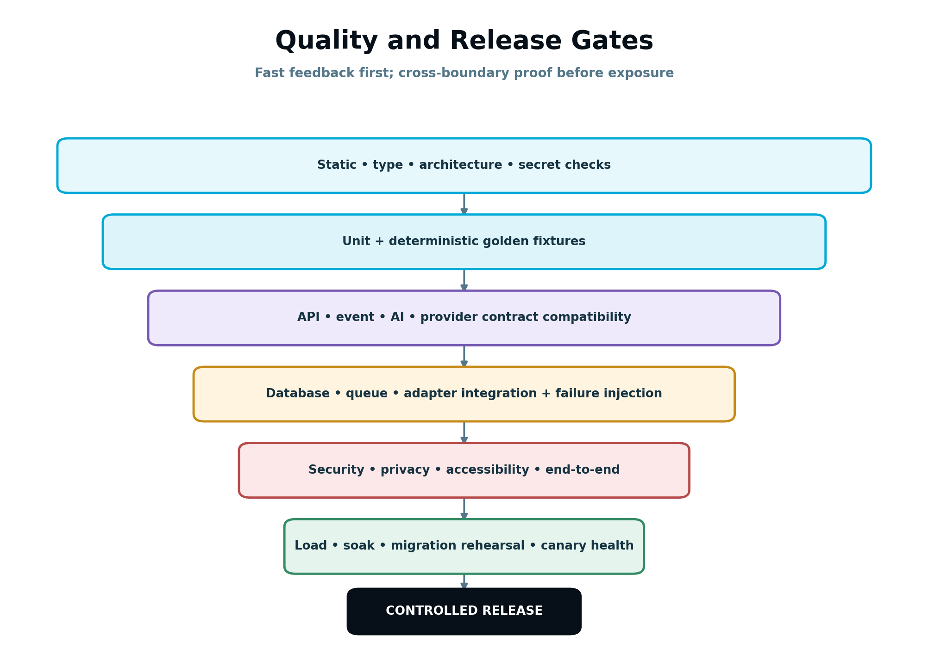
Quality gate pyramid from static checks and unit tests through contracts, integration, AI evaluation, security, end-to-end, load and canary health.
Figure 10. Higher-cost tests protect cross-boundary behavior before and during controlled release.
A feature cannot be declared launch-ready based on a happy-path demo. Required tests, telemetry, runbook, kill switch, migration and rollback evidence must be attached to its release checklist.

34. Frontend and UX Implementation

34.1 Server-authoritative state
Frontend state may optimistically improve responsiveness only for reversible local interactions. Workflow state, approval, entitlement, Capacity, publication, experiment and measurement results come from server-authoritative records. The client never marks a protected action complete before verified state.

34.2 Guided and Advanced Mode
Both modes use the same APIs, permissions and domain records. Guided Mode presents one recommended action, explanation and recovery path. Advanced Mode exposes more controls and evidence but cannot bypass gates.

34.3 State presentation
Every asynchronous screen distinguishes queued, processing, awaiting review, scheduled, provider accepted, verifying, verified, delayed, blocked, retryable failure, final failure, cancelled and unknown external state as applicable. Avoid generic spinners without durable status.

34.4 Mutation behavior
- Disable accidental duplicate submission but still enforce server idempotency.
- Send expected revision for edits/commands.
- On conflict, preserve local work and display current server version/diff.
- Use resumable uploads for large assets where supported.
- Keep background work navigable; the user does not need to stay on the page.
- Announce success only from an authoritative result.

34.5 Explainability component contract
Recommendation/result cards use structured fields: objective, recommendation/finding, why, evidence, confidence/evidence strength, expected or observed impact, limitations, approval status, measurement path and action. Do not render one unstructured AI blob.

34.6 Accessibility
Meet the approved accessibility target across keyboard, focus order, labels, landmarks, status announcements, tables/charts, color contrast, reduced motion and zoom/reflow. Confidence, state and missing data cannot rely on color alone.

34.7 Frontend telemetry and privacy
Capture route, performance and reason-coded UI failure without recording secrets, content bodies or sensitive form values. Session replay/behaviour tooling must use masking/blocking and consent policy from Part 4.

34.8 Design system
Shared components encode status, approval, evidence, version, notification, error and empty-state semantics. Module teams do not invent conflicting colors or labels for the same canonical state.

35. Operations Command Center and Supportability
The internal Operations Command Center is required for launch. It is not a customer module and does not create a second business authority.

35.1 Minimum launch views
- workspace/client/project lookup by safe identifiers;
- workflow and current authority/version timeline;
- task/job state, attempts, checkpoints and queue age;
- AI route/validation/Capacity ledger without prompt-sensitive leakage;
- connection capability/health and token-expiry metadata;
- publication receipt, verification and reconciliation state;
- measurement/source watermark and evaluation status;
- outbox/dead-letter/reconciliation queues;
- audit trail and notifications;
- feature/kill-switch evaluation snapshot;
- linked incident/support ticket.

35.2 Safe operator commands
Commands may include retry safe stage, reconcile external state, refresh capability, rebuild projection, release expired reservation, replay quarantined event after correction, resend notification or pause workload. Each command runs the same authorization, scope, compatibility and idempotency rules as production services.

35.3 Prohibited operator shortcuts
Operators cannot fabricate approval, mark external success without evidence, transfer records across workspaces, change historic evaluation meaning, reveal secrets, bypass consent or spend Capacity without an auditable policy path.

35.4 Support bundle
Generate a time-bound redacted bundle containing identifiers, versions, state history, reason codes, provider metadata, telemetry references and configuration snapshots necessary to diagnose the issue. Exclude credentials, sensitive content, raw form data and hidden model reasoning.

36. Incident Response and Recovery

36.1 Severity model
Define severity from customer/security/data impact, affected scope, duration and workaround. Security/privacy incidents follow the applicable specialized process. A single failed background task is not automatically an incident; systemic false success may be critical even at low volume.

36.2 Incident lifecycle
- Detect and assign incident commander.
- Establish impact and protect customer/data safety.
- Stop propagation using kill switch, route disable, queue pause or read-only mode.
- Preserve evidence and correlation.
- Communicate verified facts and next update time.
- Mitigate and validate recovery by authoritative states.
- Reconcile queued/uncertain records.
- Complete post-incident review and tracked prevention work.

36.3 Runbooks
Maintain runbooks for model/provider outage, credential compromise, queue backlog, database saturation, outbox stall, duplicate webhook storm, publication uncertainty, measurement lag, projection drift, Capacity settlement issue, bad release/migration and cross-tenant access concern.

36.4 Disaster recovery
Set recovery point and recovery time objectives for authoritative stores, asset storage, event/outbox records, secrets/config and indexes/projections. Projections may be rebuildable; approvals, audit, publications, Capacity ledgers and source evidence are not casually discardable.

36.5 Restoration testing
Test backup restoration in isolation. Validate schema versions, object references, encryption keys, outbox state, deleted-data journals, tenant isolation and projection rebuild. A backup job success is not proof of recoverability.

36.6 Post-incident review
Reviews are blameless but specific: timeline, triggering condition, missing control, detection gap, customer impact, why safeguards did/did not work, remediation owner and verification test. Update fixtures/runbooks/alerts, not only prose.

37. Developer Workflow and Definition of Done

37.1 Work item readiness
A work item is ready when it links to governing requirements, identifies affected contracts/states, defines scope/non-scope, includes acceptance criteria, UX behavior, security/privacy considerations, telemetry, migration/flag needs and test plan. Ambiguity that affects product behavior is resolved before implementation.

37.2 Branch and review discipline
Keep changes small enough to review. Separate mechanical refactor from behavior change where practical. Pull requests explain why, governing DEV sections, architecture impact, data/contract changes, rollout/rollback and evidence of tests.

37.3 Code review checklist
- Correct owner and dependency direction.
- Explicit trusted scope and authorization.
- No plan-name, provider or UI shortcut around policy.
- Contract/version and backward compatibility.
- Idempotency, concurrency and retry behavior.
- Error reason/recovery state.
- Sensitive-data and logging review.
- Observability and operational commands.
- Tests for success, denial, duplicate and failure.
- Migration, flag, cleanup and rollback.

37.4 Definition of Done
Work is complete only when applicable items are true:
- Behavior satisfies linked acceptance criteria and approved UX.
- Architectural boundary and scope enforcement are in code and tests.
- API/event/schema is documented, versioned and compatibility-tested.
- Authorization, entitlement, consent, approval and Capacity gates are server-side.
- Idempotency/concurrency/retry/partial-failure behavior is implemented.
- Customer-visible states and recovery paths are complete.
- Logs, metrics, traces, reason codes and dashboards are usable.
- Unit, contract, integration, security, accessibility and relevant end-to-end tests pass.
- AI changes pass the task evaluation set and cost/latency review.
- Schema changes include rehearsed migration/backfill and compatibility plan.
- Feature flag/kill switch, rollout and rollback are defined where risk requires.
- Operations Command Center and runbook support the feature.
- Documentation and ADR/deviation records are updated.
- No secrets, raw sensitive data, placeholders or debug bypasses remain.
- Staging/canary verification shows no material regression.

37.5 Technical debt
Debt is recorded with impacted contract, risk, owner, remediation and target milestone. A workaround affecting security, data integrity, protected external actions or false customer claims cannot be deferred as ordinary debt.

37.6 Completion evidence
The work item links test runs, contract diff, migration rehearsal, screenshots for UX when relevant, performance comparison, telemetry dashboard, release flag and rollout result. “Tested locally” alone is insufficient for cross-boundary work.

38. Real-World End-to-End Implementation Examples

38.1 Existing insurance website: governed content refresh

Situation
An existing insurance-agent project has an approved Unified Strategy. Part 4 detects that a Visitor Insurance page is losing qualified quote starts. The Next Best Action is an approved content/CTA refresh, not a new overlapping page.

Implementation path
- Growth Intelligence emits a versioned recommendation referencing diagnosis, objective, evidence and expected impact.
- Workflow Controller verifies no higher-priority blocker or active conflicting task and creates a Part 3 ExecutionTask.
- Context Assembly resolves the exact Business Brain, Strategy, recommendation, source page and evidence versions.
- Capacity Engine estimates/reserves one logical AI task.
- AI Orchestrator generates structured refresh sections and claims with evidence references.
- Validation checks factual insurance claims, intent ownership, originality/Information Gain, brand voice, internal links and preserved human edits.
- A new AssetVersion is created. Approval binds to that version.
- Publishing Gateway preflight detects current WordPress capability and remote content hash.
- The provider accepts the update. SEnuke AI remains in VERIFYING until read-back matches expected content/version.
- Verified exposure activates the existing versioned Measurement Plan.
- Part 4 later evaluates qualified quote starts and CRM qualification, creates a Learning Record and updates the Growth Blueprint.

Required behavior under change
If the agent manually edits the WordPress page after approval but before publish, the remote hash conflict blocks overwrite. The customer sees a diff/import/overwrite decision. No approval, publication or measurement record is fabricated.

38.2 AI provider degradation during campaign production

Situation
A Business workspace is producing a lead magnet, landing page and email sequence. The preferred model route starts returning schema-invalid email outputs.

Implementation path
- The AI task record already holds one Capacity reservation and one idempotency key.
- Schema validation fails before an asset version is created.
- Orchestrator records the attempt and allows one constrained repair.
- Repair fails; routing policy selects a compatible fallback proven for the same output schema.
- Fallback succeeds and passes domain/factual/brand validation.
- Capacity settles the logical task once using actual approved policy; attempts remain visible to operations.
- Circuit breaker degrades the failing model/task route without disabling unrelated AI tasks.

Architectural lesson
Module code does not know which provider ran. The customer receives a valid asset or a transparent recoverable failure—not provider error text or duplicate Capacity consumption.

38.3 Agency workspace: client-scoped approval and reporting

Situation
An Agency owns clients Northstar and Lakeside. A manager prepares a Northstar campaign. An Agency Owner can see both clients; each Client Viewer can see only their own.

Implementation path
- Every record, queue job, asset blob, index document and report carries workspace, Northstar client and project scope.
- Agency internal approval occurs first; configured client approval follows for the same immutable campaign version.
- Lakeside Client Viewer requests the Northstar report ID. Repository query includes Lakeside scope and returns a non-enumerating denial.
- A client edit after approval creates a new campaign version and invalidates the earlier approval.
- Publishing preflight revalidates both approval sequence and destination connection binding.
- Operations tooling requires explicit Northstar scope and records the operator reason.

Architectural lesson
Workspace membership alone is insufficient authority in an Agency. Client scope follows the work through every layer.

38.4 Ambiguous provider timeout after website publication

Situation
The website provider times out after receiving a publish request and offers no reliable idempotency key. It is unknown whether the change was applied.

Implementation path
- The durable publication intent and request fingerprint already exist.
- Worker records timeout-after-submit and enters UNKNOWN_EXTERNAL_STATE.
- It does not retry the write immediately.
- Reconciliation reads the remote page and compares version/hash.
- If matched, it records the provider receipt as reconstructed evidence and moves through verification.
- If not matched and remote state is confidently unchanged, policy permits a new controlled attempt.
- If ambiguous, it requests human resolution with expected/current diff.

Architectural lesson
Reliable systems model uncertainty. A timeout is not proof of failure and a 200 response is not proof of verified success.

38.5 Concurrent AI Capacity requests near the workspace limit

Situation
Two editors start capacity-bearing generation tasks when the workspace has allowance for only one.

Implementation path
- Both requests pass authentication and scope authorization.
- Capacity reservation runs atomically against the same workspace ledger.
- One reservation commits; the other receives CAPACITY_INSUFFICIENT with current policy-approved options.
- The admitted task continues. If it fails before billable work, reservation releases idempotently.
- Retrying either API request with its original idempotency key returns the original admission result.

Architectural lesson
The UI may disable buttons after a click, but only the central atomic ledger prevents overspend across devices and workers.

38.6 Refining legacy direct integrations without a rewrite

Situation
The functional codebase contains a content module that calls a model SDK directly and a WordPress helper that stores access tokens and marks success on HTTP 200.

Migration path
- Inventory current callers, payloads, behavior and production metrics.
- Introduce AI task and publishing adapter interfaces around existing calls.
- Route a test/internal cohort through AI Orchestrator and Connection Registry while preserving current UI.
- Add AssetVersion, approval and publication intent references at the boundary.
- Introduce provider receipt/read-back verification and outbox events.
- Compare outputs, errors, latency, Capacity and duplicate behavior.
- Expand cohort through feature flag; keep rollback to the wrapped legacy path only while it remains safe and compatible.
- Remove direct credentials/calls after zero-use telemetry and contract tests pass.

Architectural lesson
The desired result is compliant behavior and one owner—not a big-bang rewrite for its own sake.

39. Edge Cases and Required Behavior
Edge case | Required behavior
User changes workspace in another tab while command form remains open | Server evaluates the command against explicit authorized scope; stale tab cannot redirect action silently
Role removed after job admission but before protected execution | Revalidate; block protected effect and preserve safe completed draft work
Subscription becomes read-only while provider verification is pending | Continue verification/reconciliation; block new mutation/AI work
Approval exists for version 7; current version is 8 | Return APPROVAL_STALE; never inherit approval
Feature flag turns off after task is queued | Stop at next safe gate; allow required reconciliation/rollback paths
Duplicate API request with same key and same payload | Return original command/result reference
Same idempotency key with different payload | Conflict and security/quality telemetry; never choose one silently
Worker dies after domain commit but before queue acknowledgement | Redelivery sees committed effect/inbox and does not duplicate it
Worker dies after provider submit but before receipt persistence | Enter/recover through uncertainty reconciliation; do not blind retry
Webhook arrives before synchronous provider response | Deduplicate and converge on one publication state
Provider sends events out of order | Apply permitted monotonic/state-version rules; preserve later authoritative state
Provider capability disappears after plan approval | Block execution and present valid manual/alternative path without false completion
OAuth refresh token revoked | Mark connection attention-required, stop new actions, retain records and notify authorized users
Remote page edited outside SEnuke AI | Detect version/hash conflict and require explicit resolution
Model returns valid JSON with invented evidence ID | Grounding validator blocks output; retry/repair only according to policy
Retrieved webpage instructs model to reveal secrets or call a tool | Treat as untrusted data; instruction has no authority
Context dependency changes during AI generation | Result is tied to original bundle; material change marks result stale before approval
Human edits draft after AI validation | Create new version and rerun affected validators; preserve edit provenance
Two Blueprint patches touch independent fields | Rebase/apply idempotently according to typed patch policy
Two Blueprint patches conflict materially | Hold conflict for governed resolution; do not last-write-wins
Measurement source is disconnected | Show stale/unavailable limitation; do not replace missing values with zero
Late event changes earlier evaluation | Create revision with watermark/reason and stale dependent unexecuted recommendation if material
Cache contains record from another client due to bad key | Authorization/post-filter denies; security incident telemetry and cache invalidation
Search index lags deletion | Post-authorization and tombstone prevent access; reconciliation removes index record
Backfill is paused halfway | Durable cursor resumes without duplicates; old/new compatibility remains valid
Deployment has old and new workers simultaneously | Both consume supported contract versions and do not corrupt job state
Migration rollback requested after irreversible transform | Use documented forward-fix/compensation; do not run unsafe down migration
Notification provider is down | Domain action remains authoritative; notification retries/digests without duplicate attention
Operator replays dead-letter after contract changed | Compatibility validation/migration required before authorized replay
Support operator attempts cross-workspace mutation | Denied unless explicit approved privilege; every action scoped and audited
Large Agency workspace triggers bulk generation | Batch is bounded, fair-queued and separately observable; one failure does not erase other results
Daylight-saving transition affects scheduled post | Stored timezone/misfire policy determines one intended occurrence; no duplicate publish
Client Viewer triggers hidden mutation endpoint directly | Server denies regardless of UI visibility
V2 route accidentally exposed by client build | Server feature/scope policy denies; production telemetry flags attempted access

40. Refinement Implementation Sequence
The sequence is risk-driven and incremental. Teams may run compatible work in parallel, but later phases cannot be considered complete while foundational authority or isolation gaps remain.

Phase 0 — Inventory and behavioral baseline
- Map existing routes, modules, workers, databases, provider calls, model calls and credential locations.
- Map current behavior to Parts 1–5 contracts and classify compliant/wrap/refactor/migrate/retire.
- Capture production-like golden journeys, current latency/cost/error and data invariants.
- Identify competing write authorities, unscoped repositories, false-success paths and direct provider/model calls.
- Create the contract ownership and deviation registers.
Exit: the team knows what already works, what is unsafe and how compliance will be measured.

Phase 1 — Scope, authority and shared contracts
- Standardize ExecutionContext, trusted scope and policy enforcement.
- Enforce workspace/project/client scope in repositories, caches, indexes and jobs.
- Define versioned API, command, event, error and audit envelopes.
- Establish architecture import/dependency checks.
- Centralize entitlement/AI Capacity and approval access contracts.
- Add correlation/causation to critical paths.
Exit: no new code may introduce an unscoped or competing authority path.

Phase 2 — Durable workflow and consistency
- Encode Workflow Controller definitions/gates/transitions.
- Introduce durable job records, leases and checkpoints.
- Add transactional outbox and idempotent consumer/effect records.
- Implement optimistic concurrency and narrow logical locks.
- Add reconciliation for workflow, outbox, jobs, Capacity and projections.
- Migrate customer-visible status to canonical states/reason codes.
Exit: worker crashes, redelivery and concurrent requests cannot duplicate or falsely complete work.

Phase 3 — AI, assets, approvals and external actions
- Route direct model calls through AI Orchestrator using task contracts.
- Implement Context Bundle manifests, prompt/schema registry and validation pipeline.
- Normalize Asset/AssetVersion/lineage and human edit preservation.
- Bind approval to immutable versions and revalidate before execution.
- Move credentials/capabilities into Connection Registry and adapters.
- Move protected effects to Publishing Gateway with receipt, verification and uncertainty states.
- Verify Measurement Plan activation only from verified exposure.
Exit: AI and providers cannot bypass governance; provider acceptance is never represented as verified success.

Phase 4 — Security, privacy, observability and operations
- Complete authorization/tenant-isolation matrix and adversarial tests.
- Apply consent/sensitive-data controls to measurement, behaviour, prompts and logs.
- Add workflow SLIs, dashboards, traces, alerts and safe telemetry dimensions.
- Deliver Operations Command Center minimum views/commands.
- Create runbooks, kill switches, support bundle and incident controls.
- Test backup restoration and reconciliation after recovery.
Exit: customer-impacting workflows are traceable and safely operable without database shortcuts.

Phase 5 — Delivery system and compatibility
- Enforce PR, contract, prompt, security, migration and accessibility gates.
- Establish production-like provider simulators and staging topology.
- Implement feature flag governance and controlled cohort rollout.
- Rehearse expand/migrate/contract and major backfills at production scale.
- Define artifact promotion, mixed-version workers and rollback boundaries.
- Remove retired legacy paths only after zero-use telemetry and compatibility evidence.
Exit: releases, migrations and rollbacks are repeatable and evidence-backed.

Phase 6 — Launch hardening
- Automate the Section 38 journeys and Section 39 edge cases.
- Run failure injection, load, soak, security, privacy and restore exercises.
- Verify fairness and backpressure under launch/Agency load.
- Verify every V2/deferred capability is off and hidden in V1 production.
- Close or formally accept every launch-blocking deviation.
- Complete go/no-go evidence: tests, dashboards, on-call/runbooks, flags, migrations, backups and rollback.
Exit: the platform is launch-ready by measured behavior, not by code-complete status alone.

41. Acceptance Criteria

41.1 Architecture, authority and scope
- AC-001: Existing functional code is mapped to compliant, wrap, refactor, migrate or retire before a material replacement is authorized.
- AC-002: Logical components have one documented write owner for workflow, Business Brain, Strategy, approval, Capacity, publication and Growth Blueprint state.
- AC-003: A module cannot write another component’s authoritative state outside an approved contract/transaction boundary.
- AC-004: Direct navigation or module API use resolves current workflow authority and cannot create a competing workflow.
- AC-005: workspace_id, project_id and applicable client_id are explicit on authoritative tenant records, commands, events and jobs.
- AC-006: Server-side scope is derived/validated from trusted identity and resource relationships, never accepted from client fields as proof.
- AC-007: Agency client isolation applies to APIs, queries, queues, caches, indexes, object storage, reports, AI context and operator tools.
- AC-008: Client Viewer is read-only, client-scoped and cannot initiate AI or protected actions by calling a hidden endpoint directly.
- AC-009: Cross-scope access returns a non-enumerating denial and creates safe security telemetry.
- AC-010: Architecture checks prevent provider SDK imports and model calls outside approved adapter/orchestrator boundaries.
- AC-011: Deferred/V2 capabilities remain disabled and hidden from V1 server execution regardless of client behavior.
- AC-012: Material architectural deviations have owner, risk, expiry, remediation and monitoring; legacy code alone is not an exemption.

41.2 Contracts, persistence and data integrity
- AC-013: Public/internal APIs, commands, events and errors use versioned schemas with named owners and compatibility policy.
- AC-014: Persistence models are not exposed as the only external/API contract.
- AC-015: Consequential commands return a durable command/task/result resource rather than an ambiguous boolean.
- AC-016: API errors include stable reason code, category, retryability, recovery action, request ID and correlation ID without leaking internals.
- AC-017: Breaking contract changes use an explicit new version and overlap/migration/removal plan.
- AC-018: Mutable authoritative records use revision/version checks that prevent silent last-write-wins on material changes.
- AC-019: Scope is included in tenant unique keys and repository methods cannot load tenant data by unscoped ID alone.
- AC-020: Domain state change and required event are committed atomically through transactional outbox or equivalent guarantee.
- AC-021: Event consumers prevent duplicate effects using inbox/effect records and unique constraints.
- AC-022: JSON-based authoritative fields carry schema versions and are validated before use.
- AC-023: Historic records preserve the Strategy, prompt, policy, metric, mapping and other semantic versions used when created.
- AC-024: Integrity reconciliation detects orphan scope, duplicate effects, stuck outbox, stale reservations and projection divergence.
- AC-025: Retention/deletion propagates to eligible primary, derived, blob, index, cache and provider data without retaining removed content in audit.

41.3 Workflow, jobs and resilience
- AC-026: Workflow states, gates and transitions are versioned and not scattered as contradictory route-level conditions.
- AC-027: Gate evaluators are deterministic, side-effect free and return structured status, reason, evidence and policy/dependency versions.
- AC-028: A workflow transition atomically validates expected revision, current gates and permission before state change.
- AC-029: Next Best Action presentation respects blockers, approvals, recovery and already-running work before new opportunities.
- AC-030: Long-running work has a durable job record independent of queue-message lifetime.
- AC-031: Job leases expire/reclaim safely and handlers resume from checkpoints without duplicating completed stages.
- AC-032: Retry policy is bounded, jittered, reason-code driven and stops when current authority/policy no longer permits the action.
- AC-033: Commands and events distinguish requested, accepted, completed, provider-accepted, verified and measured states.
- AC-034: Dead-letter replay is authorized, compatibility-checked, idempotent and audited.
- AC-035: Scheduler records timezone, intended local time, UTC execution and misfire policy and does not duplicate work at daylight-saving transitions.
- AC-036: Circuit breakers and workload bulkheads prevent one degraded provider/task class from exhausting unrelated platform paths.
- AC-037: Timeout after possible external submission enters uncertainty/reconciliation rather than blind retry.
- AC-038: Reconciliation repairs derived state but cannot invent approvals, external verification or evidence.

41.4 Business Brain, AI and validation
- AC-039: Business Brain material facts are versioned and preserve provenance, status/confidence, freshness and sensitivity where applicable.
- AC-040: AI Context Bundles are bounded manifests of exact approved dependency/evidence versions, not unfiltered project dumps.
- AC-041: Context assembly excludes secrets/unauthorized data and labels retrieved website, CRM and document content as untrusted data.
- AC-042: Every model-provider request routes through AI Orchestrator; domain modules cannot access provider credentials directly.
- AC-043: AI task records identify task/input/output contract, context manifest, subject version, scope, sensitivity and idempotency.
- AC-044: AI routing filters for capability, sensitivity, context, entitlement and health before optimizing total successful-workflow cost.
- AC-045: AI attempts record route/model, prompt/schema, usage, latency, validation and retry/fallback reason.
- AC-046: Fallback routes support the same output contract and remain inside one logical task/Capacity ledger.
- AC-047: AI output cannot become authoritative solely because it parses; schema, domain, grounding and safety validators must pass.
- AC-048: AI-supplied evidence IDs are validated against the exact Context Bundle.
- AC-049: Model tool requests are allowlisted, schema-validated, server-scoped and cannot grant themselves new permissions.
- AC-050: Protected external actions cannot execute inside an unconstrained model tool loop.
- AC-051: Prompt/template/schema changes are versioned and pass golden, adversarial, quality, latency and cost regression tests.
- AC-052: A material context dependency change stales an unapproved/unexecuted AI result without rewriting historic attempt records.

41.5 Approval, assets and protected external actions
- AC-053: Logical assets, immutable AssetVersions, approvals and external publications are separate records.
- AC-054: Human edits create versioned provenance and cannot be silently reverted by later AI regeneration.
- AC-055: Approval binds to exact subject/version, scope, actor/role snapshot, approval class and policy version.
- AC-056: Material content/configuration/context changes invalidate or narrow earlier approval according to policy.
- AC-057: Protected action preflight revalidates current approval, role, entitlement, connection, destination, consent and remote version.
- AC-058: Agency internal/client approval sequences are enforced server-side for the same immutable version.
- AC-059: A protected action has a durable intent and effect key before provider submission.
- AC-060: Provider acceptance is stored separately from external verification and cannot be shown as verified success.
- AC-061: Verification records exact external ID/version/location and effective exposure time.
- AC-062: A remote edit/version conflict blocks overwrite and provides governed diff/import/overwrite/cancel options.
- AC-063: Unknown external state is visible, reconciled and never collapsed into failed or successful without evidence.
- AC-064: Rollback/compensation is a new governed action and is not declared complete until external result is verified.
- AC-065: Source asset changes stale only affected unexecuted derivatives while preserving published history and lineage.
- AC-066: Verified exposure—not internal completion or provider acceptance—activates official measurement.

41.6 Integrations, measurement, entitlement and AI Capacity
- AC-067: Provider credentials are encrypted and available only inside authorized adapter execution paths.
- AC-068: Connection Registry records workspace ownership, capability, scope, health, expiry and permitted client/project bindings.
- AC-069: Provider adapters translate provider payloads/status/errors into canonical contracts and do not contain growth-strategy logic.
- AC-070: Webhooks verify signature/replay protection, resolve trusted connection scope, durably receive and deduplicate before processing.
- AC-071: Provider rate limits use bounded retries, backpressure and workspace fairness without silent work loss.
- AC-072: Missing direct provider capability produces an accurate unavailable/manual path and never a fabricated completion.
- AC-073: Measurement handoff preserves objective, asset/exposure version, Metric Definitions, baseline/window, source, consent and guardrails.
- AC-074: Execution and UI code cannot write official measurement aggregates directly.
- AC-075: Late/corrected evidence creates a reproducible evaluation revision and does not silently rewrite the earlier report.
- AC-076: Consent-limited, missing, stale and unavailable measurement states remain distinct from numeric zero.
- AC-077: Entitlement and Capacity are evaluated centrally; modules do not infer rights or limits from plan names.
- AC-078: Capacity estimate, reservation, settlement, release and adjustment are idempotent ledger operations.
- AC-079: Concurrent reservations cannot overspend one workspace allowance and duplicate settlement cannot double-consume.
- AC-080: Retries/fallbacks for one logical AI task do not independently charge Capacity outside approved settlement policy.

41.7 Security, privacy and consent
- AC-081: Authentication/session/service identities follow approved expiry, revocation, rotation and least-privilege controls.
- AC-082: Authorization is enforced consistently for HTTP, background jobs, subscriptions, downloads and operator commands.
- AC-083: UI visibility is never the sole enforcement of role, client, entitlement or feature permission.
- AC-084: Cross-workspace/client tests cover indirect object access through files, reports, cache, search, AI context and operations.
- AC-085: Uploaded/fetched content is size/type validated, safely rendered and protected against script execution and SSRF.
- AC-086: Retrieved content cannot alter system policy, reveal secrets or authorize tools through prompt injection.
- AC-087: First-party/server-side measurement continues to enforce consent and permitted identity association.
- AC-088: Behaviour/form intelligence does not require sensitive field values and applies approved masking/blocking.
- AC-089: Credentials, raw sensitive form values and unrestricted recordings never enter logs, prompts, reports or support bundles.
- AC-090: Encryption keys and provider credentials have documented rotation/revocation and are never stored in source.
- AC-091: Web and API controls include parameterized queries, contextual output encoding, secure browser headers and abuse rate limits as applicable.
- AC-092: Data access/deletion/export and break-glass operations are authorized, non-enumerating and immutably audited.

41.8 Observability, performance and operations
- AC-093: Every accepted workflow carries request, correlation and causation identity across API, workers, AI, providers and events.
- AC-094: Logs use structured reason codes and redact secrets/sensitive content at a shared boundary.
- AC-095: Metrics expose queue wait, stage duration, success state, verification time, reconciliation age, data freshness and Capacity settlement lag.
- AC-096: Metric labels avoid workspace/client and other unbounded high-cardinality values.
- AC-097: Alerts are tied to customer impact/risk, include runbook and can correlate releases, flags and provider health.
- AC-098: Operations dashboards distinguish provider accepted, verifying, verified, unknown, blocked and failed states.
- AC-099: Workload fairness prevents one workspace, Agency client or provider connection from monopolizing processing.
- AC-100: Backpressure delays/degrades optional work safely and never silently drops durably accepted work.
- AC-101: Scaling is driven by queue age/service time and preserves per-provider/per-workspace limits.
- AC-102: Operations Command Center can trace and reconcile a workflow without exposing credentials or sensitive payloads.
- AC-103: Operator mutations use authorized idempotent commands with reason/ticket and before/after audit, not silent database edits.
- AC-104: Backup restore testing verifies tenant isolation, keys, schema, asset references, deleted-data journals and projection rebuild.

41.9 Migrations, CI/CD and release control
- AC-105: Consequential feature/kill/migration flags have owner, version, default, expiry/removal target and rollback behavior.
- AC-106: Server-side security, permission and entitlement behavior remains enforced regardless of client flag values.
- AC-107: Controlled rollout uses sticky cohorts, predeclared health thresholds and a tested stop/rollback path.
- AC-108: Schema changes follow backward-compatible expand/migrate/contract unless an approved exception exists.
- AC-109: Migrations are checksummed, rehearsed at production-like scale and safe during mixed application versions.
- AC-110: Backfills are bounded, resumable, observable and idempotent and have explicit partial-migration behavior.
- AC-111: Incompatible semantic definitions create new versions/boundaries rather than reinterpreting historic results.
- AC-112: Every release identifies the last safe rollback point and forward-fix/compensation for irreversible changes.
- AC-113: CI enforces lint/type, architecture, unit, contract, security/secret, migration and applicable prompt/accessibility gates.
- AC-114: One immutable artifact is built with source/contract metadata and promoted across environments.
- AC-115: Staging exercises queues, workers, webhooks, provider simulators, migrations and production-like topology.
- AC-116: Post-deployment smoke/canary checks compare current workflow success, error and latency with the prior release.

41.10 Testing, frontend and Definition of Done
- AC-117: Provider simulators cover rate limits, timeouts before/after acceptance, duplicate/out-of-order webhooks, auth expiry, remote conflict and delayed verification.
- AC-118: Failure-injection tests kill workers between durable stages and prove no duplicate business effect or false success.
- AC-119: Contract tests cover Part 2 → Part 3, Part 3 → Part 4 and Part 4 → Workflow Controller handoffs.
- AC-120: AI evaluation sets include golden, edge and prompt-injection cases and are not judged solely by another AI model for safety-critical acceptance.
- AC-121: End-to-end tests cover Personal, Business and Agency paths as applicable, including client approval/isolation.
- AC-122: Load/soak tests cover launch bursts, large Agency workspaces, AI jobs, publishing, measurement, backfills and reconciliation.
- AC-123: Frontend displays authoritative asynchronous states and never declares protected success from local optimism.
- AC-124: Frontend mutations include expected revision/idempotency and preserve user work on conflict.
- AC-125: Guided and Advanced Modes use the same server contracts and gates; Advanced Mode cannot bypass governance.
- AC-126: Missing, unavailable, stale and zero values are semantically and visually distinct.
- AC-127: Critical workflows pass keyboard, focus, screen-reader, contrast, zoom/reflow and non-color state tests.
- AC-128: Definition of Done requires telemetry, runbook, migration/flag/rollback and operational support where applicable—not only merged code.
- AC-129: Launch-blocking deviations in security, isolation, data integrity, false success or protected actions cannot be accepted as ordinary technical debt.
- AC-130: Final launch evidence proves all applicable Parts 1–5 acceptance contracts through automated tests, operational telemetry and controlled production verification.

42. Final Governing Rules
- Preserve the approved SEnuke AI product architecture; do not optimize away its governance.
- Keep workflow, Strategy, approval, Capacity, publishing and Growth Blueprint authority singular and explicit.
- Carry trusted workspace/project/client scope through every boundary.
- Keep deterministic rules deterministic and AI work bounded, structured, validated and explainable.
- Route all model work through AI Orchestrator and all protected external actions through governed gateways.
- Bind approvals, AI outputs, assets, publications, measurements and learning to exact versions.
- Treat provider acceptance, external verification and outcome evaluation as different facts.
- Design for retries, duplicates, partial failure, concurrency and uncertain external state before launch.
- Make every customer-impacting workflow observable, recoverable and supportable without database shortcuts.
- Evolve contracts and data incrementally with compatibility, migration evidence and rollback boundaries.
- Release through tested flags, canaries, telemetry and runbooks—not hope.
- Do not reopen V1 scope through implementation convenience or accidental exposure.
- Prefer wrapping and controlled migration over unnecessary rewrite, but never preserve an unsafe bypass as permanent architecture.
- A feature is complete only when its success, denial, failure, recovery and operational paths all work.
- If the system cannot prove a protected action or conclusion, it must preserve uncertainty and tell the truth.
This completes the official DEV-047 SEnuke AI Developer Playbook. Parts 1–5 together form one implementation system: understand and govern the workflow, decide from evidence, execute with approval, measure and learn continuously, and engineer every boundary for trustworthy production operation.

